Thermal Behaviour of ADP Doped With Bis-Glycine Sodium Nitrate

S. Patleª, M. Giriya^{b}, K. Rewatkar^{c}

ªDepartment of Applied Physics Priyadarshini J. L. Colege of Engineering, Nagpur.
^{b}Department of Physics, Radhika Tai Pandav College of Engineering, Nagpur.
^{c}Department of Physics, Dr. Ambedkar college of science, Nagpur.

Abstract- Single crystals of ADP doped with 10% of bis-glycine sodium nitrate (BGSN), a semi-organic nonlinear optical (NLO) material, have been grown by slow evaporation method. Good optical quality single crystals with dimensions up to 1.9 x 1.9 x 1.0 cm³ are obtained. Powder X-ray diffraction confirms the crystalline nature of crystal. The thermal stability of the crystal was studied by thermo-gravimetric analysis (TGA).

Keywords:- ADP–BGSN doped crystal; XRD, TG analysis etc.

- INTRODUCTION

Nonlinear optics is an emerging field as it extends the usefulness of lasers by increasing the original frequency of incident radiation. Nonlinear optical (NLO) materials are capable of producing higher values of the original frequency and hence, this phenomenon can find applications in optical modulation, fiber optic communication and opto-electronics. In recent years, many researchers have tried to find varieties of NLO materials for laser applications. Complexes of organic material with inorganic acids and salts are promising materials for optical second harmonic generation as they tend to combine the features of organic with that of inorganic materials. In general, organic materials (amino group) show a good efficiency for SHG. Most organic NLO crystals have usually poor mechanical and thermal properties and are susceptible to damage in applications. It is difficult to grow large optical quality crystals of these materials for device application.
Studies on ammonium dihydrogen phosphate (ADP) crystals still attract interest because of their unique non-linear optical, dielectric and antiferroelectric properties and their varied uses as electro-optic modulator, harmonic generators and parametric generator [1,2]. The salts of amino acids like L-arginine [3] and L-histidine [4] are reported to have high second harmonic conversion efficiency. Glycine is the simplest amino acid of all amino acids. It has no asymmetric carbon atom and is optically inactive. It has three polymeric crystalline forms: α, β and γ. Glycine and its methylated analogues form complexes with mineral acids exhibiting astounding physical properties like ferroelastic, ferroelectric or antiferroelectric behavior that is often associated with transitions to commensurate or incommensurate phases. However, it is astonishing that when glycine combines with sodium nitrate [5], it exhibits both ferroelectric as well as better NLO properties. In the present studies, our aim is to investigate the optical and other properties of the single crystals of bisglycine sodium nitrate (BGSN) doped ADP.
ADP doped BGSN crystals of dimensions up to 1.9 x 1.9 x 1.0 cm³ have been grown by slow evaporation method at room temperature, and Thermal behavior of crystal have been studied and discussed.

2. Experiment
2.1. Material synthesis
Step1. - The starting materials glycine and sodium nitrate (analytical grade reagents) were taken in the ratio 2:1. The calculated amount of glycine was first dissolved in the deionized water of resistivity 18.2 MΩcm⁻¹. Then sodium nitrate was added slowly to the solution with continuous stirring. BGSN salt was synthesized according to the reaction:

2NH₂CH₂COOH + NaNO₃ == Na (NH₂CH₂COOH)₂ NO₃
Glycine Sodium nitrate Bis-glycine sodium nitrate

Step2. - Saturated ADP solution was prepared according to the solubility data [6], using deionized water as solvent at room temperature. 10 mol% of BGSN was added to the Saturated ADP solution. ADP solution and BGSN were thoroughly mixed, stirred, filtered and poured into patria dishes and kept for evaporation at room temperature. Within 65 –70 days tiny crystals appeared in patria dishes. However, the first appearance of crystals was observed in 45 days in the patria dish. All crystals reached a maximum size in next 35 days.
It is observed that, unlike LAP solutions, the microbes were not formed during the growth of BGSN doped ADP probably due to the presence of NO₃ compounds which act destructively on the growth of microbes. The crystal of size to 1.9 x 1.9 x 1.0 cm³ is obtained within 65 to 70 days. The harvested crystals are shown in fig.1.
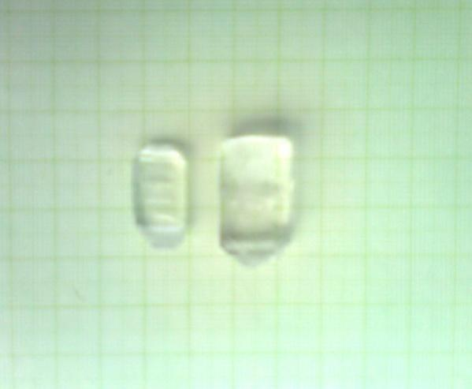
Fig.1. Grown crystals of BGSN mixed ADP

3. Characterization studies

3.1. X-ray diffraction
Powder X-ray diffraction data were collected for the grown ADP doped with 10% BGSN crystals using PHILIPS Holland, XRD System PW1710 diffractometer with Cu Kα- radiation (λ = 1.5405 Å ) with an applied operating voltage 30 kV and current 20 mA. The prominent peaks in the XRD pattern have been indexed. The experimental values were found to agree well with the calculated‘d’ values shown in Table 1. The recorded X-ray pattern of BGSN mixed ADP is shown in Fig. 2.

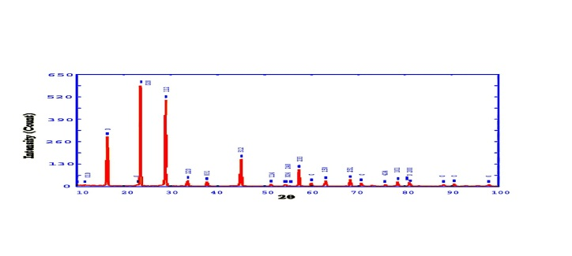
Fig.2. Powder X-ray diffraction study of ADP doped with 10% BGSN.

Table 1
X-ray powder diffraction data for ADP doped with 10% BGSN crystal
 | h k l | 2Theta  (Exp.) | 2Theta  (Calc.) | 2Theta  (Diff.) | d  (Exp.) | d  (Calc.) | Intensity  (Exp.)
0 1 0 |  | 11.782 | 11.771 | 0.011 | 7.5052 | 7.5120 | 9.68
0 2 0 |  | 23.636 | 23.669 | -0.033 | 3.7611 | 3.7560 | 588.51
1 1 2 |  | 28.962 | 29.002 | -0.040 | 3.0804 | 3.0762 | 502.79
2 2 0 |  | 33.712 | 33.720 | -0.008 | 2.6565 | 2.6558 | 35.02
0 3 1 |  | 37.788 | 37.824 | -0.037 | 2.3788 | 2.3766 | 28.16
3 1 2 |  | 45.069 | 45.061 | 0.008 | 2.0099 | 2.0103 | 158.16
1 1 4 |  | 51.379 | 51.349 | 0.030 | 1.7769 | 1.7779 | 12.55
0 2 4 |  | 54.343 | 54.372 | -0.029 | 1.6868 | 1.6859 | 10.00
2 4 0 |  | 54.615 | 54.592 | 0.024 | 1.6790 | 1.6797 | 11.39
2 3 3 |  | 57.382 | 57.378 | 0.004 | 1.6045 | 1.6046 | 97.95
1 5 0 |  | 63.090 | 63.049 | 0.041 | 1.4723 | 1.4732 | 33.02
2 5 1 |  | 68.314 | 68.328 | -0.014 | 1.3719 | 1.3717 | 39.51
4 2 4 |  | 75.756 | 75.757 | -0.001 | 1.2546 | 1.2545 | 10.96
1 6 1 |  | 78.429 | 78.401 | 0.028 | 1.2183 | 1.2187 | 27.76
2 6 0 |  | 80.897 | 80.863 | 0.034 | 1.1873 | 1.1877 | 24.23

3.2. Thermo gravimetric Analysis (TGA)

TGA of ADP mixed with 10 mole% of BGSN was carried out between room temperature (28℃) and 300℃ at a heating rate of 10 K min⁻¹ as shown Fig. 3. The experiment was performed in nitrogen atmosphere. Although the TG trace appears nearly inclined line up to 220.25 ℃, a careful examination of DTA thermogram revealed a minor endothermic peak around 220.25 ℃,

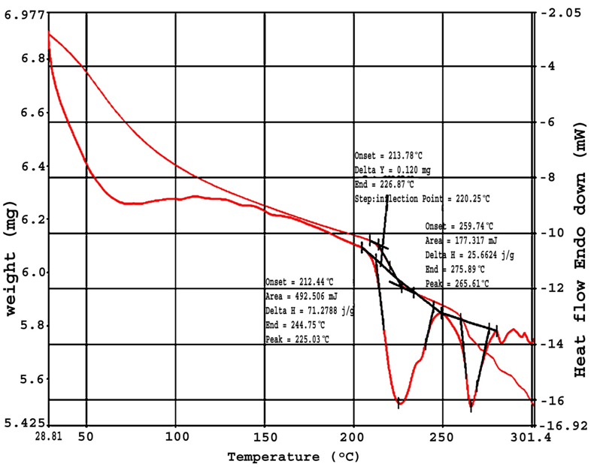
Fig.3. TGA of ADP doped with 10% BGSN.

and a steady decrease in weight observed (64.01%) up to 270 ℃, which may be due to the decomposition of the sample. At temperatures above 270℃, the final stage of decomposition occurs, giving a total loss equal to 35.94%. The DTA of BGSN doped ADP was carried out between 28 and 300 ℃ in nitrogen atmosphere using NETZSCH STA 409 PC at a heating rate of 10 K min⁻¹. The DTA trace indicates a strong endothermic starting at 226.21 ℃ due to its melting of the crystal. Hence, from these thermal studies, it is concluded that the crystal can retain texture up to 220.25 ℃. Its application is restricted up to 220.25 ℃ only, which is higher than pure ADP (215℃) and also with other semi-organic materials like L-alanine cadmium chloride (LACC) (110℃), triallyl thiourea cadmium chloride (ATCC) (101℃), triallyl thiourea cadmium bromide (ATCB) (97 ℃), triallyl thiourea mercury chloride (ATMC) (133 ℃) and allyl thiourea mercury bromide (ATMB) (125 ℃) [7–10].

Conclusion:
The BGSN doped ADP single crystal is synthesized by slow evaporation method. The optically good quality of single crystal of maximum size up to 1.9 x 1.9 x 1.0 cm³ is obtained. The crystal belongs to orthorhombic system. From TGA/DTA analysis it is found that the crystal is thermally stable up to 220.25 ⁰ C, hence we can conclude that thermal stability of ADP crystal increases due to doping of BGSN.

REFERENCES
[1] Ren Xiue, Xu Dongli, Xue Dongfeng. J Cryst Growth, 2008, 310, 2005–9.
[2] Rajesh P, Ramasamy P, Mahadevan CK. J Cryst Growth, 2009, 311, 1156–60.
[3] D. Eimert; S. Velsko; L. Davis, F. Wang; G. Loiaccono; G. Kennady. IEEE J. Quantum
Electron. 1989, 25, 179.
[4] M.D. Aggarwal; J. Choi; W.S. Wang; K. Bhat; R.B. Lal; A.D. Shield; B.G. Penn; D.O.
Frazier. J. Crystal Growth, 1999, 204, 179.
[5] R. Sankar, C.M. Ragahvan, R. Mohan Kumar, R. Jayavel, Journal of Crystal Growth,
2007, 309, 30–36.
[6] N.P. Rajesh, K. Meera, K. Srinivasan, P. Santhana Raghavan, P. Ramasamy, J. Crystal
Growth, 2000, 213, 389.
[7] D.R. Yuan; N. Zhang; W.T. Yu; D. Xu; X.T. Tao; M.H. Jiang. Chin. J. Lasers, 1990, 17,
332.
[8] D.R. Yuan; N. Zhang; X.T. Tao; D. Xu; X.T. Tao; M.H. Jiang,Chin. Phys. Lett, 1990, 7,
334.
[9] W.B. Hou; D.R. Yuan; D. Xu; N. Zhang; W.T. Yu; M.G. Liu; X.T. Tao; S.Y. Suo; M.H.
Jiang. J. Crystal Growth, 1993, 133, 71.
[10] Y.P. Tian; C.Y. Duan; C.Y. Zhao; X.Z. You; T.C.W. Mak; Z.Y. Zhang; Inorg. Chem.,
1997, 36, 1247.
[11] T. Pal; T. Kar; W. Xin Qiang; Z. Guang Ying; W. Dong; C. Xiu Feng; Y. Zhao He. J.
Crystal Growth, 2002, 235, 523.

