Customer Satisfaction Analysis In Four Wheeler Service Centre
Mr. Sanket. P. Kale¹, Mr. Prashant. N. Awachat²
¹M.tech student , Department of Mechanical Engineering
G.H Raisoni Academy of Engineering & Technology , NAGPUR , INDIA, 440016
²Assisant Professor , Department of Mechanical Engineering
G.H Raisoni Academy of Engineering & Technology , NAGPUR , INDIA, 440016

Abstract –.The Indian automobile industry is faced with tough competition because of the entry of many automobile companies. Customer satisfaction being the key element for success in business has emerged as a major concern for any industry. The increment and decrement in the no. of customer is totally depend on customer satisfaction. In the present time there is a lot of competition in the market so there is a need to be conscious about customer satisfaction. This paper deals with the review on customer satisfaction and its effect on automobile industries. At the present time each and every industry try to provide better services and quality of product as well as some additional features in their product which give additional importance in the market. Here we are talking about the four wheeler automobile service industries in which there are some gaps in between perceived and expected service and this thing directly affect the customer satisfaction, its market and brand value. Customer satisfaction is very important term in each and every industry. . The expectation of the customer is that in a less time the service center provide the best service but due to some gaps this things is not possible. The data collection was through self-prepared questionnaire using convenience sampling method. The data was analysed using SPSS Software. The result with proper interpretation is presented.
Keywords- Customer Satisfaction, Question Survey, Analysis of data.
INTRODUCTION
In the present time the automotive industry become the huge industry all over the world because new models are arrived in the market day by day. These industries also try to change in the design, development, manufacturing

and marketing of their product. For marketing of the product the term customer satisfaction is used. services it is the customer who defines the quality and human side of service is key to deliver quality. The measures of service quality obtained through consumer surveys have become a widely used business performance measurement tool. This is because service quality is related to costs, profitability, customer satisfaction and customer retention. Loyal customers and long lasting customer relationships are one of corner stones of Indian Automotive strategy. They want to ensure long-term commitment and continuity and their vision is to be customer’s number one choice. Therefore, high level of customer satisfaction is essential to their strategy and long term goals. Satisfaction can be defined as a subjective feeling of a person with fulfillment of his needs and wishes. They depend not just on the experience and expectations but also on personality and environment. Kotler gives a similar definition in which he says that degree of customer satisfaction can be found in a relationship between a realization of supply and his expectation. Customer is not satisfied if his expectations are not met. In comparison with a satisfied customer whose service or product meet or fulfill his expectations.
One of the most important factors, which is essential in successful business, is customer satisfaction. Nowadays the competition of the companies is increasing so it´s necessary to provide high-quality customer care, leading to his satisfaction. The mail goal is to keep his loyalty to the company he cooperated with. It´s important to pay the same amount of time not just to get new customers but also to put an effort in keeping the current ones
The Indian automobile industry is faced with tough competition because of the entry of many automobile companies. Customer satisfaction being the key element for success in business has emerged as a major concern for any industry
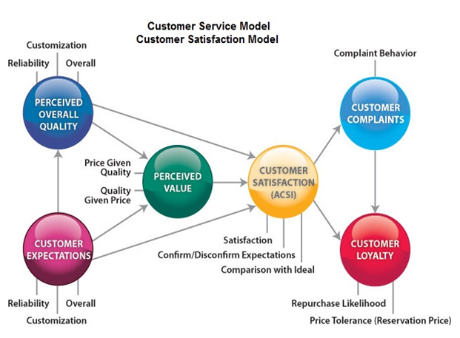
.
LITERATURE REVIEW
Dhananjoy Datta (2010) : The many factors which determine the buying behavior of the consumer are the very same factors motivating them to purchase the two-wheeler including advertisement, word of mouth, references from family, friends, own experience, features, price, etc. The survey results showed that around 51% of the customers with two-wheelers are in the age group of 20-30 years with an income below Rs. 5000. Around 64% people were unmarried, using Bajaj two wheelers. In majority of the cases, the motivating factor are friends (44%) and family (31%). People also look for installment plans and finance schemes prior to purchasing a two wheeler.
Saaravanan and Panchanatham (2009) : discussed the nessicities for promotion of a product. The result showed that a customer considers all factors at the time of purchasing a two wheeler, although majority give prominence to the brand image. This study also brought forth the socioeconomic factors which play a key role in decision making for the two wheeler customers and that the employed and the students crave for showroom services.
Murphy John and Bellman Eric(2008) : It has been discussed that Bajaj Auto Ltd in 1948 came up with import and sale of Vespa scooters. The scope of the scooters had decreased since the boom in the motorcycle market segment. The customers’ preferences changed the automotive strategies adopted by the Hero Honda Motor Co. in India.
Subhadip Roy (2006) &Mohnot (2002) : In his study of two and three wheelers, the two-wheeler has become an expression of the owners' personality. The customer while making his choice evaluates the product in terms of utility, fuel economy, reliability, maintenance, affordability, performance, good after-sales service at reasonable cost, availability of spare parts at economical prices, looks, safety and comfort, and ease of riding for driving. Total sales of two-wheeler in first eight months of 2001-02 had increased to 2.70 million units from 1.33 million units in the corresponding period of the preceding year.
Siddhartha and Mukherjee (2002): The Study reveals that, the two-wheelers in India are used for a variety of work such as visiting people, transporting goods, outdoor jobs like selling and buying. In rural areas it helps people to travel more frequently to nearby towns for their day to day needs. The two-wheeler has become a valuable support for increasing productivity and in turn the profit, besides helping as a personal mode of transportation
RESEARCH METHODOLOGY
Descriptive Research Design was used to describe customer satisfaction of 4 wheeler service centre. The study was conducted in Nagpur (Maharashtra) by Visting to 4 different service centre named
1) Maruti Suzuki (seva)
2) Rushabh Honda
3) Ketan Hyudai
4) Tata Motors
with a self prepared feedback form. In which the
Sample size of Data collected was 80. Means from One service centre we have the Survey of about 20 customers. The data was analysed using Statistical Packages for Social Sciences (SPSS) Software in Which Factor Analysis was Done.

DATA ANALYSIS
1. Maruti Suzuki (seva)

Total Variance Explained
Component | Initial Eigenvalues |  |  | Extraction Sums of Squared Loadings
 | Total | % of Variance | Cumulative % | Total | % of Variance | Cumulative %
1 | 5.104 | 56.706 | 56.706 | 5.104 | 56.706 | 56.706
2 | 1.054 | 11.709 | 68.415 | 1.054 | 11.709 | 68.415
3 | 1.004 | 11.155 | 79.570 | 1.004 | 11.155 | 79.570
4 | .642 | 7.131 | 86.701
5 | .558 | 6.197 | 92.898
6 | .292 | 3.248 | 96.146
7 | .164 | 1.820 | 97.966
8 | .112 | 1.245 | 99.211
9 | .071 | .789 | 100.000
Extraction Method: Principal Component Analysis.

- Ketan Hyundai
Total Variance Explained
Component | Initial Eigenvalues |  |  | Extraction Sums of Squared Loadings
 | Total | % of Variance | Cumulative % | Total | % of Variance | Cumulative %
1 | 5.572 | 61.915 | 61.915 | 5.572 | 61.915 | 61.915
2 | 1.213 | 13.482 | 75.397 | 1.213 | 13.482 | 75.397
3 | .682 | 7.583 | 82.979
4 | .554 | 6.156 | 89.135
5 | .389 | 4.326 | 93.461
6 | .229 | 2.541 | 96.002
7 | .163 | 1.814 | 97.816
8 | .131 | 1.461 | 99.277
9 | .065 | .723 | 100.000
Extraction Method: Principal Component Analysis.

- Rushabh Honda
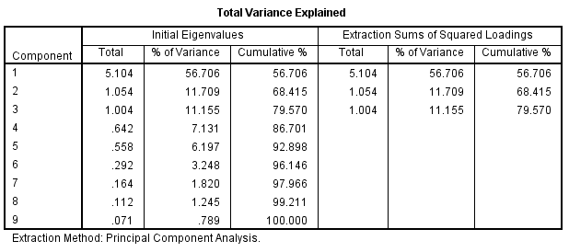

- Tata Motors
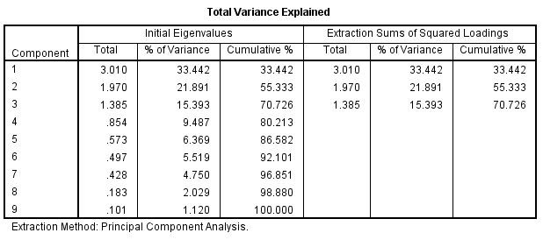

Result & Interpretation

For the present study, all the factors have Eigen value of more than one, so all the three factors are considered. The factors extracted in the study are three in number and together contribute 79.570, 75.397, 70.726, 79.570 of total variance for all 4 service centres. There is a fair percentage of variance to be explained for the suitability of the factor analysis. Thus extracting three factors from
total 9 variables for measuring the satisfaction level is good by all means. Interpretation is done by identifying the variables that have very high loadings on the same factor. These factors can then be interpreted in terms of the highly loaded variables.

Variable | Maruti Suzuki (seva) | Ketan Hyundai | Rushabh Honda | Tata Motors
1.Promptness | 56.706% | 61.91% | 56.706% | 33.42%
2. Pick-up & drop Facility | 68.415% | 75.39% | 68.415% | 55.33%
3. Problem understanding | 79.5% | _ | 79.62% | 70.26%

Conclusions

- From the Above chart we Conclude that 3 Factors where Considered for measuring Customer satisfaction level.
- These 3 Factors where namely Promptness in attending you when you arrive at your service center , Pickup& drop facility , Problem understanding of your vehicle.
- The Factors Score Shows us that Maruti Suzuki (seva) and Rushabh Honda have to give more focus to expand their Customer Base .
- While Ketan Hyundai & Tata Motors have Negligible Customer Satisfaction level .
- Maximum Number of respondents have given preference to Problem understanding & Pick up & drop Facility

REFERENCES

1] Dhananjoy Datta (2010) Factor influencing customers buying behavior of two-wheeler at Agartala, Tripura, ICFAI University Journal.

2] K. Siddhartha and S. Mukherjee, (2002), ‘Cities Urbanization and urban systems’, Kisalaya Publications Pvt. Ltd., Delhi

3] Murphy John and Bellman Eric(2008) “Riding Two-Wheelers in India”, Wall Street Journal.

4] Prof.S. Saaravanan and Prof. N. Panchanatham, (2009), Customer behavior towards show room services of two-wheeler, International Cross Industry Journal Perspectives of Innovations, Economics & Business.

5] Rajamani Singh and AS Yasso (2001) in Sathish M, A Study on Consumer Behaviour of Automobile Products with Special Reference to Two-wheelers in Tirunelveli City, Tamil Nadu, Indian Journal of Applied Research, Vol. 1, No. 3, December 2011

6] Lewis, R.C. & Boom, B.H. (1983) “The Marketing Aspects of Service” in Berry, L., Shostack, G. and Upah, G. (Eds), “Emerging Perspective on Services Marketing” American Marketing Association

7] Dr.C.Annandan & M.Prasanna Mohan Raj &Mr.S.Madhu, A Study on Brand preference of washing soaps in rural areas, Indian Journal of marketing,March(2007)

8] J.Vignesh Kumar, Dr.S .Rita,D.Catherine Rexy(2016) An Empirical approach to measure customer satisfaction of two wheelers using six sigma at International Journal of Pure and applied mathematical sciences.

9] Rachel Dardis, Horacio Soberon-Ferrer, consumer’s preferences for Japanese auto mobiles,Journal of consumer affairs, summer (1994).

10] Nitin Joshi, D.P Mishra(2011) Environment Friendly Car: A study Of Consumer Awareness with Special Reference to Maharashtra in Information Management and Business Review Vol. 2, No. 2.

