**A Review Paper on Performance Evaluation of Desiccant Wheel with Comparative Study of Dehumidification using Various Desiccant Material used in hybrid Air Conditioning**

**Bhatu R. Borane1, Dr. Vijay H. Patil2, Prof. T. A. Koli3**

*1Student, 2Academic Dean and H.O.D, 3Assistance Professor and PG Coordinator*

*1, 2,3, Thermal Engineering, Godavari College Of Engineering, Jalgaon-425002, Maharashtra, India*

*1*[*bhatuborane38@gmail.com*](mailto:bhatuborane38@gmail.com)*, 2*[*vhpatil76@yahoo.com*](mailto:vhpatil76@yahoo.com)*,3[kolitushar09@gmail.com](mailto:kolitushar09@gmail.com)4*

***Abstract –*** *Air-conditioning systems combined with rotary dehumidification were widely used in industrial buildings with low humidity requirements. In this paper, a rotary desiccant wheel based hybrid air conditioning system with natural cold source was presented, which was used in civil buildings. In this system, sensible load was undertaken by the natural cool source, and latent load was undertaken by rotary dehumidification wheel. The performances of rotary desiccant wheel based hybrid air conditioning system with natural cold source were studied in two typical outdoor meteorological conditions. The results showed that the system under both high temperature high humidity and high temperature low humidity conditions can satisfy the indoor environment demand for civil buildings, while the energy consumption on high temperature high humidity condition is less. While waste heat or solar energy is adopted as regeneration heat source, the energy consumption of rotary desiccant wheel based hybrid air conditioning system can further reduce.*

***Keywords-***  *Rotary Desiccant Wheel, Air Conditioning, Solid and Liquid Desiccant Material.*

1. **Introduction**

Air conditioning (AC) is the process of providing by mechanical means control of temperature, relative humidity, movement and purity of the air. Maintaining a space at a desired indoor condition may be achieved by simple heating (increasing the dry bulb temperature), simple cooling (lowering the dry bulb temperature), humidifying (adding moisture), or dehumidifying (removing moisture) the air. Quite often two or more of these processes are required to bring a space to the desired condition. To maintain the desired comfort conditions an air conditioning system has to handle two loads. These are the temperature associated, or sensible load and moisture associated, or latent load. The sensible load is met simply by changing the dry bulb temperature of the air. To meet the latent load of the space some moisture has to be added or removed from it. There are four principal methods [Jones 2001] of dehumidification:

* Cooling air to a temperature below its dew point
* Adsorption
* Absorption
* Compression followed by cooling.
* **Moisture Removal:**

The moisture removal capacity of a desiccant dehumidifier is related to several parameters. One parameter is the amount of “surface” area of the desiccant that is exposed to the air-stream. Each rotor contains hundreds of square feet of sheet area per cubic foot of rotor volume. This surface area multiplied by the “internal” pore surface area results in thousands of square feet of area of desiccant available for adsorption. This tremendously high ratio of surface area to volume is one of the significant reasons for the excellent performance of the desiccant dehumidifier. The rotor speed is also optimized such that a maximum amount of desiccant is “rotated” through the process air-stream without causing over heating of the desiccant. By selecting the optimum speed of rotation, the adsorption cycle is carefully balanced against the de-sorption cycle. All desiccant dehumidification rotors are bearing supported for long life and dependable mechanical support. Rotors with a diameter larger than 20-inches are shaft mounted and bearing supported. The full weight of the rotor and the adsorbed moisture are supported by the shaft and bearing arrangement.

* **Adsorption:**

Adsorption occurs when the attractive forces of a desiccant capture water vapour. The vapor is drawn to and adheres to the surface of the desiccant. The vapor is then drawn into the macro-pores and then the micro-pores by capillary action. In the process the moisture converts adiabatically from vapour to a quasi liquid and is stored within the desiccant. (An adiabatic process occurs without the external addition or removal of heat.) It is important to distinguish between the vapour quasi-phase changes as opposed to a desiccant phase change.

* **Absorption:**

Absorption, collecting moisturechanges the desiccant physically or chemically. Most absorbents, such as solutions of lithium chloride or triethylene glycol in water, are liquids.

* **Sensible heat -**

The amount of Heat required to chang the temperature of a system without changing its state or phase is known as sensible Heat.

* **Latent heat-**

The amount of Heat required to change the state or phase of a system without changing its temperature is known as Latent Heat.

* **Process Inlet:**

Air to be dried. May be outside air, inside air or, more commonly, a mixture of air with high humidity content.

* **Process Outlet:**

Air is dried by desiccant wheel. May be cooled, filtered or otherwise handled. Relative humidity is substantially lower and temperature slightly raised.

* **Reactivation Inlet:**

Air flow, usually outside air, that drives moisture off wheel. Reactivation air is heated by direct-fired gas burner or indirect-fired water or steam.

* **Reactivation Outlet:**

Hot, wet air from wheel is exhausted outside or passed through an air-to-air heat-exchanger. Using a heat exchanger to preheat incoming process air offers substantial savings in northern climates.

* **Dehumidification:**

Active dehumidification is mechanical moisture removal intended to maintain comfort and protect building materials. There are two primary ways to actively dehumidify: by condensing moisture using a heat pump refrigerant-based DEH and by adsorbing moisture using a desiccant wheel - desiccant DEH. (We use the less-familiar term adsorption to describe how water molecules adhere to the surface of a material

A conventional air conditioner consumes large amount of electrical energy especially in hot and humid climatic conditions due to high latent load which is decide by the outside contents. Desiccant wheel based hybrid air conditioning system is one of the promising alternative to handle the high latent load efficiently where sensible and latent heat of air are being removed separately. A desiccant wheel is very similar to a thermal wheel, but with a coating applied for the sole purpose of dehumidifying or ‘drying’the air stream. The desiccant is normally Silica Gel. As the wheel turns, the desiccant passes alternately through the incoming air where the moisture is adsorbed, and through a “regenerating”zone where the desiccant is dried and the moisture expelled. The wheel continues to rotate and the adsorbent process is repeated.

Regeneration is normally carried out by the use of a heating coil, such as a water or steam coil, or a direct-fired gas burner. Thermal wheels and desiccant wheels are often used in series configuration to provide the required dehumidification as well as recovering the heat from the regeneration cycle. A desiccant material can be described as a material that naturally attracts moisture from both gases and liquids. This moisture is then adsorbed or retained within the desiccant and can be released again when heated. There are various types of desiccant available on the market, but all Aggreko dehumidifier’s use what is known as Silica Gel as the desiccant within the drying wheels. Strangely silica gel is not a “gel” as the name implies, but in fact a porous granular form of silica which is made from sodium silicate. The internal structure of each silica granule is made up of a network of interconnecting microscopic pores, which by a process called physical adsorption or capillary condensation, attract and holds moisture within each granule. This trapped moisture can then, with the addition of heat, be released from the desiccant. This desiccant can then be used again and again. As low ambient temperatures do not restrict the material, it makes it a more all season drying system. desiccant wheel based dehumidification system used in HVAC industries to remove moisture from air to give better human comfort.

The benefits of desiccant dehumidification are better humidity control, more efficient latent load removal, and reduction of peak electric demands. In regions of the country where the electric utilities are having trouble servicing their peak air-conditioning loads, this energy-efficient technology can assist in meeting that demand.

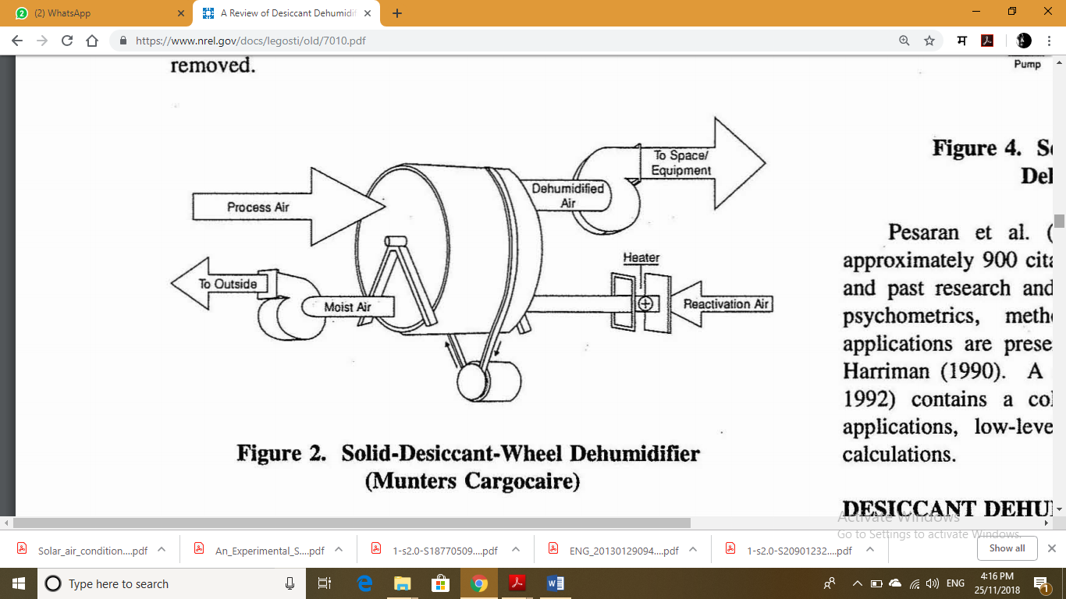Fig 1.: Desiccant Wheel

1. **System scheme and working principle**

The rotary desiccant wheel based hybrid air conditioning system using natural cold source mainly consists of desiccant wheel and surface air cooler. In order to make full use of natural cold source, two-staged surface air coolers was employed． The rotary desiccant wheel based hybrid air conditioning system using natural cold source was showed in Fig. 1. The outdoor fresh air and the indoor return air are mixed into first-stage surface air cooler to cool air, and then cooled air is pumped into desiccant wheel. Desiccant wheel absorbs moisture from air due to difference between partial pressure of moisture in the air and desiccant materials, thus latent load of process air was removed and humidity ratio of the air was low. Some common adsorbent materials are LiCl, Silica gel and Zeolite. The desiccant wheel was regenerated by the application of heat to release the moisture, which is exhausted to the outdoors. After that, process air pass into second-stage surface air cooler to deep cool air. In order to reduce the area and initial investment, the system does not consider the heat of exhaust air, but when outdoor fresh air volume is large, the heat recovery device can be added on the basis of the system to further reduce the energy consumption of the air conditioning system.



Fig.2 Schematic of Rotary desiccant Wheel Based Air Conditioning

**3. Literature Review**

**Experimental performance study of a proposed desiccant based air conditioning system, M.M. Bassuoni**, An experimental investigation on the performance of a proposed hybrid desiccant based air conditioning system referred as HDBAC is introduced in this paper. HDBAC is mainly consisted of a liquid desiccant dehumidification unit integrated with a vapor compression system (VCS). The VCS unit has a cooling capacity of 5.27 kW and uses 134a as refrigerant. Calcium chloride(CaCl2) solution is used as the working desiccant material. HDBAC system is used to serve low sensible heat factor applications. The effect of different parameters such as, process air flow rate, desiccant solution flow rate, evaporator box and condenser box solution temperatures, strong solution concentration and regeneration temperature on the performance of the system is studied. The performance of the system is evaluated using some parameters such as: the coefficient of performance (COPa), specific moisture removal and energy saving percentage. A remarkable increase of about 54% in the coefficient of performance of the proposed system over VCS with reheat is achieved. A maximum overall energy saving of about 46% is observed which emphasizes the use of the proposed system as an energy efficient air conditioning system.[1]

**An experimental study on the dehumidification performance of a low-flow falling-film liquid desiccant air-conditioner, S. Bouzenadaa*, C. McNevinb, S. Harrison c, A. N. Kaabid**, The dehumidifier is one of the main components in open-cycle liquid desiccant air-conditioning systems. An experimental study was carried out to evaluate the performance of a solar thermally driven, low-flow, falling-film, internally-cooled parallel plate liquid desiccant air-conditioner in Kingston, Ontario at Queen’s University. A solution of LiCl and water was used as the desiccant. Unlike high-flow devices, the low-flow of desiccant solution flowing across the unit’s dehumidifier and regenerator sections produces large variations in solution concentration. In this study, a series of tests were undertaken to evaluate the performance of the dehumidifier section of the unit. Results presented are based on mass flow and energy transport measurements that allowed the moisture transport rate between the air and liquid desiccant solution to be determined. Based on these results, a relationship between the desiccant concentration and the rate of dehumidification rate was found and the effect of inlet-air humidity on the dehumidification effectiveness identified. The moisture removal rate of the system was found to range from 1.1 g/s to 3.5 g/s under the conditions evaluated. These result corresponded to an average dehumidification effectiveness of 0.55.[2]

**The Experiment and Simulation of Solid Desiccant Dehumidification for Air-Conditioning System in a Tropical Humid Climate, JuntakanTaweekun*, Visit Akvanich**, The aim of this research was to study and design a solid desiccant dehumidification system suitable for tropical climate to reduce the latent load of air-conditioning system and improve the thermal comfort. Different dehumidifiers such as desiccant column and desiccant wheel were investigated. The ANSYS and TRASYS software were used to predict the results of dehumidifiers and the desiccant cooling systems, respectively. The desiccant bed contained approximately 15 kg of silica-gel, with 3 mm average diameter. Results indicated that the pressure drop and the adsorption rate of desic- cant column are usually higher than those of the desiccant wheel. The feasible and practical adsorption rate of desiccant wheel was 0.102 kg/h at air flow rate 1.0 kg/min, regenerated air temperature of 55°C and at a wheel speed of 2.5 rpm. The humidity ratio of conditioning space and cooling load of split-type air conditioner was decreased to 0.002 kg/kgda (14%) and 0.71 kWh (19.26%), respectively. Consequently, the thermal comfort was improved from 0.5 PMV (10.12% PPD) to 0.3 PMV (7.04% PPD).

**Performance Characteristics of Solid-Desiccant Evaporative Cooling Systems, RamadasNarayanan , Edward Halawa and Sanjeev Jain** , Air conditioning accounts for up to 50% of energy use in buildings. Increased air-conditioning-system installations not only increase total energy consumption but also raise peak load demand. Desiccant evaporative cooling systems use low-grade thermal energy, such as solarenergy and waste heat, instead of electricity to provide thermal comfort. This system can potentially lead to significant energy saving, reduction in carbon emissions, and it has a low dew-point operation and large capacity range. Their light weight, simplicity of design, and close-to-atmospheric operation make them easy to maintain. This paper evaluates the applicability of this technology to the climatic conditions of Brisbane, Queensland, Australia, specifically for the residential sector. Given the subtropical climate of Brisbane, where humidity levels are not excessively high during cooling periods, the numerical study shows that such a system can be a potential alternative to conventional compression-based air-conditioning systems. Nevertheless, the installation of such a system in Brisbane’s climate zone requires careful design, proper selection of components, and a cheap heat source for regeneration. The paper also discusses the economy-cycle options for this system in such a climate and compares its effectiveness to natural ventilation.[4]

**Solar Air Conditioning System Using Desiccant Wheel Technology ,Arfidian Rachman , Sohif Mat, Taib Iskandar , M. Yahya, Azami Zaharim And KamaruzzamanSopian,** The electrical energy consumption in Malaysia has increased sharply in the past few years. Modern energy efficient technologies are desperately needed for the national energy policy. In this paper, a new design of desiccant cooling is being developed at the Solar Energy Research Institute, National University of Malaysia, Malaysia. The new conception of desiccant cooling can be an energy saving and permits to produce heat or cool by using solar energy without polluting the environment. Desiccant cooling systems have been used successfully in northern Europe and a number of studies have demonstrated that solar energy can be used to drive the system in this region. However, to date, desiccant cooling has not been used in Malaysia. This paper presents the results of a study, in which a solar desiccant cooling model will used to evaluate the potential for using solar power to drive a single-stage desiccant cooling system in Malaysia. The study demonstrates that solar desiccant cooling is feasible in Malaysia, provided that the latent heat gains experienced are not excessive. However, if the relative humidity’s experienced are too high then desiccant cooling becomes impracticable simply because the regeneration temperatures required are excessive.[5]

**Solid Desiccant Cooling - An Overview D.B.Jani, Manoj Gwalwanshi, Manish Mishra, P.K.Sahoo Department of Mechanical & Industrial Engineering, I.I.T., Roorkee** Desiccant cooling is a better alternative to vapour compression cooling systems which consume lot of energy and also increase the CFC level in the environment. In detailed literature survey it has been found that desiccant cooling system can be the most promising system in hot and humid climatic condition for thermal comfort. For effective use of evaporative cooling techniques in hot and humid climate a desiccant material based rotary wheel can be utilized as a dehumidifier. In a solid desiccant dehumidification system, the moisture (latent load) in the process air is removed by a desiccant dehumidifier. The temperature (sensible load) of the dried process air is lowered to the desired comfort conditions by sensible coolers. The latent and sensible loads are handled separately and more effectively in components designed to remove the total load. The desiccant cooling system (DCS) has proven its feasibility and cost saving in the field of air conditioning. A brief overview has been provided on the development of desiccant cooling system and its mathematical modelling.

**4. Problem Definition**

In supermarkets, offices or any other public places conventional refrigeration systems tend to cycle on and off, which allows build-up of humidity and frost. A conventional air-conditioning system that handles both loads is not very efficient because there may be a need for reheat. And because the cooling coils must be at a temperature below dew point to allow for condensation, the coefficient of performance (COP) or energy efficiency ratio (EER) of the refrigeration system is not very high. If the humidity could be controlled independently of temperature, the conditioned space would be more comfortable and the maintenance due to frost on freezer cases would be eliminated.

There are various types of desiccant materials available in market. They may in be solid or liquid material. Every type has its own capacity to dehumidify air.

**5. Objectives :**

* To produce comfort conditions for summer season using the approach of Desiccant Wheel Dehumidifier.
* To compare various type of desiccant material used in desiccant wheel in the context of performance at various conditions.

**6. PROPOSED SETUP**

Dehumidification is the removal of moisture from air. Thought of in another way, dehumidification is the drying of air. The degree of dehumidification varies with the application requirements and greatly influences the type of equipment utilized. Most engineers are familiar with mechanical dehumidification. A process of cooling an air-stream to below its dew point temperature causing moisture to condense from the air. This process frequently requires re-heating of the air to avoid supplying saturated air to a space.

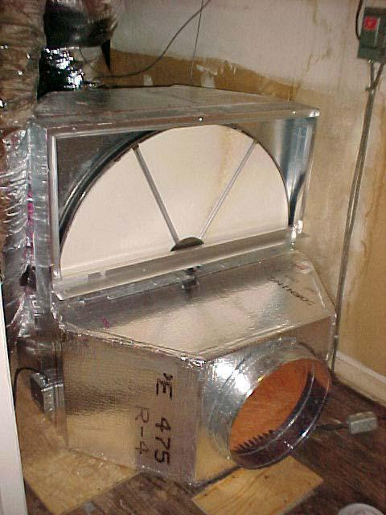

Fig 3. Experimental Setup

Desiccant dehumidification is becoming more familiar. Many engineers are just becoming knowledgeable concerning the use of desiccants for dehumidification. Desiccant dehumidifiers utilize a “sorption” material to attract and hold moisture from air. Once the sorption material, called a desiccant, is “saturated “with moisture, it can be reactivated or regenerated. Reactivation is usually accomplished by thermal means and restores the desiccant’s dehumidification capacity. The mass exchange of the moisture from and to an air. Desiccant dehumidifiers are required for use below the frost point where mechanical refrigeration type dehumidifiers experience freezing on the coil surface or when dehumidification is required, but cooling is not, such as for dry goods storage or preservation requirements.

Desiccant dehumidification is also utilized to provide for humidity control independent of temperature control in occupied spaces. Desiccant dehumidifiers are available with either dry or liquid desiccants. Dry desiccants are available with either adsorption or absorption desiccants. Desiccant dehumidifiers utilize a dry adsorption type desiccant. The removal of water vapours from air. Dehumidification can be accomplished by cooling an air stream to below its dew point temperature causing the condensation of vapours or by desiccant adsorption/absorption resulting in removal of humidity from air in the vapour phase. Desiccant dehumidification is an important “air-conditioning” process by which many industrial processes or products are improved or even possible. And now, desiccant dehumidification is being utilized in commercial HVAC applications too.

Improvements in desiccant performance and manufacturing are currently encouraging. With these improvements, desiccant-based equipment holds the promise of successful incorporation into more and more commercial HVAC applications. Such equipment is intended to reduce the adverse affects of untreated humidity contained in ventilation air as well as generated sources of humidity from within commercial buildings. Dehumidified ventilation air allows the HVAC designer another option towards improving Indoor Air Quality (IAQ) which may have been adversely affected by moisture allowing the growth of mould and mildew, etc.

.

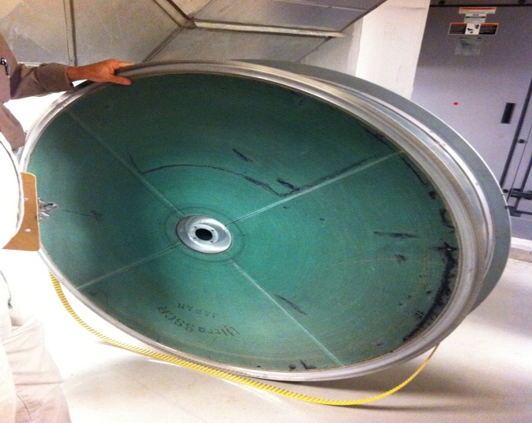

Fig 4. Desiccant Wheel

In a typical dry desiccant system, the desiccant is mounted on a rotating wheel. As the wheel turns, the desiccant passes alternately through the incoming process air where the moisture is adsorbed and through a regenerating zone where the desiccant is dried and the moisture expelled. The wheel continues to rotate and the adsorbent process is repeated. Typically, about three-fourths of the desiccant wheel is exposed to the incoming air throughout the process.

**7. Types of Desiccants**

**7.1 Solid Desiccants**

The solid desiccant is a dehumidifier made of porous and hydrophilic materials and it is adsorbing moisture from the air. Usually the solid desiccants are activated alumi-num oxide, titanium silicate, silica gel, natural and synthetic zeolites, etc. Those ad-sorbents have high regenerative temperature.

**7.2 Liquid Desiccants**

Triethylene glycol, lithium bromide, lithium chloride are used as liquid desiccants usually. Liquid desiccants have a lower regeneration temperature than solid desiccants. The regeneration temperature is usually below 80 °C. In cooling systems, it is usually used a pre-cooled desiccant in order to achieve the dehumidification and the cooling of the air because liquid desiccants also remove extra moisture and it leads to the increasing of temperature.

The most stable liquid desiccant is lithium bromide (Libr+H2O). It also has low a va-por pressure but the price of the lithium bromide is higher than the price of others. However, the strong corrosive to metals, the high price and the high temperature of the regeneration make it not so useful. There is another desiccant, which is lithium chloride (LiCl). The lithium chloride has a lower temperature of regeneration and a higher absorption capacity but it is also corrosive to metals. Another liquid desiccant is Calcium chloride (CaCl2). Calcium chloride has the same crystallization temperature about 11-12 °C as the lithium bromide. It has a lower price and no corrosion to metals but it has a lower potential of the dehumidification.

**8. Desiccant Dehumidification Applications**

Desiccant systems are especially useful when the latent load is high (i.e., when the latent-to-sensible heat ratio is high), because they remove moisture more economically than they remove sensible heat. Another desirable situation is when the cost of dehumidification with a desiccant is lower than the cost of dehumidification with a refrigeration system. This is where thermal energy comes into the picture: there are instances where desiccant regeneration done by waste heat, natural gas, or off-peak electricity is more economical compared to regular electric refrigeration. Because there is no need for reheating with desiccant dehumidification systems , another appropriate use is when conditioned air must be reheated after coming out of a coil to reach a comfortable dry-bulb temperature. Finally, the use of a desiccant is well-suited to the case where dehumidification is required at levels below freezing dew-point temperatures. For example, an ice arena has is a great deal of humidity, but the cooling coil has to cool below the freezing point. In such an environment, dehumidification with desiccants can play a major role.

Taking into consideration these "best" circumstances, several sectors of the market have characteristics to be good marketing opportunities for desiccant dehumidification. Supermarkets have provided the best opportunity. Ice rinks, hotels and motels, and retail stores have dehumidification needs that could be met very efficiently with desiccants. Restaurants have provided another opportunity for desiccants because of high ventilation-rate requirements and high moisture levels generated by cooking. Office buildings could use desiccants because of high ventilation-rate requirements in response to the "sick building syndrome" and the ASHRAE Standard 62-89 on indoor air quality; office buildings in regions with high humidity (high latent load) are especially good candidates. Hospitals and nursing homes have been using liquid-desiccant systems for many years. In the following sections, we will review three applications using desiccant dehumidification and will then provide an overview of recent development activities.

**9. Expected Outcomes**

* We will able to know that which type of desiccant is more effective for dehumidification
* We will able to know at what speed of rotation of desiccant wheel, there will be more effective dehumidification.
* We will able to know the year round performance of the desiccant wheel.

**10. Conclusion**

Performance of the desiccant wheel based hybrid air conditioning system is evaluated conclusion can be made. For a chosen regeneration temperature, hybrid air conditioning system is economically up to certain humidity level compared to window air condition alone. If the regeneration temperature increase the load get completely separated there by performance of cooling coil improve a lot 70% to 80% performance of cooling coil is significantly governed by latent load. Hybrid air conditioning can be good option when the humidity level is high.

**References**

*[1] ASHRAE, 1992, Desiccant Cooling and Dehumidification, Special Publication, American Society of Heating, Refrigerating, and Air Conditioning Engineers, Atlanta, GA.*

*[2] GRI, December 1992, “Dehumidification-A Major Opportunity for Natural Gas,” GRI Technology Focus, Gas Research Institute, Chicago, IL.*

*[3] Meckler, M., May 1989, “Integrated Desiccant Cold Air Distribution,” Heating/Piping/Air Conditioning, pp. 67- 127.*

*[4] Nimmo, B.G., R.K., Collier, and K. Rengarajan, 1993 “DEAC: Desiccant Enhancement of Cooling-Based*

*[5] Pesaran, A.A., T,R. Penny, and A.W. Czanderna, October 1992, Desiccant Cooling: State-of-the-Art Assessment, NRELffP254- 4147, National Renewable Energy Laboratory,*

*Golden, CO.*

*[6] AGCC, March/April 1994, “Hot on Desiccants,” Cool Times, Vol. 5, No.2, pp. 18-20, American Gas Cooling Center, Arlington, VA.*

*[7] Fang, X.; Winkler, J.; Christensen, D. (2011). “Using Energy Plus to Perform Dehumidification Analysis on Building America Homes.” HVAC&R Research 17(3):268–283.*

*[8] ANSI/AHRI. (2008). Performance Rating of Unitary Air- Conditioning and Air Source Heat Pump Equipment. ANSI/ AHRI Standard 210/240. Arlington, VA: Air-Conditioning, Heating, and Refrigeration Institute.*

*[9] Winkler, J.; Christensen, D.; To Merlin, J. (2011). Laboratory Test Report for Six ENERGY STAR Dehumidifiers. NREL/ TP-5500-52791. Golden, CO: National Renewable Energy Laboratory.*

*[10] Comfort conditions using Desiccant Wheel Approach paper by Hemant Panwar, UEC Ujjain*

*[11] Davanagere BS, Sherif SA, Goswami DY, 1999, Feasibility study of a solar desiccant air-conditioning system part i: psychrometrics and analysis of the conditioned zone. International Journal of Energy Research, 23, 7- 21.*

*[12] Daou K, Wang RZ, Xia ZZ, 2006, Desiccant cooling air conditioning: a review. School of Mechanical Engineering, Institute of Refrigeration and Cryogenics.*

*[13] Parmar H, Hindoliya D, 2011, Desiccant cooling system for thermal comfort: a review. International Journal of Engineering Science and Technology, 3, 4218-4227.*

*[14] Jain S, Dhar PL, Kaushik SC, 1995, Evaluation of solid based evaporative cooling cycles for typical hot and humid climates. Indian Institute of Technology, New Delhi.*

*[15] Marlinaldo J, Medeiros D, Gomes M, Silva D, Charles J, Santos D, 2009, Experimental investigation and simulation study on a desiccant air-conditioning system in brazil. 20th International Congress of Mechanical Engineering, 5-20.*

*[1sss6] Panaras G, Mathioulakis E, Belessiotis V, 2011, Solid desiccant air-conditioning systems - Design parameters, Energy, 36, 2399-2406.*