Design of Non Invasive Wrist Pulse Detector for detection of Heart Diseases
Ms. Akshita Baisware
Department of Electronics Engineering
G.H. Raisoni College of Engineering
akshita.baiswarey@gmail.com

Abstract:
In Traditional Indian Medicine (TIM) to study the prakruti of a person, a physician has to put his three fingers on the wrist (2 cm below the palm) of the individual to sense the vibrations occurring in the radial pulse. But the most predictable pulse signal acquirement instruments only captures the signal at single location which is under a set pressure, thus capturing just limited pulse analytic information. In the proposed methodology a non invasive (external) pulse signal acquisition system has been developed depending on the virtual instrument technology using LabVIEW software. The system would encompass sensors and data acquisition equipment as the hardware circuitry and the signal processing system based on LabVIEW software intended for the successful recognition of diseases. The system intends to employ more compact and feasible technique for detection of radial pulse and differentiation between the three pressure points than the existing counterparts..

Keywords: Three pressure points, Traditional Indian Medicine(TIM), Pulse Data Acquisition, Signal Processing in LabVIEW.

Introduction:
The pulse signal is the inclusive reflection of occurrence, pace, structure, intensity and pressure of pulse. The pulse signal is very strongly connected with ailment, which is extremely significant for the curing based on syndrome differentiation. The necessary tool for the study of pulse signal is the pulse signal acquisition device, and it can subjectively, accurately and real-time explain the information of pulse. It can also offer methodical references for reliability of pulse taking methods. With the advancement of many high and new expertises such as modern signal processing technology, the virtual instrument technology has improved the manufacturing of medical equipments. These technologies make the vision of many

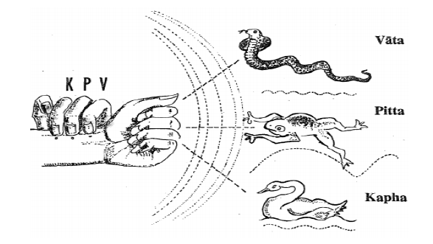

Fig. 1 Shapes of waveform of vata, pitta and kapha pulses

instruments more supportive and reliable, followed by higher detection precision. Human life is considered as an accumulation of three humors [1](Vata, Pitta and Kapha), seven minerals (tissues) and three vain (waste) products. Vata (Wind, Air) – Constitutes motion and desire, Pitta (Bile, Fire) The Theory of assimilation and transformation, Kapha (Mucus, Water) – Comprises stability (Fig.1).
Wrist pulse pressure signal has been found to be utilized in ancient Indian Ayurveda (TIM) and Traditional Chinese Medicine (TCM) for health diagnosis. Each of these methods gives prime importance to three different pulse points over wrist artery of the two hands. This is done for evaluation of health position. This matching approach is defined based on the pressure gesture reflection gait in human arteries which terminate into several organs. A regular pulse pressure signal is established in the arterial structure because further wave generated by pumping action of heart and a reflected wave generated which is a result of reflections from tangential organs.
Vata is composed of space and air which governs the activities in the mind and the body that must be kept in good balance. Vata controls exclusion of wastes, breathing and movement of thoughts across the mind. Greater amount of vata leads to fears, insomnia, cramps and constipation.
Pitta comprises fire. It regulates heat metabolism and transformation in the mind and body. It controls how we digest food, how we metabolize our sensory perceptions, and how we discriminate between right and wrong. Too much pitta can lead to anger, criticism, acidity, ulcers, rashes and thinning hair.
Kapha is the watery humors, consisting of the water and earth elements. Kapha cements the elements in the body, providing the material for physical structure. This doshas maintains body resistance, lubricates the joints, provides moisture to the skin, helps to heal wounds, gives biological strength, vigor and stability; supports memory retention; gives energy to the heart and lungs and maintains immunity.
Particularly the virtual instrument expertise has begun to enter into the field of biomedical instruments. To make the biomedical instrument technology will [6] to build up more quickly by this original force. More precision in the pulse rate calculations is needed as far as heart diseases are concerned. Non invasive method for pulse detection with utmost accuracy is the need of the hour and the methods should be cost efficient.

 | 1st pulse | 2nd pulse | 3rd pulse
Frequency | 80-95 | 70-80 | 50-60
Location | Index | Middle | Ring
Amplitude | Low | High | Moderate
Regularity | Irregular | Regular | Regular
Temperat-ure | Cold | Hot | Warm to Cool
Vessel Wall | Rough, hard | Elastic, flexible | Soft, thickening
Traits | High up, strong, high amplitude like snake | Rapid and leaps like a frog | Deep, slow, Broad like swan

Fig.2: Traits of kapha, vata and pitta

The necessity of preprocessing of wrist pulse to eliminate outlier pulses and fluctuations after the analysis of pulse pressure signal has been elaborated in [5]. Author discusses the credentials of irregular pulses present in the pulse series and minutiae associated with the extraction of time related pulse features. An approach of Dynamic Time Warping (DTW) has been utilized for the classification of outlier pulses in the wrist pulse series. A combined approach for pre-processing of the wrist pulse sequence is presented. An approach of Dynamic Time Warping has been utilized for the recognition of an outlier pulse in the wrist pulse signal and its elimination from the signal has been elaborated.

Hardware Used:

Fig.5 shows the Data Acquisition Equipment Compatible with NI LabVIEW. Compact DAQ NI 9174 Chassis and Analog DAQ card NI 9219(Fig.6) are used as the main hardware.

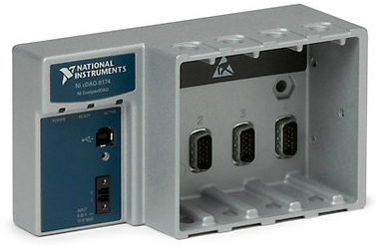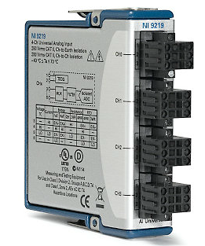

Fig.5 NI cDAQ 9174 Fig.6 NI 9219

FSRs are two-wire devices with a resistance that depends on applied force. For a simple force-to-voltage conversion, the FSR device is tied to a measuring resistor in a voltage divider configuration (see Figure 3). LM 358 has been used as the operational amplifier. The output is described by the equation:
$$V_{out}=\frac{R_{M}V}{R_{M}+R_{FSR}}$$

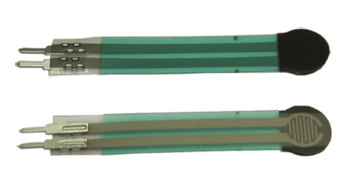
Fig.7 Force Sensitive Resistors (FSRs)

An abridged hardware circuitry had been used for pulse exposure as given in [2]. Here a key for the pressure sensor placement has been provided by the author. Three pressures using pressure sensors are considered. Device could acquire complete multichannel pulse signals, i.e., three-channel of main signals together with the sub signals, and thus more indicative features could be extracted. In future developments, improving the degree of exactness of computerized pulse diagnosis has been projected. The sensor placement in the proposed methodology has been referred from this work.

Flowchart:
Sensor interfacing with DAQ

Determining 3 Pressure points using 3 sensors

Signal Processing in LabVIEW

Determining the prakruti whether kapha vata or pitta

Determining at least one Heart Disease

Fig.3 Flow Chart of proposed system using LabVIEW

Design and extension of an original, low-cost, non-invasive and compressed device that generates pulse pressure waveforms using Infrared sensor has been discussed in [1]. This information would prove be a support to the Ayurvedic experts for better disease analysis. Further, the waveforms obtained from the apparatus are analyzed and parameters designed are the positive vigor and negative vigor content of the body, and the heart rate of the entity. Signal processing has been carried out in LabVIEW.
Fig. 3 shows the basic Flow Chart of the system proposed in which The Pulse Data Acquisition has been performed using two electrodes Force Sensitive Resistor (FSR), NI cDAQ 9174 chassis and NI 9219 Analog DAQ card. Then the acquired data has to be processed using various filters. Two parameters of the waveform have been selected viz. the frequency and the amplitude (voltage). The next step would be programming the system for the prediction of prakruti considering amplitude and frequency as the key parameters. The last part would be the programming for the detection of at least tachycardia and bradycardia.

Results:
After positioning the FSRs on the wrist of the patient, the signal processed results are shown below. Fig.5, fig. 6 and Fig.7 shows the waveforms of prakruti of the same person by using smoothing filter, high pass filter and low pass filter. The results from different filters VI had been compared for selecting the most appropriate filter.
Some novel researches on subjectifying Traditional Chinese Pulse Diagnosis (TCPD) by means of some recent signal processing methods has been discussed in [3]. Researches on time domain has been carried out and the synchronizing features in frequency domain are extracted. Monitoring the pulse and the characteristic extraction of the pulse has been introduced. Furthermore wrist pulse acquisition and analysis of system is explained by the author some of which have been used in the proposed system.
There are two columns of waveforms where the waveforms in the first column are the raw waveform and the waveforms in the second column are the signal processed waveforms of kapha, vata and pitta. The resultant waveforms are shown on the waveform charts, the predicted prakruti and the detected heart disease is shown by the LED glow as shown in the figure below. The amplitude and frequency of the output voltage were recorded in the Excel sheet depending on which the prakruti prediction has been done. Then by further programming on the block diagram, tachycardia and bradycardia were the heart ailments that could be diagnosed properly.
The necessity of preprocessing of wrist pulse to eliminate outlier pulses and fluctuations after the analysis of pulse pressure signal has been elaborated in [5]. Author discusses the credentials of irregular pulses present in the pulse series and minutiae associated with the extraction of time related pulse features. An approach of Dynamic Time Warping (DTW) has been utilized for the classification of outlier pulses in the wrist pulse series. A combined approach for pre-processing of the wrist pulse sequence is presented.

Conclusions:

The three pressure points on the wrist of a person including the prakruti of a person had been calculated successfully. The prakruti waveforms have been detected using three filters in the separate VIs. The results of a single person have been taken by using these three filters. From this, the prakruti of the person could be diagnosed accurately following with the successful diagnosis of heart diseases like tachycardia and bradycardia.
The results were taken from 20 persons for three filters. These results were recorded in the morning, afternoon and evening. The pulses that were recorded in the evening and morning were bit slower than that recorded in the afternoon i.e. for one subject the pulse rate in the morning and evening was 73Hz and 75Hz whereas in the afternoon it was 77Hz.
Out of these 20 people, three subjects were suffering from bradycardia and two subjects from tachycardia. The waveforms of tachycardia and bradycardia are shown below. In Table 10 the maximum frequency that was recorded in the vata waveforms of the person is 102Hz which is greater than 100Hz and the minimum waveform increment is 0.53volts which is greater than 0.5volts. Hence the subject is suffering from Tachycardia. In Table 11 the minimum frequency that was recorded in the kapha waveforms of the person is 39Hz which is less than 40Hz and the minimum waveform increment is 0.19volts which is less than 0.5volts. Hence the subject is suffering from Bradycardia.

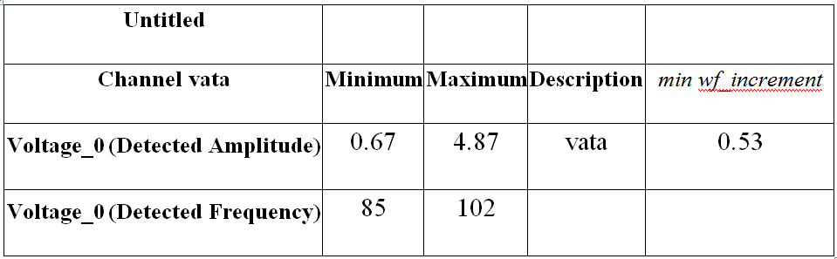

Fig.10: Results of Tachycardia recorded in the Excel sheet

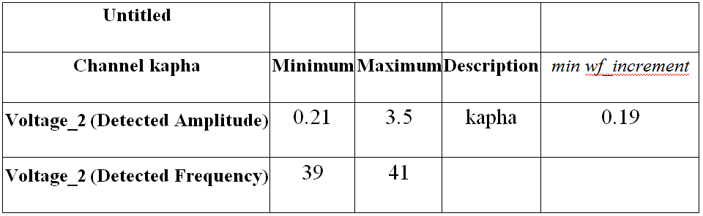

Fig.11: Results of Bradycardia recorded in the Excel sheet

References:

[1] Harsha Godhia, Yasmin Hazrat, Shashank Kabra, Mita Bhowmick, Pulse Wave Detection And Analysis.
[2] Peng Wang, Wangmeng Zuo, A Compound Pressure Signal Acquisition System for Multichannel Wrist Pulse Signal Analysis IEEE TRANSACTIONS, 6, JUNE 2014.
[3] L. Xu, K. Wang, D. Zhang, Y. Li, Z. Wan, J. wang, “Objectifying Researches on Traditional Chinese Pulse Diagnosis” Informatica Medica Slovenica, 2009.
[4] Prasad Joshi, Rohin Daruwala, Investigations into TIM perspective of Radial Pulse Analysis (IEEE January, 2013).
[5] Bhaskar Thakker, and Anoop Lal Vyas, Outlier Pulse Detection and Feature Extraction for Wrist Pulse Analysis, World Academy of Science, Engineering and Technology Vol: 3 2009-07-25.
[6] Xiao Chen, Pulse Signal Acquisition Based on LabView Software, (IEEE 2012).
[7] M.Sharmila Begum, Diagnosing Diseases Through Pulse Using Pressure Sensor 978-1-4673- 2149-5/12/ ©2012 IEEE).
[8] Peng Wang, Wangmeng Zuo, Hongzhi Zhang, Design and Implementation of a Multi Channel Pulse
Signal Acquisition System, 2012 5th International Conference on Biomedical Engineering and Informatics (BMEI 2012).
[9] Jug-Man Hwang, Jung-Min Park, and Seong-Dok
Park, Memkr, Wrist-Located Pulse Detection using IR Reflection due to Pulse Added Volume of Arterial
Blood, 2004 International Conference on Computational Electromagnetics.
[10] Chung-Shing Hu, Yu-Feng Chung, Ching-Hsing
Lu, Pulse Differences and 3D Pulse Mapping in TPNI Displacements, 978-1-4577-2168-7/11©2013
IEEE.
[11] Peng Wang, Hongzhi Zhang, Wangmeng Zuo, David Zhang, A Comparison of Three Types of Pulse
Signals: Physical Meaning and Diagnosis Performance 2013 6th International Conference on Biomedical Engineering and Informatics (BMEI 2013).
[12] Prasad Joshi, Rohin Daruwala, Objective Evaluation of Radial Pulse Signal, 2013 IEEE.
[13] Jayaraj Joseph, V Jayashankar, A Virtual Instrument for Real Time in vivo Measurement of Carotid Artery Compliance, 30th Annual International IEEE EMBS Conference 2008.

