e-ISSN: 2456-3463

International Journal of Innovations in Engineering and Science, Vol. 2, No.1, 2017
www.ijies.net

“Safety Management in Coal Mining Industrial Output Transporting System ( HAUL ROADS,BENCHES HEIGHTS , WIDTHS AND SLOPE) for Effective Production’’
Rakesh Sunil Pedapalliwar ¹ , Dr Achal Shahare² ,
¹M.tech student ,Department of Mechanical Engineering
G.H Raisoni Academy of Engineering & technology ,NAGPUR ,INDIA,440016

² Assistant PROFESSOR ,Department of Mechanical Engineering
G.H Raisoni Academy of Engineering & technology ,NAGPUR ,INDIA,440016

ABSTRACT:Productivity improvement is the very important factor for a firm to survive and to achieve breakthroughs the work carried out deals with enhancing productivity in an manufacturing industry with Safety Management in Coal Mining Industrial Output Transporting System for Effective Production In production department there is some unwanted work process is done which is taking extra time, extra effort as well as increasing the cost of product and worker affected some unwanted fatigue, so the industry not able to improve productivity. Thus the purpose of this work is to propose improvement area in the industry so that industry can increase their

productivity by analyzing the problem associated with it. Identified problems were solved by using method principles improvement was achieved by reducing cycle time of product carrying from safe way of working techniques to direct on trolley instead of pallet to proceed in the coal industry
Keywords— safety management, safety methods , safety techniques, safety equipments is part of study in effective production analysis. In an open cast mine.

INTRODUCTION
The mining technology marching towards a very faster space in this modern age but the trucks /dumpers remains the primary means of transportation of coal in the Indian coal mines. Statistically it has been seen that slope failure or bench failure is the second main reson of accident after the ground fall in the Indian underground coal mines. Out of the total accidents the total open cast coal mines, the average percentage of fatal and serious bodily accidents due to the slope failures or benches are 23% and 11% resp. Out of these figures 20% of the accidents occurred due to the slope failure of opencast benches ,failure like sliding of rock mass, 19% due to uncontrolled movements of faults , 17% due to development of tension cracks, 14% potential unstable rock design, 10% weekly bonded and steeply Deeping rock mass and 12% due to unsafe practices. Presently of the total coal production from the opencast mining comes under by benching system of haul road maintainability. Therefore it is most important for proper safety management in opencast benches workings (including the development faces).This report concentrates only the safety system of some of the effects of dynamic loads on opencast benches.
Presently of the total coal production from the opencast mining comes under by benching system of haul road maintainability. Therefore it is most important for proper safety management in opencast benches workings (including the development faces).This report concentrates only the safety system of some of the effects of dynamic loads on opencast benches.
Design of slope is an exercise to optimize the stability with respect to economy . If we increase the stability slope angle will decrease and cost of removal of o\B will increase and if we decrease the stability by increasing slope angle cost of removal of o\B will reduce . Dynamic load increases the slope angle or reduces the stability hence in designing the slope dynamic load is given due importance.
Thus dynamic load may be due to moving mass on the bench surface in term of HEMM or may be developed due to blasting or sesmic effect in the hilly or mountainous terrain , etc.
Our work will be focused only with slope in the opencast mines where dynamic load is either due to moving mass in terms of HEMM or vibrations/shocks
generated due to blasting . However in this project we will study as follows.
Therefore Inorder To Manage Proper Safety In An Opencast Mining ,The Proper Study And Analysis Of Slope Failure Can Be Considered In Regards For Effective Production Of Output Which Will Balance Or Maintain Proper Output Transportation System(roads
FOLLOWING ARE THE TYPES OF FAILURES DUE TO WHICH IT AFFECTES OUTPUT TRANSPORTING SYSTEM ( HAULROAD, BENCH HEIGHS, WIDTH AND SLOPE OF BENCHES)
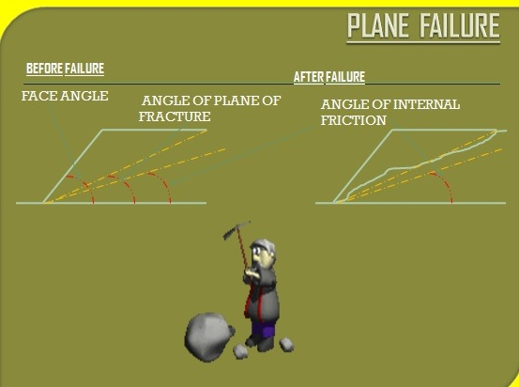
GENERAL CONDITIONS FOR PLANE FAILURE
The following geometrical conditions must be satisfied for a plane failure to takes place
(a) The failure plane must strike parallel or nearly parallel ( approx. + or - 20 degree) to the slope face.
(b)The dip of failure plane ( ψp ) must be smaller than that of slope of the face (ψ f )
(c)The dip of failure plane must be greater than the angle of friction ( θ ) of this plane
(d)Release surfaces which provide negligible resistance to sliding block

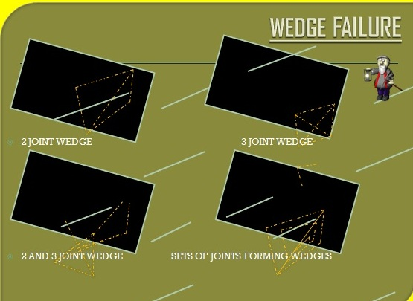
CONDITIONS OF WEDGE FAILURE
(a) Out of two planes one plane may be flat and another may be steep along the line of intersection.
(b)As in case of plane failure ,condition of sliding is just denoted by the
Ψf > Ψi> Φ
Where
Ψfi = inclination of slope face just measured at right angle to the line of intersection
Ψi = dip of line of intersection Ψfi would only be same as Ψf if dip direction of line of intersection is the same as the dip direction of the slope face
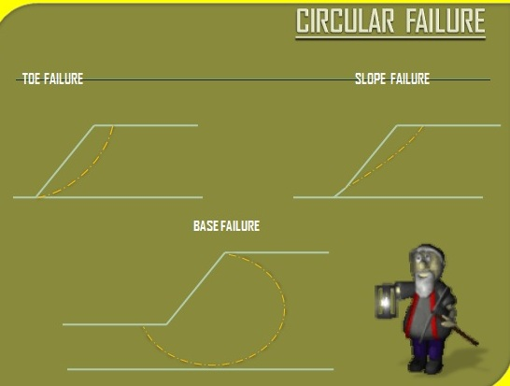

TYPES OF CIRCULAR FAILURE
(a) TOE FAILURE
In which the failure occurs along the surface that passes through the toe . It is the most common failure among circular type.
(b) SLOPE FAILURE
In which the failure occurs along a surface that intercepts the slope above the toe. slope failure occurs when the weak plane exist above the toe
(c) BASE FAILURE
In which the failure passes below the toe. Base failure occurs when a weak stratum lies beneath toe.
CONDITIONS FOR CIRCULAR FAILURE
(a) When the individual particles in a soil or rock mass are very small as compared with the size of the slope.
(b) when the particles are not interlocked as a result of their shape.
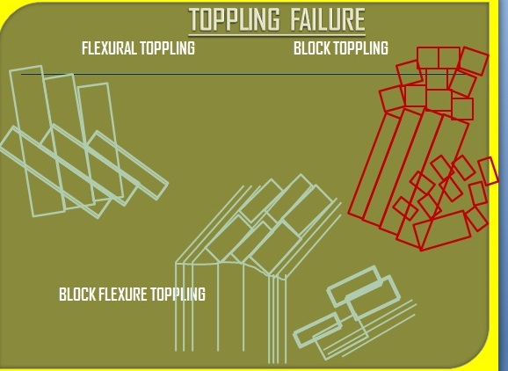
TYPES OF TOPPLING FAILURE
1. FLEXURAL TOPPLING :
It shows that continuous columns of rock which are separated to by well developed steeply dipping discontinuities break in flexure as they bend forward.
2. BLOCK TOPPLING:
Block toppling occurs when individual columns of hard rock are divided by widely spaced orthogonal joints.
3. BLOCK FLEXURE TOPPLING:
This type of toppling failure is characterized by pseudo continuous flexure along long columns which are divided by numerous cross joints.

FACTORS FOR SLOPE FAILURE

Slope failures of different types are affected by the following factors:
(a) Slope Geometry
slope geometry is the important factor which affects the slope stability.
The basic geometrical slope design parameters are bench height, overall slope angle and area of failure surfaces
Stability of slope decreases with increases in height and slope angle.
Generally overall slope angle of 45 degree is considered to be safe by DGMS
(b) Geological structure
The main geological structure which affect the stability of the slopes in the open pit mines are:
1. Amount and direction of dip
2. Intra-formational shear zones
3. Joints and discontinuities
4. Faults
(c) Lithology
The rock materials forming large pit slope determines the rock mass strength modified by discontinuities ,folding ,faulting, old working and weathering.
(d) Ground water
It causes the following
1. Alters the cohesion and frictional parameters
2. Reduce the normal effective stress
(e) Mining Method and Equipment
Basically there are four methods of advance in opencast mines. They are:
1.Strick cut- advancing down the dip
2.strike cut – advancing up the dip
3.Dip cut –along the strike
4.Open pit working

(f) Dynamic forces
Vibration , Blasting and shear stresses effects are increased momentarily as a result dynamic acceleration of material and thus increases the stability problem in the slope face
Blasting is a primary factor governing the maximum achievable bench face angles.
The effects of careless or poorly designed blasting can be very significant for bench stability
Besides blast damage and back-break which both reduce the bench face angle,vibration from blasting could potentially cause failure of the rockmass
(g) Cohesion
Cohesion is the characteristics property of a soil or rock that measures how well it resists being deformed or broken by gravity force.
slopes which having rocks /soil with less cohesion tend to be less stable.
SOURCES OF LOADINGS
Static loading
(a) W=weight of the sliding block
(b) U= upliftment force
(c) V= force exerted by the water column
Dynamic loading
(a) due to HEMM
(b) due to blasting
(C) due to sesmic activity like earthquake
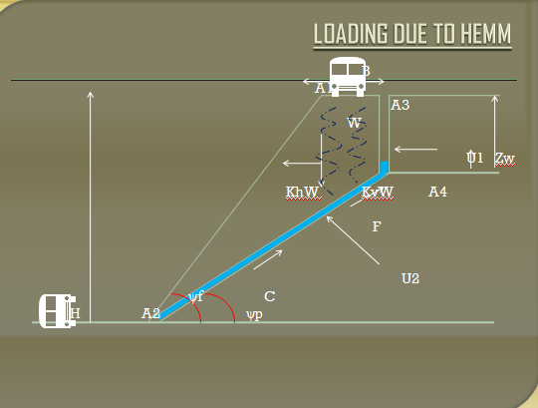

SLOPE STABILITY ANALYSIS & SLOPE FAILURE MECHANISM
- STATIC SLOPE STABILITY ANALYSIS
Static slope stability analysis is specifically based on the static equilibrium of unstable rock mass .
In static equilibrium , the sum of the forces ,and moments on each element of the system is zero.
The unstable rock masses are defined on a categorized geometry of blocks isolated by discontinuity planes.
The resisting and driving forces are calculated by solving equilibrium equations in order to determine the factor of safety defined as
FOS= Resisting force /Driving force
The unstable rock block is in a condition of “Limiting equilibrium” when the driving forces are exactly equal to the resisting forces and the factor of safety is equal to 1.For this reason , this method of slope stability analysis is termed as limit equilibrium analysis
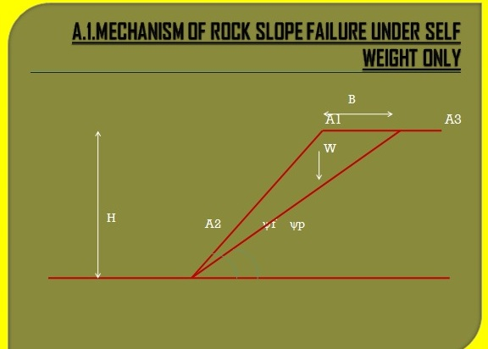
The simplest expression for factor of safety of a rock slope against plain failure is
FOS = Fr/Fi
=cA+Wcosψptanφ / Wsinψp
where, Fr = resisting sliding force
Fi = inducing sliding force
W = weight of rock mass block A1A2A3 with an inclination to the horizontal at an angle ψp
A = area of the base A2A3
C = cohesion
φ =angle of internal friction

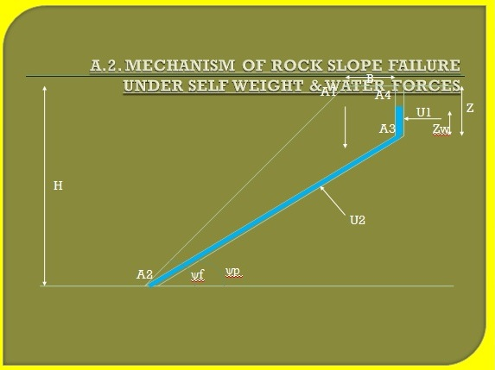
For water forces acting on the sliding surface, the expression for factor of safety of a rock slope against plain failure is
FOS =cA+(Wcosψp – U1sinψp – U2)tanφ
Wsinψp+ U1cosψp
where,
W= weight of the rock mass block A1A2A3A4 with an inclination angle ψp
U1= horizontal force due to water pressure in the tension crack
U2 = uplift force due to water pressure on the joint plane
φ = angle of internal friction

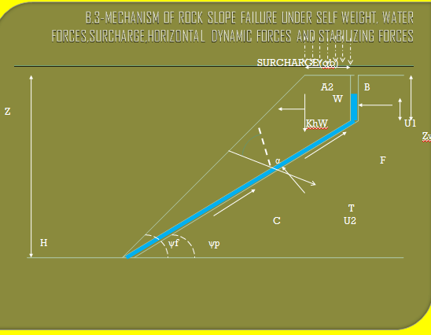

- ASSUMPTIONS-
- Sliding block is of unit thickness
- Negligible resistance is offered to lateral boundaries of the sliding block
The analytical expression with surcharge q placed at the top of the slope subjected to horizontal dynamic force-
F.O.S = CA+{W(cosψp-Khsinψp)-U1sinψp-U2+Tcosα}tanθ
W(sinψ+Khcosψ)+U1cosψ-Tsinα
Findings-
- F.O.S. of rock slope with in surcharge
- The rate of decrease is relatively for lower values of surcharge
- For specific surcharge, F.O.S. depends significantly on all other parameters, except for unit wt. of rock and higjer values of inclination of stabilizing force to the normal at failure plane
- A perfectly stable slope at relatively surcharge could become unsafe with an surcharge

EFFECTS OF DYNAMIC LOADING & THEIR CORRLATION WITH VARIOUS PARAMETERS
These are the various values for which the following effects were studied.
Effect of angle of inclination of failure plane to the horizontal:
(A) VARIATION OF FOS WITH ANGLE OF INCLINATION OF FAILURE PLANE TO THE HORIZONTAL(Ψp) FOR DIFFERENT VALUES OF HORIZONTAL (kh) and VERTICAL(kv) DYNAMIC COEFFICIENT:
FOS with different sets of horizontal dynamic coefficient & vertical dynamic coefficient (kv) as: 0.0,0.0; 0.1,0.05, 0.2,0.1; 0.3,0.15; 0.4,0.2; 0.1,0.05; 0.2,0.1; 0.3,0.15 and0.4,0.2;
Consider a particular set of parameter
Ψf= 50ᵒ, z=0.1, Zw=0.05, c=0.1, Ф=25ᵒ, q=0.5, T=0.1, Υ=2.5 and α=45ᵒ
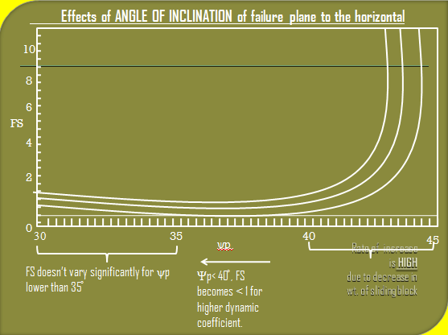
Effects of angle of inclination of the slope face to the horizontal:
(B) VARIATION OF FOS WITH ANGLE OF INCLINATION OF THE SLOPE FACE TO THE HORIZONTAL (Ψf) FOR DIFFERENT VALUES OF HORIZONTAL(kh) AND VERTICAL (kv) DYNAMIC COEFFICIENTS:
FOS with different sets of horizontal dynamic coefficient & vertical dynamic coefficient (kv) as: 0.0,0.0; 0.1,0.05, 0.2,0.1; 0.3,0.15; 0.4,0.2; 0.1,0.05; 0.2,0.1; 0.3,0.15 and0.4,0.2;
Consider a particular set of parameter
Ψp= 35ᵒ, z=0.1, Zw=0.05, c=0.1, Ф=25ᵒ, q=0.5, T=0.1, Υ=2.5 and α=45ᵒ
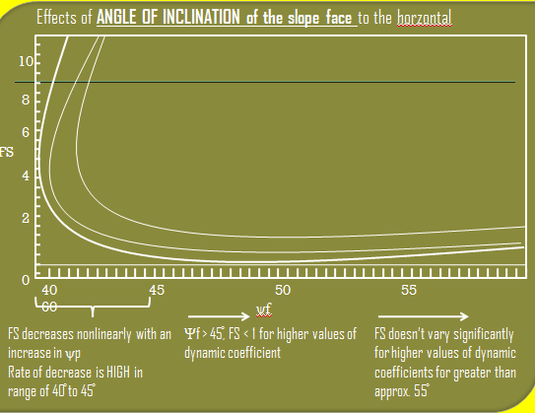

METHODOLOGY
Open cast mining industry is considered as one of the toughest and hazardous jobs by huge investment and by proper safety planning techniques. The miners have to work in severe work condition in narrow openings with substantial heat and humidity, heavy noise and vibration, poor illumination, airborne dust and noxious gases. These hazards pose a serious problem of managing safety and health risks to mine workers. As a result, accidents/injuries are prevalent across all in opencast mining. Several factors such as mining methods, benches width and heights dynamic loads of movable hemmm, geological disturbances, excessive horizontal stress, size of mine, undulating floor, seasonal variations and conditions of mine roof and floor contribute to these accidents/injuries. Identification of these factors may
play an important role in accident mitigation. Further, different workers face differential risks due to their different job occupations. Attempt should me made for clustering the mine workers with their differential risk contours. Accident data analysis, if used properly, can well address these areas which ultimately lead towards achieving better safety standards in mines. The study includes consideration of injury details and discussions with mine management for identifying these specific problem areas to improve the mine safety performance. Risk has two components such as (1) probability -how likely is it to occur, and (2) consequences-what happens if it does occur? In this study, the risk in terms of frequency rate for occupation, cause, and occupation-cause group combined, body
Parts injured, and body parts-cause group combined was computed. The consequences of the various risk factors were measured in terms of man days lost per injury. The various occupation groups considered for the study of benching and benches stability with respect to slope.
Therefore it is necessary to manage proper safety plan with respect to study of dynamic loads effects and maintainability of slope angle .

References
[1] Mining Engineers’ Journal. Vol.2 No.7.
[2] Mining Engineers’ Journal. Vol.3 No.8.
[3] The Indian Mining and Engineering Journal Vol. 40 No. 12.
[4] The Indian Mining and Engineering Journal Vol. 53 No. 11.
[5] DGMS Circulars.
[6] The Coal Mines Regulation
[7] MINING ENGEERINGS AUTHORS GUIDE SIR B P VERMA

