Utilization Of Waste Plastic In Manufacturing Of Plastic Sand Bricks
Mohammad Sultan*, Rahul Jaiswal , Roshan Jaiswal , Falgunee Ram Sahu , Devannand
Department of Civil Engineering , Rungta college of Engineering and Technology , Bhilai , India, 490023
*Corresponding Author
Email: mohd.sultan25@gmail.com

Abstract – Plastics are key resources in circular economy and recycling after the end of useful life with economic value creation and minimal damage to environment is the key to their sustainable management. The project elucidates about the use of plastic in civil construction. The component used include everything from plastic screws and hanger to bigger plastic parts that are used in decoration, electric wiring, flooring, wall covering and waterproofing. There has been a considerable imbalance between the availability of conventional building materials and their demand in the recent past. On the other hand the laterite quarry waste is abundantly available and the disposal of waste plastics (PET, PP,etc.) is a biggest challenge, as repeated recycling of PET bottles pose a potential danger of being transformed to a carcinogenic material and only a small proportion of PET bottles are being recycled. The bricks manufactured possess the properties such as neat and even finishing, with negligible water absorption and satisfactory compressive strength in comparison with laterite stone to satisfy the increasing demand of conventional building materials.
Keyword – Poly-ethylene terephthalate (PET), Plastic waste, Bitumen, Compressive strength, Plastic-sand bricks.
1 INTRODUCTION
Soil is a loose, unconsolidated material on the earth’s crust and it is formed by the weathering of solid rocks. The laterite formation was named in southern India1807, and it was described by Francis Buchanan-Hamilton. He named it from the Latin word “later” which means brick. This rock can be easily cut into brick shaped blocks for building construction. The laterite stone is rich in iron and aluminium and it is formed in hot and wet tropical areas. A good reservoir of laterite stone is present in the coastal Karnataka and some norhten parts of Karnataka and also in the northern parts of Kerala, due to which lot of quarrying of laterite bricks takes place. In quarries while cutting out the laterite stones with the help of cutting machines which produces 15-20% of soil wastes which pose a problem of disposal. The quantity of plastic waste in Municipal Solid Waste (MSW) is expanding rapidly. It is estimated that the rate of expansion is double for every 10 years, this is due to rapid growth of population, urbanization, developmental activities and changes in life style which leading widespread littering on the landscape. Thus disposal of waste plastic is a serious problem globally, since they are non biodegradable and also researchers have found that the plastic materials can remain on earth for 4500 years without degradation [1]. Plastic have many good characteristics which include versatility, lightness, hardness, and resistant to chemicals, water and impact There is considerable imbalance in the conventional building materials; there is a great demand in recent past years. In quarries while cutting out the lateritic stone with help of cutting machines which produces 15-20% of soil wastes which poses a problem of disposal & utilizing the quarry waste. The quantity of plastic waste in municipal solid waste collection is expanding rapidly ,the rate of expansion is double for every 10 years .since it is non-biodegradable which remain on earth for 4500 years without degradation & it is a great challenge in disposing of waste plastics ,it is also danger in repeat recycling of plastic waste it poses a danger of being transformed to a carcinogenic materials & only a small amount of pet bottles are recycled, it has a many good characteristics such as versatility , hardness, resist to chemical ,water impacts. In recent years ,the natural sand is replaced by the m-sand .m-sand is also used in mixture of plastic & soil , in this work an attempt has been made to manufacture of bricks by using the waste plastic in range of 60-80% by weight of lateritic quarry waste & m-sand mixture. The bricks manufactured possess the properties such as neat & even-finishing with negligible water absorption & which satisfies the compressive strength to a certain extent
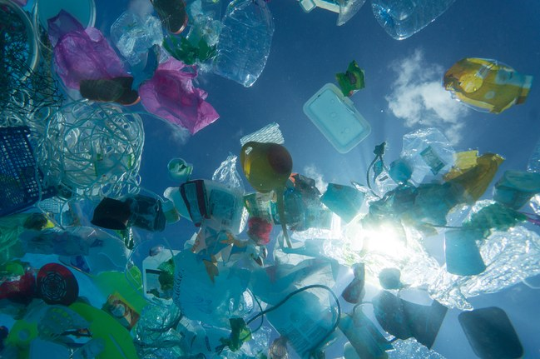
1.1 Plastic- Plastic is a non-bio-degradable substance which takes thousands of years to decompose that creates land as well as water pollution to the environment. The quantity of plastic waste in Municipal Solid Waste (MSW) is expanding rapidly.

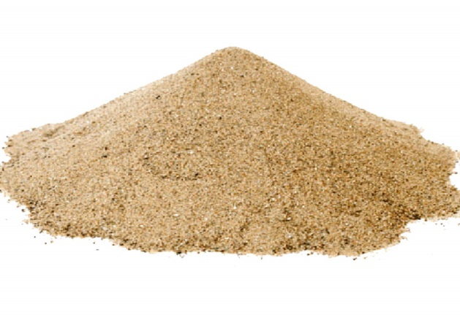
1.2 Sand - It is a sediment just like clay, gravel and silt. Most common sand-forming mineral is quartz. There are two good reasons for that. Desert sand composed almost exclusively of rounded quartz grains. Natural river sand was used as a fine aggregate.
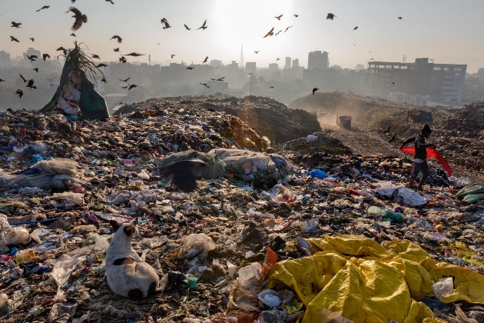
1.3 Waste Plastic - Plastics are commonly used substances which play an important role in almost every aspect of our lives. The widespread generation of plastics waste needs proper end-of-life management.

2 LITERATURE REVIEW
According to a Technical newsletter “Focus on PET”, Poly ethylene terephthalate belongs to the polyester family of polymers, one of the largest and most diverse of the polymer families. This family of polymers is linked by the common feature of having an ester (-COO-) link in the main chain, but the range of polyester materials is probably the largest of all the polymer families. And also the chemical structure of the PET is having only atomic species that are carbon, hydrogen and oxygen. Therefore melting of PET won’t result in release of noxious gases and also its properties reveal that a melting temperature of 260 ºC is required. Also from the properties of the PET it can be understood that it has got good chemical resistance and better resistance to UV rays [9]. In a paper “An review on waste plastic utilization in asphalting of roads” [1], the techniques to use plastic waste for construction purpose of roads and flexible pavements, which were developed by various researchers has been reviewed. And collectively emphasises the concept of utilization of waste plastic in construction of flexible road pavement. In the construction of flexible pavements, bitumen plays the role of binding the aggregate together by coating over the aggregate. It also helps to improve the strength and life of road pavement. But its resistance towards water is poor. A common method to improve the quality of bitumen is by modifying the rheological properties of bitumen by blending with synthetic polymers like rubber and plastics. This bitumen mix show better binding property, stability, density and more resistant to water. Research on “The Use of Recycled Materials in Highway construction” [6] and “Utilization of waste plastic in Bituminous Concrete mixes” [7] to determine the suitability of plastic waste modifier in construction of bituminous mixes, where the heated. aggregates are transported on conveyor belts the shredded plastic is sprayed on it. So that plastic makes a coat on the aggregate this plastic coated aggregate was later blended with hot molten bitumen to result in plastic modified bitumen. The research concluded that this waste plastic usage in bituminous concrete mixes resulted in improved resistivity to water absorption and better bonding with reduced susceptibility to stripping. “Useful products from oil and organic chemistry”[8], classifies the plastic as Thermo softening plastics (Thermo plastics) and Thermo setting plastics (Thermo set plastics). Thermo setting plastics can be made plastic and malleable at high temperatures only once. Modern thermoplastic polymers soften anywhere between 65 ºC and 200+ ºC. In this state they can be moulded in a number of ways they differ from thermo set plastics in that, they can be returned to this plastic state by reheating. They are then fully recyclable. PET used in this project belongs to thermo plastics. Thermo-set plastics differ in that they are not re-mouldable. Strong cross links are formed during the initial moulding process that gives the material a stable structure. They are more likely to be used in situations where thermal stability is required. They tend to lack tensile strength and can be brittle. Polyester resin, Urea formaldehyde etc. belongs to this type. An attempt to utilize the laterite wastes available abundantly in the laterite quarry for the manufacture of laterite soil bricks using cement as a stabilizing agent [2]. This can be used as an alternative to the usual laterite stone. The laterite soil was procured from the laterite quarry near sullia. The study concluded that laterite soil stabilized with 7% cement for manufacturing of interlocking bricks with a good compressive strength of 4.72 N/mm2 . The concept of interlocking bricks of size 30x20x18cm was adopted which resulted in a cost effective construction [2]. As per the research work on “Use of Cement-Sand Admixture in Laterite Brick Production for Low Cost Housing” [4], in Makurdi (Nigeria) and other locations within Benue State, abundant lateritic soil deposits exist which can be harnessed for brick production. Results showed that laterite used in this study cannot be stabilized for brick production within the economic cement content of 5% specified for use in Nigeria. However, bricks made with laterite admixed with 45% sand and 5% cement attained a compressive strength of 1.80 N/mm2 which is greater than the specified minimum strength value of 1.65 N/mm2 . Cost comparison of available walling materials in Makurdi metropolis showed that the use of bricks made from 45% sand and 5% cement resulted in a saving of 30 - 47% when compared with the use of sand concrete blocks while the use of fired clay bricks resulted in a savings of 19% per square meter of wall. The study therefore recommends the use of laterite bricks in Makurdi and other locations because it is more economical and environmental friendly than fired clay bricks.
Puttaraj Mallikarjun Hiremath et al in 2018 reported a manufacturing of the bricks by using waste plastics in range of 60 to 80% by weight of laterite quarry waste and 60/70 grade bitumen was added in range of 2 to 5% by weight of soil in molten form and this bitumen- plastic resin was mixed with laterite quarry waste to manufacture the bricks. The bricks manufactured possess the properties such as neat and even finishing, with negligible water absorption and satisfactory compressive strength in comparison with laterite stone to satisfy the increasing demand of conventional building materials.
Arvind Singhal et al in 2018 reported a manufacturing of bricks and tiles we used earth-based clay. In plastic waste we consider Drinking Water Bottles, Carry Bags, Bottles Caps, house hold Articles, Milk Pouches, Sacks, Carry Bags, Bin Linings, Cosmetics and Detergent Bottles, Bottle Caps and Closures, Wrappers of Detergents, Biscuit, Electricals Fittings, Handles and Knobs, Casting, Bonding Fibres etc. In this, we get to crush the plastic waste into fine particles and heated on a furnace (Bhatti). We use stone dust as fine aggregates (size below than 4.75mm), heated on a furnace. Now, we mix heated plastic waste and heated stone dust and pour into mould and form bricks and tiles. We observed that the characteristics of bricks and tiles is far much better than normal bricks and tiles as minimum water absorption, highly compressive strength, smooth surface, unbreakable, less weight etc.
Jeevan Ghuge et al in 2019 reported a manufacturing of paver block by using waste and recycled materials, using waste and recycled materials in concrete mixes for paver blocks becoming increasingly important to manage and treat both the solid waste generated by industry and municipal waste. This study demonstrates use of waste plastic for manufacturing the concrete paver blocks and with this efficient disposal way of plastic waste is possible.
3 METHODOLOGY
The main objective of this research work is to develop an efficient way to effectively utilize the waste plastic which is a great threat for the sustainment of ecological balance, With the laterite quarry waste to manufacture an alternative building material by which both the questions of a scientific disposal of waste plastic as well as scarcity of traditional building materials can be answered. The laterite quarry waste was collected from Aletti. When the laterite stone is cut from the quarry nearly 15-20% of laterite waste is obtained. This waste was crushed using rammers and sieved in a 2.36mm IS sieve. This sieved laterite soil was brought to laboratory for preparation of bricks. This soil was sun-dried to reduce the water content. A mould of size 20x10x10cm was prepared. Bricks of different mix proportions were prepared, for each brick 3kg of the laterite soil was added with varying bitumen content of 2, 5 and 10% along with variation in percentage of plastic. Bricks were prepared by compacting through vibration. 9kg of clean sieved laterite quarry waste is collected. 70% of plastic (PET) by weight of soil is cleaned and heated to a molten state. Then sieved soil is added at intervals with proper mixing. At the final stage 2% of bitumen by weight of soil is added and mixed for uniform distribution to prepare 3 bricks. The hot mix is poured into the moulds and then compacted by vibration. The bricks are demoulded after 30 min and air dried for a period of 24hr for proper heat dissipation. Of each mix proportion bricks were prepared and tested for compressive strength in the compressive testing machine (CTM).
3.1 COMPRESSIVE STRENGTH
The tests on Compressive strength of the specimen brick shall be calculated for 3 aspects after 7, 14 & 28 days of curing using the formula ,

The UTM was using the tests. The compressive strength of bricks. After the curing period gets over bricks are kept for testing. To test the specimens, the bricks are placed in the calibrated compression testing machine of capacity 3000

KN (Kilo Newton) and applied a load uniform at the rate of 2.9 kN/min. By obtaining the maximum load shall be taken as failure of load with specimen fails to produce any further increase in indicator reading on testing machine.
3.2 WATER ABSORPTION
Bricks should not absorb water more than 12% by its weight. The bricks to be tested should be dried in an oven at a temperature of 105oC to 115oC till attains constant weight cool the bricks to room temperature and weight (W1). Immerse completely dried and weighed (W1) brick in clean water for 24 hrs. at a temperature of 27±20oC. Remove the bricks and wipe out any traces of water and weigh immediately (W2).
3.3 CRUSHING TEST
This is the main test conducted to test the suitability of the brick for construction work. This test is executed with the help of compression testing machine. A brick is placed in a compression testing machine. It is pressed till it breaks. Then the compression strength of the brick is recorded from meter of the compression testing machine. A brick after undergoing compression test, this test is carried out for both fly ash bricks and as well as burnt clay bricks.
4 ADVANTAGES
¬ Allow recycling of waste plastic.
¬ If made with hollow cells, they can be filled with compacted dirt, increasing their potential utility for projects lasting several years.
¬ They can be used for insulation
¬ They should be sufficiently economical, with potential for easy recycling. Under submerged conditions they should last much longer.
¬ Exotic shapes are possible for decorative purposes.
¬ Overall cost of brick will be reduced
5 DISADVATAGES
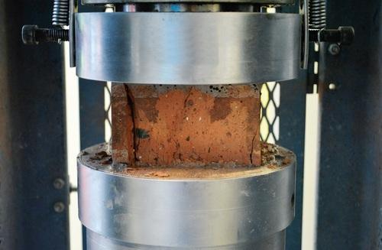
¬ Mortar would not stick, unless they are designed with specialized rough surface. Even then, mortar is not expected to stick reliably.
¬ Plastic may appear strong, but it would deform under pressure.
¬ As such they would have a limited lifespan due to degradation by UV. Extreme arctic weather would make them brittle. Or else, they would crack in several years due to thermal cycling. Skilled labors are required.
¬ When we are burning plastic for preparation plastic brick it emits taxi-gases into atmosphere.
6 APPLICATION OR FUTURE WORKS
Plastic sand bricks give us hope and a way to work on innovative things related to the plastic and to try to invent some new civil engineering materials which shows some remarkable response in future industry and changes the thoughts of the researchers, users and industries. Such as, in going for
¬ Plastic sand wall in framed structures as a partition wall
¬ Plastic sand benches in the parks
¬ Plastic sand tracks for running and jogging in place of concrete or stone tracks.
¬ Research on Composition of plastic with fly ash, Quarry dust etc.
7 CONCLUSIONS
¬ Waste plastic, which is available everywhere, may be put to an effective use in brick.
¬ Plastic bricks can help reduce the environmental pollution, thereby making the environment clean and healthy.
¬ Plastic sand bricks reduce the usage of clay in making of bricks.
¬ Plastic sand bricks give an alternative option of bricks to the customers on affordable rates.
¬ Water absorption of plastic sand brick is zero percent.
¬ Compressive strength of plastic sand brick is 5.6 N/mm2 at the compressive load of 96KN.
¬ We conclude that the plastic sand bricks are useful for the construction industry when we compare with Fly Ash bricks and 3rd class clay bricks.
8 REFERENCES
[1] Amit Gawande, G. Zamare., V.C Renge., Saurabh Tayde, G. Bharsakale.. “an overview on waste plastic utilization in asphalting of roads”, Journal of Engineering Research And Studies (JERS) ,Vol. III, Issue II, AprilJune 2012,pp 01-05.
[2] Bharath Raj,Varshith A,Rashmitha Kotian, N.G. Ashwath. “Study on Laterite-Cement bricks” Project reportK.V.G College of Engineering, Sullia.DK. 2011-2012.
[3] Dr. B.C Punmia, “Soil Mechanics and Foundations”,Lakshmi Publications, sixteenth edition, New Delhi,2010,pp 37-66 & 87-107.
[4] Isaac Olufemi Agbede and Manasseh Joel, “Use of Cement-Sand Admixture in Laterite Brick Production for Low Cost Housing” Department of Civil Engineering, University of Agriculture, Makurdi Benue State, Nigeria.,Issue 12,Jan –June 2008,pp 163-174.
[5] S.K Khanna. and C.E.G Justo. “Highway Engineering”, Nem chand and Bros. Publications, Ninth Edition, New Delhi.2001, pp 301-310.
[6] L.R Schroceder, “The Use of Recycled Materials in Highway construction”, Public Roads, Vol 58, Issue 2,1994.
[7] Sunil Bose, Sridhar Raju, “Utilization of waste plastic in Bituminous Concrete mixes”, Roads and Pavements, vol 3 2004.
[8] “Useful products from oil and organic chemistry”, Topic 11/5 available at http://www.tep.org.uk/a2z_glossary/a2z/plastics.htm
[9] “Zeus Industrial Products”, Technical newsletter, Inc. 3737 Industrial Boulevard Orangeburg, SC 29118, pp 2-4 available at http://www.zeusinc.com/technicalservices/technicalbulle tins/technicalnewsletters.asp
[10]Puttaraj Mallikarjun Hiremath, Shanmukha shetty, Navaneeth Rai.P.G, Prathima.T.B (2018), Utilization Of Waste Plastic In Manufacturing Of PlasticSoil Bricks, INTERNATIONAL JOURNAL OF TECHNOLOGY ENHANCEMENTS AND EMERGING ENGINEERING RESEARCH , VOL2, ISSUE 4, ISSN 2347-4289.

[11]Arvind Singhal, Dr. Omprakash Netula (2018), Utilization of plastic waste in manufacturing of plastic sand bricks, https://www.researchgate.net/publication/325870842, page no. 207-210.
[12]Jeevan Ghuge, Saurabh Surale, Dr. B.M. Patil, S B Bhutekar (2019), Utilization of Waste Plastic in Manufacturing of Paver Blocks, International research journal of engineering and technology (IRJET) Volume: 06, Issue: 04, page no. 1967-1970.
[13]Maneeth P D, Pramod K , Kishor Kumar, Shanmukha Shetty (2014), Utilization of Waste Plastic in Manufacturing of Plastic Soil Bricks, International Journal of Engineering Research & Technology (IJERT), Vol. 3, Issue 8, page no 529-536.
[14]Dinesh.S, Dinesh.A, Kirubakaran.K (2016), Utilisation of waste plastic in manufacturing of bricks and paver blocks, International Journal of Applied Engineering Research, ISSN 0973-4562, Vol. 11, No.3,page no. 364-368.
[15]V.Kasselouri-Rigopoulou, S. Gavela, S. Kolias“Use Of Polymeric Wastes in The Concrete Production” Polymers in concrete: a vision for the 21st century, Cement & Concrete Composites 21: (1999) 449-452. [6] L.R Schroeder, “The Use of Recycled Materials in Highway construction”, Public Roads, Vol 58,Issue 2, 1994.
[16] madan mohan reddy ,k,ajitha .B and bhavani.R(2012) “Melt- Densified Post-Consumer Recycled Plastic Bags Used as Light Weight Aggregate in Concrete”, International Journal of Engineering Research and Applications (IJERA) ISSN: 2248-9622 Vol. 2, Issue, pp.1097-1101.
[17] Dr.prahallada M.C and Dr.prakash K.B “strength nd workability characteristics of waste plastic fibre nforced concrete produced from recycled aggregates”international journal of engineering research and applications(IJERA) ISSN:2248-9621]
[18]Aeslina Abdul Kadir, Noor Amira Sarani, “An Overview of Wastes Recycling in Fired Clay Bricks” International Journal of Integrated Engineering, Vol. 4 No. 2 (2012) p. 53-69
[19] Maneeth P D, Pramod K , Kishor Kumar, Shanmukha Shetty (2014), Utilization of Waste Plastic in Manufacturing of Plastic Soil Bricks, International Journal of Engineering Research & Technology (IJERT), Vol. 3, Issue 8, page no 529-536.

