**Microstrip Patch Antenna Performance Optimization by Variation in Position of Rectangular Shape Slot**

**Pravin R Bhole1, Pramod J Deore2**

*1Research Scholar*

*R C Patel Institute of Technology, Shirpur, India, Pin-425405*

*2Professor*

*R C Patel Institute of Technology, Shirpur, India, Pin-425405*

*prbhole.rcpit@gmail.com*

***Received on****: xxxx,20xx,* ***Revised on****: xxxx,20xx,* ***Published on****: xxxx,20xx*

***Abstract –*** *The design and simulation of a rectangular microstrip patch antenna including a rectangular slot defective ground (DGS) structure are the subjects of this study. The antenna designed for center frequency of 2.4 GHz and is simulated utilizing HFSS software. The aim of the study is to evaluate the influence of the faulty ground structure on the performance of the antenna by varying the position of the rectangular slot. Performance parameters such as return loss, bandwidth, VSWR and gain are carefully evaluated to measure the effectiveness of the DGS structure. By systematically adjusting the of rectangular slot position, the antenna’s working performance under different configurations is thoroughly investigated. The results show significant improvements in antenna performance after introducing the rectangular slot defect. Notably, the operating bandwidth of the rectangular microstrip antenna experiences a significant increase from 60 MHz to 298 MHz, highlighting the effectiveness of the DGS structure. The comprehensive simulation and analysis of this study provides valuable insights into the optimization of microstrip patch antennas and paves the way for the creation of high-performing antennas that satisfy contemporary communication systems' required specifications.*

***Keywords-*** *Microstrip Patch Antenna, Bandwidth, Rectangular Slot, Defected Ground Structure.*

**INTRODUCTION**

In the sphere of communication, engineers and academics are becoming more and more interested in the study of smart antenna systems. The main goal is to improve system performance via increasing bandwidth, optimizing the use of spectrum, expanding the coverage area, directing multiple beams for monitoring mobile devices, and mitigating multipath and co-channel interferences during signal propagation. Of particular note, the quick growth of wireless local area networks (WLANs) and global microwave access interoperability (WiMAX) systems has attracted widespread attention due to their simple structure, multiple bands, compact size, and cost-effective antennas. The Microstrip patch antenna has emerged as a highly effective radiator across various applications owing to its numerous advantages, including low weight, volume, and cost, as well as its conformal configuration as well as suitability for integrated circuits. Microstrip patch antennas do have a few shortcomings, though, which includes low gain, large ohmic loss, low efficiency, limited ability to handle low RF power. For addressing these challenges, one of the techniques employed is the defective ground structure (DGS). The concept of DGS encompasses the introduction of a geometric irregularity on the ground plane. This irregularity disturbs the distribution of shielded currents, a phenomenon that varies based on the specific shape and dimensions of the defect. The excitation and transmission of electromagnetic waves within the substrate layer can be controlled which taken place due to this current disturbance. The disorder in the shielded current influences the input impedance of the antenna and the movement of current. Furthermore, this disruption can change the transmission line's properties, taking into account its corresponding inductance and capacitance, in order to accomplish the band-stop and slow-wave effects. By incorporating DGS, Additional inductance is induced by the magnetic flux within the etched opening and capacitance due to the gap present at the ground plane. Changes in impedance present at surface because of the etched ground flaws which further disrupt the shield current distribution, leading to changes to the currents phase velocity and, hence changes in the apparent effective permittivity. Here, we describe the design of a 2.4 GHz rectangular inset feed microstrip antenna. With no change to the rectangular patch antenna's dimensions, a rectangular slot defect is introduced on the ground plane. Performance of the antenna with respect to return loss, gain, bandwidth, and Voltage Standing Wave Ratio is examined by changing the rectangular slot DGS's location from from the ground plane's edge to edge by a gap of two millimeters, maintaining a fixed length dimension of 48mm and a gap width dimension of 2mm. This study aims to elucidate the impact of the rectangular slot DGS on the antenna's performance metrics, offering insights into enhancing the efficiency and effectiveness of microstrip patch antennas in modern communication systems.

**LITERATURE REVIEW**

The pursuit of improving bandwidth in microstrip patch antennas, particularly through the strategic integration of slots at the ground level, has attracted considerable attention in the field of antenna design and wireless communications. Numerous studies have been conducted to investigate various techniques for improving the bandwidth of microstrip patch antennas, with particular emphasis on the use of ground plane slots, a method that has become one of the most extensively studied approaches. A study by Devashree et al. (2016) extensively addressed bandwidth improvement by introducing different shaped slots (T, E, Phi and double-phi) at the ground level of a microstrip patch antenna. The results showed a remarkable increase in the antenna's bandwidth from 67 MHz to 292 MHz. This improvement was attributed to the changed electromagnetic field distribution induced by the introduced slot [2]. In a separate work, an asymmetric Sai-shaped ground defect was proposed, which leads to a significant improvement in bandwidth [3]. Similarly, Anita et al. (2015) developed a simple but effective design that includes a rectangular slot on the footprint of a microstrip patch antenna. The introduction of a single vertical slot at the ground plane resulted in significant bandwidth expansion (111 MHz) and improved radiation characteristics, confirming the effectiveness of slot-based techniques in expanding antenna bandwidth [4]. Sharma et al. (2018) studied the bandwidth improvement by introducing a T-shaped slot on the ground plane and achieved a remarkable improvement attributed to the changed electromagnetic field distribution caused by the slot [5]. In a different approach, Sukur et al. (2016) used circular slots for bandwidth improvement [6]. Jangid et al. (2018) contributed to this area by using two U-shaped slots and converting the antenna to a three-band configuration with a maximum bandwidth of 157 MHz in lower frequency bands [7]. Meanwhile, Misra (2019) proposed a straightforward but extremely effective technique. The design included a slotted microstrip patch antenna with an E-shaped cut and a rectangular hole, resulting in a significant bandwidth increase to 49.81% at a resonant frequency of 4.89 GHz. Importantly, this improvement was achieved while maintaining a return loss of -29.49 dB [8]. Additionally, the work of Ujjal Chakraborty (2014) investigated the use of U-shaped slots at the ground level of microstrip patch antennas for bandwidth improvement. Their research highlighted the critical importance of slot geometry and placement in achieving optimal bandwidth improvement without compromising other antenna parameters [9]. These studies collectively demonstrate the effectiveness of ground-level slot-based techniques for bandwidth improvement in microstrip patch antennas. By strategically introducing slots, researchers have managed to alter the electromagnetic field distribution, resulting in wider bandwidth and improved antenna performance. The diverse approaches highlight the flexibility and potential of slot-based techniques to advance the capabilities of microstrip patch antennas for various wireless communication applications.

**METHOLOGY**

The suggested microstrip patch antenna is rectangular in shape, and is built on a foundation of FR4 glass epoxy resin having 4.4 relative permittivity. The patch itself measures 30 mm x 38 mm, while the ground plane extends to 50 mm x 50 mm. The substrate maintains a thickness of 1.6 mm, ensuring structural integrity and efficient electromagnetic propagation. For the feed of the rectangular microstrip antenna, a microstrip inset feed configuration is employed, featuring a length of 17.4 mm and a width of 3 mm. This feed design facilitates optimal signal transmission and impedance matching, contributing to the antenna's overall performance. To enhance the antenna's characteristics, defect is introduced on a ground plane, by using a rectangular shape slot. A slot with dimensions of 48 mm for the length and 2 mm for the width creates the required defect on the ground plane. The rectangular shape slot's length is specifically selected to maximize and justify the impedance and resonance characteristics.

**DESIGN**

Figure 1 illustrates the configuration of the rectangular microstrip antenna, featuring a ground plane measuring 50 mm x 50 mm

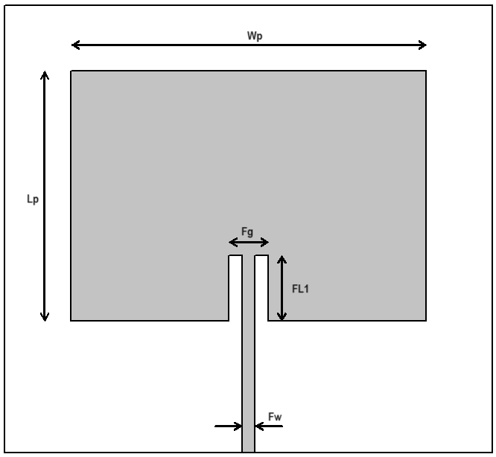

Figure 1(a) Rectangular microstrip antenna patch antenna

In Figure 2, defect in the ground plane is depicted, which is characterized through a length 48 mm and a width 2 mm.

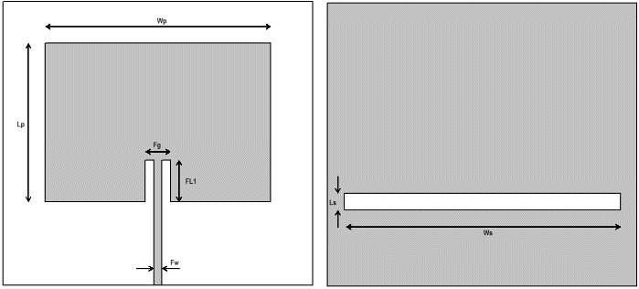

Figure 2 proposed antenna with rectangular slot DGS

In antenna design, patch width and length are critical parameters determined by factors such as relative permittivity and operating frequency.

Table 1: Design parameters of proposed antenna

|  |  |
| --- | --- |
| Antenna Parameters | Value (in mm) |
| Width of Substrate | 50 |
| Length of Substrate | 50 |
| Thickness (h) | 1.6 |
| Patch width (Wp) | 38 |
| Patch length (Lp) | 30 |
| Fg | 7 |
| FL1 | 9.4 |
| Fw | 2 |
| Ls | 2 |
| Ws | 48 |

The study uses an FR4 base having thickness of 1.6 mm and 4.4 as relative permittivity. These values affect the propagation of electromagnetic waves and the interaction with the patch. The equations provided in reference [1] help to calculate the length and width of the patch, ensuring resonance at the desired operating frequency.

**RESULT & DISCUSSION**

An integral feature of this antenna involves the insertion of a rectangular slot defect into the ground plane. To assess its impact, simulations are conducted by systematically varying the slot's position relative to the center of the ground plane, adjusting the slot's location in 2 mm increments. The slot length is also optimized and fixed to length of 48 mm and a width of 2mm. The reference position is established from one edge of ground plane, and subsequent variations are explored by shifting the slot. The simulation process is executed using HFSSv15 (High Frequency Structure Simulator), a solver which uses finite element method is renowned for its accuracy in analyzing electromagnetic structures. This comprehensive simulation strategy involves the evaluation of both the rectangular shape microstrip antenna and its counterpart, i.e. suggested antenna with rectangular shape ground defect. In order to optimize rectangular slot DGS for performance enhancement, parametric study performed.

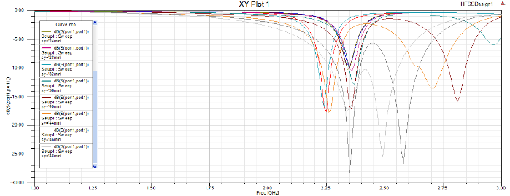

Figure 3 Optimization of the rectangular shape ground slot position

Figure 3 shows result of return loss obtained through parametric study. The primary aim is to enhance the antenna's performance by methodically analyzing the effects of varying parameters including slot position, slot length, and slot thickness. Through meticulous examination, various combinations of these parameters are explored to assess their impact on essential performance indicators such as return loss, bandwidth, VSWR, and gain. Utilizing a combination of simulations and practical experiments, the research endeavors to pinpoint the optimal slot position, length, and thickness that yield the most significant performance improvements for the antenna.

Figure 4 illustrates return loss results obtained for traditional 2.4GHz antenna and suggested antenna which have ground slot. The return loss plots for various positions are depicted from Figure 3. Analysis of the results reveals that the rectangular shape microstrip patch antenna lacking ground defects exhibits a -20 dB return loss, whereas the antenna with DGS positioned at a distance of 41 mm (from substrate edge) showcases a return loss of -32 dB, as demonstrated in Figure 4.

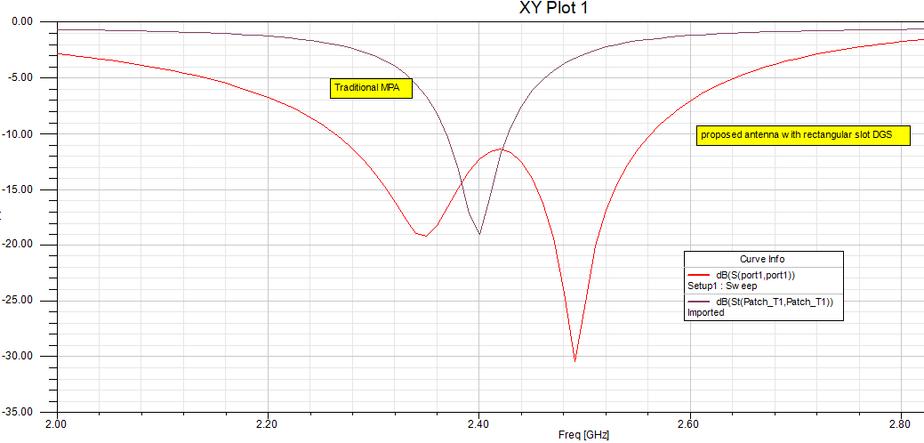

Figure 4 Return loss plot of rectangular microstrip antenna without DGS and with DGS

Comparing bandwidth metrics, the rectangular microstrip antenna without DGS exhibits a bandwidth of 60 MHz. In contrast, the introduction of horizontal rectangular slot beneath of inset feed DGS expands the bandwidth to 298 MHz. This increase underscores the efficacy of incorporating a rectangular slot defect on the ground plane in enhancing antenna performance. The presence of defect on the ground plane amplifies the fringing field, and thus adding parasitic capacitance. The coupling between the ground plane and the conducting patch is strengthened by this capacitance, thus facilitating bandwidth enhancement.

Figure 5 displays simulation results showing VSWR. It clearly shows improvement in VSWR from without DGS 1.6 to 1.02 when rectangular slot DGS used.



Figure 5 VSWR plot of rectangular microstrip antenna without DGS and with DGS

Due to the presence of rectangular shape slot defect on the ground plane generates an extra inductance due to the result of the magnetic flux flow in the aperture that has been etched out, allowing for effective control over the inductance by altering the slot's physical dimensions. The defect present on ground plane magnifies fringing field effects, which causes parasitic capacitance to be introduced. The ground plane and conducting patch are more closely coupled as a result of this extra capacitance, thereby contributing to bandwidth enhancement. Simulation results demonstrate that incorporating a rectangular shape slot defect into the ground plane and with proper selection of slot position significantly enhances the return loss, improving from -20 dB to -32 dB. Moreover, the bandwidth experiences a significant boost, expanding from 60 MHz to 298 MHz. The results were when compared with the previously reported findings on a similar bandwidth enhancing techniques [4] show that this method performs better.

**CONCLUSION**

The performance analysis of the rectangular shape microstrip patch antenna involves creation of a rectangular shape slot defect in ground plane and optimization of its position for antenna bandwidth enhancement. Based on simulation results, the bandwidth performance and return loss of the antenna are improved by the rectangular slot DGS compared to the same antenna configuration without the DGS function. The results of the simulation indicate that, through the adjustment of the ground plane's rectangular slot defect, the antenna with DGS is found to have an enhanced return loss of -32 dB and improved bandwidth from 60 MHz to 298 MHz. Consequently, this microstrip antenna with a defective ground structure emerges as a viable option for wireless applications.

**REFERENCES**

1. Constantine A. Balanis, Antenna Theory-Analysis and Design, John Wiley & Sons, Inc., New York, 1982.
2. D. S. Marotkar and P. Zade, Bandwidth enhancement of microstrip patch antenna using defected ground structure, 2016 International Conference on Electrical, Electronics, and Optimization Techniques (ICEEOT), Chennai, India, 2016, pp. 1712-1716, doi: 10.1109/ICEEOT.2016.7754978.
3. D. S. Marotkar, P. Zade and V. Kapur, Design of microstrip patch antenna with asymetric sai shape DGS for Bandwidth enhancement, 2015 IEEE Applied Electromagnetics Conference (AEMC), Guwahati, India, 2015, pp. 1-2, doi: 10.1109/AEMC. 2015.7509193.
4. R. Anita and Chaitanya Kumar M.V, Analysis of microstrip antenna performance by shifting position of rectangular slot DGS, 2015 International Conference on Communication Networks (ICCN), Gwalior, India, 2015, pp. 47-52, doi: 10.1109/ ICCN.2015.10.
5. Bhatia, S.S. and Sharma, N. (2020). A compact wideband antenna using partial ground plane with truncated corners, L – shaped stubs and inverted T – shaped slots, Progress In Electromagnetics Research M, 97, pp. 133–144. doi:10.2528/pierm20072503.
6. Sukur, M.I., Rahim, M.K. and Murad, N.A. (2016) Bandwidth enhancement of rectangular dielectric resonator antenna using circular slot coupled technique, Microwave and Optical Technology Letters, 58(3), pp. 505–509. doi: 10.1002 /mop. 29604.
7. Krishan Jangid, P.K. Jain, N. Choudhary, Brajraj Shrama. U-shaped slots loaded patch antenna with defected ground plane for multiband modern communication systems, May 2018, Journal of Engineering Science and Technology 13(5):1396-1410
8. Misra, Y.S. and Verma, R.K. (2019). Enhancement of bandwidth and gain of a slotted E-shaped patch antenna, International Conference on Intelligent Computing and Smart Communication 2019, pp. 749–758. doi:10.1007/978-981-15-0633-8_76.
9. Chakraborty, U., Chowdhury, S.K. and Bhattacharjee, A.K. (2014) ‘Frequency tuning and miniaturizations of a bandwidth enhanced rectangular microstrip antenna’, Microwave and Optical Technology Letters, 56(7), pp. 1600–1603. doi: 10.1002/mop.28398.
10. Uqaili, R.S. et al. (2020) A study on dual-band microstrip rectangular patch antenna for Wi-Fi, Proceedings of Engineering and Technology Innovation, 16, pp. 01–12. doi:10.46604 /peti.2020.6266.