Synthesis and Studies of Non-Isothermal Kinetics, Biological Activities of Novel Copolymer, Derived From Salicylic acid, and Thiosemicarbazide

Dr.KamlakarNandekar ¹, Dr.ShaileshMandavgade²
^{1,2}Department of Chemistry, G. H. Raisoni Polytechnic, Nagpur-440028

Abstract – The Copolymer (SATF-III) was synthesized by polycondensation of Salicylic acid and Thiosemicarbazide with formaldehyde in the presence of 2M HCL as a catalyst at 126±2 ⁰C for 5 hrs. with molar proportion of reactants. Thermo gravimetric analysis of (SATF-III)copolymer resins in present study have been carried out by non-isothermal thermo gravimetric analysis technique, in which sample is subjected to condition of continuous increase in temperature at linear rate. Thermal study of the resins was carried out to determine their mode of decomposition and relative thermal stabilities. The copolymer (SATF-III) was characterized by FT-IR, ¹H-NMR Spectroscopy.. Thermal activation energy (Ea) calculated with above two mentioned methods are in close agreement. Freeman Carroll and Sharp-Wentworth methods were used to calculate the thermal activation energy (Ea), the order of reaction (n), entropy Change (∆S), free energy change (∆F), apparent entropy change (∆S), and frequency factor (Z). The thermal activation energy determined with the help of these methods was in good agreement with each other.

Keywords- Synthesis, Polycondensation, thermal analysis, activation energy.
INTRODUCTION

The study of thermal behavior of copolymers in air at different temperature provides information about the nature of species produced at various temperatures due to degradation. Copolymers having good thermal stability and catalytic activity have enhanced the development of polymeric materials. Copolymers having good thermal stability and catalytic activity have

enhanced the development of polymeric materials. [1-5].Kinetic parameters of the terpolymerinvolving 2,2-
dihydroxybiphenyl, urea, and formaldehyde were calculated by theFreeman–Carroll (FC) [6], and Sharp–Wentworth (SW)[7] methods. From the results, itwas reported that the terpolymers have good thermal stability, and the decompositionreaction follows the first order kinetics[8]. Thermoanalytical Studies and Kinetics of Newly Synthesized Copolymer derived from p-Hydroxybenzoic acid and Semicarbazide have been reported [9] . Recently, our research group havesynthesized and Non-Isothermal Kinetic Studies of salicylic acid and thiosemicarbazide have been reported[10].The result of the study reveals that thekinetics study of thermal degradation of resin derived from salicylaldehyde, ethylenediamine and formal dehydepossess higher thermal stability [11].A survey of the literature reveals that the copolymers, thermal, catalytic and antimicrobial aspects of polychelates of phenolic resin with lanthanides (III) have also been reported [12]
The present paper deals with the synthesis, characterization, adnoun-isothermal thermo gravimetric analysis and biological studies of copolymer derived from of salicylic acid (SA), thiosemicarbazide (T), with formaldehyde (F). However, the literature studies have revealed that no copolymer has been synthesized by using the said monomers. Sample is subjected to thermal degradation data with Sharp-Wentworth (S-W) and Freeman-Carroll (F-C) methods, activation energy and kinetic parameters such as ∆S, Z, S* and n (order of reaction) have been evaluated [13-17].

MATERAILS AND METHODS
Materials:
The entire chemical used in the synthesis of various new copolymer resins were procured from the market and were analar or Fluka or chemically pure grade. Whenever required they were further purified by standard methods like thin layer chromatography, reprecipitation and crystallization which are generally used for the analytical purification purpose.

Methods:
Polycondensation of SATF-III copolymer resins:
The new copolymer resin SATF-III was synthesized by polycondensation of salicylic acid (0.3mol) and thiosemicarbazide (0.1 mol) with formaldehyde (0.4 mol) in a mol ratio of 3:1:4 in the presence of 2 M 200 ml HCl as a catalyst at 126 ⁰ C ± 2 ⁰ C for 5h, in an oil bath with occasional shaking, to ensure thorough mixing. The separated copolymer was washed with hot water and methanol to remove unreached starting materials and acid monomers. The properly washed resin was dried, powdered and then extracted with diethylether and then with petroleum ether to remove salicylic acid-thiosemicarbazide formaldehyde copolymer which might be present along with SATF-III copolymer. The yellow color resinous product was immediately removed from the flask as soon as reaction period was over and then purified. The reaction and suggested structure of SATF-III is shown in Fig. 1.
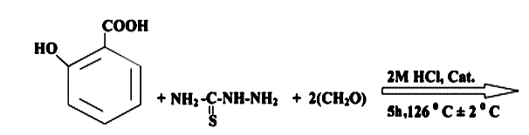
Salicylic Acid Thiosemicarbazide Formaldehyde

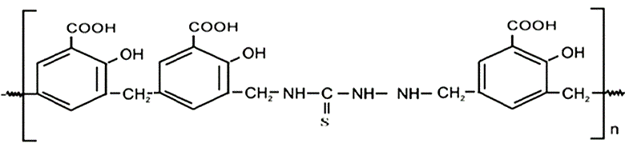
Fig.1. Synthesis of SATF-III copolymer resin.

The copolymer was purified by dissolving in 10% aqueous sodium hydroxide solution, filtered and reprecipitated by gradual drop wise addition of ice cold 1:1 (v/v) concentrated hydrochloric acid / distilled water with constant and rapid stirring to avoid lump formation. The process of reprecipitation was repeated twice. The copolymer sample p-HBSF thus obtained was filtered, washed several times with hot water, dried in air, powdered and kept in vacuum desiccators over silica gel.

ThermogravimetricAnalysis:

The non-isothermal thermo gravimetric analysis was performed in air atmosphere with heating rate of 10 ⁰C.min⁻¹ from temperature range of 50 ⁰C to 600 ⁰C using Perkin Elmer Diamond TGA analyzer in argon environment. The thermo grams were recorded at Sophisticated Instrumentation Centre for Applied Research and Testing (SICART), VallabhVidyanagar, Gujrat.The thermal stability of copolymer, based on the initial decomposition temperature, has also been used here to define their relative thermal stability, neglecting the degree of decomposition. A plot of percentage mass loss versus temperature is shown in the Fig. 4 for a representative SATF-III copolymer. From the TG curves, the thermo analytical data and the decomposition temperatures were determined for different stages. To obtain the relative thermal stability of the copolymer, the method described by Sharp-Wentworth and Freeman-Carroll adopted.

RESULTS AND DISCUSSION

The newly synthesized purified SATF-III copolymer resin was found to be yellow in color. The copolymer is soluble in solvents such as DMF, DMSO and THF while insoluble in almost all other organic solvents. The melting point of SATF-III copolymer resin is 313⁰C and the yield of the copolymer resin was found to be 85 %.

FT-IR Spectra: A broad band appeared in the region 2800-3200cm⁻¹may be assigned to the stretching vibrations of phenolic hydroxy (-OH) groups exhibiting intermolecular hydrogen bonding. The sharp band displayed at 1600-1680 cm⁻¹may be due to the stretching vibrations of carbonyl group (C=O)and 1600-1400 cm⁻¹may be due to (C=S) moiety . The presence of -NH in thiosemicarbazide moiety may be assigned due to sharp band at 2800-3000 cm⁻¹. A strong sharp peak at 1625-1500 cm⁻¹may be ascribed to aromatic skeletal ring . The bands obtained at 1400 – 1200 cm⁻¹suggest the presence of methylene bridges in the polymer chain. The weak band appearing at 720 - 760 cm⁻¹is assigned to C – OH bond. 1,2,4,6 tetrasubstitution of aromatic ring is recognized from the bands appearing at 902, 1084, 1201, and 1290 cm⁻¹ respectively.
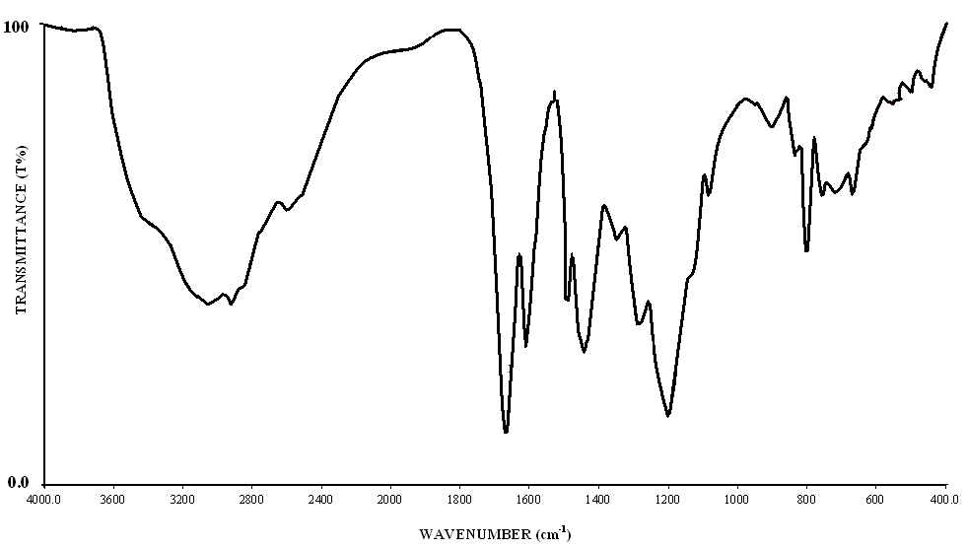
Fig.2: FT-IR Spectra of SATF-III copolymer

NMR Spectra:
Weak signal in the range of 7.8ppm is attributed to phenolic -OH proton. The NMR spectra ofSATF-II copolymer resins show a weak multi plate signal (unsymmetrical pattern) in the region 6.8 (δ) ppm which is due aromatic protons. A medium singlet peak appeared at 3.9 (δ) ppm may be assigned to methyl protons of Ar-CH₂-NH group. Intense signal appeared in the region 2.5 (δ) ppm may be due to Ar–CH₂-NH .Triplet signal appeared in the region 3.77 (δ) ppm can be assigned to amido proton of –CH₂-NH-CO- linkage.

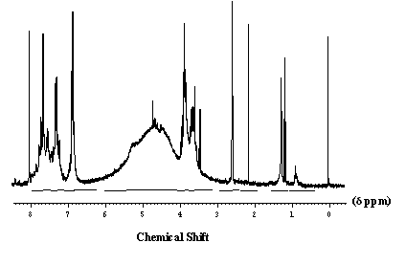
Fig.3: NMR Spectra of SATF-III copolymer
Thermo gravimetric:

The thermo gravimetric data provide information regarding the thermal stability of a polymer. The thermo grams were obtained by heating resin sample in air at 10⁰C/min. The results of percentage weight loss of the copolymer resins depicts three steps decomposition in the temperature range 120-570ºC and are furnished in Figure 4. The slow decomposition between 40-120ºC corresponds to 5.90% loss which may be attributed to loss of water molecule against calculated 5.15% present per repeat unit of the polymer. The first step decomposition start from 120-265ºC which represents loss of hydroxyl group and acid group (30.40 % found and 35.72% cal.). The second step decomposition start from 265-500ºC corresponding to 81.00 % removal of aromatic nucleus and methylene bridge against calculated 82.48%. The third step decomposition side chain from 500-570ºC corresponding to removal of Thiosemicarbazide moiety (99.18 % found and 98.42% cal.).
With the help of thermo gravimetric data the thermal activation energies (Ea) and order of reaction (n) calculated. Also other thermodynamic parameters such as entropy change (∆S), apparent entropy change (S*) and frequency factor (Z) are determined and reported in the Table 1& 2. To provide further evidence regarding the degradation system of analyzed compounds, we derived the TG curves by applying an analytical method proposed by Sharp-Wentworth and Freeman-Carroll. The ‘average Ea’ calculated by Freeman-Carroll (24.51 KJ/mole) and ‘average Ea’ by Sharp- Wentworth (24.85KJ/mole) is nearly same.
Sharp -Wentworth method:
Using the equation derived by Sharp and Wentworth [1],
log [(dc/dT)/ (1-c)] = log (A/β) – [Ea/2.303R]. 1/T …..(1)
Where,
dc/dT = rate of change of fraction of weight with change in temperature
β = linear heating rate dT/dt.
By plotting the graph between (log dc/dt)/ (1-c) vs 1/T we obtained the straight line which give energy of activation (Ea) from its slope. Where β is the conversion at time t, R is the gas constant (8.314 Jmol⁻¹K⁻¹) and T is the absolute temperature. The plots (figure 2) give the activation energies at different stages of degradation reaction take place.
Freeman-Carroll method:
The straight-line equation derived by Freeman and Carroll , which is in the form of n
[Δlog (dw / dt)] / Δ log Wr = (-E / 2.303R) . Δ (1/ T) / Δ log Wr + n ------(1)
Where, dw/dt = rate of change of weight with time.
Wr = Wc-W
Wc = weight loss at completion of reaction.
W = fraction of weight loss at time t.
Ea = energy of activation. ,n = order of reaction.
The plot between the terms [Δ log (dw/dt)] / Δ log WrVs Δ (1/T) / Δ log Wr gives a straight line from which slope we obtained energy of activation (Ea) and intercept on Y-axis as order of reaction (n). The change in entropy (S), frequency factor (z), apparent entropy (S*) can also be calculated by further calculations.
(i) Entropy Change:
Intercept = [log KR/hфE] + S / 2.303 R -------------- (2)
Where, K = 1.3806 x 10-16 erg/deg/mole, R = 1.987 Cal/deg/mole
h = 6.625 x 10-27 erg sec. , ф = 0.166
S = Change in entropy, E = Activation energy from graph.
(ii) Free Energy Change:
ΔF = ΔH – TΔS _____________________________(3)
Where ,ΔH = Enthalpy Change = activation energy
Copolymers | Decomposition  Temp. (⁰C) | Activation Energy (kJ/mol)
 |  | F.C | S.W
SATF-I  SATF-II  SATF-III | 150  150  120 | 22.97  24.51  23.74 | 22.14  24.85  23.36
T = Temperature in K
S = Entropy change from (i) used.
(iii) Frequency Factor:
Bn= Log ZEa / фR---------------------------------- (4)
B1 = log [ ln 1 /1-α ] – log P (x) -------------------(5)
Where, Z = frequency factor, B = calculated from equation (5)
Log P(x) = calculated from Doyle‟s table corresponding to activation energy.

(iv) Apparent Entropy Change:
S* = 2.303 log Zh / KT* ------------------------- (6)
Z = from relation (4)
T* = temperature at which half of the compound is decomposed from it total loss
Table. 1: Results of Thermo gravimetric Analysis of SAT copolymer

Coplymers | Entropy  Change  -∆S(J) | Free Energy  Change  ΔF(kJ) | Frequency  factor  Z (S -1) | Apparent Entropy Change (S*) | Order of  reaction  (n)
SASF-I SATF-II  SATF-III | 277.17  300.67  298.59 | 119.54  129.63  119.72 | 430  438  430 | -24.29  -24.25  -24.25 | 0.90  0.92  0.90
Table.2: Kinetic Parameters of SAT copolymer

Anti-bacterial and anti-fungal Activities of SATF-III copolymer :
SATF-III copolymers were tested at different concentration to test their efficacy in inhibiting the growth of the human pathogens. The bacterial activity was assayed against B. Subtilis, E. Coli, S. Aureus, S. Typhi, A. Niger,C. Albicans. The diameters for the zone of inhibitions at different concentration against the test bacteria are given in Table 3. The standard antibiotic disc (Gentamycine disc 5μg ⁄disc) shows the growth of B. Subtilis by 8-25 mm E. Coli by 18-25 mm,. Aureus 13-34 mm and S. Typhi by 2-25 mm. The standard antibiotic disc (Amphotericin disc 5μg ⁄disc) shows the growth ofA.Nigerby 0-100 mm, and C. Albicansby 0-50 mm [13-14].
The results of present antimicrobial assay revealed that the SATF-III copolymer showed inhibitory activity against onlyB.subtilis, E. coli the tested pathogens, suggesting that the presence of thiosemicarbazide group may enhances antibacterial activity shown in Fig. 8. As the SATF-III content increases in the copolymer, the effectiveness of the copolymers to inhibit the growth of microorganism increases as expected [15-16].

CONCLUSION

A copolymer, SATF-III based on the condensation reaction of Salicylic acid, thiosemicarbazide formaldehyde in the presence of acid catalyst was prepared. From the FT-IR and ¹H NMR spectral studies the proposed structure of the SATF-III copolymer has been determined. In TGA the energy of activation evaluated from the Sharp-Wentworth and Freeman-Carroll methods are found to be nearly equal and the kinetic parameters obtained from Freeman-Carroll method are found to similar, indicating the common reaction mode. However, it is difficult to draw any unique conclusion regarding the decomposition mechanism. Low values of collision frequency factor (Z) may be concluded that the decomposition reaction of Salicylicacid,thiosemicarbazide, formaldehyde copolymer can be classified as ‘slow reaction’. The decomposition reaction was started at higher temperature, indicating a copolymer SATF-III is thermally stable at higher temperature.
SATF-III copolymer showed inhibitory activity against onlyB.subtilis, E. coli the tested pathogens, suggesting that the presence of thiosemicarbazide group may enhances antibacterial activity.

ACKNOWLEDGEMENTS
Authors are thankful to the SAIF, Punjab University,Chandigarh for carried out spectral analysis, and also to the SICART, Vallabhvidyanagar,Gujrat, thankful toBiogenics, Hubli Karnataka, for carried out antibacterial screening, for carried out the thermal analysis.

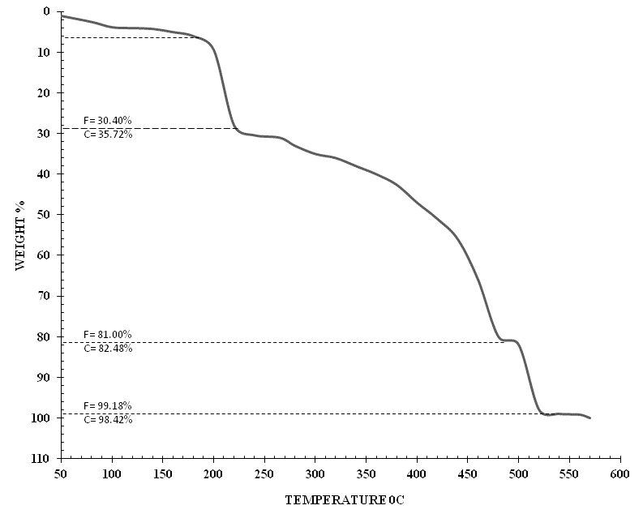

Fig. 4: Decomposition Pattern of SATF-III copolymer Resin.

Fig. 5: Sharp-Wentworth plot of SATF-III copolymer

Fig. 6: Thermal activation energy plot of SATF-III copolymer

Fig. 7: Freeman-Carroll plot of SATF-III copolymer

Table3: Antimicrobial activities of SATF-III copolymer resin
Organism | 0.0625 mg | 0.125 mg | 0.25 mg | 0.5 mg | 1.0 mg | 2.0 mg | MIC mg
B. subtilis | 0 | 0 | 0 | 0 | 0 | 4 | 2
E. coli (ETEC) | 0 | 0 | 0 | 0 | 0 | 5 | 2
S. aureus | 0 | 0 | 0 | 0 | 0 | 0 | NF
S. typhi | 0 | 0 | 0 | 0 | 0 | 0 | NF
A. niger | 0 | 0 | 0 | 0 | 0 | 0 | NF
C. albicans | 0 | 0 | 0 | 0 | 0 | 0 | NF

Note: NF- MIC not found among the concentrations screened
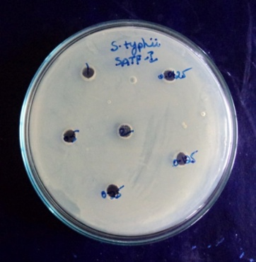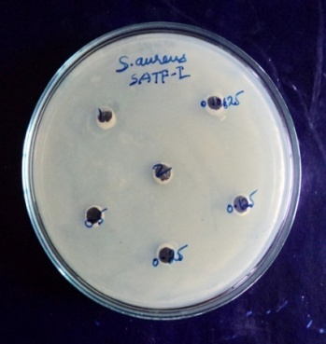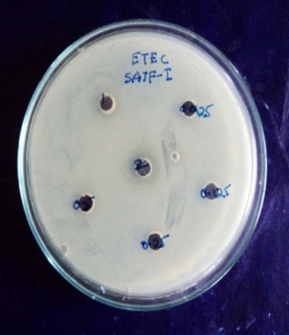
Salmonella typhiStaphylococcus AureusEscherichia coli
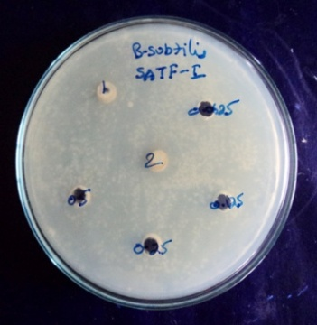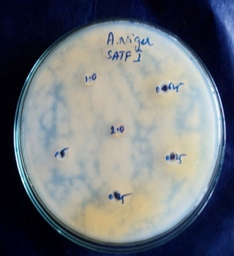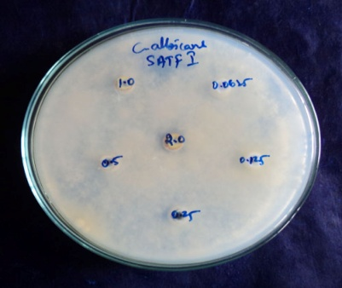
Bacillus subtillusAspergillusnigerCandida albicans
Fig.8: Antimicrobial Screening of SATF-III Copolymer.

REFERENCES
- RiswanAhamed MA, Azarudeen RS, Jeyakumar D, Burkanudeen AR (2011) Terpolymerchelates:synthesis, characterization, and biological applications. Int J Polym Mater 60:142–143

- Liu Q, Zao Y, Bei Y, Qi G, Meng Y (2008) Mechanic properties and thermal degradation kinetics ofterpolymer poly(propylene cyclohexene carbonate)s. Mater Lett 62:3294–3296

- Sun JT, Huang YD, Gong GF, Cao HL (2006) Thermal degradation kinetics of poly(methylphenylsiloxane) containing methacryloyl groups. PolymDegrad Stab 91:339–346

- Singru RN, Gurnule WB (2010) Thermogravimetric study of 8-hydroxyquinoline 5-sulfonic acidmelamine–formaldehyde terpolymer resins-II. J Therm Anal Calorim 100:1027–1036

- Nandekar KA, Gurnule WB, Dontulwar JR (2012) “Antimicrobial screening and thermoanalytical studies of newly synthesized copolymer derived from p-hydroxybenzoic acid, and thiosemicarbazide” J. Chem. Pharma. Res., 4(7), 3628-3636

- Freeman ES, Caroll B (1958) The application of thermoanalytical techniques to reaction kinetics. The thermogravimetric evaluation of the kinetics of the decomposition of calcium oxalate monohydrate. J PhysChem 62:394–39717.

- Sharp JB, Wentworth SA (1969) Kinetic analysis of thermogravimetric data. Anal Chem 41:2060–2062

- Jadhao MM, Paliwal LJ, Bhave NS (2006) Resin II: thermal degradation studies of terpolymerresinsderived from 2,2-dihydroxybiphenyl, urea, and formaldehyde. J ApplPolymSci 101:227–232

- Nandekar KA, Gurnule WB, Dontulwar JR (2012)Thermoanalytical Studies and Kinetics of Newly Synthesized Copolymer derived from p-Hydroxybenzoic acid and SemicarbazideRasayan J. Chem.,5 (3), 261-268

- Nandekar KA, Gurnule WB, Dontulwar JR (2012)Synthesis and Non-Isothermal Kinetic Studies of Novel SATF-II Copolymer, Derived from Salicylic acid and ThiosemicarbazideJ. Pharm. Bio chem. Sci.3(4), 552-561

- Masram DT, Bhave NS, Kariya KP (2010) Kinetics study of thermal degradation of resin derivedfromsalicylaldehyde, ethylenediamine and formaldehyde. E J Chem 7:564–568

- Patel MM, Kapadia MM, Joshi JD (2009) Thermal, catalytic and antimicrobial aspects of polychelatesof phenolic resin with lanthanides (III). EurPolym J 45:426–436

- Parveen S, Ahamad T, Nishat N (2008) New anti-bacterial polychelates: synthesis, characterization, and anti-bacterial activities of thiosemicarbazide–formaldehyde

resin and its polymer–metal complexes. ApplOrganometChem 22:70–77

- Nandekar KA, Gurnule WB, Dontulwar JR(2012), Synthesis and Characterization of high performance terpolymer resin derived from p-Chlorophenol, biuret and formaldehyde J. Knowl. Engg., 3(1), 151-153

- Nandekar KA, Gurnule WB, Dontulwar JR (2012), Thermal Behaviour of Newly Synthesized Copolymer Derived from Salicylic acid, and Thiosemicarbazide, Der PharmaChemica, 4(4), 1644-1652

- Nandekar KA, Gurnule WB, Dontulwar JR (2013) “Thermoanalytical and biological studies of novel copolymer, derived from salicylic acid and semicarbazide” DerPharmaChemica, 5(5), 160-168.

- Nandekar K.A, Mandavgade. S.K, Gurnule. W.B,(2016) “Studies of chelating ion exchange properties of Novel copolymer, derived from salicylic acid, and semicarbazide, NCETET4(1), 177-188.

