“WIND POWER GENERATION USING MAGNETIC LEVITATION: A Review”
Prof.S.K.Malode¹
¹Department of Electrical Engineering S.S.C.E.T, Bhadrawati
Vaishali A. Randive ²
²M-Tech Student Department of Electrical Engineering S.S.C.E.T, Bhadrawati

Abstract: The term “Levitation” refers to a class of technologies that uses magnetic levitation to propel wind turbines with magnets rather than with axles and bearings. Maglev (derived from magnetic levitation) uses magnetic levitation to propel wind turbine for the generation of electricity. The present scenario indicates that the demand for electricity is increasing day by day and to meet it many research are going on. Electricity generation through renewable energy sources has gained attention in the last few decades due to depleting conventional energy sources and can help in reducing dependency on fossil fuels. One of the fastest growing renewable energy sources in the world is wind energy source. With the use of magnetic levitation the efficiency of the wind turbine can be increased and losses minimized. It also increases the life span of the generator. Magnetic Suspension Wind Power Generators, represent a very promising future for wind power generation.
Key words: Wind Power Generation, Magnetic Levitation, Magnets.
I. INTRODUCTION
Energy is the primary and most universal measure of all kinds of work by human beings and nature. Everything that happens in the world is the expression of flow of energy in one of its forms Energy is an important input in all sectors of a country’s economy. The standard of living is directly related to per capita energy consumption. Due to rapid increase in the population and standard of living, we are faced with energy crisis. Conventional sources of energy are increasingly depleted. Hence, Non Conventional Energy Sources have emerged as potential source of energy in India and world at large. Nowadays wind power increasingly attracts interests and its utilization has entered a rapid development stage. The wind speeds in most of Asian zone is much lower than 7 m/s, especially in the cities, but the mechanical frictional resistance of existing wind turbines is too big, usually it can't start up when the wind speed is not big enough. This project introduces structure and principle of the proposed magnetic levitation wind turbine for better utilization of wind energy. The principal advantage of a maglev windmill from a conventional one is, as the rotor is floating in the air due to levitation, mechanical friction is totally eliminated. That makes the rotation possible in very low wind speeds.
II. LITERATURE SURVEY
During the year 2014-15, the per capita electricity generation in India was 1,010 kWh with total electricity consumption (utilities and non utilities) of 938.823 billion or 746 kWh per capita electricity consumption. Electric energy consumption in agriculture was recorded highest (18.45%) in 2014-15 among all countries. The per capita electricity consumption is lower compared to many countries despite cheaper electricity tariff in India.
When the mechanical friction is totally eliminated on that condition rotor is floating in the air due to levitation. That makes the rotation possible in wind speeds as low as 1.5 meters per second (m/s).The main drawback of this vertical axis wind turbines is not use for large scale industry because when increase the size of the rotor and also increase the cost [1]
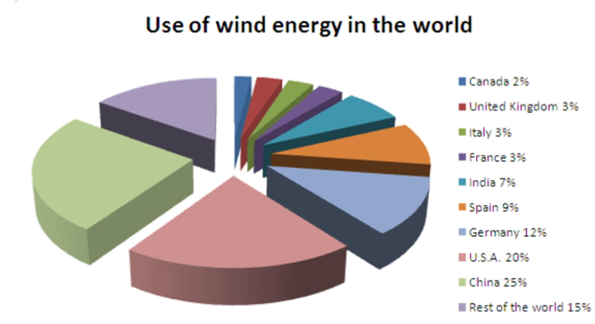
Figure I. - Use of wind Energy
Finding the Capacity factors of the optimum windmill. Long term wind speed data of the sites were used, considered the wind speed is high, the wind turbine size will be a bigger and the capacity factor decreases and vice-versa [2]. Low speed and capacity multi polar synchronous generator system is applied in the Vertical axis windmill because it has low noise, vibration, number of rotation. The generator is produced by a magnetic powder. Magnetic powder core is used for made the stator because less cost. Magnetic powder core has not used for electric tool [3].The intra-cavity wind energy is developed by vertical axial wind turbine of three hastate windmill. Vertical axial windmill of three hastate is coaxial with the permanent magnet generator has many advantages such as low power consumption, low noise and low cost. Vertical axial windmill of three hastate and closed cavities. It remove the eddy current loss [4].Permanent magnet generator with small scale windmill is increase the electrification ratio. The permanent magnet and the electric machine are 350 Watt brushless direct current motor at rotor. The electric machine is used as electric generator [5]. Wind turbines are used to convert the kinetic energy into mechanical energy. This mechanical energy is used for some task like grinding grain or a generator can convert into kinetic energy. Maglev wind turbines have more advantages than the conventional wind turbines [6].Vertical low wind speed magnetic levitation wind turbine and the traditional vertical wind turbine is similar but only the traditional mechanical bearings instead of using magnetic bearings this helps to elimination of mechanical friction [7]. Design the maglev vertical axis wind turbine with modified magnetic circuit generator and this analysis is used for test the generating capability of the wind turbine. A dual magnetic surface is attached into the structure through an external mechanical structure to reduce the mechanical oscillation [8]. The all above methods are following drawbacks are not use for large scale industry, magnetic permeability is low and hysteresis loss is large in magnetic powder. To overcome this we have developed another new technology are cost reduction, one time investment, used for both AC and DC applications.
III.MAGNETIC LEVITATION PRINCIPLE
Magnetic levitation, maglev or magnetic suspension is a method by which an object is suspended above other with no support other than magnetic field. The electromagnetic force is used to counteract the effect of gravitational force. Magnetic Levitation Magnetic levitation is known as maglev and this phenomenon works on the principle of repulsion characteristics of permanent magnets this technology has been mainly used in the railway industry in the Far East to provide very fast and reliable transportation on magnetic levitation trains and with ongoing research its popularity is increasingly attaining new heights. Neodymium magnet pair is used for magnetic levitation and substantial support can be easily experienced. By placing these two neodymium magnets on top of each other on the same poles for making repulsion on each other the magnetic levitation or repulsion will be strong enough to keep both magnets at a distance away from the each other. Repulsion force or levitation is also used for suspension purpose and its strong to balance the weight of an object depending on the verge (threshold) of the magnets in this project we expects to implements this technology from the purpose of achieving vertical orientation with our rotor as well as axial flux generator.

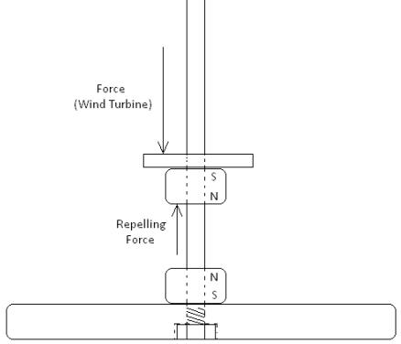

Figure II.-Basic Magnet Placement
IV .WORKING
A turbine is used in order to harness the power of the wind into the mechanical power of electricity. The term wind energy is the process of converting wind into a valuable power source. The wind turbine is designed to take the kinetic energy of the wind and turn it into pure mechanical power. The power of the wind can be used in many different ways. The kinetic energy of the wind can be used on a farm for pumping water or grinding grain. When the natural energy of the wind is transferred to a generator the power is used as electricity for businesses, homes and schools etc. A wind turbine resembles the propeller blades. The propeller blades of the turbine rotate because of the moving air. The rotation of the propellers powers an electric generator and then generator supplies a home with electric current. To simplify the process the wind rotates the blades, the rotation causes a shaft to spin, and the shaft connects to a generator to make electricity. Maglev wind turbine has several advantages over conventional wind turbine. For instant they are able to use winds with starting speed as low as 1.5m/s, also they could operate in winds exceeding 40 m/s. currently the largest conventional wind turbines in the world produce only 5 MW of power. However, one large maglev wind turbine could generate 1 GW of clean power, enough to supply energy to 7,50,000 homes. It also increases generator capacity by 20% over conventional wind turbine and decreases operational cost by 50%. The maglev wind turbine will be operated for about 500 years, but the wind will blow only intermittently and unpredictably. Therefore, it is necessary to store the electricity produced when the wind is blowing and then release it at a steady rate to maintain a steady supply of electricity to the consumers hence for this purpose it s can also be used in conjunction with hydroelectricity. An area may have some water but not enough to generate a large amount of electricity continuously. Maglev wind turbines can be installed to pump the water from the lower level reservoir to the upper level reservoir during the night so that there will be enough water to activate the electric generators during the day. Such combination of wind turbine and hydroelectric generation could supply electricity to many towns and cities.
V. MAJOR COMPONENTS OF MAGLEV WIND TURBINE
MAGNET
Two ring type or hollow type Neodymium (Ne-fe-B) magnet of diameter 40mm outer and inner diameter is 20mm and 10 mm thickness. Are placed at the shaft by which the required repulsion between the rotor and stator.These magnets are responsible for generating the useful flux that is going to be utilized for the power generation system.
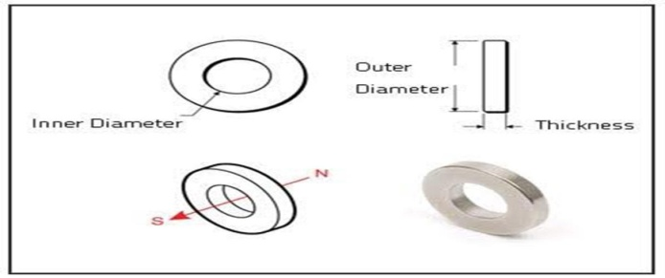

GENERATOR
Generator is a device which converts the mechanical energy into electrical energy. Generator is used for various applications and the most part have similarities that exist between these applications. However the few different presents what is really distinguishes a system operating on motor. With the axial flux generator design, its operability is based on permanents magnets alternator where the concepts of magnets and magnetic field are the dominants factors in this form of generator functioning these generators have air gap surface perpendicular to the air gap generates magnetic fluxes parallel to the axis.

TYPE OF TURBINE
There are many types of turbine used in wind power plant and this wind turbine has two main categories. Horizontal axis turbines (HAWTs) and vertical axis wind turbine (VAWTs). As the name pertains, each turbine is distinguished of their rotor shafts. The former is the more conventional and common type everyone has come to know, while the latter due to seldom usage and experimentation, is quiet unpopular. The HAWTs usually consist of two or three propeller-like blades attached to a horizontal and mounted on the bearings the top of a support tower. When the wind blows, the blades of the turbine are set in motion which drives a generator that produces AC electricity.
For optimal efficiency these horizontal turbines are usually made to point into the wind with the aid of a sensor and a servomotor or a wind turbine application with the vertical axis wind turbines the concepts behinds their operation similar to that of the horizontal designs.
VI. ADVANTAGES
The biggest advantages of using wind energy, as a power source is that wind is a free, renewable resource. This is a reliable energy supply for the future. This is a power source that is non-polluting and clean. Magnetic levitation is an extremely efficient system for wind energy. It uses the repelling properties of magnets to lift an object off the ground. The benefit of having it floating in midair is that it cuts down on the friction that causes so much inefficiency in the traditional windmill
VII. APPLICATIONS
The demand for electric power from regional power grids is not constant, but varies substantially with time. Typically, power demand is low during the night time, increasing substantially during the day. Most of the time, electrical grids experience two distinct peak demand periods, the first in the morning and the second in the afternoon. It would be expensive and technically difficult to have coal and nuclear power plants go up and down in power output to meet the fluctuating load demand. The cost of wind generation of electricity using maglev technology is once seen as prohibitive, but is now becoming more competitive. Wind energy can be used to generate electrical power that could be stored for introduction into the power grid as needed.
VIII. CONCLUSION
As per the project concept the future scope is to save depleting fossil fuels and use maglev technology in generating power even in residential areas as it is cost effective, less spacious, efficient and practical. Sustainable generation of electric power is the key to realizing the vision of a world free from dependency on fossil fuels – the challenge is to ramp up the production of electricity to a level that can begin to approach the energy we get from burning coal and oil, without the perceived dangers of going nuclear. If large scale maglev wind turbines can supply vast amount of electricity at economic cost then the advance of maglev wind turbine is a very timely developed. It plays a major role in the development of world. Magnetic levitation is an important development to reduce stress from the mechanical load on the wind turbine.
REFERENCES
[1]Minu John, Rohit John, Syamily P,S, and Vyshak P.A. ”Maglev Windmill”, International Journal of Research in Engineering and Technology (IJEIT)Volume 3,Issue 1 ,May 2014.
[2]Ziyad M. Salameh, Irianto Safari.” Optimum Windmill-Site Matching”, IEEE Volume 7, Issue 4, December 1992.
[3]Katsunori Soejima, Tsuyoshi Higuchi, Takashi Abe and Tadashi Hirayama.” Development of Magnetic Powder Type Synchronous Generator System for Vertical Axis Windmill”.
[4]Lei SONG, ZongXiao YANG, ShuQi HOU, RuiTao DENG and ShuLing jt.” Development of Vertical Axial Wind Turbine driven by Three Hastate Windmill and Permanent Magnet Generator”, July 2010.
[5]B.Dwiseno Wihadi, Y.B. Lukiyanto.”Permanent Magnet Motors Used for Optimum Electric Generating from Small Windmill”, IEEE, 2015.
[6]. Dinesh N Nagarkar, Dr.Z.J.Khan.” Wind Power Plant Using Magnetic Levitation Wind Turbine”, International Journal of Engineering and Innovative Technology (IJEIT) Volume 3, Issue 1, July 2013.
[7]Huachun Wu, Ziyan Wang Yefa Hu.” Study on Magnetic Levitation Wind Turbine for Vertical Type and Low Wind Speed”, IEEE, 2010.
[8]Aravind CV, kamalinni, TaySC, Jagadeeswaram A and RN Firdaus.”Design Analysis of MAGLEVVAWT with Modified Magnetic Circuit Generator”IEEE2014

