A Histochemical Demonstration of Developing Oocytes and Trophocytes in Cybister Tripunctatus

K.B.Nagarnaik
Department of Zoology,Science college ,Pauni , Dist- Bhandara

Abstract-The colleterial gland secretes predominatly the proteinaceous secretion which is revealed through histochemical studies. The Secretory activity of the colleterial gland shows parallel advancement with the process of vitellogenesis.

- INTRODUCTION

In Adephaga most of the work on histology of female reproductive System and some physiological mechanisms of vitellogenesis are confined to Dytiscusmarginalis. Joly, 1945, 1950; Urbani and Russo – Caia, 1969 b; Datta Gupta, 1963; Urbani, 1970; Barde and Shinde, 1984). Extensive studies on Dytiscusmarginalis pertaining to female Reproductive system, particularly ovaries and oocyte development were Initiated by Urbani and his co-workers since 1950. They first descrived Origin, structure and functions of Giardiana body (urbani 1950, a, b, c, 1951), Synthesis and transport of nucleic acids during oogenesis (Urbani and Russo-Cais, 1964), intercellular connections and transport of nucleic acids between nurse cells and oocyted( steinert and Urbani, 1969), cytological,
Cytochemical, autoradiographic and ultrastructural studies on oogenesis have Been thoroughly made ( Russo-Caia and Urbani, 1968, Ficq and Urbani, 1969; Urbani and Russo-Caia, 1969 a, b; Gall et al., 1969; Urbani, 1969, 1970; CiofiLuzzatto and Rossattivalente, 1971; Urbani, 1972 ).Besides Dytiscus, in other Dytiscid beetles like Cybister. Lateromarginalis and Hygrobiatarda some aspects of oogenesis have been Studied ( Urbani 1950,a, b, c, 1951), during which absence of Giardina bodies has been reported in Cybister. Some cytological, cytochemical and Autoradiographic studies were also carried out in Cybister (Urbani and Russo-Caia1969,a; Urbani 1969,1970,1972) particularly, on the ovarian nurseCells (Urbani and CiofiLuzzatto, 1970). The review of existing literature on Coleoptera including the family Dytiscidae, suggests clearly that the information on the female reproductive System, particularly, vitellogenesis is almost lacking in the Indian aquatic Beetle, Cybistertripunctatus. Present study has been undertaken to revels the Histochemical demonstration of synthesis, accumulation and transport of DNA, RNA, protein, carbohydrate and lipid during oogenesis; histochemical of the yolk material and secretory material of the colleterial gland and Thorough study of the process of vitellogenesis.
- MATERIAL AND METHOD
Histochemical staining techniques are as follows
Table 1:- Histochemical staining techniques.
- Best’s carmine - Cornoy’s Glycogen MC Manus and Mowry (1958)
- Feulgen/unhydrolysed –Cornoy’sDNA Pearse (1968)
- Feulgen/hydrolysedCornoy’sDNA Pearse (1968)
- Toluidine blue TBCornoy’sRNABrachet (1953)
- TB /after perchloric acid TB/Perchloric acid Cornoy’sRNA Brachet (1953)
- TB /ribonuclease TB/RNase Cornoy’sRNA Brachet (1953)
- Mercury-bromophenol blue Hg-BPB Cornoy’sProteins Mazia et al. (1953)
- Mercury-bromophenol blue after Hg- BPB/Pepsin Cornoy’sProteins Mazia et al . (1953)
- Pepsin
- Periodic acid Shiff’sPAS Cornoy’sCarbohydrates Hotchkiss (1948)
- PAS after acetylation PAS/acetylation Cornoy’sCarbohydratedHotchkiss (1948)
- Sudan black B SBB Calcium formalin Sudanophilic lipids Chieffelle and Putt (1951)
- SBB after pyridine SBB/Pyridine Weak Bouins Sudanophilic lipids Baker (1946)

III-OBSERATIONS
The histochemical observations of the developing oocytes and Trophocytes are summerised in Table-2
Deoxyribo nucleic acid
The nuclei of trophocytes and follicle cells show intense Feulgen Reaction suggesting synthesis and accumulation of DNA during the Pre-vitellogenic to mid- vitellogenic stages. The germinal vesical of terminal Oocytes react Feulgen reaction at pre- vitellogenic stage.
Ribo nucleic acid
The nuclei of follicle cells react intensely with the toluidine blue Suggesting continues synthesis of RNA from pre- vitellogenicto late- vitellogenic Stages. The trophocytes react with toluidine blue from pre- vitellogenic to Late- vitellogenicstages . The ooplasm also stained with TB during previt to Mid- vitellogenic stages.
Carbohydrate
The oocytes and nurse cells of the terminal follicles do not react With PAS at previtellogenic and early- vitellogenic stages. The yolk bodis of the Oocyte are intensely stain with PAS during mid, late maturation stages Suggesting in carporation of carbohydrate yolk material in terminal oocyte. TheFollicular epithelial cells during mid-vitellagenic stage react intensely with PAS. The trophocytes are often negative to the PAS reaction.

EXPLANATION O F FIGURES
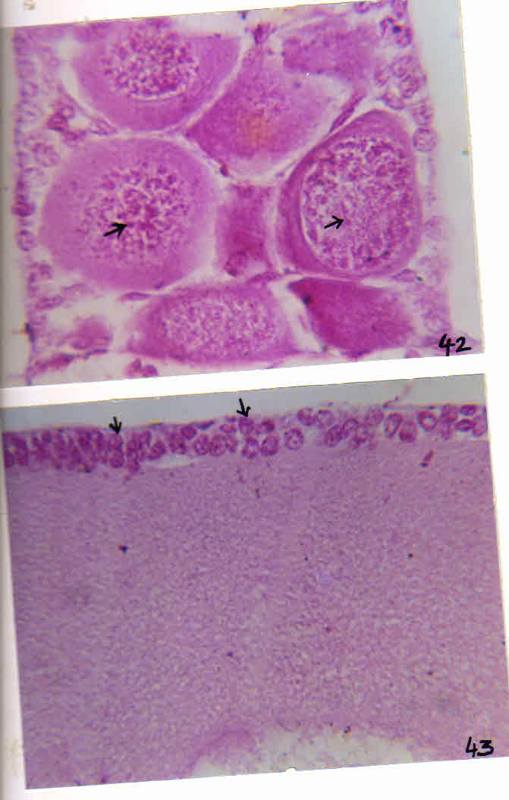
Fig.42 DNA in trophocyte nuclei Feulgen X 400
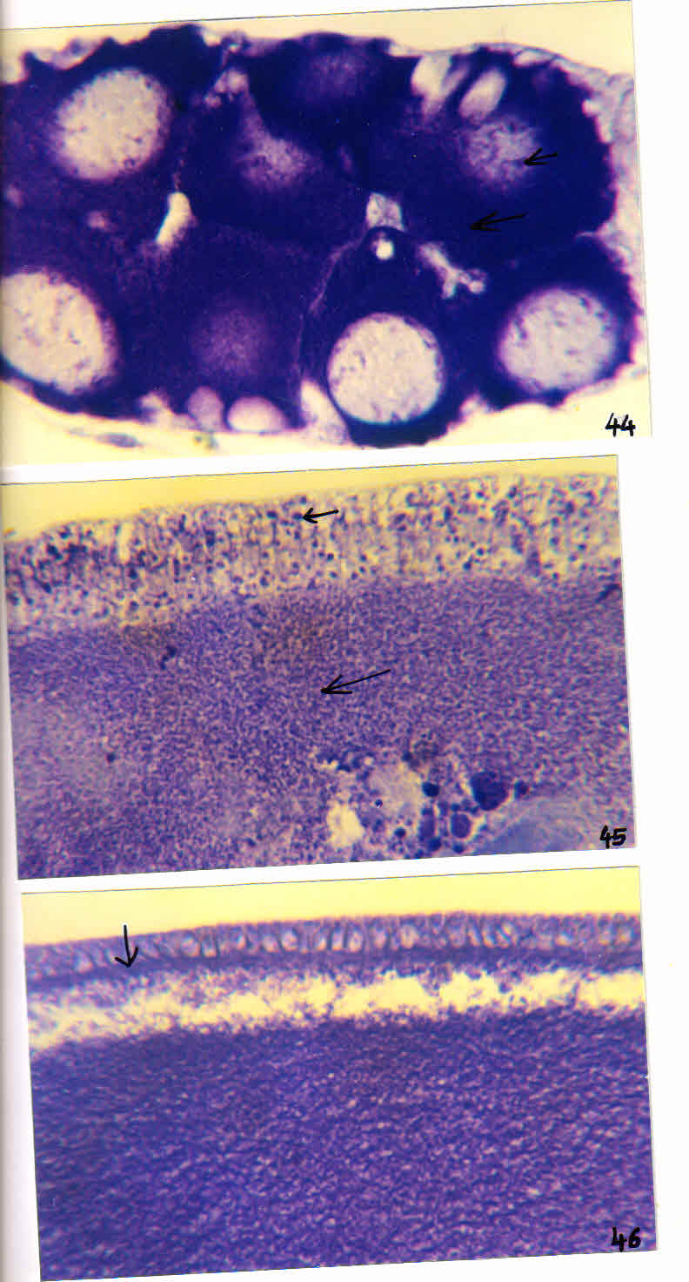
Fig.43 Vit. Ooc. FE showing DNA in nuclei Feulgen X 400( → - DNA )

EXPLANATION OF FIGURES

Fig. 44 RNA in trophocyte Toluidene blue X 400
Fig. 45 RNA in follicular epithelial cells and oocytes during early vit. Stage Toluidene blue X 160
Fig. 46 RNA in follicular epithelial cells and occyte during lateVietellogenic oocyte Toluidene blue X 400
( → - RNA )
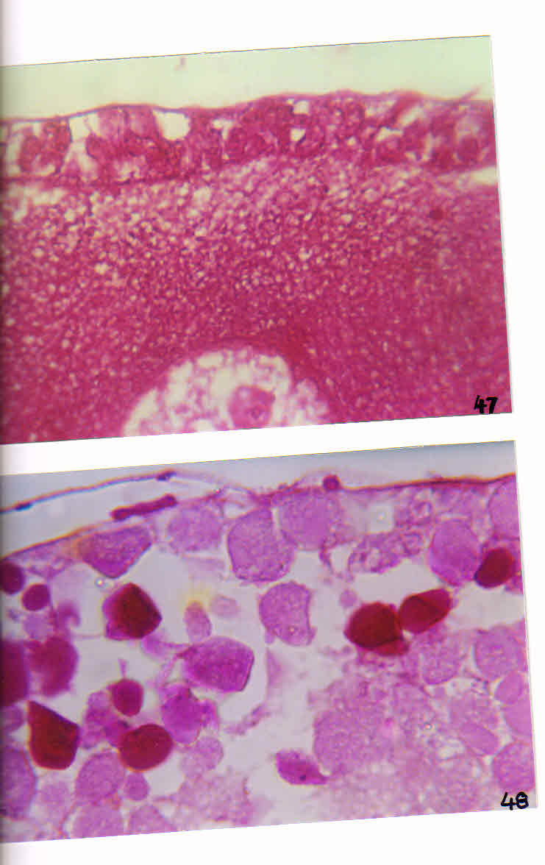
EXPLANATION OF FIGURES
Fig.47 Deposition o fcarbohydrate through FE in oocyte during earlyVitellogenic stage PAS (PAS ) X 400

Fig.48 Carbohydrate yolk bodies In oocyte during maturation stage PAS X 400( → - carbohydrate )
Protein
The fine Hg- BPB positibe granules are seen in follicle and nurseCells while totally absent in the oocyte in previtellogenic stage. The fineGranules in the peripheral ooplasm stain intensely with Hg-BPB in the terminalOocyte during early vitellogenic stage. Large number of yolk bodies stain.
Intensely with Hg- BPB in terminal oocyte during mid to maturation stages. TheChorion and vitelline membranes also react intensely with Hg- BPB. The follicularEpithelial cells show strong reaction with Hg-BPB during early to late vitellogenic.
Stage.

Lipid :
The yolk bodies of mid, late and matured oocytes stain intensely With Sudhan Black- B reaction. The follicular epithelium of mid and Late –vitellogenic oocytes also shows SBB positive reaction. The trophocytes are
Oftern SBB negative.

EXPLANATION OF FIGURES
Fig.49 Deposition of protein granules in peripheral ooplasm at early Vitellogenic stage Hg-BPB X 500
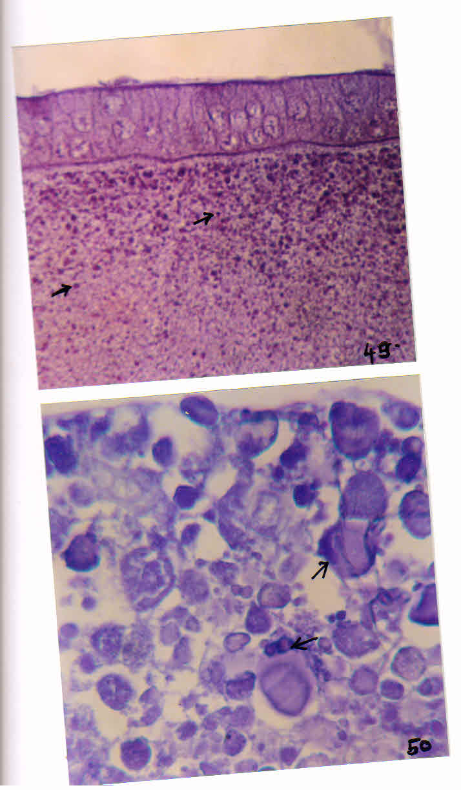
Fig. 50 Protein yolk bodies in matured oocyte Hg- BPB X 400( → - Protein)

EXPLANATION OF FIGURES
Fig. 51 Presence of lipid granules in FE and oocyte during late vitStage SBB X 400
Fig.52 Deposition of liquid yolk in matured oocyte (SBB) SBB X 400( → - Lipid)
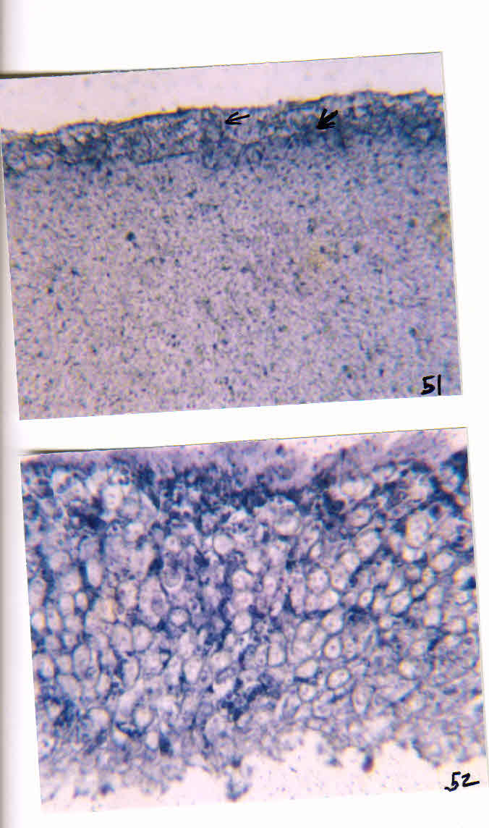
IV-DISCUSSSION
The histochemical studies on colleterial gland in Cybistertripunctatus Reveal internsely stained nuclei with Feulgen and Toluidine blue reactions while The Cytoplasmic content is Hg-BPB positive suggesting proteinaceous nature of The secretory material and thus resembling with that of Phlebotomuspernicionus And GesonulaPunctifrons. Koeppe et al., (1985) suggested a function to theSecretory material of colleterial glands in hardening of ootheca in Periplaneta Americana while Kaulenes (1992) emphasized its role in construction of the oothece in Schistocercagregaria. In Cybistertripunctatus moreover, the females oviposit on the stones in water and the eggs are covered with glue-like secretion of the colleterial gland in order to attach them on the substratum firmly, similar to that in various aquatic insects (Kaulenas, 1992).
REFERENCES
[1] KALLAPUR, V(1978) Effect of exercise on lipid transport in the beetles, CybisterConfuncus. Indian J Exp, Biol. 16(5), 608-610.
[2] KANOST, M.R., KAWOOYA, J.K.LAW, 1H., RYAN, RO, VAN HEUSDEN, M.C., AND ZIEGLER, R. (1990) Insect hemolymph proteins, Adv. Insect plysiol, 22.299-396
[3] KATO, K.(1968) Cytochemistry and fine structure of elimination chromatin in Dytiscidae. Exp. Cell Res, 52, 507.
[4] KAULENAS, M.S. (1992) Insect accessory reproductive structures and development, springer, Berlin.
[5] KHALIFA A., (1986) Oocyte development in the scavenger heetleDermestes maculatus Klug. (Dermestidae : Coleoptera) 8-1: () "002T pu
[6] KNIPLING, EF.(1959) Sterile male method of population control. Science. 130: 902-04.
[7] KOEPPE, J.K, JARNAGIN, FN, AND BENNET, LN.(1981) Changes in follicle cell morphology, ovarian protein synthesis and ovarian DNA synthesis during oocyte maturation in Leucophoramaderae J sect Pysiol. 27 (4): 281-292
[8] KOPPE, J.K., FUCHS, M., CHEN, T.T., HUNT, L., KOVALICK, G.E., BRIERS, T.(1985) The role of juvenile hormone in reproduction. In :Comprehensive Insect Physiology, Biochemistry and Pharmacology. 8 :165-203.

Table 2 Histochemistry of developing oocytes

Sr.No. | Histochemical Test | Substance | Developing oocyte
 |  |  |  | PV |  |  | EV |  | MV |  |  | LV |  |  |  | MO
 |  |  | FC | TC | OC | FC | TC | OC | FC | TC | OC
1 | Feulgen reaction (FR) | DNA | + | ++ | + | ++ | ++ | - | ++ | ++ | - | - | - | - | - | - | -
2 | FR after hydrolysis |  | - | - | - | - | - | - | - | - | - | - | - | - | - | - | -
3 | Toluidine Blue (TB) | RNA | + | ++ | ++ | ++ | + | ++ | ++ | + | ++ | ++ | - | - | - | - | -
4 | TB after Ribonuclease  Treatment | RAN | - | - | - | - | - | - | - | - | - | - | - | - | - | - | -
5 | Periodic Acid Schiffs (PAS) | Carbohydrate | - | - | - | - | - | - | ++ | - | ++ | - | - | ++ | - | - | ++
6 | PAS without PA |  | - | - | - | - | - | - | - | - | - | - | - | - | - | - | -
7 | PAS after acetylation |  | - | - | - | - | - | - | - | - | - | + | - | - | - | - | -
8 | Mercuty Bromophenol blue  (Hg- BPB ) | Protein | + | ++ | - | + | ++ | + | +++ | ++ | ++ | +++ | + | ++ | - | - | +++
9 | Hg- BPB after pepsin  Treatment |  | - | - | - | - | - | - | - | - | - | - | - | - | - | - | -
10 | Sudan Black B (SBB) | Lipid | - | - | - | - | - | - | + | - | + | ++ | - | ++ | - | + | +++
11 | SBB after pyridine treatment |  | - | - | - | - | - | -- | - | - | - | - | - | - | - | - | -

Abbr. : - Absent, + little, ++ moderate, +++intese,
Vitelagenic state – PV – Previt,
EV- Early vitellogenic, MV- mid vit, FC – Follicul cells, NC – nurse cells, OC - Occyte

