Pervious Concrete: Potential Advantages in Regions with High Precipitation

**Mohammadali Pishdadakhgari1**

*1 Department of Civil Engineering  
 Islamic Azad University, Semnan Branch, Semnan, Iran.*

***Abstract –*** *In regions with high precipitation, the accumulation of surface runoffs in public passages where the restriction of traffic load of vehicles and people would potentially cause lots of problems and the necessity of using pervious concrete becomes clear. The structure of this type of concretes is almost the same as the regular concretes; only due to its significant porosity, the surface runoffs can cross through the concrete body. In this forum, while describing the methods of making pervious concretes and their implementation and physical properties, some other advantages of using these concretes especially in regions which are receiving heavy load of rain are addressed; so that, given the performed investigations, in many cases, constructing roads with pervious concretes seems to be more cost effective than using the traditional methods such as asphalt or impervious pavements.*

***Keywords-*** *Aggregate, Constructing Material, Pavement, Pervious Concrete, Porosity, Rain Load, Surface Runoffs.*

**INTRODUCTION**

Today, with the advancement of the construction industry and the expansion of using concrete as one of the best building and bridge materials, a great variety has been generated in concrete production. Pervious concrete is among the interesting types of concrete which is gaining attraction due to their unique properties. As can be realized from the name of this concrete, its property and performance are preferable to direct water through its thickness or in other words, it has a permeable body. The ideas of using pervious concrete was developed since in some areas, rainfall load is significant, and it causes the accumulation of surface runoffs and since it is impossible for the water to cross the ground which covered by the impervious concrete or asphalt pavements. Although in some parts of the world such as the state of Florida in the U.S this concrete is in use successfully, unfortunately, in other part of the world the accumulation of the surface runoffs always creates many problems, this has not been addressed so far. In this forum, while identifying the pervious concretes, the potential advantages of using this concrete in application for high precipitation region are discussed.

|  |
| --- |
|  |

Figure 1: Pervious concrete sample in the passage of water.

**BODY OF KNOWLEDGE**

## Pervious Concrete Structure

In making the pervious concrete, like the other regular concretes, the granular materials, water, and cement are used. For example, in pervious concretes, the low water to cement ratio about 0.3 to 0.4 is used. Moreover, to provide porosity for permeability, only gravel is used as the granular material. This means that due to the absence of sand, the empty spaces among the gravels are not filled. Although in some cases, by adding a small amount of fine-grained sand, the compressive strength of the concrete is enhanced [1, 2].

Pervious concrete has a very low slump of about 2 cm and a very high porosity about 15 % to 30 %. This high porosity leads to the permeability of water in the concrete and in other words, drainage of water in the surface. The specific weight of the pervious concrete is less than the regular concretes. In many cases, 1600 to 2000 kg/m3 has been reported. This type of concretes has a compressive strength of 3.5 to 25 MPa depending on their mixing plan. The important point is that the pervious concretes are not usually made for providing a high compressive strength, but it can be used as a filling material is some part of the bridge structures [3]. However, having minimum compressive strength concrete is needed in some cases [4, 5].

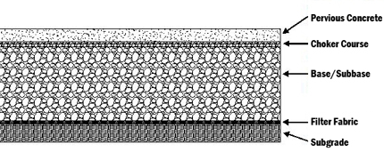

Figure 2: Typical pervious concrete pavement section.

## Implementation of Pervious Concretes

Like the other concretes, in making and implementing the pervious concretes, the following cases must be examined:

a) Mixing: To make concrete, first, the cement is mixed with the coarse-grained sand, then water is added to this mixture. Also in some cases, to provide more compressive strength, a little fine-grained material (sand) is added to the above mixture. Similar the regular concretes, the mixing operation can be performed by the concrete mixers.

b) Placement: after making the concrete, the transferring and discharging operations are similar to regular concretes. Since the pervious concretes have a small water to cement ratio, in a short time, the water of concrete evaporates. Thus, in warm weather conditions, its implementation speed is very important. Meanwhile, these concretes are often used on flat surfaces like roads, parking lots, etc. and they are not technically justified for being used in members such as beams and columns.

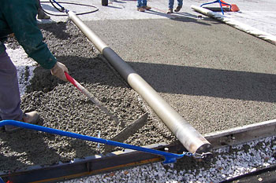

Figure 3: Casting pervious concrete in conventional methods.

c) Density: the surface of pervious concrete is thicker than the regular concretes. After concrete placement, the density operation is conducted by the vibrating steel roller (vibrating roller). The density operation of these concretes is like asphalt’s density.

d) Curing: like the other concretes, processing the pervious concrete is very important. In this filed, the concrete surface is often sprayed with water and then, it is covered by a plastic layer for seven days to maintain the moisture needed during the curing period.

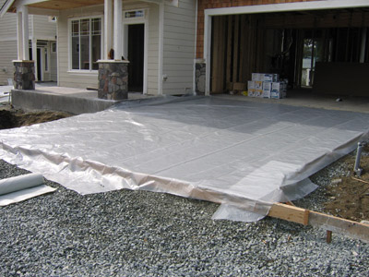

Figure 4: Concrete curing using plastic wrap.

Experiences in some countries show that the quality and performance of the pervious concretes depend on the familiarity level of the implementer with their work. For example, the success of implementing any pavement with the pervious concrete is for providing sufficient porosity for directing the surface runoffs instead of providing compressive strength.

## Benefits and Uses of Pervious Concretes

As usual, the pavement of urban spaces including sidewalks, parking lots, etc. are often performed by asphalts or other impervious surfaces such as pavement, mosaic, or regular concretes. Pervious concrete can be used in pedestrian walkway in Accelerated Bridge Construction technology [6]. Hence, when rain falls, the surface waters that cannot penetrate these surfaces are directed to unknown destinations through small drained channels. Of course, in most of these cases, the destinations of this water are rivers and lakes. Given the pollution of the mentioned surfaces in the urban spaces that are often impregnated with petroleum and chemical materials like oil due to the vehicular traffic, they will naturally pollute the rivers and lakes and this phenomenon will bring irreparable damages to the environmental cycle over time.

The pavements constructed with pervious concretes are from the simple ways to resolve this problem. The experiences in this field indicate that these concretes can pass 10 to 50 liters of water per minute for each square meter depending on their porosity rate. This capability can easily prevent the accumulation of the surface waters on passages, parking lots, etc. This problem is challenging, especially in the region with heavy rainfall; because in addition to the environmental problems caused by transferring pollutions to the new environments, the surface runoffs make the appearance of the city’s scenes disharmonious. Application of this pervious concretes has helped to mitigate most of these problems. For example, pervious concrete could be use in low-water bridges in rural areas to help to runoff the water over the deck and decrease the weight of the deck [7]. In addition to the above-mentioned cases, other benefits can be mentioned for using the pervious concretes. One of these cases is the bright color of the concrete surfaces compared to the dark color of asphalt that requires less energy for lightening the traffic roads at night in addition to providing more security for pedestrians and drivers.

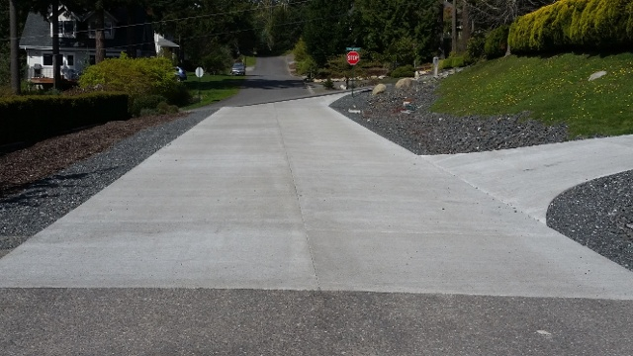

Figure 5: Using pervious concrete in park curb and parking lots.

Furthermore, economic estimates show that the implementation of pervious concretes in pavements consumes less cost compared to the regular pavements regarding the costs of substructure, asphalt, and plotting for directing the runoffs, etc. so that in implementation of the pervious concrete pavements, there is no need of any specific substructure like the asphalt paths and these concretes can be also implemented on the permeable soil. Due to high porosity, these concretes are also resistant to frequent freezing and watering of water; hence, they can be used in cold areas, too.

Other potential application of this concrete would in the new modern timber construction and framed steel and concrete buildings. Among this construction type is Cross-laminated timber building (CLT). This panels are composed of several layers on timber that are glued using structural adhesives. These panels can be used for floor or wall application. In the floor panel they are usually used with concrete topping. Furthermore, in steel and concrete framed structure, reduction in seismic demands of the structures [8, 9, 10] depends mostly on reduction weight of the non-structural parts of the buildings such as floor, stairs and internal and external wall finishing stage. Pervious concrete due to its lights weight and suitable strength can be an appropriate option to reach that goal [11, 12, 13, 16].

It worth noting that the pervious concrete pavements are not significantly usable in the routes with a high traffic or the routes with the traffic of heavy and semi-heavy vehicles; because they are easily eroded and destructed due to the heavy loads [13, 14, 15].

**Conclusion**

Due to the desirable properties of the pervious concretes, using it in areas with a significant rainfall rate can resolve many environmental problems and urban abnormalities caused by the accumulation of the surface runoffs. Thus, it is desirable that many relevant organizations pay a significant attention to using this type of concretes in the urban spaces such as sidewalks, parking lots, and the routes of light vehicles through employing the current experiences all over the world. Moreover, academic and laboratory studies on using the indigenous materials can also be helpful in this field.

**REFERENCES**

1. *Family, H. (1994); Concrete-ology (Concrete Properties), Jahad Daneshgahi Publications of Iran University of Science and Technology, Tehran*
2. *E.. Eshtiaqi & Azam Manesh, Pervious Concretes, Journal of Iranian Society of Concrete, No. 25, Spring 2007*
3. *R Taghinezhad, JH Gull, H Pham, LD Olson, A Azizinamini,2017,Vibration Monitoring During the Deconstruction of a Post-tensioned Segmental Bridge: Case Study,*
4. *Transportation Research Board 96th Annual Meeting Transportation Research Board.*
5. *Eng. Navarchi, Sponge Concrete, www.irancivilcenter.com. Accessed in June 2017.*
6. *Oskouei, V.A. and Mahdavifar, V., 2013. Modeling of two-cell concrete cores for investigation of reliabality of equivalent column method.*
7. *A Mohammadi, JH Gull, R Taghinezhad, A Azizinamin, 2014,Assessment and Evaluation of Timber Piles Used in Nebraska for Retrofit and Rating.*
8. *R Taghinezhadbilondy,2016, Extending Use of Simple for Dead Load and Continuous for Live Load (SDCL) Steel Bridge System to Seismic Areas*
9. *Soltangharaei, V., Razi, M. and Gerami, M., 2016. Comparative Evaluation of Behavior Factor of SMRF Structures for Near and Far Fault Ground Motions. Periodica Polytechnica. Civil Engineering, 60(1), p.75.*
10. *Soltangharaei, V., Razi, M. and Vahdani, R., 2016. Seismic fragility of lateral force resisting systems under near and far-fault ground motions. International Journal of Structural Engineering, 7(3), pp.291-303.*
11. *Mahdi, T. and Gharaie, V.S., 2011. Plan irregular RC frames: comparison of pushover with nonlinear dynamic analysis. Asian J Civil Eng Build Housing, 12(6), pp.679-690.*
12. *Mahdavifar, V., 2017. Cyclic performance of connections used in hybrid cross-laminated timber (Doctoral dissertation).*
13. *Mahdavifar, V., Barbosa, A., Sinha, A., Muszynski, L. and Gupta, R., 2017. Hysteretic behaviour of metal connectors for hybrid (high-and low-grade mixed species) cross laminated timber, WCTE 2016 World Conference on Timber Engineering, August 22-25, 2016, Vienna, Austria*
14. *Hamedi, A., Mahdavifar, V., Sajjadi, S. and Fesharaki, M., 2017, Sensitivity Analysis of Earthquake Acceleration and Drainage Efficiency on the Stability of Weighted Concrete Dams.*
15. *Hamedi, A., Mansoori, A., Shamsai, A., & Amirahmadian, S. 2014. The Effect of End Sill and Stepped Slope on Stepped Spillway Energy Dissipation. Journal of Water Sciences Research, 6 :1-15.*
16. *Azizhemmatlou, Y., Hamedi, A., Farbehi, H., Iranyar, D. The Optimum water to cement ratio for designing impermeable water storage tanks. in 1st International Conference on Non Osmosis Concrete (1st ICNOC)-Water Storage Tanks. Guilan, Iran. 2011.*
17. *Mahdavifar, V., Barbosa, A.R. and Sinha, A., Nonlinear Layered Modelling Approach for Cross Laminated Timber Panels Subjected to Out-of-Plane Loading.*

**Mohammadali Pishdadakhgari** is an instructor in the Department of civil engineering at the Semnan Islamic Azad University. He has been involved in a variety of structural analysis and design of steel and concrete structures including commercial, high-rise, education and residential buildings. He has expertise in seismic design, structural dynamics, concrete technology, finite element analysis.