Low-Permeability Concrete: Water-to-Cement Ratio Optimization for Designing Drinking Water Reservoirs
Majid Dashtibadfarid¹; Ali Afrasiabi²
¹ Project Management Department,
Tavanab Engineering Consulting, Tehran, Iran
majid.dashtibadfaridi@gmail.com
² Research and Development Department
Tavanab Engineering Consulting, Tehran, Iran

Abstract – One of the important debates for designing concrete reservoirs of drinking water is making a concrete with low permeability that has attracted the attention of researchers to determine materials and their ratio to achieve this goal. The ratio of water/cement due to its impact on strength, durability and permeability of concrete is one of the key design discussions. In this study, by analyzing the experimental results provided by other researchers in terms of durability, strength and permeability in concrete, optimum water/cement ratio is presented to design concrete reservoirs of drinking water. The water/cement ratio due to its impact on strength, durability and permeability of concrete is one of the key design discussions. The fundamental question is what should be the best water/cement ratio to design low permeability concrete reservoirs for drinking water.
Keywords- Concrete Reservoirs for Drinking Water, Permeability, Water/cement Ratio, Concrete Strength, Concrete Durability.
INTRODUCTION
For designing concrete reservoirs for drinking water, maintaining the proper strength of concrete should be concerned in addition to the durability and low permeability of concrete. In other words, concrete should be designed that has both low permeability and good strength. In the fields of strength and permeability, many experiments have been carried out by various researchers on concrete, and it has been determined that each depends on different parameters such as water/cement ratio, cement to aggregate ratio, grain size, surface texture, shape, strength and hardness of aggregate particles as well as the maximum aggregate size and permeability of aggregates. In this study, the water-to-cement ratio is considered as a factor that has the greatest impact on the strength and permeability of a fully compressed concrete.
LITERATURE REVIEW

Concrete Strength and Water-to -Cement Ratio
When ordinary aggregates up to a maximum of 40 mm are used, it can be argued that factors such as the ratio of cement to fine-grained aggregates, surface texture, shape, strength, the hardness of aggregate particles and maximum aggregate size are less important than the water/cement ratio [16]. But according to Bloem and walker, the strength of concrete depends on the strength of the mortar, the adhesion of the mortar, and the strength of coarser aggregates. [2]
Some Equations have been presented for the strength of concrete and its relation to the water/cement ratio, some of them are as follows: Duff Abroms (1919) stated that there is an inverse relationship between strength and the water/cement ratio:
$f_{c}=\frac{k_{1}}{k_{2}\frac{w}{c}}$ (1)
In this Equation, w/c is water/cement ratio and k1 and k2 are empirical constants. [9]
Rene Feret (1896) also considered concrete strength to be related to water and cement ratio, and introduced Feret's Law as follows:
$f_{c}=k{\left(\frac{c}{c+w+a}\right)}^{2}$ (2)
In this Equation; fc is the strength of the concrete, c is the volume of the cement, w is the volume of water and a is the volume of air and k is constant. [9]

Concrete Permeability and Water-to -Cement Ratio
There have been several researches on the permeability of concrete and various Equations have been presented including the Darcy law for determining the penetration coefficient, as well as the Equation for converting penetration depth to permeability coefficient provided by Valenta.
The Darcy Act for porous media and capillary flow in saturated concrete is as follows:
$\frac{dq}{dt}\frac{1}{A}=\frac{k^{'}ρg}{μ}\frac{Δh}{L}$ (3)
In this Equation: dq/dt is water flow rate, A is concrete cross-sectional area, L is thickness, ρ is fluid density (water, μ is fluid dynamic viscosity coefficient, Δh is hydraulic pressure drop from a sample and g is gravity acceleration based on the SI metric system. Also, k' is the intrinsic permeability of material in square meters and independent of the type of fluid used [16] because the water is always used for designing reservoirs for drinking water:
$k=\frac{k^{'}ρg}{μ}$ (4)
In this case, k is the permeability coefficient in m/s. However, due to the presence of the viscosity parameter in the above Equation, which changes with temperature, it is assumed that k depends on the temperature of the room, and finally the following Equation is obtained as the flow equation in a slow and steady state:
$\frac{dq}{dt}\frac{1}{A}=k\frac{Δh}{L}$ (5)
The permeability (k) is easily obtained from this Equation [16]
Valenta also has presented an Equation below to convert the penetration depth to the permeability coefficient in good quality concrete with no flow from this type of concrete, while the water penetrates the concrete to a certain depth: [10]
$k=\frac{e^{2}v}{2ht}$ (6)
In this Equation e is depth of penetration in meters, h is a height of water in meters, tis a time of exposure under pressure in seconds, and v is part of the volume of concrete occupied by pores.
The depth of penetration of the water after blasting the sample and viewing its surface is such that the wet concrete is darker after a given time. If e is less than 50 mm, the concrete is impenetrable. [5] V also shows apart pores in concrete such as air bubbles that are filled with water pressure and can be calculated from the amount of increase in concrete mass during the test. Of course, given that only the pore where water penetrates the area is filled with water. These pores should be considered in calculations, and most often this value is between 0.02 and 0.06. [6] The height of the water with pressure is also in the range of 0.1 to 0.7 MPa. [5]
In the case of permeability tests, it can be stated that they have not yet been standardized [1] and the numbers obtained from different standards vary greatly and are not comparable. These standards include Civil United States Institute with the method of 4913-92 [15], in which the water pressure equivalent to 2.76 MPa equal to 282 meters height of liquid is used, and can Canadian and German methods 1048-1991 DIN [3] can be noted, in which the water pressure to cross the sample is very large and can change the natural state of the concrete.
STRENGTH AND PERMEABILITY TESTS OF CONCRETE
As shown in Figure (1), the strength curve to the water/cement ratio is approximately one hyperbolic curve. The use of the ratio of cement to water, due to the hyperbolic property displayed with y=k/x, gives a linear relationship when k is equal to 1.
Which is 1.2 to 2.5 in the range of cement, and this relationship was first proposed by Professor W. [16] and then approved by Alexander and Ivanusec [16] as well as Kakizaki et al. [8]. The researchers believe the use of this linear relationship, especially when interpolation is needed is much simpler than using the water-to-cement curve. In Figure 2, data are shown linearly based on water/cement ratio.
In Figure. 1, it can be stated that in the part of the diagram where the water/cement ratio is low, and the compaction is not completely possible, the curve does not follow the similar trend to the rest of figure. By using better compaction tools, the curve gets closer to the main path. But in general, the Figure shows that the lower the water/cement ratio, the strength of concrete increases.
Of course, you should also consider specific cases. For example, in mixtures with a very low water/cement ratio and a high amount of cement more than 530 kg/m3 especially when large aggregates are used, the strength usually begins to decrease; therefore, less water/cement ratio does not improve the strength. [9]
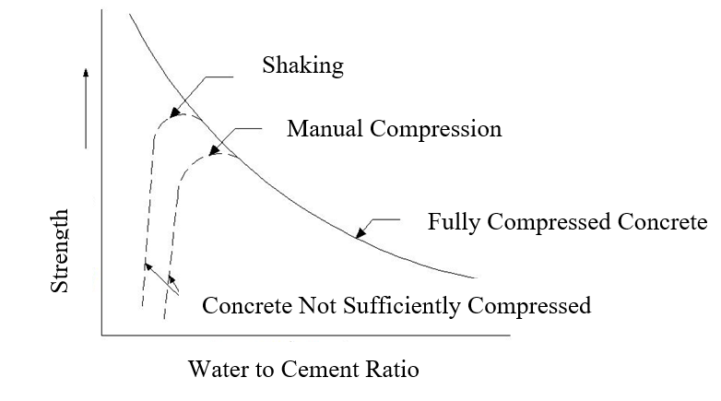
Figure 1 - The Relationship Between the Strength and Water/cement Ratio [16]
Figure. 2, which is drawn from the cement to water ratio in strength, shows two lines with different slopes. The first line continues to the water/cement ratio of 2.6. (Which is equal to water/cement ratio of 0.38) In this line, the maximum hydration is usually less 100 %. However, in the second line, when water/cement ratio is increased to 2.6, usually the maximum hydration reaches 100 %. [7] And the diagram in general shows that the higher water/cement ratio, the strength of the concrete also increases. For example, in bridge structures higher compressive strength can lead to more economical elements, such as fewer beam and pier sizes and therefore lower cost in materials and finally increases the service life of the high bridges [23, 24].
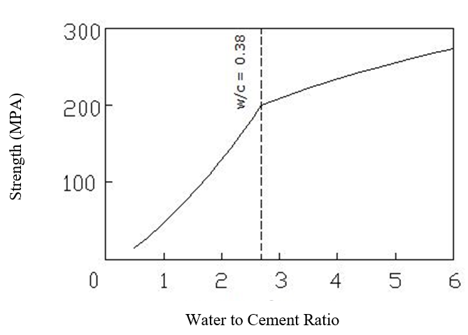
Figure 2 - The Relationship Between Strength of Heat-Curable Dough and Water/cement Ratio with Maximum Hydration Assumption [16]
Regarding the diagrams and data obtained by other researchers, the most suitable water/cement ratio for concrete strength is less than 0.45. However, the use of water/cement slightly higher and slightly less than 0.38 is more suitable and common for strength. [16]
The permeability of the concrete depends on several factors, including the distribution, shape, size, and twist of the path, the bonding of the pores, and pre-mature micro-cracks during early hydration. The later was investigated by Assi et al, for cement paste using acoustic emission [17] Despite the high number of pores due to the very fine texture of hardened cement, its permeability is very low, while in aggregates, with a smaller number of pores, permeability is more due to larger pores. [14] As the hydration progresses, the permeability is reduced, so that the cement dough has a permeability by 20 to 100 times that of the gel [14], and the gel gradually occupies some of the initial spaces filled with water. As the hydration progresses, the volume of the gel increases and does not nearly equal to ½ times the amount of non-hydrated cement. In the case of the effective parameter for permeability, it can be stated that size and concentration of the initial grains of the cement are effective in the fresh dough. But in the maturated dough, shape, size, the concentration of the gel and sinusoidal or continuous capillary tubes are effective. [12]
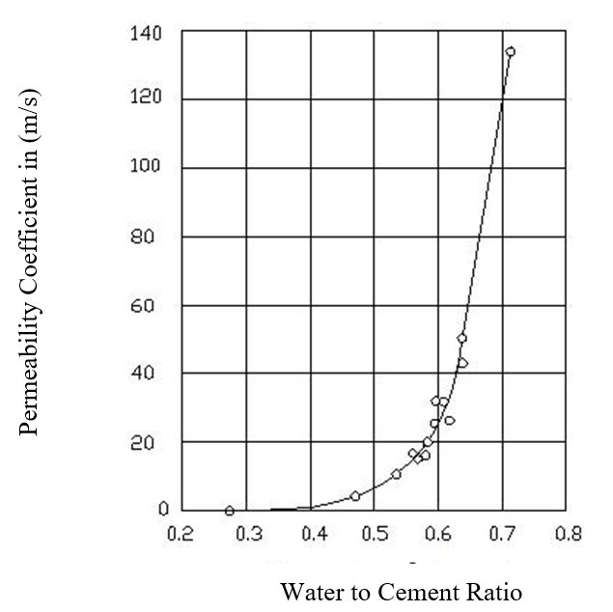
Figure 3 - The Relationship Between Permeability and Water/cement Ratio for Cement Dough with Hydration of 93 % [13]
Powers et al. (1954), in a test on concrete with a water/cement ratio of 0.7, showed that the longer the concrete's dough lasted, its permeability decreased, which could be due to increased gel volume and closure of capillary tubes. [13] Bonzel (1966) also stated that the lower the water/cement ratio, the lower the permeability would occur more quickly, for example, if the specific permeability for the water/cement ratio was 0.6 is 28 days and for the water/cement ratio of 0.45 is 7 days; i.e. 0.75 times faster [5]. If the hydration rate is equal in the different dough, the dough with less water to ratio has less permeability. [13]
As shown in the diagram above, this curve has two different parts: the first part indicates water/cement ratio to 0.6 and the next part water/cement ratio above 0.6. In the first part, the slope of the curve is mild, but in the second part, the slope is steep, so that by decreasing the water/cement ratio from 0.7 to 0.3, the permeability coefficient decreases by 3 times.
Whiting (1988) stated that reducing the water/cement ratio from 0.75 to 0.26 reduces the permeability coefficient by 4 times and reducing the water/cement ratio from 0.75 to 0.45 reduces the permeability coefficient by 2 times. He introduced the permeability coefficient of ${10}^{10}m/s$ for a water/cement ratio of 0.75 as a highly permeable concrete, he also stated that for water/cement ratio of 45 % indicates a permeability coefficient of 10-11 to 10-12and showed a low Permeability concrete [2]
In the above curve, it is clear that in the water/cement ratio less than 0.4, the capillary tubes are discontinued, but with increasing this ratio, this incidence is less, and the permeability is significantly increased. Other factors also affect the level of permeability, including the increasing the curing time of wet concrete for water/cement ratio; if this time is extended from 1 day to 7 days, permeability decreases by 5 times. [2] Another factor that is effective in this field is the type of cement and the type of aggregate. Powers' research (1954) shows that the constant water/cement ratio, paste or fine-grained cement produces a much lower permeability than paste or coarse cement [13].
Also, the use of low permeability aggregates is for making a surface with a low permeability against the water and force the water to bypass the aggregates in a longer path that has a good effect on reducing the permeability. But it should also be reminded that hardened cement paste has the greatest impact on the permeability of concrete [14]. Regarding the discussions mentioned earlier, it can be stated that water/cement ratio in the range of less than 0.4 is a reasonable permeability.
The permeability of concrete is of great significant for other construction types. For instance, in timber construction, recently cross-laminated timber panels have gained attention as timber panel product that is suitable for floor application [18,19]. In this product, a concrete topping is used to improve the performance of timber floors and they are transferring the load through out-of-plane load carrying [18, 19] connected to the rest of construction using metal connections [20, 21]. Low-Permeability Concrete can be used for repair of in service timber pile bridge decks and precast components once it increases durability of concrete decks [28, 29, 30]. In concrete and steel structures, which are exposed to high humidity and corrosive condition, using low-permeable concrete in frame elements and floors leads to more durability of structure and retains integrity of concrete diaphragm and frame elements against lateral load such as earthquake [22, 23, 24]. On the other hand, the permeability of concrete is an important factor in design of concrete dams. The water in the dam reservoir tend to cross through the dam body as well as the foundation of the dam through the soil underneath [25, 26, 27]. In these cases, and many other cases of application of concrete, having a good design mix with appropriate water-to-cement ration is of great reliance.
CONCLUSION
According to the results presented for the strength and permeability of concrete, water/cement ratio in the range of 0.35 to 0.4 is suitable for the design of concrete reservoirs of drinking water. However, if full hydration is considered, the best water/cement ratio is from 0.38 to 0.4. As the water/cement ratio increases to more than 0.4, the permeability rate increases sharply and by decreasing the water/cement ratio less than 0.35 %, hydration percentage decreases.
REFERENCES
- D. Ludirdja, R.L. Berger and J.F. Young, Simple method for measuring water permeability of concrete, ACI Materials journal ,86, No.5, pp. 433-9 (1989)
- D. Whiting, Permeability of selected concretes, in Permeability of concrete, ACI SP-108, pp. 195-221 (Detroit, Michigan, 1988).
- DIN 1048, Testing of hardened concrete specimens prepared in moulds, Deutsche Normen, Part 5 (1991)
- Discussion of paper by H.J. Gilkey: Water/cement ratio versus strength - another look, J.Amer.Concr.Inst., Part 2,58, pp.1851-78(Dec1961).
- J. Bonzel,Der Einfluss des Zements, des W/Z Wertes, des alters und der Lagerung auf die Wasserundurchlassigkeit des Betons, Beton, no.9,pp.379-83; No 10, pp.417-21(1966)
- J. Vuorinen, Applications of diffusion theory to permeability tests on concrete Part1: Depth of water penetration into concrete and coefficient of permeability, Mag.Concr.Res.,37, No.132, pp. 145-52 (1985)
- L.F. Nielsen, 1993, Strength development in hardened cement paste: examination of some empirical equations, Materials and Structures ,26, No.159, pp.255-60
- M. Kakizaki, H.Edahiro, T.Tochigi and T.Niki, Effect of Mixing Method on Mechanical Properties and Pore Structure of Ultra High-Strength Concrete, Katri
- National Sand and Gravel Association, Joint Tech. Information Letter No.155 (Washington DC,29 April 1959)
- O. Valenta , Kinetics of water penetration into concrete as an important factor of its deterioration and of reinforcement corrosion , RILEM International Symposium on the Durability of Concrete , Prague, Part1, pp 177-93 (1969)
- Report No.90, 19 pp. (Kajima Corporation, Tokyo, 1992) (and also in ACI SP-132) (Detroit, Michigan, 1992).
- T.C Powers, L. E Copeland and H.M Mann, Capillary continuity or discontinuity in cement pastes, J.Portl.Cem. Assoc. Research and Development Labortories, 1, No.2, pp.38-48 (may 1959).
- T.C Powers, L.E Copeland, J.C. Hayes and H.M. Mann, Permeability of Portland cement paste, J.Amer. Concr. Inst., 51, pp.285-98(Nov.1954).
- T.C Powers, Structure and physical properties of hardened Portland cement paste, J.Amer. Ceramic Soc., 41, pp. 1-6 (jan.1958).
- U. S Beureau of Reclamation, 4913-92, Procedure for water permeability of concrete, Concrete Manual, Part 2, 9th Ed, pp. 714-25 (Denver, Colorado,1992)
- Famili - H. (2008). The book of "Concrete Properties" by Abourihan Beyroni, First Edition (1010 pages) -16
- Assi, L., Soltangharaei, V., Anay, R., Ziehl, P. and Matta, F., 2017. Unsupervised and supervised pattern recognition of acoustic emission signals during early hydration of Portland cement paste. Cement and Concrete Research.
- Mahdavifar, V., 2017. Cyclic performance of connections used in hybrid cross-laminated timber (Doctoral dissertation).
- Mahdavifar, V., Barbosa, A.R. and Sinha, A., Nonlinear Layered Modelling Approach for Cross Laminated Timber Panels Subjected to Out-Of-Plane Loading.
- Mahdavifar, V., Barbosa, A., Sinha, A., Muszynski, L. and Gupta, R., 2017. Hysteretic behaviour of metal connectors for hybrid (high-and low-grade mixed species) cross laminated timber.
- Oskouei, V.A. and Mahdavifar, V., 2013. Modeling of two-cell concrete cores for investigation of reliabality of equivalent column method.
- Soltangharaei, V., Razi, M. and Gerami, M., 2015. Behaviour factor of buckling restrained braced structures for near and far fault ground motions. International Journal of Structural Engineering, 6(2), pp.158-171.
- Ramin Taghinezhadbilondy, 2016, Extending Use of Simple for Dead Load and Continuous for Live Load (SDCL) Steel Bridge System to Seismic Areas.
- Ramin Taghinezhad, Jawad H Gull, Huy Pham, Larry D Olson, Atorod Azizinamini, 2017, Vibration Monitoring During the Deconstruction of a Post-tensioned Segmental Bridge: Case Study
- Soltangharaei, V., Razi, M. and Gerami, M., 2016. Comparative Evaluation of Behavior Factor of SMRF Structures for Near and Far Fault Ground Motions. Periodica Polytechnica. Civil Engineering, 60(1), p.75.
- Mahdi, T. and Gharaie, V.S., 2011. Plan irregular RC frames: comparison of pushover with nonlinear dynamic analysis. Asian J Civil Eng Build Housing, 12(6), pp.679-690.
- Hamedi, A., Mahdavifar, V., Sajjadi, S. and Fesharaki, M., 2017, Sensitivity Analysis of Earthquake Acceleration and Drainage Efficiency on the Stability of Weighted Concrete Dams.
- Jawad H Gull, Alireza Mohammadi, Ramin Taghinezhad, Atorod Azizinamini,2015, Experimental Evaluation of Repair Options for Timber Piles, Transportation Research Record: Journal of the Transportation Research Board
- Alireza Mohammadi, Jawad H Gull, Ramin Taghinezhad, Atorod Azizinamini,2014, Assessment and Evaluation of Timber Piles Used in Nebraska for Retrofit and Rating
- Atorod Azizinamini, Aaron Yakel, Ardalan Sherafati, Ramin Taghinezhad, Jawad H Gull,2016, Flexible Pile Head in Jointless Bridges: Design Provisions for H-Piles in Cohesive Soils, Journal of Bridge Engineering
- Hamedi, A., Mansoori, A., Shamsai, A., & Amirahmadian, S. 2014. The Effect of End Sill and Stepped Slope on Stepped Spillway Energy Dissipation. Journal of Water Sciences Research, 6 :1-15.
- Azizhemmatlou, Y., Hamedi, A., Farbehi, H., Iranyar, D., 2011, The Optimum water to cement ratio for designing impermeable water storage tanks. in 1st International Conference on Non Osmosis Concrete (1st ICNOC)-Water Storage Tanks. Guilan, Iran.

Mohammadali Pishdadakhgari is a senior enginerr in the Project Management Department at the Tavanab Engineering Consulting, Tehran, Iran. He has been involved in a variety of analysis, design and constructions in numerou projects including commercial, high-rise, educational, and residential buildings. He has expertise in managing huge projects with especial experites in finding innovtove slution using new materials.

Hamed Aliabadi is a senior engineer in the Research and Development Department at the Tavanab Engineering Consulting, Tehran, Iran. The main goal of this department is to find innovative solutions for the challenges the company is facing in the ongoing and future projects. Recently the company started to expand its vision for using new construction solutions such as using innovative concrete and timber materials.

