Drift Avoidance in Photovoltaic System with Modified Perturb & Observe MPPT Algorithm

Amit Bhuyar¹, Ujwala V Dongare ²
Electrical Engineering Department
Government College of Engineering, Amravati, Maharashtra, India 444601
^{amitbhuyar.25@gmail.com1}
^{ujwala.0610@gmail.com2}

Abstract: Efficiency of PV system is depending on maximum power point tracking(MPPT). It will help to extract maximum power from PV system. Perturb and Observe (P&O) maximum power point tracking algorithm is adopted everywhere, due to its simplicity and economic point of view. But in case of rapid change in insolation(G) it suffers from drift in tracking maximum power point (MPP). It is the main demerit of the P&O MPPT algorithm. This may happen due to confusion of whether power get increases due to perturbation or change in insolation(G). The drift effect is severe in case of a rapid increases in irradiations. This technique propose in this paper is lead to avoid drift in tracking maximum power point (MPP). SEPIC converter are proposed with direct duty ratio control technique for free from drift in P&O MPPT algorithm. MATLAB/Simulation modeling and analysis of a voltage and power of PV system under rapid change in atmospheric condition with conventional P&O algorithm. Study to drift phenomenon. The comparison between conventional P&O and Modified P&O shown in simulation and experimental results showing changes in duty cycle that the proposed algorithm track maximum power in change in insolation (G).
Keywords Photovoltaic (PV), maximum power point tracking (MPPT), perturb and observe (P&O), drift phenomena
I. INTRODUCTION
Due to increase in level of greenhouse emission gas and climb in fuel prices are the main reason behind efforts to utilize various uses of renewable sources of energy. Among them electrical energy from photovoltaic (PV) cells is widely used as a natural energy source that is more useful, since it is free, abundant, clean, and distributed over the Earth. The main difficulty of solar energy is the initial high capital cost of PV modules. The disadvantage of solar energy production is that the power generation is not constant throughout the day, it changes with weather conditions. The efficiency of solar energy conversion to electrical energy is very low. This means that a fairly vast amount of surface area is required to produce high power. Therefore, maximum power point tracking (MPPT) is an essential part of the photovoltaic (PV) system to ensure that the power converters operate at the maximum power point (MPP) of the solar array. Until now a large number of MPPT techniques have been developed to increase the efficiency of the PV system. MPPT algorithms such as fractional open circuit voltage [3], fractional short circuit current [3], Hill-climbing [4], perturb and observe (P&O) [3]– [4], incremental conductance (Inc. Cond) [3], incremental resistance (INR) [4], ripple correlation control (RCC) [4], fuzzy logic [9], neural network [10], particle swarm optimization (PSO) [11], sliding mode [12], techniques are some of the MPPT techniques. Overview of various MPPT techniques are discussed in [13].while generating electric energy from Photovoltaic system(PV) are: the efficiency of electric power generation is very low, particularly under low radiation , and the other disadvantages the amount of electric power generated by solar arrays is always fluctuating with weather conditions,(i.e., irradiance and temperature).It is be observed that the output power characteristics of the PV system is function of irradiance and temperature. which is nonlinear and is critically prejudiced by solar irradiation and temperature. Thus, to overcome this problem, several methods for extracting the maximum power has been proposed. The P&O MPPT algorithm is widely used, due to its easiness of implementation. It is based on: if the operating voltage of the PV array is perturbed in a given direction and the power drawn from the PV array increases, this means that the operating point has moved toward the MPP and, hence, the operating voltage must be additional perturbed in the same direction. Else, the power drawn from the PV array decreases, the operating point has moved away from the MPP and, thus, the direction of the operating voltage perturbation must be reversed. Although P&O has remarkable advantages, the sudden change in atmospheric conditions causes this P&O algorithm [31]- [33]to drift away from Maximum power point. This paper presents a clear analysis of drift. Drift in system is mainly due to change in insolation(G), also it effects on operating on P-V curve. The drift phenomena in case of adaptive P&O technique are also incorporated in this paper. The solution to the drift in the name of full curve evaluation is presented in by evaluating the entire trend in P − V curve but it is not possible to evaluate entire trend in P − V curve in case of a rapid change in insolation as the operating point moves into the new point on the corresponding insolation curve for each insolation change. This paper presents an accurate and simple solution to this drift problem by evaluating an another parameter, i.e., change in current (dI) by modifying the conventional P&O MPPT algorithm
II. MODELING OF SOLAR PANEL

Solar energy is directly converted to Electrical energy at the light incident on PV cell [1]. PV cell is nothing but a semiconductor diode. A group of large amount of PV cell to form the PV module, which further interconnection in series-parallel then PV array obtained. Fig.1 is the equivalent circuit of PV cell, Where photocurrent of the cell ($Iph$) act as current source, R_{sh} and R_{s} are the shunt & series resistance of the cell. Where the value of the series resistance is too small & shunt resistance is too large.
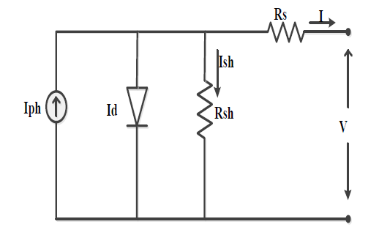
Fig. 1-Equivalent circuit of PV cell
Mathematically equations of PV panel as given as [2]
Output current of PV module (I):
$I=Np*Iph-Np*I0-Ish$ (1)
Photo current ($Iph$):
$Iph=\left[Isc+KI\left(T-298\right)\right]G/1000$ (2)
Thermal voltage is $Vt$:
($Vt=$Ns*K*α*T/q)

Module saturated current (Io):
$IO=\frac{ISC+KI∆T}{{[e}^{(\frac{Vd}{Vt})}-1]}$ (3)
Reverse saturation current ($Irs$):

$Irs=\frac{Isc}{[e^{\left(\frac{Vd}{Vt}\right)}-1]}$ (4)
Where,
I= Current (A)
V=Voltage(V)
Isc=Short circuit current(A)
Np=Number of parallel cell
Ns=Number of series cell
G=Insolation(Wb/m^2)
K= Boltzmann’s constant (1.385*10^ (-23)) (J/K)
q= Electron charge (1.6*10^ (-19))
Ish=Current through shunt Resistance(A)
Voc=Open circuit voltage(V)
∆T=Change in temperature(K)
Α=Identity factor
KI=short circuit current Temperature coefficient

III. SEPIC CONVERTER
To interface between load and Photovoltaic(PV) System DC-DC converter is use. Here the single ended primary inductance converter (SEPIC) [13] is used. It acts as Buck-Boost, but it does not change the polarity. V0 is the output voltage, Vs is an of the converter input voltage. L1 & L2 are inductor (H), C1 & C2 are capacitor (F), Load act as resistance (R) in ohm. As given in fig.2.
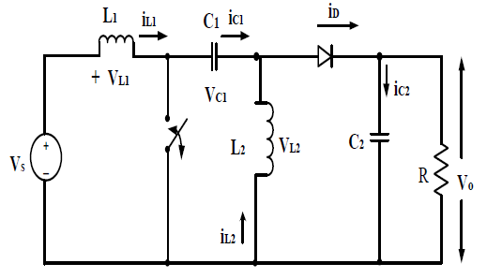
Fig. 2-Equivalent circuit of SEPIC converter
The output voltage is
$Vo=Vs(\frac{D}{1-D})$ (5)
D is the duty ratio of switch
$D=\frac{Vo}{Vs+Vo}$ (6)

IV. CONVENTIONAL PERTURB AND OBSERVE
(P&O) METHOD

The most widely used in MPPT is P&O Algorithms because of its simple structure and it requires only few parameters [6]. The flow chart of P&O method is given in Fig.3. It perturbs the PV array’s terminal voltage periodically, and then it compares the PV output power with that of the previous cycle of perturbation. When PV power and PV voltage increase at the same time and vice versa, a perturbation step size, ΔD will be added to the duty cycle, D [6] to generate the next cycle of perturbation in order to force the operating point moving towards the MPP. When PV power increases and PV voltage decreases and vice versa, the perturbation step will be subtracted for the next cycle of perturbation. This process will be carried on endlessly until MPP is reached. In these process the system will oscillate around the MPP and this will result in loss of energy. Although these oscillations can be minimized by reducing the perturbation step size but it slows down the MPP tracking system [6].
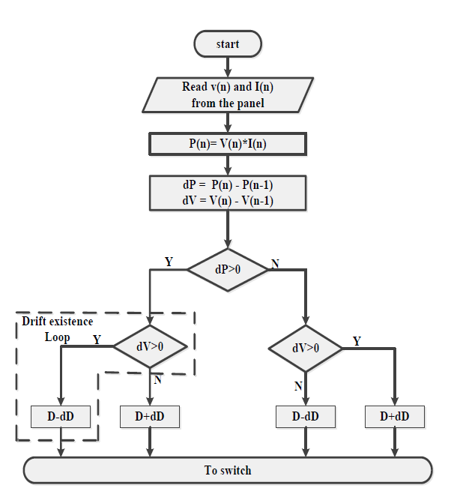
Fig. 3-Flowchart of conventional P&O Algorithm
- Steady State Three Level Operation

Steady state three level operation is shown in fig.4, Assume that the operating point is been moved from point A to point B and the [6], [11] decision is to be taken at point B by considering the values of dP and dV. As dP = (P2 −P1) > 0 and dV = (V2 − V1) > 0, the algorithm decreases the duty cycle and the operating point moves to the point C. At point C as dP = (P3−P2) < 0 and dV = (V3−V2) > 0 the algorithm increases the duty cycle and hence the operating point moves back to point B. And operating point oscillate around MPP.
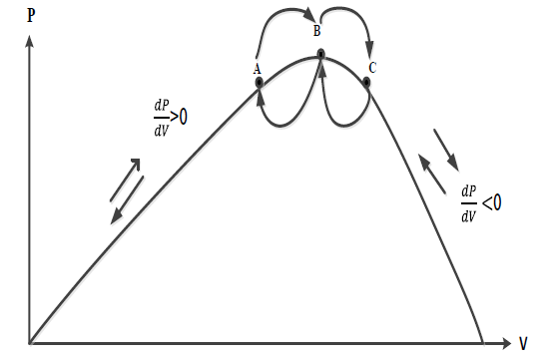
Fig. 4-Steady State Three Level Operation

B. Drift Analysis

Drift problem occurs in system due to increase in insolation and these problem is severe for a rapid increase in insolation. This is the main drawback of conventional P&O algorithm. Drift can occur from any of the three points as shown in Fig.5. Depending on the instant of change in insolation in between the perturbation time (Ta) interval. Drift occurs due to the lack of knowledge in knowing whether the increase in power (dP > 0) is due to perturbation or due to increase in insolation. Suppose there is an increase in insolation while operating at point A as shown in above Fig.5, then the operating point will be settled to a new point F. The point F is in new insolation curve during the same nTa perturbation interval. Now at point F as dP = P4(nTa) − P2((n− 1) Ta) > 0 and dV = V4(nTa) −V2((n − 1) Ta) > 0 the algorithm decreases the duty cycle and thereby moving to point E Point E is away from the MPP in the new curve which is called drift.
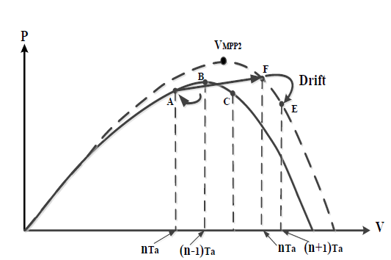
Fig. 5-Drift Analysis
This drift problem will be severe in case of a rapid increase in insolation and in case of adaptive P&O, as ΔD is large for a change in insolation which will results in the
operating point to move in a wrong direction far away from the MPP.

V. DRIFT FREE MODIFIED P&O MPPT

To overcome demerit of drift in case of a rapid increase in insolation due to confusion as discuss in section IV. This confusion can be eliminated by evaluating another parameter dI. It can be noticed that for an increase in insolation both V PV and I PV increases. Thus, with the information of ΔV and ΔI the drift phenomena can be avoided by detecting the increase in insolation [14]. The I −V characteristics of the PV module and the change in operating point due to increase in insolation is shown in Fig.7. suppose there is an increase in insolation while operating at point C, then the operating point will settle to a new point E in the new insolation curve. Now the decision has to be taken by the algorithm at point F where dI = I4(nTa) − I2((n − 1) Ta) > 0 as shown in Fig. 7 At the same time on the P – V characteristics at point E, both dP = P4(nTa) − P2((n −1) Ta) > 0 and dV = V4(nTa) − V2((n − 1) Ta) > 0 as shown in Fig. 8. Thus, all three parameters dP, dV and dI are positive at point E, as shown in Fig.7, and Fig.8. Thus, the positive value of dP is due to perturbation or due to increase in insolation can be detected by using the additional parameter dI. From fig.7 it can be observed that the two parameters both dV and dI can never have the same sign for a same insolation. It observes that dV and dI will be positive only for an increase in insolation. So, Increase in insolation can be detected by using the additional parameter dI and thereby increasing the duty cycle (decreasing the operating voltage) Where both dV as well as dI are positive can eliminate the drift problem by moving the operating point closer to the MPP. Similarly, in case of an increase in insolation the drift problem can be solved by incorporating dI into the algorithm and the movement of operating point with the proposed drift free modified P&O MPPT technique in case of a rapid increase in insolation. The flowchart of this drift free modified P&O MPPT technique is shown in Fig. 6.

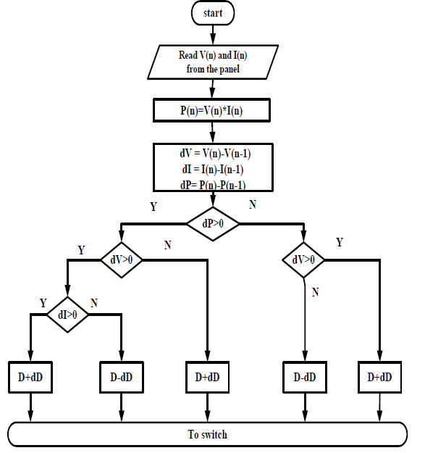

Fig. 6-Flowchart of drift free modified P&O Algorithm
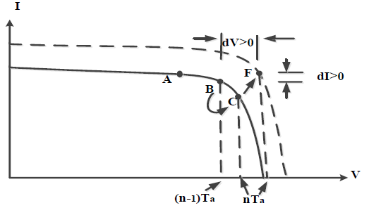
Fig. 7-No drift concept of Modified P&O MPPT
changing current

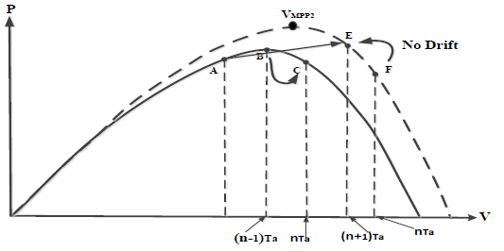

Fig. 8-Increasing an insolation at single
time

VI. SIMULATION & RESULT

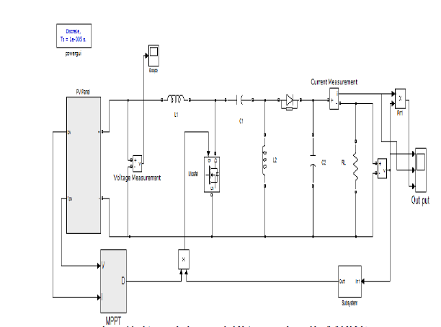
Fig. 9-Simulation of PV panel with MPPT

The single diode model of PV panel with consisting
parameters at nominal condition are selected as. α =1.3,
Ipv =10A in SEPIC converter components are chosen as
L1=180µH, L2=180µH, C1=47µF, C2=3300µF, RL=100Ω Simulation result of drift free proposed system compared with conventional Perturb & Observe algorithm given in fig.10 and fig.11 as increase in insolation level. Drift due change in insolation is observe in simulation result.

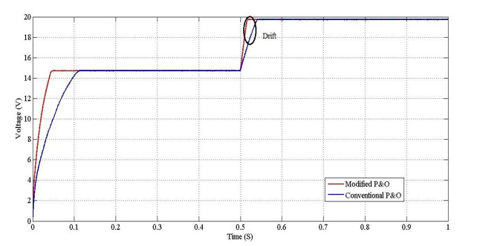

Fig. 10-comparison between conventional & modification of P&O algorithm in single change in insolation voltage vs time

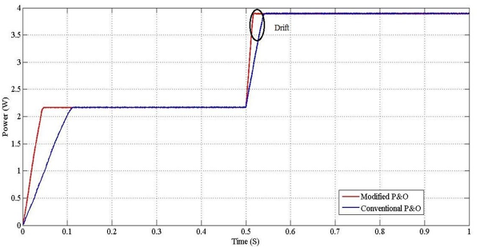
Fig. 11-comparison between conventional & modification of P&O algorithm in single change in insolation power vs time

VII. CONCLUSION
This paper shows, demerits of Perturb & Observe
MPPT algorithm as drift occurs in increase in solar
insolation then the modification produced in algorithm is
proposed to eliminating drift. Simulation of PV panel &
the recommended techniques are done with SEPIC
converter by controlling the duty ratio. Simulation results prove that the drift can be avoid by proposed modified P&O algorithm. It has increases performance of PV system. Result shown by the comparison between
conventional P&O algorithm and modified P&O
algorithm. Life cycle of PV panel & energy are go up
with recommended method.

REFERENCES
- W. D. Soto, S. A. Klein, and W. A. Beckman, “Improvement and validation of a model for photovoltaic array performance,” Solar Energy, vol. 80, no. 1, pp. 78–88, Jan. 2006.
- M. G. Villalva, J. R. Gazoli, and E. R. Filho, “Comprehensive approach to modelling and simulation of photovoltaic arrays,” IEEE Trans. Power Electron., vol. 24, no. 5, pp. 1198–1208, May 2009.
- Athira B., Greeshma V., Jeena Johnson “Analysis of Different MPPT Techniques,” IJAREEIE. Vol. 5, ISSN 2320 – 3765 March 2016.
- U. Patel, Ms. D. Sahu, D. Tirkey, “Maximum Power Point Tracking Using Perturb & Observe Algorithm and Compare with another Algorithm,” IJDACR. Vol. 2, ISSN: 2319-4863 September 2013.
- T.C. Srinivasa Rao, Fatima Unisia, D. Shobha Rani, N. Srinivas
“Photovoltaic Power Converter as an Input Source for SEPIC Converter,” International Journal of Computer Applications (0975– 8887) Vol. 78 – No.13, September 2013.
- N. Femia, G. Petrone, G. Spagnuolo, and M. Vitelli, “Optimization
of perturb and observe maximum power point tracking method,”
IEEE Trans. Power Electron., vol. 20, no. 4, pp. 963–973, Jul. 2005
- M. A. Algendy, B. Zahawi, and D. J. Atkinson, “Assessment of perturb and observe MPPT algorithm implementation techniques for PV pumping applications,” IEEE Trans. Sustain. Energy, vol. 3, no.1, pp. 21–33, Jan. 2012.
- Q. Mei, M. Shan, L. Liu, and J. M. Guerrero, “A novel improved variable step-size incremental-resistance MPPT method for PV systems,” IEEE Trans. Ind. Electron., vol. 58, no. 6, pp. 2427–2434, Jun. 2011.
- A. Nabulsi and R. Dhaouadi, “Efficiency optimization of
a DSP-based standalone PV system using fuzzy logic and dual-MPPT control,” IEEE Trans. Ind. Informant., vol. 8, no. 3, pp. 573–584, Aug. 2012.
- Syafaruddin, E. Karatepe, and T. Hiyama, “Artificial neural network polar coordinated fuzzy controller based maximum power point tracking control under partially shaded conditions,” IET, Renew. Power Gener., vol. 3, no. 2, pp. 239–253, Jun. 2009
- K. Ishaque and Z. Salam, “A deterministic particle swarm optimization maximum power point tracker for photovoltaic system under partial shading condition,” IEEE Trans. Ind. Electron., vol. 60, no. 8, pp. 3195– 3206, Aug. 2013.
- E. Bianconi, J. Calvente, R. Giral, E. Mamarelis, G. Petrone,
C. A. Ramos-Paja, G. Spagnuolo, and M. Vitelli, “A fast
current-based MPPT technique employing sliding mode
control,” IEEE Trans. Ind. Electron., vol. 60, no. 3, pp.
1168–1178, Mar. 2013.
- M. A. G. de Brito, L. Galotto, L. P. Sampaio, G. A. e Melo,
and C. A. Canesin, “Evaluation of the main MPPT techniques
for photovoltaic applications,” IEEE Trans. Ind. Electron.,
vol. 60, no. 3, pp. 1156–1167, Mar. 2013.
- Bhim Singh, Fellow, IEEE, Shailendra Dwivedi, Ikhlaq
Hussain, Student Member, IEEE and Arun Kumar Verma,
Member, IEEE Grid “Integration of Solar PV Power
Generating System Using QPLL Based Control Algorithm
” IEEE 6th Power India Conf. Dec 2014

