Advanced Oxidative Degradation of Indigo Caramine

Samiksha Mahakulkar¹, Mrunal Hulke¹, Renuka Gajaralwar¹,P.S.Agrawal²

1Reaserach Scholar, 2Professor, Department of Applied Chemistry, Laxminarayan institute of technology, R.T.M.Nagpur University, Nagpur -440010

Abstract: Risk to ecosystem vary significantly depending upon the nature and extend of exposure to hazardous chemicals. Environment remediation, particularly in the field of waste water treatment, has gained utmost importance in recent years. Indigo Caramine is widely used in food preservatives, textile and pharmaceutical industries. Anthropogenic releases of such chemicals into the environment are predominately into water and soil. In the present study, advance oxidation processes namely UV/H2O2 Fenton and Fenton like were investigated for the degradation of indigo caramine in lab-scale photo reactor. Hydroxyl radicals are powerful oxidizing reagents. The study reports that on the advanced oxidation of indigo caramine in an acid medium by means of the combined action of polychromatic UV –radiation dose, hydrogen peroxide concentration, Fenton’s reagent and pH. The process is being highly dependent on experimental parameters, degradation studies were carries out at different concentration of (Fe⁺²/ H2O2) and the optimum results were obtained.
Keywords: Advanced Oxidation Process, Indigo Caramine, Waste treatment.
- INTRODUCTION
Variety of dyes are used by textile industries. After getting consumed in dyeing process, remaining is disposed as textile effluent. This dye is famous for its rich royal blue colour. Estimated annual production of commercially available dyes are over 7x105 tons [1-2]. These highly colored dyes from pharmaceutical, food and textile industries which contain high amount of auxiliary chemicals entering the water bodies, causes serious trouble to aquatic dwellers and also causes various environmental problems on entering food chains. Industrial revolution has led to economic growth, along with environmental pollution and clean water deficiency [3]. The dyes used widely in textile industries are those which follow simple dyeing procedure and are stable to washing [4]. Dyes are stable and have complex aromatic structure. Its degradation by conventional biological treatment is less effective, therefore it remains in the environment [5]. To remove them completely from the environment, advanced processes are the major requirement in today’s era which can mineralize organic compounds to carbon dioxide, water and non-toxic inorganic compounds.
II- ADVANCED OXIDATION PROCESS
Advanced oxidation processes (AOPs) generate hydroxyl free radicals (HO·) as powerful oxidant which destroy non-biodegradable compounds that are not treated by conventional methods [6]. The versatility of AOP is its ability to enhance different possible ways for HO· radicals formation. Generation of HO· radicals is accelerated by combining O3, H2O2, TiO2, UV radiation, electron-beam irradiation and ultrasound.

III-PROPERTIES OF INDIGO CARAMINE
Table 1 Properties of Indigo Caramine
1 | Molecular formula | C16H8N2Na2O8S2
2 | Molar mass | 466.35 g/mol
3 | Chemical name | 5,5′-indigodisulfonic acid sodium salt
4 | absorption maximum | 608nm
5 | CAS number | 860-22-0
IV- METHODOLOGY
Materials and Reagents
All the chemicals were of AR grade from Merck, sd-fine and SRL. All the solutions were prepared from distilled water . H2O2 was used of 30%W/V. pH was maintained using 1N NaOH and 1N HNO3. Stock solution of 10⁻³ M was prepared as a synthetic pollute. Feso4 and fecl3 were prepared of concentration 10-2.
UV –VIS spectrophotometer 118 from Systronics, magnetic stirrer from Remi Equipments and monochromatic UV light of 8 watt and 245nm were used.

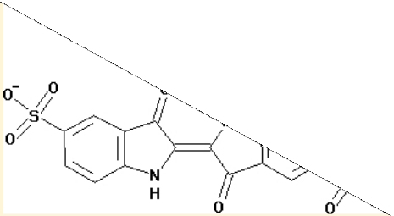
Figure 1 Structure of Indigo Caramine Dye [7]

Experimental Set up
The experimental set up for the process is displayed in the figure 2-3.

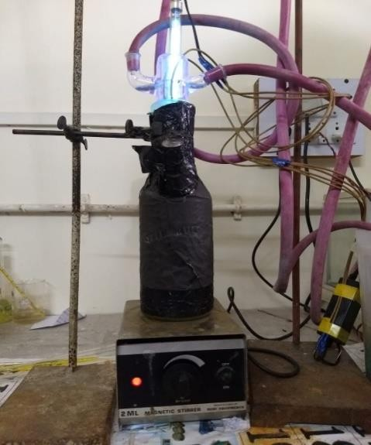
Figure 2 Photo Reactor and magnetic stirrer
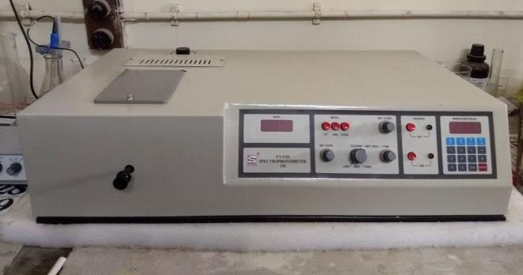
Figure 3 Spectrometer 118

CALIBERATION OF INDIGO CARAMINE
The spectrum of a conventional Indigo Caramine concentration is depicted in Figure 5 .The wavelength ( λ max) at which absorbance was maximum was 608 nm. The calibration curve was prepared to examine the concentration of solution left behind after treatment. The range of dye concentration was from 1x 10-5 to 1.5 x10-5M. The calibration curve (figure 4) between concentration and corresponding absorbance was at 608nm.The calibration curve was linear and obeyed Beer’s and Lambert’s law.
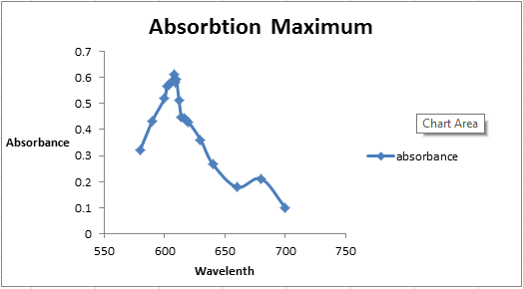
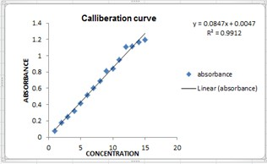
Figure 4 Calibration curve of IC at λ max = 608 nm.
Figure 5 Visible Spectrum of Indigo Carmine

Mechanism

Fenton’s assisted photon process is a combination of FeSO4, Fecl3, H2O2 and UV radiations that gives rise to extra _OH radicals by two additional reactions: (i) photo reduction of Fe3+ to Fe2+ ions as shown in Eq. (1) [8] and (ii) peroxide photolysis via shorter wavelengths (Eq.(2)).
Fe²⁺ +H2O2 •OH + Fe³⁺+OH⁻ ---Eq (1)

H2O2+UV •OH+•OH ---Eq(2)
In photo-Fenton process in addition to the above reaction the formation of hydroxyl radical also occurs by the following reactions Eq (3).
Fe³⁺+ H2O+UV •OH+ Fe²⁺ + H ⁻⁻⁻Eq(3)

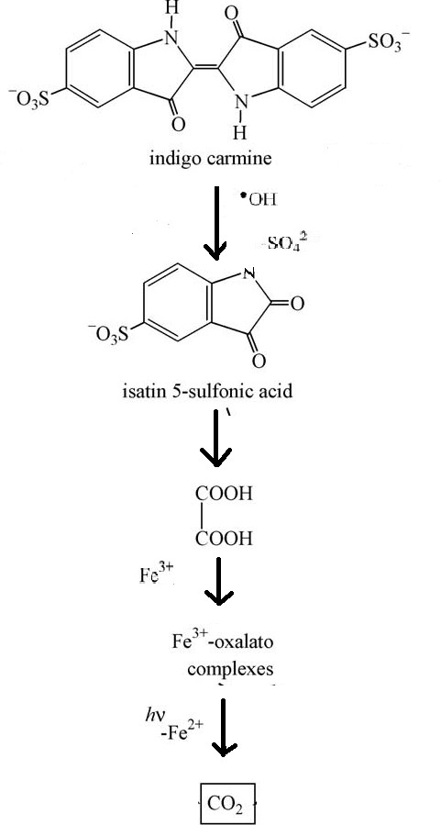

Figure 6 General Reaction sequence proposed for the degradation of indigo carmine in acid medium by-Fenton assisted photon
The stock solution of 10-3 M Indigo Carmine dye was prepared by dissolving 466.36 mg of dye in 1 L of distilled water. Different solutions of Indigo Caramine were prepared. Each solution contained 100 ml of dye stock and varying volume of H202 and FeCl3/FeSO4 and rest volume of water to makeup a complete volume of 800 ml. The overall concentration of dye in solution was 1.25× 10-4M. The pH of these solutions was set at 3.5. This solution was then transferred to a 800 ml reactor and was exposed to monochromatic 245 nm UV radiations. The functioning conditions were stabilised at room temperature. The optimized parameters were established accordingly.

V-RESULT AND DISCUSSION

The degradation of indigo Caramine dye varies according to the concentration of H202 , FeSO4 / FeCl3 added. It has been found that the percentage degradation and kinetics of the reaction is a function of volume of H202 and FeSO4/ FeCl3 added and the time for which the solution is exposed to UV rays.
Initially volume of H202 added is varied and FeSO4=2ml is kept constant. The table given below shows comparative results:
Table 2 percent degradation by variation of H202
H202(ml) | Dye %  Degradation | Rate of reaction, × 10-5, mol  L-1 min-1 | R2
1.5 | 64.11 | 0.3 | 0.9903
1 | 95.42 | 0.2 | 0.9184
0.8 | 98.16 | 0.5 | 0.9355
0.5 | 51.14 | 0.4 | 0.9545

After H202 is optimized, it is kept constant and FeSO4 is varied. The below given table shows the comparative results obtained:
Table 3 Percent degradation by variation of FeSO4
FeSO4  (ml) | Dye %  Degradation | Rate of reaction, × 10-5, mol  L-1 min-1 | R2
1.5 | 79.9 | 0.4 | 0.9652
2 | 98.04 | 0.5 | 0.9355
2.5 | 32.8 | 0.3 | 0.9842
The same procedure is followed in case of FeCl3. Initially H202 is optimized , putting FeCl3 = 2ml . The below given table shows:
Table 4 Percent degradation by variation of H202
H202(ml) | Dye %  Degradation | Rate of reaction ,  × 10-5,  mol L-1 min-1 | R2
2 | 80.48 | 0.08 | 0.9484
1.5 | 96.86 | 0.2 | 0.9785
1 | 98.47 | 0.3 | 0.9898
0.8 | 95.26 | 0.3 | 0.9751

H202 is optimized at 1 ml, FeCl3 is varied. The below given table shows the comparative results:
Table 5 Percent degradation by variation of FeCl3
FeCl3 (ml) | Dye %  Degradation | Rate of reaction, × 10-5 mol L-1  min-1 | R2
1 | 67.77 | 0.03 | 0.9452
2 | 77.72 | 0.3 | 0.9898
3 | 31.82 | 0.2 | 0.9902

It has been observed that as the volume of H202 and FeSO4/ FeCl3 added increases, the degradation also increases until a certain value. On further increase the amount of degradation decreases due to scavenging effect. Hence a particular optimum value of H202 and FeSO4/ FeCl3 was determined based on the experimental results obtained ,for which maximum degradation was observed and kinetics of the reaction was also fast. From the experimental data it can FeSO4 / FeCl3 and UV rays are combined used. For degradation of 1.25× 10-4 M Indigo Caramine dye solution the optimized parameters for Photo Fenton process were 0.8 ml H202, 2 ml FeSO4. Similarly for Photo Fenton like process, optimized parameters were 1 ml H202 , 2 ml FeCl3. Requirement of acidic medium is one of the major drawbacks of this process. The treated effluent should be neutralized again before, it is suitable for dispose or reuse. Advanced oxidation process is currently the most efficient and economic process to mineralized solution containing indigo Caramine dye. It is an environment friendly process as it destroys the harmful dye contents without formation of any other complex or precipitate. Modified advanced oxidation process are acknowledged for more efficient and cost effective results like Solar and Nanotechnology since the Fenton process are pH dependent, nanotechnology can be used to increase the working range.

Acknowledgements
The authors would like to thank P.S. Agrawal, Department of Applied Chemistry, Laxminarayan Insititute of technology for the support and providing the platform to do the project. We acknowledge the contribution of Journals and research papers in the reference.
REFERENCES

- P. Shukla, S. Wang, H. Sun, H.-M. Ang, M. Tade´ , Chemical Engineering Journal 164 (2010)
- Robinson, T., McMullan, G., Marchant, R., Nigam, P. Remediation of dyes in textile effluent: a critical review on current treatment technologies with a proposed alternative. Bioresource Technol. 77, 247, 2001.
- Pierce J. Colour in textile effluents the origins of problem. J Soc Dyers Color 1994;110:131e3.
- Yang Y, Xu L. Reusing hydrolyzed reactive dyebath for nylon and wool dyeing. Am Dyestuff Rep 1996; 3:27e34.
- (Beydili et al., 2001; Aygün et al., 2012)
- Guoet al. 2010; Dwyer et al., 2008) and ultrasonic (Seitelska.
- UV Photolytic Decolorization Study of Synthetic Waste Water Containing Indigo Carmine Dye in Presence of H2O2 FARTODE A. P.1, PARWATE D.V.2
- Pan, N.C., S.N. Chattopadhyay and A, Day .2003. Dyeing of jute with natural dyes. Indian J. Fibreand Textile Research, 28:339-342
.

