Abstract
As the competition is increasing day by day because of the new latest technologies, the pressure to score well is also increasing between the students. This pressure leads to self harm among the students. Reason behind this is they are unable to deal with their studies. To solve this problem we are using data mining technique. In this paper we want to give a brief explanation that using a data mining technique can predict the result of student based on previous three years result. This is referred as term prediction analysis and it is the best example of data mining in the field of education. It can also be called as education data mining.

Keywords
Data mining, prediction analysis, train set.

INTRODUCTION
Data mining
Extraction of implicit, previously unknown and useful information from database. Data mining is defined as the procedure of extracting some useful data from database. We can say that data mining is mining knowledge from data. Data mining came into view around 1990’s.it can be used to implement classification, regression, clustering and implementing association rules. 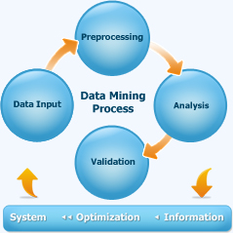

Prediction Analysis
Prediction analysis is nothing but the process which is use to obtain the current or future results based on past information. We are performing prediction analysis in our project by using the data mining. On the basis of previous year’s results a pattern will be made by using the generated pattern the upcoming result will be predicted. Using all the attributes and properties a pattern will be arranged and using data mining extraction of data is performed, the data gets stored. After that the stored pattern information of the current result is tested and the result will be predicted

METHODOLOGY
Data warehouse
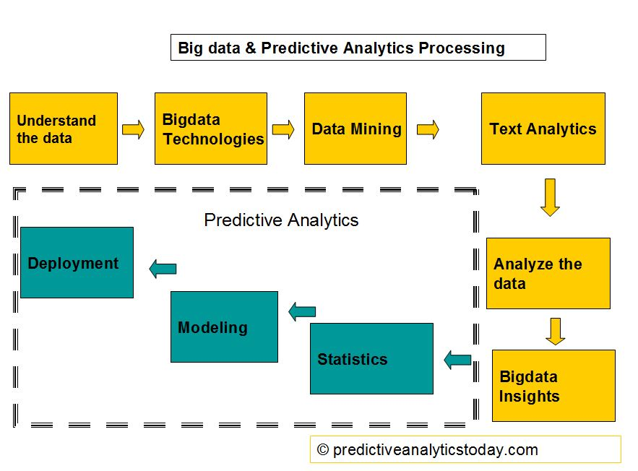
This is one or set of database, data warehouses, spreadsheets, or other kinds of information repositories. Data cleaning and data integration techniques may be performed on the data. A large store of data accumulated from a wide range of sources within a company and used to guide management decisions
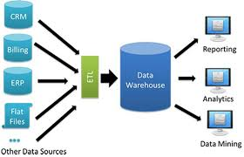
Data Warehouse refers to a database that is maintained separately from an organization’s operational database .A subject oriented, integrated, time variant and non volatile collection of data in support of management decision making process is called as data warehouse.
Big data Technologies
Big data is data whose scale, diversity and complexity requires new architecture, techniques ,algorithms and analytics to manage it and extract value and hidden knowledge from it. Big data a word phrase which is used to describe a massive volume of both structure and unstructured data that is so large it is difficult to process using additional database software techniques. The term big data, especially hen used by vendors, may refer to the technology that an organization requires to handle the large amounts of data and storage facilities.
Data Mining
Data mining is nothing but the extraction of meaningful information from the large database. Data mining is the process of discovering interesting knowledge from large amounts of data stored either in databases, data warehouse, or other information repositories .data mining deals with the extraction of previously unknown and interesting information from raw data. Data mining is the process which occurs after data warehouse. The purpose of data mining is knowledge discovery.
Text Analytics
In text analytics the inputs are taken from user .for ex in this project we are taking data from user in terms of caste, branch, and year, and providing the output by comparing these attributes on the basis of previous years result.
Statistics
In statistics comparison is performed between previous year data and after comparing the previous year results it predicts the next year result.
Predictive analysis
By collecting the previous year results it performs prediction analysis on collected data and generates the results of future on the basis of previous data. Predictive analytics contains the three components are as follows results, modeling, statistics.
In predictive analytics random forest algorithm is used. Random forest is a tree-based algorithm which involves building several trees (decision trees), then combining their output to improve generalization ability of the model. The method of combining trees is known as an ensemble method. Resembling is nothing but a combination of weak learners (individual trees) to produce a strong learner.
Literature Survey
Sr. No. | Title of Website | Owner | Major Observations
1. | iitnit.com | JoSAA  ( Joint Seat Allocation Authority) | This is an online college predictor that considers the JEE- Mains and Advanced ranks of the students as well as homestead universities of the candidates and generates the choice list accordingly.  Advantages – Highly Accurate.  Disadvantages – Only considers JEE scores and allots NITs and IITs only.
Sr. No. | Title of Website | Owner | Major Observations
2. | Shiksha.com | Info edge India Ltd. | Unlike any other college predictors this is the quickest one and the most suitable one for staring rounds.  Advantages - Considers MH-CET.  Disadvantages – Not accurate enough.

Conclusion
By using prediction analysis we have answered to the question of present and future on the basis of previous data. Our website will be very useful for the students those who wants the proper guidance for their admission. We are providing the list of colleges that can students go for according to their percentage.
References
- https://www.analyticsvidhya.com/blog/2015/09/perfect-build-predictive-model-10-minutes/ To get started with data analysis.
- Nice, Charles (2007), Predictive Analytics White Paper (PDF), American Institute for Chartered Property Casualty Underwriters/Insurance Institute of America,
- Fletcher, Heather (March 2, 2011), "The 7 Best Uses for Predictive Analytics in Multichannel Marketing", Target Marketing
- GitHub repositories
- Fletcher, Heather (March 2, 2011), "The 7 Best Uses for Predictive Analytics in Multichannel Marketing", Target Marketing

