Review on Performance of Different Micro-channel Condensers

Siddesh Palaskar¹ and Vivek W. Khond²
¹Student, M.tech (HPE), Mechanical Engineering Department, G. H. Raisoni College of Engineering, Nagpur, Maharashtra, India
²Assistant professor, Mechanical Engineering Department, G. H. Raisoni College of Engineering, Nagpur, Maharashtra, India
E-mail: ¹siddeshpalaskar@gmail.com
Abstract – Micro-channel condenser is vital component of vapor compression refrigeration system (VCRS).Use of micro-channel condenser is common in refrigeration and air conditioning industry. Feature of compactness and relatively less weight makes it more suitable for automotive application. Comparison with conventional condenser has shown that performance was high in terms of more COP and improved refrigeration effect. The problem of air mal-distribution effect which was common in air conditioning was reduced with proper modifications. The shape of port of micro-channel condenser had effect on performance of overall system and condenser.
Keywords- Micro-channel condenser, vapor compression refrigeration system , COP, Mal-distribution.
INTRODUCTION
Condenser is an important part of vapor compression refrigeration system. The studies on condensation inside the condenser started from 1900 when scientist Nusselt (1900) gave the correlation for heat transfer coefficient to shah’s correlation (1979) for two phase. The traditional condenser is round tube condenser which due to water cooling has an problem of tubes getting corroded which directly affects the heat transfer. The scale formation also led to decreased heat transfer and to overcome this demerit, came air cooled Micro-channel condenser. Micro-channel condenser has an tube which is divided into number of ports. The shape of part may be an circle, triangle, square. As the diameter of tube is less it increases surface area which causes heat transfer to increase.[1]
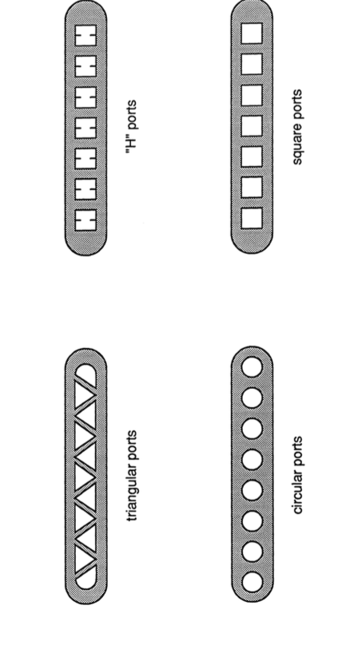
The typical Micro -channel condenser is shown in figure(with louvered fins). Tube is divided into number of small ports (Triangular).The louvered fins are attached to tubes so as to increase heat transfer.[2].Air is flowing in a cross direction to refrigerant flow. Various shapes such as ‘H’ ports, Square ports, Triangular ports, circular ports are shown in figure.
Figure1-Various shapes of ports of micro-channel condenser [1]
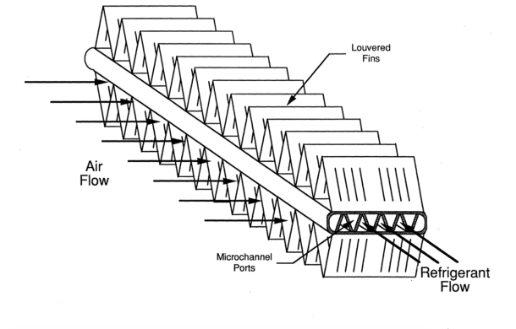
Figure 2: Micro-channel condenser tube with louvered fins[1].
A commercially available Micro-channel condenser is the Modine PF condenser. Micro-channel condenser has an header which feeds refrigerant to tubes. (Fig2)

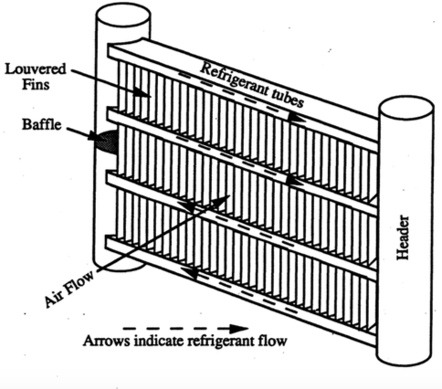
Figure3: Schematic of typical micro-channel condenser [9].

A baffle plate is used to separate the incoming and outgoing refrigerant. The louvered fins separate the tubes and are used to increase heat transfer [3]. The size of port commonly used in application is 5 to 20 times less in size than Round-tube condenser [3]. Use of Micro-channel condenser is more in automobile application due to its compactness. The use of Micro-channel condenser is started in residential and commercial air-conditioning [4]. For the proper analysis of Micro-channel condenser the flow of refrigerant inside the condenser is divided into liquid, vapor and liquid-vapor phase.[2]various arrangements of Micro-channel condenser is also possible with minimum modification. The merits of Micro-channel condenser are less weight, more compactness, more COP, etc. The problem of pressure drop and air mal-distribution is common [6].

REVIEW STUDIES

D. A. LUHRS, W. E. DUNN [1]

Test facility was built for experimentation on micro-channel condenser. Condensation study inside Micro-channel condenser was done by using setup. Micro-channel condenser with louvered fins was used where a tube was divided into number of ports and was separated by fins. Port of shape triangle ,square, circle was used to check the performance of Micro-channel condenser. The square port was most effective in terms of performance but was difficult to manufacture. The model for air side heat transfer resistant was developed. As this study did not consider two phase flow inside the tubes, it was less effective. The aim was to develop various theory models with the help of this study and suggest modification [1].

D.J. ANDRES AND W.E.DUNN [2]

Micro-channel tubing is used so as to enhance the internal heat transfer with refrigerant R-134a with a air flowing on condenser for heat transfer in cross direction. The theoretical energy balance and practical condition found to agree within 3% error. The value of heat transfer coefficient for various condition was calculated. The data for sub-cooled phase, superheated phase and two phase region was obtained using readings at different operating conditions. Here understanding physics of Micro-channel condenser was priority so as to ripe benefits of Micro-channel condenser. Wilson plot was used for comparison of heat transfer on air side and refrigerant side. Theoretical and practical data was not within the error limit at lowest air flow rate. At lower mass flow rate it was found that heat transfer for air side and refrigerant side came more close to each other. The value of mass flow rate of 0.53 gave refrigerant side value of 400 Watt but on air side it was 410 Watt [2].

M.K. HEUN AND W.E. DUUN [3]

The first study on Micro-channel condenser was done by this duo. The condensation process in multi-port Micro-channel condenser was done. This paper provided how port shape affect the performance of Micro-channel condenser. The hydraulic diameter range for study was 0.6mm to 1.5 mm. Various shapes like circular, square, triangular was taken for experimentation. The calculation for single phase flow was done which was in agreement with correlation (Churchill). The two phase data was in agreement with Dobson but little modification was done. The correlation for circular tube was found applicable for non-circular port with little adjustments. The conclusion from this study was that small size of ports leads to less volume of condenser. The efficiency of condenser increases when the ports are parallel with short tubes for small ports. The internal volume was in ascending order of circle, square, triangle for greater heat transfer in turbulent flows in tubes or ports. The pressure drop is less in Micro-channel condenser due to arrangement for flow of refrigerant. The maximum value for volume of Micro-channel condenser to traditional condenser is 0.3 which is less clearly[3].

C. V. PARK, P. S. HRNJAK [4]

Prototype of residential air conditioning system with round-tube condenser and Micro-channel condenser was designed and developed and its performance was evaluated. Volume, face area, fin density was same for both condensers. The values of Heat transfer coefficient was compared for two systems. There was improvement in coefficient of performance, cooling capacity for new condenser. The charge was 9% less as compared to round-tube condenser. A scroll compressor along with refrigerant R-410A was used. At different operating conditions of evaporator COP and Evaporator capacity was higher for Micro-channel condenser i.e. 43% and 18.8% higher respectively. Heat transfer coefficient on air side was 38% higher for Micro-channel condenser, which shows improvement even though air flow over both condensers was at same rate. The pressure drop of charge for Micro-channel condenser was 32% of round-tube condenser with single pass arrangement [4].

M.R.HOEHNE, P.S.HRNJAK [5]
The experimentation using natural refrigerant was done here due to its lower GWP (global warming potential). A condenser with fins and parallel tubing was used for performance analysis. With the help of Micro-channel condenser a cooling capacity between 1Kw to 2Kw with less than 150 Gm of refrigerant can be obtained. Even though the pressure drop was more in Micro-channel condenser it did not affect heat transfer as it was found more. The charge requirement dropped from 200 Gm to less than 130 Gm. The highest achieved cooling rate was 1.3 KW. The material chosen for experimentation was aluminum due to high thermal conductivity which helped in more heat transfer [5].

VISHWANATH SUBRAMANIAM [6]

The effect of air mal-distribution on performance of residential air conditioning system was studied here. The calculation for design of Micro-channel condenser assumes uniform air distribution over condenser which is not the case in reality. By considering a heat load of 14.5 KW condenser tube parameter, fin density was designed. The mass required for this load was 2.54 Kg. The 50% mal-distribution led to increase in refrigerant required to 2.73 Kg. It was found that variation of height of tube and fin density to 40% and 20% respectively changes mass by 2.65 Kg. The design done so as to minimize the air mal-distribution effect reduced the mass requirement by 19%. The positive degree of mal-distribution of about 0.5 lead to increase in refrigerant requirement whereas negative degree of -0.2 reduced the mass required. The proper design of fin density and fin height led to increase in mass of 3% without considering the effect of mal-distribution [6].
WEN WANG, XUN WANG [7]
The experiment on two phase flow of refrigerant in heat exchanger with micro-channel condenser was done. Here flow was restricted to only laminar. The experimental investigation was found close to Koyama correlation. Friction coefficient was calculated which was close to certain correlations. Conclusion derived about R-134a refrigerant were, Heat transfer coefficient is dependent on mass flow rate, heat per unit area and dimensions of channel through which refrigerant is flowing. The division of condensing flow was slug flow, bubble flow, annular flow which is independent of pressure [7].
AKHIL AGRAWAL, TODD M. BANDHAUER, SRINIVAS GARIMELLA [8]
The performance analysis of Micro-channel condenser with Non-circular shapes. The range of diameter considered here is between 0.424 to 0.839 mm of Micro-channel condenser. Different shapes such as triangular shape formed by insert, square, rectangular, circular. The refrigerant R-134a was used and thermal stratification method was used and thermal amplification method was used for the measurement. Conclusion was corners with acute angle of condenser , mist flow model was best suitable [8].
D.G.PATIL, J.H.BHANGALE, K.S.DESHMUKH [9]
Experimental work on Micro-channel condenser has been done by trio. Performance comparison of Micro-channel condenser, coil tube condenser, Round tube condenser was done .The Micro-channel condenser with same Surface area and fin density and depth was taken for experimental investigation. Here Micro-channel condenser with louvered fins was used and fins separate the tubes through which refrigerant passes. The header through which refrigerant goes inside tubes has an baffle plate separating the incoming and outgoing flow of charge. Here efficiency which ratio of COP to Carnot COP was highest for Micro-channel condenser at every refrigeration load . It was found here that load efficiency remained same which gave the highest efficiency value .A COP was found to 7.8 percent higher for Micro-channel as against conventional condenser. The condensing Temperature was lower by 2.5degree Celsius .The pressure drop was also reduced from 160 KPa to 57 KPa for Micro-channel condenser. The charge requirement was smaller for Micro-channel condenser by 9.2 percent. They found mal distribution effect (un-even distribution of air on condenser) was dependent on geometry of condenser [9].
PATIL DEEPAK, J. H. BHANGALE, D. PALANDE [10]
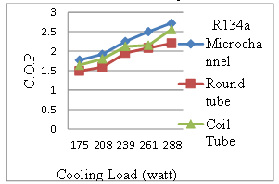
Comparison of refrigeration system working on three condensers i.e. micro-channel condenser, Round-tube and Coil-tube condenser for refrigerant R-134a, R-290. In test setup this three condenser at different load was calculated where load was in range of 175-288 W. The performance parameter was calculated for each condenser like COP, efficiency of system, Heat removal from condenser .The Micro-channel condenser with square port was used for experiment of local vehicle manufacturing company. COP for micro-channel condenser was more as compared to other two. The COP for micro-channel condenser was 19.75 percent and 8.65 percent more than round-tube condenser and coil-tube condenser respectively for R-134a.Heat removal out of Micro-channel condenser is 15.73 percent greater than round-tube condenser and 7.36 percent than coil tube condenser. Almost every parameter has shown improvement with Micro-channel condenser[10].

Figure4-Actual coefficient of performance comparison for three different condensers
HUA SHENG WANG, JIE SUN, LIN RUAN, JOHN W. ROSE [11]
The theory of heat transfer in condenser of micro-channel type was given. The experimental investigation included the water as condensing fluid in condenser. The experimental investigation was done to find out which correlation is more accurate for calculation of heat transfer coefficient. The effect of surface tension on the performance was measured here. The surface tension caused the steam-water to flow towards corner of tubes and where it formed the thin films which led to increase in heat transfer. The heat transfer coefficient value was high at inlet and was constant in between inlet and exit at a value of 60KW/mk at a distance of 200mm from inlet up to exit. The higher vapor flow rate led to higher heat transfer coefficient at inlet. The case for condensation of FC72 was predicted to behave similar to water/steam but suggested more study[11].
V. M. BHATKAR, V. M. KRIPLANI, G. K. AWARI [12]

The experimental analysis for performance evaluation of Micro-channel condenser by using more environment friendly refrigerant was done. Vapor compression refrigeration system used an HC (hydrocarbon) refrigerant instead of R-134-a(HFC).The mixture of R-290 and R-600 i.e. Propane and Iso-butane respectively in 50-50 percent of mass was used. The GWP(Global warming potential) of HC refrigerant i.e. an natural refrigerant was low i.e. less than 4 and Latent heat which will be helpful in condensation is twice as that of R-134a .Experiment involved condenser temperature at 44 degree Celsius and Evaporator temperature in between -15 to 15 deg. Celsius. 1TR of refrigeration of vapor compression system was designed and developed .The setup was fabricated for .86 kw of heat removal capacity of condenser which was made up of aluminum material. The plot for compressor power ,COP , Refrigeration effect, etc of R-134a and HC refrigerant was drawn for evaporator temperature of range -15 to 15 Deg. Celsius. The compressor power was more by 13.3 percent and COP was reduced by 43 percent .Refrigeration effect increased by 185.4 percent(As shown in figure).The refrigeration requirement was 42-45 percent as that of R-134a [12].

KAMLESH CHHAJED, NILESH PATIL [13]
The air conditioner for domestic or commercial application has been developed with Micro-channel condenser and round-tube condenser and their performance comparison was done. Micro-channel condenser with same face area and volume as that of round-tube was made available. The advantages that were found from this study are reduction in refrigerant required, the pressure drop became less and more heat transfer coefficient on both air side and refrigerant side. Fan power requirement to cool the condenser was less as drag coefficient was less. Prototype in which two condenser were kept in parallel for performance evaluation . In addition to this the compactness was more for micro channel condenser which makes it suitable for automobile application. Suggestion for use of micro fins and wire inserts to increase performance of system. The performance parameters such as COP, Refrigeration effect has seen improvement for Micro-channel condenser. The theoretical calculations and experimental value of heat transfer coefficient was not within error limit [13].
P. G. LOHOTE, Dr. K. P. KOLHE [14]
The work for enhancement of COP of VCR system was done by duo. Household refrigerator of capacity 165 liters was used for experimental purpose. The parts of Vapor compression refrigeration system such as Compressor, Evaporator, Throttling valve were conventional whereas Micro-channel condenser and spiral condenser were used on two different system .The condenser be it Micro-channel or spiral is there to absorb heat from refrigerant which was added into refrigerant during compression and process of evaporation .The modification or optimization of values of dimension of condensers was done to improve COP of system as COP is dependent on operating temperature. A refrigeration system performance was checked for three different condenser. In experimentation use of refrigerant R-600 was made. The condenser geometry changed from existing to Micro-channel led to an increased COP. The Pitch of coil played important role in performance enhancement of system .The heat rejection from refrigerant was more with increased pitch. Surface area was more which led to increased COP but beyond certain limit S.A. created reverse effect .In the end COP was more by 5.06 percent and 13.82 percent for spiral and Micro-channel condenser over existing condenser. The refrigeration effect and charge requirement to achieve 1TR of refrigeration was also more for replacement [14].
CONCLUSION
Paper discussed the performance of micro-channel condenser under various conditions. Micro-channel condenser was superior to round channel and spiral condenser in performance parameter such as COP and refrigeration effect.
- Highest COP increase percentage attained over round tube condenser was 19.75.and highest COP increase percentage over coil tube and spiral condenser was 8.65 and 5.06 respectively.
- The performance indicators of refrigeration system such as pressure drop in condenser, heat removal from condenser, refrigeration effect has shown improvement for micro-channel condenser.
- In case of air conditioning system where a micro-channel condenser is used the problem of mal distribution of air comes which was reduced by proper arrangements and dimension optimization of micro-channel condenser.
- A refrigeration system’s highest i.e. optimum performance can be evaluated so as to determine the upper limit of that refrigeration system by keeping in view above factors.

REFERENCES
- D.A. luhrs, W.E. dunn, "Design and construction of a micro-channel condenser tube experimental facility". ACRCTR-65,doi:jully 1994
- D.J. andres, W.E. dunn, "Design and construction of a condensation experimental facility for use with micro-channel condenser tubing", ACRCTR-66. doi:September 1994.
- M.K. heun, W.E. dunn, "Performance and optimization of micro-channel condenser", ACRCTR-48. doi:July 1995.
- C.V. perk, P.S.hrnjak, "R-410A air conditioning system with micro-channel condenser", International refrigeration and air conditioning conference paper no-556. doi:2002.
- M.R. Hoehne,P.S. hrnjak, "Charge minimization in systems and components using hydrocarbons as a refrigerant",ACRCTR-224.doi: January 2004.
- Vishwanath subramaniam , "Design of air cooled micro-channel condensers for mal-distributed air flow conditions",Gorgia institute of technology. doi:July 2004.
- Wen Wang, Xun Wang, "Experiments of condensation heat transfer in micro-channel heat exchanger",International refrigeration and air conditioning conference. doi:2010.
- Akhil agarwal, Todd bandhauer, Srinivas garimella, "performance analysis of noncircular microchannels of refrigeration system",international journal of refrigeration. doi:.2010
- D.G.patil, J.H. bhangale, K.S. Deshmukh, "Experimental analysis of refrigeration system using micro-channel condenser and round tube condenser", IJIRAE volume-1. doi:June 2014.
- D.P.patil, J.H. bhangale, D.D. palande,"Comparative analysis of various condensers in vapour compression refrigration system", IJESRT. doi:September 2014.
- Hua sheng wang, Jie sun, Lin ruan, John.w. rose, "Preliminary measurement of heat transfer during condensation in micro-channels",4th micro and nano flow conference. doi:september 2014.
- V.M.bhatkar, V.M. kriplani, G.K.awari, "Experimental analysis of micro-channel condenser using R-134a and drop in substitute mixture of R-290 and R-600a", IJAME Volume-10. doi:december 2014.
- Kamlesh chhajed, Nilesh patil," Adsorption of N2, CH4, CO and CO2 gases in single walled carbon nanotubes", IJARSMT. doi:December 2015.
- P.G. lahote, K.P. kolhe, "Enhancement of COP by using spiral and micro-channel condenser instead of conventional condenser VCR system",JETIR Volume-3.. doi:july 2016.

