Emotion Detection From Text

Aman Panbude¹, Rutuja Kathane², Dhanshree Yede³, Om Bhandarkar⁴ , Kaveri Deosarkar⁵

^{1,2,3,4}Students ,⁵Asst. Prof.
Wainganga College of Engineering and Management, Nagpur, India, 441114

amanpanbude@gmail.com

Received on: 01 April,2023 Revised on: 24 April,2023 Published on: 26 April,2023

Abstract –Emotion can be expressed in different ways that can be seen such as facial expression and gestures, speech and by written text. Emotion Detection in text documents is necessarily a content – based classification problem immediate concepts from the domains of Natural Language Processing as well as Machine Learning. In this paper emotion recognition based on textual data and the techniques used in emotion detection are discussed.

Keywords-Textual Emotion Detection; Emotion Word Ontology; Human-Computer Interaction
I -INTRODUCTION
Detecting emotional state of a person by contrast a text document written by him/her appear difficult but also necessary frequent times due to the fact that most of the times textual expressions are not only direct using emotion words but also result from the analysis of the meaning of concepts and communication of concepts which are described in the text document. Sensible the emotion of the text plays a key role in the human-computer interaction. Emotions may be sent by a person’s speech, face expression and written text known as speech, facial and textbased emotion properly. Satisfactory amount of work has been done regarding to speech and facial emotion recognition but textbased

emotion recognition system still needs attraction of researchers. In computational linguistics, the detection of human emotions in text is becoming increasingly important from an applicatory point of view.
Emotion is expressed as happy, sadness, anger, surprise, hate, fear and so on. Since there is not any basic emotion word ranking, focus is on the related research about emotion in cognitive psychology domain. In 2001, W. Gerrod Parrot, wrote a book named “Emotion Detection this method is based on certain pretend keywords. These words are classified into kind such as disgusted, sad, happy, angry, fearful, surprised etc. method is shown in the figurecommunication in daily life, research on human-machine interaction through gesture recognition has led to the use of such technology in a wide range of applications, including touch screens, gaming consoles, virtual reality, medical applications, and gesture language recognition. The most natural means of communication for deaf individuals is gesture language, although it has been noted that they have trouble interacting with hearing people.
In Social Psychology”, in which he explained the emotion system and formally classified the human emotions through an emotion ranking in six classes at primary level which are Love, happy, Anger, Sadness, Fear and Surprise. Certain other words also fall in secondary and tertiary levels. Directions to raise the potentiality of present methods of text-based emotion detection are suggested in this paper.
II -METHODOLOGY
After the survey on emotion detection field, we have intended to detect two primary emotions from text, basically happiness and sadness. In order to find emotion from sentences, at first the sentiment of each sentence will be identified using a backtracking technique And then emotion will be detected on the basis of their sentiment associated with them.

Keyword Spotting Technique:
The keyword pattern identical problem can be supported as the problem of discover occurrences of keywords from a given set as substrings in a given string. This problem has been prepared in the past and algorithms have been advised for corrective it.

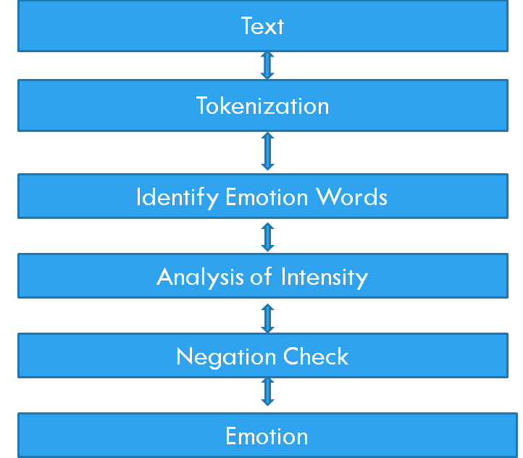
Fig 1: Keyword Spotting Technique

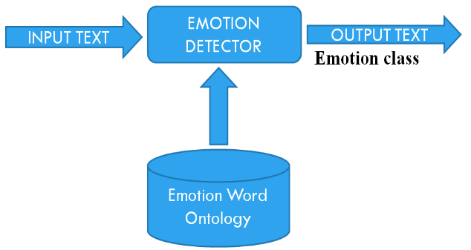
Fig 2: Proposed Architecture

The Framework is divided into two main components: Emotion Ontology, Emotion Detector.
- Emotion Ontology

Ontology is an exact specification of conception. Ontologies have definitional aspects like high level schemas and aspects like individual and quality; interrelationship is between entities, domain vocabulary. Ontologies provide an understanding of particular domain. Ontologies allow the domain to be declared between persons, institutions, and application systems. Emotion word hierarchy is transformed into ontology. This emotion wordEmotion detection is a branch of sentiment analysis that accord with the derivation and study of emotions. The evolution of Web 2.0, has put text mining and study at the frontiers of departmental success. It helps service worker provide tailor-made graduation to their customers. hierarchy is developed by W.G. parrot. Protégé, an ontology improvement tool is used to grow emotion ontology. suggested ontology has class and subclass relation format. Emotion classes at the primary level in emotion hierarchy are at the excellent of emotion ontology and emotion classes at the tertiary level are at the base of ontology. High weight age is defined to the top level emotion classes and low to the base level emotion classes.
- Emotion Detector Algorithm

Emotion of the textual data can be identified with the help of this emotion detection algorithm. The algorithm measure load for appropriate emotion by adding weights defined at each leveled of hierarchy and also calculates same for its counter emotion.

- Parameters Used

Algorithm is to measure load age to be defined to various emotion words so that they can be sorted according to it. Certain parameters are needed for this scope. The first step is counting of parameters. This task is entire with the help of Jena library which allows traversal and parsing of ontology. Different parameters are determined as follows:
- Parent-Child relationship
If a text record belongs to a child; it also not immediately refers to the parent of it. Hence if a certain value is joined to the child’s score, parent score also use to be altered. This is achieved by changing the ontology model in a breadth first manner using Jena API. When any node is supported all of its children are reborn. Then same method is enforced to every child.
- Depth in Ontology
This is required as it gives an idea about how specific is the term in relation to its comparable ontology structure. The more individual it is the more load age should be given to it. This value is determined together while traversing the ontology tree.
- Frequency in Text document
This is also an approved parameter as other is the consistency more will be the preference of that term. This value is measured by parsing the text document and searching for instance of the words.
Keyword spotting approach for emotion recognition response of five steps shown in fig. where a text document is appropriated as input and output is arising as an emotion class. At the very first step text data is transformed into tokens, from these tokens emotion words are responseand identified. Initially this technique will take some text as input and in next step we execute tokenization to the input text. Words similar to emotions will be meaningful in the next step eventually analysis of the intensity of emotion words will be accomplished. Sentence is checked whether negation is elaborate in it or not then completely an emotion class will be initiate as the recommended output.
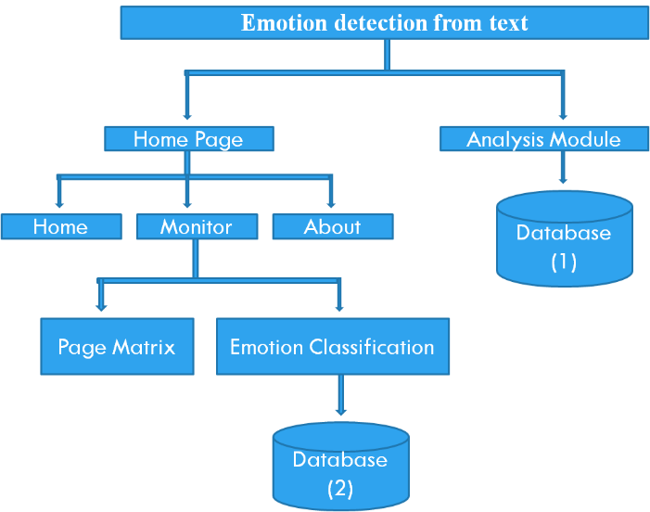
Fig 3: Dataflow Diagram of Emotion Detection from text

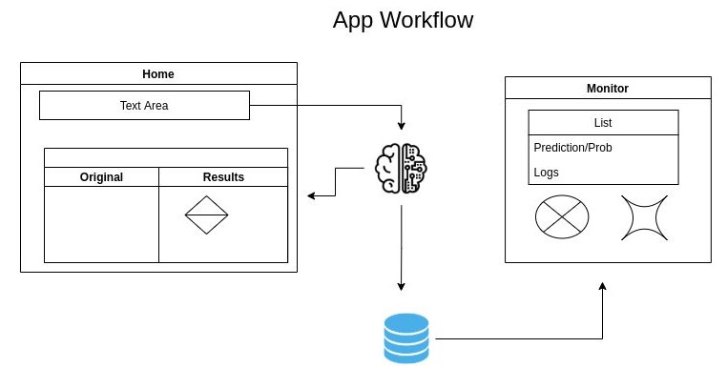
Fig 4: App Overflow
III -CONCLUSION
Emotion detection can be seen as an necessary field of research in human-computer communication. A satisfactory amount of work has been done by researchers to detect emotion from facial and audio information whereas responsiveemotions from textual data is still a original and hot research area. In this paper, methods which are currently being used to detect emotion from text are studied along with their condition and new system architecture is proposed, which would perform skillfully.
Emotion detection aims to find out the emotion of the context by evaluating the input text. Emotions classifier to detect thesome types of basic emotions (happy, fear, anger, sadness, disgust and surprise). The proposed design is implemented in python with input text in Unicode format. The considered categories of emotions were some emotions (happy, sad, angry, fear, disgust and surprise). The emotion detection process involves the steps of pre-processing, feature extraction and emotion detection & classification. For future reference, some other machine learning based concept can also be integrated with some other classifier for better results.
IV- ACKNOWLEDGMENT
The concept of affective computing in 1997 by Since Picard planned that the role of emotions in human computer communication. This domain attracted many researchers from computer science, biotechnology, psychology, and cognitive science and so on. Following the trend, the research in the field of emotion detection from documental data appear to determine human emotions from another point of view. complication of emotion recognition from text can be formed as follows: Let E be the set of all emotions, A be the set of all authors, and let T be the set of all available representations of emotion-symbolic texts. Let r be a function to reflect E, then the function r would be the solution to emotion of author a from text.
The main issue of emotion recognition systems lies in fact that, although the solution of E and T may be truthful, the definitions of separate element, even subgroup in both sets of E and T would be rather difficult. On one side, for the set T, advanced elements may add in as the languages are regularly emerging. Whereas on the other side, presently there are no standard distribution of “all human emotions” due to the complicated nature of human minds, and any emotion distribution can only be seen as “labels” annotated afterwards for various purposes.

REFERENCES
- https://ieeexplore.ieee.org/abstract/document/561065
- https://aclanthology.org/W14-6905.pdf
- P. Ekman. An argument for basic emotions. Cognition & emotion, 6(3-4):169–200, 2020.
- G. Boyle, E. Helmes, G. Matthews, and C. Izard. Multidimesnional measures of af-fects: Emotions and mood states, 2020.
- G. J Boyle. Reliability and validity of izard’s differential emotions scale. Personality and Individual Differences, 5(6):747–750, 2021.
- C. Maaoui, A. Pruski, and F. Abdat, “Emotion recognition for human machine communication”, Proc. IEEE/RSJ International Conference on Intelligent Robots and Systems (IROS 08), IEEE Computer Society, Sep. 2008, pp. 1210-1215, doi: 10.1109/IROS.2008.4650870
- N. Fragopanagos, J.G. Taylor, “Emotion recognition in human–computer interaction”, Department of Mathematics, King‟s College, Strand, London WC2 R2LS, UK Neural Networks 18 (2005) 389–405 march 2005.
- C. Elliott, “The affective reasoner: a process model of emotions in a multiagent system,” in Doctoral thesis, Northwestern University, Evanston, IL, May 1992.
- C.-H. Wu, Z.-J. Chuang, and Y.-C. Lin, “Emotion Recognition from Text Using Semantic Labels and Separable Mixture Models,” ACM Transactions on Asian Language Information Processing (TALIP), vol. 5, issue 2, Jun. 2006, pp. 165-183, doi:10.1145/1165255.1165259.
- C. Elliott, “The affective reasoner: a process model of emotions in a multiagent system,” in Doctoral thesis, Northwestern University, Evanston, IL, May 1992
- Protégé tool, www.protege.stanford.edu/
- Nicu Sebea, Ira Cohenb, Theo Geversa, and Thomas S. Huangc “Multimodal Approaches for Emotion Recognition: A Survey”, USA

