Age and Gender Prediction Using Deep Learning

Shobhit Yadav¹, Ashutosh Somavanshi², Teertharaj Haldar³, Prof. Rupali satpute⁴

^{1,2,3} UG Student, ⁴Assistant professor, Electronics and Telecommunication, Shobhityadav
KJ Somaiya IT, Mumbai, India, 400022

shobhit.y@somaiya.edu

Received on: 29 March, 2023 Revised on: 16 April, 2023 Published on: 18 April, 2023

Abstract – Attribute information such as age and gender improve the performance of face recognition. A data of pertained images is taken that are used to train model using HAAR Feature-based Cascade Classifiers and our main objective is to train a model which can predict age and gender in most efficient way. We are using CNN deep learning method because it is time consuming and the process gives defined results of large dataset.

Keywords- Age and Gender prediction, Deep Convolution Neural Networks, Deep learning ,CNN.

INTRODUCTION
Human face is a storage of various information about personal characteristics, including identity, emotional expression, gender, age, etc. This plays a significant pertinent- verbal communication between humans. Automatic gender classification and age detection is a fundamental task in computer vision, which has attracted immense attention. It is a very important role in an exceedingly wide selection of the real-world applications like targeted advertisement, forensic science, visual surveillance, content-based searching, human-computer interaction systems, etc. The general flow off ace recognition consists of three steps: capture face images bya camera with visible or near-infrared illumination,extractfeaturesfromfaceimagesandevaluatethesimilaritybetweenfeatures.Inthepastwhenthereisanimprovementdoneonfacerecognitiononlargescale,atthatpointalinkbetweenfacerecognition and Convolution Neural Network(CNN) is proposed and by studying it further we created a system in which a limited amount of face data sets are used to accurately predict age and gender. A data of pertained images is taken that are used to train model using HAAR Feature-based Cascade Classifiers and our main objective is to train a model which can predict age and gender in most efficient way. Age and gender, two of the key attributes, playa very initial role in social communications, making age and gender approximation from a singleimageanimportanttaskinintelligentapplications,suchasaccesscontrol,humancomputerinteraction,lawapplication,marketing intelligence and visual observation, etc. It can be used to supposetheageandgenderof the user and use this information to makemodified product and understanding for eachuser. It plays the vital role in marketing for themarketer by addressing the target audience onthebasisofageandgender.

II. LITERATURE REVIEW
Age and Gender Bracket Using Wide Convolutional Neural Network and Gabor Filter Year 2019, Author Sepideh Sadat Hosseini, Seok Hea Lee. Age and gender bracket has entered attention lately owing to its important part in friendly intelligent systems. In this paper, we propose a convolutional neural network( CNN) grounded armature for age-gender bracket, where we use the Gabor sludge responses as the input. The weighting of Gabor- sludge is learned through backpropagation in an end- to- end armature. The armature is trained to label the input images into 8 ranges of age discovery and 2 types of gender discovery. Our approach shows bettered delicacy in age and gender bracket compared to the state- of- the- art methodologies. We've observed that adding the range of neural network would increase the delicacy of the system. Age and Gender Bracket Using Wide Convolutional Neural Network and Gabor Filter Year 2019, Author Sepideh Sadat Hosseini, Seok Hea Lee. Age and gender bracket has entered attention lately owing to its important part in friendly intelligent systems. In this paper, we propose a convolutional neural network( CNN) grounded armature for age-gender bracket, where we use the Gabor sludge responses as the input. The weighting of Gabor- sludge is learned through backpropagation in an end- to- end armature. The armature is trained to label the input images into 8 ranges of age discovery and 2 types of gender discovery. Our approach shows bettered delicacy in age and gender bracket compared to the state- of- the - art methodologies. We've observed that adding the range of neural network would increase the delicacy of the system.
Advantage
Higher contrast image could be used to rapidly segment the desired objects from a digitized image.
Disadvantage
Need to improve safety, stability, and efficacy of the monitoring system, including the detection algorithms and application software.
III. METHODOLOGY
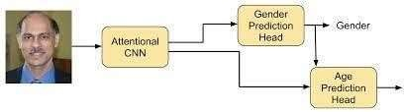
The first application of Convolutional Neural Network(CNN) is LeNet-5 network by using optical characterrecognition.Ifwecomparethisactivitywithmoderndeepconvolutional network technique it is considered to beverysimpleandhumbleasthattimetherewerelimited computational resources and there are challenges totrainalgorithms.Nowthetime hascomewhenneuralnetworks become so deep that they became 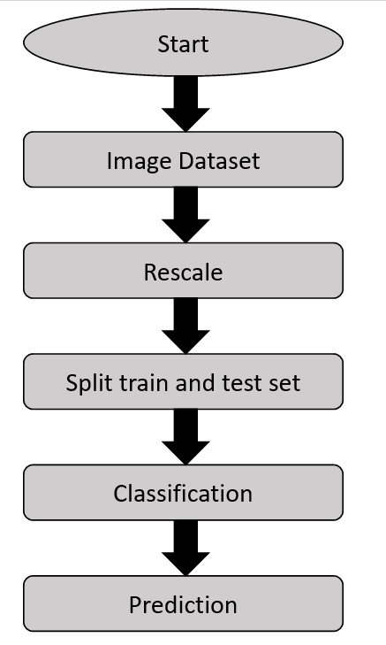
prevalentdue to increase in computational resources and thetrainingdataiseasilyavailableoninternet.Moreover,now such methods are available that can train dataeasily and readily. Now there are various applicationof Convolutional Neural Network (CNN) are presentlike human pose estimation, face parsing, facial keypoint detection, and speech recognition and actionClassification.Onunconstraintphotothisistheirfirstapplicationaccordingtoourknowledge.Wehavenoticed that if we want to gather large datasets ofimagesfromsocialplatformthemitmayrequiretheirprivacy permission or may become a security hazardand its very time taking to label is manually. Datasetfrom real world social images we have noticed thattheyarelimitedinsizeandtheyhavenomatchinsizewithlargesdatabaseimagesets.Overfittingisa commonproblemwhileusingmachinelearningbasedmethods on small image collections . This problem isintensifiedwhenconsideringdeepconvolutionalneural networks due to large parameters. So we haveto be very careful while using such methods. Thesystemweproposedworksperfectlyfinewithexperiments in classification for age and gender. Ournetworksconsistofthreeconvolutionallayersinwhich two of them are fully connected with smallnumber of neurons. We use small network design fortaking less risk for over fitting and also for the natureofproblemwearegoingtosolve.Classificationofageondatasetrequirestodifferentiatebetweeneightclasses and for two genders. Thus we can say that tenthousandclassesareusedtotrainthedatasetsusedforfacerecognition.

IV. DESIGN (if any)
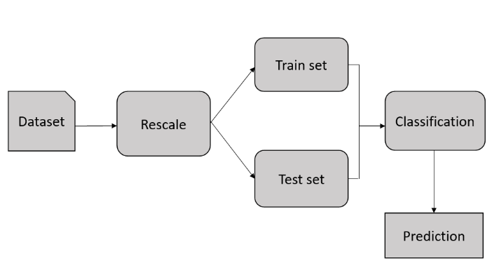

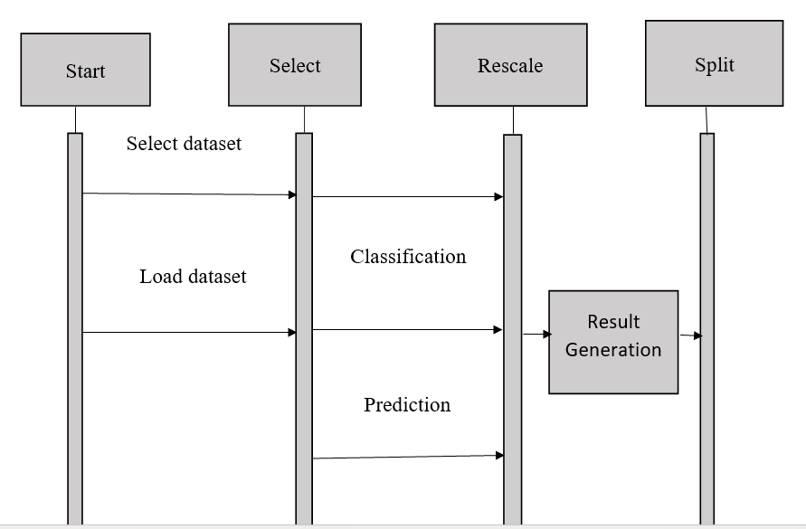

V. RESULT & DISCUSSION
The Final Result will get grounded based on the overall classification and prediction. The performance of this proposed approach is estimated using some measures like,
- Accuracy
- Precision
- Recall
- F-Measure
- Confusion matrix

VI. CONCLUSION
In this composition age and gender discovery using deep literacy system with artificial neural network is proposed and enforced. The age and gender estimation system correspond of face discovery and model training for the bracket. Using deep CNN, model is trained to an extent that delicacy of Age and Gender come 89 using HAAR slinging. Its delicacy could be increased more using more effective algorithms and more precise armature of CNN so that it could have been used more in different platforms. In this study, lately, age, gender, and the regency of particular prints have come important information for several associations and governments for business, identification, security and, operation. Also, this data collected from persons through the enterprise system, so the form validators were proposed to reduce the stoner data entry crimes. In this paper, we essay to propose a new result to validate these data by prognosticating age and gender from a single person print and comparing it with age, gender and tan discovery. Also, after evaluation, we set up it has good results in gender vaccination, but it still suffers in age vaccination. It has good results in Tan vaccination Consume a lot of coffers and optimize it to be usable. Also, regarding low delicacy results in age and gender vaccination from womanish prints, due to several problems we bandied ahead, it’s reasonable to train a new model through CNN using a that contains further than prints and a lot of prints for ladies that are wearing Hijab, also assessing it using the testing dataset.
REFERENCES
- R.L. Hsu,M. Abdel- Mottaleb, andA.K. Jain, ― Face discovery in color images, ‖ IEEE Trans. Pattern Anal. Mach.Intell.,vol. 24,no. 5,pp. 696 – 706, May 2002, doi10.1109/34.1000242.
- R. Yamashita,M.Nishio,R.K.G. Do, andK. Togashi, ― Convolutional neural networks an overview and operation in radiology, ‖ perceptivity into Imaging,vol. 9,no. 4. Springer Verlag,pp. 611 – 629,Aug. 01, 2018, doi10.1007/ s13244-018-0639-9.
- Paul Viola and Michael J Jones. Robust real- time face discovery. International journal of computer vision, 57( 2) 137 – 154, 2004.
- Savas, Burcu Kir, SumeyyaIlkin, and Yasar Becerikli." The consummation of Face Detection and Fullness Detection in Medium by Using Haar Cascade Classifiers." 2016 24th Signal Processing and Communication Application Conference( SIU), 2016. doi10.1109/ siu.2016.7496215.
- Rath, Subrat Kumar, and Siddharth Swarup Rautaray." A check on face discovery and recognition ways in different operation sphere." International Journal of Modern Education and Computer Science6.8( 2014) 34
- Hatem, Hiyam, Zou Beiji, and Raed Majeed." A check of point base styles for mortal face discovery." International Journal of Control and robotization8.5( 2015) 61- 78
- E.Alajrami,H.Tabash,Y. Singer andM. Astal," On using AI- Grounded mortal Identification in perfecting Surveillance System Efficiency", 2019 International Conference on Promising Electronic Technologies( ICPET), 2019. Available10.1109/ icpet.2019.00024( penetrated 4 June 2020).
- Bhattacharya, Jhilik, etal." Real- time DNN- grounded Face Identification for the Blind." International Conference on Applications in Electronics Pervading Industry, Environment and Society. Springer, Cham, 2017. Qawaqneh, Zakariya, Arafat Abu Mallouh, and BuketD. Barkana." Deep Convolutional Neural Network for Age Estimation grounded on VGG- Face Model." arXiv preprint arXiv1709.01664( 2017)
- N. Chauhan," prognosticate Age and Gender using Convolutional Neural Network and openCV", Medium, 2020.( Online).

