Experimental Investigation of Kerf Width and Kerf Taper in Fiber Laser Cutting of Aluminium Alloy

P. P. Kharche¹, Dr. Vijay H. Patil²
¹ Research Student
Department of Mechanical Engineering, GF’s Godavari College of Engineering, Jalgaon, India, 425003
² Professor & Principal
Department of Mechanical Engineering, GF’s Godavari College of Engineering, Jalgaon, India, 425003
Email of Corresponding Author: mprashantk@gmail.com

Received on: xxxx,20xx, Revised on: xxxx,20xx, Published on: xxxx,20xx

Abstract – In order to examine the impact of process parameters on the laser cutting process, the laser cutting of Al 6061 is explored in this work using a fibre laser with variable laser power. The Kerf Width and Kerf Taper Angle are considered as a response characteristic. Response Surface Methodology (RSM) approach is used for experimental design. Box-Behnken Design (BBD) method of Response Surface Methodology (RSM) is used to plan the experiment.
Keywords- Laser Cutting, Response Surface Methodology, Laser Beam Machining, Kerf Width, Kerf Taper Angle.
INTRODUCTION
Aluminum is one of the most adaptable, affordable, and beautiful metallic materials for a variety of applications, from soft, highly ductile wrapping foil to the most demanding engineering ones. This is due to the special combinations of qualities that aluminium and its alloys offer. The utilization of aluminium alloys as structural metals is second only to that of steel. [1]. Aluminium and its alloys are currently regarded as the top materials of choice utilised in many industries, including the automotive and aerospace industries, following steel[2][3].
One of the most common thermal energy-based advanced machining processes is laser beam machining (LBM), which uses laser energy instead of traditional mechanical energy. It is a two dimensional machining process in which material removal is achieved by focusing a highly intense laser beam on the work piece [4][6]. A laser beam with a high energy density provides highly targeted heating on a workpiece in the Laser Beam Machining method. The material is caused to melt, vaporize or ablate in order to remove the material from the piece at micron level. It is an energy-less thermal beam based non-contact tool with several unique advantages, such as a micro-machining potential, elimination of finishing operations, automation adaptability and increased material usage and faster machining [5].
LITERATURE REVIEW
In [4], the author employs top kerf deviation, bottom kerf deviation and top kerf width as output parameters and pulse width, pulse frequency, gas pressure, and cutting speed as input parameters. They used Taguchi methodology for modeling and fuzzy logic as optimization technique. In [10], author uses laser power, cutting speed, pulsing frequency and gas pressure used as input parameters and kerf width, cut edge surface roughness and heat affected zone used as output parameters. They used Taguchi-Fuzzy hybrid approach for modelling and optimization. Cutting speed and pulsing frequency are found as the significant parameters for the laser cutting of Aluminum alloy 5083.
As input parameters in [11], the author employs pulse energy, pulse width and cutting speed,; as output parameters, material removal rate and surface roughness. According to experimental findings, the lowest surface roughness was 6.23 μm with the following parameters: V=1.2 mm/s, E=4.5 J, and w=0.5 ms. With input parameter values of V=1.8 mm/s, E=6.8 J, and W=0.5 ms for the material AA1200 aluminium alloy, the maximum MRR achievable is 57.494 mg/min. In [12], author uses Laser power and scanning speed are used as input parameters and area, perimeter as the output responses. To conduct their work, they used a L9 orthogonal array and the Taguchi method. In [13], author uses assistant gas flow, distance between surface of work piece and beam focus location (defocus), repetition rate frequency, and pumping current used as process parameters. Depth, width, and contrast of engraved zone considered as output parameters for the material Al-SiC composite. Central composite design method is used to design experiments based on the response surface methodology (RSM). The result shows that increasing of repetition rate frequency and pumping current simultaneously, leads to decreasing in width and depth of engraved zone, and increasing in assistant gas flow, leads to increasing in width and depth of engraved zone. In [14], author used Nd:YAG laser and Nitrogen as an assist gas. Pulse energy, pulse width and cutting speed, are considered as controllable input parameters. surface roughness, kerf width, kerf deviation, and material removal rate are measured as output parameters. ANN-PSO model combining Artificial Neural Networks (ANN) and Particle Swarm Optimization (PSO) was used for prediction and optimization.
PERFORMANCE PARAMETERS
The performance of laser machining mainly depends on appropriate selection of input process parameters. Due to converging–diverging shape of laser beam profile as shown in figure 1, kerf taper always exist during laser machining.
Kerf is the width of material that the process removes as it cuts through the plate. Each cutting process removes a different amount of material, or kerf. The more precise processes, like waterjet and laser, remove a smaller amount of kerf, which is one of the reasons of more precise.
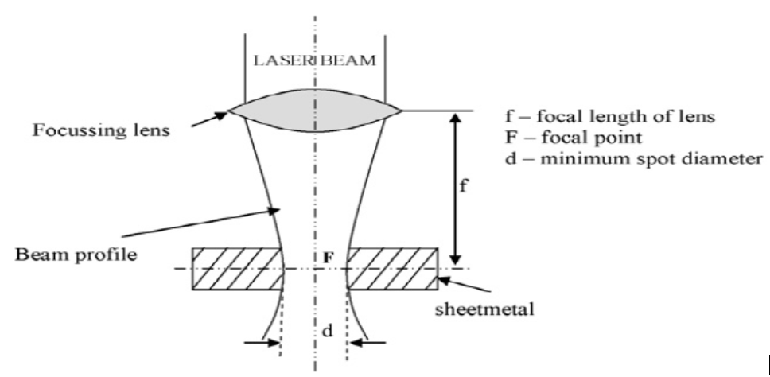
Fig. 1- Kerf taper in laser machining [4]
Figure 2 shows the schematic diagram of top and bottom kerf width. Figure 3 shows schematic diagram of kerf width. Kerf taper angle measurements of the all samples are measured by the use of profile projector. The quality control inspection team will find this tool, often referred to as a shadow graph, handy in a small parts machine shop or manufacturing line. The built-in projection screen is used to display the specimen's profile once it has been magnified by the projector. In order to observe or measure a straight edge of the machined object, the X-Y axis of this screen may normally be rotated 360 degrees to align with the grid. For more ease in calculating linear measures, this projection screen shows the specimen's profile and is magnified. The grid on the screen is matched up with an edge of the specimen to be examined. To determine the distance to other sites, straightforward measurements are made from there. On a magnified profile of the specimen, this is being done. Measuring using a profile projector's enlarged projection screen might be easier and less prone to error. The kerf taper angle is calculated by
$θ=\tan^{-1}{\frac{(W_{t}-W_{b})}{2h}}$ (1)
where, W_{t} = kerf top width (mm), W_{b} = kerf bottom width (mm), h = thickness (mm)
The kerf top width is calculated by taking three reading at fixed interval from top surface of the specimen and its average is taken.
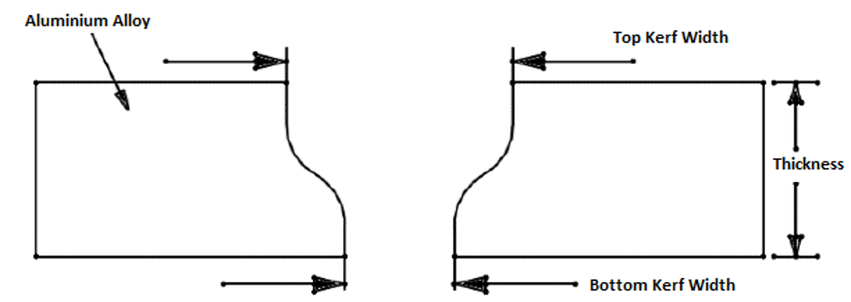
Fig. 2- Schematic representation of top and bottom kerf width
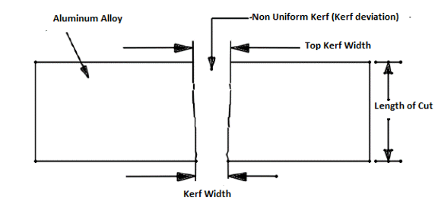
Fig. 3- Schematic representation of kerf width
MATHEMATICAL MODEL
The relationship between the output and inputs can be expressed by a linear, second order (quadratic), or exponential equation when the kerf width values are viewed as the output and the cutting parameters as the inputs.
Linear model
It is possible to think of the dependent variable V as a linear combination of the independent variables Cutting Speed, Laser Power, and Gas Pressure. Therefore, the equation is as below:
$V=k_{0}+k_{1}A+k_{2}B+k_{3}C$ (2)
where, A represents Laser Power, B represents Cutting Speed, C represents Gas Pressure.
Second order model
The association between the dependent variable V and the independent variables Cutting Speed, Laser Power, and Gas Pressure is apparently shown by the equation below.
$V=k_{0}+k_{1}A+k_{2}B+k_{3}C+k_{4}A^{2}+k_{5}B^{2}+k_{6}C^{2}+k_{7}AB+k_{8}AC+k_{9}BC$ (3)
EXPERIMENTATION
Specifications of Al 6061 Plate
Aluminium 6061
Sheet Dimensions – 250mm * 220mm* 12 mm
Sheet thickness – 12mm
Cut Part Dimensions 30 * 30 mm.

DOE Based Experimental Plan
Response surface methodology (RSM) approach [5][6] is used for experimental design. Design-Expert software is used for Response surface methodology (RSM) approach. Box-Behnken design (BBD) method of response surface methodology (RSM) is used to plan the experiment. In the present study, AMADA LCG3015AJ 6000W fibre laser is used. Laser machining is completed at M/s Anand Lasers, Pune, India. Material used is 12mm thick Al 6061 [Commercial Aluminium] with size of 250mm × 220mm × 12 mm. Nitrogen is used as assist gas. The square shape blocks with dimensions of 30mm × 30mm are cut by laser machine with different combinations of input parameters and the series of experiments are performed on 17 samples according to the experimental plan. Table 1 shows the levels of process parameters for LBM of Al 6061. Table 2 shows experimental plan for LBM of Al 6061 material of specimen thickness 12 mm and data for kerf width. Table 3 shows Experimental data for kerf taper.
Table 1- Levels of Process Parameters for LBM
Process Parameter | Min | Max
Laser power (watt) | 5500 | 6000
Cutting speed (mm/min) | 1300 | 1700
Gas pressure (MPa) | 1.4 | 1.8

Table 2- Experimental plan and Data for Kerf Width
 |  | Factor 1 | Factor 2 | Factor 3 | Response 1
Std | Run | A:Laser power  (watt) | B:Cutting speed  (mm/min) | C:Gas pressure  (MPa) | Kerf Width  (mm)
7 | 1 | 5500 | 1500 | 1.8 | 0.24
17 | 2 | 5750 | 1500 | 1.6 | 0.265
16 | 3 | 5750 | 1500 | 1.6 | 0.27
5 | 4 | 5500 | 1500 | 1.4 | 0.23
8 | 5 | 6000 | 1500 | 1.8 | 0.29
4 | 6 | 6000 | 1700 | 1.6 | 0.235
2 | 7 | 6000 | 1300 | 1.6 | 0.35
14 | 8 | 5750 | 1500 | 1.6 | 0.265
3 | 9 | 5500 | 1700 | 1.6 | 0.23
13 | 10 | 5750 | 1500 | 1.6 | 0.25
1 | 11 | 5500 | 1300 | 1.6 | 0.28
12 | 12 | 5750 | 1700 | 1.8 | 0.225
15 | 13 | 5750 | 1500 | 1.6 | 0.275
11 | 14 | 5750 | 1300 | 1.8 | 0.31
10 | 15 | 5750 | 1700 | 1.4 | 0.23
9 | 16 | 5750 | 1300 | 1.4 | 0.26
6 | 17 | 6000 | 1500 | 1.4 | 0.235

Table 3- Experimental plan and Data for Kerf Taper
 |  | Factor 1 | Factor 2 | Factor 3 | Response 1
Std | Run | A:Laser power  (watt) | B:Cutting speed  (mm/min) | C:Gas pressure  (MPa) | Kerf Taper  (degree)
7 | 1 | 5500 | 1500 | 1.8 | 0.2476
17 | 2 | 5750 | 1500 | 1.6 | 0.2864
16 | 3 | 5750 | 1500 | 1.6 | 0.266
5 | 4 | 5500 | 1500 | 1.4 | 0.3647
8 | 5 | 6000 | 1500 | 1.8 | 0.2298
4 | 6 | 6000 | 1700 | 1.6 | 0.3348
2 | 7 | 6000 | 1300 | 1.6 | 0.2444
14 | 8 | 5750 | 1500 | 1.6 | 0.2742
3 | 9 | 5500 | 1700 | 1.6 | 0.3814
13 | 10 | 5750 | 1500 | 1.6 | 0.2506
1 | 11 | 5500 | 1300 | 1.6 | 0.2202
12 | 12 | 5750 | 1700 | 1.8 | 0.3509
15 | 13 | 5750 | 1500 | 1.6 | 0.2557
11 | 14 | 5750 | 1300 | 1.8 | 0.2208
10 | 15 | 5750 | 1700 | 1.4 | 0.4089
9 | 16 | 5750 | 1300 | 1.4 | 0.2533
6 | 17 | 6000 | 1500 | 1.4 | 0.2931

STATISTICAL ANALYSIS & DEVELOPMENT OF MODELS
Models are developed for all output parameters and analyzed using analysis of variance (ANOVA). Then models are validated by calculating percentage errors in predicted responses.
Analysis of Variance (ANOVA) is used to analyze models created in RSM. Table 4 shows ANOVA for kerf width. Table 5 shows ANOVA for Kerf Taper.
Table 4- ANOVA for Kerf Width
Source | Sum of Squares | df | Mean Square | F-value | p-value
Model | 0.0172 | 9 | 0.0019 | 17.51 | 0.0005 | significant
A-Laser power | 0.0021 | 1 | 0.0021 | 19.39 | 0.0031
B-Cutting speed | 0.0098 | 1 | 0.0098 | 89.97 | < 0.0001
C-Gas pressure | 0.0015 | 1 | 0.0015 | 13.89 | 0.0074
AB | 0.0011 | 1 | 0.0011 | 9.70 | 0.0170
AC | 0.0005 | 1 | 0.0005 | 4.65 | 0.0680
BC | 0.0008 | 1 | 0.0008 | 6.94 | 0.0337
A² | 1.645E-06 | 1 | 1.645E-06 | 0.0151 | 0.9057
B² | 0.0003 | 1 | 0.0003 | 2.55 | 0.1542
C² | 0.0012 | 1 | 0.0012 | 11.01 | 0.0128
Residual | 0.0008 | 7 | 0.0001
Lack of Fit | 0.0004 | 3 | 0.0001 | 1.57 | 0.3281 | not significant
Pure Error | 0.0004 | 4 | 0.0001
Cor Total | 0.0179 | 16
The model is suggested to be significant by the model's F-value of 17.51. An F-value this large might happen as a result of noise only 0.05% of the time. Significant model terms are those with P-values less than 0.0500. In this case A, B, C, AB, BC, C² are significant model terms. The Lack of Fit F-value of 1.57 implies the Lack of Fit is not significant relative to the pure error. There is a 32.81% chance that a Lack of Fit F-value this large could occur due to noise.
Table 5- ANOVA for Kerf Taper
Source | Sum of Squares | df | Mean Square | F-value | p-value
Model | 0.0532 | 9 | 0.0059 | 16.28 | 0.0007 | significant
A-Laser power | 0.0016 | 1 | 0.0016 | 4.30 | 0.0767
B-Cutting speed | 0.0361 | 1 | 0.0361 | 99.38 | < 0.0001
C-Gas pressure | 0.0092 | 1 | 0.0092 | 25.26 | 0.0015
AB | 0.0013 | 1 | 0.0013 | 3.45 | 0.1056
AC | 0.0007 | 1 | 0.0007 | 1.99 | 0.2009
BC | 0.0002 | 1 | 0.0002 | 0.4477 | 0.5249
A² | 0.0000 | 1 | 0.0000 | 0.0451 | 0.8378
B² | 0.0030 | 1 | 0.0030 | 8.23 | 0.0240
C² | 0.0010 | 1 | 0.0010 | 2.70 | 0.1446
Residual | 0.0025 | 7 | 0.0004
Lack of Fit | 0.0017 | 3 | 0.0006 | 2.77 | 0.1747 | not significant
Pure Error | 0.0008 | 4 | 0.0002
Cor Total | 0.0557 | 16
The model is suggested to be significant by the model's F-value of 16.28. An F-value this large might happen owing to noise just 0.07% of the time. Model terms are considered significant when the P-value is less than 0.0500. In this case B, C, B² are significant model terms. The Lack of Fit F-value of 2.77 implies the Lack of Fit is not significant relative to the pure error. A large Lack of Fit F-value has a 17.47% likelihood of being caused by noise.
Equation in terms of actual factors is used to calculate the predicted values of kerf width and kerf taper angle and given in table 6 and 7 along with experimental values. From table 6 and table 7, it is observed that the minimum and maximum percentage deviation between experimental and predicted values of kerf width are 0 and 6.0 and for kerf taper angle 0.23 and 6.91 respectively.
The relationship between the actual and predicted values of experiment of Al 6061 for 12mm using laser machining process is shown in figure 4. It has observed that the developed model is adequate and predicted results are in good agreement with the experimental results.

Table 6- Experimental and predicted values of Kerf Width
 | Process Parameters |  |  | Kerf Width
Run | Laser Power | Cutting Speed | Gas pressure | Experimental | Predicted | Percentage Deviation (%)
1 | 5500 | 1500 | 1.8 | 0.2400 | 0.2350 | 2.08
2 | 5750 | 1500 | 1.6 | 0.2650 | 0.2650 | 0.00
3 | 5750 | 1500 | 1.6 | 0.2700 | 0.2650 | 1.85
4 | 5500 | 1500 | 1.4 | 0.2300 | 0.2300 | 0.00
5 | 6000 | 1500 | 1.8 | 0.2900 | 0.2900 | 0.00
6 | 6000 | 1700 | 1.6 | 0.2350 | 0.2388 | -1.62
7 | 6000 | 1300 | 1.6 | 0.3500 | 0.3413 | 2.49
8 | 5750 | 1500 | 1.6 | 0.2650 | 0.2650 | 0.00
9 | 5500 | 1700 | 1.6 | 0.2300 | 0.2388 | -3.83
10 | 5750 | 1500 | 1.6 | 0.2500 | 0.2650 | -6.00
11 | 5500 | 1300 | 1.6 | 0.2800 | 0.2763 | 1.32
12 | 5750 | 1700 | 1.8 | 0.2250 | 0.2213 | 1.64
13 | 5750 | 1500 | 1.6 | 0.2750 | 0.2650 | 3.64
14 | 5750 | 1300 | 1.8 | 0.3100 | 0.3188 | -2.84
15 | 5750 | 1700 | 1.4 | 0.2300 | 0.2213 | 3.78
16 | 5750 | 1300 | 1.4 | 0.2600 | 0.2638 | -1.46
17 | 6000 | 1500 | 1.4 | 0.2350 | 0.2400 | -2.13

Table 7- Experimental and predicted values of Kerf Taper Angle
 | Process Parameters |  |  | Kerf Taper Angle
Run | Laser Power | Cutting Speed | Gas pressure | Experimental | Predicted | Percentage Deviation (%)
1 | 5500 | 1500 | 1.8 | 0.2476 | 0.2505 | -1.17
2 | 5750 | 1500 | 1.6 | 0.2864 | 0.2666 | 6.91
3 | 5750 | 1500 | 1.6 | 0.2660 | 0.2666 | -0.23
4 | 5500 | 1500 | 1.4 | 0.3647 | 0.3451 | 5.37
5 | 6000 | 1500 | 1.8 | 0.2298 | 0.2494 | -8.53
6 | 6000 | 1700 | 1.6 | 0.3348 | 0.3307 | 1.22
7 | 6000 | 1300 | 1.6 | 0.2444 | 0.2318 | 5.16
8 | 5750 | 1500 | 1.6 | 0.2742 | 0.2666 | 2.77
9 | 5500 | 1700 | 1.6 | 0.3814 | 0.3940 | -3.30
10 | 5750 | 1500 | 1.6 | 0.2506 | 0.2666 | -6.38
11 | 5500 | 1300 | 1.6 | 0.2202 | 0.2243 | -1.86
12 | 5750 | 1700 | 1.8 | 0.3509 | 0.3354 | 4.42
13 | 5750 | 1500 | 1.6 | 0.2557 | 0.2666 | -4.26
14 | 5750 | 1300 | 1.8 | 0.2208 | 0.2138 | 3.17
15 | 5750 | 1700 | 1.4 | 0.4089 | 0.4159 | -1.71
16 | 5750 | 1300 | 1.4 | 0.2533 | 0.2688 | -6.12
17 | 6000 | 1500 | 1.4 | 0.2931 | 0.2902 | 0.99

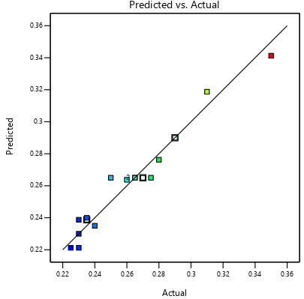
(a)
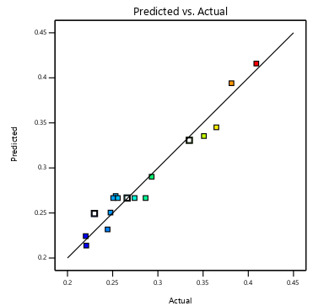
(b)
Fig. 4- Actual vs Predicted values for (a) Kerf Width (b) Kerf Taper Angle
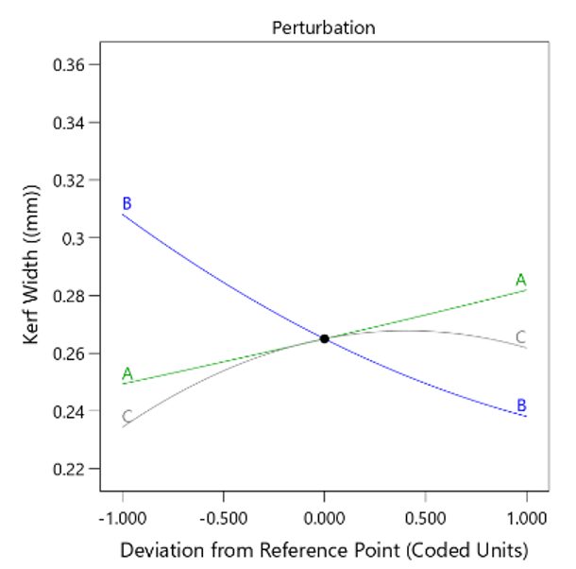
(a)

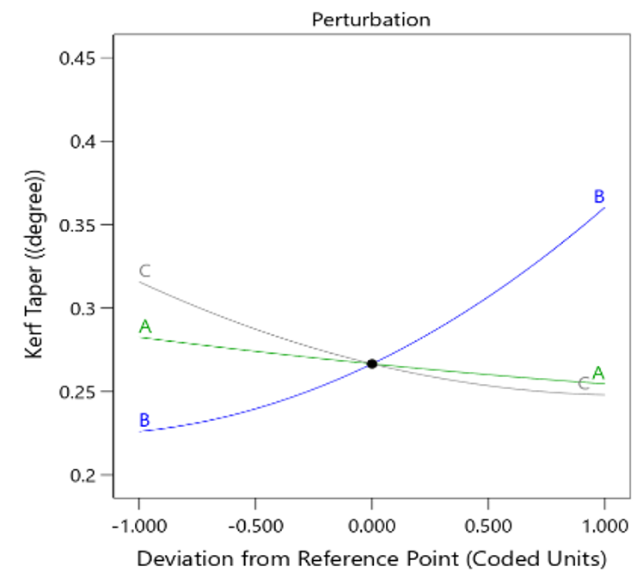
(b)
Fig. 5- Influence of process parameters for (a) Kerf Width (b) Kerf Taper Angle
CONCLUSION
Analysis of the influence of process parameter on the laser cutting process has performed with fiber laser machine on 12 mm thickness of Al 6061. After DOE analysis total 17 run have identified for experiment with sheet operation. Experimental result shows that minimum kerf width of 0.225 mm is obtained at cutting speed 1700 mm/min, gas pressure 1.8 MPa, laser power of 5750 W, minimum kerf taper of 0.2202 degree is obtained at cutting speed 1300 mm/min, gas pressure 1.6 MPa & laser power of 5500 W. Kerf width decreases with increase in cutting speed remarkably. With increase in laser power and gas pressure causes little increase in kerf width. Kerf taper increases with increase in cutting speed. Increase in gas pressure and laser power causes slight decrease in kerf taper.
REFERENCES
- J.R. Davis (2001). Aluminum and Aluminum Alloys, Alloying: Understanding the Basics, ASM International, p351-416.
- Mandal KK, Kuar AS, Mitra S, “Experimental Investigation on Laser Micro-Machining of Al 7075Alloy”, Optics and Laser Technology 107: 260–267, 2018.
- Smith C, Liu Q, ZhuangW, “An Experimental Study of Initial Flaws in Thin Sheets of 2024 Aircraft Aluminium Alloy”, International Journal of Structural Integrity, 5(2):120–128, 2014.
- Avanish Kumar Dubey, Vinod Yadava, Laser beam machining—A review, International Journal of Machine Tools and Manufacture, Volume 48, Issue 6, Pages 609-628, 2008, ISSN 0890-6955.
- Pravin R. Kubade, Harshada A. Deshinge, Sonal S. Gaikwad, Nikita A. Katkar, Pooja P. Sarnaik, “Experimental Investigation of Effect of Laser Beam Machining on Performance Characteristics in Machining OHNS E0300”, International Research Journal of Engineering and Technology (IRJET), Volume: 05 Issue: 10, October 2018.
- Bijoy Bhattacharyya, BiswanathDoloi, 2020 Chapter Four - Machining processes utilizing thermal energy, Editor(s): Bijoy Bhattacharyya, BiswanathDoloi, Modern Machining Technology, Academic Press, Pages 161-363, 2020, ISBN 9780128128947.
- Naveed Ahmed, Salman Pervaiz, Shafiq Ahmad, Madiha Rafaqat, Adeel Hassan & Mazen Zaindin, “LBM of aluminum alloy: towards a control of material removal and roughness”, The International Journal of Advanced Manufacturing Technology, 105, 1901–1915, 2019. https://doi.org/10.1007/s00170-019-04365-y
- O.S. Fatoba, E.T. Akinlabi, S.A. Akinlabi, M.F. Erinosho, ―Influence of Process Parameters on the Mechanical Properties of Laser Deposited Ti-6Al-4V Alloy. Taguchi and Response Surface Model Approach‖, Materials Today: Proceedings, Volume 5, Issue 9, Part 3, Pages 19181-19190, 2018, ISSN 2214-7853.
- Arun KumarPandey,AvanishKumarDubey, “Taguchi based fuzzy logic optimization of multiple quality characteristics in laser cutting of Duralumin sheet”, Optics and Lasers in Engineering 50 (2012) 328–335.
- Arvind Kumar Chaudhary, Arun Kumar Pandey∗ and Avanish Kumar Dubey, “Computer Aided Taguchi-Fuzzy Multi-Optimization of laser cutting process”, Journal of Intelligent & Fuzzy Systems 26 (2014) 801–810.
- Sudipto Chaki, Ravi N. Bathe, Sujit Ghosal ,G. Padmanabham, “Multi-objective optimisation of pulsed Nd:YAG laser cutting process using integrated ANN–NSGAII model”, J Intell Manuf 29, 175–190 (2018).
- V. Senthil Kannan, K. lenin, P. Navneethakrishnan, “Machining parameters optimization in laser beam machining for micro elliptical profiles using TOPSIS method”, Materials Today: Proceedings, Volume 21, Part 1, 2020, Pages 727-730, ISSN 2214-7853.
- Mohammad Hosein Rahimi, Mahdi Shayganmanesh, Rassoul Noorossana, Farhad Pazhuheian, “Modelling and optimization of laser engraving qualitative characteristics of Al-SiC composite using response surface methodology and artificial neural networks”, Optics & Laser Technology, Volume 112, 2019, Pages 65-76, ISSN 0030-3992.
- Sudipto Chaki, Digbalay Bose & Ravi N. Bathe, “Multi-Objective Optimization of Pulsed Nd: YAG Laser Cutting Process Using Entropy-Based ANN-PSO Model”, Lasers in Manufacturing and Materials Processing, 7, 88–110 (2020).

