Online Salon Booking App

Prof Rashmi Kannake, Tushar Gabhane, Mrunal menghre,
Papita Tarare, Shreyash Salodkar, Karan Boyar.
Department of Information Technology& Engineering
Wainganga Collage of Engineering & Management ,Dongargaon, Nagpur, India.
tushargabhane2001@gmail.com

Shreyashsalodkar358@gmail.comtararepapita1999@gmail.com
pillu1999menghare@gmail.combhoyarkaran1@gmail.com
Received on: xxxx,20xx, Revised on: xxxx,20xx, Published on: xxxx,20xx

Abstract Salon Book is a web-based salon management application with appointment scheduling functionality. It connects clients, salons, and stylists in an online community allowing users to browse salons and stylists, and book or cancel appointments. Users can also write and read reviews of salons and particular stylists. Salons can specify the stylists that work at their salons, as well as the services they offer. Salons can also book appointments for customers, and can view and print schedules in convenient formats. OpenTable.com serves a similar need in the restaurant industry, but nothing quite like this existed to bring clients and beauty salons together online. SalonBook.com fills this void in a way that is on-demand, easy to use, and effective for users and salon managers.
My project will use MySQL and PHP to back the interface with strong database functionality. For appointment scheduling, SalonBook will integrate WebCalendar as abackend database for appointments as well as a front-end scheduling interface. WebCalendar is a PHP-based calendaring application that can be a stand-alone00
program or integrated into other applications. This project will target the major web browsers as the initial platform for the Beta version.The final deliverable will be a functioning web application that can handle all specified use cases. Some of the major use cases include user account registration, login/logout,appointment scheduling, schedule viewing and printing, adding stylists and services to a salon account, adding schedules to stylist account, accumulating points in a client account, writing and reading reviews for specified salons and/or services,

and creating temporal salon promotions that users can browse and filter.

Keywords-(HTML ,CSS,JAVA,XML)

INTRODUCTION
Today is the era of digital technology and the development of technology. The rise of the INTERNET gives a boost in the digital field and India is also accepting it and runs many movements like digital India, UPI money transfer, and many more. The growth of internet users is increasing day by day and we are well aware of the advantage of the internet.As beauty and fashion become a great trend disregarding the agelimit and gender. All the Salon Owners are relying on their Customers; who visit Salons to fullfill their own beauty needs. This system is designed for students studying at different colleges and universities. Students have limited time for their grooming because of the schedule of classes, projects and assignments, and many extracurricular activities. After booking their appointment in the saloon there is no need to stand in the queue just reach there in the allotted time and students will get the service without any delay or waiting in the saloon.
Being a salon client today is inconvenient. You have to remember that you need to make an appointment, then hope you remembered during business hours, and finally scramble to find the phone number and take time out of your busy day to make the call. And never mind finding user reviews of local salons and stylists; tracking those down somewhere on the web is a headache that most don’t even attempt.
This is the experience of countless salon-goers every day, even as we move well into the twenty- first centuryMy project uses MySQL and PHP to back the interface with strong database functionality. To build the data tables I’ve used PHPMyAdmin, which is a web-based interface for MySQL. For the front-end development, I primarily used HTML and JavaScript widgets to style the site and create a simple, clean interface. To facilitate the process of styling the application, I used Adobe Dreamweaver. However, Dreamweaver is very limited, and the scope of my project quickly outgrew that of Dreamweaver’s capabilities.

METHOLOGY
30 Learn PHP and MySQL, literature review complete
2/17 Design data tables and build them with phpMyAdmin
3/1Build PHP database objects using ADODB
3/20 Initial version of user interfaces complete
3/27 Integrate interfaces with database; start building PHP functionality
4/5Build functionality for all use cases except scheduling
4/24 Full integration of WebCalendar system and build all user scheduling functionality
5/1Project and Presentation completed

DESIGN
Design Goal
(user)
- Create A New Account
- Log In
- Search For Salons By:
Location (City, Zip)
NAME
- View And Edit Account Information
- Make An Appointment For:
Haircut (Male Or Female)
Beauty Salon Services
**Allows Users To Make Recurring Appointments**
- Cancel An Appointment
- View Appointments
- Rate Salon/Stylist (Can Only Rate Salons/Stylists After An Appointment)
- View User Ratings Of Salon And Stylist (Filter By Salon Location, Service)
- View “My Points”
- View Salon Promotions
- View Top-rated Salons By
Hair Service
Beauty Service
Atmosphere
Customer Service

(salon)
- Create a salon account
- Log in
- Edit Salon Account Information
- Add a Stylist
- Remove a Stylist
- Edit the services a stylist provides
- Add/remove beauty services your Salon offers
- View hair ratings of your salon by stylist
- View beauty ratings of your salon
- View/Print schedules
- Add and publish promotions
- Edit promotion information (start date, expiration date, promotion, services)
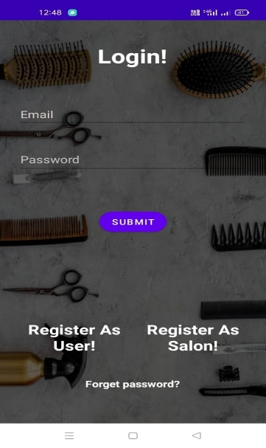

CONCLUSION
This system will help saloons to pitch their businesunderneath their space to expand their everyday business. This project also helps local vendors to show their presence globally on the internet and serve their customers with their art. In the salon and beauty industry, the Online Reservation System is suitable for use to reduce customer waiting time and experience a hassle-free environment.
ACKNOWLEDGMENT
Abstract Salon Book is a web-based salon management application with appointment scheduling functionality. It connects clients, salons, and stylists in an online community allowing users to browse salons and stylists, and book or cancel appointments.
REFERENCES
- Ms vikky chaudhary, “Smart Hair Salon Management System”PublishedSams Teach Yourself: PHP, MySQL, and APACHE by Julie Melony Number footnotes separately in superscripts. Place the actual footnote at the bottom of the column in which it was cited. Do not put footnotes in the reference list. Use letters for table footnotes.
- 1ADODB official website: http://adodb.sourceforge.net/
- Melon fire Web Articles about using ADODB:
- GoogleCalendar API: http://code.google.com/apis/calendar/docs/2.0/developers_guide_protocol.html# Melony
- http://www.melonfire.com/community/columns/trog/article.php?id=142&page=8,http://www.melonfire.com/community/columns/trog/article.php?id=144&page=7
- https://www.predictiveanalyticstoday.com/top-salon- spa-management-software/
- https://www.softwareworld.co/top-salon-software/

