Design Of Autoclave
Taufique T Ansari¹, Mahesh H Gupta², Ritesh D Maurya³, Rugved V Patil⁴
¹Mrs. Archana Gaikwad, Professor in Department of Mechanical Engineering
Lokmanya Tilak College Of Engineering, Navi Mumbai, India, 400709

Email of Corresponding Author:ansariat888@gmail.com

Received on: xxxx,20xx, Revised on: xxxx,20xx, Published on: xxxx,20xx

Abstract – Autoclave is known as Steam Sterilizers. The size of autoclave can vary depending on the capacity required and the application. The recommended temperatures for sterilization range between 121°C to 135°C, with the minimum exposure time required to kill microorganisms being determined by the manufacturer. In this paper, the main focus is to create a system in which the waste of material do not take place. By using the spiral binding process over the autoclave to reduce the adhesiveness of the material over the inside wall of the autoclave. It also include research methodology which shows the gap between the previous research and this research. Testing parameters such as design pressure, temperature, working pressure, temperature, and hydraulic test pressure are crucial before using an autoclave in an industrial setting. This paper involve 3-D Designing of Autoclave which was execute in Autodesk Fusion 360.
Keywords- Steam sterilizers; Autoclavable; Material Selection; Methodology
INTRODUCTION
An autoclave is a machine used to carry out processes that require elevated temperature and pressure, making it a versatile tool in various industries, including medical, chemical, and industrial applications. In the medical field, autoclaves are used to sterilize equipment and instruments before surgical procedures. In the chemical industry, autoclaves are used for curing coatings, vulcanizing rubber, and performing hydrothermal synthesis. Autoclaves are known as steam sterilizers. Autoclaves use steam as the sterilizing agent and the pressure inside the machine helps to increase the temperature of the steam, making it more effective at killing harmful microorganisms. The sterilization process in an autoclave is typically monitored using physical indicators such as temperature, pressure, and time. Some autoclaves also have biological indicators, which are used to confirm that the sterilization process was successful by testing for the presence of live microorganisms after the cycle is complete. In the healthcare industry, autoclaves are commonly used to sterilize medical instruments and supplies, such as surgical instruments, gowns, and drapes. The use of autoclaves is essential in preventing the spread of infections and diseases in healthcare facilities. In industrial applications, autoclaves are used to sterilize a wide range of items, including laboratory equipment, food and beverage containers, and industrial components. Overall, autoclaves play an important role in ensuring the safety and cleanliness of items in a variety of settings The manufacturer's instructions for use should always be followed to ensure that the sterilization process is effective. a widely used sterilant in autoclaves because of its reliability and effectiveness at killing microorganisms. Additionally, steam is considered safe for the staff operating the autoclave.
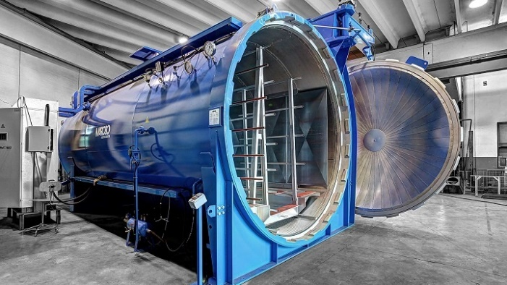
Fig. 1- Autoclave
It's also important to note that the door system of the autoclave plays a crucial role in ensuring the pressure inside the chamber is maintained during the sterilization process. Uniform temperature and pressure are essential for an effective sterilization process, as they help to ensure that the steam penetrates all parts of the items being sterilized, killing any harmful microorganisms present. Autoclaves are also used in the tire re-treading process to vulcanize tire treads to the casing of a used tire. Vulcanization is the process of heating rubber with sulfur and other agents to form cross-links between the polymer molecules, which results in a stronger and more durable material.
METHOLOGY
To attain the better result, using the following methodology in the flow chart shown in the Fig. 2,
Research Methodology
Mathematical Calculation of Autoclave
3D Model
Result & Conclusion
Fig. 2- Flow Chart (Methodology)

RESEARCH METHODOLOGY
Previous research papers, namely Evaluation of skin-core adhesion bond of out-of-autoclave. Authors R.R. Butukuri, K. Rupel, published on July, 2016.
In this research paper, an experiment was performed in which they have created a small size autoclave and they used some materials which have to processed to kill the microorganism and when the started the process, they face the problem of material adhesiveness over the inside wall of the autoclave due to which when the process we continue the other material also get effected and material get wasted.
Research Gap:
In this Research paper, we are trying to overcome the problem of adhesiveness of material over the inner wall of the autoclave. The process and the construction, working has been explained further.

DESIGN
Dimensions Of Autoclave:
Inside diameter of Autoclave, d = 2500 mm
Thickness of Autoclave = 45 mm
Outside diameter of Autoclave,
D = 2500 mm + 45 mm
= 2545 mm
Height of Autoclave, h = 2545 * 1.5
= 3818 mm
= 4 m
h = l m
Volume of the Autoclave$= π*r^{2}*h$
$= π*{\left(\frac{2500}{1000*2}\right)}^{2}*4$
$=20 m^{3}$
$=20KL$ ………. ($1{ m}^{3}=1000 l)$
Material Selection
Autoclave is equipment which operates under high pressure and temperature. The selection of the appropriate material for the construction of the autoclave chamber is critical, as it can impact the operation, safety, and durability of the equipment. While choosing material following parameters should be considered:-
- Cost
- Strength requirement for design temperature and pressure
- Ready market available
- Corrosion resistance
- Fabric ability
In addition to these factors, it's also important to consider any regulations and codes that may apply to the autoclave and its use, as these can dictate the specific material requirements. It's always best to consult with an expert in the field to ensure that the best material is chosen for your specific application.
Most engineers are willing to construct pressure vessels by plain carbon steel, low and high alloy steels, other alloys, clad plate and reinforced plastics. In this case we should focused on safety and economical factors to achieve goal.
- Plain Carbon Steel
1% carbon and small amounts of magnesium, silicon, sulfur, phosphorous except iron is present. Carbon content has an ability to decide weld ability and most of other characteristics of this steel. Plain carbon steel is divided into 4 groups as follow:-
Medium Plain Carbon Steel is the Selected Material
Low (Mild Steel):
- Have less than $0.3 \%$of carbon.
- Machining and welding can be done easily.
- More ductile
Medium:
- Contains $0.3 \%-0.45 \%$ Carbon.
- Hardness and tensile strength are greater than mild steel, but ductility and ability of machining is less.
High:
- Consists with $0.45 \%-0.74 \%$ carbon.
- Hard to weld and has to be pre heat, post heat or heating during welding.
Very High:
- Up to$1.5 \%$ of carbon
- Used to produced hard steel products and welding is not easy
Low alloy steel:
- Specially designed for welded application
- Carbon content is usually below 0.25 % and even sometimes less than 0.15 %
- Improve corrosion resistance
- But it negatively influences crack susceptibility

High alloy steel:
- Stainless steel
- Contains at least 12 % of chromium and higher nickel content
It’s like medium plan carbon steel is the most appropriate material for autoclave manufacturing based on the considerations mentioned above. The combination of its good welding properties, cost-effectiveness, and availability in the market, along with its high tensile strength and relatively low corrosion rate, makes it a good choice for the design requirements of the autoclave unit. However, it's important to note that the suitability of a material for a specific application can depend on various other factors such as the operating conditions, size and shape of the autoclave, and the specific design requirements. Therefore, it's always recommended to consult with a material expert or engineer to determine the most appropriate material for a given application.

Calculation of Design Temperature
The design temperature of a pressure vessel has a significant impact on its strength and behavior. Higher temperatures can result in a reduction in strength and a shift towards ductile behavior, while lower temperatures can lead to brittleness. The standard design temperature for most vessels is typically 50℉ (122℃) above the maximum working temperature to account for fluctuations in temperature and to ensure that the vessel remains within safe operating limits.
Design temperature = working temperature $+ 122℃$
Design Temperature = $125℃+122℃$
$=247℃$
Design Temperature$=247℃$

Calculation of Design Pressure
The curing chamber must be designed to withstand the maximum pressure to which it is likely to be subjected in operation. So some fair standard percentage is added to working pressure to obtain design pressure. Mostly that percentage is between 5 % - 10 %.
Design Pressure $=$ Working Pressure + 10% of working pressure
$=420+10\%×420$
$=462$ Kpa
Design Pressure$=462$ KPa

The maximum allowable stress or normal stress is a characteristic of a construction material, and it can vary with temperature. As the temperature increases, the design stress usually decreases, and as the temperature decreases, the design stress increases. This phenomenon is known as the temperature-stress relationship of a material. Above selected material ‘Medium Plain Carbon Steel.
Design Stress at design temperature $(247℃)$ by interpolation;
Selected Design Stress$=95.6 N/{mm}^{2}$
$200℃$ $105 N/{mm}^{2}$
$250℃$ $95 N/{mm}^{2}$
$247℃$ $95.6 N/{mm}^{2}$

Calculation of Hoop & Axial Stress
Thickness of the Autoclave is $45 mm$.

Hoop Stress

$$σ_{Hoop} =\frac{P ×d}{2t}$$

$=\frac{462000×2.5}{2×0.045}$

$=12.83 Mpa$

Axial Stress

$σ_{Axial} =\frac{P ×d}{4t}$

$=\frac{462000×2.5}{4×0.045}$

$=64.25 Mpa$
Therefore, design stress > Hoop & Axial stress
The Design stress is Safe.

THEORY, CONSTRUCTION & WORKING

In this Autoclave, there are two inlets and two outlets. From first inlet, the material will passed in the autoclave which has to be processed to kill the microorganism and from the first outlet the new fresh material will be collected. From the second inlet, viscous fluid will be passed which will produced heat and restrict the adhesiveness of the material on the inside wall of the autoclave. The spiral binding on the cylindrical wall is the passage of the viscous fluid which flowing inside.
Having such autoclave will be beneficial for the industry to reuse the material through processing and have good fresh material.

3D MODEL
The 3D Design model is made on Autodesk Fusion 360 Software using the dimension got from the calculations.
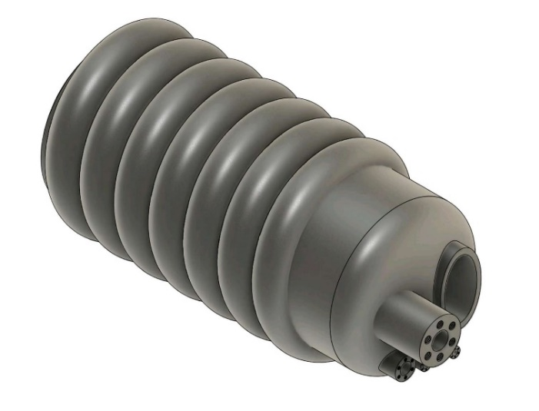
Fig. 3.1- 3D Model of Autoclave
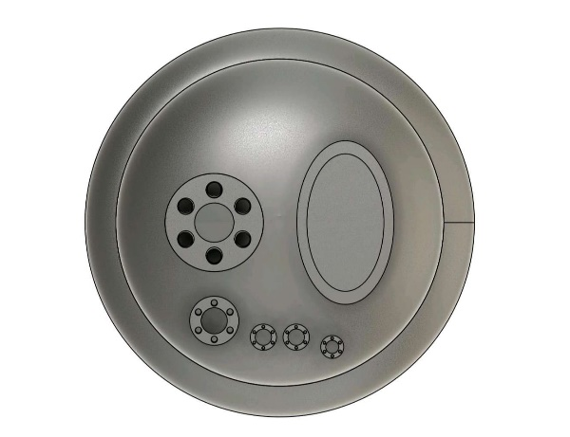
Fig.3.2- Front View of Autoclave

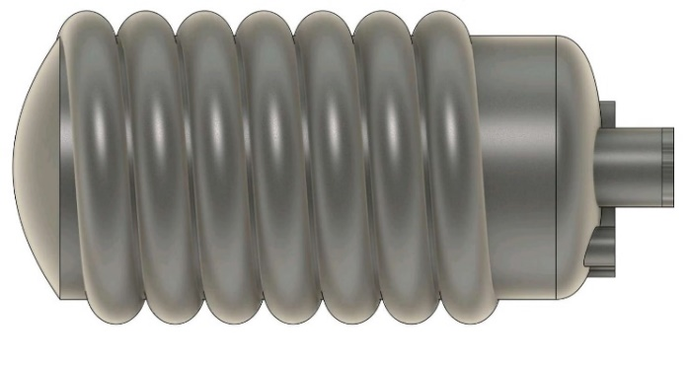
Fig. 3.3- Side View of Autoclave

RESULT
Graphical conclusion is extracted on SolidWorks platform of the parameters Temperature and pressure. Comparison of parameter is achieved between Inlet, Outlet, Ambient ⁰C in Autoclave.
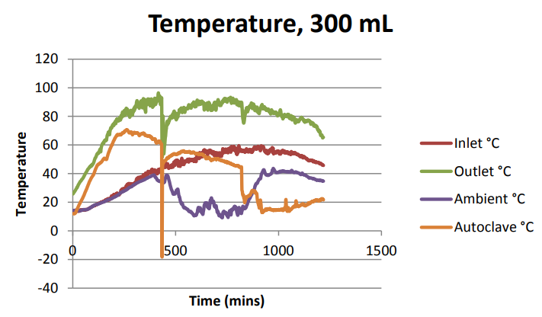
Fig. 4- Temperature v/s Time
In the above graph, the temperature of inlet, outlet, autoclave and ambient is shown. The Green line indicates the autoclave temperature, orange line indicates the autoclave inside temperature, red line indicates temperature of the viscous fluid flowing inside the spiral binding over the autoclave and blue line indicates the ambient temperature.
The graph indicates that due to the viscous fluid the inside temperature of autoclave increases because of which the adhesiveness of material decreases.

CONCLUSION

With this we demonstrated to overcome the problem of adhesiveness in autoclave and design have been successfully completed with Design calculations, 3D Model of the Autoclave and graphical conclusion.

REFERENCES
- Association for the Advancement of Medical Instrumentation. (2017). ANSI/AAMI ST79:2017 comprehensive guide to steam sterilization and sterility assurance in health care facilities.
- autoclave-sterilization-principle-working-pdf-ppt-autoclave-validation
- Autoclave material properties, process, phenomenon and manufacturing,

