A Crowd-Based Approach for the 'MGNREGA' Program to Support Tree Plantation in Bharat using Machine Learning

Pramod B Gosavi¹ , Dr. Girishkumar Patnaik²

¹Research Scholar, S S B T College of Engineering and Technology, Jalgaon,India,425001, gosavi.pramod@gmail.com,
²S S B T College of Engineering and Technology, Jalgaon,India,425001 ,patnaik.girish@gmail.com,

Received on: xxxx,20xx, Revised on: xxxx,20xx, Published on: xxxx,20xx

Abstract
Increasingly, Crowdsourcing involves harnessing the collective contributions of diverse individuals who may either volunteer or engage in part-time work for the purpose of socioeconomic production, primarily in the digital realm. The primary objective of the Mahatma Gandhi National Rural Employment Guarantee Act (MGNREGA) is to ensure livelihood security for individuals residing in rural areas. The utilization of Remote Sensing (RS) and Geographical Information System (GIS) offers a highly efficient approach for gathering, storing, and analyzing the assets associated with the MGNREGA. The suggested plantation system involves leveraging resources under the MGNREGA through a crowd-based approach. Machine Learning techniques help to identify area for tree Plantation. This approach entails referencing a database of various tree types suitable for different areas and locations across Bharat (India) for the purpose of tree plantation. Examples of such trees include Mango trees, Amrud (Guava) trees, Sitafal (Custard Apple), Anar (Pomegranate), Jamun (Java Plum), Chikoo (Sapodilla) trees, Peepal trees, Neem trees, and Vad (Banyan tree).

Keywords: MGNAREGA, Climate , Crowd-sourcing, Trees Plantation

I.Introduction

The term "crowdsourcing" was initially introduced in 2005 by Jeff Howe and Mark Robinson, who served as editors for Wired magazine. It gained further prominence a year later when Jeff Howe utilized it in one of his articles. The concept of "crowdsource" was first observed by Surowiecki in 2005, and his notion is summarized by the phrase "Many hands make light work." This idea was further supported by Majchrzak and Malhotra in 2013, who emphasized that crowdsourcing yields superior outcomes.

Surowiecki referred to the effective implementation of crowdsourcing methods as the "collection," which serves as a framework to guide and coordinate the efforts of freelancers. With the advancements in technology, this collection process can now be conducted in the digital realm. The fundamental principles of crowdsourcing involve delegating various tasks, including ideation, problem-solving, voting for the best solutions, and completing mini-tasks, to a diverse group of individuals.

II. LITERATURE REVIEW

The IT industry encompasses specific domains such as IT project management, web design, various development fields, database administration, programming, network administration, and more. These domains continually seek ways to enhance their services for customers and meet the growing global demand for IT. In this article, we will explore several key research questions, including:

- Who can participate in crowdsourcing?
- Why is crowdsourcing beneficial?
- What is the concept of crowdsourcing?

Throughout its history, Earth has experienced significant and devastating shifts in its climate, which have had profound effects on its geology, geography, and the evolution of life. Currently, our planet is once again undergoing detrimental climate changes. However, this time, the changes are primarily driven by human activities and are occurring at a much faster rate compared to natural events in the past [1].

The Mahatma Gandhi National Rural Employment Guarantee Act (NREGA) supports multiple initiatives aimed at assisting impoverished rural individuals in generating wage employment opportunities and creating productive assets. According to data available on NREGASoft, approximately 30 lakh assets are generated annually during a financial year under the Mahatma Gandhi NREGA. To enhance the management and understanding of these assets, the Ministry of Rural Development plans to utilize GIS solutions for visualizing, analyzing, and exploring the associated data.

Bharat (India) experiences the blessing of six distinct seasons, and the climate varies across all states of the country. The abundant variety of trees nurtured in Bharat serves various purposes, and comprehensive knowledge about each tree type, its uses, and benefits can be found in the literature of Bhartiya culture.

III. METHODOLOGY

Countries worldwide have committed to creating a new international climate agreement following the UNFCCC Conference of the Parties (COP21) in Paris in December 2015. India has also submitted its Nationally Determined Contribution (NDC) to the UNFCCC, outlining its post-2020 climate actions under the new agreement. India's NDC includes two key commitments:
- Creating an additional carbon sink of 2.5 to 3 billion tonnes of CO2 equivalent through increased forest and tree cover by 2030.
- Enhancing adaptation to climate change by investing in development programs in sectors vulnerable to climate change, such as agriculture, water resources, fisheries, health, disaster management, and in regions like the coastal and Himalayan regions.

The selection of climatic hotspots was based on temperature and precipitation changes compared to historical scenarios. A temperature hotspot was defined as a forested grid projected to experience a temperature rise of over 1.5°C compared to the 1860-1900 scenario, while a precipitation hotspot referred to a change in rainfall greater or less than 20\% compared to the 1960-1990 scenario [2].

Machine learning can be used to detect hotspot of pollution using satellite image by training an algorithm to identify patterns in the satellite imagery that are associated with pollution. This can be done by providing the algorithm with a training dataset of satellite images that have been labeled as either polluted or not polluted. The algorithm will then learn to identify the features in the images that are most predictive of pollution.

Once the algorithm has been trained, it can be used to classify new satellite images as either polluted or not polluted. This can be done by passing the new images through the algorithm and seeing which class it predicts. If the algorithm predicts that the image is polluted, then it is likely that the image contains a hotspot of pollution.

Here are the steps on how to use machine learning to detect hotspot of pollution using satellite image:
- Collect a training dataset of satellite images that have been labelled as either polluted or not polluted.
- Train a machine learning algorithm on the training dataset.
- Use the trained algorithm to classify new satellite images as either polluted or not polluted.
- Identify the areas that are most likely to be polluted by looking at the images that the algorithm has classified as polluted.
Here are some of the machine learning algorithms that can be used to detect hotspot of pollution using satellite image: Machine learning is a powerful tool that can be used to detect hotspot of pollution using satellite image. By training an algorithm on a dataset of labeled satellite images, it is possible to identify areas that are most likely to be polluted. This information can be used to improve air quality, protect public health, and plan environmental policies.

Once an area with high pollution levels is identified, it is selected for tree planting. The type of trees planted in this area will vary depending on the local climate and environment. Some trees, such as oxygen-producing trees, fruit-bearing trees, and herbal medicine trees, can help to improve air quality and combat climate change. The selection of the area for tree planting is based on a machine learning algorithm. This algorithm takes into account a variety of factors, such as pollution levels, soil quality, and climate conditions, to identify the most suitable areas for tree planting. The suggested areas for tree planting are then shared through the MANREGA-GIS platform.

Using Random Forest for Pollution Detection: Random Forest is a powerful machine learning algorithm commonly used for classification and regression tasks. Here's a step-by-step guide on how to use Random Forest for pollution detection:
- Data Preparation: Preprocess and clean dataset by handling missing values, removing irrelevant features, and encoding categorical variables if necessary. Split data into training and testing sets to evaluate the model's performance.
- Feature Selection: Analyze the features in dataset and select the relevant ones for pollution detection. Consider factors such as pollutant levels, weather conditions, geographical data, or any other variables that might contribute to pollution.
- Feature Engineering: Create new features or transform existing ones to improve the model's performance. This step involves tasks such as scaling numerical features, creating interaction terms, or extracting meaningful information from raw data.
- Training the Random Forest Model: Import the necessary libraries (such as scikit-learn in Python) and create a Random Forest model. Set the hyperparameters, such as the number of trees, maximum depth, and number of features considered at each split. Fit the model on the training data.
- Model Evaluation: Use the testing dataset to evaluate the performance of Random Forest model. Common evaluation metrics for classification tasks include accuracy, precision, recall, and F1 score. Adjust the hyperparameters if needed to improve the model's performance.
- Predictions: Once model is trained and evaluated, can use it to make predictions on new, unseen data. Provide the necessary input features related to pollution, and the model will output the predicted class or probability.
The Mahatma Gandhi NREGA GIS Solution aims to establish a comprehensive and unified asset information system covering rural areas across India. This will be achieved through a GIS-enabled portal, functioning as an e-Governance platform. The portal will serve as a gateway, facilitating the exchange and sharing of geospatial data among stakeholders at various jurisdictional levels within the spatial data community. It will enable users to search, locate, and publish geospatial data, while ensuring appropriate login authentication to maintain data security. This platform will cater to the diverse needs of user groups, allowing them to access, share, and publish geospatial data. The GIS-enabled portal will effectively manage, process, store, distribute, and enhance the utilization of geospatial data for planners, decision-makers, and the public [3].

A web-based management system, built on interactive web GIS technology, will be implemented to maintain comprehensive information regarding MGNREGA assets. This system will provide users with the capability to create new data, update existing data pertaining to assets, generate queries, and perform spatial queries such as buffering. Additionally, the system will enable users to generate reports, maps, and other relevant outputs for effective asset management and analysis. The interactive web GIS-based management system will serve as a valuable tool for managing and utilizing MGNREGA assets efficiently[3].

The Mahatma Gandhi NREGA Geographical Information System refer Fig. 1, encompasses a wide range of tasks and responsibilities, including:
- Capturing satellite image of area and detecting area for tree plantation using machine learnging.
- Geo-referencing satellite images and scanned images by assigning real-world coordinates to them.
- GIS mapping, which involves creating digital data for assets across rural India as specified in Schedule I of the MGNREGA Act.
- Designing and developing a centralized GIS data model that can store both spatial and attribute information.
- Facilitating the periodic capturing, updating, and maintenance of existing asset information using a Mobile GIS platform.
- Geotagging images and integrating them with the corresponding assets.
These activities collectively contribute to the effective implementation and management of geospatial data within the Mahatma Gandhi NREGA framework.

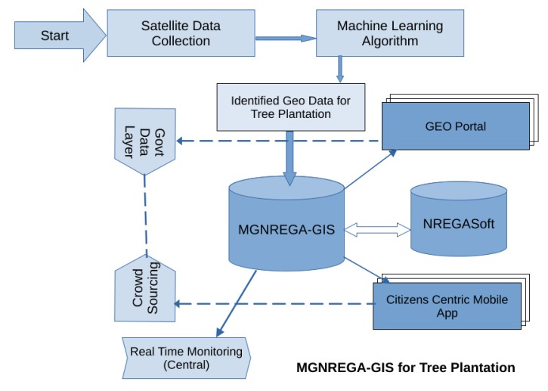
Fig 1. MGNREGA-GIS for Tree Plantation

Henry et al. state that, The primary goal of this study is to address the question of "who should be involved in crowdsourcing?" It is important to note that crowdsourcing is not limited to businesses alone, as indicated by the inclusive definition provided by Estellés-Arolas and González-Ladrón-de-Guevara in 2012. Crowdsourcing refers to a participatory online movement where individuals, organizations, non-profit associations, or establishments invite a diverse and numerous group of people with various expertise through an open call to voluntarily engage in a task. Participants in crowdsourcing often find satisfaction through financial rewards, social recognition, personal esteem, and skill advancement, while the entity seeking crowd contributions benefits from utilizing their goods or services [1].

- Mahatma Gandhi NREGA workers: These individuals will benefit from the solution by receiving information about work availability in nearby locations, as well as real-time transparent attendance and payment information. They will also have access to work site location details, which will aid them in finding suitable employment opportunities.
- Citizens: The implementation of the Geo Portal for MGNREGA assets will generate demands, suggestions, critiques, and data from both citizens and the agencies involved. This will enable concurrent social audits by citizens and provide feedback on work quality validation and other aspects to the District Programme Coordinators (DPC) and State Government responsible for implementing the program.
- Central Government/State Government/PRIs/Other PIAs/District Programme Coordinators/Programme Officers: These stakeholders will benefit from the incorporation of geo-fencing of assets. Triggers can be set up to send text messages or email alerts when government officers with GPS-enabled devices enter or exit the boundaries of MGNREGA assets. The web management system will display the geographical locations of assets on a map, allowing all stakeholders to access this information. The Geo-NOC (Geographical Network Operations Center) will facilitate asset audit and management.
IV. RESULT

The Table 1, shows that the majority of work allotted in Maharashtra state is completed within the stipulated time.

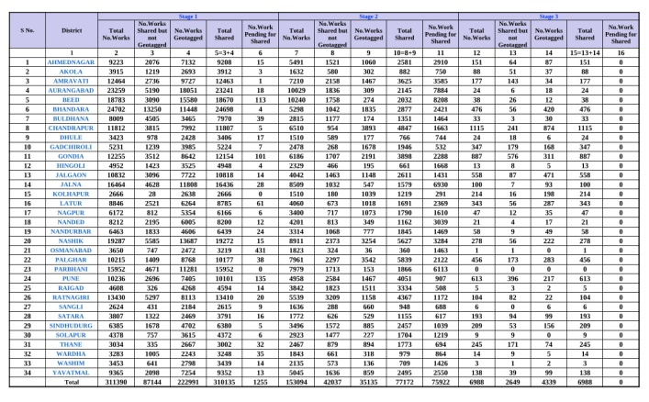
Table 1. Maharashtra state work allotment chart

The country's total tree cover has been calculated to be 95,748 square kilometers, representing an increase of 721 square kilometers compared to the previous assessment conducted in 2019. The estimated standard error of the national tree cover is 4.01%. At the state level, the standard error ranges from 2.23% to 16.49%. Maharashtra has the highest tree cover with an extent of 12,108 square kilometers, followed by Rajasthan (8,733 sq km), Madhya Pradesh (8,054 sq km), Karnataka (7,494 sq km), and Uttar Pradesh (7,421 sq km).

The ISFR 2021 report highlighted the importance of addressing climate change through a targeted model for 2030, 2050, and 2085. One of the recommended strategies is to increase tree cover, which can have a positive impact on reducing atmospheric temperatures. To achieve this significant increase in tree cover, the MGNREGA-GIS system can be a valuable tool. By utilizing machine learning algorithms, the system can analyze suitable areas for reforestation. Additionally, a crowd-sourced approach can be employed to distribute the task of tree plantation. The selection of tree types and plantation locations is based on factors such as state, climate, and soil conditions[3].

The tree cover in India has been increasing over the past five biennial assessments. In the 2011 assessment, the tree cover was 90,844 square kilometers. In the most recent assessment, the tree cover has increased to 95,748 square kilometers, an increase of 4,904 square kilometers over the past decade. This represents a significant increase in tree cover, and is a positive sign for the country's forests[3].

V. DISCUSSION

The Mahatma Gandhi National Rural Employment Guarantee Act (MGNREGA) has been successfully implemented in India. The act provides employment to rural people, and has been used to plant trees in many areas. The use of machine algorithms to detect areas suitable for tree plantation has helped to increase the effectiveness of the MGNREGA program.

The use of machine algorithms has allowed the government to identify areas that are most suitable for tree plantation. This has led to an increase in the number of trees planted, and an improvement in the quality of the tree cover. It is estimated that the tree cover in India could increase by 100% in the coming decade,

Acknowledgments
The authors would like to express their sincere gratitude to Forest Survey of India, Ministry of Environment, Forest & Climate Change, provide online State of Forest Report 2021, also The Mahatma Gandhi National Rural Employment Gurantee Act 2005 under Ministry of Rural Development, Government of India provide online Reports.

Reference
[1] Henry Oluchukwu Ikediego, Mustafa Ilkan, A. Mohammed Abubakar, Festus Victor Bekun, Crowd-sourcing (who, why and what), Dogu Akdeniz Universitesi, Famagusta, Cyprus, International Journal of Crowd Science, Vol. 2 No. 1, 2018, pp. 27-41, Emerald Publishing Limited 2398-7294 DOI 10.1108/IJCS-07-2017-0005}
[2] ISFR 2021, Published by Forest Survey of India, Ministry of Environment Forest and Climate Change, Chapter 11 Mapping of Climate Change Hotspot in India Forest. \url{https://fsi.nic.in/isfr-2021/chapter-11.pdf} referred in June 2023
[3] GEOMGNREGA, Standard Operating Manual (Pilots & Wave-1) in partnership with National Remote Sensing Centre, ISRO, & CGARD(Centre for Geoinformatics Application in Rural Development), National Institute of Rular Development and Panchayati Raj.

