Critical review on curing in Concrete
Amit Kumar Dewangan ¹, Dr. Lokesh Singh², Virat Kantode³, Pritam Verma⁴
Department of Civil Engineering

R. S. R. Rungta college of engineering and technology, Kohka, Bhilai, Durg, Chhattisgarh, India 490020

A b s t r a c t –

This paper presents different types of curing. Curing has important for regaining moisture losses in concrete for doing proper hydration of cement without curing concrete dose not gain its full strength and generate some minor cracks which make concrete weak. Curing are divided into four types and they are: Water curing, Application of heat, Membrane curing, Miscellaneous Water Curing. Water curing are divided into 4 sub type and they are: Immersion, Pounding, Spraying or Fogging, Wet covering. Curing by Application of heat has Four sub types Steam curing at ordinary pressure, Steam curing at high pressure, Curing by Infra-red radiation, Electrical curing. Miscellaneous Water Curing has 3 types curing by Calcium chloride, Moist Sand Curing and Air Curing.

K e y w o r d s –

Concrete, Curing, Curing method, Water curing, Application of heat, Membrane curing,, Immersion, Membrane curing, Plastic Sheeting method.

INTRODUCTION
Curing is the maintenance of a satisfactory moisture content and temperature in concrete for a period of time immediately following placing and finishing so that the desired properties may develop. The need for adequate curing of concrete cannot be overemphasized. Curing has a strong influence on the properties of hardened concrete; proper curing will increase durability, strength, water-tightness, abrasion resistance, volume stability, and resistance to freezing and thawing and deicers. Exposed slab surfaces are especially sensitive to curing as strength development and freeze-thaw resistance of the top surface of a slab can be reduced significantly when curing is defective.
Curing plays an important role on strength development and durability of concrete. Curing takes place immediately after concrete placing and finishing, and involves maintenance of desired moisture and temperature conditions, both at depth and near the surface, for extended periods of time. Properly cured concrete has an adequate amount of moisture for continued hydration and development of strength, volume stability, resistance to freezing and thawing, and abrasion and scaling resistance [12].
The objective of curing is to keep concrete saturated or as nearly wet to assist the hydration of cement. The rate and degree of hydration, and the resulting strength of concrete and other properties, depend on the curing process that follows placing and consolidation of the plastic concrete. Hydration of cement continues for years at a decreasing rate as long as the mixture contains water and the temperature conditions are favorable. Once the water is lost, hydration ceases.
When portland cement is mixed with water, a chemical reaction called hydration takes place. The extent to which this reaction is completed influences the strength and durability of the concrete. Freshly mixed concrete normally contains more water than is required for hydration of the cement; however, excessive loss of water by evaporation can delay or prevent adequate hydration. The surface is particularly susceptible to insufficient hydration because it dries first. If temperatures are favorable, hydration is relatively rapid the first few days after concrete is placed; however, it is important for water to be retained in the concrete during this period, that is, for evaporation to be prevented or substantially reduced.
With proper curing, concrete becomes stronger, more impermeable, and more resistant to stress, abrasion, and freezing and thawing. The improvement is rapid at early ages but continues more slowly thereafter for an indefinite period.
The most effective method for curing concrete depends on the materials used, method of construction, and the intended use of the hardened concrete. For most jobs, curing generally involves applying curing compounds, or covering the freshly placed and finished concrete with impermeable sheets or wet burlap. In some cases, such as in hot and cold weather, special care using other precautions is needed. The curing period may depend on the properties required of the concrete, the purpose for which it is to be used, and the ambient conditions, ie the temperature and relative humidity of the surrounding atmosphere
Curing is designed primarily to keep the concrete moist, by preventing the loss of moisture from the concrete during the period in which it is gaining strength. Curing may be applied in a number of ways and the most appropriate means of curing may be dictated by the site or the construction method.
Curing of concrete is very essential for its strength gain and durability. Proper curing becomes very difficult under hot weather conditions as low humidity and high ambient temperature greatly assist in the evaporation of the mix-water. Concrete is generally cured by water pounding. However, membrane-forming curing compounds are also utilized for this purpose. Curing compounds are utilized in situations where curing by water ponding is not practical. However, with increasing scarcity of water, there is pressure on the construction industry to decrease its water consumption. This problem is more acute in countries where natural sources of water are scarce and it has to be obtained from other sources, such as desalination of the seawater.

In general, curing ensures that the mix water is available for cement hydration. A minimum of 80% humidity is required for hydration of cement. Moreover, he suggested that the permeability of the surface concrete may increase five to ten folds if concrete is insufficiently cured. High wind and temperature increases the drying of concrete skin. Therefore, the recommendations of ACI Committee 305 regarding minimizing the rate of water evaporation, such as lowering concreting temperature, increasing the humidity by water spraying, and erecting wind barriers, should be adopted. The protection of concrete against corrosion of steel, which is mainly due to the ingress of chloride ions, is greatly decreased with an increase in the period of curing.

Curing becomes even more important if it contains supplementary cementing materials, such as fly ash, ground granulated blast furnace slag, or silica fume, and it is subjected to hot and dry environments immediately after placement and consolidation. However concretes moist cured for only two days exhibited significant improvement in strength and other characteristics, as compared with concrete without any curing. Concrete is mostly cured by covering it with wet burlap. In some cases it is also done by coating the freshly cast surface with a curing compound. The curing compound acts as a barrier coating and does not allow the mix water to evaporate from the concrete in case of dry conditions prevailing on the surface of concrete. In some cases a curing compound is applied after initial water curing for a certain period of time.

The most effective method of curing is to keep the exposed concrete surfaces continuously moist by pounding or spraying with water. In this method, the concrete is kept fully saturated during the period, the ideal condition for strength development and hydration of cement. Another curing method is to cover the surface with an impermeable sheet, such as polyethylene.

Curing Methods: Curing methods may be divided broadly into four categories:
(1)Water curing
- Immersion
- Pounding
- Spraying or Fogging
- Wet covering
(2) Application of heat
- Steam curing at ordinary pressure.
- Steam curing at high pressure
- Curing by Infra-red radiation
- Electrical curing.
(3) Membrane curing
- Using polyphone sheets
(4) Miscellaneous Water Curing
- curing by Calcium chloride,
- Moist Sand Curing
- Air Curing

(1) Water curing
Water curing is carried out by supplying water to the surface of concrete in a way that ensures that it is kept continuously moist. The water used for this purpose should not be more than about 5°C cooler than the concrete Surface. Spraying warm concrete with cold water may give rise to thermal shock that may cause or contribute to cracking. Alternate wetting and drying of the concrete must also is avoided as this causes volume changes that may also contribute to surface crazing and cracking [20] Several methods of water curing are described below:

(a) Immersion
(b) Pounding
(c) Spraying or Fogging
(d) Wet covering
(a) Immersion curing: Immersion curing with water consists of total immersion of the hardened concrete element. This method is commonly used in the laboratory for curing the concrete specimens. This method of curing satisfies all the requirements of curing, namely, promotion of hydration, elimination of shrinkage and absorption of heat of hydration. It is pointed out that if the membrane method is adopted, it is enviable that a certain extent of water curing is done before the concrete is covered with membranes. The precast concrete items are normally immersed in curing tanks for certain period. In some cases, wet coverings such as wet gunny bags, hessian cloth, jute matting are wrapped to vertical surface for keeping the concrete wet [9].
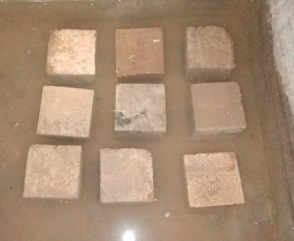
Fig.-1 Immersion curing

(b) Pounding: Pounding On flat surfaces, such as pavements and floors, concrete can be cured by pounding. Earth or sand dikes around the perimeter of the concrete surface can retain a pond of water. Pounding is an ideal method for preventing loss of moisture from the concrete; it is also effective for maintaining uniform temperature in the concrete. The curing water should not be more than about 11°C (20°F) cooler than the concrete to prevent thermal stresses that could result in cracking. Since pounding requires considerable labor and supervision, the method is generally used only for small jobs [20].
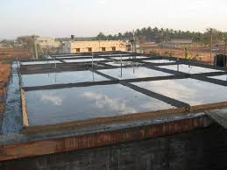
Fig.-2 Cuing by Pounding

(c) Fogging and Sprinkling: Fogging and sprinkling with water are excellent methods of curing when the ambient temperature is well above freezing and the humidity is low. A fine fog mist is frequently applied through a system of nozzles or sprayers to raise the relative humidity of the air over flatwork, thus slowing evaporation from the surface. Fogging is applied to minimize plastic shrinkage cracking until finishing operations are complete. Once the concrete has set sufficiently to prevent water erosion, ordinary lawn sprinklers are effective if good coverage is provided and water runoff is of no concern. Soaker hoses are useful on surfaces that are vertical or nearly soothe cost of sprinkling may be a disadvantage. The method requires an ample water supply and careful observation. If sprinkling is done at intervals, the concrete must be prevented from drying between applications of Fogging and sprinkling Burlap must be free of any substance that is harmful to concrete or causes discoloration [21].
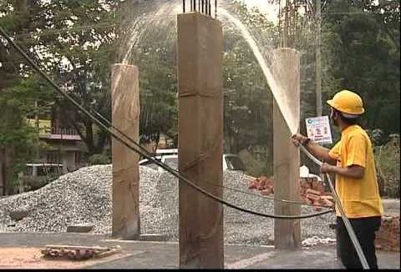
Fig.-3 Cuing by Fogging and Sprinkling

(d) Wet Coverings: It is most often used curing method in the construction industry. In this method moisture retaining fabrics such as burlap cotton mats and rugs are used as wet covering to keep the concrete in a wet condition during the curing period, for if the drying is permitted, the cover will itself absorb the water from the concrete. Alternative cycles of wetting and drying during the early period of curing will cause cracking of the surface. The major disadvantage of this method is discoloring of concrete [26].
In India wet coverings such as wet gunny bags, jute matting, straw etc., are wrapped to vertical surface for keeping the concrete wet. For horizontal surfaces saw dust earth or sand are used as wet covering to keep the concrete in wet condition for a longer time.

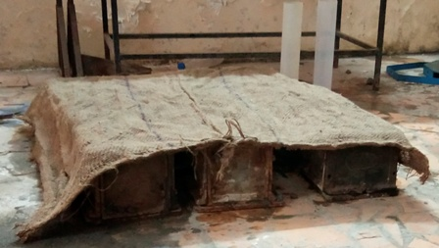

Fig.-4 Curing by Wet Covering

(2) Application of heat:

In the modern factory production of concrete products it is frequently desirable to hasten the curing process. This necessity arises generally for two reasons: firstly to release moulds and pallets as quickly as possible and secondly to put the finished article on the market as soon as feasible to avoid having to provide extensive storage space. Although some acceleration of setting and hardening can be achieved by chemical means, steam curing is more effective and more susceptible to accurate control [14].
The development of strength of concrete is a function of not only time but also that of temperature. When concrete is subjected to higher temperature it accelerates the hydration process resulting in faster development of strength. Concrete cannot be subjected to dry heat to accelerate the hydration process as the presence of moisture is also an essential requisite. Therefore, subjecting the concrete to higher temperature and maintaining the required wetness can be achieved by subjecting the concrete to steam curing [13].

(a) Steam curing at ordinary pressure: Steam curing at atmospheric pressure is one of the techniques for obtaining high early strengths in concrete especially in precast concrete production This technique enables early removal of shuttering and facilitates early vacating of the pre-stressing bed in precast industry providing a major economic advantage as well. It also aids in faster and safer construction as sufficient strength is attained in short period and maintained without any other form of curing [15].
This method of curing is often adopted for prefabricated concrete elements. Application of steam curing to in situ construction will be a little difficult task. However, at some places it has been tried for in situ construction by forming a steam jacket with the help of tarpaulin or thick polyethylene sheets. But this method of application of steam for in situ work is found to be wasteful and the intended rate of development of strength and benefit is not really achieved.
Steam curing at ordinary pressure is applied mostly on prefabricated elements stored in a chamber. The chamber should be big enough to hold a day’s production. The door is close and steam is applied. The steam may be applied either continuously or intermittently. A accelerated hydration takes place at this higher temperature and the concrete products attain the 28 days strength of normal concrete in about 3 days. In India, steam curing is often adopted for precast elements, specially prestressed concrete sleepers. Concrete sleepers are being introduced on the entire Indian Railway. For rapid development of strength, they use special type of cement namely IRST 40 and also subject the sleepers to steam curing. Large number of bridges are being built for infrastructural development in India. There are requirements for casting of innumerable precast prestressed girders. These girders are steam cured for faster development of strength which has many other associated advantages.

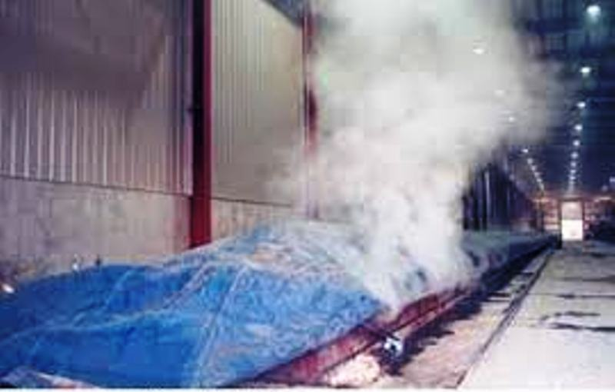
Fig.-5 Steam curing at ordinary pressure

(b) High Pressure Steam Curing : In the steam curing at atmospheric pressure, the temperature of the steam is naturally below 100°C. The steam will get converted into water, thus it can be called in a way, as hot water curing. This is done in an open atmosphere. The high pressure steam curing is something different from ordinary steam curing, in that the curing is carried out in a closed chamber. The superheated steam at high pressure and high temperature is applied on the concrete. This process is also called “Autoclaving”. The autoclaving process is practiced in curing precast concrete products in the factory, particularly, for the lightweight concrete products. In India, this high pressure steam curing is practiced in the manufacture of cellular concrete products, such as Siporex, Celcrete etc [13].

The following advantages are derived from high pressure steam curing process:

(a) High pressure steam cured concrete develops in one day, or less the strength as much as the 28 days strength of normally cured concrete.
(b) High pressure steam cured concrete exhibits higher resistance to sulphate attack,
freezing and thawing action and chemical action. It also shows less efflorescence.
(c) High pressure steam cured concrete exhibits lower drying shrinkage, and moisture
Movement
Disadvantages of High Pressure Steam Curing :

1. Steam curing method cannot be applied in large surface.
2. It is costly as curing is done in temperature above 22°C.
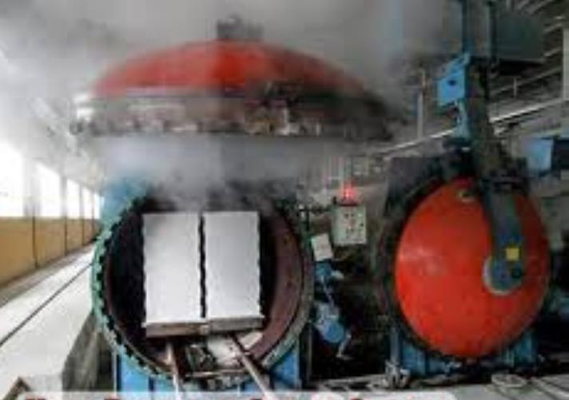
Fig.-6 High Pressure Steam Curing
(c) Curing by Infra-red Radiation : Curing of concrete by Infra-red Radiation has been practiced in very cold climatic regions. It is claimed that much more rapid gain of strength can be obtained than with steam curing and that rapid initial temperature does not cause a decrease in the ultimate strength as in the case of steam curing at ordinary pressure. The system is very often adopted for the curing of hollow concrete products. The normal operative temperature is kept at about 90°C [13].
Infrared radiation curing is different phenomenon compared to thermal curing. Infrared radiation is directly incident on the top surface of the composite laminate to be cured and the inner layers are heated by conduction of heat from the top layer. Since the laminate receives heat simultaneously from all the sides of the laminate as it is a volumetric heating process and thereby uniformly heating the entire laminate. Infrared radiation is transparent to the medium of air in between the infrared source and the laminate. It is ideally suited for flat surfaces. The losses are minimized and it is an energy efficient method [25].

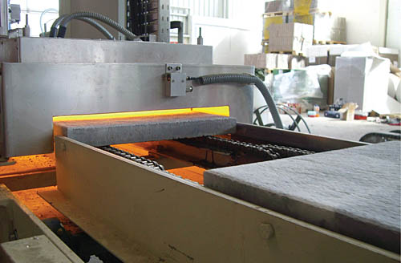

Fig.-7 Curing by Infra-red Radiation

(d) Electrical Curing: Another method of curing concrete, which is applicable mostly to very cold climatic regions is the use of electricity. This method is not likely to find much application in ordinary climate owing to economic reasons. Concrete can be cured electrically by passing an alternating current (Electrolysis trouble will be encountered if direct current is used) through the concrete itself between two electrodes either buried in or applied to the surface of the concrete. Care must be taken to prevent the moisture from going out leaving the concrete completely dry.
Concrete is not conductive but it can show a conductive feature until it gets its final setting time since it includes water. Furthermore, additive minerals in concrete can change in terms of electrical resistivity of concrete. Different methods have been developed to measure electrical conductivity of mortars and various researches and applications which examine cement’s microstructure developments have been carried out. Electrical conductivity of concrete in cement based systems can be explained through the ion movement in space. It is considered that electrical conductivity is related with both porosity and conductivity of space amount. Free space water which is in the gaps of the mixture is used in the chemical reactions for producing hydration products and in hydrolysis for conducting electric current. Therefore, by increasing water and binder amount, hydrolysis reaction is accelerated [17].

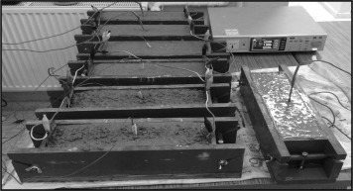
Fig.-8 Curing by Electrical Conductivity

(3) Membrane Curing:
Sometimes, concrete works are carried out in places where there is acute shortage of water. The lavish application of water for water curing is not possible for reasons of economy. It has been pointed out earlier that curing does not mean only application of water, it means also creation of conditions for promotion of uninterrupted and progressive hydration. It is also pointed out that the quantity of water, normally mixed for making concrete is more than sufficient to hydrate the cement, provided this water is not allowed to go out from the body of concrete. For this reason, concrete could be covered with membrane which will effectively seal off the evaporation of water from concrete. It is found that the application of membrane or a sealing compound, after a short spell of water curing for one or two days is sometimes beneficial [13].
Sometimes, concrete is placed in some inaccessible, difficult or far off places. The curing of such concrete cannot be properly supervised. The curing is entirely left to the workmen, who do not quite understand the importance of regular uninterrupted curing. In such cases, it is much safer to adopt membrane curing rather than to leave the responsibility of curing to workers.
Large number of sealing compounds have been developed in recent years. The idea is to obtain a continuous seal over the concrete surface by means of a firm impervious film to prevent moisture in concrete from escaping by evaporation. Sometimes, such films have been used at the interface of the ground and concrete to prevent the absorption of water by the ground from the concrete. Some of the materials, that can be used for this purpose are bituminous compounds, polyethylene or polyester film, waterproof paper, rubber compounds etc [13].
Liquid membrane-forming compounds consisting of waxes, resins, chlorinated rubber, and other materials cane used to retard or reduce evaporation of moisture from concrete. They are the most practical and most widely used method for curing not only freshly placed concrete but also for extending curing of concrete after removal of forms or after initial moist curing [21].

Bituminous compound being black in colour, absorbs heat when it is applied on the top surface of the concrete. This results in the increase of temperature in the body of concrete which is undesirable. For this purpose, other modified materials which are not black in colour are in use. Such compounds are known as “Clear Compounds”. It is also suggested that a lime wash may be given over the black coating to prevent heat absorption.
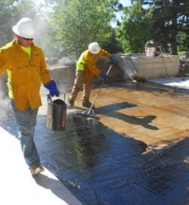
Fig.-8 Curing by Bituminous compound

Membrane curing is a good method of maintaining a satisfactory state of wetness in the body of concrete to promote continuous hydration when original water/cement ratio used is not less than 0.5. To achieve best results, membrane is applied after one or two days’ of actual wet curing. Since no replenishing of water is done after the membrane has been applied it should be ensured that the membrane is of good quality and it is applied effectively. Two or three coats may be required for effective sealing of the surface to prevent the evaporation of water [13].
(a) Plastic sheeting: Plastic sheets, or other similar material, form an effective barrier against water loss, provided they are kept securely in place and are protected from damage. Their effectiveness is very much reduced if they are not kept securely in place. The movement of forced draughts under the sheeting must be prevented.
They should be placed over the exposed surfaces of the concrete as soon as it is possible to do so without marring the finish. On flat surfaces, such as pavements, they should extend beyond the edges of the slab for some distance, eg or at least twice the thickness of the slab, or be turned down over the edge of the slab and sealed.
For flat work, sheeting should be placed on the surface of the concrete and, as far as practical, all wrinkles smoothed out to minimize the mottling effects (hydration staining), due to uneven curing, which might otherwise occur. Flooding the surface of the slab under the sheet can be a useful way to prevent mottling. Strips of wood, or windrows of sand or earth, should be placed across all edges and joints in the sheeting to prevent wind from lifting it, and also to seal in moisture and minimize drying.
For decorative finishes or where colour uniformity of the surface is required sheeting may need to be supported clear of the surface if hydration staining is of concern. This can be achieved with wooden battens or even scaffolding components, provided that a complete seal can be achieved and maintained. For vertical work, the member should be wrapped with sheeting and taped to limit moisture loss. As with flatwork, where colour of the finished surface is a consideration, the plastic sheeting should be kept clear of the surface to avoid hydration staining.
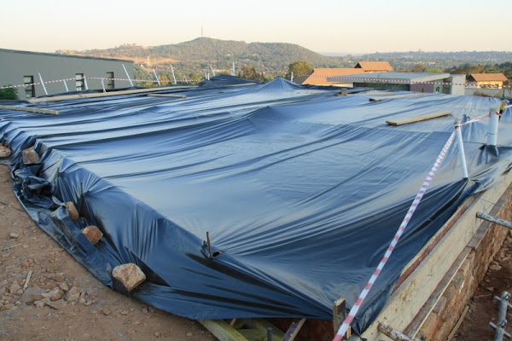
Fig.-9 Membrane curing by using Plastic sheeting
Care must also be taken to prevent the sheeting being torn or otherwise damaged during use. A minimum thickness is required to ensure adequate strength in the sheet. Plastic sheeting may be clear or coloured. Care must be taken that the colour is appropriate for the ambient conditions. For example, white or lightly coloured sheets reflect the rays of the sun and, hence, help to keep concrete relatively cool during hot weather. Black plastic, on the other hand, absorbs heat to a marked extent and may cause unacceptably high concrete temperatures. Its use should be avoided in hot weather, although in cold weather its use may be beneficial in accelerating the rate at which the concrete gains strength. When waterproofing paper or polyethylene film are used as membrane, care must be taken to see that these are not punctured anywhere and also see whether adequate lapping is given at the junction and this lap is effectively sealed.
Clear plastic sheeting tends to be more neutral in its effect on temperature (except in hot weather, where it fails to shade the surface of the concrete) but tends to be less durable than the coloured sheets, thereby reducing its potential for re-use.
Plastic sheets such as polyethylene film are used to cure concrete. Polyethylene films are lightweight, impervious hence prevent the moisture movement from the concrete and can be applied to simple as well as on complex shapes. Major disadvantage of this type of curing is that it causes patchy discoloration especially if the concrete contains calcium chloride. Discoloration is more pronounced when the film develops wrinkles and it is difficult and time consuming on a large project to place the sheets without wrinkles [26].
Md. Safuddin el at [8] Wrapping curing is more efficient than dry-air curing as it results in greater compressive strength, ultrasonic pulse velocity and dynamic modulus of elasticity and lower surface absorption. This is because wrapped curing moisture movement from the concrete surface was hindered due to the impervious layer for the film and as a result good amount of moisture was available to be used throughout the hydration process [26].
(4) Miscellaneous Water Curing:
(a) Calcium chloride: It is used either as a surface coating or as an admixture. It has been used adequately as a curing medium. Both these methods are based on the fact that calcium chloride being a salt shows similarity for moisture. The salt not only absorbs dampness from atmosphere but also retains it at the surface. This moisture held at the surface prevents the mixing water from evaporation and thereby keeps the concrete wet for a long time to stimulate hydration. Formwork prevents escaping of moisture from the concrete, mainly, in the case of beams and columns. Keeping the form work essential and sealing the joint with wax or any other sealing compound prevents the evaporation of moisture from the concrete [1].

(b) Moist Sand Curing: This involved burying the entire concrete cube specimens in wet sand which was kept moist by wetting with water on a daily basis. Sand has Good water absorption capacity so that sand make concrete wet all day.

(c) Air Curing: This served as the control. It involved no form of active curing by just exposing the specimens to ambient air in the Laboratory.

Summary- Curing is the process of maintaining water content in cement for completing the hydration process. If curing is not done properly than concrete is not gaining proper strength and cracks may be develop. There are different types of curing method present which are mainly based on the consumption of water, in traditional curing method process lots of fresh water has been wastage for making concrete wet for several days. In present days world are facing water crises and curing needs lots of fresh water and we have limited fresh water, so we have to find alternate Curing method because in tradition method use lots of fresh water, in county like U. A. E. fresh water is too expensive and unavailable, India has also facing water problem ground water table are continuously going down.
REFERENCES

- Ankita V.Kalbande, Anand G.Chavan, Feroz H. Khan- Membrane Curing Of Concrete
- Er. Rajesh Sharma, Dr. Hemant Sood- Effect of Curing Methods on Various Concrete Grades
- Akinwumi, I.I., Gbadamosi, Z.O. - Effects of Curing Condition and Curing Period on the Compressive Strength Development of Plain Concrete
- Manish A. Kewalramani- Environmentally Sustainable Concrete Curing with Coloure Polythene Sheets
- J. Wang, R. K. Dhir, M. Levitt- Membrane curing of concrete: moisture loss
- R. L'Hermite- Polyethylene film as concrete curing material in a tropical climate
- O. James ,P.N.Ndoke and S.S.Kolo - Effect of different curing methods on the compressive strength of concrete
- Md. Safiuddin, S.N. Raman and M.F.M. Zain - Effect of Different Curing Methods on the Properties of Microsilica Concrete
- D.Gowsika, P.Balamurugan, R.Kamalambigai- Experimental Study on Curing Methods of Concrete
- Dr. K.V.Krishna Reddy - A Comparative Study on Methods of Curing Concrete –Influence of Humidity
- M. Ibrahim, M. Shameem, M. Al-Mehthel, M. Maslehuddin- Effect of curing methods on strength and durability of concrete under hot weather conditions
- By Jerzy Z. Zemajtis, Ph.D., PE (WA)- Role of Concrete Curing
- M.S. SHETTY– Concrete technology theory and practice
- R. W. Nurse- Steam curing of concrete
- Pratik Deogekar, Ashwini Jain, Sudhanshu Mishra, Prakash Nanthagopalan- Influence of Steam Curing Cycle on Compressive strength of Concrete
- A.S. Al-Gahtani- Effect of curing methods on the properties of plain and blended cement concretes
- Tayfun Uygunog˘lu, Ismail Hocaog˘lu- Effect of electrical curing application on setting time of concrete with different stress intensity
- Magda I. Mousa a, Mohamed G. Mahdy a, Ahmed H. Abdel-Reheem a, Akram Z. Yehia- Self-curing concrete types; water retention and durability
- A. Arafah, R. Al-Zaid and M. Al-Haddad- Influence of non-standard curing on the strength of concrete in arid areas
- Ajay Goel, Jyoti Narwal, Vivek Verma, Devender Sharma, Bhupinder Singh- A Comparative Study on the Effect of Curing on The Strength of Concrete
- Shaikh A.S., Lahare P.S., Nagpure V.B, Ghorpde S.S- Curing of Concret
- T. James, A. Malachi, E.W. Gadzama, V. Anametemfioka- Effect of curing methods on the compressive strength of concrete
- Emmanuel Nana Jackson1 , Benjamin Boahene Akomah- Comparative Analysis of The Strength of Concrete With Different Curing Methods In Ghana
- Prerna Tighare, Mr. R. C. Singh- Study of Different Methods of Curing of Concrete & Curing Periods
- P. Kiran kumar, N V Raghvendra, B K Sridhara- Development of infrared radiation curing system for fiber reinforced polymer composites: An experimental investigation
- Nirav R Kholia, Prof. Binita A Vyas, Prof. T. G. Tank- Effect on concrete by different curing method and efficiency of curing compounds.

