Role Model Village Concept for Sustainable Rural Development

Bhushan R. Ambade¹, D. K. Parbat², A. W. Pawde³

^{1,2,3}Department of Civil Engineering,
Govt. Polytechnic, Brahmaputra, Maharashtra (India)
bhushan150169@gmail.com, parbatdk@gmail.com, awpawde@gmail.com

Received on: 15 December, 2022 Revised on: 12 January,2022 Published on: 14 January,2022

Abstract – In addition to development of the country, development of the people of the country is very important for improving human development index. In India about 68 % populations residing in rural areas whereas, after a long period of independence they generally remain outside the mainstream of innovative development processes. The development of the country shall be only viable when these populations should bring in the main stream of the development. The development of science and technology should be infiltrate in rural areas to satisfy the basic needs of the rural people. Also education, health and employment should be provided to them. The aim of this paper is to present the role model village concept as a model village to achieve the human and village development, sustainability and resilience of rural areas, relying on the analysis of basic theories of sustainable and persistent growth. The model plan has been developed bridging rural and urban development focussing quality education, library, coaching, health, employment, nutritious food, mass agriculture, internet facilities, agro-based industries and market which improve socio-economic status of the rural people. The goals of sustainable developments should also be fulfil up to certain extent by this model plan which strengthened the relations between rural and urban culture.
Keywords- Rural development, Role model village, sustainability, socio-economic development

- INTRODUCTION

According to the Census of India 2011, the population of India stood at 1,210,854,977 comprising of 623,270,258 males and 587,584,719 females. 68.86% Indian lives in rural areas and 31.14% lives in urban areas (Table 1) [1; 2].
Rural development is necessary not only for an over-whelming majority of the population living in villages but the development of rural activities is essential to accelerate the pace of overall economic development of the country. It is the product of interaction between various physical, technological, economic, socio-cultural, institutional and environmental factors. The concept was later extended to its wider meaning to embrace changes of political, social, cultural, technological, and economic and also the psychological frame of society. It is a process of developing and utilizing natural and human resources, technologies, infrastructure facilities, institutions and organizations, Government policies and programs to encourage and speed up economic growth in rural areas, to provide jobs, and to improve the quality of rural life towards self-sustenance [3; 4].
India is predominately an agricultural country and farming is their main occupation. In terms of methods of production, social organization and political mobilization, rural sector is extremely backward and weak. Moreover, technical developments in field of agriculture have increased the gap between the rich and poor. Therefore felt necessary to make arrangements for the distribution of fruits of development to the rural weak and backward section of the society [3; 5].
India is a democratic country. The constitution of India has given fundamental rights and constitutional rights to every citizen of India. Only good governance is not sufficient in the name of development but citizen’s voice, their participation, strengthening key institutions, providing basic needs and nurturing a democratic culture are also important. The democracy should not scarify for the development [6].
An attempt has been made in this paper to underline the issues in rural areas of India, to discuss the possible opportunities in rural development and role model village concepts are to be outlined for overall development of rural areas.

Table 1- Proportion of rural and urban population in India
 | Proportion of India
 | 2001 | 2011
Total | 102.9 Crore | 121.0 Crore
Rural | 72.19 % | 68.84 %
Urban | 27.81 % | 31.16 %
(Source: http://censusindia.gov.in/ ; ruralindiaonline.org)

II - DEVELOPMENT
Development has been defined variety of ways by various authors. Preston, 2000 defined as development theory by itself has little value unless it is applied and it translates into results; also unless it improves people’s lives (Lewis T. Preston, Former President, World Bank, Quoted in Todaro 2000, p. 77). Development seeks to apply identified tools and approaches to the economic, social and institutional aspects of developing countries in order to achieve improvements in the standard of living (Belkaoui 1994, p. 2; Todaro 2000, p. 7). All countries change over time, and generally experience economic growth and societal change. This process has occurred over the centuries, and might be generally accepted as ‘development’ in the context of this discussion [7].
Thomas (2000, 2004) and Gore (2000: 794) suggested another prospective of development as occurring in terms of a set of short- to medium-term ‘performance indicators’ – goals or outcomes – which can be measured and compared with targets. Poverty reduction objectives in general, and the United Nations millennium development goals (MDGs ) in particular, now play a major role in the thinking of the international agencies [7; 8]. This suggested that development of the country includes development of the people of the country. Thus, socio-economical development of the people of the country plays vital role in the development of the country.

By studying the definition of development it has been understand that it is a major area of controversy. Implicit value assumptions and associated policy responses are logically linked to the nature of the definitions employed. Values are central to disputes about the definition of development; what to improve, how to improve it and, especially the question of who decides? For much of the post - World War II period development has been defined in terms of a long term view with an emphasis on socio-economic structural transformation (for example the shift from an agrarian economy to an industrial economy). However, since the 1990s development has come to be defined with a shorter horizon related to policy objectives and performance indicators (such as growth of income per capita and poverty reduction). The United Nations poverty reduction goals for 2015, known as the MDGs, are prominent in this latter context amongst international agencies [7; 8].

Infrastructural development of the country – Union and state Governments of India allocated massive budget to push infrastructure sector such as transport, communication, energy, logistics, construction and development, increasing private sector involvement, smart cities, express highways, oil and gas, fertilizers, metro and mono rails, railways, airports, renewable energy, SEZ, swachha bharat mission etc. These facilities shall helps in infrastructural development of the country.

Development of the people of the country – The infrastructural development helps for the overall development of the country which is useful for marching towards developed country. But, the development of the people of the country with respect to their basic needs (food, cloth, and shelter) and social needs like education, health, employment and social securities shall be made available so that there should be development of the people of the country also. Unless socio-economic development of people of country fulfills, the development of country has no meaning.

III-ISSUES IN RURAL AREAS
Global Multi-Dimensional Poverty Index (MPI) 2020 Report indicates that India is 62nd among 107 countries with an MPI score of 0.123 and 27.9%9 population identified as multi-dimensionally poor, the number was 36.8% for rural and 9.2% for urban India [9]. The issues in rural areas are enumerated as less literacy in quality education, poverty, unemployment, inadequate infrastructural facilities, less irrigation for agriculture, non-infiltration of technology, inadequate health facilities, higher child malnutrition rates and rural urban migration [10; 11; 12].

IV- INDICATORS OF DEVELOPMENT

The United Nations Development Program Human Development Report [13] was established in 1990 with influential work of Amartya Sen, Mahbub ul Huq, Richard Jolly, Frances Stewart and Meghnad Desai at the UNDP. The report provided a new framework known as ‘Human Development’ or the ‘Capabilities Approach’ and a related set of composite indicators led by the UNDP’s Human Development Indices such as Human Development Index (HDI), Gender Development Index (GDI), Human Poverty Index (HPI). The Millennium Declaration (United Nations, 2000) lists six fundamental values as some of which are only partially represented in the MDGs (Table. 2 ).

Table 2: United Nation Millennium Development Goals (MDGs) [14]
Goal No. | Descriptions
MDG. 1 | Eradicate extreme poverty and hunger.
MDG. 2 | Achieve universal primary education.
MDG. 3 | Promote gender equality and empower women.
MDG. 4 | Reduce child mortality.
MDG. 5 | Improve maternal health.
MDG. 6 | Combat HIV/AIDS, malaria, and other diseases.
MDG. 7 | Ensure environmental sustainability.
MDG. 8 | Develop a global partnership for development.
^{(Source: UN, 2007)}

Human and Infrastructural Development
In 2020 India have rank at 131 out of 189 countries in the latest Human Development Index (HDI) rankings released by the United Nations Development Programme (UNDP). In the 2020 Global Hunger Index, India ranks 94th out of the 107 countries with sufficient data to calculate 2020 GHI scores. With a score of 27.2 India has a level of hunger that is serious. As per the latest report of the Economist Intelligence Union (EIU), the South Asian giant fell another two spots to 53rd position in the Democracy Index 2020. India have 7th rank in world’s wealthiest countries. India ranked 6th in GDP (Normal) and 144th in GDP per capita (Normal) [15].

V- SUSTAINABLE DEVELOPMENT

The Sustainable Development Goals (SDGs) were adopted by all United Nations Member States in 2015 as a universal call for action by all countries to promote prosperity while protecting the planet. They recognize that ending poverty must go hand-in-hand with strategies that build economic growth and address a range of social needs including education, health, social protection, and job opportunities, while tackling climate change and environmental protection also ensure that all people enjoy peace and prosperity by 2030. The 17 SDGs are integrated that is, they recognize that action in one area will affect outcomes in others, and that development must balance social, economic and environmental sustainability [16]. Achieving the SDGs requires the partnership of governments, private sector, civil society and citizens alike to make sure we leave a better planet for future generations [14].

Table 3: United Nation Sustainable Development Goals (SDGs) [16]
Goal No. | Descriptions
- No Poverty | End poverty in all its forms everywhere.
- Zero Hunger | End hunger, achieve food security and improve nutrition and promote sustainable agriculture
- Good health and well being | Ensure healthy lives and promote well beings for all at all ages.
- Quality Education | Ensure inclusive and equitable quality education and promote lifelong learning opportunities for all.
- Gender Equality | Achieve gender equality and empower all women and girls.
- Clean Water and Sanitation | Ensure availability and sustainable management of water and sanitation for all.
- Affordable and Clean Energy | Ensure access to affordable reliable, sustainable and modern energy for all.
- Decent Work and Economic Growth | Promote sustained, inclusive and sustainable economic growth, full and productive employment and decent work for all.
- Industry, Innovation and infrastructure | Build resilient infrastructure, promote inclusive and sustainable industrialization and foster innovation.
- Reduce Inequality | Reduce inequality within and among the countries.
- Sustainable Cities and Communities | Make cities and human settlements inclusive, safe, resilient and sustainable.
- Responsible Consumption and Production | Ensure sustainable consumption and production patterns.
- Climate Action | Take urgent action to combat climate change and its impacts.
- Life Below Water | Conserve and sustainably use the oceans, seas, and marine resources for sustainable development.
- Life on Land | Protect, restore and promote sustainable use of terristorial eco-systems, sustainable manage forests, combat desertification, and halt and reverse land degradation and halt biodiversity loss.
- Peace, Justice and Strong Institutions | Promote peaceful and inclusive societies for sustainable development, provide access to justice for all and built effective, accountable and inclusive institutions at all levels.
- Partnership for the goals | Strengthen the means of implementations and revitalize the global partnership for sustainable development.
^{(Source: UN, SDGs)}

VI- ROLE MODEL VILLAGE DEVELOPMENT
Quality education, good health, employment, taps water and sanitation, nutritious food, social security, irrigation, agro-market and industries, library, internet facilities should be provided to the rural population. The role model village has been developed considering facilities in four fold levels (Fig. 2). Village level facilities are inter-related to Panchayat (Taluka) level. Taluka level facilities are inter-related to District level. The District level facilities are governed by State or Union Government. The organization structure of local bodies and Government officials is already in existence in every state. There is only a need to implement the schemes up to the village level considering constitutional morality for all round development of people of rural area.

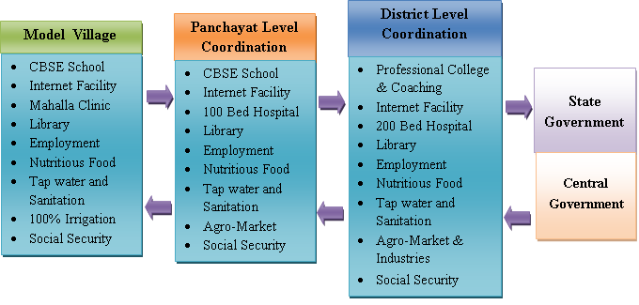
Fig. 2 (a): Model village development plan
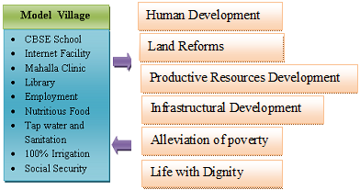
Fig. 2 (b) : Model village development plan

VII-IDEAL VILLAGES IN MAHARASHTRA
Hiware-Bazaar, Maharashtra - This is a village located in the rainshadow region of the Sahyadri mountain range in Maharashtra’s Ahmednagar district. Till the 1980s, farming in the village was largely rainfed, and farmers were forced to migrate seasonally to surrounding areas for work. From the 1990s onwards, things began to change. The village Panchayat adopted a holistic focus on a variety of activities, with community groups responsible for various aspects of the village economy and social development. Women thrift groups, Milk Dairy Society and Youth Clubs are examples of such community-based organizations. The village Panchayat also focused on family planning and reforestation, for which awareness programmes and drives have frequently been organized in the village. The village Gram Sabha also launched a watershed development programme, and an annual water audit is being conducted in the village since 2004 for more efficient and equitable management of water resources. It has also contributed to greater agricultural productivity. Today, the village is considered a model for community-led, multi-sectoral growth of rural parts of the country [17].
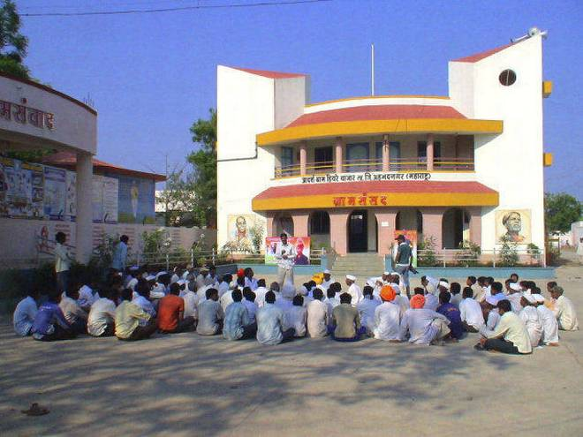
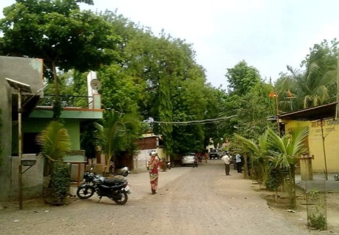
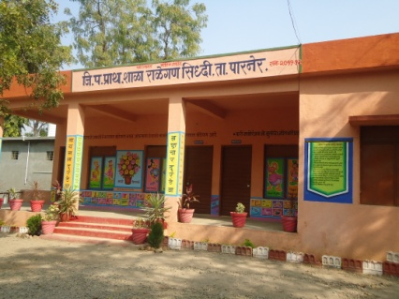
Fig. 3 : Ideal villages Hiwre Bazaar, Patoda, and Ralegaon Sidhhi
Patoda Village, Maharashtra - A village named Patoda on the outskirts of Aurangabad exemplifies civic management which big cities in India like Mumbai, Pune, Bangaluru, Delhi and Chennai need to copy. The residents of this village are provided free flour mill service to its villagers, free milk to kids, free drinking water, free hot water, and free Internet service!!! The village soon might get free dinner also. However, to avail free services each villager has to follow some basic rules of their Gram Panchayat. It is a give and take relation. Villagers have to be self-disciplined to be the beneficiary of every “Free” service mentioned above. No organization, can run without the financial discipline – be it a nation or be it a small village, monetary discipline has to be there for its sustenance. After all, the village panchyat needs to maintain the expenses. The villagers need to pay water tax based on actual consumption; the village gram panchayat has posted 100% water and property tax recovery over the past few years. This regular and sufficient income has allowed the gram panchayat to introduce innovative measures for the benefit of the villagers [18].
Ralegaon Siddhi, Maharshtra - Today Ralegaon Siddhi is being taken as a role model for other villages by the Maharashtra government and by other states too. Massive tree plantation has been undertaken, and hills have been terraced to check erosion. Large canals with ridges on either side have been dug to retain rainwater. As a result, the water table in this area is now considerably higher and the wells and tube wells are never dry, making it possible to raise three crops a year where only one was possible before. The village's biggest achievement is undoubtedly in the area of non-conventional energy. All the streets in the village are lit by solar lights, each with a separate panel. There are four large community biogas plants and one of them is fitted to the community toilet. There is a large windmill used for pumping water. A number of households have their own biogas plants. The village is self-sufficient [19].

VIII- CONCLUSION

India is democratic country, adopted the principle of welfare state. The welfare of the people of India is the ultimate goal of the country. The qualitative facilities are neglected in rural areas by various reasons. We experienced the efficiency of these facilities during Covid-19 period. The Governments should provide quality education, nutritious food, health facilities, tap water and sanitation, power at affordable cost, employment, irrigation facilities, communication facilities, and basic infrastructural facilities in rural area people. These facilities are also important to achieve SDGs framed by UN. These facilities help them to live with dignity, improve educational status, improve economy, improve health and make them to come forward in main stream development of the country. The rural- urban migration should also be minimized which reduces the burden on cities. This shall be achieved by inculcating constitutional and human morality to each and every citizen of India.

REFERENCES

- http://statisticstimes.com/demographics/population-of-india.php. Accessed on 11/01/2020.
- http://censusindia.gov.in/Tables_Published/A-Series/A-Series_links/t_00_005.aspx. Accessed on 11/01/2020.
- Srivastava, P. and Agrawal, B. (2017) ‘Innovative strategies for the development of rural India through village cottage and agribusiness enterprises’, Global Business and Economics Review, Vol. 19, No. 3, pp.276–298.
- A A Aziiza and T D Susanto 2020. The Smart Village Model for Rural Area (Case Study: Banyuwangi Regency). IOP Conf. Ser.: Mater. Sci. Eng. 722 012011. doi:10.1088/1757-899X/722/1/012011. Pp. 1-10.
- Chand, Ramesh, Srivastava S. K, and Singh Jaspal, 2017. Changing Structure of Rural Economy of India Implications for Employment and Growth; Discussion Paper. National Institution for Transforming India NITI Aayog.
- UN 2013. Democracy and Development: The Role of UN. https:/ /www .idea. int/ sites/ default/files/publications/democracy-and-development-the- role-of- the-united - nations.pdf. Accessed on 14/10/2021.
- Chaptaer One. What is Development? Pp. 9-30. https://www.academia. edu / 8065393/ CHAPTER_ONE_What_is_Development. Accessed on 14/10/2021.
- Bubaker F. Shareia. 2015. Theories of Development. International Journal of Language and Linguistics Vol. 2, No. 1; Pp 78-90.
- GAUR Dr. SEEMA & RAO Dr. N SRINIVASA. 2020. POVERTY MEASUREMENT IN INDIA: A STATUS UPDATE. Working Paper No. 1/2020. Ministry of Rural Development. India. Pp. 1-22.
- Kumari Sangita. RURAL - URBAN MIGRATION IN INDIA: DETERMINANTS AND FACTORS, International Joural of Humanities and Social Sciences, Vol. , Issue , pp 161-180. 2014.
- Narain JP. Health of tribal populations in India: How long can we afford to neglect?. Indian J Med Res [serial online] 2019 [cited 2020 Jan 11];149:313-6. Available from: http://www.ijmr.org.in/text. asp?2019/ 149/3/313/261113.
- Niti Ayog, 2019. Composite Water Management Index: a tool for water management. pp 1 - 180, http://social.niti.gov.in/uploads/sample/water_index_report2.pdf. Accessed on 14/10/2021.
- UNDP, 1990. Human Development Report. United Nations Development Programme (UNDP) New York Oxford Oxford University Press. www. http://hdr.undp.org/sites/default/files/reports/219/hdr_1990_en_complete_nostats.pdf. Accessed on 14/10/2021.
- UN, 2007. The Millennium Development Goals Report. U N I T E D N AT I O N S N E W YO R K. https://www.un.org/millenniumgoals/pdf/mdg2007.pdf. Accessed on 03/10/2021.
- https://statisticstimes.com/economy/projected-world-gdp-ranking.php. Accessed on 14/10/2021.
- Transforming Our World: The 2030 Agenda For Sustainable Development sustainable development.un.org A/RES/70/1. United Nation. https://sustainabledevelopment.un.org/content/documents/21252030%20Agenda%20for%20Sustainable%20Development%20web.pdf. Accessed on 14/10/2021.
- Singh S. 2010. Hiwre Bazaar - A Village of Millionaires, Maharashtra, India. Enhancing agriculture by ecosystem management in Hiwre Bazaar, India. http://www.teebweb.org. Accessed on 14/10/2021.
- Hattangadi Vidya, 2020. How the best civic amenities are offered at village Patoda. https://drvidyahattangadi.com/how-the-best-civic-amenities-are-offered-at-village-patoda/. Accessed on 14/10/2021.
- A model Indian village- Ralegaon Siddhi. http://edugreen.teri.res.in/explore/renew /rallegan.htm. Accessed on 14/10/2021.

