COVID-19 Detection From X-Ray Images Using Data Analytics, AIML & CNN Algorithm

Mohini Dilip Dandekar, Rahul Nawkhare, Bharti Sayankar
Mohini Dilip Dandekar
Department of Electronics Engineering.
Wainganga College of Engineering & Management.
Dongargaon, Wardha road, Nagpur
Rahul Nawkhare
Assistant Proffesor
Department of Electronics Engineering.
Wainganga College of Engineering & Management.
Dongargaon, Wardha road, Nagpur

Received on: xxxx,20xx, Revised on: xxxx,20xx, Published on: xxxx,20xx

Abstract – To control the spread of disease we need to detect is fast and quick test module. COVID-19 continuous to have very major and severe effects on human lives. To fight this disease, it is necessary to detect the affected patients in a less turnaround time and inexpensive way. One of the most convenient step to detect this disease is through radiological examination. The most accessible and least priced alternative is a chest X-ray. In this paper, we have proposed a Deep Convolutional Neural Network-based solution which can detect the COVID-19 +ve patients using chest X-Ray images. The proposed work uses many state-of-the-art CNN models, including DenseNet201, Resnet50V2, and Inceptionv3They have been trained individually to make independent predictions. Then the models are combined, using a new method of weighted average assembling technique, to predict a class value. To test the efficacy of the solution we have used publicly available chest X-ray images of COVID +ve and –ve cases. 500 images of COVID +ve patients and 500 images of COVID –ve patients have been divided into training, test and validation sets. The proposed approach gave a classification accuracy of 91.62% which is higher than the state-of-the-art CNN models as well the compared benchmark algorithm, the proposed method had a 91 percent classification accuracy. This application can be used by any medical personnel on any computer to detect COVID +ve patients using Chest X-Ray images in a matter of seconds. T X-Ray being the most easily available and least expensive option.

INTRODUCTION
In Wuhan, the first official case of Corona virus detected, as confirmed by WHO. Wuhan, the largest metropolitan area of the Hubei province in China. It has already taken several lives of people.Currently, genetic tests known as Reverse Transcription Polymerase Chain Reaction (RTPCR) are utilized to diagnose COVID-19 (RT-PCR). These tests are quite precise. But expensive. Perceiving these limitations, a stand-in approach to detect the disease can be radiography scanning, where the existence of, or symptoms of, the new can be detected using chest radiography pictures coronavirus. Studies show that viruses belonging to this family demonstrate significant manifestation in radiographic images. As a result, classification using radiographic images such as a chest X-ray (CXR) can be considered to be possible. It can be accurate but at the same time much faster and less expensive than the PCR test.

Related Work

Covid – 19 detection in X-ray images using CNN algorithm” by Areej A. Wahab & Ashraf Yunis Maghari, 2020 International Conference on promising Electronic

In this paper, based on best published research from Stanford University, the CheXNet algorithm was developed to diagnose and detect pneumonia from chest X-rays. To achieve best performance than experienced radiologists from the same university, simple changes were made to the algorithm to diagnose 14 pathological condition in the chest X-ray with a performance that exceeds all previously developed Deep Learning.

Automatic COVID-19 detection from X-ray images using ensemble learning with convolutional neural network” by Amit Kumar Das1,2 · Sayantani Ghosh1 · Samiruddin Thunder2 · Rohit Dutta2 · Sachin Agarwal2 · Amlan Chakrabarti1, Pattern Analysis and Applications (2021) 24:1111–1124COVID-19 continues to have severe effects on the lives of human beings throughout the world. To fight this disease, it is necessary to test the affected patients in a quick turn around time and inexpensive way. One of the most viable steps towards achieving this goal is through radiological examination, Chest X-Ray being the most easily available and least expensive option.

In this paper, they have proposed a Deep Convolutional Neural Network-based solution which can detect the COVID-19 +ve patients using chest X-Ray images. The proposed work uses many state-of-the-art CNN models, including DenseNet201, Resnet50V2, and Inceptionv3
Individually, they've been taught to make predictions on their own. Then the models are combined, using a new method of weighted average assembling technique, to predict a class value.
To test the efficacy of the solution we have used publicly available chest X-ray images of COVID +ve and –ve cases. Training, test, and validation sets were created using 538 photos of COVID +ve patients and 468 images of COVID –ve patients.
The proposed method had a 91.62% classification accuracy, which is higher than the state- Multiple state-of-the-art CNN models—DenseNet201, Resnet50V2 and Inceptionv3, have been adopted in the proposed work. Benchmark algorithm. They have developed a GUI-based application for public use.
This application can be used by any medical personnel on any computer to detect COVID +ve patients using Chest X-Ray images in a matter of seconds.

COVID-19 Detection from Chest X-ray Images Using Feature Fusion and Deep Learning” by Nur-A-Alam 1, Mominul Ahsan 2,* , Md. Abdul Based 3 , Julfikar Haider 2 and Marcin Kowalski 4.

This project presents that Currently, COVID-19 is considered to be the most dangerous and deadly disease for the human body caused by the novel corona virus.

In December 2019, the corona virus spread rapidly around the world, thought to be originated from Wuhan in China and is responsible for a large number of deaths. Earlier detection of the COVID-19 through accurate diagnosis, particularly for the cases with no obvious symptoms, may decrease the patient’s death rate. Chest X-ray images are primarily used for the diagnosis of this disease. This research has proposed a machine vision approach to detect COVID-19 from the chest X-ray images. Through CNN training, the characteristics extracted from X-ray pictures by the histogram oriented gradient (HOG) and convolutional neural network (CNN) were fused to construct the classification model (VGGNet).

The significant fracture region in the input X-ray images was identified using a watershed segmentation algorithm.

For the model's performance evaluation, the testing step used generalised data. A 5-fold method could successfully hamper the overfitting problem, according to cross-validation studies.

METHOLOGY

In This paper we are going to study the CNN design network with the help of dataset train and test model.

Figure. 1 Proposed plan of work and design methodology
Dataset creation, train, test, validataion
Whenever we are working on project as we are already remembered that we need to work on database collection. We have a certain database for training and testing in that we have covid X ray images and non covid X ray images that is normal images. Once the data is been collected now we need to do the preprocessing before that we can able to split our data set into train test and then validation. Purpose of using train that dataset which is going training process. Once the training is completed. We can check it out with the help of test data. Whereas validation data set helpful for validating our results.

CNN Design
Image classification, medical image classification late diseases detection or any image or videos based detection, these are the 3 ways-
- Pre- Trained model – Train model with huge database.
- Build it from the scratch – We can start it from the beginning like we can design our neural network we will test that and we will get error and we need fitting so we used to tune some of the parameters, we need to observe accuracy and we can play with that.
- Transfer learning concept – We are going to used pre- trained model file we can use to remove the last layer and will replace that last layer with new custom dataset layer.

Pre- processing
Preprocessing is based on your network.
Each and every model and algorithm will have pre- requisitions that image should be in that size and shape, and that image should be in the format of colour like grey scale. So, like wise it is having some pre- requisites.
We need to preprocess our complete dataset with just train, test and validation.

Training Model
We have to train our model by using certain algorithm basis on our neural network we will train it with the help of dataset.

Load Model Test
Once the training is completed we will get the model file. Will used to get the trained model file that is having that intelligence.
Once the model is being trained if you want to test it out if you want to deployment state so we use to load the model and again pre – process input images.

Classification
With the performance evaluation of our training model we can classify our report for covid and normal x-ray image.

EXPERIMENTAL RESULTS
We are going to design a graphical user interface by using PyQt tool kit to detect COVID-19 using X-Ray images.
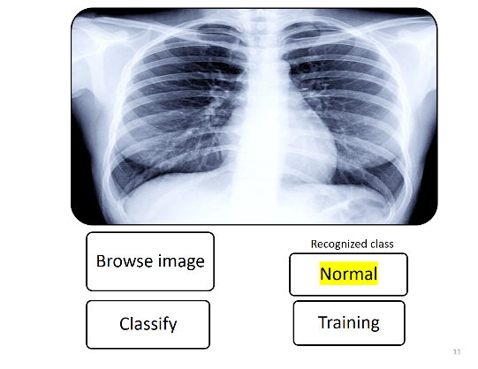
Figure. 2 Output of normal Xray image.
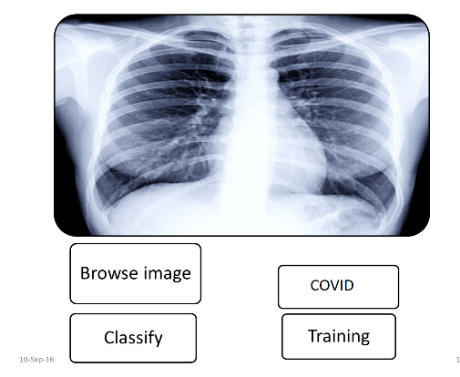
Figure. 3 Output of Covid positive Xray image.

CONCLUSION AND FUTURE SCOPE
Early diagnosis of COVID-positive patients is critical to preventing the disease from spreading and keeping it under control.
The goal of this study is to find a simple and economical approach to detect COVID-positive patients using chest X-ray pictures.
The proposed model has an accuracy rate of 98.23%. What's more, it has a sensitivity of around 95% for COVID +ve cases, which indicates that out of every 100 COVID +ve patients, our suggested model can correctly diagnose more than 95.
It is envisaged that this research, together with the GUI interface, will allow clinicians to detect afflicted individuals in a matter of seconds utilizing computer-aided analysis.
We believe this will have a huge impact on the medical industry.
REFERENCES
- WHO—Emergencies preparedness, response. World Health Organization (2019) Pneumonia of unknown cause China. https:// www.who.int/csr/don/05-january-2020-pneumonia-of-unkowncause-china/en/?mod=article\_inline. Accessed 29 Mar 2020
- The SARS-CoV-2 outbreak: what we know 94:44–48 the concatenation of Xception and ResNet50V2. Inf Med Unlock 19:100360
- Bustin SA (2000) Absolute quantification of mRNA using realtime reverse transcription polymerase chain reaction assays. J Mol Endocrinol 25(2):169–193
- Makris A, Kontopoulos I, Tserpes K (2020) COVID-19 detection from chest X-ray images using deep learning and convolutional neural networks. medRxiv. Accessed 29 Mar 2020
- COVIDAID: COVID-19 detection using chest X-ray. arXiv: 2004. 09803 Rahimzadeh M, Attar A (2020) A modified deep convolutional neural network for detecting COVID-19 and pneumonia from chest X-ray images based on the concatenation of Xception and ResNet50V2. Inf Med Unlock 19:100360
- Rajpurkar P, Irvin J, Zhu K, Yang B, Mehta H, Duan T, Ding D, Bagul A, Langlotz C, Shpanskaya K, et al (2017) Chexnet: radiologist-level pneumonia detection on chest x-rays with deep learning. arXiv preprint arXiv: 1711. 05225
- Wang L, Lin ZQ, Wong A (2020) COVID-Net: a tailored deep convolutional neural network design for detection of COVID-19 cases from chest X-ray images. Scientific Reports, Vol. 10
- Mangal A, Kalia S, Rajgopal H, Rangarajan K, Namboodiri V, Banerjee S, Arora C (2020)

