Experimental Analysis of Self compacting Concrete (SCC) using Fly ash, Stone Dust and Silica Fumes
Nitesh Ashok Bhange¹, Priti Radheshayam Nandagawali²
¹ Lecturer, Government Polytechnic, Bramhapuri (India)
² MTech in Civil Engineering, Nagpur (India)

Abstract: The new advancement in concrete technology is self-compacting concrete (SCC) and its production getting popularity now a days in world as a result of its superior properties. The well-organized equipment and workmanship are require for preparation of SCC. The aspects of proper proportioning and proper curing, mineral admixtures and the mixing ratio of aggregates(coarse & fine aggregate) holds utmost importance in respect of mechanical & fresh properties of SCC. Current application of SCC is concentrated on more reliable, high performance and better quality. Self-compacting concrete (SCC), is a non-segregating, flow-able concrete that fills framework and congested reinforcement, without any vibration. Adjustments to conventional mixes and additional of super plasticizers creates flow-able SCC. The investigation in laboratory was conducted to evaluate 3,7,28 days compressive strength by changing proportion of fly-ash, silica fumes and stone-dust with cement in SCC. The addition of stone-dust, silica fumes and fly ash render numerous advantages regarding compressive strength.
Keywords: Silica fumes, Stone Dust, Fly ash, Self-Compacting Concrete.

1.INTRODUCTION

Self-compacting concrete (SCC) technology is based on increasing the quantity of fine material like fly ash, lime stone filler etc. without varying the water quantity as compared to ordinary concrete. The self-compacting or super -workable concrete is a self-levelling cohesive concrete or highly flowable that can spread quickly into place through and around dense reinforcements under its self-weight. The Modern application of SCC is focused on its higher strength & higher performance, durability improvement, ease & faster construction. The SCC has been described as “Most revolutionary development in concrete construction for several decade". Originally developed in Japan to offset a growing shortage of skilled labour.SCC, requiring no compaction energy and use of vibrators in site, completely filling the formwork even in the presence of dense reinforcement—has been developed in Japan in the late 1980s, to improve the reliability of concrete and concrete structures (Ali -¹Kandemir 2010)(1).
Neelam Pathak et al. conducted experimental study to investigate the properties of Self-Compacting-Concrete with (class F fly ash ranging from 30% to 50%) and without fly ash. The property investigated were compressive strength, splitting tensile strength, rapid chloride permeability, porosity, and mass loss when exposed to elevated temperatures. Test results showed little improvement in compressive strength within temperature range of 200–300 LC as com-pared to 20–200 LC but there were little reduction in splitting tensile strength ranging from 20 to 300 LC and with the increase in percentage of fly ash.
2. LABORATORY INVESTIGATION
2.1 Material
2.1.1 Cement
Cement is binder, a substance use for construction the sets, hardens and adheres to other material, binding them together.OPC 43 cement shall conform to IS: 8112-1989 and the designed strength of 28 days shall be minimum 43 MPa or 430 kg/cm². The cement was OPC i.e. ordinary Portland cement. C3A content higher than 10% may cause problems of poor workability retention. The typical content of cement is 350-450 Kg/m³.More than 500 Kg/m3 cement can be dangerous and increase the shrinkage, less than 350 Kg/m3 may only be suitable with the inclusion of other fine filler, such as fly ash, pozzolona etc.
2.1.2 Aggregate
Aggregate provided the concrete with its body and strength and act as filler material to give the homogeneous mass of concrete along with cement paste. Mostly, the aggregates were considered chemically inactive and acting as only filler material. But now it is recognized that many types of aggregate form chemical bonds with cement paste. Mainly two type of aggregate are used in concrete Fine aggregate (less than 4.75mm), Course aggregate (more than 4.75 mm). Sand is a naturally occurring granular material composed of finely divided rock and mineral particles. It is defined by size, being finer than gravel and coarser than silt. The aggregate gives volume, stability, resistance to wear or erosion, and other desired physical properties to the finished product. Gap graded aggregates are frequently better than those continuously graded, which might experience greater internal friction and give reduced flow.
2.1.3 Fly-ash
Fly ash is a by-product from burning pulverized coal in electric power generating plant. Fly ash, a waste generated by thermal power plants is as such a big environmental concern. Fly ash can be used as prime material in block, paving or bricks; however, one the most important applications is PCC pavements. PCC pavements use large amounts of concrete and substituting fly ash provided significant economic benefits.
2.1.4 Silica Fume
Silica fume is a by-product of producing silicon metal or ferrosilicon alloys. One of the most beneficial uses for silica fume is in concrete. Silica fume is also referred to as micro silica or condensed silica fume, but the term silica fume has become generally accepted. It is a by-product of the manufacture of silicon and ferrosilicon alloys from high-purity quartz and coal in a submerged-arc electric furnace (Neville, 1995). Silica fume has been widely used in all over the world, where high strength and durable concrete is required. The use of silica fume in conjunction with super plasticizer has been the backbone of modern high performance concrete.
2.1.5 Stone Dust
Pulverized stone used in the construction of walkways or other stable surfaces. The dust is mixed with soil and compacted or used with gravel to fill spaces between irregular stones. Stone dust is a by-product of stone crushing operations. Concrete is a mixture of binding material, coarse and fine aggregates and water. It is a versatile construction material due to its reasonable cost and easy availability of its constituents. Increasing the dust content up to 30%, improved compressive strength of concrete and minimum absorption obtained when dust content was 20%. Dust content higher than 30%decreased the compressive strength and dust content more than 20% increased the absorption of the concrete.
2.1.6 Super Plasticizer
Plasticizers or dispersants are additives that increase the plasticity or decrease the viscosity of a material. These are the substances which are added in order to alter their physical properties. These are either liquids with low volatility or may be even solids. They decrease the attraction between polymer chains to make them more flexible. Plasticizer and super plasticizers work by the principle of adsorption.
2.2 Testing
The test carried out during study are as follows.
2.2.1 Flow test
The flow-table test or flow test, also known as the slump-flow test, is a method to determine consistency of fresh concrete. Flow table test is also used to identify transportable moisture limit of solid bulk cargoes. It is used primarily for assessing concrete that is too fluid (workable) to be measured using the slump test, because the concrete will not retain its shape when the cone is removed. Evaluate the deformability of SCC in the absence of obstacles. Two different aspects are measured. The filling ability by measuring the horizontal flow (spread) diameter SF. The viscosity of mix by measuring the time needed for SCC to reach 500 mm flow (t500).The segregation resistance in this test can be detected visually.
2.2.2. Course Aggregate & Fine Aggregate-Sieve analysis
The sample taken for sieve analyses for course aggregate are of quantity 10 Kg and for fine aggregate 2 Kg. The table below shows the results found after the test.
Table 1: Results of Sieve analyses for Course Aggregate
Sieve size (mm) | Retained wt.  (gm.) | %  Retained | % Cumulative
80 | 0 | 0 | 0
40 | 0 | 0 | 0
20 | 4633 | 46.33 | 46.33
10 | 5215 | 52.15 | 99.48
4.75 | 152 | 15.20 | 100
Fineness modulus = 245.81/100=2.45

Table 2: Results of Sieve analyses for Fine Aggregate
Sieve size (mm) | Retained wt.  (gm.) | %  Retained | % Cumulative
10 | 0 | 0 | 3.1
4.75 | 62 | 3.1 | 15.5
2.36 | 248 | 12.4 | 45.95
1.18 | 609 | 30.45 | 77.6
600 | 633 | 31.65 | 97.10
300 | 390 | 19.5 | 99.7
150 | 52 | 2.6 | 100
Fineness modulus = 338/100= 3.38
2.2.3 Fineness of cement:
To determine the fineness of cement by dry sieving as per IS: 4031(part) -1996. The principle of this is that we determine the proportion of cement whose grain size is larger than specified mesh size. The fineness observed from the test 1 %.
Table 3: Results of various test performed on the material
Materials | Test Performed | Test Value
Cement | Fineness | 1%
 | Standard Consistency | 24 mm
Stone Dust | Fineness | 2.5%
Silica Fume | Fineness | 1%
Sand | Bulking of Sand | 2 %
 | Fineness Modulus | 3.38
Fly ash | Fineness | 2%
Aggregate | Fineness Modulus | 2.45

3. EXPERIMENTAL WORK

For testing the compressive strength of self-compacting concrete, 60 concrete Cube of SCC of 150x150x150 mm were casted. The cubes are cured in curing tank. Each of these cubes was crushed at compression testing machine after time period of 3, 7 and 28 days. From these 60 blocks 30 were built for M20 grade and another 30 were built for M25 grade. The Proportioning of material used for SCC are shown in table no. 4.
Table 4: Proportioning of material used for SCC sample
Material | Conc. Mix | PCC | PCC + FLY ASH 20% | PCC+ SILICA FUME 20% | PCC+ STONE DUST 20%+ FLY ASH 20%
Cement (Kg) | M20 | 3.27 | 2.61 | 2.62 | 1.65
 | M25 | 3.89 | 2.76 | 2.81 | 2.15
Sand (Kg) | M20 | 4.78 | 6.88 | 6.85 | 7.3
 | M25 | 4.59 | 5.87 | 5.93 | 6.02
C.A (Kg) | M20 | 10.36 | 8.58 | 8.56 | 9.13
 | M25 | 9.96 | 7.36 | 7.45 | 7.54
Silica fume (Kg) | M20 | - |  | 0.656
 | M25 | - |  | 0.67
Stone Dust (Kg) | M20 |  |  |  | 0.54
 | M25 |  |  |  | 0.709
Fly ash (Kg) | M20 | - | 0.65 |  | 0.54
 | M25 | - | 0.66 |  | 0.709
Water (Liter) | M20 | 1.3 | 1.4 | 1.4 | 1.5
 | M25 | 1.6 | 1.85 | 1.5 | 1.4
Super plasticizer (ml) | M20 | - | 20 | 20 | 30
 | M25 | - | 35 | 30 | 35

4. RESULT AND DISCUSSION
The result obtained from testing of 60 cubes for M20 & M25 concrete for changing in proportion of Fly ash, Stone dust, Silica fumes with respect to cement are as shown in tables below.

Table 5: Result of Compressive Strength Test
Sr no. | Proportion | Curing period  (Days) | Load applied  (KN) | Compressive strength (N/mm2)
1 | PCC M-20 | 3 | 65 | 3.21
 |  | 7 | 280 | 12.01
 |  | 28 | 430 | 19.8
2 | PCC M-25 | 3 | 90.22 | 4.01
 |  | 7 | 241 | 15.67
 |  | 28 | 558 | 24.95
3 | PCC + FLY ASH: M20 | 3 | 72.25 | 3.93
 |  | 7 | 271 | 14.43
 |  | 28 | 445.5 | 21.12
4 | PCC + FLY ASH: M25 | 3 | 72.25 | 5.36
 |  | 7 | 271 | 16.9
 |  | 28 | 445.5 | 26.35
5 | PCC + SILICA FUME: M20 | 3 | 80 | 4.1
 |  | 7 | 342 | 15.23
 |  | 28 | 479.5 | 21.3
6 | PCC + SILICA FUME: M25 | 3 | 95 | 5.5
 |  | 7 | 252 | 17.2
 |  | 28 | 563 | 26.96
7 | PCC + FLY ASH + STONE DUST: M20 | 3 | 65 | 4.35
 |  | 7 | 318 | 14.11
 |  | 28 | 501.5 | 22.3
8 | PCC + FLY ASH + STONE DUST: M25 | 3 | 80 | 6.3
 |  | 7 | 250 | 18.63
 |  | 28 | 612.5 | 28.21

Based on the compressive strength of the cubes following graphs are obtained.
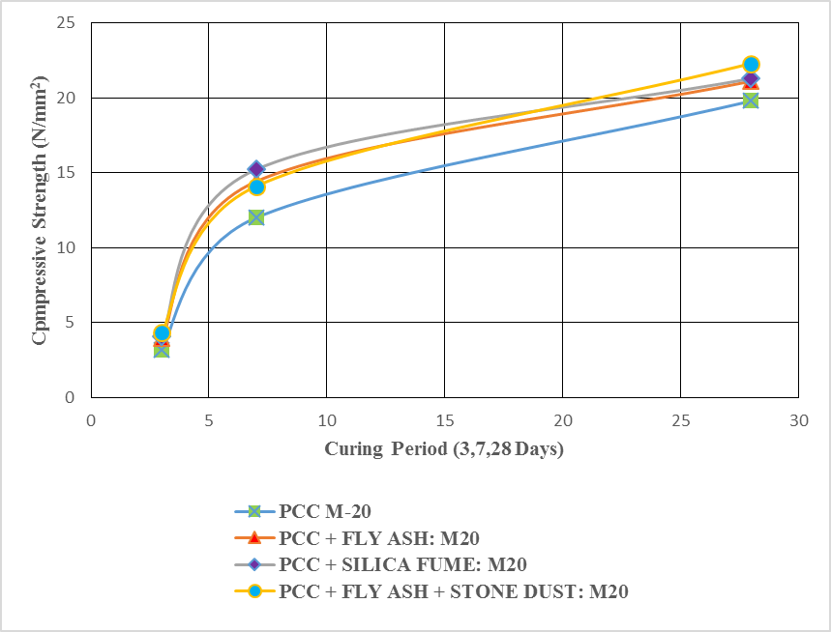
Figure 1:Graphical representation of Result from M20
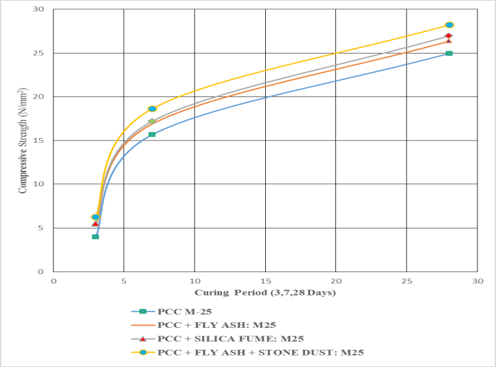
Figure 2: Graphical representation of Result from M25
5. CONCLUSION
From experimentation and tests it was observed for M20 grade highest compressive strength was given by SCC containing stone dust and fly ash at 28 days compressive strength of concrete was 22.3 N/mm² and M25 grade highest compressive strength was given by SCC containing stone dust and fly ash at 28 days compressive strength of concrete was 28.31 N/mm²
Hence the waste material i.e. Fly-ash, Stone dust can be effectively as used so as to reduce the quantity of cement and also reduced the cost of construction. Hence both these combinations are suitable for field as they yield higher results.
6. References
[1] | Selçuk Türkel1 and Ali Kandemir2 , “Fresh and Hardened Properties of SCC Made with Different Aggregate and Mineral Admixtures” journal of materials in civil engineering © ASCE / OCTOBER 2010.
[2] | Cong Ma1; Longzhu Chen2; and Bing Chen, Ph.D.3 “Experimental Study of Effect of Fly Ash on Self- Compacting Rammed Earth Construction Stabilized with Cement-Based Composites” J. Mater. Civ. Eng.
[3] | IS 3812-Specification for fly ash for use as  Pozzolona and admixture, Part-I (2003), Part-II (2003)
[4] | The European Guidelines for Self-Compacting Concrete Specification, Production and Use.Petersson, Ö., Billberg, P., Van, B.K., ‘A model for self-compacting Concrete’, Proceedings of International RILEM Conference on ‘Production Methods and Workability of Concrete’, edited by P.J.M. Bartos, et al. (Chapman & Hall/E &FN Spon) (Paisley, 1996) 483.
[5] | IS 383:1970 – Specification for coarse and fine aggregates from natural sources for concrete National Ready Mixed Concrete Association.

Author Profile
Nitesh A. Bhange received B.E. in civil Engineering from shri Ramdeobaba College of engineering, Nagpur in 2011. Currently working as Lecturer in Government Polytechnic Bramhapuri (India) selected through Maharashtra Public Service Commission (MPSC).
Priti R. Nandagawali received B.E. in Civil Engineering from Amravati University in 2011 and M.Tech in Geotechnical Engineering from shri Ramdeobaba college of Engineering, Nagpur in 2014.

