Effect On The Compressive Strength Of Concrete Of Improper Supervision Conditions
Anisha Mire* & Mr.R.C.Singh**
*Asst.Prof. ,Dept of Civil Engg.RSRRCET,Bhilai.
**Asso.Prof. & Head, Dept. of Civil Engg.RSRRCET,Bhilai.
Abstract
Quality assurance of building materials and supervision of construction work is very important in order to build strong durable and cost effective structures. When construction is planned building materials should be selected to fulfill the functions expected from them. The objective of this project work is to determine the importance of quality assurance of most common building materials such as concrete, aggregates, cement in accordance with relevant standards and the long term and short term effects that would results if building materials. Material testing is a must in all industries, particularly the building sectors. This is because an incorrect assessment of a material would ultimately be harmful to people and the environment. The infrastructural development of a nation, eventually leads to the prosperity and growth of that country. Utilization of high quality construction materials leads to high quality infrastructures. The quality of such materials should be assessed properly in an accepted laboratory, using standard test methods. In this research work M20 & M25 grades of concrete were used to make cubes with Ultratech 53 grade PSC & PPC cements and effects of various curing duration, effect of variation in compaction and effects of water cement proportions is determined and viewed as graphical way.
Keywords
Curing method, compressive strength, concrete
1.0 Introduction
In the world, India is the largest democracy, it is full of natural resources. The development of India as a developed nation will mainly depend on the right balance of urban development along with the infrastructure growth. The cities in India are becoming disordered, complex, and often congested as many people are migrating from villages to cities in search of employment, education, other facilities. Construction is the process where our designs are put into practice and the customer starts paying. How good the design is, it is only as good as what the construction stage of the processes makes it depending on supervision. In engineering and construction projects the type and nature of defects vary drastically, the point at which they become apparent, at one end of the scale minor defect can easily be corrected, before the building is handed over to the customer, while at the other extreme condition, significant defects may occur after long duration after the original work has been completed and requires extensive remedial works to correct. It is commonly seen a higher incidence of faulty construction practice during period of very fast construction on part of site supervisors & labours, inspectors are over loaded with work pressure, and building authorities are under constant pressure of completion of projects within time allotted and move the workload through their office. Faulty construction practice may not be some times intentional, but may effect the durability of structure.
Faulty construction is one of the problems most public building is facing in India and this can be attributed to inexperience and inconsistency in the training of supervisors and working force and negligency. Negligency in construction in early stages of construction is one of the causes of early deterioration of building. The common construction faults include inadequate compaction and failure to position reinforcement so that it has adequate concrete cover. It is observed that those faults will reduce the service life of the structure as a result of reinforcement rusting after the concrete has become strong and the cost of maintenance can be substantial.
2.0 Literature review
The uses of Reinforced Concrete in India in general, most references to pre-twentieth century concrete buildings. In India are for unreinforced concrete An example is "Concrete-Building at Simla, India,"published in 1886 that refers to the construction of two large buildings, the Sectariait and the Army Headquarters". Both are iron-framed structures using mass concrete for the foundations, walls, and floors formed by cashing concrete onto curved corrugated uon sheets that spanned between beams. The concrete was made manually on site from lime burnt in local lumps and crushed stones. There are some examples of reinforcement in concrete foundations such as the hoop-lron put in the concrete foundations of the High Court in Calcutta but the real use of reinforced concrete began with the Royal Engineers m the first years of the twentieth century ZS The majesty of contemporary accounts in architectural and enginemen journals on the use of reinforced concrete In India refer to its use in buildings, structures and civil engineering works such as roads and bridges. It was, however, extensively employed for more mundane items such as lamp and fence posts, and railway sleepers. There was also mentions that India should build reinforced concrete sleepers for the coastal trade to save on imported steel. The following 1s a summary of buildings and enginemen structures and other miscellaneous uses, selected to illustrate the various forms and applications of reinforced concrete.”. Concrete is used in such large amounts because it is, James Mitchell Crow simply, a remarkably good building material, not just for basic road construction, but also for rather more glamorous projects. Concrete is a building material that is not only strong and durable, Tarun. R. Naik found that can also be produced in ways that are environmentally friendly, and moldable in pleasing forms. With sustainable concrete structures and infrastructure, the concrete industry can develop a sustainable future for generations yet to come. Author Qin Weizu found China is one of the big developing countries in the world. There has been a large increase in infrastructure construction in the last 20 years. Concrete is the main construction material for all infrastructures. One of the crucial factor in concrete technology is it durability in hydraulic structures. Concrete has to resist against abrasion due to the crash of particles carried by water. In his study, Abolfazl Shamsai studied the role of water to cement ratio in compressive and abrasion strength of nano silica concrete was determined. Khaled Marar investigated the effects of cement content and water/cement ratio on workable fresh concrete properties with slump changing between 90 to 110 mm, and determines the relations among fresh concrete properties such as slump, compacting factor, VeBe, unit weight and setting times of mortar with temperature history.

3.0 Properties of different materials
Table 1 Physical Properties of Portland Slag Cement
S.No | Physical RequirementsUltraTech Cement (Portland Slag Cement)
1 | Fineness (kg\m²) | 351
2 | Standard Consistency (%) | 32
3 | Setting Time (minutes)  Initial  Final | 160  250
4 | Compressive Strength (N/mm²)  3 days | 27
5 | 7 days | 43
6 | 28 days | 63

Table 2 Physical Properties of Portland Pozzolana Cement
S.No | Physical RequirementsUltraTech Cement (Portland Pozzolana Cement)
1 | Fineness (kg\m²) | 345
2 | Standard Consistency (%) | 37.5
3 | Setting Time (minutes)  Initial  Final | 190  280
4 | Compressive Strength (N/mm²)  3 days | 29
5 | 7 days | 41
6 | 28 days | 56

Table 3 Physical Properties of Aggregate
S.No | Type of Properties | Normal Aggregate | Recycled Aggregate
1 | Abarasion value(%) | 20.45 | 27.7
2 | Aggregate Impact Value (%) | 17.7 | 36.2
3 | Aggregate Crushing Value (%) | 17.28 | 35.86
4 | Absorption (%) | 0.625 | 0.712

4.0 Determination Of Compressive Strength Test Of Concrete
The quality of concrete acceptance is according to IS:456-2000. The 28-days compressive strength shall alone be the criterion for acceptance or rejection of the concrete. In order to get quicker idea of quality of concrete, optional test for 7 days compressive strength of concrete be carried out.

4.1 Casting Of Concrete Cubes
Cubes were casted of M20 grade of concrete and M25 grade of concrete ,for natural aggregates, size of the cubes were of 150 x 150 x 150 mm.
For determining the importance of curing at different ages, 3 cubes were casted for 3 cubes for 3rd day testing, 3 cubes for 7th day testing , 3 cubes for 14th day testing and 3 cubes for 28th day testing. the effects of improper curing was tested on M20 and M25 concrete grade and also on Ultratech PSC-53 cement and PPC cement..
For determining the importance of compaction effort on concrete 3 cubes each were filled with M20 & M25 grade of concrete made with PSC and PPC respectively, 3 cubes were filled and were compacted as per recommended by IS Code 456-2000, were as 3 cubes each were filled in mould without compaction and top surface is made leveled, and were cured for 28 days, and was tested in compressive testing machine after 28 days and results were compared.
For determining the importance of water cement ration in concrete , cubes were casted with concrete having w/c according to mix design for M20 & M25 grade of concrete for PSC & PPC were as 3 cubes were casted with 30% excess of water than required ( segregation condition ), the casted cubes were allowed to cure in water for 28 days & there results were compared.

4.2 Testing of the hardened concrete

The compressive strength of the test cubes were determined by crushing the cubes under the compression machine. All the cubes were casted according to IS 456-2000 code specifications and testing is done after 28 days in all the cases in compression testing machine.

5.1 Importance Of Curing Of Concrete For 28 Days
In this experimental investigation, the effect of compaction on concrete strength was assessed in this experimental work importance of curing according to Indian standards was assessed, M20 & M25 grade of concrete was designed according to IS 10262-2009 and cement used was PSC & PPC Ultratech Cement was used as binders. Concrete specimens were casted and allowed for different duration of curing in water at room temperature, 3 cubes were tested for each day testing and average of the 3 determined compressive strength of concrete.
3 Cubes were casted and cured for 3 days in water and allowed for air curing for 25 days and tested after 28 days.
3 Cubes were casted and cured for 7 days in water and allowed for air curing for 21 days and tested after 28 days.
3 Cubes were casted and cured for 14 days in water and allowed for air curing for 14 days and tested after 28 days.
3 Cubes were casted and cured for 28 days in water and tested after 28 days.

Table 4 PSC Cement M 20 Grade of Concrete Compressive strength at 28th day
Curing done for | 3 days | 7 days | 14 days | 28 days
Compressive Strength in N/mm² | 12.50 | 18.20 | 24.50 | 27.30
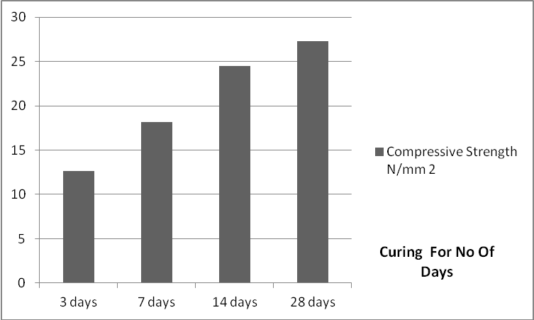
Fig. 1 PSC Cement M 20 Grade of Concrete Curing
For PSC cement M20 grade of concrete in fig. 1, table 4 from the result we can see that the cubes those cured for 3 days only in water curing attains 45% of its 28th day cube compressive strength cured in water.
Cubes those cured for 7 days only in water curing attains 66% of its 28th day cube compressive strength cured in water.
Cubes those cured for 14 days only in water curing attains 89.37% of its 28th day cube compressive strength cured in water.
Table 5 PSC Cement M 25 Grade of Concrete Compressive strength at 28th day
Curing done for no of days | 3 days | 7 days | 14 days | 28 days
Compressive Strength in N/mm² | 14.20 | 21.19 | 25.73 | 30.28
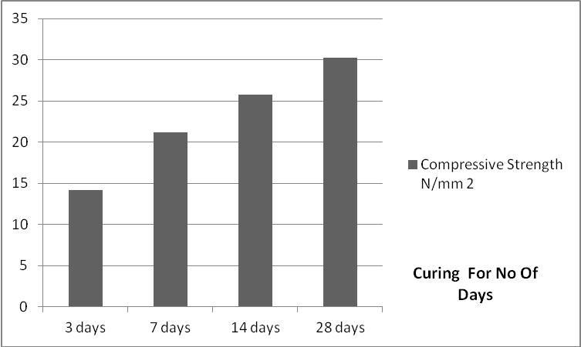
Fig. 2 PSC Cement M 25 Grade of Concrete Curing

For PSC cement M25 grade of concrete, in fig. 2, table 5 from the result we can see that the,
Cubes those cured for 3 days only in water curing attains 46.89% of its 28th day cube compressive strength cured in water.
Cubes those cured for 7 days only in water curing attains 69.98% of its 28th day cube compressive strength cured in water.
Cubes those cured for 14 days only in water curing attains 84.97% of its 28th day cube compressive strength cured in water.

5.2 Importance Of Concrete Compaction
Concrete compaction is the most important site operations that enable the fresh concrete to reach its ultimate design strength, its density and hence low permeability. Table 21 PSC Cement Table 6 M 20 Grade of Concrete Compressive strength at 28th day
 | Improper Compaction | Compaction According To IS Code
Compressive Strength In N/mm² | 17.8 | 24.44

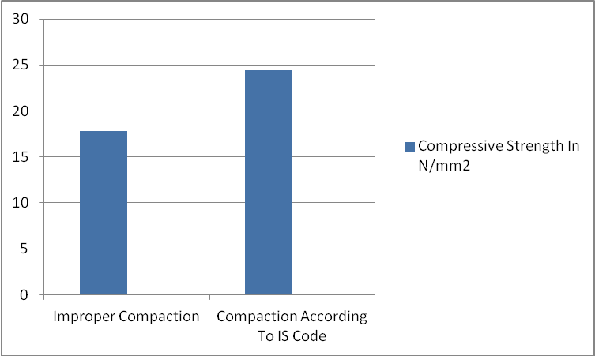
Fig. 3 PSC Cement M 20 Grade of Concrete Compaction
For PSC cement M20 grade of concrete. in fig. 3, table 6 as we can see concrete cube improper compacted gives only 17.8 N/mm² after 28 days of curing, where as properly compacted concre cube gave 24.44 N/mm² .
Table 7 PSC Cement M 25 Grade of Concrete Compressive strength at 28th day
 | Improper Compaction | Compaction According To IS Code
Compressive Strength In N/mm² | 22.71 | 30.28
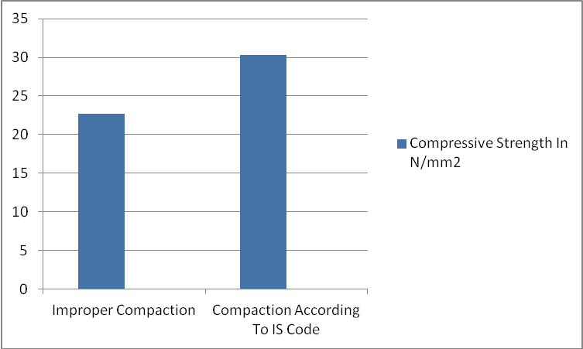
Fig. 4 PSC Cement M 25 Grade of Concrete Compaction
For PSC cement M25 grade of concrete, in fig. 4, table 7 as we can see concrete cube improper compacted gives only 21.71 N/mm² after 28 days of curing, where as properly compacted concre cube gave 30.28 N/mm² .
Table 8 PPC Cement M 20 Grade of Concrete Compressive strength at 28th day
 | Improper Compaction | Compaction According To IS Code
Compressive Strength In N/mm² | 17.59 | 24.44
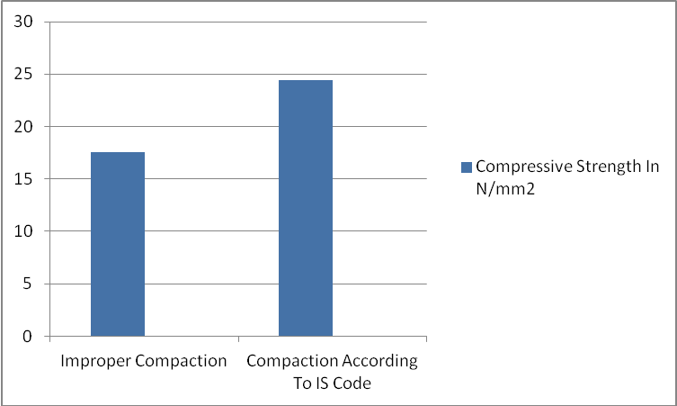
Fig. 5 PPC Cement M 20 Grade of Concrete Compaction
For PPC cement M20 grade of concrete, in fig. 5, table 8 as we can see concrete cube improper compacted gives only 17.59 N/mm² after 28 days of curing, where as properly compacted concre cube gave 24.44 N/mm² .
Table 9 PPC Cement M 25 Grade of Concrete Compressive strength at 28th day
 | Improper Compaction | Compaction According To IS Code
Compressive Strength In N/mm² | 18.92 | 28.90
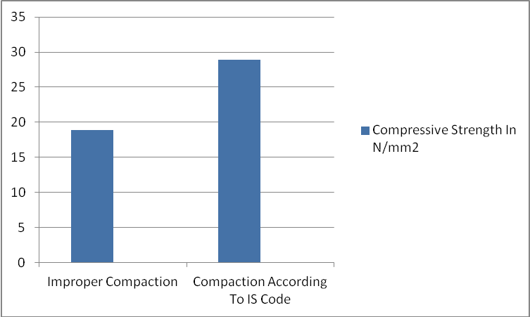
Fig. 6 PPC Cement M 25 Grade of Concrete Compaction
For PPC cement M25 grade of concrete. in fig. 6, table 9 as we can see concrete cube improper compacted gives only 18.92 N/mm² after 28 days of curing, where as properly compacted concre cube gave 28.90 N/mm² .

5.3 Importance of Water Cement Ratio in concrete
Hardening of concrete is a result of the chemical reaction between cement and water (known as hydration, this process produces heat and it is called the heat of hydration).
Table 10 PSC Cement M 20 Grade of Concrete Compressive strength at 28th day
 | W/C according to design | 30% excess water according to design | 30% less water according to design
Compressive Strength In N/mm² | 24.44 | 18.66 | 12.24
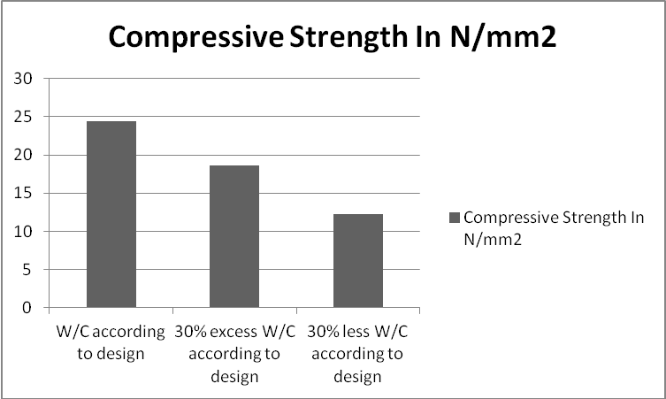
Fig. 7 PSC Cement M 2O Grade of Concrete W/C
For PSC cement M20 grade of concrete, in fig. 7, table 10 as we can see concrete cube with 30% excess water gives 18.66 N/mm² where as 30% less water gives 12.24 N/mm² as compared to water cement ration according to concter mix design which gives 24.44 N/mm² after 28 days of curing. As we can see in the compressive strength obtained in different water cement ratios, compressive strength obtained in case of 30% less water according to design is less as compared to other conditions because in 30% less water condition cement does not get sufficient amount of water to react with cement so that hydration reaction can take place and cement paste can gain strength. Where as in case of 30% excess water as compared to requirement according to design , in this due to excess water , cement has flown with excess water , which has been used for forming paste leaving behind fine aggregates and coarse aggregates, this condition is considered to be of segragation.
Table 11 PSC Cement M 25 Grade of Concrete Compressive strength at 28th day
 | W/C according to design | 30% excess water according to design | 30% less water according to design
Compressive Strength In N/mm² | 30.28 | 19.07 | 16.65

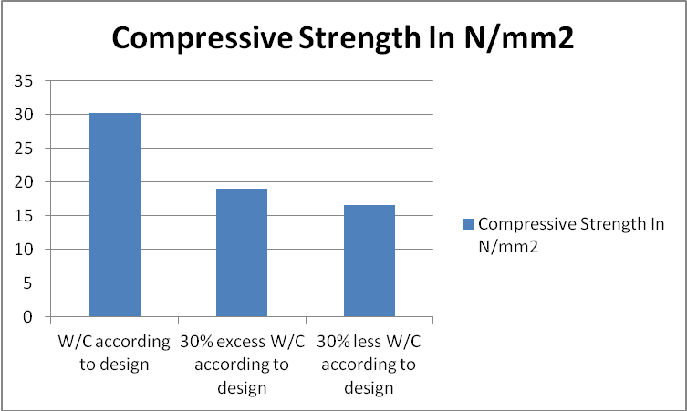
Fig. 8 PSC Cement M 25 Grade of Concrete W/C
For PSC cement M25 grade of concrete, in fig. 8, table 11 as we can see concrete cube with 30% excess water gives 19.07 N/mm² where as 30% less water gives 16.65 N/mm² as compared to water cement ration according to concrete mix design which gives 30.28 N/mm² after 28 days of curing.
Table 12 PPC Cement M 20 Grade of Concrete Compressive strength at 28th day
 | W/C according to design | 30% excess water according to design | 30% less water according to design
Compressive Strength In N/mm² | 29.49 | 17.69 | 14.85
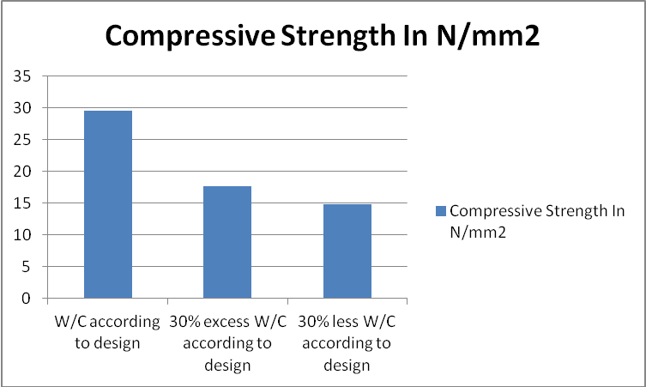
Fig. 9 PPC Cement M 20 Grade of Concrete W/C
For PPC cement M20 grade of concrete, in fig. 9, table 12 as we can see concrete cube with 30% excess water gives 17.69 N/mm² where as 30% less water gives 14.85 N/mm² as compared to water cement ration according to concter mix design which gives 29.49 N/mm² after 28 days of curing.
Table 13 PPC Cement M 25 Grade of Concrete Compressive strength at 28th day
 | W/C according to design | 30% excess water according to design | 30% less water according to design
Compressive Strength In N/mm² | 28.92 | 18.29 | 15.85

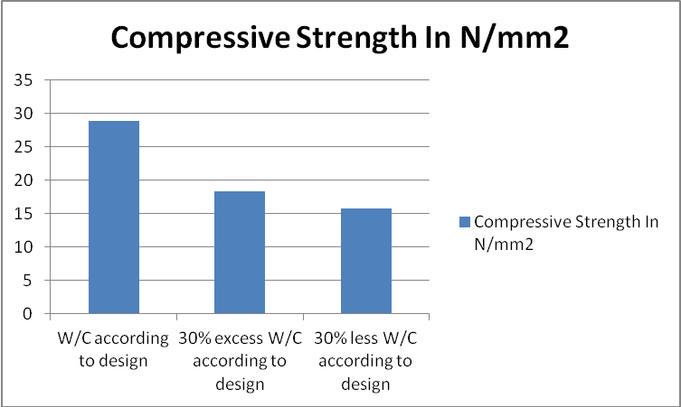
Fig. 10 PPC Cement M 25 Grade of Concrete W/C
For PPC cement M 25 grade of concrete, in fig. 10, table 13 as we can see concrete cube with 30% excess water gives 18.29 N/mm² where as 30% less water gives 15.85 N/mm² as compared to water cement ration according to concter mix design which gives 28.92 N/mm² after 28 days of curing.
Hence considering all the above experimental work we can conclude that it becomes very important to supervise fresh concrete while making, mixing, placing, compacting and curing, on all these factors ultimate compressive strength of concrete and durability of concrete depends.
Table 14 PPC Cement M 20 Grade of Concrete Compressive strength at 28th day
Curing done for no of days | 3 days | 7 days | 14 days | 28 days
Compressive Strength in N/mm² | 11.23 | 18.30 | 22 | 24.44
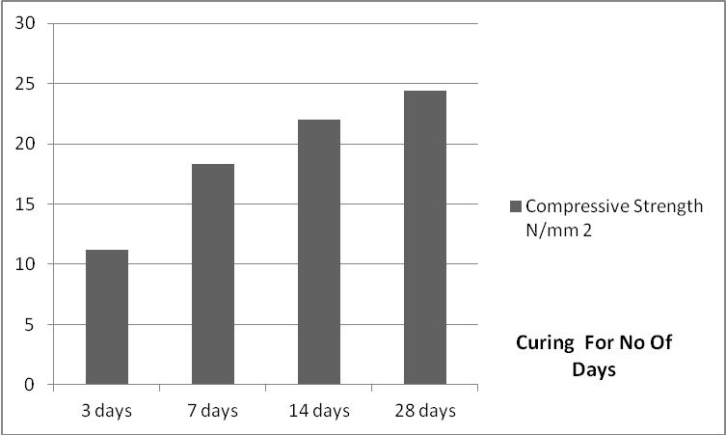
Fig. 11 PPC Cement M 20 Grade of Concrete Curing
For PPC Cement M 20 Grade of Concrete, in fig. 11, table 14 from the result we can see that the, Cubes those cured for 3 days only in water curing attains 45.94% of its 28th day cube compressive strength cured in water.
Cubes those cured for 7 days only in water curing attains 74.87% of its 28th day cube compressive strength cured in water.
Cubes those cured for 14 days only in water curing attains 90% of its 28th day cube compressive strength cured in water.
Table 15 PPC Cement M 25 Grade of Concrete Compressive strength at 28th day
Curing done for no of days | 3 days | 7 days | 14 days | 28 days
Compressive Strength in N/mm² | 13.45 | 20.25 | 23.15 | 28.90
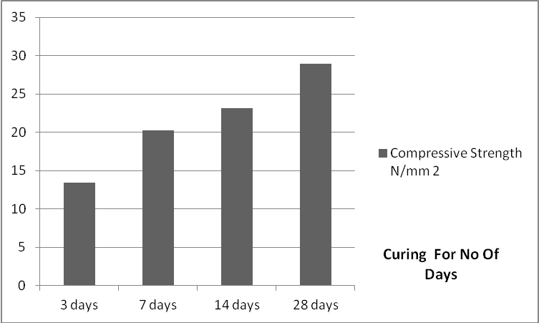
Fig. 12 PPC Cement M 25 Grade of Concrete Curing
For PPC cement M25 grade of concrete, in fig. 12, table 15 from the result we can see that the.
Cubes those cured for 3 days only in water curing attains 46.53% of its 28th day cube compressive strength cured in water.
Cubes those cured for 7 days only in water curing attains 70.41% of its 28th day cube compressive strength cured in water.
Cubes those cured for 14 days only in water curing attains 80.10% of its 28th day cube compressive strength cured in water.

6.0 Conclusions
As we know concrete structures are plastic in nature and one it has been constructed and given shape it cannot be remolded again, hence during concrete construction it becomes important duty of supervisor to supervise the construction work very accurately and sincerely because any single mistake at the time of execution at the time of concrete construction can cause heavy damage in long run, because if concrete is of inaccurate proportion it will of low strength that will affect the durability of structure. During any construction large amount of investment has been involved, hence the construction has to be done with seriousness and with accuracy, such that concrete mix design should be done properly, testing of various ingredients has to be done properly, placing of concrete has to be done properly, compaction has to be done properly so that air should expel from concrete properly so that concrete should become strong, so that it can bear heavy loads.
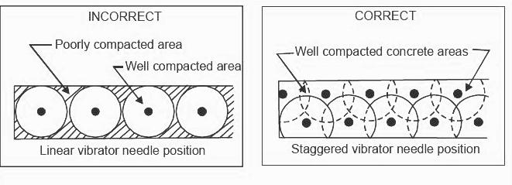
Fig. 13 Arrangement Of Particles In Case Of Incorrect & Correct Compaction
Also water cement ratio should also be maintained so that proper cement paste should be formed , water should not be too less, water should not be too more, so that there should not be condition of segregation. Supervision should be done and important points to be considered during brick work. Important points to be considered during casting of slab, beams and columns. Important points to be considered during finishing
References
- S. Mahesh, Self Compacting Concrete And Its Properties, Int. Journal of Engineering Research and Applications www.ijera.com ISSN : 2248-9622, Vol. 4, Issue 8( Version 7), August 2014, pp.72-80
- Elias B Sayah*, Mahadeo S Randive, Gajanan M Sabnis, The Effects Of Unskilled Labor On The Quality Of Concrete Construction Civil Engineering Scholar COEP, University of Pune, India.
- Thushara Priyadarshana and Ranjith Dissanayake, Importance Of Consistent Cement Quality For A Sustainable Construction, International Journal of Materials, Mechanics and Manufacturing, Vol. 1, No. 4, November 2013
- Quality Management In Concrete Construction , Alok Sarkar , The Indian Concrete Journal October 2007 38-41
- Kamal Rahmani, Abolfazl Shamsai,Bahram Saghafian & Saber Peroti, Effect of Water and Cement Ratio on Compressive Strength and Abrasion of Microsilica Concrete, Middle-East Journal of Scientific Research 12 (8): 1056-1061, 2012, ISSN 1990-9233
- Effects Of Faulty Construction On Building Maintenance , International Journal Of Technology Enhancements And Emerging Engineering Research,Vol-2,Issue 373 ISSN 2347-4289 Copyright © 2014 IJTEEE., Lagos, Nigeria 73-79
- Quality Assurance and Quality Control, Technical Summary-A summary of chapter 9 of the IMCP Manual (reference information on page 4) p.p 241–272
- Abolfazl Shamsai, Kamal Rahmani, Peroti & Loghman Rahemi, The Effect of Water-Cement Ratio in Compressive and Abrasion Strength of the Nano Silica Concretes, World Applied Sciences Journal 17 (4): 540-545, 2012, © IDOSI Publications, 2012, ISSN 1818-4952
- Isaac Akiije, Effects of Using 0.5, 0.55 and 0.6 Water Cement Ratio Separately With a Nigerian Grade 42.5R Portland Cement, International Journal of Science, Technology and Society, ISSN: 2330-7412 (Print); ISSN: 2330-7420 (Online), 2016; 4(6): 80-88
- H.S. Wong1and N.R. Buenfeld, Determining the water-cement ratio, cement content, water content and degree of hydration of hardened cement paste: Method development and validation on paste samples, Concrete Durability Group, Imperial College London, SW7 2AZ, UK, Cement & Concrete Research (2009), 39 (10) 957-965
- Thushara Priyadarshana & Ranjith Dissanayake, Importance of Consistent Cement Quality for a Sustainable Construction, International Journal of Materials, Mechanics and Manufacturing, Vol. 1, No. 4, November 2013 p.p 393-397
- Liana Iureş and Corneliu Bob, The Future Concrete: Self-Compacting Concrete by p,p 93-100
- Khaled Marar & Ozgur Eren, Effect of cement content and water/cement ratio on fresh concrete properties, International Journal of the Physical Sciences Vol. 6(24), pp. 5752-5765, 16 October, 2011, DOI: 10.5897/IJPS11.188, ISSN 1992-1950 ©2011 Academic Journals
- Elias B Sayah, Mahadeo S Randive , Gajanan M Sabnis The Effects Of Unskilled Labor On The Quality Of Concrete Construction, 33rd Conference On Our World In Concrete & Structures: 25 – 27 August 2008, Singapore
- Sandra Juradin, Goran Baloevic, Alen Harapin, Impact of Vibrations on the Final Characteristics of Normal and Self-compacting Concrete, Materials Research. 2014; 17(1): 178-185 © 2014
- Tarun R. Naik , Sustainability Of Cement And Concrete Industries, Center for By-Products Utilization Presented and Published at the Global Construction: Ultimate Concrete Opportunities, July 2005, Dundee, Scotland
- Tsung‐Chieh, Furusaka, S. Han,T, Comparative Study on Quality Assurance of Construction Project in Taiwan and Japan, National Yunlin University of Science & Technology, Taiwan, Kyoto University, Japan p.p 308-318
- ASCC Education, Assessing the Impact of “Green” Concrete Mixtures on Building Construction , Research & Development Foundation. December 2013
- Fourth International Conference on Sustainable Construction Materials and Technologies
Vasu Krishna, and Rakesh Kumar, Water to Cement Ratio: A Simple and Effective Approach to Control Plastic and Drying Shrinkage in Concrete
- Nwofor, T.C., Durability of block work: the effect of varying water/cement ratio of mortar joint, Pelagia Research Library, Advances in Applied Science Research, 2012, 3 (3):1848-1853
- Olutoge, F. Adeyemi and Amusan, G. Modupeola, The Effect of Sea Water on Compressive Strength of Concrete, International Journal of Engineering Science Invention, Volume 3 Issue 7 July 2014, PP.23-31, ISSN (Online): 2319 – 6734, ISSN (Print): 2319 – 6726
- Satpute Manesh B., Wakchaure Madhukar R., Patankar Subhash V. Effect of Duration and Temperature of Curing on Compressive Strength of Geopolymer Concrete, International Journal of Engineering and Innovative Technology (IJEIT) Volume 1, Issue 5, May 2012, p.p152- 155
- Hamed Ahmadi Moghadam, Omolbanin Arasteh Khoshbin , Effect of Water- Cement Ratio (W/C) on Mechanical Properties of Self-Compacting Concrete (Case Study), World Academy of Science, Engineering and Technology, International Journal of Civil and Environmental Engineering p.p 317-320
- Francis A. Oluokun, Fly Ash Concrete Mix Design And The Water-Cement Ratio Law, ACI Materials Journal / Julv-Auaust 1994 , p.p 362-371
- Dale P Bentz & Pierre Claude Aitcin, The hidden meaning of water cement ratio , Concrete International , May 2008, p.p 51-54
- R.Savitha, Importance of quality assurance of materials for construction work Building Materials Research and Testing Division, National Building Research Organization
- S. Mahesh , Self Compacting Concrete And Its Properties , Int. Journal of Engineering Research and Applications www.ijera.com ISSN : 2248-9622, Vol. 4, Issue 8( Version 7), August 2014, pp.72-80
- L.Ranjith Kumar, M.Karthikeyan, R.Raghu , Influence of Water-Cement Ratio on Compressive Strength of burnt bricks IOSR Journal of Mechanical and Civil Engineering (IOSR-JMCE) e-ISSN: 2278-1684,p-ISSN: 2320-334X, Volume 14, Issue 2 Ver. II (Mar. - Apr. 2017), pp 91-94
- https://en.wikipedia.org/wiki/2009_Korba_chimney_collapse
- www.chemistryworld.org James Mitchell Crow, March 2008
- https://www.designingbuildings.co.uk/wiki/Concrete#Benefits_of_concrete
- Ahmad, Irtishad U. and Sein, Maung K. (1997) Construction project teams for TQM:a factor-element impact model.Journal Construction Management and Economics,Vol.15,
No.5, 457-467.
- Alwi, S., Hampson, K., Mohamed, S. (1999) Investigation into the relationship between rework and site supervision in high rise building construction in Indonesia. The Second International Conference on Construction Process Reengineering,Sydney, July, 189-195.

