**Process Evaluation and Optimization of CO2 Welding Parameters using Taguchi Method**

**Naresh Besekar1, Dr. Chandrahas Golghate2**

*1 Lecturer in Mechanical Engineering, Government Polytechnic, Gondia*

*2 Principal, Government Polytechnic, Gondia*

***Received on****: 11 December, 2020,* ***Revised on****: 11 January, 2021 , Published* ***on****: 16 January, 2021*

***Abstract -*** *Main parameters that control the weld quality are current, voltage, electrical stick out and travel speed of the welding gun. The technique of design of experiments is used in order to optimize the parameters. This method helps to statistically analyze different parameters affecting the weld pool geometry thus enabling to select the optimum parameters for the process. Experimental result has shown that levels of current, voltage, electrical stick out and travel speed of electrode have been set properly to obtain the optimum weld pool geometry and the weld pool geometry is greatly improved.*

***Keywords - Design of Experiment, Taguchi Method, and CO2 Welding Parameter Optimization..***

# **i-Introduction**

CO2 Welding is also called as MAG (Metal Active Gas) Welding process where electric arc where an electric arc is created between a consumable wire electrode and the material to be joined. In this process, pure CO2 is used as a shielding gas for the weld pool. Iron becomes brittle when it combines with nitrogen that exists much in the atmosphere. CO2 gas, therefore, is often used to shield the weld pool from the atmosphere.CO2 arc welding offers higher efficiency, lower welding costs and better economy, better penetration without slag. [7].

The purpose is to efficiently determine the optimum welding parameters used for welding ATM bodies of manganese steel material for achieving the optimum weld pool geometry in the range of different affecting parameters by systematic approach of Design of Experiment in order to meet the purpose in terms of efficiency and effectiveness by using Taguchi method and ANOVA [11]. A series of structured tests are designed in which planned changes are made to the input variables of a process or system. The effects of these changes on a predefined output are then assessed [12].

**II- LITERATURE SURVEY**

Bhushan P Jain et al (2019) worked on parametric optimization of CO2 welding on FE410 to optimize the various process parameters such as Current, Voltage, and Gas Flow Rate (GFR) which has influence on tensile strength and hardness of the joint. However, investigation is based on the Taguchi’s approach of orthogonal array using analysis of variance [1]

Ilesanmi afolabi daniyan et al (2019) worked on optimization of welding parameters using Taguchi and response surface methodology for rail car bracket assembly. The experimental design which consists of Taguchi orthogonal array of L9, three level-four factor matrix was used as input parameters to determine the weld distortion and hardness while the RSM was used to study the cross effect (interaction) of various process parameters on the weld distortion. Analysis of variance (ANOVA) was used to further test and validate the developed model for adequacy [2]. Chetan Vyavahare et al (2019) did review on parametric optimization of MIG Welding by Taguchi’s Method [3]. Monika et al (2017) did review on gas metal arc welding (GMAW) of mild steel 1018 by using Taguchi technique [4]. Jigar shah et al (2017) did review on optimization and Prediction of MIG Welding Process Parameters Using ANN [5]. S.Utkarsh et al (2014) worked on experimental investigation of MIG welding for ST-37 using design of experiment and got the confirmatory experiment at specific range and got the optimum value of strength and S/N ratio [6]. Digvijay V Jadeja et al (2013) did review on parametric optimization by factorial Design approach of Mag-CO2 Welding Process [7]

**III-METHODOLOGY**

**Design of Experiment:**

[Design of experiments (DOE) is a systematic method to determine the relationship between factors affecting a process and the output of that process. In other words, it is used to find cause-and-effect relationships. This information is needed to manage process inputs in order to optimize the output [13].](https://www.flowsurfv3.net/c.php?cu=https%253A%252F%252Fwww.isixsigma.com%252Ftools-templates%252Fdesign-of-experiments-doe%252Fdesign-experiments-%2525E2%252590%252593-primer%252F&sh=www.isixsigma.com/tools-templates/design-of...&l=IN&po=1&u=mbeh-20201205-3792515-flchff17&a=3100&tr=n11c2572ngd&keyword=DESIGN%2BOF%2BEXPERIMENT%2BMETHODOLOGY&aid=5fd1f7be1f931&t=8&bc=0&rt=1607595965.5922&n=4&loc=n)

**Taguchi Method:**

Taguchi Method is a process/product optimization method that is based on 8-steps of planning, conducting and evaluating results of matrix experiments to determine the best levels of control factors. The primary goal is to keep the variance in the output very low even in the presence of noise inputs.

The Taguchi method involves reducing the variation in a process through robust design of experiments [16].

**ANOVA:**

Analysis of variance (ANOVA) is a collection of [statistical models](https://en.wikipedia.org/wiki/Statistical_model) and their associated estimation procedures (such as the "variation" among and between groups) used to analyze the differences among group means in a [sample](https://en.wikipedia.org/wiki/Sample_(statistics)). ANOVA was developed by the [statistician](https://en.wikipedia.org/wiki/Statistician) [Ronald Fisher](https://en.wikipedia.org/wiki/Ronald_Fisher). The ANOVA is based on the [law of total variance](https://en.wikipedia.org/wiki/Law_of_total_variance), where the observed [variance](https://en.wikipedia.org/wiki/Variance) in a particular variable is partitioned into components attributable to different sources of variation. In its simplest form, ANOVA provides a [statistical test](https://en.wikipedia.org/wiki/Statistical_test) of whether two or more population [means](https://en.wikipedia.org/wiki/Mean) are equal, and therefore generalizes the [t-test](https://en.wikipedia.org/wiki/Student%27s_t-test#Independent_two-sample_t-test) beyond two means [14].

**Design of Experiment for CO2 Welding using the effect of S/N ratio.**

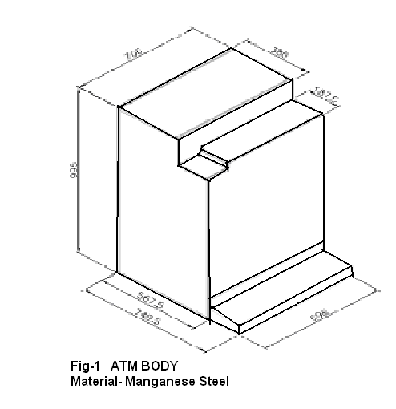

**Step1**: Identify the main function, side effects and their failure mode.

Main Function: Welding of ATM body and ensuring that the welded joint has adequate strength and good surface finish.

Side Effects:Poor surface quality, as result considerable amount of grinding needs to be done post welding.

Failure Mode:The joint should have adequate strength.

Before going to further steps, it is necessary to list down main parameters that are effecting and influencing the process and from those parameters we have to identify the noise and control factor.

*Table 1- Parameters that affecting the process are:*

|  |  |  |
| --- | --- | --- |
| **Sr.No.** | **Parameter** | **Factor** |
| 01 | Current | C.F |
| 02 | Voltage | C.F |
| 03 | Electrode Stick Out | C.F |
| 04 | Travel Speed | C.F |
| 05 | Gas Flow Rate | N.F |
| 06 | Wire Feed Rate | N.F |
| 07 | Pretreatment of material | N.F |
| 08 | Wire Diameter | N.F |
| Where C.F-Control Factor,  N.F-Noise Factor | | |

After completing the above step, we have to decide the parameters, which are affecting more on the process, and those will be treated as control factors and others will be consider as noise factor.

**Step2:** Identify the noise factors, testing condition and quality characteristics to be observed.

Noise Factors:

Raw Material, Raw Material conditioning, Method of Raw Material conditioning

**Table: 2**

|  |  |
| --- | --- |
| **Quality characteristics** | **Testing conditions** |
| Dimension | Measuring the weld bead height by dial indicator of 20 micron |

**Step3:** Identify the objective function to be optimized.

Objective function: Normal the Best type for control of weld bead height.

S/N ratio for static problem:



**Step4:** Identify the control factors and their level:

**Table: 3**

|  |  |  |  |
| --- | --- | --- | --- |
| **Factors** | **Levels** | | |
| Current(C) | 200amp | 220amp | 240amp |
| Voltage (V) | 24 volts | 27 volts | 30 volts |
| Electrode Stickout (ES) | 8mm | 12mm | 17mm |
| Travel Speed (TS) | 280mm | 300mm | 320mm |

**Step5:** Select the orthogonal array for experimentation-

Degree of Freedom: 01 for noise factor - 8 (2 x 4) for each control factor.

Total number of degree of freedom –09

Therefore minimum 09 numbers of experiments has to be carried out. Out of 3 levels available orthogonal arrays are most suitable for experimentation L9.

L9 Orthogonal Array:

**Table: 4**

|  |  |  |  |  |
| --- | --- | --- | --- | --- |
| **Expt. No** | **Control Factors** | | | |
| **A** | **B** | **C** | **D** |
| 01 | 1 | 1 | 1 | 1 |
| 02 | 1 | 2 | 2 | 2 |
| 03 | 1 | 3 | 3 | 3 |
| 04 | 2 | 1 | 2 | 3 |
| 05 | 2 | 2 | 3 | 1 |
| 06 | 2 | 3 | 1 | 2 |
| 07 | 3 | 1 | 3 | 2 |
| 08 | 3 | 2 | 1 | 3 |
| 09 | 3 | 3 | 2 | 1 |

**Step6:**

***Table: 5*** *-Conduction of the Experiments (next Pg)*

Data Summary for Experiments:

*Table: 6- Summary of Weld Bead Heights and S/N Ratios*

|  |  |  |  |  |  |
| --- | --- | --- | --- | --- | --- |
| **Exp. No** | **Set1** | **Set2** | **Set3** | **Mean** | **S/N Ratio** |
| 01 | 1.886 | 1.9 | 1.906 | 1.898 | 38.19 |
| 02 | 1.6 | 1.6 | 1.606 | 1.602 | 53.3 |
| 03 | 2.246 | 2.26 | 2.246 | 2.251 | 48.89 |
| 04 | 1.773 | 1.746 | 1.753 | 1.757 | 41.97 |
| 05 | 1.68 | 1.666 | 1.666 | 1.671 | 46.33 |
| 06 | 1.686 | 1.693 | 1.713 | 1.697 | 41.67 |
| 07 | 1.806 | 1.833 | 1.826 | 1.822 | 42.28 |
| 08 | 1.74 | 1.746 | 1.74 | 1.742 | 54.02 |
| 09 | 1.966 | 1.96 | 1.986 | 1.971 | 43.21 |

As per the S/N ratios found for the nine experiments, we will plot a graph of S/N Ratio Versus Controlling factors:

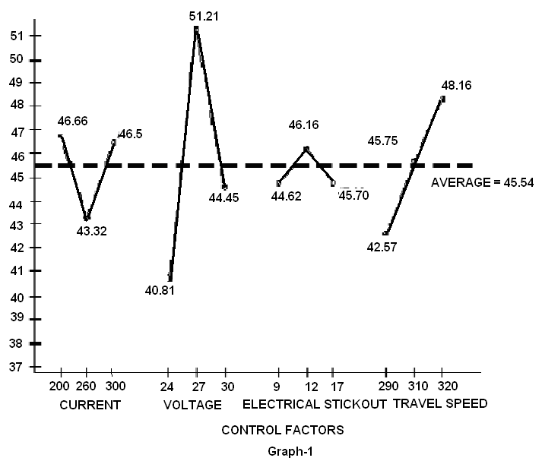

***Table: 5*** *-Conduction of the Experiments*

|  |  |  |  |  |  |  |  |  |  |
| --- | --- | --- | --- | --- | --- | --- | --- | --- | --- |
| **Experiment Numbers** | | | | | | | | | |
| **Set No.** | **1** | **2** | **3** | **4** | **5** | **6** | **7** | **8** | **9** |
| **1** | 1.88 | 1.60 | 2.26 | 1.78 | 1.68 | 1.70 | 1.82 | 1.74 | 1.98 |
| 1.88 | 1.60 | 2.24 | 1.78 | 1.68 | 1.68 | 1.80 | 1.74 | 1.96 |
| 1.90 | 1.60 | 2.24 | 1.76 | 1.68 | 1.68 | 1.80 | 1.74 | 1.96 |
| **2** | 1.90 | 1.60 | 2.26 | 1.76 | 1.68 | 1.68 | 1.84 | 1.74 | 1.96 |
| 1.90 | 1.60 | 2.26 | 1.74 | 1.66 | 1.70 | 1.82 | 1.76 | 1.96 |
| 1.90 | 1.60 | 2.26 | 1.74 | 1.66 | 1.70 | 1.84 | 1.74 | 1.96 |
| **3** | 1.90 | 1.60 | 2.26 | 1.76 | 1.68 | 1.72 | 1.82 | 1.74 | 2.00 |
| 1.90 | 1.60 | 2.22 | 1.76 | 1.66 | 1.70 | 1.82 | 1.74 | 1.98 |
| 1.92 | 1.60 | 2.26 | 1.74 | 1.66 | 1.72 | 1.84 | 1.74 | 1.98 |

**Inference from the Graph:**

The average value of S/N ratio is 45.54

As in S/N ratio, the noise factor is in denominator so we have to reduce the effect of it and after reducing the effect of noise factor, the overall S/N ratio in increased so we have to select a level of control factor, which is having highest S/N ratio.

We select the least value present below the average line.

The selected values of S/N ratio would thus be as follows:

-Current: 200 Amps

-Voltage: 27 Volts

-Electrode Stickout: 12mm

-Travel Speed: 300 to 320 mm/second

The above values are determined as follows:

Consider current = 200 Amps. (Level 2)

We know that 200A current used in experiments 4,5 and 6 as shown in the L9 orthogonal table. Therefore we take the mean of S/N ratio of experiments 4,5 and 6.

i.e. (41.97 + 46.33 + 41.67) / 3 = 43.32

In this manner we plot the S/N ratio versus control factors graph for each value of each parameter.

**Additional Observation found out during the study:**

**Lamellar Cracking:**

It’s been noted that the present process has a high probability of undergoing lamellar cracking. It is related to the design of joint. To be more specific it depends on the direction and position of chamfer given on the plates before they are subjected to welding operation. The description of the lamellar cracking is as follows:

These tears appear as a cracks parallel to and under the steel surface. In general, they are not in heat-affected zone and they have step like configuration. They result from the thin layers of nonmetallic inclusions that lie beneath the plate surface and have very poor ductility. These inclusions are separate when severely stressed, producing laminated cracks. These cracks are evident if the plate edges are exposed. A solution to this problem is to redesign the joints in order to impose the lowest possible strain throughout the plate thickness [9].

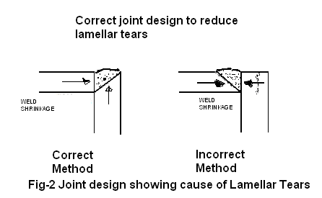



*Fig-3 ATM Bodies after Welding*

Reconsideration in the joint design as shown in Fig-3 can prevent lamellar cracking.

**Effect using Mean Response & S/N Ratio:**

The objective of using S/N ratio as performance measurement is to develop products and processes insensitive to noise factors. The S/N ratio indicates the degree of predictable performance of product or process in the presence of noise factors. Process parameters setting with the highest S/N ratio always yield the optimum quality with the minimum variance. Thus the level, which has higher value, determines the optimum level of each factor [14].

***Table: 7***

|  |  |  |  |  |  |  |
| --- | --- | --- | --- | --- | --- | --- |
| **Sl.No** | **Current**  **(Amp)** | **Voltage**  **(Volt)** | **Electrical**  **Stickout**  **(mm )** | **Travel speed of electrode**  **(mm /min.)** | **Mean Response** | **S/N Ratio** |
| 01 | 200(1) | 24(1) | 8(1) | 280(1) | 1.8977 | 38.19 |
| 02 | 200(1) | 27(2) | 12(2) | 300(2) | 1.6022 | 53.3 |
| 03 | 200(1) | 30(3) | 17(3) | 320(3) | 2.2511 | 48.49 |
| 04 | 220(2) | 24(1) | 12(2) | 320(3) | 1.7577 | 41.97 |
| 05 | 220(2) | 27(2) | 17(3) | 280(1) | 1.6711 | 46.33 |
| 06 | 220(2) | 30(3) | 8(1) | 300(2) | 1.6977 | 41.67 |
| 07 | 240(3) | 24(1) | 17(3) | 300(2) | 1.8222 | 42.28 |
| 08 | 240(3) | 27(2) | 8(1) | 320(3) | 1.7422 | 54.02 |
| 09 | 240(3) | 30(3) | 12(2) | 280(1) | 1.9711 | 43.21 |

Average effect response table for the Weld Bead Height (Raw Data):

**Table: 8**

|  |  |  |  |  |
| --- | --- | --- | --- | --- |
| Levels | Current | Voltage | Electrical Stickout | Travel Speed of electrode |
| 1 | 1.917 | 1.8258 | 5.3376 | 1.8466 |
| 2 | 1.7088 | 1.6718 | 1.7770 | 1.7073 |
| 3 | 1.8451 | 1.9733 | 1.9148 | 1.917 |
| Max-Min | 0.2082  (4) | 0.3015  (2) | 3.5606  (1) | 0.2097  (3) |

Average effect response table for the S/N Ratio:

**Table: 9**

|  |  |  |  |  |
| --- | --- | --- | --- | --- |
| Levels | Current | Voltage | Electrical Stickout | Travel Speed of electrode |
| 1 | 46.66 | 40.81 | 44.62 | 42.57 |
| 2 | 43.32 | 51.21 | 46.16 | 45.75 |
| 3 | 46.50 | 44.45 | 45.70 | 48.16 |
| Max-Min | 3.34 | 10.4 | 1.54 | 5.5834 |

To carry out ANOVA of the observations, the sums of squares of certain deviations are required. One determines these sums of squares as follows:

Let, T = sum all observations

= Y1 + Y2 + Y3 + Y4 + Y5 + Y6 + Y7 + Y8

The correction factor (CF) is defined as

CF = T2 / N, Where N-Total numbers of observation obtained.

The sum of squares (ST) is

ST  = Sum (i = 1 to N) [Y1]2 – CF

The factor sums of squares are

SA = [A1]2 / NA1 + [A2]2 / NA2  - CF,

SB = [B1]2 / NB1 + [B2]2 / NB2  - CF,

SC = [C1]2 / NC1 + [C2]2 / NC2  - CF,

SD = [D1]2 / ND1 + [D2]2 / ND2  - CF,

SE = [E1]2 / NE1 + [E2]2 / NE2  - CF,

Hence that factor sum of squares for 1st factors is

SA = [A1]2 / NA1 + [A2]2 / NA2  - CF = (Y1 +Y2 + Y3 + Y4)2 / 4 + (Y5 +Y6 + Y7 + Y8)2 / 4 - (Y1 +Y2 + Y3 + Y4 + Y5 +Y6 + Y7 + Y8 )2 / 4

This mean sum of squares are calculated for each control factor by dividing the sum of squares by respective degree of freedom and by calculating the F-factor for each factor and is compared with other tabulated F-factor. Calculated F-factor should be greater than tabulated F-factor. The graphs of mean response and S/N ratio versus control factor levels are plotted as below:

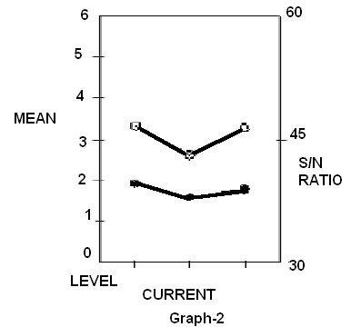

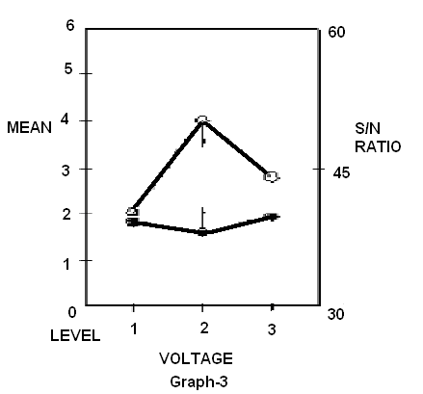

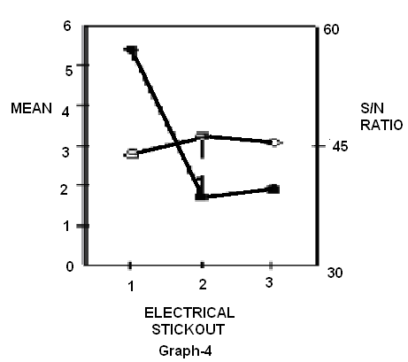

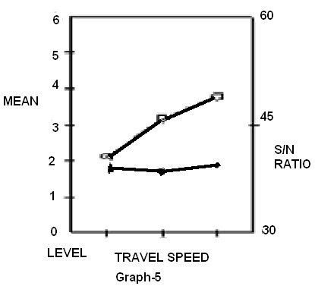

Response graphs of all the factors indicating the optimum level of response mean and optimum level of S/N ratio

**IV-ANALYSIS & DISCUSSION:**

Here as seen from the graph-2, 3,4 & 5 of mean and S/N ratio versus control factors. On Y-axis mean and S/N ratio is plotted and on X-axis different levels for all four control factor is plotted. From the voltage graph the least mean value appears at the second level and highest S/N ratio also appears at the second level so that means the second level of voltage is optimum and to be set for the experiment. Similarly in a graph of electrical stick out the second level has lowest mean response and highest S/N ratio. In case of current and travel speed level differs in mean & S/N ratio. So we can select either of the level and can conduct the experiment.

So the optimum parameters are as follows:

A1B2C3D4 so the experiment is to be conducted as per given settings of experiment.

Where A-Current,

B- Voltage,

C- Electrical Stick Out,

D-Travel Speed of electrode Torch.

**V- CONCLUSION**

The experiment conducted for improvement of weld pool geometry by Taguchi method shows that the weld bead height is directly proportional to the weld speed but inversely proportional to the weld voltage as shown in response graphs. However the weld bead width is directly proportional to the weld voltage. The increase in weld voltage increases the heat input caused by higher arc energy which results in a larger weld bead width. The weld speed can change the heat input and therefore affects the weld bead height. As the welding gun moves faster the amount of heat input to the joint is reduced thus reducing the weld bead height. However if the travel speed is very high then the penetration would not be sufficient causing the joint to be weak. By plotting the graph of S/N ratio versus control factors, we get the optimum parameters for nominal weld bead height. These parameters ensure that the weld bead height is nominal thus saving on unnecessary regrinding operation. Though post welding grinding operation cannot be eliminated completely, it can however be reduced by selecting the optimum parameters as found above.

The optimum weld pool geometry has four smaller the better quality characteristics i.e. current, voltage, electrical stick out and travel speed of electrode. This orthogonal array using taguchi method is adopted to solve the optimal weld pool geometry with four smaller the better characteristics.

Experimental result has shown that levels of current, voltage, electrical stick out and travel speed of electrode have been set properly to obtain the optimum weld pool geometry and the weld pool geometry id greatly improved.

**REFERENCES**

1. *Bhushan P Jain1, Darshan V Sanghavi2, Rayappa S Mahale3 “ parametric optimization of co2 welding on fe410 using taguchi technique” International Research Journal of Engineering and Technology (IRJET) e-ISSN: 2395-0056 Volume: 06 Issue: 04 | Apr 2019*
2. *Ilesanmi afolabi daniyan et al “Optimization of welding parameters using Taguchi and response surface methodology for rail car bracket assembly” The international journal of advanced manufacturing technology, volume 100, pages2221–2228 (2019) .*
3. *Chetan Vyavahare et al (2019) did review on Parametric Optimization of MIG Welding by Taguchi’s Method.*
4. *Monika et al (2017) did review on gas metal arc welding (GMAW) of mild steel 1018 by using taguchi technique.*
5. *Jigar Shah1, Gaurav Patel2, Jatin Makwana3 “A review on Optimization and Prediction of MIG Welding Process Parameters Using ANN”, International Journal of Engineering Development and Research, 2017 IJEDR | Volume 5, Issue 1 | ISSN: 2321-9939*
6. *S.Utkarsh1, P. Neel2, Mayank T Mahajan3, P.Jignesh4, R. B.Prajapati5 “experimental investigation of MIG welding for ST-37 Using design of experiment”, International Journal of Scientific and Research Publications, Volume 4, Issue 5, May 2014 1 ISSN 2250-3153 .*
7. *Digvijay V Jadeja1, Satyam P Patel2 ,”A review On Parametric Optimization By Factorial Design Approach Of Mag-Co2 Welding Process”,**International Journal of Engineering Research and Applications (IJERA) ISSN: 2248-9622 , Vol. 3, Issue 2, March -April 2013, pp.420-424.*
8. *”Welding Handbook – Applications of Welding “, by charlotte Weisman, Sixth Edition (Section 5), 1976, American Welding Society (AWS), pp-84.1 to 84.25*
9. *”Welding Metallurgy”, by George E. Linnert, Third Edition, 1966 (Volume 2), American Welding Society, pp 141 – 158.*
10. *Welding Handbook – Metals and Their Weldability”, by W.H.Kearns, Seventh Edition, 1982 (Volume 4), pp 2-48*
11. *”Welding Principles & Applications”, by Larry Jeffus, Fourth Edition, 1999, Delmar Publishers.*
12. *“Taguchi Method Explained”, by Tapan P Bagchi, 1993, Prentice Hall of India Pvt. Ltd.*
13. *”Taguchi methods – Applications in world industry” by A. Bendell, J.Disney.*
14. *Amar Patnaik, Sandhyarani Biswas, and S.S.Mahapatra (2007), ‘An evolutionary approach to parameter optimization of submerged arc welding in the hard facing process’, Int.J.Manufacturing research, Vol2, No.4.*
15. *Khosla Arun, Kumar Shakti, Aggrarwal K.K, ‘Identification of strategy parameters for particle swarm optimizer through Taguchi Method’, Journal of Zhejiang University Science A 2006 7(12):1989-9994*
16. *S.S.Madaeni, S.Koocheki, ‘Application of Taguchi Method in the optimization of wastewater treatment using spiral wound reverse osmosis element’, Chemical Engineering Journal 119 (2006) 37-44.*