IMPLEMENTATION OF BUDDY COPS FOR WOMEN SAFETY
Namrata Telrandhe, Jagruti Gadhawe, Faiyyaz Khan, Nikita Khadse, Vivek Deshmukh
All UG Students, Department of Computer Technology, Priyadarshini College of Engineering, Hingna, Nagpur.

Prof. Mrs. Snehal Golait (Project Guide)

Abstract : Women’s safety is one of the largest concerns in India. Every time we turn on the news channel or pick up a newspaper, we learn of a different woman who was murdered, raped, beaten up or fallen victim to an acid attack. In such a country, where even getting on the bus without being groped is difficult, the simplest of measures make a large difference. Police launched the Buddy Cop to help working women feel safer. This system basically makes use of WhatsApp to connect police offers to women in an attempt to help them reach out to someone in the fastest way possible. Here’s how it works: Whoever wishes to be a part of the Buddy Cop initiative registers at their nearest police station. They are added to a WhatsApp Group of the same police station. The admin of each group is your buddy cop and can be contacted at any time. If the particular cop is off duty, they he/she can assign someone else to you, thus making the service available 24/7. If help is needed in a different area, which is not under the jurisdiction of your buddy cop, they inform the police station nearest to you and send someone for help.
Key Words
Girls Hostel Security, Crime against Women, Nagpur safety

INTRODUCTION

1.1 Need of Buddy Cops:
We can see that technology has touched many spheres of our lives in India. There is technology in business, in education, in socializing and maintaining human relations, in purchasing, in

agriculture, in banking, communication, and almost every The buddy cops is an application basically designed to manage police reports on this new idea that police department has come up with. This application will keep the record of the hostels. This application will also keep record of the lady police officer who will visit the hostel allotted to them. Using this application head of police as well as the police officers can keep record of the visits and complaints. This application will also be used to upload pictures of visits. By now, it has spread across 10 police stations in the city and over 45,00 women have registered. Women are encouraged to call for help for absolutely anything that threatens their safety; it could be something as simple as being afraid to travel in a certain area alone. Although it started off slow, the response has picked up with more and more women seeking out help. Matters such as a woman not being allowed to shift compartments on a train when she felt uncomfortable with the men she was seated with, have been resolved by the police getting in touch with the Railway Protection Force directly. Since the launch, 6 serious offenses have been registered and the accusers caught. The Buddy Cop system is currently active in police stations that fall under Zone I and II of the Nagpur Police, including stations from Wadi, Ambazari, Shankarnagar, Dharampeth, Pratapnagar, chatrapati, Bardi, Khambla, and Ravi Nagar to name a few. The plan is to extend this service to the entire city and make all women feel safer.
part of our lives. This intrusion of technology has aided the work in all these sections, and has proved beneficial, and time and effort saving. The only major part of our society that still remains majorly devoid of this luxury is the Indian Police Department. The Indian Police Department has ever since remained manually driven for most of its routine chores. The officials have been adopting the basic fundamental methods of carrying out the proceedings with the traditional “pen and paper” method being highly prevalent. These traditional practices were comfortable in earlier days, when population was far less, and the women hostels were also comparably minimal. But in today’s India, when the women are becoming independent and stepping out of the home and becoming independent, it has become a very tedious task to provide the security to all the hostellites and all their related problems, manually. Digitization in Police department is the need of the hour.
1.2 What is Buddy Cops?
The Buddy Cops is the android application . It is an initiative by the police department concerning the women safety. This app is deigned to use in safety of the girls and working women who are living away from their houses and staying in hostels. With this app the police department can keep track of the women in the various hostels. This app will be installed in different police officers especially lady constables who are going to visit the hostels allotted to them. Among the city various zones will be added, then various police stations and hostels under that police stations will be recorded. . This application will keep the record of the hostels. This application will also keep record of the lady police officer who will visit the hostel allotted to them. Using this application head of police as well as the police officers can keep record of the visits and complaints. This application will also be used to upload pictures of visits

METHOLOGY
The proposed work for buddy cops is shown in figure 1:
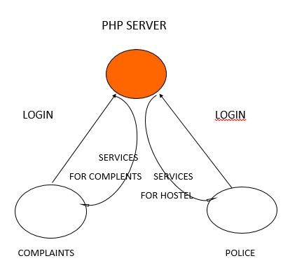
Figure 1: Server/App Interaction

The above figure works as follows:
First, the authenticated user(lady constable) will login to the app when she will visit to the hostel. After logging in, she will supervise the ambience and the condition of the hostel, will talk to the girls in the hostel. Based on that, she will fill the information in the fields described in the form, take photo to ensure the visit and submit. After submitting, the information will go to the php server.

The below algorithm give the brief of the app:
Alogorithm:
package com.extwomultiscreen;
import android.os.Bundle;
import android.app.Activity;
import android.content.Intent;
import android.view.Menu;
import android.view.View;
import android.view.View.OnClickListener;
import android.widget.Button;
public class MainActivity extends Activity {
Button btn1;
protected void onCreate(Bundle savedInstanceState) {
super.onCreate(savedInstanceState);
setContentView(R.layout.activity_main )
// Code for button click startshere
btn1 = (Button) findViewById(R.id.button1);
btn1.setOnClickListener(new OnClickListener() {
public void onClick(View v) {startActivity(new Intent(getApplicationContext(),SecondScreen. class));
finish();
}
});
//Code for Button click ends here
}
public boolean onCreateOptionsMenu(Menu menu) {
// Inflate the menu; this adds items to the action bar if it is present.
getMenuInflater().inflate(R.menu.main, menu);
return true; }}

TECHNOLOGY USED

1. Android
Android is a mobile operating system developed by Google, based on a modified version of the Linux Kernel and other open source software and designed primarily for touchscreen mobile devices such as smart phones and tablets. Variants of Android are also used on game consoles, digital cameras, PCs and other electronics. Android’s default user interface is mainly based on direct manipulation, using touch inputs that loosely correspond to real-world actions. The response to user input is designed to be immediate and provide haptic feedback to the user. Applications (“apps”), which extend the functionality of devices, are written using the Android software development kit (SDK) and, often, the Java programming language.

2. Eclipse

Eclipse is an integrated development environment (IDE) used in computer programming, and is the most widely used Java IDE. It contains a base workspace and an extensible plug-in system for customizing the environment. Its primary use is for developing Java applications, but it may also be used to develop applications in other programming languages. Eclipse software development kit (SDK) is free and open-source software, released under the terms of the Eclipse Public License. It was one of the first IDEs to run under GNU Classpath and it runs without problems under IcedTea.

3. Hostinger Server

Hostinger was created in 2004 and since then, we have been on an epic ride. The idea of Hostinger is to let people create a website for free. It includes MySQL and PHP, cPanel and no ads policy which have created a complete freedom online. It allows to host the web application on Cheap VPS hosting cloud servers. Hostinger uses MySQL administrative tool called PhpMyAdmin that allows to manage the database using
web browser.

4. PHP

PHP is a server-side scripting language designed for
web development but also used as a general-purpose
programming language. MySql is the database which
saves data for the programs. PHP is used to access this
database. PHP is compatible with almost all servers
used today.

EXPERIMENTAL RESULT

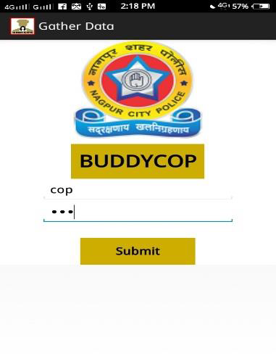
- Login: Enter Id and password. Authentication required..

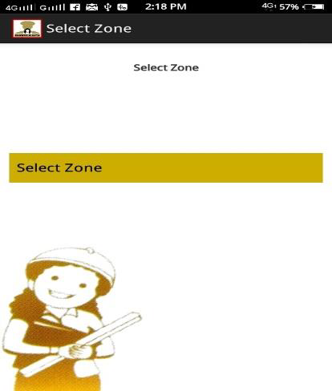

- Select zone

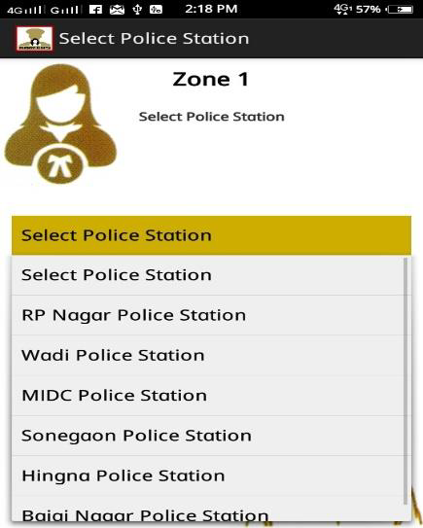

- select police station

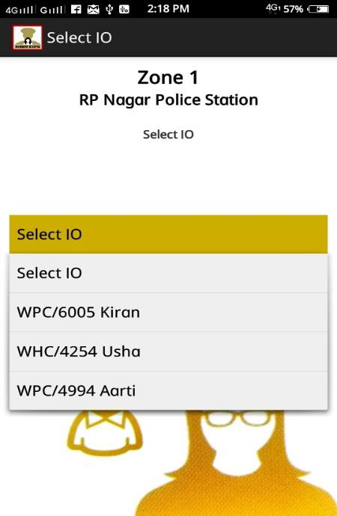
- select I/O
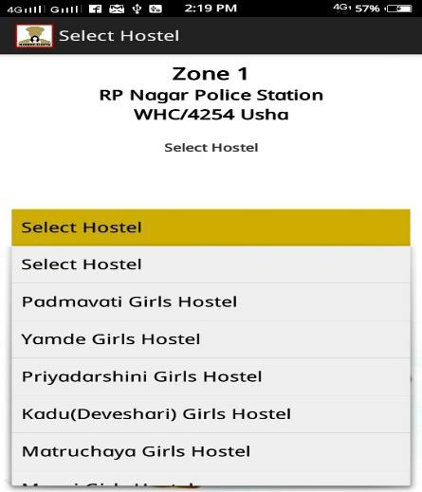
- select hostel

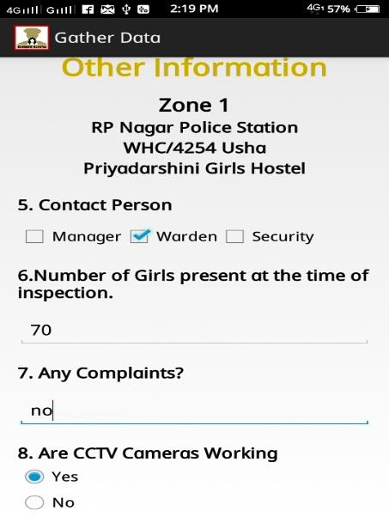
- Fill Information
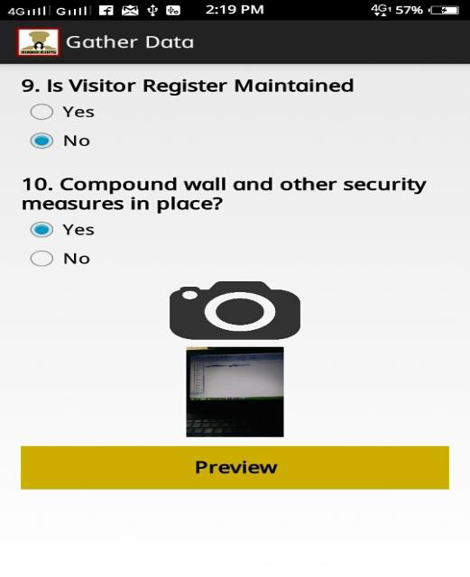 7.Preview
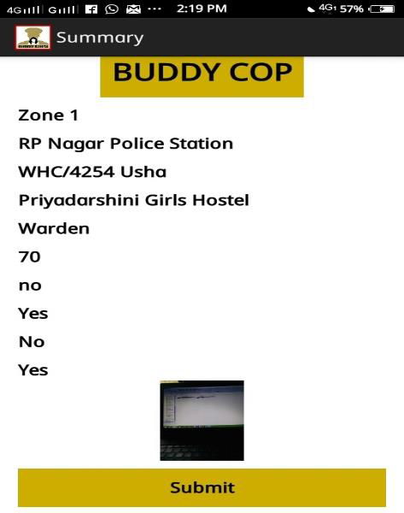
- Submit

CONCLUSION:

This application will help in finding the problem faced by women's in hostel. This will also keep record of the hostels and officers.

ACKNOWLEDGMENT
We would like to place on record our deep sense of gratitude to project guide Prof. Mrs. Snehal Golait mam for her stimulating guidance, continuous encouragement and supervision throughout the course our project work. information provided towards this project. We feel privileged to express our deepest sense of gratitude and sincere thanks to our Prof. Nita Thakre mam, Head of the Department, Computer Technology, PCE mam for the generous guidance, valuable suggestions and

REFERENCES
- Nagpur Available from: Hindustan Time Acessed on 19 September 2017, 06:11 IST.Nagpur Available from: Times of India Acessed on 25 March 2017, 06 .
2. Details about FIR gathered from the source:
https://en.wikipedia.org/wiki/First_Information_Repo
rt
3. Complaint Registration procedure information
example obtained here:
https://mumbaipolice.maharashtra.gov.in/complaint.
asp
4. Got to learn more about android platform through
the given site:
http://developer.android.com/training/basics/firstapp
/index.html
5. PHP tutorials helped us gain through knowledge:
http://www.w3schools.com/php/

