Comparative Study of Seismic Behaviour of High Rise Building with and Without Use of Fluid Viscous Damper Using E-Tabs

Milton Fernandes¹, Swane Rodrigues², Suraj Sharma³, Smit Raut⁴ , Mr. Shreeshail Heggond5

¹²³⁴UG Students, Department of Civil Engineering, St John College of Engineering & Management, Palghar ⁵Assistant Professor, Department of Civil Engineering, St John College of Engineering & Management, Palghar
Received on: 10th January,2021, Revised on: 29th May,2021, Published on: 2nd June,2021

Abstract – High rise building construction is adopted everywhere as we have sophisticated designing software’s, engineers and also due to advancement in the field on engineering and technology. As the structure height increases its response to seismic and wind loading also increases. Codes suggest that the forces and displacements of a structure are directly proportional to its height.
A lot of research work is going on for reduction in responses during extreme loading condition due to wind and earthquake. Passive control devices like various types of dampers come very handy as they can be easily installed, requires no operation cost and are easily replaceable. These devices become active only when loading is applied. In this project we are going to study & discuss the reduction in response of a G+25 RCC commercial building when viscous dampers are used considering seismic loading and wind loading. Buildings with high ratio of its height to plan area will generate higher overturning moments while buildings with large plan areas may not act as expected due to differences in ground behavior (differential ground settlement) which are not always predictable. Torsion can be of great concern because of the eccentricity in the building layout which is not taken into consideration by the architects. Best type of bracing configuration, its location and comparison of dampers is to be studied. The analysis is done on ETABS 2019 and special emphasis is laid on reduction of displacement and storey drift.
Keywords- Dynamic Analysis, Seismic Performance, Viscous Dampers

I -INTRODUCTION
Earthquake is the important term that comes to mind while designing any multi storey building. This earthquake are one of the most disastrous of natural criteria, This earthquake is known as ‘Along fault plane the vibration and shaking takes place at the earth surface due to underground ground motion. There is a huge loss of life, property and many essential services. For this we have to take care while constructing the building, the structure should be an earthquake resistant. The earthquake resistant structures are the structures which can resist the largest earthquake that can possibly occur in particular area as per the standard codes. The structure should be having a good building configuration than it is an earth quake resistant structure it should be having better lateral stiffness, ductility, lateral strength, stability and integrity .The structure to be made earthquake resistant many technologies are developed in that seismic control devices are now more widely used in buildings.
Mainly there are three types of structural control systems, they are active energy dissipation system, semi active energy dissipation system, and passive energy dissipation system. For the seismic effects the passive energy systems are used. Damping may be defined as the process by which the free vibration of a vibrating body decreases in the amplitude. The range of damping is depending on the different types of materials used in construction, construction type and also the non-structural elements. Measuring of damping done through critical damping. Dampers are placed in a structure to absorb the energy developed and lesser the shaking of the structure and reduction in the damage of the building.
Seismic control devices are Dampers During earthquake ground motion high magnitude energy is developed that develop a forces on building if the building is free of damping its stiffness is less and vibration in the structure is more, or else the structure is damped it increases the stiffness of the building as of the vibration reduces. Among various passive energy dissipating devices Fluid viscous dampers are more widely used in buildings. Fluid viscous dampers are enhance the performance of the building.
A. Fluid viscous damper
Fluid viscous dampers are one of the passive energy vanishing devices, for controlling vibration caused in structure and mechanical systems. In military and aerospace industry they use extensively these type of dampers from past years now a days these are used in the buildings to control the vibrations caused by wind and earthquakes. One of the greatest unique capacity of the dampers is it will together decreases both the stress and deflection within the structure subjected to transient. This is because the dampers vary its force only with the velocity, due to flexing of the structure the response that is permanently out of phases with the stresses. To vanishes the energy in the building these dampers are used because these dampers are velocity dependent. To reduce the responses in the building these effective damping should be done by using these type of dampers. FVDs are frequency independent devices without a stiffness component.
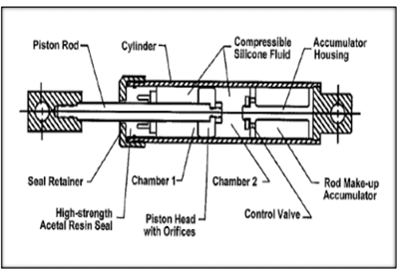
Fig 1: Longitudinal section of Fluid viscous damper
The figure shows in which dampers is in mid stroke position. The main pressure chamber is called cylinder, it consists full of fluid inside .It including the volume on both sides of piston. Piston head is connected with the piston rod. Clevis is present at the left hand side of the piston rod to attach the structure. These piston rod, piston head and clevis act as a single unit during dynamic phase they all move as one component and other components remains stationary. The fluid present in the cylinder is compress able viscous fluid silicone oil which is stable for heat, toxic free, inflammable and also environmental friendly.

B. Damping characteristics
The operation of FVD is happens when structure moves and it will add a resisting force and they do not add any stiffness to structure and do not carry any load. As a request we can add stiffness to the dampers. In FVDs the pressure is developed when a piston move back and forth. The orifice which is custom designed with piston develop and optimized relationship that produce this pressure that varies with velocity. Higher the velocity, higher the will be the resisting force .This relationship is represented by a equation.
Damping force = Damping constant x velocity α
F D= C x V α
α is the damping exponent. The value of α a very important role in magnitude of damping force .The damper with α value 1 then its is a linear damper in this case as per above equation the damper force is proportional to the velocity. As per practical application the value of α greater than 1 not still in practice.
The value of damping coefficient varies from the 0.2 to 2.0 depending on the specific application. In some cases it varies with a range of 0.3 to 1.0. Value of α is very important for a present day structure design with seismic characteristics with a range of 0.3 to 0.5 is common.
There are many configurations are available for arrangement of dampers in a structural frame which can avoid significant functional and architectural compromises. The main point is considered is that the damper should be properly connected to points in the structure and act effectively when there is a motion due to sway of building. One of the simplest method to apply distributed damping to the structure the diagonal bracing method is most common to be used.

II- OBJECTIVES

The following objectives are considered in the present studies
1. To know the response of a multi-storey buildings for a seismic activity a rectangular plan with rectangular column and beam sections are considered.
2. Comparison is made for a building with and without Fluid viscous dampers using both equivalent static method and response spectrum method.
3. To check the reduction in the various storey responses (Displacement, Storey shear, storey drift, modal periods and frequencies)

III- METHODOLOGY

1. In this present study, the ETABs 2019 abbreviated as “Extended Three-dimensional Analysis of Building system” software is used for modelling as well as analysis of the structure.
2. The symmetrical plan of reinforced concrete structure having 25-story is considered.
3.The structure without damper is modelled and analysed in ETABs 2019. The model is assigned the class of gravity loads.
4. First the Earthquake loads as per IS1893-2002, Part1 are applied for structure located in zone 3. And dynamic analyses i.e. Response spectrum method is carried out for 5% damping and scale factor considered as per IS code in both X and Y directions.
5. To control the seismic response of the structure and to absorb or to transfer the lateral loads of the structure, the viscous damper is provided. The viscous damper is modelled in the ETABs software. And the parameters like displacement, storey drift and storey shears are studied and will be presented in the report.
A. Methods of analysis
There are many methods are available for the seismic analysis of a selected building to find out the forces developed in structure due to seismic activity. Mainly analysis is done on the basis of model of structure selected, materials used in the structure and also on the external inputs.
I. Equivalent static method is also called as equivalent lateral force method. Seismic analysis on a building is done on a assumption of the horizontal force is similar to the dynamic loading, In the method periods and shape of higher mode of vibration are not required so the effort for the analysis is less, except for the fundamental period. The base shear is calculated depends on the mass of structure, its fundamental periods of vibration and shapes. Firstly the base shear is calculated for a entire structure then along the height of building distribution is done. At each floor level the lateral force obtained are distributed to each structural element. This method is usually adopted for a low to medium height building.
II. Response spectrum method is also called as a modal method or mode superposition method. This method is used in a structure where the modes will affect the response of structure other than the fundamental one mainly this method used for a dynamic analysis of a building which are asymmetrical in plan or irregularity in areas. In case of multi storied buildings to find the forces and displacements caused due to medium range earthquake motion this method is used for analysis.
In this method directly from the earthquake design spectrum the peak response of a building is obtained during an earthquake ground motion. Peak responses obtained in this method are quite precise with the structural design application. In this method multiple mode of response are considered. Based on modal frequency and modal mass the individual mode response is read from the response spectrum.
IV. MODELLING AND ANALYSIS
A 25 story moment resisting residential building was designed without any basement with plan dimension 25.61m by 14.92m (The total height of the building is 75m and typical floor to floor height is 3 m. The building is modelled symmetrically to avoid torsion effects. The inherent damping of the frame is considered 5%. The frames have been modelled as rigid frames. All restrains that have been modelled are assumed to be fixed. Dead and live loads were assigned to the shell elements of the structure according to IS code. The compressible soil condition was not considered and the entire building was supported by fixed foundation.
A. Description of building model
Table 1- Description of building model
Structural Part | Dimensions
Type of Building | Commercial Office Building
Location of Building | Mumbai
Plan dimensions | 25.61m x 14.92m
Numbers of floors | 25
Length in X- direction | 25.61m
Length in Y-direction | 14.92m
Floor to Floor height | 3m
Total height of building | 75m
Slab thickness | 150mm
Column size | Column 500x300 (1217)  Column 500x500 (2)
Beam size | Beam 450x300 (1697)  Beam 500x350 (3)  Beam 600x400 (1)
Zone | 3
Seismic Intensity | Moderate
Importance factor(I) | 1.2
Response Reduction Factor (R) | 5 for SMRF
Soil type | TYPE III (Soft Soil)
Grade of concrete(Beam) | M-40
Gradeof concrete(Column) | M-40
Grade of concrete(Slab) | M-40
Reinforcement | HYSD500  Mild250
Unit weight of concrete | 40kN/m²
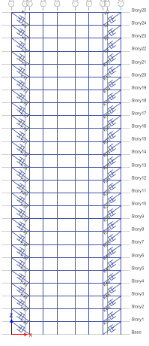

Fig.3- FVD at exterior corner Elevation in YZ plane

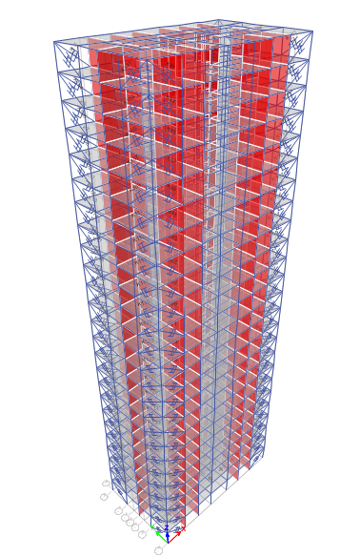
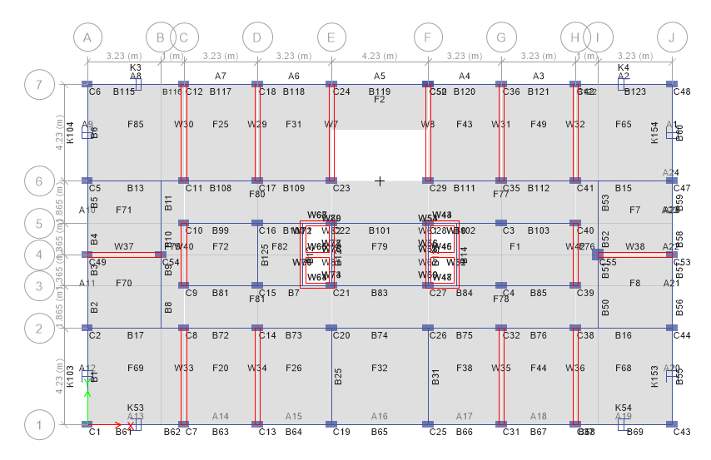
Fig. 1- Plan view of building with FVD in ETABS

Fig.2- 3D View of Model In Etabs
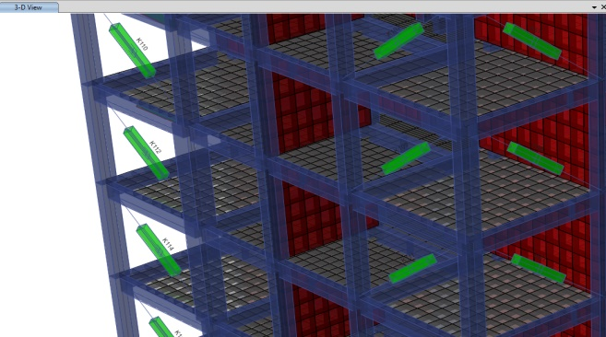
Fig.4- FVD at exterior corner extrude view

V- RESULT

Modelling of building is done with the all the defined loads as per the code provisions. Then the analysis of the structure is done with both Equivalent static method and Response spectrum method. After the analysis various storey responses are compared and comment should be made on those results. A storey response includes storey displacement storey drifts, storey shear and Modal time and frequencies are considered and compared.
A. Storey displacement
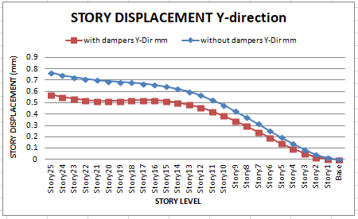
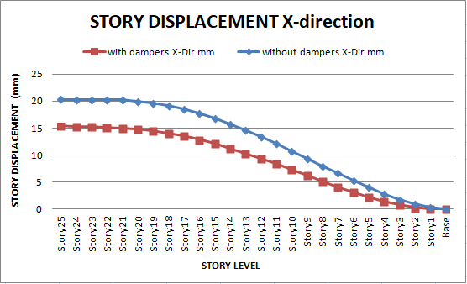
Storey displacement is a main storey response that get reduced after adding dampers to the structures. For a G+25 storey building with and without viscous dampers the displacement value obtained for both equivalent static method and response spectrum method along both x and y direction
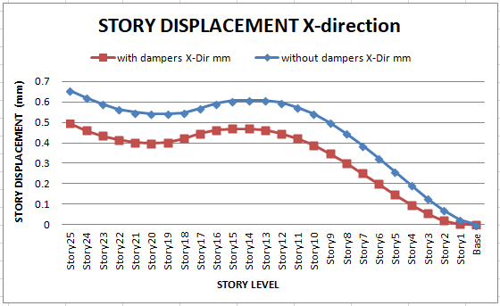
Graph 1: Storey displacement in x direction for Static method
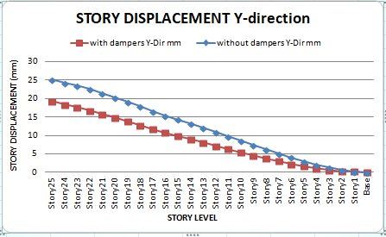
Graph 2: Storey displacement in x direction for response spectrum method
Graph 3: Storey displacement in Y direction for Static method
Graph4: Storey displacement in Y direction for response spectrum method
Table 2- Displacement Table
Story | Elevation | Story Displacement
 |  | X-Direction |  | Y-Direction
 |  | Without Damper | With  Damper | Without Damper | With  Damper
Story25 | 75 | 20.361 | 15.39 | 25.278 | 19.345
Story24 | 72 | 20.252 | 15.311 | 24.258 | 18.341
Story23 | 69 | 20.307 | 15.269 | 23.485 | 17.62
Story22 | 66 | 20.333 | 15.197 | 22.511 | 16.766
Story21 | 63 | 20.255 | 15.059 | 21.443 | 15.832
Story20 | 60 | 20.045 | 14.834 | 20.301 | 14.841
Story19 | 57 | 19.692 | 14.509 | 19.099 | 13.811
Story18 | 54 | 19.191 | 14.076 | 17.853 | 12.755
Story17 | 51 | 18.542 | 13.535 | 16.571 | 11.685
Story16 | 48 | 17.754 | 12.889 | 15.439 | 10.736
Story15 | 45 | 16.837 | 12.143 | 14.317 | 9.845
Story14 | 42 | 15.804 | 11.307 | 13.179 | 8.955
Story13 | 39 | 14.668 | 10.392 | 12.027 | 8.066
Story12 | 36 | 13.446 | 9.412 | 10.864 | 7.182
Story11 | 33 | 12.155 | 8.384 | 9.694 | 6.306
Story10 | 30 | 10.813 | 7.322 | 8.525 | 5.443
Story9 | 27 | 9.439 | 6.248 | 7.363 | 4.6
Story8 | 24 | 8.054 | 5.18 | 6.219 | 3.784
Story7 | 21 | 6.68 | 4.141 | 5.104 | 3.007
Story6 | 18 | 5.341 | 3.153 | 4.035 | 2.279
Story5 | 15 | 4.064 | 2.244 | 3.03 | 1.616
Story4 | 12 | 2.88 | 1.44 | 2.113 | 1.035
Story3 | 9 | 1.827 | 0.774 | 1.311 | 0.556
Story2 | 6 | 0.951 | 0.279 | 0.661 | 0.24
Story1 | 3 | 0.316 | 0.064 | 0.219 | 0.227
Base | 0 | 0 | 0 | 0 | 0

By observing all the above results the placing of FVD in the building will reduces the storey displacement due to seismic loads effectively in both directions. From the results of storey displacements bare framed building without a FVD having maximum displacement when compared with a building with FVD
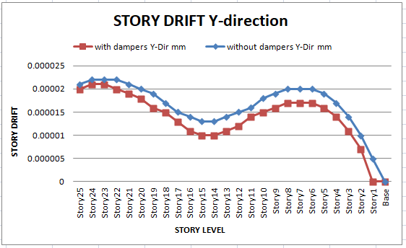
B. Storey drifts
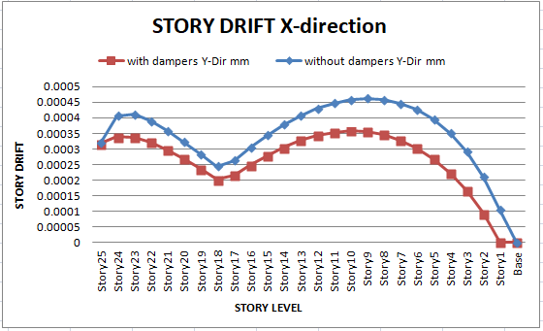
The inter storey drifts values for the considered building along x and y direction are tabulated below. As per IS 1893:2016 for a storey with minimum assigned lateral force, having partial load factor 1.0 the storey drift value does not exceed 0.004 times the height of a storey.
Graph 5: Storey drift in x direction for Static method
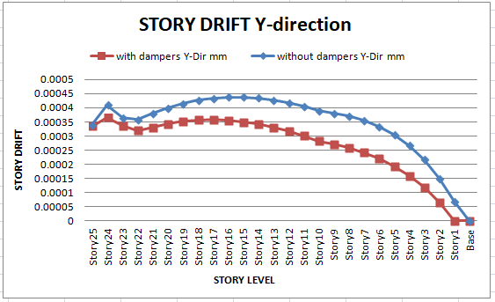
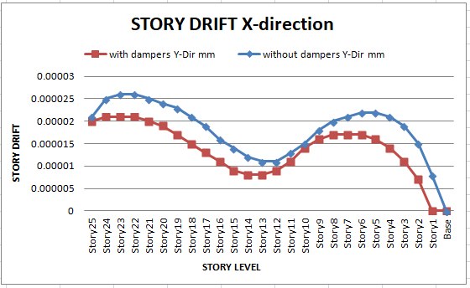
Graph 6: Storey drift in x direction for response spectrum method
Graph 7: Storey drift in Y direction for Static method
Graph 8: Storey drift in Y direction for response spectrum method
STORY | ELEVATION | STORY DRIFT
 |  | X-DIRECTION |  | Y-DIRECTION
 |  | WITHOUT DAMPER | WITH  DAMPER | WITHOUT DAMPER | WITH  DAMPER
Story25 | 75 | 0.00032 | 0.000317 | 0.00034 | 0.000335
Story24 | 72 | 0.000407 | 0.000339 | 0.00041 | 0.000366
Story23 | 69 | 0.000411 | 0.000337 | 0.000366 | 0.000336
Story22 | 66 | 0.00039 | 0.000322 | 0.000359 | 0.00032
Story21 | 63 | 0.000359 | 0.000298 | 0.000381 | 0.00033
Story20 | 60 | 0.000323 | 0.000269 | 0.0004 | 0.000343
Story19 | 57 | 0.000284 | 0.000236 | 0.000416 | 0.000352
Story18 | 54 | 0.000245 | 0.000202 | 0.000427 | 0.000357
Story17 | 51 | 0.000263 | 0.000216 | 0.000434 | 0.000358
Story16 | 48 | 0.000306 | 0.000249 | 0.000438 | 0.000356
Story15 | 45 | 0.000344 | 0.000279 | 0.000438 | 0.00035
Story14 | 42 | 0.000379 | 0.000305 | 0.000435 | 0.000342
Story13 | 39 | 0.000407 | 0.000327 | 0.000428 | 0.000331
Story12 | 36 | 0.00043 | 0.000343 | 0.000419 | 0.000317
Story11 | 33 | 0.000447 | 0.000354 | 0.000406 | 0.000301
Story10 | 30 | 0.000458 | 0.000358 | 0.000391 | 0.000282
Story9 | 27 | 0.000462 | 0.000356 | 0.000381 | 0.000272
Story8 | 24 | 0.000458 | 0.000346 | 0.000371 | 0.000259
Story7 | 21 | 0.000446 | 0.000329 | 0.000356 | 0.000242
Story6 | 18 | 0.000426 | 0.000303 | 0.000335 | 0.000221
Story5 | 15 | 0.000395 | 0.000268 | 0.000306 | 0.000194
Story4 | 12 | 0.000351 | 0.000222 | 0.000267 | 0.00016
Story3 | 9 | 0.000292 | 0.000165 | 0.000217 | 0.000118
Story2 | 6 | 0.000211 | 9.30E-05 | 0.000151 | 6.70E-05
Story1 | 3 | 0.000105 | 0 | 6.90E-05 | 0
Base | 0 | 0 | 0 | 0 | 0
Table 3 - Drift Table

From the above observation the storey drift will be max for a building without damper as compared to building with damper. The max drift value for any building does not exceed the limited value specified by the IS standards. By placing the dampers in the building will reduce the drift value.
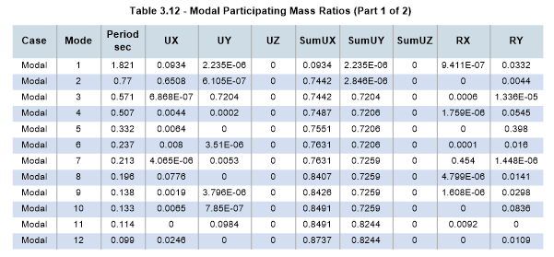
C. Storey shear
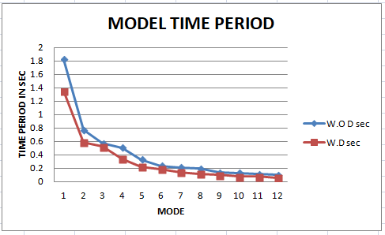
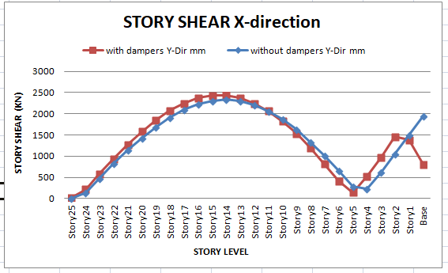
The storey shear is the shear value computed from the adding of design lateral forces at the levels above the storey consideration of the structure. Usually the storey shear value is maximum at the lower stories and minimum at the higher stories.
Graph 9: Storey shear in x direction for Static method
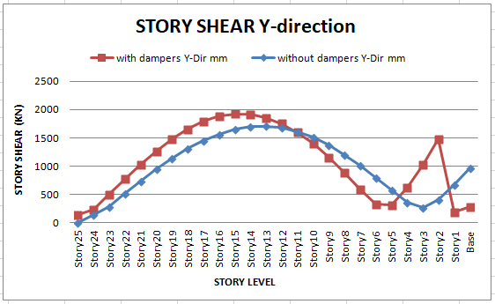
Graph 10: Storey shear in Y direction for Static method

From the above observation we seen that the shear value is increases towards the bottom stories in case of without damped building, But in case of damped building the shear value is increases towards the upper stories. By adding dampers to the building the max shear value will be reduced in a building. Shear at the base will be reduced in damped building.

D. Modal periods and frequencies
During earthquake or wind, all modes are excited in different manner .Depends on the spatial distribution and frequency content of the load the length of dynamic loading excites the modes of vibration. In this study 12 modes are considered and their time period and frequencies.

Graph 11: Modal periods
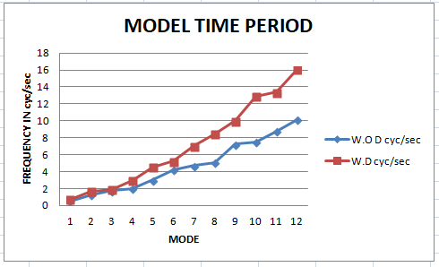
Graph 12: Modal frequency
The time period for a without damping building is more as compared to the damping building. The time period is inversely proportional to the frequency of the structure. So the natural frequency of the damped building is more compared to the building without damper. As the frequency of the structure increases the stiffeness of structure is also increases because stiffeness is directly proportional to the frequency. For a higher elevation building the frequency is more because of more mass

VI- CONCLUSION

For a G+25 storey symmetric building the earthquake analysis is carried out by equivalent static method and response spectrum method and following are the observation made and concluded from the present study, they are

The main objective of this Project is to determine how dampers and its configuration could improve the performance of buildings or structures so as to be satisfactory for the higher seismic zones

In this project, viscous dampers are to be used to reduce the seismic effect of the structure which are subjected to the earthquake load. The frames (with and without viscous damper) is modeled according to the properties of the structure

The seismic behavior of the Reinforced Concrete structure is judged by observing the parameters such as:

1. Displacement:

Storey displacement in a regular building not having dampers will have a maximum displacement value when compared to a building provided with damper. By the addition of dampers to the structures will drastically reduce the displacement value and increase the stability of the structure. As the height of the building increases the displacement value also increases so in order to reduce storey displacement dampers are used

2. Story Drift:

Storey drift value for a regular building will be more when compared to the building with damper. By adding damper to the structure the drift value will be reduced and the max drift value of a building does not exceed the limited value specified by the Indian standards

3. Story Shear ( kN )

Storey shear value for a building without damper will be maximum at the base and for a building with damper will have a max shear value at the top storey, but the shear value of a undammed building will be more compared to the damped building

4. Time periods

For 12 modes for a undammed building is more due to which frequency are reduces. But for a damped building time period are less frequency is more. Observed that 75% of frequency increases so that stiffness of building increases effectively by using FVD 500 dampers at the exterior corners of the building

REFERENCES
- jreshwari Umachagi, Katta Venkataramana, G. R. Reddy, Rajeev Verma, “Applications of Dampers for Vibration Control Of Structures: An Overview” International Journal of Research in Engineering and Technology, Nov-2013.
- Liya Mathew & C. Prabha, “Effect of Fluid Viscous Dampers in Multi-Storeyed Buildings”, International Journal of Research in Engineering & Technology, Vol. 2, Issue 9, Sep 2014, 55- 60.
- Su Myat Aye, Dr. Kyaw Moe Aung, “Comparative Study on Seismic Response of RC Structure Using Viscous Dampers and Viscoelastic Dampers”, International Journal Of Scientific Engineering And Technology Research, Vol.03, Issue.08, May-2014, Pages:1468- 1478
- Douglas Taylor, President, Taylor Devices Inc., “History, Design and Application of Fluid Dampers in Structural engineering”
- The manufacturer of the Viscous Damper product Taylor Devices Inc., India.
- Mohammad Javad Dehghan, Mostafa Soleymannejad, “Improving Seismic Performance of Concrete Buildings with Special Moment Frames Using Viscous Damper”, InternationalJournal of Modern Engineering Research, Vol. 5, Issue. 7, July 2015.
- Yuvraj Bisht, Saraswati Setia, “Seismic Behaviour Of A Soft Storey Building With & Without Viscous Dampers”, International Journal of Engineering Research and Applications (IJERA) ISSN: 2248-9622, pg. no 10-15
- The manufacturer of the Viscous Damper product Taylor Devices Inc., India.
- Lee. D., and Taylor. D. P, “Viscous damper development and future trends”, Struct., Des., Tall Build, vol-10(5), 2001, pg.no-(311–320).
- Alireza Heysami, “Types of Dampers and their Seismic Performance during an Earthquake”, CurrentWorld Environment, Vol. 10(Special Issue 1), 1002-1015 (2015).
- Dharmesh Chandnani, Riddhi Joshi, Kumarpal Trivedi, “Characteristics & Applications of Different Types of Dampers as Seismic Energy Dissipater”, International Journal of Computer Science and Network, Volume 5, Issue 2, April 2016 pg.no (369-372).
- Jenn-Shin Hwang, Chun-Hsiang Tsai, Shiang-Jung Wang, Yin-Nan Huang, “Experimental study of RC building structures with supplemental viscous dampers and lightly reinforced walls”, Engineering Structures, accepted 6 March 2006, pg.no (1-9), at 2006 Elsevier Ltd.
- Alessandra Aprile; Jose A. Inaudi/ and James M. Kelly, ”evolutionary model of viscoelastic dampers for structural applications”, journal of engineering mechanics, pp 551-560B. Samali, “Use of viscoelastic dampers in reducing wind- and earthquake- induced motion of building structures” Engineering Structures, Vol. 17, No. 9, pp. 639-654, 1995

