Fabrication Of Water Tank Cleaning Machine
Mr. Shubham Samrit, Mr.Divyarajsingh Mandale,Mr. Ankit Rokade, Mr.Paresh Choudhary, Mr.Faisal Khan, Mr.Abhijeet Kongre, Mr.Harshal dalvi, Mr Saurabh Zade * Prof. M.S.Giripunje**
*Department of Mechanical Engineering, Priyadarshini college of engineering Nagpur
**Assistant Professor, Department of Mechanical Engineering, Priyadarshini college of engineering Nagpur
Abstract - Aim of this project is to develop a mechanical system for cleaning domestic cylindrical water tank. The mechanical system includes two main mechanisms which are rack and pinion gear mechanism and motion reversal mechanism.
The rack and pinion arrangement is used to move whole mechanical system up and down for cleaning the cylindrical tank. The rack is fixed on the motor and the rotational mechanism is attached to the motor shaft. PVC brushes are attached to the ends of the four-bar linkage. Four bar linkage is made in such a way that it can be adjusted according to inside diameter of the tank.
Key Words: rack and pinion mechanism,linkage.

INTRODUCTION
A tank cleaning machine helps in cleaning the enormous variety of chemical residues and algae. Chemical tankers transport an enormous variety of chemical and oil products in global and short sea trade. Due to this variety the next cargo is almost never identical with the previous cargo.Thus, tank cleaning is essential on chemical and product tankers. The products that need to be cleaned vary widely in their properties and characteristics. In addition, the chemical industry and their customers have continuously increasing quality requirements.This results in high standards regarding the cleanliness of tanks. MIRACLE provides comprehensive Information and guidance about Tank Cleaning. This will help to fulfill these requirements.Tank Cleaning proposals provide cleaning guidance for some 7000 chemicals shipped regularly in bulk.The success of a tank cleaning job depends on many factors such as thorough planning of the cleaning job, the design of tanks, cleaning machines and their operation, design of piping, heating capabilities etc. which are known only to ship’s command.
2. EXISTING SYSTEMS

A.Rack And Pinion
A rack and pinion pair is a type of linear actuator that comprises a pair of gears which converts rotational motion into linear motion. A circular gear called “the pinion” engages teeth on a linear “gear” bar called “the rack”. Rotational motion applied to the pinion causes the rack to move relative to pinion. Thus, the motor attached to the rack is moved in vertical direction along the guide way

B. Motor
Gear motor is used to produce high torque with low speed. motor used has specifications as single phase 12V, 15A which produces power of 0.15 HP and frequency of 25Hz and the shaft speed is 20-25 rpm. We have two DC motors, one for translation motion and another for rotational motion. Both motors have independent control for each purpose.
C. Brushes
The brushes are made up of Poly Vinyl Chloride (PVC) polymer. Brushes attached to the ends of horizontal shaft at the bottom end of the vertical rotating rod revolve due to rotation of motor shaft to clean the inner vertical surfaces of the tank.
D. Central Rod
Rod made up of mild steel of diameter 15mm is used to transmit rotary motion from motor to the bottom horizontal brushes. This rod sits inside the hollow sleeve, also made of mild steel, with help of bearing on the either ends of the sleeve.
3 . CONSTRUCTION
Construction of tank cleaning machine is as shown above. It consists of cylindrical tank in which there is one vertical rod inside a sleeve and a horizontal shaft which has brushes at the bottom and the either end. The vertical sleeve contains a rack and pinion mounted on it and is run by motor. The power of motor is 0.15 HP and frequency of 25Hz and the There are two types of brushes used- one is vertical and another is horizontal. Vertical brush is in contact with inner surface of the tank. And horizontal brush is directly contact with the bottom surface of the water tank.Electrical motor is connected with rack and pinion mechanism. And power is transferred through the pulley. Clamp is used for providing the fix support between water tank and cleaning mechanism.
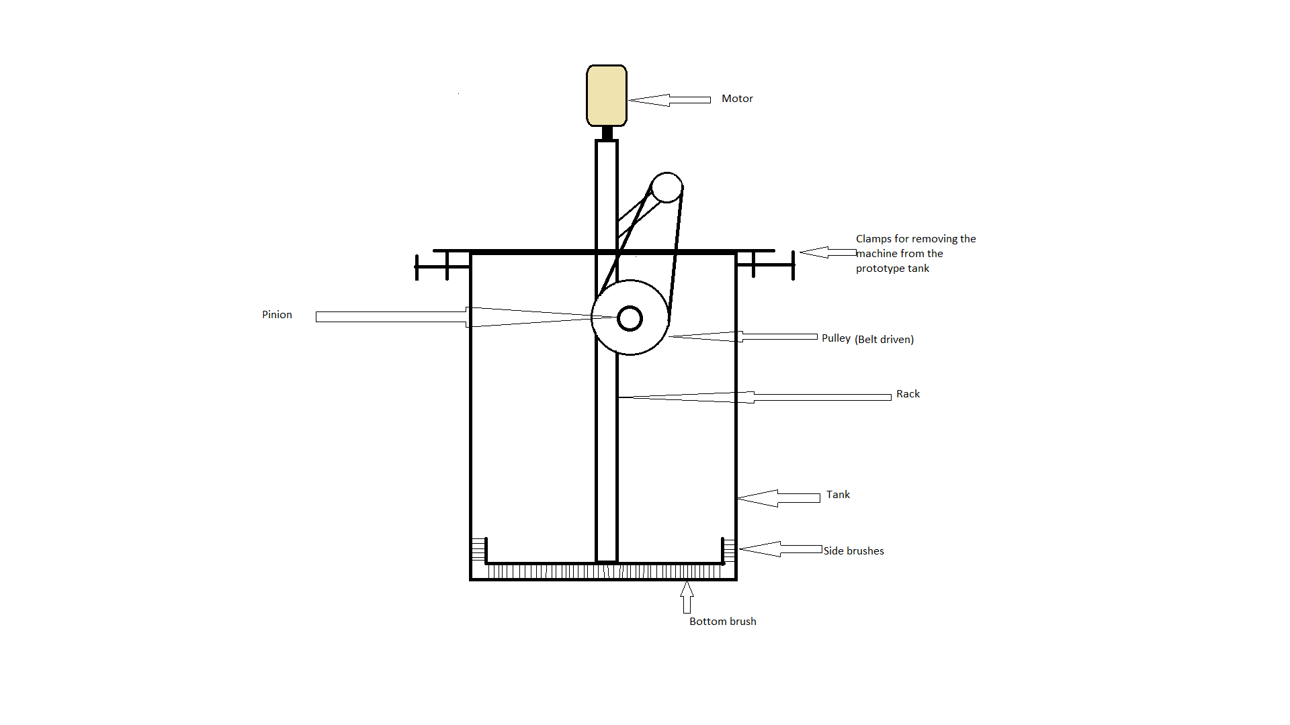

4.Working
Working of the tank cleaning machine is based on the principle of reciprocating mechanism in which motor is used for generating the power and transmit through the pulley. Rack and pinion mechanism is used for providing the reciprocating motion. This mechanism gives the reciprocating and rotational motion to the brushes.Rack and pinion mechanism is used to provide reciprocating motion. This reciprocating motion is used to translate the vertical sleeve up and down, due to which inner surface of water tank is in direct contact with the vertical and horizontal brushes. There are three switches used for operating the machine. First one is used for switching the electrical motors on or off. The second is used for toggling the rotational direction and the third is used for toggling the translational direction. These two switches are to be in the same state for the machine to work, i.e. when both the switches are kept on, the assembly goes down rotating clockwise, and when these switches are kept off, the assembly goes up with the brushes in anticlockwise rotation.
This is mechanism on which this project is entirely based.
5.Future Scope
The machine can be operated on solar energy.It can be fully automated by using sensors.
Timer can be used for stroke of motion, during toggling of motions.
The machine can be remotely operated.
The horizontal shaft having brushes on the ends can be fitted with nozzles, which can provide continuous little amounts of water on the walls to enable smooth flow of dirt.

6. Conclusion
The water tank cleaner was used to clean the water tanks by using rotating brushes. This method was more effective and safe than the conventional methods. This method is capable to clean water tanks within less time and human efforts. For cleaning the tank we need one worker which take more time as well as water.As we know, now a days wastage of water is a great issue.To resolve these issue we made these machine at great priority.

REFERENCE
This gives an idea of what types of tank cleaning machines are available now and how much expensive they are.

-From the subject of Kinematics of Machines, we took the mechanism of screw pair for giving the rotational and translation motion simultaneously. But there were some limitations of weight that comes on the motors. Therefore, we improvised and changed the underlying mechanism of this machine.

