JOURNAL ON USE OF RECYCLED CONCRETE AGGREGATE OVER NATURAL AGGREGATE.
AANCHAL SAHU, SAMEEKSHA RAI, DRISTY BISWAS, SHAILENDRA MESHRAM, K. DIVYA KOTECHA .
CIVIL DEPARTMENT, RSR RUNGTA COLLEGE OF ENGINEERING AND TECHNOLOGY, BHILAI, C. G.

Abstract - The aim of this project is to use the RCA as an economic alternative use over the natural aggregate in any project of construction. The results of the test programme to study the use of RCA in high strength 70N/mm^2 concrete are described. The result showed that up to 30% coarse RCA had no effect on concrete strength, but there after there was a gradual reduction as the RCA content increases. The tests were conducted by replacing the coarse aggregate in high strength concrete mix by 0, 10, 20, 30, 40 & 50% of recycled coarse aggregates by weight and the mixes are tested for a period of 7 and 28 days. A 50% replaced mix with reduced W/C ratio was also tested. The most important tests are carried out in the paper such as compressive strength test, mixed proportion, W/C ratio, physical appearance, acid resistance, etc.
KEYWORDS- Natural Aggregate, High strength concrete, Recycled concrete aggregate, Physical appearance.
INTRODUCTION
Crushed concrete aggregates also known as Recycled Concrete Aggregates are fragments and pieces of concrete buildings which are demolished or rebuild .Crushed concrete aggregate eliminate the need for disposal by using the readily available concrete as an aggregate source for new concrete. The construction work required several material like cement, concrete, steel, bricks, stone, glass, clay, mud, wood and so on. However cement and concrete is the most important part of construction work. Nowadays the construction and demolition wastes have been producing in a very large quantity every year. Thus it affects the environment and

economy. So that many governments throughout the world are promoting the policies aimed to use RAC.
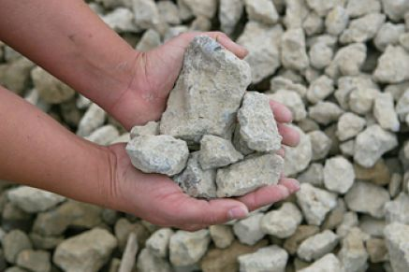
Reducing the use of primary resource and increasing re-use and re-cycling. The utilisation of recycled aggregate is particularly very promising as 75% of concrete is made of aggregate. After demolition of old roads and buildings the removed concrete is often considered worthless and disposed of demolition waste. Buck cities the beginning of RCA use to the end of World War 2, when there was excessive demolition of buildings and roads and a high need to both get rid of the waste material and rebuild .Central Pollution Control Board has estimated current quantum of solid waste generation in India to 40 million tons per annum of which waste from construction industry accounts for 25%. The use of RCA in high strength concrete have been examine in relatively few studies and experimental data are limited. A study considering high strength concrete containing coarse RCA contents of 5, 10 and 12.55 indicated that the strength at a given W/C ration was similar to that containing natural aggregate. It is also acknowledged that recycling the use of demolition waste to use as aggregate, after an environmentally responsible and economical route to convert scrap material to a valuable resource,

TESTS TO BE PERFORMED IN RAC
- MIX DESIGN
According to IS design method, mix design is done. It is used to produce concrete with as 0%, 10%, 20%, 30%, 40% & 50% with 0.4 W/C ratio, 50% with 0.34 W/C ratio replacement of RCA, once the optimum concrete mix is determined
Table 1 Mix design for High strength concrete

Cement | Water | Sand | Aggregate
367 | 147 | 726 | 1230
1 | 0.4 | 1.97 | 3.35

- Slump Test-
The slump is taken for each mixing of concrete with 0%, 10%, 20%, 30%, 40% & 50% with 0.4 W/C ratio, 50% with 0.3 W/C ratio replacement of RCA. The low slump is found when N
CA is 100% replaced by RCA. Thus the slump is low because higher water absorption in RCA while mixing process
Table 2 Result of Slump Test
Percentage of recycled aggregate | Slump(mm)
0 | 87
10 | 86
20 | 82
30 | 81
40 | 79
50% with 0.4 W/C ratio | 77
50% with .34 W/C ratio | 64

- COMPRESSIVE STRENGTH
Compressive strength of concrete is the strength of hardened concrete measured by the compression test. The compression strength of concrete is measure of the

concrete’s ability to resist loads with tend to compress it. It is measured by crushing cube concrete specimen in compression testing machine.
In these test 150mm standard cube mould is used for concrete mix. The apparatus should be clean and free from hardened concrete and surplus water before testing. The test is carried out for each cube. The reported compressive strength is the average of 3 measurements tested at the age of 7 and 28 days

Table-3 Compressive strength test.

S.I.no | % of RCA replacement | Average Split Tensile (7 days) | Average compressive strength in MPa (28 days)
1 | 0 | 29 | 42.1
2 | 10 | 27 | 38.2
3 | 20 | 24.5 | 35.3
4 | 30 | 22.6 | 32.5
5 | 40 | 21.5 | 30
6 | 50% with .4 W/C ratio | 19 | 26.6
7 | 50% with 0.34 W/C ratio | 26 | 37
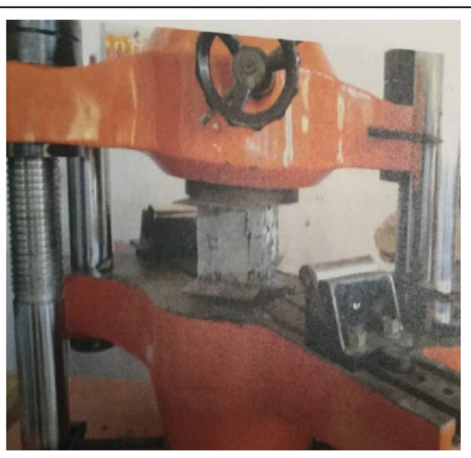
Fig- Compressive strength test apparatus

- ACID RESISTANCE
For acid attack test concrete cube of size 150*150*150mm are prepared for various percentage of silica fume addition. The specimens are cast and cured in mould for 24 hours , after 24 hours, all the specimen are de-moulded and kept in curing for 7days.
The percentage loss in weight of concrete cubes after 45 days immersion in 3%
sulphuric acid increases as the percentage of RCA replacement increases.
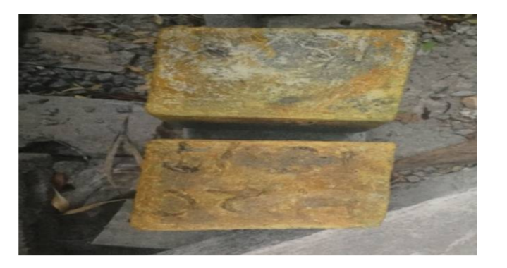
Fig- Acid reaction on cube’s surface.

PHYSICAL PROPERTIES
- BULK DENSITY
- The compacted bulk density for the RCA was 1344kg/m^3, whereas that for the NCA was 1678kg/m^3.
- The higher the bulk density of coarse aggregate is an indication of the presence of fewer voids to be filled by small particles such as sand and cement.
- The ratio of the loose bulk density to the compacted bulk density of the RCA was 0.88 and the NCA was 0.93.

- SPECIFIC GRAVITY
- The specific gravities of the RCA were 2.17, 2.35 & 2.63 are 20%, 15% & 7% less than that of NCA respectively.
- The most commonly utilised natural aggregates have specific gravities that vary from 2.2 to 3.0.

- ABSORPTION
- The absorption test determine the total pore volume by measuring the amount of water that the aggregate particles can absorb into its pore structure.
- The conducted absorption test result confirm that the amount of water absorb by the RCA was 7.5%, which is 4.2 times higher that by the NCA utilised in these experimental study.
- However they are in the range between 0 to 8% where absorption capacity of normal weight often fall and the value of absorption of RCA comes into these range respectively.

- SHAPE, SIZE & TEXTURE
- The shape and texture of the RCA and the NCA used in this experimental work were visually assessed.
- SHAPE
Both types of coarse aggregate were identified as angular in shape with an angularity number of 5. The computed angularity number lie in the range where the conventional aggregate usually fall i.e.,0-11
- SIZE
The fineness modulus of RCA is 1.48, while for NCA 2.42. Which out of typical range where conventional aggregate often lie between 2.3-3. Both types of aggregate yield 37.5mm which is the maximum limits for normal weight coarse aggregate used for concrete production .
- TEXTURE
The surface texture of the RCA was rougher than the NCA.

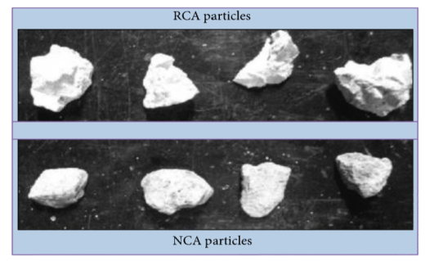
Fig- Shape, size and texture

- TOUGHNESS AND ABRASION
- The value of L.A. abrasion loss of the NCA was 19.11% whereas RCA was 32.88%.
- However it is suitable for general construction since its L.A. abrasion loss is well under the upper limit 45%.

- WORKABILITY
- RCA concrete mix demands additional water to achieve the similar level of workability as of the NCA concrete.
- But, the workability of concrete also affected by shape that the shape of RCA doesn’t effect the workability.
- The degree of workability is consider to be very low when the slump of fresh concrete falls in the range between 0 and 25mm.
CONCLUSION
- The RCA showed relatively lower physical properties as compared to the NCA.
- This will bring huge environmental and economic advantages to the society as it greatly helps us to conserve natural resources and reduce waste disposal and haul as well increasing employment.
- The results showed that up to 30% coarse RCA has no effect on the ceiling strength on concrete, but thereafter this reduces with increase RCA content this was observed consistently for concrete mix tested at 7 and 28 days.
- Another result found in the research is that when we reducing the W/C ratio used in recycled aggregate mixes, strength are also improved.
- The use of 100% RCA is possible to produce concrete with acceptable quality. The concrete produced with RCA has generally 80-90% of the strength of a comparable NCA concrete. The reduction in strength of RCA concrete is caused by the slightly lower physical property of RCA and inadequately dense transition zone between RCA and bulk cement paste.
- The percentage loss in weight of concrete cubes after the conduct of acid resistance is negligible for 30-40% RCA replacements moreover reduction in the strength is also nominal, which shows that this mix were less attacked by acid.
- The water absorption and porosity of RCA replaced mix are higher than normal mix but within the permissible limits. This properties can be modified by reducing the W/C ratio and by incorporating admixture.
- RCA can be used in high quality concrete such as high strength, high performance and self consolidating concretes by appropriate materials selection and mix design.
- It is important to recognise that there is need to introduce new standard to recycled aggregates and demonstrate that this materials can be used successfully in practice, under arrange of exposure conditions.
- The specific gravity of natural aggregate and RCA is 2.75 and 2.23 respectively which is responsible for compressive strength of concrete.
REFERENCES
- Md. Safiuddina,1, U bagaram Johnson Alengaramb,2, Md. Moshiur Rahmanb,3,Md. Abdus Salamb,4, and Mohd. Zamin Jumaatb,5 A Department of Civil and Environmental Engineering, Faculty of Engineering “USE OFRECYCLED CONCRETE AGGREGATE IN CONCRETE”

- Nik. D. Oikonomou *Laboratory of Building Materials, Department of Civil Engineering, AristotleUniversity of Thessaloniki, 54124 Thessaloniki, Greece “Recycled concrete aggregates”,
- International Journal of Innovative Research in Science, Engineering and Technology An ISO 3297: 2007 Certified Organization Volume 7, Special Issue 5, April 2011 1st International Conference on Recent Innovation in Civil Engineering and Management (ICRICEM '18)22nd March 2018Organized by Department of Civil Engineering & MBA, Loyola Institute of Technology, Chennai, Tamilnadu , India Copyright to IJIRSET www.ijirset.com 363A Study Using Recycled Coarse Aggregates inHigh Strength ConcreteAnderson.P.S1, Dr. M. Seethapathi2PG Student, Department of Civil Engineering, Tamilnadu College of Engineering, Coimbatore, Tamilnadu, India1Professor, Department of Civil Engineering, Tamilnadu College of Engineering, Coimbatore, Tamilnadu, India2

- M C Limbachiya, A Koulouris, J J Roberts and A N Fried, “Performance of Recycle Aggregate Concrete”, Kingston University, UK, 2004,
- Keith W. Anderson, Jeff S. Uhlmeyer, Mark Russell, “Use of Recycled Concrete Aggregate in PCCP”, June 2009.

- . Nik. D. Oikonomou, “Recycled concrete aggregates”, Laboratory of Building Materials, Department of Civil Engineering, Aristotle University of Thessaloniki, 54124 Thessaloniki, Greece.
- “Experimental Studies on High Strength Concrete by using Recycled Coarse Aggregate” N.Sivakumar1, S.Muthukumar2, V.Sivakumar2 D.Gowtham2, V.Muthuraj2 1Assistant Professor, Department of Civil Engineering Jay Shriram Group of Institutions, Tirupur-638660, TamilNadu, India. 2UG Students Department of Civil Engineering Jay Shriram Group of Institutions, Tirupur-638660, TamilNadu, India.
- Suitability Investigation of Recycled Concrete Aggregates for Concrete Production: An Experimental Case Study Department of Civil Engineering, Aalto University, P.O. Box 12100, FI-00076 Aalto, Finland
Correspondence should be addressed to Woubishet Zewdu Taffese; woubishet.taffese@aalto.fi.Received 16 April 2018; Revised 31 August 2018; Accepted 9 September 2018; Published 30September 2018.Proceedings of ICE: Structures & Buildings 134 (3) (Aug.
1999) 257-274.

