Analytical & Numerical Study of Gas Turbine Combustor

Ms. Urvashi. T. Dhanre
Assistant Professor
Priyadarshini College of Engineering,Nagpur-440019.
urvashidhanre@gmail.com

Ms. Sonam V. Sontakke
Assistant Professor
Priyadarshini College of Engineering,Nagpur-440019.
ssonamsontakke@gmail.com

Abstract – Gas turbine plays an important role in many modern industries. The most prominent industries come into the mind are aerodynamic industries and power production industries. Although gas turbines offers many advantages but it has to satisfy some performance requirements, such as combustor exit temperature profile, exhaust emission, flame stability, structural entities, etc. These are related to the proper functioning of combustor.
The primary purpose of this study is to discuss the main requirements of gas turbine combustors in industrial application. The principal geometrical and aerodynamic features that are common to most types of gas turbine combustors are briefly reviewed. Reference is made to most of the key issues involved in combustor design and development. Manual calculations are somewhat tedious, so in order to save time and money, computer programming approach is attempted. Due to large parameters, the challenges in designing high performance combustion system have not changed significantly, but the approach has shifted towards a more sophisticated analysis process.
In this paper, analytical formulae described by various researchers are studied and also their parametric study on the design of combustor is discussed. The various combustor components such as diffuser, swirler, combustor liner, combustor casing and different zones are systematically designed and c-programming is provided for quick access and change of the design parameters on combustor performance.
Keywords: Combustor, Design ,diffuser, swirler, c-programming.
INTRODUCTION
A combustor is a part of a gas turbine engine where combustion takes place. In a gas turbine engine, the combustor is fed with high pressure air by the compression system i.e. compressor. The combustor then heats this air at constant pressure. After heating, air passes from the combustor to the turbine. The engines used a single chamber known as a can type combustor. Today three main configurations exist: can, annular and cannular.
A. Combustor Terminology :-
The Figure 1 illustrates the combustor terminology. The case is the outer shell of the combustor. The casing serves as a pressure vessel that must withstand the difference between the high pressures inside the combustor and the lower pressure outside. Diffuser is provided to slow the high speed, highly compressed air from the compressor to a velocity optimal for the combustor. The liner contains the combustion process and introduces the various air flow into the combustion zone The swirler are the part of the combustor that the primary air flows through as it enters the combustion zone.
Their role is to generate turbulence in the flow to rapidly mix the air with fuel. The function of primary zone is to sustain flame & to provide optimum temperature. Gas diluted with air through intermediate holes.
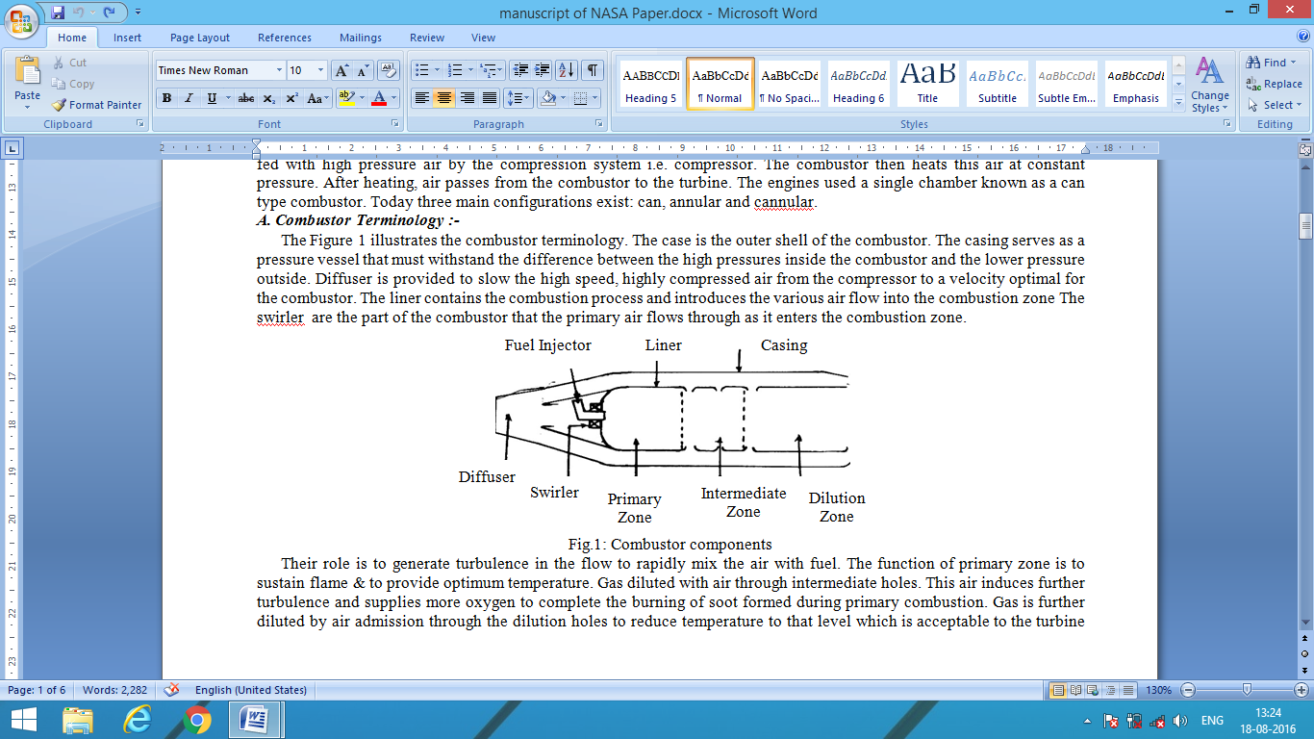
Fig.1: Combustor components
This air induces further turbulence and supplies more oxygen to complete the burning of soot formed during primary combustion. Gas is further diluted by air admission through the dilution holes to reduce temperature to that level which is acceptable to the turbine blades. In axial-flow compressors, the stage pressure rise is very dependent on the axial flow velocity. To achieve the design pressure ratio in the minimum number of stages, a high axial velocity is essential, in many gas turbine engines, compressor outlet velocities may reach 150 m/s or higher. It is impractical to attempt to burn fuels in air flowing at such high velocities. Here the fundamental pressure loss would be excessive. Thus, before combustion can proceed, the air velocity must be greatly reduced, usually to about one-fifth of the compressor outlet velocity. This reduction in velocity is accomplished by fitting a diffuser between the compressor outlet and the combustor inlet.
B. Diffuser Geometry:
The geometry of straight-walled diffusers may be defined in terms of three geometric parameters, as shown in Fig.2.
- Area ratio(AR): Function is to achieve prescribed reduction in velocity.
AR=A2/A1
Continuity eqn ; A2×V2 = A1×V1
A2/A1=V1/V2
i.e. there is inverse variation in area ratio & velocity ratio. For maximum AR there is more velocity reduction in diffuser i.e. high pressure recovery.
2. Non dimensional length (L/R1): In combination with the area ratio the length defines the overall pressure gradient which is the principal factor in boundary-layer development. Usually, either the wall length, L, is used as a characteristic length. It is expressed in non dimensional form by dividing by a representative inlet dimension.
3. Divergence angle(θ) : In long diffusers of low θ, the pressure loss is high. With an increase in θ, both diffuser length and friction losses are reduced, but stall losses become more significant.
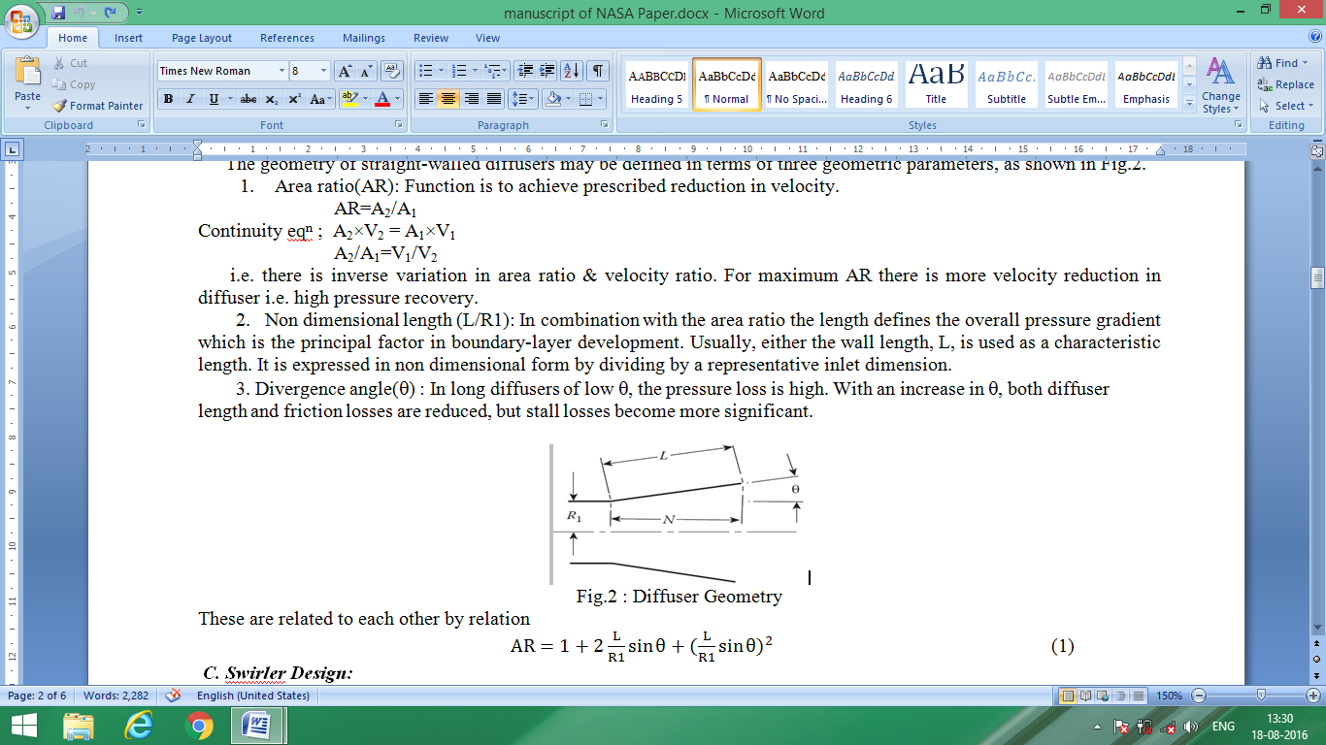
Fig.2 : Diffuser Geometry
These are related to each other by relation
...................(1)
C. Swirler Design:
The primary-zone airflow pattern is of prime importance to flame stability. Many different types of airflow patterns are employed, but one feature common to all is the creation of a toroidal flow reversal that recirculates a portion of the hot combustion products to mix with the incoming air and fuel. These vortices are continually refreshed by air admitted through holes pierced in the liner walls, supplemented in most cases by air flowing through swirlers and by air employed in atomization.
One of the most effective ways of inducing flow recirculation in the primary zone is to fit a swirler in the dome around the fuel injector. Vortex breakdown is a well-known phenomenon in swirling flows; it causes recirculation in the core region when the amount of rotation imparted to the flow is high. This type of recirculation provides better mixing than is normally obtained by other means, such as bluff bodies, because swirl components produce strong shear regions, high turbulence, and rapid mixing rates. These characteristics of swirling flows have long been recognized and have been used in many practical combustion devices to control the stability and intensity of combustion and the size and shape of the flame region.
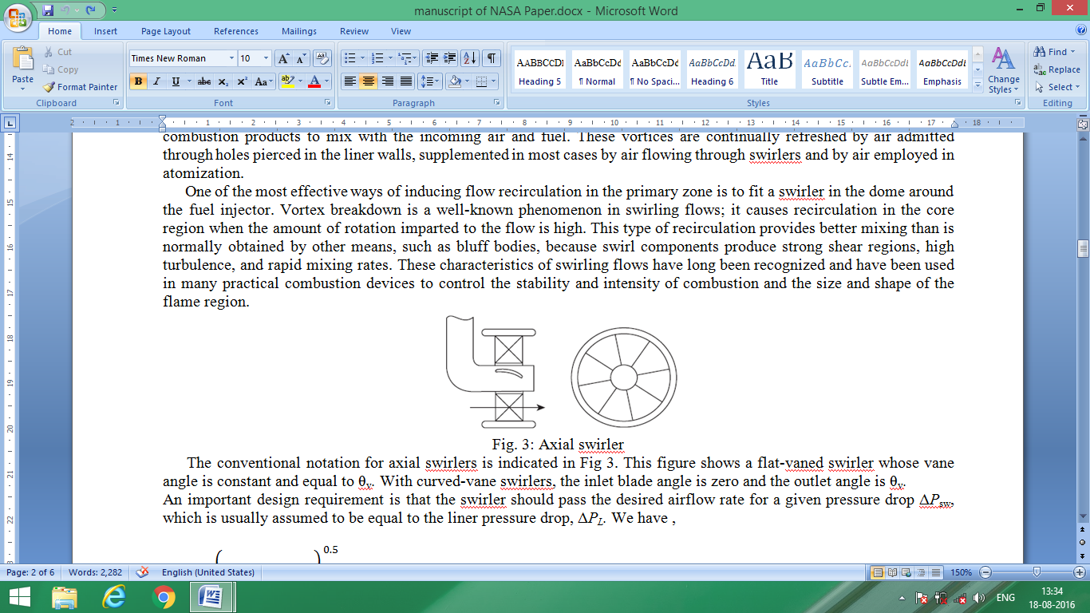
Fig. 3: Axial swirler
The conventional notation for axial swirlers is indicated in Fig 3. This figure shows a flat-vaned swirler whose vane angle is constant and equal to θv. With curved-vane swirlers, the inlet blade angle is zero and the outlet angle is θv.
An important design requirement is that the swirler should pass the desired airflow rate for a given pressure drop ΔPsw, which is usually assumed to be equal to the liner pressure drop, ΔPL. We have ,
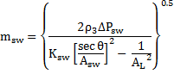......................(2)
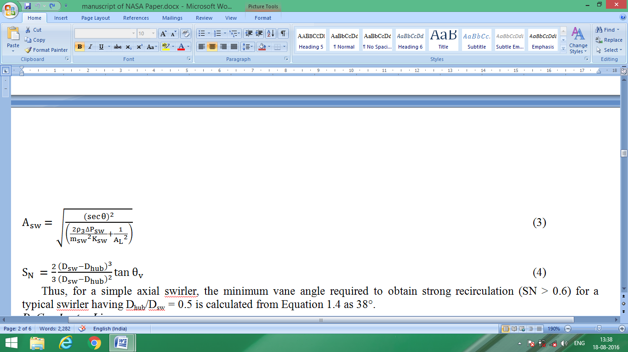 ........................(3)
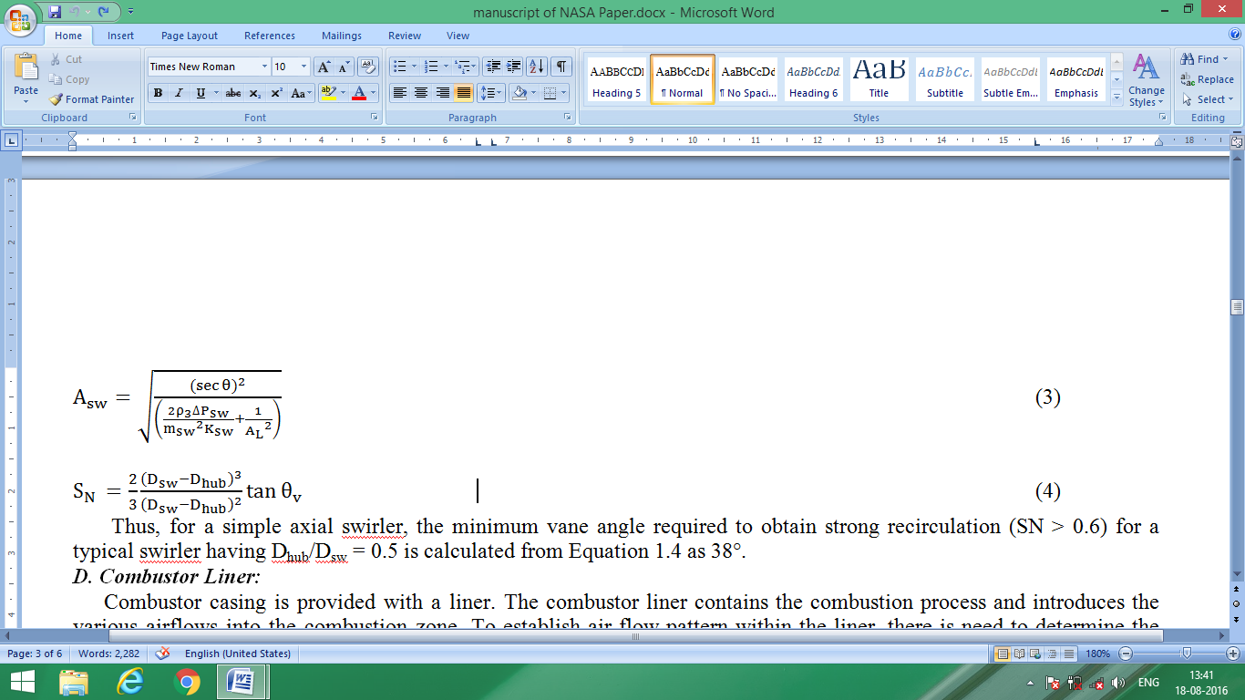.......................(4)
Thus, for a simple axial swirler, the minimum vane angle required to obtain strong recirculation (SN > 0.6) for a typical swirler having Dhub/Dsw = 0.5 is calculated from Equation 1.4 as 38°.
D. Combustor Liner:
Combustor casing is provided with a liner. The combustor liner contains the combustion process and introduces the various airflows into the combustion zone. To establish air flow pattern within the liner, there is need to determine the number, size, shape and deposition of liner holes. Necessary for easy light-up, efficient and stable combustion, adequate wall cooling and delivery of hot gases with a suitable temperature profile.
If liner wall contains a row of n holes, each of which has an effective diameter dj , then the total mass flow rate mj of air through these holes is given by
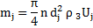 ..................................(5)
Now
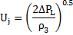 ..............................(6)
Hence,
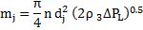...............................(7)
Add,
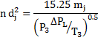 .............................(8)
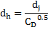 ................................(9)

Flowcharts (1)
^{A}
^{START}
Declare T3,T4,P3,afr,Cv,Teffi,Cpg,R,f,e,Pi,B,P4,Cd,h,tn,Ksw,as constant
^{Take pressure ratio from user}
Calculate turbine exit temperature
Display turbine exit temperature
Take total work output of engine
Calculate mass flow rate of fuel, air required for combustion
Calculate mass flow rate of air entering primary zone, mfr of total air required
Display work required to run the turbine
^{Display mass flow rates}
Calculate reference area and reference velocity

Calculate liner area, length of primary zone & intermediate zone
Display liner area, length of primary zone & intermediate zone
^{Take pattern factor}
Calculate total liner length, length of primary zone
Display total liner length, length of primary zone
^{STOP}
^{A}

Fig.4: Algorithm to calculate mass flow rates, reference quantities and liner dimension
^{START}
Calculate mass flow rates of air entering in primary zone, intermediate zone and dilution zone.

Display mass flow rates of air entering in primary zone, intermediate zone and dilution zone.

Calculate number of holes on primary zone, intermediate zone and dilution zone.

Display number of holes on primary zone, intermediate zone and dilution zone.

^{STOP}

Fig.5: Algorithm to calculate number of holes on
primary, intermediate and dilution zone.

^{Calculate pressure at swirler.}
^{Take vane angle from user.}
Display swirl number and swirler area.

Take number of vanes from user.

^{Display swirler diameter.}

^{STOP}
^{START}
^{Display pressure at swirler.}
Calculate swirl number and swirler area.
^{Calculate swirler diameter.}

Fig.6: Algorithm to calculate swirler dimensions
^{START}
Calculate area ratio, diffuser inlet area, diameter and radius.
Take inlet and exit velocity of diffuser from user.
Display area ratio, diffuser inlet area, diameter and radius.

Take diffusion angle from user.
^{Calculate diffuser length.}
^{STOP}
^{Display diffuser length.}

Fig.7: Algorithm to calculate diffuser dimensions.

RESULTS
1.. Effect of diffusion angle on diffuser length:
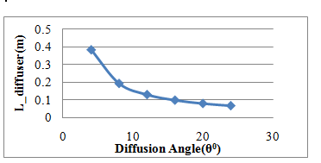
Fig. 8: Effect of diffusion angle(θ) on diffuser length(L_diff)
The graph is given for a tubular combustor with turbine output and pressure ratio equal to 30 kW and 3 respectively. Diffusion angle is an important parameter as it affects the flow of air through diffuser. Graph shows that as there is an increment in the diffusion angle from 0 to 25, the length of diffuser will get reduce. Initially the nature of curve is deeper from diffusion angle 4 to 8 than the curve for the angles 8 to 24. As the angle increases from 4 to 8 the length decrement is intense and after that only small changes occur. Again larger angle is responsible for the eddy formation along the wall it results in flow separation, so the proper angle selection is required.
2. Effect of various vane angle on swirl number:
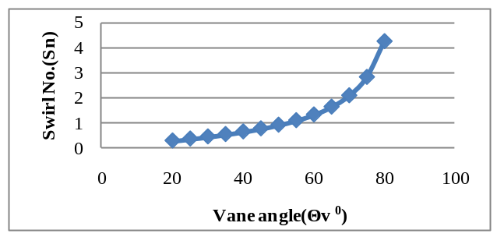Fig. 9: Effect of various vane angle(θv) on swirl number(Sn).
As the swirl angle get increase the swirl number also get increases. Initially, from vane angle 20 to 35 there is no recirculation in the flow as the swirl number is less than 0.6. For strong recirculation the swirl number should be greater than the value 0.6(Sn>0.6), for that proper swirl angle selection is important.
3. Effect of turbine work output on fuel mass flow rate distribution for different pressure ratios.
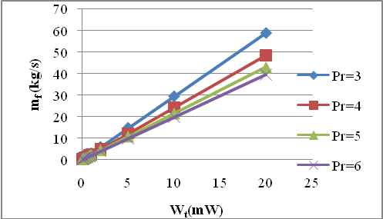Fig 10: Fuel mass flow rate(mf) Vs turbine work output(Wt) for different pressure ratios.
The graph is plotted for different pressure ratios (Pr) from 3 to 6. Overall it is clear that as the turbine work output is more, the fuel requirement is also more.

4. Combustor Liner Length and Holes Distribution:
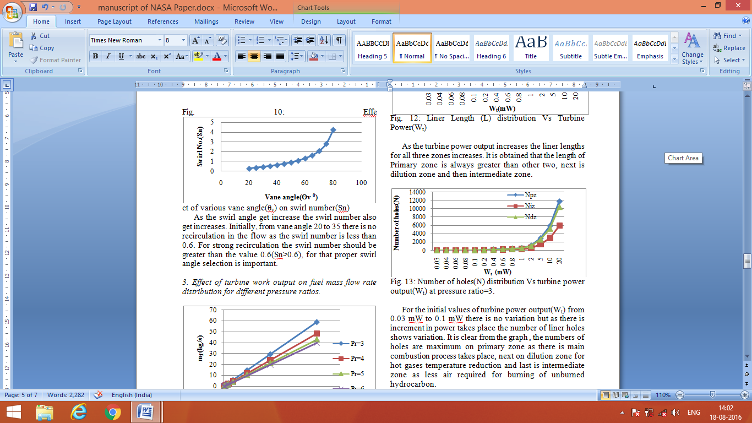Fig. 11: Number of holes(N) distribution Vs turbine power output(Wt) at pressure ratio=3.
For the initial values of turbine power output(Wt) from 0.03 mW to 0.1 mW there is no variation but as there is increment in power takes place the number of liner holes shows variation. It is clear from the graph , the numbers of holes are maximum on primary zone as there is main combustion process takes place, next on dilution zone for hot gases temperature reduction and last is intermediate zone as less air required for burning of unburned hydrocarbon.
5. Fuel Injector Parameters:
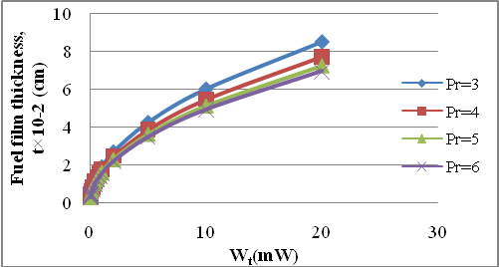
Fig. 12: Fuel film thickness (t) Vs turbine power output(Wt) for various pressure ratios.
The graph indicates that as the pressure ratio(Pr) increases the fuel film thickness become thin. For initial values i.e. for less power upto 1mW there are very few variations but as power increases graph shows variation.
6.Adiabatic Flame Temperature:
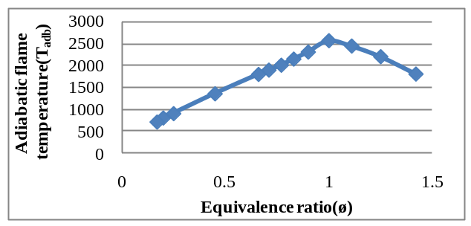Fig. 14 : Adiabatic flame temperature(Tadb) Vs equivalence ratio(Ø).
As the equivalence ratio(Ø) increases the adiabatic flame temperature also get increases upto the point where Ø =1 i.e. the stiochoimetric mixture condition and then get reduce for further increment in the Ø value. Left part of curve , from Ø=1, shows the lean mixture and the right part, from Ø=1, is for rich mixture of air and fuel condition.
CONCLUSION
As the manual calculations are very tedious and time consuming job. It should get overcome with the help of computer simulations for design of combustor. It is advantageous as in this practice no need to perform the experiment again and again user get the required parameters affecting combustor design by just providing required output from the gas turbine in the c- program. It is also beneficial to select design giving better performance due to ease in comparison between two or more design.
REFERENCES
[1] Lefebvre A.H., “Progress And Problems In Gas- turbine Combustion” , Tenth Symposium (International) on Combustion, 1965,pp.1129-1137.
[2] Gupta A.K.(1997), “Gas Turbine Combustion : Prospects And Challenges”,Energy Convers, Vol. 38, No. 10-13,pp.1311-1318 .
[3] Gupta, A. K., Lilley, D. G., and Syred, N. ,“Swirl Flows”, Abacus Press, Tunbridge Wells, UK,1984.
[4] Sovran, G., and Klomp, E. D.( 1967), “Experimentally Determined Optimum Geometries for Rectilinear Diffusers with Rectangular, Conical or Annular Cross Section,”in G. Sovran, ed., Fluid Mechanics of Internal Flow, Elsevier, Amsterdam, 1967, pp. 270–319.
[5] Channwala S. A. & Kulshreshtha D.B. ,“Numerical Simulation to study the effect of divergence angle on performance of inlet diffuser section of gas turbine chamber”, Tenth International Congress of Fluid Dynamics , Stella Di Mare Sea Club Hotel, Ain Soukhna, Red Sea, Egypt, ICFD10-EG-30I3, December 16-19.
[6] Lefebvre, A. H. & Ballal, D. R.,2010. Gas Turbine Combustion Alternative Fuels and Emissions. 3rd ed. CRC Press is an imprint of the Taylor & Francis Group,.
[7] Samanta, D.,2006. Classic Data Structure. New Delhi, 7th printing 2006. Prentice Hall of India Private Limited.
Rajaraman, V., 1994. Computer Programming in C. New Delhi, 2nd Edition, Prentice Hall of India Private Limited.
[8] Ganesan, V.,2000. Computer Simulation Of Compression-Ignition Engine Processes. Hyderabad, First published 2000, Universities Press(India) Limited.
[9] Cohen, H. , Rogers, G.F.C. & Saravanamuttoo, H.I.H.,1987. Gas Turbine Theory. 3rd Edition, Longman scientific and Technical , New York, 40-200. .
[10] Mathur, M. L., Sharma, R. P., 1976. Internal Combustion Engine. 1st Edition, 23rd Reprint 2012, Dhanpat Rai Publications (p) LTD, 894-923.

