A Study: Innovation of Touchless Touchscreen

Shivanee Chincholkar¹, Prof. Nikhil Khandar²
¹Student, ² Professor Department of MCA
GH Raisoni Institute of Engineering and Technology, Nagpur, India, 440028

schincholkar988@gmail.com

Received on: 11 June ,2022 Revised on: 30 July ,2022, Published on: 02 August,2022

Abstract – Before the touchless Screen, there was Touch screen technology that created a great impact at the start. The Touch screen enables the user to relate directly with what is displayed, rather than using any other intermediate device. But it has some demerits like the screen may get spoiled. Also, the common touching of a Touch screen shown with a pointing device such as a finger or stylus can result in gradual de-sensitization of the Touch screen to input & can at last lead to malfunction of the Touch screen. A simple user interface for Touchless control of electrically operated equipment is being developed to avoid this. It lets you control your gadgets like Computers, MP3 players, or mobile phones without touching them. A simple user interfaces for Touchless control of electrically operated equipment. Unlike other systems that depend on the distance to the sensor or sensor selection, this system depends on hand and or finger motions, a hand wave in a certain direction, a flick of the hand in one area, or pointing with one finger.

Keywords-Touchless Technologies, Motions, Sensor, Display, and Pattern Recogni

I. INTRODUCTION
A few decades before, mobile phones had buttons on them to exercise any of their operations. The era of touchscreen phones emerged later with the virtual keypad present on the screen and this eradicated the phones with manually pressing buttons. A touchscreen is a user interface that uses the sensation of touch to navigate the user to the different areas on the screen. In every technological component, this technology is used. For example Mobile phones, laptops, in-car entertainment systems. When people started using touchscreen phones which were also operated using the stylus stick. But, years after the invention many flaws in touchscreen technology were found by the people; regular touching of touchscreen display with a pointing device such as a finger will result in slow desensitization of the touchscreen and a failure of the touchscreenThe chances of the different keys being pressed on the virtual keyboard in the touchscreen interface are high, for example, in the music system of the car. The screen of touchscreen mobile phones might break when it is trashed as in the case of mobile phones. The screen cannot be seen in the presence of sunlight, also the battery of the phones and other electronic gadgets get deduced, as the brightness of the screen is raised. Also sometimes the sensation of the touch surface might get lost. A better invention came to light which is the touchless touchscreen technology Due to many such flaws in this technology. The Touchless touchscreen sounds like it would be nice and easy, however, after closer examination, it looks like it could be quite a workout. This screen is made by TouchKo, White Electronics Designs, and Group 3D. It works by hand waving in certain directions in front of it or by detecting your hand movements.

Elliptic Labs named “Touchless Human or Machine User Interface for 3D Navigation”. To monitor devices such as computers, MP3 players, or mobile phones without having to touch them, Elliptic Laboratories created this innovative technology. Unlike other methods depend the system is based on optical model recognition which consists of a solid-state optical matrix sensor with an objective detecting hand motions. This sensor is then connected to a digital image processor that recognizes the movement of the patterns that move away from the sensor or the range of sensors, this technique is based on the movements available from the finger, a wave from the hand in a certain direction, or shaking of the hand in one area, or holding the hand in one area or pointing with a finger. (Starting from as far as 5 feet) for instance. It simply uses a wave of the hand in a particular direction or a helping hand in an area, or we simply point the finger at the device in the air and move it accordingly to control navigation within the deviceIn the touch screen if the screen is cracked then we cannot operate the device by just touching a screen. The system needs a sensor. This system requires a sensor, but it is not manually installed or present on the display. The sensor can be positioned on the table or next to the monitor. The hardware configuration is small enough to fit into a device like a smartphone or a laptop screen. It can detect an object's location from a distance of 5 feet. "Don't touch me" technology is another name for it.

When Microsoft debuted its unrelated Surface tablet to consumers, the technology was renamed Pixel Sense. The term "Pixel Sense" relates to how the technology works: an infrared backlight is covered with a touch-sensitive protective glass. The light is reflected by integrated sensors when it touches the glass, which transforms the light into an electrical signal. The signal is called a "value," and the values combine to form a picture of what's on the screen. After then, image processing techniques are used to analyze the image, and the results are relayed to the linked computer.

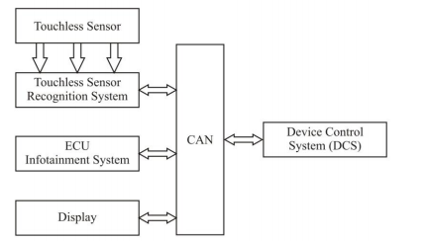
Fig. 1- Block diagram of the touchless gesture recognition system. [1]
II- LITERATURE REVIEW

The Touchscreen Era Is Coming To An End. HP began developing a massive touchscreen panel for their Manhattan PR agency about seven years ago. The Wall of Touch, their final product, was such a hit that it has now been installed in the offices of additional clients, with more on the way. Despite its name, another feature that distinguishes the Wall is that users are not required to contact it. The Wall of Touch is made up of up to nine 1080p 43-46-inch displays. HP opted against it since only one large panel would necessitate rear projection and translucent screen material, both of which would reduce the resolution.The HP Z800 workstation drives the wall, thereby turning it into a massive HP Touch Smart computer. Built-in optical cameras and a magnetic strip detect when users are approaching the screen, eliminating the need to actually touch it. If users are unable to reach the corners, they can still utilize a mouse or keyboard. Touchscreen technology is the best and most ubiquitous technology we have so far. It was shortly replaced by touchless touchscreen technology. According to the BBC, an Israeli start-up, XTR3D, is preparing to produce touchless cell phones and televisions.People will be able to change channels on their TV by only making a hand gesture rather than using a remote control with this new technology. According to an XTR3D representative, the company's technology has all of the benefits of a 3D camera, but it can work in broad daylight, is significantly less expensive, and consumes significantly less power. It's compatible with any consumer electronics device. Early next year, the business plans to offer the first motion control smartphone on the market [2].

III. HISTORY

A.1980’s: The decade of touch.Nimish Mehta created the first human-controlled multi-touch gadget at the University of Toronto in 1982. It was more of a touch tablet than a touch screen. The university's Input Research Group discovered that a frosted-glass panel with a camera behind it could detect motion by recognizing the various "black spots" that appeared on-screen. Bill Buxton was the key to the advancement of multi-touch technology. A translucent plastic filter was installed over a sheet of glass and lighted from the side by a fluorescent lamp as the touch surface. A video camera mounted beneath the touch surface captured the shadows that appeared on the translucent filter. (To expand the optical path, a mirror in the housing was employed.) The camera's output was digitized and analyzed using a signal processor. Beginning in the early 1980s, touch displays became heavily popularised. In September 1983, HP (then known as Hewlett-Packard) threw its hat into the ring with the HP-150. The computer ran MSDOS and had a 9-inch Sony CRT with infrared (IR) emitters and detectors to determine where the user's finger landed on the screen. The system, which cost around $2,795, was not instantly accepted due to several usability concerns. Poking the screen, for example, would block other infrared rays that could inform the computer where the finger was pointing. This caused "Gorilla Arm," or muscle exhaustion caused by a user holding his or her hand out for an extended period. Bell Labs created the first multi-touch screen in 1984. According to [Bill Buxton], Bob Boie's screen "used a transparent capacitive array of touch sensors placed over a CRT." It allowed the user to "manipulate graphical objects with good response time using fingers." The finding paved the way for today's multi-touch technology found in tablets and smartphones. To accommodate the complexity of kanji characters, which were stored as tiled images, Fujitsu created a touch pad for the Micro 16 in 1984. [15] The TerebiOekaki, commonly known as the Sega Graphic Board, was introduced in 1985 for the Sega SG-1000 video game console and SC-3000 home computer. It consisted of a plastic pen and a clear glass through which pen pushes could be sensed [3].

B. 1990s: Everyone should have a touch screen! In the same year, Apple released the Newton PDA, a touch-screen PDA. Despite the fact that the Newton platform had been there since 1987, Apple's Message Pad was the first product to use it. According to Time, John Sculley, Apple's CEO at the time, created the word "PDA" (or "personal digital assistant"). The Message Pad, like IBM's Simon Personal Communicator, included handwriting recognition software and was controlled with a stylus [3].

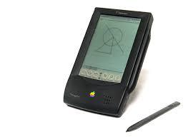
Fig. 2- Original Message Pad 100
Gesture Pad: Westerman and his faculty advisor, John Elias, eventually established a company called Finger Works. The company launched a variety of multi-touch gesture-based products, including the Touch Stream, a gesture-based keyboard. This was beneficial to persons with disabilities such as repetitive strain injuries and other medical issues. Finger Works was later acquired by Apple in 2005, and many people credit this acquisition for technology like the multi-touch Trackpad and the iPhone's touch screen. [3]

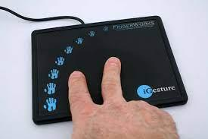

Fig. 3- Gesture Pad
C. 2000s and beyond: With so many various technologies gathering in prior decades, the 2000s were the time for touch screen technology to fully take off. Touch displays also became the preferred tool for design collaboration in the 2000s [3].

D. 2001: Alias | Wavefront’s gesture-based Portfolio Wall, D. 2001 Companies poured increasing money into integrating touch screen technology into their daily procedures as the new century approached. With the introduction of the Portfolio Wall, 3D animators and designers were specifically addressed. This was a large-format touch screen designed to be a dynamic version of the project tracking boards used by design studios [3].

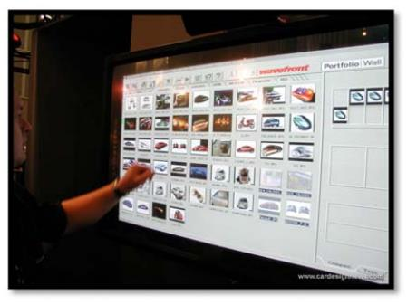
Fig. 4- Alias/Wavefront’s gesture-based Portfolio Wall
While development began in 1999, the Portfolio Wall was first shown at SIGGRAPH in 2001, thanks to a collaborative partnership between General Motors and Alias' team. Buxton, who now works as a key researcher at Microsoft Research, was the project's chief scientist. Ripping people down and changing the way they communicate and conduct business in the office, "He stated at the time."Portfolio Wall's gestural interface allows users to interact directly with a digital asset. It allowed users to inspect images, animations, and 3D files with just their fingers. Scaling images, creating 3D models, and playing back footage was also simple. In 2002, Sony developed a flat input air that could recognize multiple hand positions and touch points at the same time. The company called it Smart Skin. To measure the distance between the hand and the surface, the system used capacitive sensing and a mesh-shaped antenna. Unlike camera-based gesture recognition devices in other technologies, the sensing components were all built into the touch surface. This also meant that it would not fail in low-light situations. The ultimate goal was to transform everyday surfaces, such as a table or a wall, into interactive ones by using a nearby PC. In a white paper published by Sony's Computer Science Laboratories, TJunRekimoto outlined the benefits of this technology. Smart Skin, he claims, provides "natural support for multi-hand operations with numerous users." More than two users can touch the surface at the same time without interruption. The second prototype, in comparison to the first, used a finer mesh to map more precise finger coordinates. Overall, the technology was designed to offer virtual items a realistic feel, resembling how humans pick up and control objects with their fingers [3].

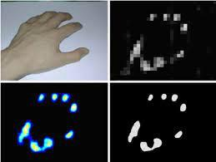
Fig. 5- Smart Skin sensed gestures
Multi-touch technology was struggling in the mainstream, emerging in specialist goods but never catching on. One got close in 2002 when DSI Dato tech developed the Hand Gear With GRT technology (the acronym "GRT" refers to the device's Gesture Recognition Technology). The interface's multipoint touchpad worked similarly to the I Gesture pad, allowing users to recognize different motions and utilize it as an input device to monitor their PCs. Hand Gear also allowed users to "pull" in three-dimensional items in real-time, thus broadening the concept of design freedom and efficiency. The API was made available to developers even through Auto Desk.Unfortunately, as Buxton points out in his multi-touch summary, the company ran out of money before their device was ready, and DSI shut down [3].

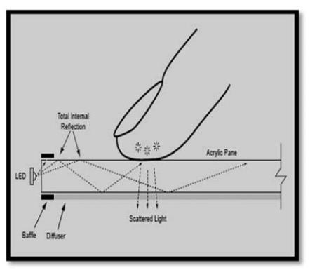
Fig. 6- Touching to display
WHAT IS A TOUCHLESS TOUCHSCREEN?

Imagine being able to control the world with your hands. Elliptic Labs was responsible for its creation. This technology relies on finger or hand motions, such as waving your hand in a specific direction and does not require your hand to touch the screen. It necessitates the use of a sensor, which can be positioned near the screen or on the table. "Touch Less Human or Machine User Interface for 3D Navigation," according to Elliptic Labs. The touchless touchscreen technology is divided into the following parts for its working.[10]

A. Movement detection
This technology identifies changes in the location of an object in relation to its surroundings, as well as changes in the position of the surroundings in relation to the object. The motion or movement detecting system can be mechanical or electronic. This is accomplished with a motion detector, which detects changes in the positions of objects or their surroundings. The sensor positioned near the motion detector's displays is the most significant component. It recognizes changes based on their interaction with the line of sight, which is disrupted by any motion.

B. Optical pattern recognition
Optical pattern recognition is a system that understands and detects motions using optical patterns and a solid-state particle matrix.

C. Motion pattern interruption
The sensor interrupts the motion pattern. It's linked to a digital picture processor that decodes movement patterns. Signals are sent from the digital picture processor to devices, machinery, and appliances. Electrical signals are used to control these gadgets.
D. Screen pointing
Users can utilize the screen pointing mechanism to point at items and icons on the screen without touching them. This technology reads a variety of human hand movements to determine which task the user wishes to complete.
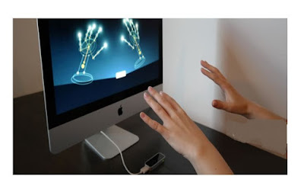
Fig. 7- Touchless Touchscreen
III - WORKING
Motion is sensed and processed into on-screen movements by interacting with the line-of-sight of the sensors that are installed around the screen that is being utilized. There is a mechanism in place to prevent inadvertent motions from being utilized as input, but it appears to be promising nonetheless. Without ever putting your fingertips on the screen, the device can detect movements in three dimensions. For navigation control, we do not need to wear any specific sensors on our hands with a touchless interface. We must manipulate objects in 3D by pointing fingers at the screen. The best thing about a touchless touch screen is that the technology will be small enough to fit into any mobile device.Sensors are positioned surrounding the screen being used, and motion is recognized and translated into on-screen movements by interacting in the line of sight of these sensors. The device detects hand gestures with the help of a lens using optical pattern recognition and a solid-state optical matrix sensor.

This sensor is then connected to a digital image processor, which analyses the motion patterns and outputs the results as signals for controlling fixtures, appliances, machines, or any other electrically controlled devices. You can manipulate items in 3D by just pointing at the screen (from up to 5 feet away) [2].

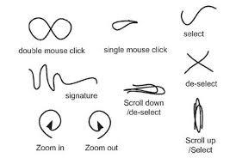

Fig. 8- 3D Navigation of Hand Movements in Touchless Screen
IV-BLOCK DIAGRAM

It is made up of IR sensors located near the screen. When light strikes a three-dimensional object, it is reflected. It comprises a solid-state optical matrix sensor with a lens that uses reflected light to recognize the optical pattern of hand gestures. There are matrix pixels in each of these sensors. Photodiodes with charge storage regions are connected to each pixel. The reflected IR light reaches the pixel matrix and enters the sensors.

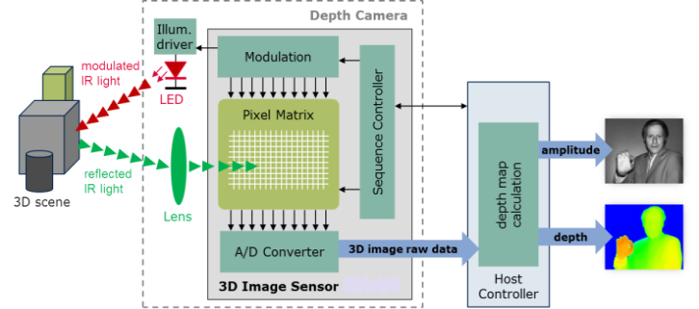

Fig. 9- Block diagram [4]
When a photon with sufficient energy reaches the photodiode, it produces an electron-hole pair. If the absorption happens in the depletion zone, the built-in electric field of the depletion region sweeps the carriers away from the junction. As a result, holes migrate towards the anode and electrons toward the cathode, resulting in current and an electric charge. Which is given by,
I = Q/t
Where,
I = Current
Q = Charge
t = time
As a result, the sensor produces electrical signals. These signals are analogue in nature. Thus, using an analogue to digital converter, these impulses are converted into digital signals for further processing. The host controller receives the digital output of the ADC (Analog to Digital Converter) (HC). The host controller is in charge of packet transmission on the bus. 1msec frames are used. A Start of Frame (SOF) packet is generated by the host controller at the start of each frame. The SOF packet is used to synchronize the start of the frame and keep track of the frame number. It also manages the depth map, which is an image that provides data about the distance between the surfaces of scene objects and a viewpoint. The sequence controller receives the output from the host controller. The human actions and computer logic that commence, interrupt, or end transactions are controlled by the sequence controller. Sequence controllers allow users to take charge of their computer interactions; they strive to anticipate user needs and provide suitable user control options and computer replies in every scenario. The sequence controller's output is sent to the pixel matrix and modulator to control the action. The digital modulator converts the incoming binary signal waveform into an analogue signal waveform. It modifies the sequence controller's digital output. As a result, the 3D movement is recognized and translated into electric signals, which are then processed by the digital image processor and sent to the devices, allowing the navigation to be controlled by the user's hand gestures. Touchless screen technology works in this fashion [2].

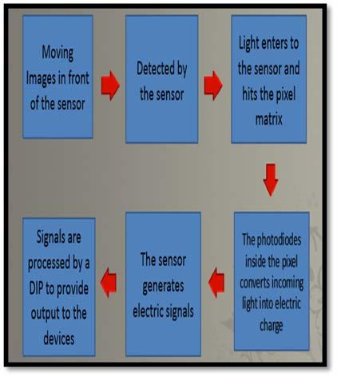

Fig. 10- Workflow
V- APPLICATIONS

The applications of Touchless Screen Technology are:
▪ Touchless Monitor
▪ Touch Wall
▪ Touchless UI
▪ Touchless SDK
A. Touchless Monitor
The touch-less display is intended for uses where the mouse is ineffective or when touch is problematic, such as for surgeons wearing surgical gloves. This TouchKo monitor was recently demonstrated at the CeB by White Electronic Designs and Tactyl Services. Capacitive sensors on the display can detect movements up to 15- 20cm distant from the screen, and the software converts these gestures into screen commands [5].

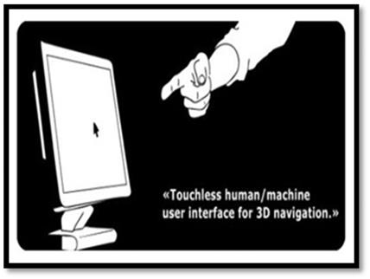
Fig. 11- Touchless Monitor
Motion is detected in three dimensions using the technology. It does not require the use of a specific sensor. The user can manipulate the 3D item by merely pointing their finger at the screen. The sensor is neither hand-mounted nor on the panel in a touchless screen. It can be put on a table or near the screen, and the hardware arrangement is small enough to connect to a small device like an iPod or MP3 player, or even a mobile phone. [5]

B. Touch wall
It is made up entirely of touch screen hardware. The Touch wall's related software, Plex, is based on a regular version of Windows Vista. Touch wall and Plex have a lot in common with Microsoft Surface, a multitouch table computer that was first introduced in 2007 and has only lately gone commercial. It's mostly available in select AT&T stores. The simple mechanical mechanism is also substantially less expensive to manufacture. Three infrared lasers scan a surface to create a touch wall. When something breaks through the laser line, a camera records it and feeds it back to the Plex program. On a cardboard screen, earlier prototypes were created. The Plex interface is displayed on the cardboard using a projector, and the solution works perfectly. Touch wall isn't the first iPhone multi-touch product. In addition to the Surface, there are several early prototypes in the works in this arena. What Microsoft has accomplished with a few hundred dollars worth of reality-based gear is nothing short of amazing.

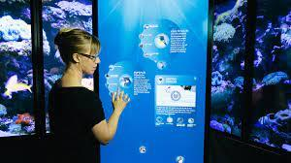
Fig. 12- Touch Wall
It's also evident that the projector's sole true limit, which is the entire wall, can be simply converted into a multi-touch user interface. Instead of using whiteboards in the office, turn any flat surface into a touch display. [5]

C. Touchless User Interface (UI)
The basic concept is straightforward: there would be sensors arrayed around the perimeter of the device capable of sensing finger movements in 3-D space. The user would be able to use his or her fingers similarly to a touch phone, but without having to touch the screen, which is why it's so fascinating [5].

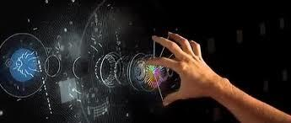
Fig. 13- Touchless User Interface (UI)
Touch interaction and mouse input will not be the only widely recognized ways for clients to interact with interfaces in the future, according to future technologies and studies in human-computer interaction. In the future, there will be less touching. These new technologies will allow companies and varieties to create new forms of media and interfaces to attract their customers' attention (and imagination). They'll make it easier for people to interact with their products and media in new ways, boosting brand exposure, adoption, and sales. [5]

D. Touchless Software Development Kit (SDK)
The term SDK refers to a software development kit. Typically, it is a collection of software development tools. It allows users to augment applications with extra functionality, ads, push notifications, and other features for a specific software package, software framework, hardware platform, computer system, video game, or similar development platform. The Touch-less SDK for.NET applications is an open-source SDK. It allows programmers to construct multitouch applications that use a webcam for input. Color-based markers defined by the user are tracked, and their data is published to SDK clients through events. "Touch without touching" is now possible [5].

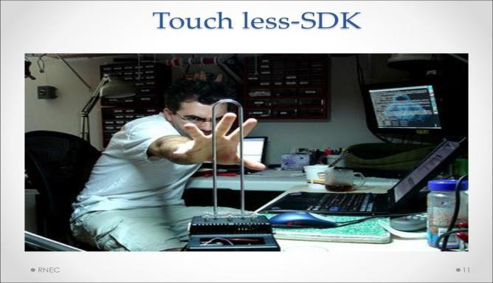
Fig. 14- Touchless Software Development Kit
VI-MINORITY REPORT INSPIRED TOUCHLESS
In 2002, using less gesture-based technology instead of clicking and typing was a part of a science fiction film, but it is no longer science fiction today. Touchless Technology Inspired by Minority Report comes in eight different varieties.
The following are examples:

A. Tobii Rex
Tobii Rex is an eye-monitoring device. A Tobii eye tracker is a computer accessory that comes with software that allows the user to operate the machine with his or her eyes just by placing it near the phone. It can be used to zoom in and out as long as the user knows exactly where to zoom in. The eye can be used to choose programs because it functions essentially as a pointing device. It can also be used to automatically scroll through text when reading. A pair of infrared sensors are placed into the device to monitor the user's eyes [5].
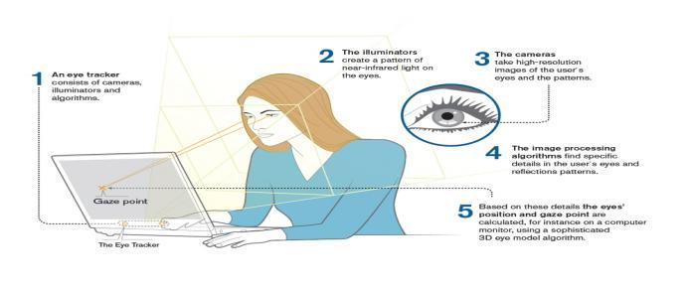
Fig. 15-Tobii Rex
B. Elliptic Labs
Elliptic Labs' Windows 8 Gesture Pack allows users to manage their computers without touching them by waving their hands in specific directions. It works with your audio devices rather than cameras because it employs ultrasonic. It's ideal to have six speakers and eight microphones, but it could also work with laptop speakers and a normal microphone. The speaker will generate ultrasonic, which will bounce back to microphones, allowing the Elliptic Labs software to track a user's hand movements. This technology, which was created for the Windows 8 platform, is anticipated to function on tablets, smartphones, and potentially automobiles. Elliptic Labs is not for sale to the general public because the company focuses on selling to original equipment manufacturers (OEMs) [5].

C. Airwriting
Air writing is a technique that allows you to send text messages or emails while flying. Sensors on the glove track hand motions and a computer system catch and translate certain signals into text, which may subsequently be used to create emails, text messages, and other forms of communication.

D. Eyesight
Eyesight is a gesture system that tracks a user's finger movements and guides them through the device by pointing at them. Eyesight only requires a typical 2D webcam (including built-in ones) to function, and the app's screen does not need to be touch-enabled. To navigate, simply move the cursor with one finger and press the button with the other (like pushing a button). Eyesight not only works with PCs and laptops, but also with cellphones, televisions, and other devices [5].

E. Mauz
Mauz is a free third-party app that turns your iPhone into a trackpad or mouse. Install the driver on the machine, then connect the device to the iPhone via an adapter port. Mauz connects to the device via Wi-Fi. Continue to use the mouse as usual to manage the machine: left-click, right-click, and scroll [5].

F. Point Grab
Point the advanced handshape and movement algorithms are utilized to analyze where the hand is and perform a comprehensive series of actions that allows the user to monitor the apps and version of the windows aids using the usual 2D camera included in the device. This is similar to EyeSight, which may be activated by just pointing at the eye [5].

G. Leap Motion
Leap Motion is a motion sensor system that detects the user's fingertips using infrared LEDs and cameras. Nothing registers when fingers travel over it to type on the keyboard because it only knows the fingertips. When one hovers their fingertips above the screen, it can be manipulated like a smartphone or tablet: flick to search pages or pinch to zoom [5].

H. Microsoft Kinect
Kinect is an exception. There is no holding, swinging, pushing, or pulling devices. The user is in command. Kinect allows you to use your body and voice to engage with games and entertainment in the most natural way imaginable. When it comes to gaming, Kinect is ground-breaking; it puts an entire universe of entertainment at the user's fingertips [5].

VII- NEW INNOVATIONS

A. New technology to check virus spread
Through a printing approach, Bengaluru scientists have reported an affordable solution for developing a low-cost touch-cum-proximity sensor. The researchers stated their activities were motivated by a desire to limit the risk of infections spreading, particularly in public settings where touchscreens on self-service kiosks, ATMs, and vending machines are unavoidable. DST-Nanomission at the Centre for Nano and Soft Matter Sciences financed this effort by a team led by Prof GU Kulkarni of Jawaharlal Nehru Centre for Advanced and Scientific Research and co-workers (CeNS). The findings were published in the journal Materials Letters recently. JNCASR and CeNS are both independent departments within the Department of Science and Technology (DST). "CeNS and JNCASR scientists have established a semi-automated facility for the production of printing-aided patterned (resolution of roughly 300 m) transparent electrodes, which have the potential to be used in advanced touchless screen technologies," according to DST. According to Dr. Ashutosh K Singh, a scientist working on this research, the team created a touch sensor that can detect a proximal or hover touch from a distance of 9cm away. "We're developing a few more prototypes using our patterned electrodes to see if they can be used in other smart electrical applications," says the researcher. "These patterned electrodes can be made available on a request basis to industry and R&D labs to explore collaborative initiatives," said Indrajit Mondal, a co-author of the study. The revolutionary low-cost patterned transparent electrodes, according to DST, have a lot of promise for usage in advanced smart electronic products including touchless screens and sensors and can help minimize virus propagation through contact.

B.Touchnetix unveils the New Generation Of 3D Touchless User Interfaces.
7 April 2022, Trondheim, Norway – TouchNetix is a world leader in developing innovative touch-based user experiences. TouchNetix today announced fully integrated aXiom touchscreen chips that enable touchless functionality in a variety of automotive, industrial, and consumer contexts by recognizing air motions. The Signal-to-Noise Ratio (SNR) of AXiom is more than 100 times higher than that of typical touchscreen controllers on the market. The single-chip aXiom technology from TouchNetix allows for proximity detection up to 10-15 cm above the screen's surface. Multiple hover gestures are also detected 5-6 cm above the screen. These added safety features turn the user interface into a more inventive and intuitive experience. Touchless technology in the car HMI (human-machine interface) allows users to lessen the amount of eye contact with the touchscreen, boosting safety. Touchless technology drastically minimizes the risk of virus and bacterial infection in public and multi-user touchscreen applications. The aXiom chips give these extra functions without the use of additional sensor electrodes, board-level components, or other sensing gear. When compared to alternative sensing technologies like infrared sensing or cameras, these 3D and Touchless User Interface features are achieved at the lowest potential system cost. The aXiom chip series supports a wide range of aspect ratios and display sizes ranging from 5" to over 55". "I am happy to reveal our 3D and Touchless technology, which revolutionizes the touchscreen business," said Vegard Wollan, Chief Executive Officer of TouchNetix. Our intuitive gesture operation makes touchscreens more hygienic and safer in a variety of settings. Many of our customers and partners are launching products with 3D and Touchless capabilities this year, and many of them will offer global distribution of their solutions." TouchNetix offers a global network of manufacturing and distribution partners, allowing them to quickly create, implement, and deliver to customer specifications. TouchNetix is poised to offer the next generation of user interface technology chips to a global market thanks to a strong supply chain. The Automotive Electronic Council AEC-Q100/Q006 standard has been met by TouchNetix'saXiom chips.

C. TouchPoint
Since their invention in 1965, touchscreens have gone a long way. TouchPoint, one of today's most inventive inventions, can turn any surface into a touchscreen. His work also covers non-traditional surfaces for the technology. Ceramic, metal, plastic, glass, and even wood can be used with this technology. TouchPoint employs a novel haptic touch technique. It detects whether a finger is contacting a certain surface using 3D ultrasonic technology. This is how you can make non-traditional surfaces into touchscreens. The sound waves detect whether a finger is hitting the surface and can distinguish between different touches. Allowing for the possibility of multipurpose gesturing in the future. The touchless touchscreen is the next technological innovation that is desired and possibly even required as we move to the future.

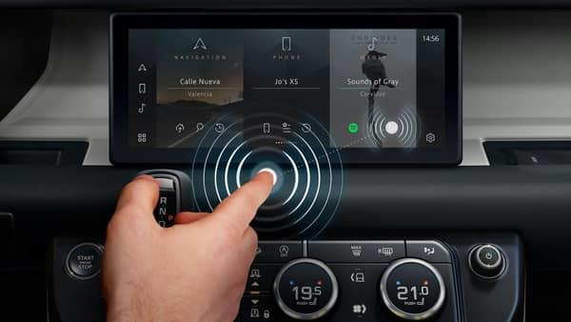
Fig. 16- Touchpoint
D. Glamos
Glamos is a unique touchless touchscreen technology that can transform almost any screen. It detects movement and provides a signal to the gadget, instructing it on how to respond. The user does not need to touch the device; instead, the user must touch the air within a 180-degree radius. You can interact with the touchscreen from a distance if you use this technology with an existing touchscreen. You can swipe the air to clean the device and, more importantly, keep yourself safe. A smart television may be controlled without a remote by simply tapping the air that corresponds to the location on the screen. This can also be used for multitasking. If you don't want to touch your laptop, tablet, or smartphone because your hands are unclean, simply air touch the screen. Glamos can detect motion within a three-foot radius, and a revolving mirror provides additional coverage. This gadget is compatible with all smart televisions, as well as Android, iOS, and all PCs running Windows 7 and higher. Because this technology is open-ended, the user decides how to use it. The device's best feature is its size. It's tiny, measuring only 1.5 inches by 1.3 inches. The device's size is quite promising.

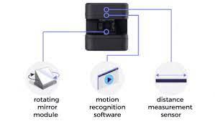

Fig. 17-Glamos
VIII- CONCLUSION

The purpose of this paper is to provide an overview of touch-less touch screen technology. The user gains flexibility in how they use the system by utilizing this technology. The maintenance of touch screen displays can be reduced by utilizing this technology. Because an external sensing element, such as a camera, is not required, it is an extremely low-power solution. The level of fault detection is also quite low, making the method small and interesting. Because the market for touchless and gesture recognition is expected to increase dramatically, implementation will be critical.

Computers, cell phones, webcams, laptops, and other electronic gadgets can all benefit from touchless screen technology. Perhaps, after a few years, our bodies will be transformed into a virtual mouse, virtual keyboard, or input device. While the gadget has potential, it appears that the API that supports it is not yet able to comprehend the entire spectrum of sign language. The controller may now be used to recognize basic signs with some effort, but it is not suitable for complex signs, particularly those that require extensive face or body contact. Because of the significant rotation and line-of-sight obstruction of digits during the discussion, signs become erroneous and indistinguishable, rendering the controller (at this time) unsuitable for communication. When dealing with signs as single entities, however, there is the possibility of training them in Artificial Neural Networks.

Advantages
- The device would last for a long time and is simple and easy to use.
- Because the screen is touchless, a transparent image is always visible.
- Because commands are accepted via sensors such as verbal or hand gestures, the GUI necessitates the use of lie space. As a result, the touch area is reduced, and the text quality on the screen improves.
- No screen desensitization required
- Suitable for people with physical disabilities.

Disadvantage
- High-resolution cameras are required. (HD).
- The public’s interaction must be monitored.
- Image processing is extremely sensitive to noise (lens aberrations).
- The initial cost is very high.
- Used in a sophisticated environment.
- Needs very high-speed image processing (S/W, H/W)

REFERENCE

- S. Prakasam1, M. Venkatachalam2 M. Saroja2, N. Pradheep, “Gesture Recognition Using a Touchless Sensor to Reduce Driver Distraction,” e-ISSN: 2395 -0056 p-ISSN: 2395-0072,International Research Journal of Engineering and Technology (IRJET), Volume: 03 Issue: 09 | Sep-2016

- Ms. Gayatree S. Nakhate Prof. Anup A. Pachghare, “Touchless Screen Technology,” IETE Zonal Seminar, ISSN: 2277-9477 Recent Trends in Engineering & Technology - 2017 Special Issue of International Journal of Electronics, Communication & Soft Computing Science and Engineering.

- Nilofar E. Chanda N.B. Navale College of Engineering, Solapur, Maharashtra, India, “Study of Touch Less Touch Screen Technology” ISSN (PRINT): 2393-8374, (ONLINE): 2394-0697, VOLUME-4, ISSUE-11, 2017

- Kavitha. G1, Veena. M2 Department of CSE Sapthagiri College of Engineering, VTU, India, “Survey on Touchless Touch Screen Technology using Hand Gestures, “ International Journal of Engineering Science and Computing, April 2019

- ATHIRA M Department of CSE, Musaliar College of Engineering and Technology, Pathanamthitta, “Touchless Technology,”e-ISSN: 2395-0056 p-ISSN: 2395-0072 International Research Journal of Engineering and Technology (IRJET),Volume: 07 Issue: 03 | Mar 2020

- Kalaiselvi N and Vengateshkumar S, “Touch Less Touch Screen”,International Journal of Recent Scientific Research Vol. 10, Issue, 10(C), pp. 35353-35356, October 2019

- Muneer Al-Hammadi, (Member, IEEE), Ghulam Muhammad, (Senior Member, IEEE), Wadood Abdul, (Member, IEEE), Mansour Alsulaiman, Mohamed A. Bencherif, And Mohamed Amine Mekhtiche,”Hand Gesture Recognition for Sign Language Using 3DCNN”ISSN: 2169-3536,Issue: 27 | April 2020, Volume 8, 2020

- Y.Vamsi Krishna 1, Akshatha K P 2, Meghana B3,” Machine Learning for Touchless Touch Screen”, ISSN (Online): 2319 - 8753 ISSN (Print): 2347 – 6710, International Journal of Innovative Research in Science, Engineering and Technology, Volume 7, Special Issue 6, May 2018

- Deepak Chahal1, Vidit Narang2,” An Insight to Touch-Less Touch-Screen”, ISSN 2319 – 1953, International Journal of Scientific Research in Computer Science Applications and Management Studies, Volume 8, Issue 2 (March 2019)

Mr. VrushabhShivanandSaharkar,” Touchless Touch Screen Devices”, International Journal of Multidisciplinary Research Professionals (IJMDRP), Volume 01, Issue 01 (November 2020)

- Gagana H, Mrs. Neha Singhal, KavyashreeS,”Innovation of Touchless Touchscreen Technology in Automotive User Interface”, e-ISSN: 2456-9437, 4th National Conference on Advancements in Information Technology,Volume 03, Issue 02

