Fabrication of Solar Operated Drilling Machine

Komal V Kharwade ¹, Gowardhan T Kumbhare ², Deepak S Admane ³, Shubham S Vibhute ⁴, N.H.Chahande ⁵

^{1,2,3,4,} Student, ⁵Assistant Professor ,Govindrao Wanjari Collage of Engineering & Technology, Nagpur, India

komalvk46@gmail.com

Received on: 25 April ,2022 Revised on: 30 May ,2022, Published on: 1 June,2022

Abstract: A Drill machine that can be mounted and used in places with space constraints, powered by solar as a source of electricity instead of the conventional grid power. The mechanism provides easy movement of the drill and helps fix alignment problems during drilling at certain angle. Here horizontal, vertical and upside and downward drilling operations can also be performed. Solar as a source helps pursuit of clean energy. The accuracy of drilling operation can be improved.

Keywords : Solar panel ,DC Motor, Battery, Drill Chuck, Drill Bit, Diode Circuit.

I - INTRODUCTION
This utility model claims a solar energy flat plate collector numerical control drilling machine drilling mechanism in turn wherein: It comprises guide rail horizontally driven device and drilling platform guide rail is set on the machine frame the upper sleeve is connected with a platform platform and the horizontal driving device is connected with the; On said platform is equipped with a driving electric machine and the linkage of the drill head platform sides of front and back are respectively set with a pair of locating block and limiting sensor o said solar energy flat plate collector numerical control drilling machine drilling mechanism in turn wherein: Said driving electric motor through belt and the drill bit is linked.

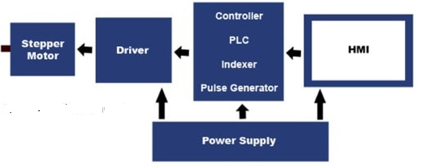

And the comparing of foreign to be developed because of its manufacturing technique of the strict and complex in our country the solar energy flat plate collector is in one aspect is the state of the backward. Because the solar energy flat plate collector its structure is large amount of the copper tube and inlet and outlet pipe the heat absorbing pipe is between claims an armature is connected to the problem of production so it does not need to the different diameter of the pipe material to hole. And existing equipment and the type of special equipment only by workers through the normal operation of the punching machine a manual to adjust the rotating hole and chamfer angle of the back part can finish the production efficiency is very low the product quality it is difficult to ensure the and so on many abuses. Connected with the demand amount of the constantly increased how to high yield and it is in the industry a need to solve the problem of. And the production steps of firstly to hole and chamfer angle of the distribution of working obviously the waste of labor but also waste working time if he compression and the production process is no doubt of improving production efficiency a shortcut.

II -METHOLOGY
- Considering various problem identification and study of current system find alternative method of making dig in soil.
- Study of the Literature for the soil digging machine
- Considering the ergonomics and aesthetics factor in mind, Select the shape and size of project.
- Our focus on to make this machine portable, we are trying to eliminate excess parts of machine and make it less bulky and light in weight.
- We are trying to keep its operation as simple as possible.
- Selection of material and components utilized in fabrication such as solar plate, battery, motor, auger bit, frame etc.
- Selection of size of equipment as the requirement.
- Finding the different components for experimental set up according to design.

III -FABRICATION
Drilling is a cutting process that uses a drill bit to cut or enlarge a hole of circular cross-section in solid materials. The drill bit is a rotary cutting tool, often multipoint. The bit is pressed against the work piece and rotated at rates from hundreds to thousands of revolutions per minute. This forces the cutting edge against the work piece, cutting off chips from the hole as it is drilled.
Equipment’s Used:
- Solar Panel
- Bit Drill
- DC Motor
- Battery
- Nut, Bolt & Washer
- Drill Chuck
- Table Stand – Fabrication
- Rotary Table
- Keyway Shaft (Column)
- Stand Base
- Lever up down Mechanism (Power-Feed)
- Self-relief Spring
- Solar Plate fixing frame – Fabrication
- Diode circuit
- Motor on/Off Switch

SOLAR PANEL

Solar energy is the renewable energy resources. Solar energy can be directly converted to electrical energy by means of photovoltaic effect which is defined as the generation of the electro motive force as a result of the absorption of ionization radiation. Solar energy is the conversion of the light energy into the electricity. Here we are using photovoltaic cells, energy from the sun can be converted into electricity that we can use every day. Silicon is one of main materials that can be used in a photovoltaic cell to convert the sun’s energy into electricity. As sunlight strikes a silicon solar cell the electricity generated can be used to power a motor. A lens can be used to collect a large amount of light and concentrate it to hit a smaller solar cell.

This Solar panel is 12V panel
.
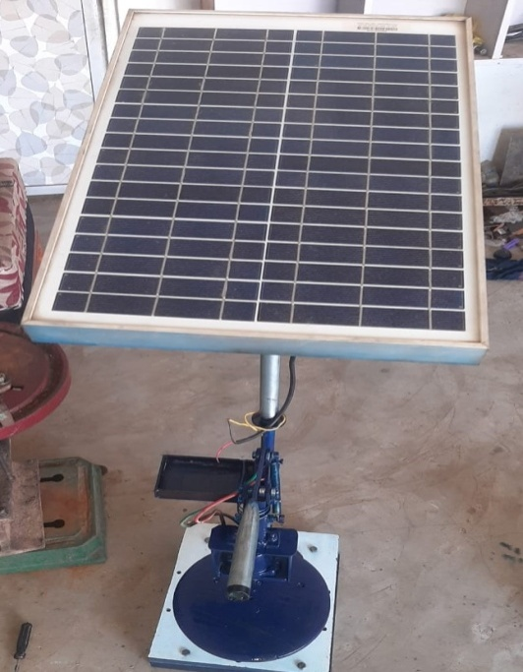
Maintenance:
Solar panel conversion efficiency, typically in the 20% range, is reduced by the accumulation of dust, grime, pollen, and other particulates on the solar panels, collectively referred to as soiling. "A dirty solar panel can reduce its power capabilities by up to 30% in high dust/pollen or desert areas", says Seamus Curran, associate professor of physics at the University of Houston and director of the Institute for Nano Energy, which specializes in the design, engineering, and assembly of nanostructures.[40] The average soiling loss in the world in 2018 is estimated to be at least 3% - 4%.
DC MOTOR: - The power source for the solid digging machine is obtained from DC power supply. Hence DC motor is used to operate the auger drill the motor power is about 0.33 HP and it has a torque about 4.2 Nm sufficiently enough to turn the auger and lift the mud from the ground. DC geared motor: Selection of this motor done on the basis of Torque Constant – 8 N.m (80 kg-cm), high torque motor beneficial for the drilling into the soil, so from online Manufactures CatLog we have selected this 12-volt dc motor Voltage: 12 Volt DC • Output: 250 Watt • Torque Constant – 8 N .m (80 kg-cm) • Roller Diameter 0.3 inch • Roller Width 0.16 inch.
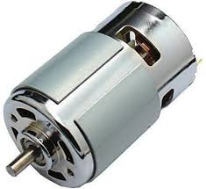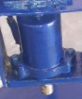
Drill Chuck :
Drill Chucks are often connected to a machine's spindle with a removeable Drill Chuck Arbor. The arbor is simply a double-ended shaft of steel, with one end machined to fit up into a machine's spindle, and the other end machined to fit into the back of a drill chuck. A second common type of machine has no removable arbor: the chuck instead mounts directly onto a male projection machined into the spindle itself.
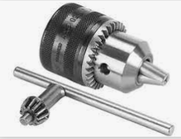
BATTERY: - A battery is a electronic device which is used for storing of electrical energy. In isolated systems away from the grid, batteries are used for storage of excess solar energy converted into electrical energy. The only exceptions are isolated sunshine load such as irrigation pumps or drinking water supplies for storage. In fact for small units with output less than one kilowatt.
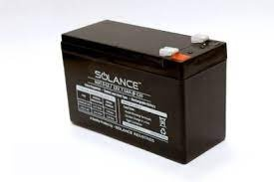
Lever up down Mechanism (Power-Feed)
The power-feed drilling machine is usually larger and heavier than the handfeed. They are equipped with the ability to feed the cutting tool into the work automatically, at a preset depth of cut per revolution of the spindle, usually in thousandths of an inch per revolution. These machines are used in maintenance shops for medium duty work, or work that uses large drills that require power feeds.
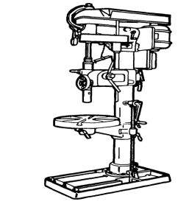
IV -WORKING OF PROJECT
The mechanism consists of primary links and secondary links. These linkages are connected by screws. For better rotation bearings can be used instead of screws. This mechanism is a pilot model designed to be used for light duty drilling purposes. The base can be rotated 360 degrees. The linkages help in providing free rotation of the secondary arm. The drill is placed on secondary arm and is allowed to rotate freely. The drill is connected to a battery for power requirements. This battery is charged using solar panels. Thus solar panels provide independence from intermittent grid electricity supply. The battery gets charged from the solar panels and this stored energy is used to power the drill. For large drills, bigger solar panels and batteries can be used.
Drilling machines use a drilling tool that has cutting edges at its point. This cutting tool is held in the drill press by a chuck or Morse taper and is rotated and fed into the work at variable speeds. Drilling machines may be used to perform other operations
V- CONCLUSION
Drilling machines or drill presses are one of the most common machines found in the machine shops/mechanical workshops. A drill press is a machine that turns and advances a rotary tool into a work piece. The drill press is used primarily for drilling holes, but when used with the proper tooling, it can be used for a number of machining operations. The most common machining operations performed on a drill press are drilling, reaming, tapping, counter boring, countersinking, and spot facing. These are quite common machines & available everywhere, but for specific applications we need special purpose drilling machines. Availability of these machines in our country is critical; we may have to import them, for which we have to spend lot of amounts. In this regard it is essential to develop special purpose drilling machines indigenously; therefore, this project work is taken up.
REFERENCES
- A.Kannan, K. Esakkiraja, S. Thimmarayan, “Design modifications in multipurpose sewing machine”, Vol.2 Issue.1, January 2014.
- A.R. Kyada, D.B. Patel. , “Design and development of manually operated seed planter machine”, AIMTDR 2014 December.
- B.T Ersson, L. Jundén, U. Bergsten, M. Servin, “Simulated productivity of one- and two-armed tree planting machines”, 2013,SilvaFennica vol. 47 no. 2 article id 958.
- Design of jigs, fixtures and press tools by C.Elanchezhian, T.Sunder selwyn, B.vijaya Ramnath Published by Eswar press.
- Design of jigs, fixtures and press tools by Venkataraman published by Tata McGraw hill
- Dr. K. Prahlada rao “solar powered ground driller for agricultural purposed” International Research Journal of Engineering and Technology (IRJET-2019)
- Dr.S.M. Mowade, Design and Fabrication of Solar perated Water Sprayer:Global Journal of Engineering Science and Research (IJTRS), [ICEMESM-18]
- High-capacity drills can be paired with bigger solar panels and bigger batteries for large scale production. Motors can be connected at the joints and using arduino a robotic drilling arm can be made.
- Limo kipkoecheliud, Rotich martin kibiwott, “Design of a tractor driven hole drilling machine for tree-planting” project number: SMK 02/2011, june 2011
- Prof. GadhiaUtsav D, Shah Harsh A, Patel Viral A, Patel Kushang P, Amin Harsh J, Design & Development Of Universal Pneumatic Drilling Machine: A Review Study, International Journal For Technological Research In Engineering Volume 3, April-2016, Pages 1614 –1616.
- Prof. Manjunatha “Solar Powered Digging and Seed Sowing Machine”International Journal for Research in Applied Science & Engineering Technology (IJRASET-2017)

