CONTROLLING OF AIR HANDLING UNIT BY USING PLC
Author: -Ramteke Dhanashree ⁽¹⁾, Deshmukh Mayuri ⁽²⁾, Kalamkar Kirti ⁽³⁾, Awchat Payal ⁽⁴⁾,Deshmukh Akhil⁽⁵⁾ ,Patil Pritam⁽⁶⁾
¹Datta Meghe Institute of Engineering Technology And Research, Wardha Maharashtra 442001,
dhanashreeramteke39475@gmail.com
²Datta Meghe Institute of Engineering Technology And Research, Wardha Maharashtra 442001,
mayurid2207@gmail.com
³Datta Meghe Institute of Engineering Technology And Research, Wardha Maharashtra 442001,
kirtikalamkar1999@gmail.com
⁴Datta Meghe Institute of Engineering Technology And Research, Wardha Maharashtra 442001,
payalawachat1502@gmail.com
⁵Datta Meghe Institute of Engineering Technology And Research, Wardha Maharashtra 442001,
deshmukhakhil66@gmail.com
⁶Datta Meghe Institute of Engineering Technology And Research, Wardha Maharashtra 442001,
patilpritam866@gmail.com
Abstract: - Industrial fires have caused multiple medical injuries to a people, loss of life, damage to expensive equipment in industry (workplace), many environment hazardous to the nature. PLC has various industrial application and provide more reliability and flexibility to system. This paper gives brief idea about controlling of AHU using Programmable Logic Controller (PLC) on other hands using sensor, damper, exhaust and switches. This helps to starve out the fire smoke from workplace by proper feedback control of PLC.
Keywords: - AHU (Air Handling Unit), PLC (Programmable Logic Controller), Starve out.
- Introduction
Fire is a most common hazard, which may affect the people lives, environmental pollution and damage to working place. The majority of fire related deaths are caused by smoke inhalation of toxic gases produce by fire.
Some 50%-80% of fire deaths are result of smoke inhalation because smoke has poisonous gases (carbon monoxide, cyanide, etc). Hence, inhaling smoke for short time can causes harm to human being. According to National Fire Protection Association (NFPA) 70% of fire related deaths caused due to suffocation and only 30% due to burn in fire. People always try to escape from fire but do not realise the seriousness of smoke inhalation. So, this survey is done for aware about the risk of smoke inhalation during fire accident.
Years | Risk Ranking
2014 | 12%
2015 | 9%
2016 | 8%
2017 | 5%
Table: Rise ranking of fire climbs.
According to NCRB, in fire accident 1193 injuries and 17,700 deaths due to suffocation in 2015.
“Delhi Anaj Mandi fire: End came while labourers were sleeping, most died because of the suffocation” Dr. Sudhir Gupta, professor and head of forensic sciences at All India Institute of Medical Science, said at the time of tragedy most of victims were sleep so it is possible that they felt due to smoke unconscious to smoke. Chemicals released and gases enter the lungs which caused infection. Even among those who has survive a long-term care is required to recovers.
“Surat fire: 22 killed in coaching centre blaze, horrific visuals show kids falling off burning building”, Fire occurred at third and fourth floor of Takshashila Centre in Surat, Gujrat. At least 22 students were killed due to suffocation in accident because there is no proper window to escape the fire.

- Methodology
Developing the preventing ideas to ensure the smoke inhalation in fire accidents. As initially the turning ON and OFF function of AHU was manual but by using this newly design system it can be done automatically.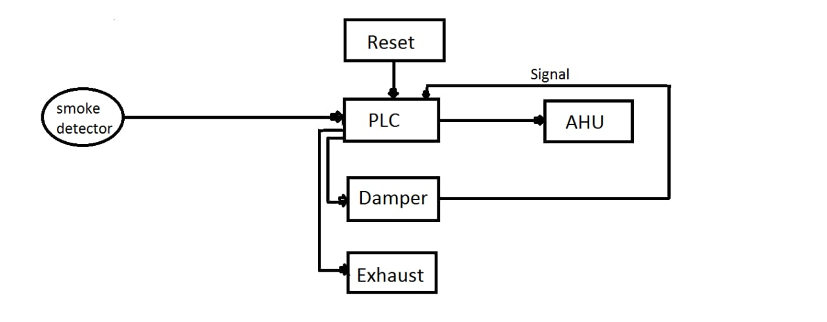
- PLC Used
PLC used is DVPSA2 which is reliable. The second generation DVP-SA2series slim type PLC offers bigger program capacity and executing efficiency, offering 100 khz high speed output and counting function It is extendable with DVP-S series left side and right side. It can be master or slave.
Specification:
MPU points: 12(8D1+4D0)
MAX I/O points: 492(12+480)
Program capacity: 16K steps
Comb port: Built in RS-232 and RS-485 ports Compatible with Modbus ASCII/RTU

- Software Specification:
For programming purpose WPLSOFT2.47 software is used. WPLSOFT is a software for delta PLC. When PLC is in operation use the software to monitor the set value or temporarily save value in time (T), counter (C) and register (D), and force ON/OFF of output contacts. WPLSOFT has designated in advance the type document it produces as *dvp* and will set beforehand the currently created filename as “dvpo.dvp”. This software is free software you can download, install also simulate the PLC program without any licence.

- Working
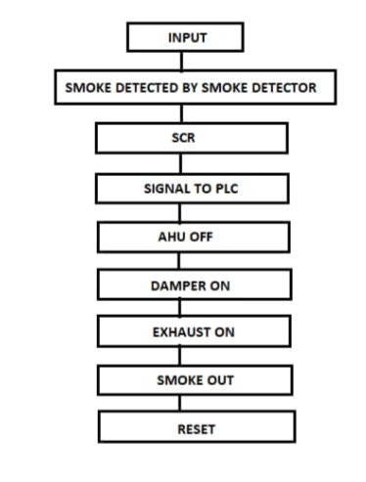
This system consists of smoke detection and getting rid of it. Also, it consists of various components like PLC, smoke detector, limit switches, dampers, exhaust, motor, relay, transformer. In this project PLC is heart of the system because it works on PLC.
When Fire accident occurs, smoke is producing and this smoke is detected by the smoke detector. Once the smoke detector detects the smoke it will give signal to SCR and SCR has property as it once gets ON it cannot be off. As SCR gets ON it gives signal to PLC. After that PLC gives signal to AHU and AHU gets OFF. Thereafter damper gets open. In PLC programming timer is set such that after opening the damper exhaust gets on in couple of second. In this way smoke is extract from the work place. As the whole is completed and normal state is achieved by using reset switch.
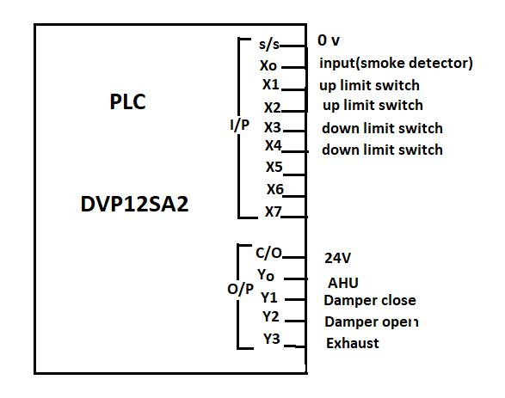
In this PLC there are 8 inputs and 4 outputs. As per requirement 4 inputs are used as shown in fig. X0 tends to input (smoke detector). X1 and X2 are for UP limit switch. X3 and X4 are used as DOWN limit switch. 24V gives to C/O. The O/P contact of Y0 is used for AHU. Y1 tends to damper close and Y2 tends to damper open. The O/P contact of Y3 is used as exhaust.
- Simulation
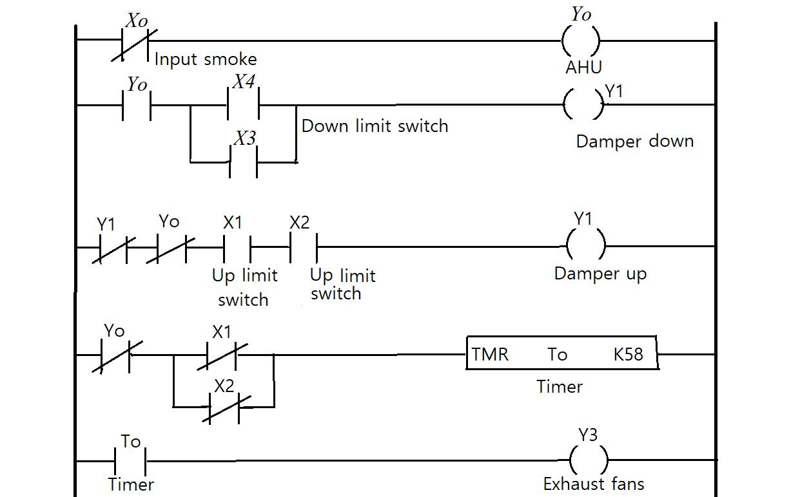
- X0 is an input which is normally closed switch from where smoke is detected.
- X0 is connected to Y0 i.e. AHU. When input is given to X0 it becomes normally open and Y0 becomes OFF.
- Adan block of Y0 is taken, 2 down limit switches i.e. X3 and X4 are connected to it.
- When Y0 is ON X3 and X4 is also ON and at that time damper is closed.
- Now when X0 is normally open Y0 becomes ON and damper opens i.e. Y1
Contact of Y1 is taken i.e. normally closed and denoted as damper down, Y0 is normally closed switch which is for AHU is connected to Y1.
- After that Y0 becomes OFF and when upper limit of damper is reached to desired position.
- After that timer gets ON which is of 5 second afterwards the fans get ON.
- AS whole smoke is starved out it comes to initial position by pressing reset switch.

Results
As per observation these work show that, due to automation the fire smoke getting rid out of the work place and reduce the number of deaths due to smoke inhalation.

- Discussion and conclusion

This project concludes that, Air Handling Unit using Programmable Logic Controller is more effective solution over manually controlled AHU. Using PLC provides many advantages such as availability of large number of input and output also output of PLC can easily extended.
As most of death occurred due to smoke inhalation and our system is so designed that smoke can be extracted out immediate hence saves human life. This automated system takes very less time to complete the process. Due to this man work is reduce and time is consumed.

- Future scope
This system can be used for starving out the smoke that is cause due to fire, from accident place. It can be used in big malls, theatres, industries, auditoriums in case of fire accident. This system will also use for all types of closed places where AHU is installed.
- References

- International Journal of Engineering Trends and Technology (IJETT)-Volume 33 number,7 MARCH 2016.
- “Programmable Logic Controller programming methods an application” by John R. Hackworth and Frederick D. Hackworth, Jr.
- Fire smoke detection based on contextual object detection.
- http://m.khaljeetimes.com
70% of fire deaths cause due to suffocation.

