Design and Analysis of Jig and Welding Fixture for Car Panel to Shift the Locate Pin

Diksha R. Bahadure ¹, Dr. Subhash N. Waghmare ²
¹M.Tech. a student in Mechanical Engineering Design, Priyadarshini College of Engineering, Nagpur, India, 440022
²Assistant Professor in Mechanical Engineering Department, Priyadarshini College of Engineering, Nagpur, India, 440019

Abstract – The fixture is a collection of working holdings that holds, supports, and locates the workpiece. Depending on their application, the fixture is needed in different industries. The locating pin is used to restrict the panel's degree of freedom. The panel will affect the loading and unloading of the panel due to a fixed position pin, so we have to configure the shift tool to change the positioning pin during loading and unloading of the panel. In this project we will create a CAD model with a jig and welding fixture. The change unit or the position unit will be designed as compact as possible, depending on the need for the jig and the welding fixture. This project is designed to move the positioning pin between the locating pin and the panel to avoid interference during loading and unloading.
Keywords- Locating pin, panel, CAD model, welding fixture, jig

INTRODUCTION
The jigs and fixtures are an economical way to mass-produce a part. Thus jigs and fixtures are used and are one of the most critical installations of the mass production system. These are special work holding and tool guiding device. The output quality of a process primarily determined by the quality of the jigs and fittings used for this purpose. What makes a fixture special is that everyone is designed to match a particular part or shape. A fixture has the main function of locating and retaining a workpiece during service. In addition to locating and supporting the workpiece, a jig differs from a fixture in the sense that it directs the tool to its correct location or movement during operation. Fixture required Specialization to accurately hold the work-piece during the welding operation. The Fixture designed hold job and rotate the job at required Speed. The reduced cycle time and operator labor while increasing functionality [1].
Depending on their application, the fixture is needed in different industries. Due to some drawbacks the configuration of a new fixture is changed over the current fixture. The part fixture is installed manually so loading and unloading of the material take more cycle time.
Work-holding methods have also changed considerably; the core principles of clamping and position are still identical. Mass production methods require a simple and easy way to put work on them for various operations. To address this issue we designed the welding fixture with enhanced mobility [2].
In general, clamping is necessary to hold the job in the jig. Much as in the automotive market, jigs may also be concept guides or templates. Special cramping jigs to ensure that the panel is placed in the right position. The fixture is a strong and rigid mechanical device that attaches to a machine and allows the stock to slide while holding firmly, allowing for simple, easy and reliable accuracy of position, support, and clamping. A fixture is a device for locating, holding, and supporting a work-piece during a manufacturing operation. This consists of locators, clamps, supports, and fixture body [5].
The unit's contents describe jigs and fixtures as a workpiece clamping device and guiding device for the machine. The use of jigs and fittings directly impacts the output level of the operation. It increases work efficiency by eliminating the manufacture of low-quality goods and reducing product cycle times. Jigs and fixtures design always depends on the type of operation and the machine tool to be used for that operation. Using jig and fixture means placing the workpiece in the appropriate location on the machine tool. The purpose of the position is to decide the points on the work where all the movements should be restricted so that the work can be completed without any problems. For this reason, other position principles are followed, such as 3-2-1 position theory, flat locator, cylindrical and conical locator, and jack pin locator. The key aim of the position theory is to curb the rigidity of the clamping. At the same time all of this leaves the production area open and ready for production. The unit also defines different types of clamping devices and the characteristics of a successful clamping system along with the attachments, jigs are used to direct the movement of the tool during service. They are made of steel that is hardy, wear-resistant, and corrosion-resistant. It also defines the widely used fixtures in the room. [5, 6, 7, 17]
METHOLOGY
Design Selection
Design selection is the process of selecting the concept that has been evaluated according to the requirement and the appropriate criteria. When comparing the relative strengths and limitations of the model, choose the best definition to be used for further analysis. Generally speaking, idea selection is the method of narrowing up the alternative definition considered. The screening form was chosen for the final design for the jig. This approach will help designers determine which concept is best.
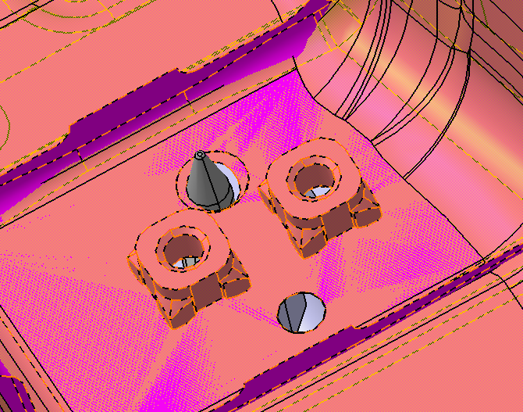
Fig. 1- Location of pin damaging panel (before modifications)

Final Concept
The final design of the semi-auto insertion jig is much better than the second design, which for this design is the assembly component, which is also simple.

Basic Design Principle for Jig and Fixture
The basic concept when designing the jig and the fixture is to help, locate, clamp, and keep the job. This concept originates from the final design of semi-auto insertion. The support of the part should be rigid. From this semi-auto insertion jig, make sure that the supporting design is robust enough to ensure accuracy when inserting the e-ring into the main lever portion. The fool proofing tool used for these parts is pins which clearly can position parts correctly and prevent parts from entering this jig incorrectly. Using screw clamps, this semi-auto inserter jig. The torque is used by the base screw clamp to hold a part in places by direct pressure on another part. The retaining power for this jig uses the screws and nuts. The bolts and nuts are simple to use and can be mounted from any component.

Design for safety
The design of the product is safe and easy to use when designing jig and fixtures. Sharp corners should be avoided on the jig or fixture body. When designing the semi-auto insertion jig in this project, each design component uses chamfers in each corner to ensure that there is no sharp corner that can damage the operator when using the jig Bolt and groove should be inside the body and should not protrude the surface. The surface of this semi-auto insertion is well built as something bold is placed inside the jig which makes the work surface clear and can prevent injury and obstacles while doing the job.

DESIGN
FORCE CALCULATION AND ANALYSIS OF CLAMP-
CLAMPING FORCE CALCULATION (BEFORE MODIFICATION)
Where F1= Clamping force
F2= Cylinder force
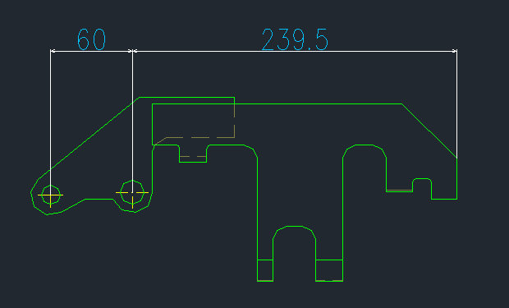
Fig. 2: Clamp dimensions of A and B
Given,
The bore diameter of cylinder = Φ50
F2 = Cylinder force = 78 kgf
A = 60 mm
B = 239.5 mm
Therefore,
The clamping force is 192 N

CLAMPING FORCE CALCULATION (AFTER MODIFICATION)
Where F1= Clamping force
F2= Cylinder force
Given,
Bore diameter of cylinder = Φ63
F2 = Cylinder force = 124 kgf
A = 60 mm
B = 239.5 mm

Therefore,
The clamping force is 305 N
Table 1- According to Japanese Industrial Standards (JIS) bore diameter and force of cylinder is given below
Sr.no | The bore diameter of the cylinder | Cylinder force
1 | Φ 40 | 78 kgf
2 | Φ 50 | 78 kgf
3 | Φ 63 | 124 kgf
4 | Φ 80 | 201 kgf

Table 2- Mechanical Properties of Steel (SS400)
Sr.no | Stress | Safety factor | Allowable stress (MPa)
1 | Tensile | 1.67 | 140
2 | Compression | 1.67 | 140
3 | Bending | 3.0 | 80
4 | Shear | 1.67 | 140

Table 3- Maximum allowable deflection (mm)
Sr.no | Parts | Allowable deflection (mm)
1 | Stool | 0.5199
2 | Bracket | 0.306
3 | Stopper | 0.391
4 | Clamp | 0.203

Table 4- Thermal Properties of Steel (SS400)
Sr.no | Temperature (⁰C) | Young Modulus(GPa) | Poisson’s ratio
1 | 50 | 209.05 | 0.3
2 | 100 | 205.74 | 0.3
3 | 200 | 198.90 | 0.3
4 | 300 | 192.14 | 0.3
5 | 400 | 183.65 | 0.3
6 | 500 | 174.52 | 0.3

Table 5- According to Japanese Industrial Standards (JIS) flat steel sizes are given below
Sr.no | Sectional Dimension |  | Break area (cm²) | Unit weight (Kg/m)
 | Thickness (mm) | Width(mm)
1 | 12 | 100 | 12 | 9.42
 |  | 125 | 15 | 11.8
 |  | 150 | 18 | 14.1
 |  | 180 | 21.6 | 17
 |  | 200 | 24 | 18.8
 |  | 230 | 27.6 | 21.7
 |  | 250 | 30 | 23.6
 |  | 280 | 33.6 | 26.4
 |  | 300 | 36 | 28.3
 |  | 32 | 5.12 | 4.02
 |  | 38 | 6.08 | 4.77
 |  | 44 | 7.04 | 5.53
2 | 16 | 50 | 8 | 6.28
 |  | 65 | 10.4 | 6.16
 |  | 75 | 12 | 8.16
 |  | 90 | 14.4 | 9.42
 |  | 100 | 16 | 11.3
 |  | 125 | 20 | 12.6
 |  | 150 | 24 | 15.7
 |  | 180 | 28.8 | 18.8
 |  | 200 | 32 | 22.6
 |  | 230 | 36.8 | 25.1
 |  | 250 | 40 | 28.9
 |  | 280 | 44.8 | 31.4
 |  | 300 | 48 | 35.2

The finite element analysis of the parts of the jig is given below:
To shift the locating pin, the shift cylinder arrangement is designed because of that stresses are developed in the following parts.
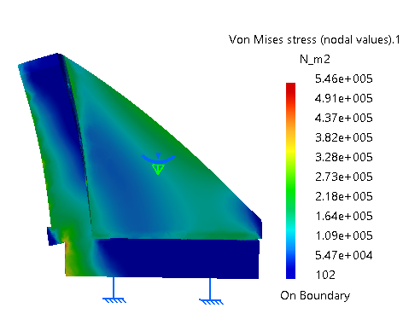
Fig. 3: Model showing stresses in SS400
The maximum stress develops in the above part is 5.46e+005, which is 54.6 MPa. This is less than maximum allowable stresses as shown in table 2. Therefore, the design is safe.

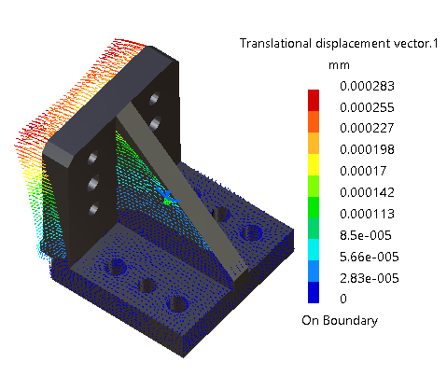
Fig. 4: Model (Stool) showing deflection in SS400
The maximum deflection develops in the above part is 0.000283 mm, which is less than the maximum allowable deflection as shown in table 3. Therefore, the design is safe.

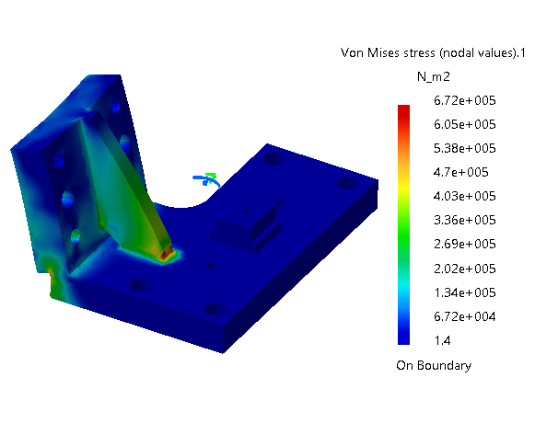
Fig. 5: Model showing stresses in SS400
The maximum stress develops in the above part is 6.72+005, which is 0.672 MPa. This is less than maximum allowable stresses as shown in table 2. Therefore, the design is safe.

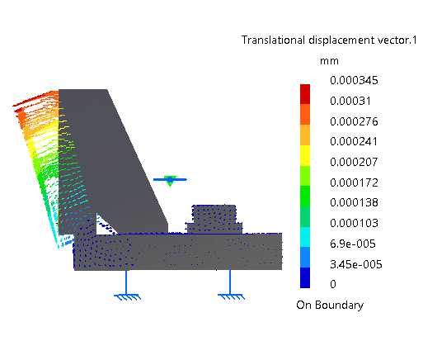
Fig. 6: Model (Bracket) showing deflection in SS400
The maximum deflection develops in the above part is 0.000345 mm, which is less than the maximum allowable deflection as shown in table 3. Therefore, the design is safe.
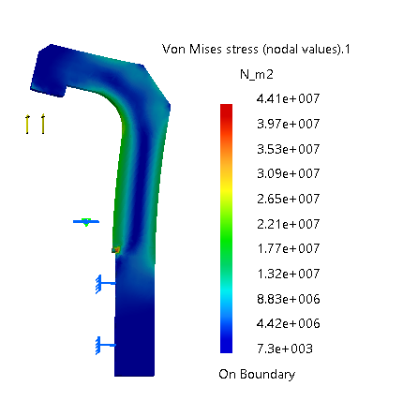
Fig. 7: Model (Stopper) showing stresses in SS400
The maximum stress develops in the above part is 4.41e+007, which is 4.41 MPa. This is less than maximum allowable stresses as shown in table 2. Therefore, the design is safe.

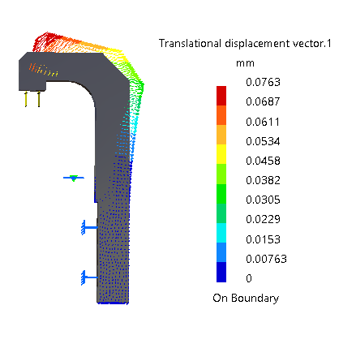
Fig. 8: Model (Stopper) showing deflection in SS400
The maximum deflection develops in the above part is 0.0763 mm, which is less than the maximum allowable deflection as shown in table 3. Therefore, the design is safe.
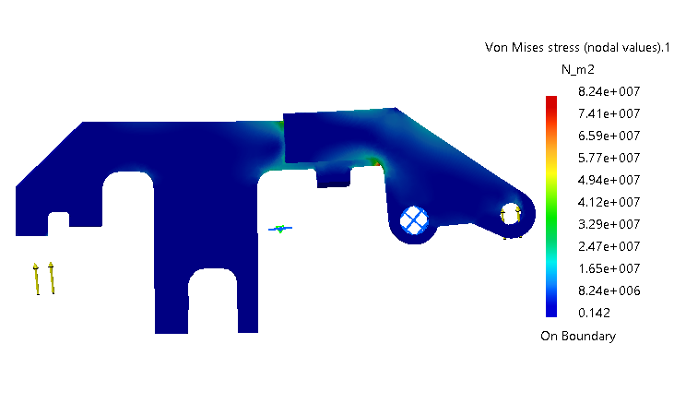
Fig. 9: Model (Clamp) showing stresses in SS400
The maximum stress develops in the above part is 8.24e+007, which is 82.4 MPa. This is less than maximum allowable stresses as shown in table 2. Therefore, the design is safe.
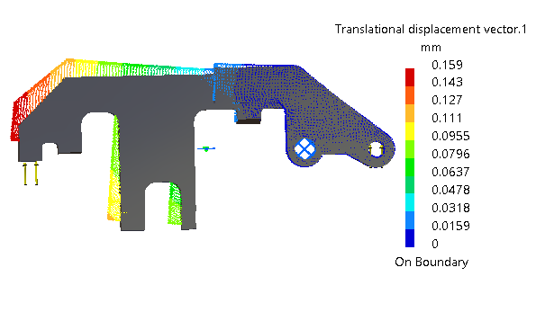
Fig. 10: Model (Clamp) showing deflection in SS400
The maximum deflection develops in the above part is 0.159 mm, which is less than the maximum allowable deflection as shown in table 3. Therefore, the design is safe.
The engineering design process is one of the steps required for product creation. Phase in the design of a jig and fixture is to find the right combination of design characteristics at a fair cost by assessing its functional requirements. At this point, the tool design process will clearly state the problem that needs to be solved and accomplished. The design process also included research involving the product, such as the clamping location, load distribution, selection of materials, and more research and design details. This method will also clarify how to build the semi-auto e-ring insertion jig and how to carry out the study. The software CATIA CAD is used for the design. These values are very necessary to decide if the design of the component is acceptable and complies with the requirement.

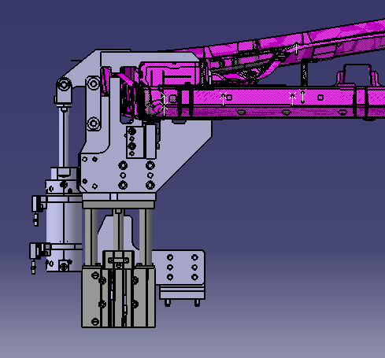
Fig. 11: Jig with Shift cylinder arrangement
The shift unit is shifted 70mm below as the shift cylinder is of 75mm stroke length. 5mm clearance is maintained.
By using these flat bar sizes the parts of the jig and welding fixture has designed. All parts of the jig are shown in figure 11.

CONCLUSION
In this research work, the shift unit in the jig is made as compact as possible according to the necessity of the jig and the welding fixture. This project has planned to shift the locating pin to prevent interference during the landing and takeoff of the panel. To make this kind of arrangement some parts of the jig have to modify. By using Japanese Industrial Standards (JIS) parts get modified in CATIA. By using the same, parts get drafted in Auto CAD; with the modifications in design the objective is achieved.
REFERENCES
[1] Prit Shah, Hetal Agrawal, S P Joshi, Udayan Patel, “Design and Manufacturing of Modular Welding Fixture”, National Conference on Recent Trends in Engineering & Technology, 2011
[2] S.N.Shinde, Siddharth Kshirsagar, Aniruddha Patil, Tejas Parge, Ritesh Lomte, “Design of Welding Fixtures and Positioners”, International Journal of Engineering Research and General Science, Volume 2, Issue 5, ISSN 2091- 2730, August-September, 2014
[3] Bing Li. Hui Tang. Xiaoping Yang. Hao Wang, “Quality design of fixture planning for sheet metal assembly”, International Journal of Manufacturing Technology, 2007
[4] Biswajit Parida, Shiv Dayal Vishwakarma and Sukhomay Pal, “Design and development of fixture and force measuring system for friction stir welding process using strain gauges”, Springer Publication, Journal of Mechanical Science and Technology, 2015
[5] Naveen A M, V A Girisha, Pruthvi HM, “Design and Analysis of Welding Fixture for Motor Case Assembly”, International Journal of Mechanical and Production Engineering, ISSN: 2320-2092, Volume- 2, Issue-8, August 2014
[6] Kalpesh Khetani, Jafar Shah, Vishal Patel, “Design and Thermal Stress Analysis of Welding Fixture of a Brake Pedal”, International Journal on Recent Technologies in Mechanical and Electrical Engineering, ISSN: 2349-7947 Volume: 2 Issue: 5, pp 029 – 032, May 2015.
[7] Omkar Joshi, Dr. Arunkumar, “Design and Analysis of Welding Fixture For Orbital Welding Machine”, International Journal of Production Management and Engineering, Volume III Issue IV, October – December 2015
[8] Yogesh Ingale, Kuldip Rade, Nitin Bhalerao, Dr. Kailas Nath Suta, “Design and Analysis of Welding Fixture for Inlet Header of Shell and Tube Heat Exchanger”, International Journal of Engineering Research, 2015
[9] Jigar D Suthar, K.M Patel, Sanjay G Luhana “Design and analysis of fixture for welding an exhaust impeller”, International Journal of Engineering Science Direct and Technology, Vol. 51, pp 514 – 519, 2013
[10] Chetan D. Borse, Prasad V. These, Ravi P. Vishwakarma, Jainendrakumar S. Yadav, “Design and Analysis of Fixture for a Stone Crusher Body” On International Journal of Research in Engineering and Technology, ISSN: 2319-1163, ISSN: 2321-7308, Volume: 04 Issue: 06, June 2015.
[11] Vaishak Bhandari M, Sudeep N S, Naveenakrishna P V, “Design and Analysis of Robot Full Welding Fixture for Front Chassis of Wheel Loader” NCAMES, ISSN: 2231-5381, 2016
[12] A. M. Mhaske, R. M. Metkar, S. D. Hiwase “Design and Analysis of Welding Fixture for Tacking and Welding of Inner Boom of Loadall Handler”, International Journal of Research in Mechanical Engineering and Technology, ISSN: 2249-5762, Vol. 5, Issue 2, May-Oct 2015
[13] H. Asada and A. By, “Kinematic analysis of work part fixturing for flexible assembly with automatically reconfigurable fixtures”, IEEE Journal of Robotics and Automation, 2, pp 86-93, 1984.
[14] K. Wright and C. C. Hayes, “Automated planning in the machining The domain”, Knowledge-Based Expert Systems for Manufacturing,
ASME, PED-24, pp 221–232, 1986.
[15] Y. C. Chou, V. Chandru, and B. Barash, “A mathematical approach To automatic configuration of machining fixtures: analysis and Synthesis”, Transactions ASME, Journal of Engineering for Industry, 111(4), pp 299–306, 1989.
[16] A. Y. C. Nee, K. Whybrew, and A. Senthil Kumar, Advanced Fixture Design for FMS, Springer-Verlag, 1995.
[17] P H Joshi, “Jigs and Fixtures”, Third Edition, 2004, (Tata McGraw Hill Publishing)

