Brain Tumour Diagnosis System using ML

Dr.(Mrs.) Snehal Golait¹,Amulya Pawshekar²,Ruchita Rahate³, Supriya Malewar⁴, Tanaya Deodhe⁵, Tanvi Thakre⁶

^{1,2,3,4,5,6}Computer Technology, Priyadarshini College of Engineering,Nagpur,Maharastra,440019,India.

pendke@gmail.com

Received on: 11 June ,2022 Revised on: 31 July ,2022, Published on: 02 August,2022

Abstract- Tumors are abnormal cell growth in the brain that eventually lead to cancer. The most common approach for identifying brain excrescence is magnetic resonance imaging (MRI). Information from MRI imaging is linked to the abnormal towel development in the brain. In colorful exploration articles, Machine Learning and Deep Learning techniques are utilized to uncover brain excrescence. The vaticinator of brain excrescence occurs extremely quickly when these algorithms are applied to MRI images, and a high degree of delicacy assists in delivering therapy to the cases. The radiologist's capacity to make quick judgments is also improved by vaticinator.
The suggested study employs a tone-defined Artificial Neural Network (ANN) and a Convolution Neural Network (CNN) to detect the existence of brain excrescence and their performance. To forecast and diagnose brain tumors, the proposed study leverages picture segmentation from the Kaggle MRI dataset.

Keywords- Convolution Neural Network, Brain Tumour , Machine Learning, Algorithm.

I – INTRODUCTION
ANN and CNN are used to classify normal and tumour brains in this study. A digital computer is coupled with a large number of interconnections and networking, allowing the neural network to train using basic processing units applied to the training set and to store the experiential knowledge. It is made up of numerous layers of neurons that are connected. In the learning phase, the neural network can use a data set to learn. An input and output layer will be included, as well as some hidden layers.[1]. Although ANN utilizes entirely linked layers, it requires a lot of processing, and this study also includes CNN because an image is utilized as input. CNN employs a mathematically linear method known as convolution neural networks (convolution neural network). At each layer of the CNN, the visual dimension is lowered without affecting the training data. Convolve, max pooling, droop out, flatten, and dense are some of the processing techniques used to generate the model. The goal of this research is to create a self-defined architecture for ANN and CNN models, then compare their performance on a brain tumor MRI dataset.

II- LITERATURE REVIEW
In this study, ANN was employed to build a Brain Tumor Detection System. When compared to current classifiers, the recommended approach for categorizing brain images utilizing ANN as a classifier offers a high classification efficiency.
Image processing methods used included histogram equalization, picture segmentation, image enhancement, and feature extraction. The sensitivity, specificity, and accuracy have all been improved. The strategy presented is both computationally efficient and yields great results.
This study employed the Convolution Neural Network (CNN) to detect gloom, meningioma, and pituitary tumours, with an overall accuracy of 91.3 percent and recalls of 88, 81, and 99 percent, respectively. Deep learning architecture based on 2D convolutional neural networks for categorising different forms of brain tumours in MRI image slices. This study employs data collection, pre-modeling, data preprocessing, and hyper parameter model optimization and modification. The model's generalizability was subsequently validated on the complete dataset using 10fold cross validation.
Hough voting is a technique for completely automated localization and segmentation of anatomical regions of interest, which was applied in this study. It also employs a learning-based segmentation method that is adaptable to a variety of media and versatile, wide, multi-regional. Different quantities of training data and data dimensionality are utilised to anticipate outcomes.
Convolutional neural networks, Hough voting with CNN, and Efficient patch-wise evaluation with CNN were used to analyse the image.
The brain is an important organ in the human body that organizes and controls the functions of other body parts. It is in charge of the human body's daily voluntary and involuntary functions. The tumour is a fibrous web of undesired tissue development inside our brain that develops out of control. Magnetic resonance imaging (MRI) is used by radiologists to analyse the stages of brain tumours in order to prevent and treat them. The purpose of this examination is to determine whether or not a brain tumour exists.

III- DATASET

The information was gathered via Github. This dataset contains MRI images of brain .In the two folders, one contains normal brain scan images and the other contains tumour photos. There are a total of 2068 images in these two folders. Figure 1 shows a sample of normal and brain tumour picture. There are 1088 timorous images and 980 non-tumorous photographs in total.[8] The photographs are a variety of sizes (630X630, 225X225, etc.) and have been downsized to 256x256 pixels. There are 1675 training photographs, 186 validation photos, and 207 testing photos. Among the 1675 training photographs, there are 877 tumour shots and 798 non-tumor photos. There were 92 tumour pictures and 94 non-tumor images among the 186 validation shots. There were 116 tumour photos and 91 non-tumor images among the 207 testing images.
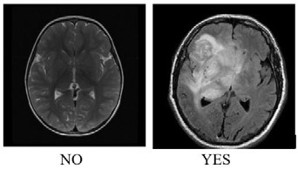

VI- PROPOSED METHODOLOGY
The two techniques, ANN and CNN, are used on the dataset, and their effectiveness in categorizing image is assessed. The following are the steps for applying ANN to the brain tumor dataset:
1. Import all required packages
2. Open the data directory and import it.
3. Read the photographs, give them labels (set Image with Brain Tumour to 1 and Image without Brain Tumour to 0), and save them to the Data Frame.
4. Read each image one at a time to change the image size to 256x256.
5. Make the image normal.
6. Separate the data into three sections: training, validation, and testing.
7. Create the model
8. Assemble your model.
9. Assemble the train set with the model.
10. Apply the model to the test set to evaluate it.

The ANN model used in this case has seven layers. The first layer isflatten and it compresses the 256x256x3 images into a singledimensional array. The dense layers have 128,256,512,256, and 128 neurons, respectively, and have the same activation function as the preceding five levels. The output layer is the last dense layer with a sigmoid activation function, with one neuron representing each of the two classes, and these five levels are the hidden layers.
The model is built using the Adam optimization strategy and the binary cross entropy loss function. The model is developed and trained by providing training and validation photographs. After the model has been trained, it is tested using the test picture set. The CNN algorithm is then fed the same dataset. The following are the steps for applying CNN to the brain tumour dataset:
1. Import all required packages
2. Open the data directory and import it (Yes and No)
3. Assign classes to picture labels (1 for Brain Tumour and 0 for No Brain Tumour)
4. Create a form with the photographs (256X256)
5. Make the image normal.
6. Sort the photographs into three categories: training, validation, and testing.
7. Create a model that is sequential.
8. Assemble your model.
9. Make use of the train dataset (use validation set to evaluate the training performance).
10. Evaluate the model using the test images.
11. Make a graph that contrasts the accuracy of training and validation.
12. Compare the actual and predicted results in a confusion matrix.
By mandating different layers, the CNN sequential model is constructed. The input image is resized to 256x256 pixels. The convolve layer is applied to the input image using the relu activation function and padding equal, resulting in output images that are identical to the input image.[7] The number of filters is 32,32,64,128,256 for different convolve layers.
A 2x2 window size is used for max pooling, and the droupout function is invoked with 20% of the droupout. The attributes are flattened into a one-dimensional array using the flatten method. The dense approach is used to produce the completely linked layer, using 256 units and relu as the activation function.[2]
The output layer has one unit for each of the two classes, as well as a sigmoid as an activation function. Figure 2 depicts the architecture of the CNN model. The implementation, which is written in Python, is carried out using Google Colab. The training and validation datasets are used to apply the model to 200 epochs. The execution history is saved and made available to aid understanding of the models created.
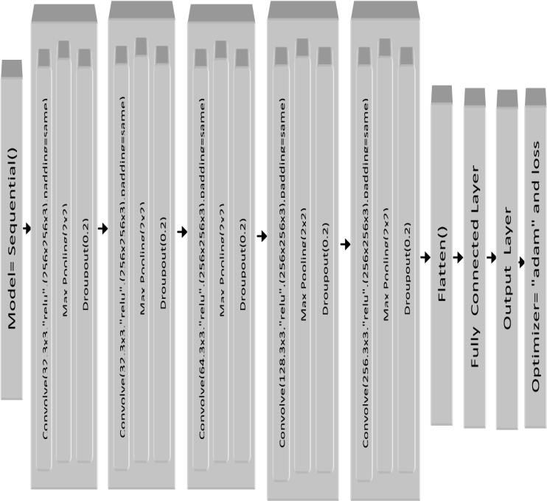

Fig 2- Architecture of CNN model

(i) Image Pre-Processing:
It's difficult to process an image. Before dealing with an image, it's critical to eliminate any extraneous elements. After eliminating unnecessary curios, the photo may be efficiently prepared. Image The essential breakthrough in image processing is pre-processing. Pre-processing techniques include picture transformation to greyscale, noise evacuation, and image reproduction.[3] Changing the image to greyscale is the most well-known pre-processing approach. Excess noise is eliminated once the image is converted to greyscale using a variety of separation techniques.
(ii)Image Segmentation
The term "segmentation" refers to the process of separating a digital image into many sections, each of which has pixel layouts and super pixels. The division approach may be used to generate goals such as rearranging and altering the portrayal of an image such that it becomes increasingly nitty gritty, crucial, and simple for the inquiry process[4]. To insert elements and limits in photographs, such as lines and bends, image division can be employed. A name is assigned to each pixel in an image, and pixels belonging to the same mark have similar visual highlights. Every pixel in the district is compared using certain highlights or graphical qualities like shading, force, and surface. Neighboring locations are extremely different in terms of similar highlights.
The edge esteem used in the threshold segmentation strategy technique is used to convert a dark scale highlighted picture to a paired image. The most flexibility in the strategy comes in choose which edge to use as an incentive. Morphology is a way for determining the structure and form of an entity.[5] Many malformations can be noticed in paired photographs. Morphological picture preparation aims to characterize image shape and structure in order to reduce these flaws. This is usually used to indicate objects or borders within a scene.
(iii) Feature Extraction
It's a method of dividing a huge picture into smaller chunks. It generates several pixel combinations inside a single picture[6]. A tag is applied to each pixel in an image, and pixels with the same mark share certain highlights. Fragmenting a complicated picture makes it easier to break down and grasp crucial data structures.

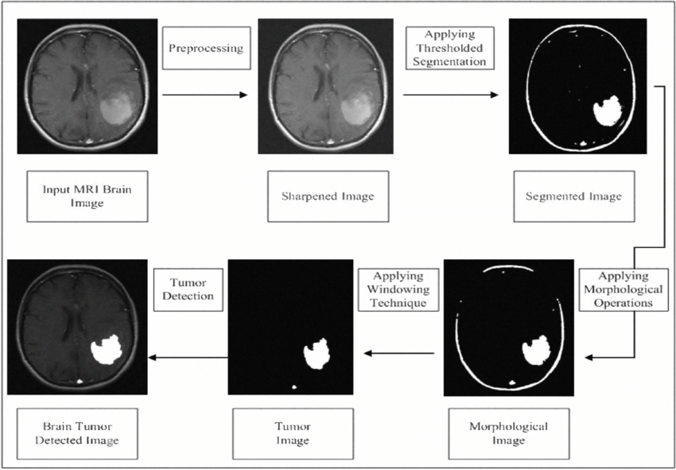
For picture classification, several learning techniques or models might be utilised. CNN, on the other hand, has emerged as the model of choice for a variety of reasons. To successfully categorise pictures, the CNN design implicitly combines the benefits of normal neural network training with the convolution process. Furthermore, because the CNN (and its derivatives) are neural networks, they are scalable for big datasets, which is frequently the situation when pictures must be categorised.
1).CNN compares each component of the picture separately. As a result, CNN outperforms entire picture matching algorithms when it comes to detecting similarity.
2). Because CNN is a deep learning neural network, there is transfer learning, which means it will learn more and make less mistakes.
3) CNN may be viewed of as picture feature extractors that work automatically.
4). CNN essentially down samples the picture using neighbouring pixel information, followed by convolution and finally a prediction layer.
5). CNN performs well in terms of feature extraction and accuracy.
Neither is necessarily "better," yet they both have advantages and disadvantages. CNN is particularly well suited to image recognition. You could certainly use CNN to analyse sequence data, but they really shine when it comes to sifting through large amounts of data and detecting non-linear relationships. SVMs are margin classifiers that support a variety of kernels for classification. When the size of the class labels is large, SVM has difficulty predicting them. Also, it’s difficult to parallelize SVM but the CNN architecture inherently support parallelization. RNN are good at Sequence data prediction.
IV-EXPERIMENTAL RESULTS
The image data is saved in the data nearly data type variable. The picture class labels are also produced and saved in an array in the data target variable. The images are then placed into the data frame. Training, validation, and testing are the three components of the image dataset. Figure 3 shows the accuracy and loss obtained using the ANN model on the training and validation datasets. The training accuracy is 97.13 percent and the validation accuracy is 71.51 percent when the ANN model is run for fifty epochs on the training data. It has an accuracy of 80.77 percent when applied to the testing data.
The greatest validation accuracy is 94.00 percent when the model is applied to the training dataset for 200 epochs. The ratio of training accuracy to validation accuracy, as well as training and validation loss, are depicted in figure 4.
Model performance is defined by two key metrics: training/validation accuracy and model loss. Accuracy of training/validation: This is the most important metric for assessing classification models.
• True positive (TP): a positive prediction that is right.
• False positive (FP): a positive prediction that is inaccurate.
• True negative (TN): a correctly predicted negative outcome
• False negative (FN): a negative prediction that is inaccurate.
𝐴𝑐𝑐𝑢𝑟𝑎𝑐𝑦 = Number of Correct Predictions/ Total Number of Predictions

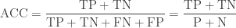

Accuracy improves when Loss decreases, and vice versa.
Model loss: A Loss function can be used to improve the performance of a machine learning algorithm. In reality, this loss function is how the machine learns. The loss function will yield an extremely high value if the forecasts diverge too far from the actual findings.
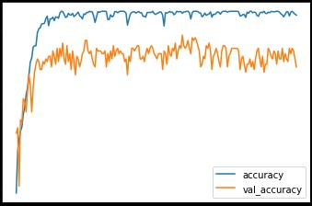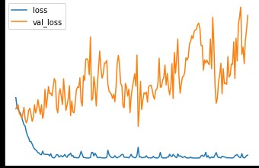

Fig 4- compares CNN model training/validation accuracy and loss.
The model is evaluated using the test image dataset. Figure 5 depicts the intended output's confusion matrix. The result of developing a prediction for testing and validation is as follows.
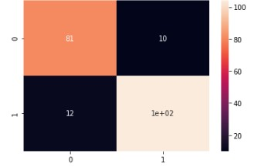
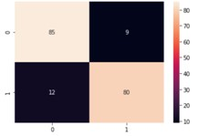
Fig 5- The CNN model's confusion matrix for the testing and validation dataset
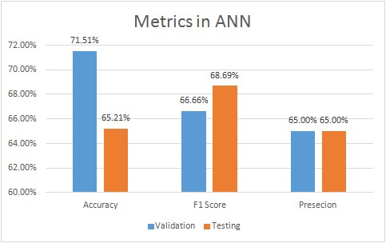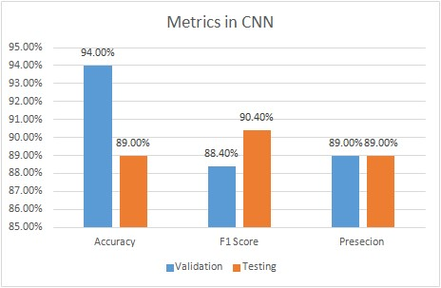

Figure 6 displays the accuracy, recall, and f1-score of both models
The CNN model is 89 percent accurate in applying the testing data. When precision, recall, and f1 score are used to compare the performance of ANN and CNN in detecting the presence of a brain tumour, CNN appears to be the best supporting strategy since it has the greatest precision value.

VI - CONCLUSION
One of the most used algorithms for analyzing picture collections is CNN. The prediction is created by shrinking the image without losing important details. The testing accuracy of the ANN model created here is 65.21 percent, which might be improved by giving more picture data. Using picture augmentation techniques and analysing the performance of the ANN and CNN, the same may be done. The model you see here was created through trial and error. Optimization algorithms might be employed in the future to predict the number of layers and filters that could be utilised in a model. CNN is presently the best approach for predicting the existence of a brain tumor for the dataset presented.

REFERENCES
- Raheleh Hashemzehi Seyyed Javad Seyyed Mahdavi Maryam Kheirabadi Seyed Reza Kamel 2020 Detection of brain tumours from MRI images base on deep learning using hybrid model CNN and NADE Elsevier B.V. on behalf of Nalecz Institute of Biocybernetics and Biomedical Engineering of the Polish Academy of Sciences Online Publication.
- Javeria Amin Muhammad Sharif Mudassar Raza Mussarat Yasmin 2018 Detection of Brain Tumour based on Features Fusion and Machine Learning Journal of Ambient Intelligence and Humanized Computing Online Publication.
- Rajeshwar Nalbalwar Umakant Majhi Raj Patil Prof.Sudhanshu Gonge 2014 Detection of Brain Tumour by using ANN International Journal of Research in Advent Technology 2.
- Fatih Özyurt Eser Sert Engin Avci Esin Dogantekin 2019 Brain tumour detection based on Convolutional Neural Network with neutrosophic expert maximum fuzzy sure entropy Elsevier Ltd 147.
- Fausto Milletari Seyed-Ahmad Ahmadi Christine Kroll Annika Plate Verena Rozanski Juliana Maiostre Johannes Levin Olaf Dietrich Birgit Ertl-Wagner Kai Bötzel, Nassir Navab 2016 Hough-CNN: Deep learning for segmentation of deep brain regions in MRI and ultrasound Elsevier Inc 164 92-102.

- Dena Nadir George Hashem B Jehlol Anwer Subhi Abdulhussein Oleiwi 2015 Brain Tumour Detection Using Shape features and Machine Learning Algorithms International Journal of Scientific & Engineering Research 6 12 454-459.
- Sobhangi Sarkar Avinash Kumar Sabyasachi Chakraborty Satyabrata Aich Jong-Seong Sim Hee-Cheol Kim 2020 A CNN based Approach for the Detection of Brain Tumour Using MRI Scans Test Engineering and Management 83 16580 – 16586.
- Komal Sharma Akwinder Kaur Shruti Gujral 2014 Brain TumourDetection based on Machine Learning Algorithms International Journal of Computer Applications 103 7-11.
- Brain Tumour Survey: https://www.cancer.net/cancer-types/brain-tumour/statistics

