Sustainable Approach for Energy Requirement during Construction
Prerana Shankarsing Rajput¹, Deepa A. Joshi²
¹ PG Student, Department of Civil Engineering, Dr. D Y Patil Institute of Technology, Pimpri, Pune, Maharashtra, India.
²Professor, Department of Civil Engineering, Dr. D Y Patil Institute of Technology, Pimpri, Pune, Maharashtra, India.

Abstract – Renewable power generation can help countries meet their sustainable development goals through provision of access to clean, secure, reliable and affordable energy sources. The construction sector significantly uses non-renewable energy. The idea is to check the effectiveness of utilization of the renewable energy sources i.e. solar power for the various activities during construction. The energy requirement during construction activities is studied in detail. Comparative study of present scenario of energy resources for construction activities and the proposed renewable energy utilization for the same is carried out. This paper elaborates the use of solar power for the energy consumption during the construction activities and also the feasibility check is carried out by technical analysis and also financial analysis for implementation of solar panels during the construction by LCCA for the proposed site with solar panels and without solar panels, payback period, benefit/cost ratio and cumulative cash flow. In the present work case study of an industrial site has been considered and solar power plant is implemented on the site for the construction activities during the construction phase for all the electrical equipment used on site and LCCA is carried out by using net present value. The grid connected solar of 50 kW is proposed for the site by considering the energy consumption of site for which the relevant data from site is collected and the solar is proposed on visitors car parking with no disturbance to the construction activities and technical as well as financial analysis is done for the same.

Keywords- Solar panels, LCCA, Payback period, B/C ratio
INTRODUCTION
The need for energy conservation is a real challenge and need of everyone’s attention. Construction sector, which causes environmental pollution by using considerable part of natural resources, uses energy beginning from raw material extraction phase going through construction, usage and demolition phases. Therefore exploitation of renewable energy resources and resolving environmental problems come into the sphere of interest of engineers and sensibility increasing by environmental and energy problems obligates to work together all disciplines related with construction industry. In this context sustainable construction concept find interest and acceptance more and more by the day in the world. Providing the conservation of resources by using renewable energy resources instead of non renewable energy sources helps to solve environmental problems. In order to solve environmental problems and create awareness it is beneficial to define said concepts, determine the criteria for energy use by prompting the use of renewable energy resources in infrastructure before, during and after its construction and maintenance. Sustainability is a key concept that requires careful and efficient usage of the natural resources in order to supply sufficient resources and healthy habitats for the next generations ^{[1]}. The energy consumed on a construction site varies continuously, and generally increases as a project progress in all stages. The usual practice of considering annual energy consumption is wholly inappropriate for the construction businesses because every project is different, and projects run only for a short term period ^{[2]}. In this paper it is discussed that solar power can be the option as a sustainable energy source for construction activities. The long term objective is to use solar energy for construction activities during the construction phase of project by implementing solar solutions at the site which can be further used for the operation and maintenance phase of that particular project.
OBJECTIVES

The objective of this work is
- To Study the energy consumption of construction industry and analyze the option of solar energy during the construction activities.
- To carry out technical and financial analysis for the feasibility of implementing solar energy for the electrical equipments used during construction activities.

LITERATURE REVIEW
The construction sector significantly uses non-renewable energy. These operations of buildings account for 25% to 40% of total final energy used in countries ^{[5]}. However, energy consumption is not limited to the energy used for the operation. A substantial amount is also used in construction activities, including the manufacturing and transportation of construction materials and demolition of buildings. Thus, it is imperative for this sector to adopt a sustainable energy system. In order to implement such a system, the potential in renewable energy needs to be tapped and also environmentally preferable procurement practices need to be developed. The adoption of renewable energy could also add value towards enhancing the environmental performance of the construction sector. The construction sector could be “prime movers” in promoting renewable energy ^{[3]}. The major benefit of installing solar power in construction is for the cost-savings associated with it. Incorporating solar power can sometimes produce more energy than is needed. In that instance, these property owners can sell their excess clean energy to power companies who can source solar energy right into the grid to supply others with clean energy. Additionally, many people who choose to use solar power in their construction plans can apply for government incentives that offset the cost of solar systems simply because it’s good for the environment and for the energy industry at large ^{[4]}. Both the pre-feasibility report and the feasibility report, form the basis on which the decision will be made to approved or reject the proposed solution of solar at the construction site.
A substantial amount is also used in construction activities, including the manufacturing and transportation of construction materials, and demolition of buildings. Thus, it is imperative for the sector to adopt a sustainable energy system. In order to implement such a system, the potential in renewable energy needs to be tapped and also environmentally preferable procurement practices need to be developed. The adoption of renewable energy could also add value towards enhancing the environmental performance of the construction sector. The environmental performance of the construction sector has been an issue of concern in Sweden, which is due to the sector’s impact on the Swedish environmental objectives ^{[5]}.
METHODOLOGY
After the detailed literature survey methodology of the project has been decided. For that the study of energy consumption of construction industry was carried out and assessment of present scenario in construction was done. A case study of industrial construction is taken to implement solar power during the construction activities. The electrical equipments used on site were listed and energy consumption of those equipments is carried out. After the calculations of energy requirement of the equipments solar panel is suggested for the required energy consumption and the solar panel can be installed on the visitors parking by calculating the required area for the solar plant. For that the detailed technical analysis is done and also financial analysis is carried out for the solar plant. Feasibility is checked by the financial analysis by doing LCCA, B/C ratio analysis, payback period is calculated and also cumulative cash flow analysis. After carrying the technical and financial analysis it is decided whether the solar panel can be implemented on any construction site.
CASE STUDY AND ANALYSIS
Basic Aspects And Data Collected For Analysis
Technical Analysis:
- Site Details:
“Givaudan” is a food production industry which is located at Ranjangaon, MIDC, Maharashtra. The total built up area of site is 18364.99 sqm.

- Electrical equipments used at site and their consumption (kWh/day)

Sr. No | Equipment | Capacity (kW) | Hrs per day | Consumption in kWh per day
1 | Plate compactor | 4.85 | 6 | 29.1
2 | Bar bending machine | 2.24 | 4 | 8.96
3 | Bar cutting machine | 3.73 | 4 | 14.92
4 | Ring bending machine | 3 | 4 | 12
5 | Chop saw machine | 1.12 | 2 | 2.24
6 | Submersible pump (2 units) | 1.49 x 2 | 6 | 17.88
7 | Sodium lamps (15) | 0.4 x 15 | 6 | 36
8 | Welding machine (2 units) | 1.5 x 2 | 2 | 6
9 | Drill machine (3 units) | 0.35 x 3 | 4 | 4.2
10 | Grinding machine | 1.2 | 6 | 7.2
11 | Vibrator needle (3 units) | 1.64 x 3 | 6 | 29.52
12 | Weighing machine | 0.1 | 1 | 0.1
13 | Ply cutting machine | 1.2 | 4 | 4.8
14 | Chipping machine | 22 | 2 | 44
15 | Fan (10 units) | 0.25 x 10 | 6 | 15
16 | LED lights ( 18units) | 0.12 x 18 | 6 | 12.96
17 | Computers (5 units) | 0.45 x 5 | 6 | 13.5
 | Total Load Connected (kW) | 44.3
 | Total Consumption (kWh) |  |  | 258.38
Table:1 Electrical equipments with consumption in kWh
- Solar panels:
Solar panels refer to a set of solar photovoltaic (PV) module electrically connected and mounted on a supporting structure. A PV module is connected assembly of solar cells. Solar panels can be used as a component of a lager PV system to generate and supply electricity in commercial and residential applications. Each module is rated by its DC output power under standard test conditions, and typically ranges from 100 to 320 watts. Solar modules use light energy (photon) from the sun to generate electricity through the PV effect. A PV system typically includes panel or array solar modules, an inverter and sometimes a battery and / or solar tracker and interconnection wiring.
- Specifications of solar panels:
Solar panels used here of wattage: 300Wp or more.
Efficiency: 13.5% ~15%
Operating conditions: 40 to 85°C
PV modules: 50Kw crystalline (320X 156 nos.)
Inverter: 50KVA with efficiency 85% and power factor 0.9
Mounting structures: MS. Mounting structure. Panels shall be mounted on galvanized frames inclined at degrees as per geographical conditions to the south. The structure is designed in such a manner that module can be replaced easily and is easy to install and service in future.
- Grid connected solar system:
Solar photovoltaic (PV) modules generate electricity from sunlight, which can be fed into the mains electricity supply of a building or sold to the public electricity grid. Reducing the need for fossil fuel generation, the growing grid connected solar PV sector across the globe is helping enabling families and business to be economic. The electricity is supplied at the point of use, thus avoids the losses which occur in electricity distribution. It can be used at any scale from less than kWh up to MWh scale systems on large public buildings and it is simple and reliable. Because of this, it is a valuable way to raise awareness of electricity supply and use, and thus helps to highlight the potential for renewable energy.
- Area required for solar panels:
Space required for this system is approximately 70-80 sqft. Space required for 50kW solar is 396.57sqm. Visitor’s car parking is chosen for this system. So that on the fabricated structure of parking the solar system can be implemented.
Financial Analysis:
- Pay Back Period:
The payback period estimates the time required to recover the principal amount of an investment in a particular project. This method determines how long it will take (in years) to pay back invested capital.
Payback Period= Cost of the project/ Cash inflows in one year
= 2715700/ 388548
= 6.98 years

- LCCA:
- LCC with solar plant
Life-cycle cost analysis (LCCA) is a method for assessing the total cost of facility ownership. It takes into account all costs of acquiring, owning, and disposing of a building or building system. LCCA calculations are done using the solar power approach. Calculations are done for 30 years from the implementation of solar panels on the site, considering the use of installed solar panels for regular activities of the industrial building after completion of construction, the LCCA has been carried out. In case the requirement of power for regular utilization is less than 50kW, the generated power can be sold to MSEB and in case the requirement is more than 50kW, the additional power can be taken from the MSEB or by installing additional solar panels. However, this savings of power or requirement of addition power is not considered in the presented calculations.
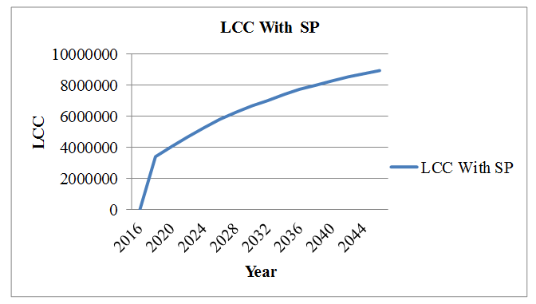
Figure1. LCC with solar power panels

2) LCC without solat plants
There is no recommendation of any energy saving technique & no additional investment for without energy efficient approach. Calculation has been done by taking Average Inflation rate as per consumer price index for future 30 years, average inflation rate as per Energy Index for future 30 years, Average Interest rate as per Reserve Bank of India for future 30 years. The values of C, R, S, A, M&E has taken Zero.

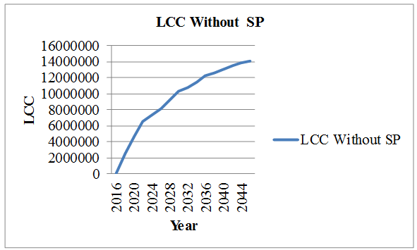
Figure2. LCC without solar power panels
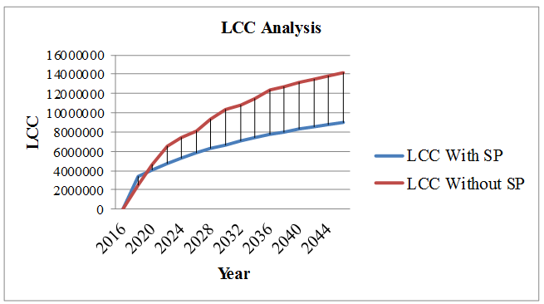
Figure 3. LCCA with & without solar power panels

- Benefit cost ratio:
The benefit cost ratio method of analysis is based on the ratio of the benefits to cost with a particular project. Benefit cost ratio calculated by dividing present value of benefit to the capital cost of installing Solar power plant. The higher the benefit cost ratio better the investment .Benefit cost ratio for without energy efficient approach has been taken Zero. Benefit /cost ratio for energy efficient approach=1.98, B/C ratio is more than 1 hence energy efficient approach is better investment.

Figure4. B/C Ratio

- Cumulative Cash Flow:
The total cost saved each year in other word it is called cash inflow. It is calculated from total cost (excluding C) of with solar power panels & without solar power panels. . It can be seen from the analysis that due to solar panels at site saving the energy bills can be achieved every year.
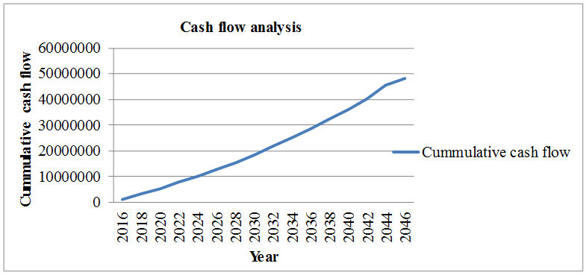
Figure5. Cumulative cash flow
CONCLUSION
- Technical analysis concludes the requirements of solar power plant on the construction site and its implementation.
- The Payback period of solar panels at site is 6.9 i.e 7 years.
- The B/C ratio obtained is 1.98 it is more than 1 hence solar power panel is better investment for the energy conservation at construction site during the construction activities for the equipments running on electricity.
Feasibility analysis of these project of implementing solar for construction activities is done and it is found that the project is technically and financially viable at particular construction sites , not all the construction sites and it is acceptable and economically justified. In the present case study the grid connected solar is proposed of 50kW which is used for the energy requirement by electrical equipments used on site for construction activities. After the construction phase the solar can be utilized at site for the operational phase and if the requirements are not fulfilled by 50kW solar then another solar of same or more capacity can be installed or remaining electricity can be obtained from MSEB.
Solar panels for construction activities is not feasible at every construction site but at some sites it is possible to achieve the benefits of solar where the space required for solar panels is available, where MSEB connections is not available particularly that sites which are situated at outskirts of city. Solar energy is an effective solution for the environmental pollution and also it has savings in the total cost of particular site. Solar initial investment is more but it has huge savings after the payback period as it is natural and renewable source of energy and requires less maintenance.
ACKNOWLEDGMENT
I hereby take this opportunity to express my profound thanks and deep sense of gratitude towards my guide Prof. Dr Deepa A. Joshi, Professor, Department of Civil Engineering for his valuable guidance, constant encouragement and supervision.
I would also like to thank Dr. R. S. Jahagirdar, Principal, Dr. Deepa A. Joshi, Head of the Department of Civil Engineering and the faculty of Department of Civil Engineering whose constant encouragement and expert guidance was instrumental in the completion of this paper. I would also like to thank Mr. Rahul Bhosale and Mr. Sameeer Shaikh, ARRA Solar Solutions for their cooperation.
Let me, at the end, express gratitude to all those from whom I received co-operation, help & motivation during the paper.

REFERENCES
- Arzuhan Burcu GULTEKĐN, Ciğdem Belgin DĐKMEN,-“Usage Of Renewable Energy Resources In Buildings in The Context Of Sustainability” Journal of Engineering Science and Design,Vol:1 No:3, 2011, pg. 96-100.
- Adolphe NDAYIRAGIJE,-“ Modelling Study of Energy Use on a Construction Site” (Reg. No. 200494711) Project Thesis, Sep 2006, pg.9.
- “The Impacts of Construction and the Built Environment”,VERSION 1 DEC 2010
- www.sol-solutions.com
- Berit Balfors, Kedar Uttam, Ulla Mörtberg-“ Promoting renewable energy in the construction sector using environmental impact assessment as a tool” Environmental Management and Assessment Research Group. World renewable energy congress 2011, Sweden, 8-11 May 2011.
- Nilima N. Kale, Deepa Joshi, Radhika Menon “ Life Cycle Cost analysis of Commercial Buildings with Energy Efficient Approach” Prespectives in science,Vol.8, 452-454, Sep 2016.
- Sieglinde Fuller , Life-Cycle Cost Analysis (LCCA), National Institute of Standards and Technology, 2010.
BOOKS
- Manual for preparing feasibility studies”, NICMAR Publications.
- “Financial Management”,Tata Mc Graw-Hill Publishing Company Ltd.,Delhi. Prasnna Chandra (2001).

