IoT-based Agriculture Pump Control

Vaibhav Milke¹, Prajwal Nannaware ², Palash Nohawar³, Adnesh Panchbhai ⁴, Sachin Jolhe ⁵

^{1,2,3,4}Final year Student,⁵Assistant Professor,
Electrical Engineering Department, Government College of Engineering, Nagpur, India, 441108

Received on: 21 April, 2023 Revised on: 18 May, 2023 Published on: 20 May, 2023

Abstract – In India, agricultural areas are crucial to the country's economic growth. Numerous issues are being faced by farmers. There is no 24-hour supply of electricity. Since the farm is far from his home, there is a need to provide an effective and dynamic control system for the motor. The automatic control allows monitoring the motor's working parameters from a distance, controlling it, and obtaining a response from the motor itself. The proposed work details a technology that uses smartphones to operate a water pump for farming. A microcontroller (such as an Arduino) and GSM SIM module can be used to ON and OFF an agricultural water pump. The issues experienced by Indian farmers are what inspired the concept for this proposed work. The goal is to use mobile SMS and missed calls to remotely control the motor while it is ON or OFF and to receive feedback. By determining the voltage of the source and ensuring system feedback whether it is over or under voltage, the safe operation of the motor is guaranteed. Once more, similar comments are received via SMS as well. In the event of any issues, such as SPP, dry run, or overheating, the motor will shut off automatically. Because there is a GSM network almost everywhere in our nation, it is decided to use it to control motors and send feedback data. The proposed work can also be used in the industrial sector, and this will make operating a motor and providing it with protection convenient and affordable.
Keywords-Smartphone, GSM model, Arduino, microcontroller, sequence phase protection (SPP), short message service (SMS)
I -INTRODUCTION
In India, approximately 58% of India's population relies mostly on agriculture for their livelihood. Indian agriculture has a long history that extends back to the Indus Valley Civilization. India is second in the world for agricultural output. In 2018, more than 50% of Indian workers were working in agriculture, which also made up 17–18% of the GDP. Agriculture is regarded as the basis of life for all living things since it is the only source of food granules and other organic elements and because it is so important to the expansion of a nation's riches. When it comes to this situation, new technologies are bringing computerized, continuous, and user-friendly capabilities for messaging programme [1].
Additionally, it offers the population numerous, ample employment alternatives. The development of the agriculture sector is essential for the improvement of the economic situation of the nation [2]. Unfortunately, the majority of farmers still use traditional irrigation techniques, which results in poor yields of food grains and other agricultural goods [2]. The yield has increased compared to the manual ways by using advanced automatic machinery and computerized irrigation systems [3].
Agriculture would not be possible without irrigation. It is noticed that irrigation plays a significant part in farming and that crop fields are typically positioned distant from the farmer's home. To get to their crop, farmers must travel long distances. The difficulties faced by farmers gave rise to the concept of this initiative. Since irrigation must be performed every day, regardless of the distance between the farm and the farmer's residence, the farmer must visit the crop fields every day to turn on the irrigation system and deliver water to the farms. This regular journey to the fields has two drawbacks: time and money wastage. As a result, working remotely is preferable to travelling.

It's that easy to operate an agricultural pump using GSM technology while at home by pressing a button on your smartphone. The proposed work is specifically made to operate remote pumps for farmers and agricultural businesses, where wireless pump and motor control is necessary to save time and money. An Arduino is used as the microcontroller for GSM-based mobile pump controller. The proposed work includes all the essential motor protection. When all three phases are available, the system is prepared. A microcontroller keeps track of the motor's overall condition and regulates the starter's activity depending on that information. The motor will start and provide feedback to the user when all the conditions are favorable.
The suggested solution seeks to advance irrigation through IOT and automation technologies. The standout features of the proposed system include GSM control of a water pump with or without internet access and notification of the water pump's status.
II - PROPOSED METHODOLOGY
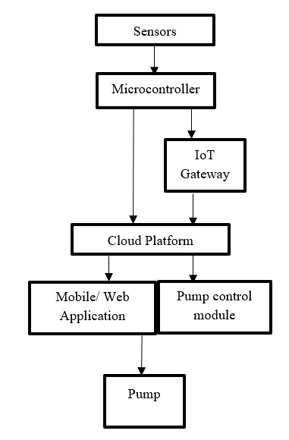
Fig. 1- Connection diagram of IoT-based Agriculture Pump Control
Figure 1 depicts the connection diagram for IoT-based agriculture pump control. Several sensors are utilized to gather information about agricultural characteristics.

Based on predefined algorithms or user-defined rules, the microcontroller/single-board computer receives sensor data, processes it, and controls the pump operation. IoT Gateway serves as a link between the internet and the microcontroller/single board computer. It makes it easier to move data from the gadget to the cloud platform. The IoT gateway sends sensor data to the cloud platform, which receives and saves it in a database. Additional services like data analysis, visualization, and remote monitoring/control may also be offered. Users can access the cloud platform via a mobile or web application to monitor real-time data, modify pump control parameters, get notifications, and carry out other relevant tasks. The pump Control Module supervises the functioning of the agricultural pump(s) in accordance with control commands received from the cloud platform or the mobile/web application. the actual pumps used in agricultural fields to irrigate crops or carry out other water-related chores.
(UART) or serial communication is used in the proposed topology. This is one of the simplest communication protocols between two devices. By connecting two wires—one serving as the transmission line and the other as the receiving line—between the devices, data can be sent between them. There are two different types of UARTs involved in this connection, including transmitting and receiving UARTs, and these two can explicitly communicate with one another. Other devices, such as a microcontroller, RAM, CPU, etc., can use a parallel data bus to complete the data transfer of a UART. Three bits, such as start, stops, and parity, are inserted into a data packet after it receives the parallel data from the bus. In order to remove the three bits from the data packet, it reads the data packet bit by bit and changes the obtained data into the parallel form.
III-SIMULATION OF PROPOSED METHODOLOGY
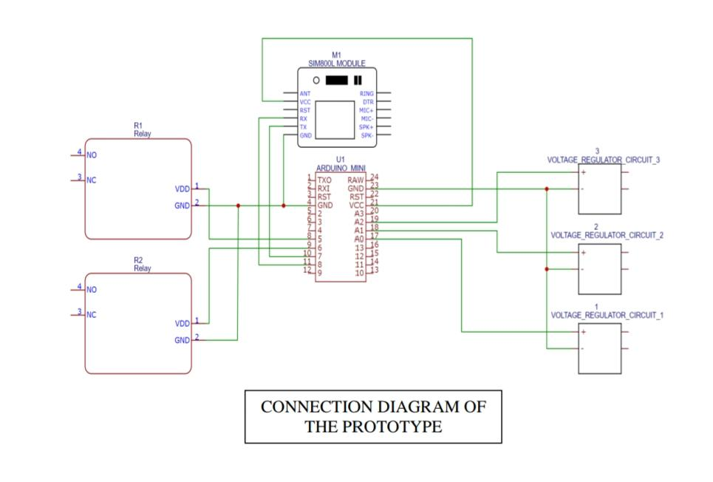
Fig.2. Simulated circuit of IoT-based Agriculture Pump Control

The controller represented by U1 in the Fig.2 is an ARDUINO MINI. SMS messages are received and sent using the SIM800L receiver and transmitter module. SPDT relays are shown by the relays (R1, R2) in the connection. The SIM800L module is connected to the ARDUINO MINI through pins number 7 and 8. Pin number 8 serves as the MINI's transmitter and is connected to the SIM800L's RX pin, which is used to send data to the SIM800L module, and pin number 7 serves as the controller's receiver and is connected to the SIM800L's TX pin, which serves as the SIM800L's receiver and will be receiving from the SIM800L module. Relay R1 is connected to pin 5 of the controller for on operation, whereas R2 is connected to pin 6 for off operation.
SMS-Controlled GSM motor is an automatic control system that can respond to a series of command instructions sent via short message service (SMS) and take the appropriate actions, such as starting, stopping, and controlling speed. In order to deliver the commands using SMS service in accordance with the necessary activities, a specific modem/mobile is utilized at the receiver module, or with the model itself. An intellectual device is known as the Microcontroller is interfaced with the GSM modem that is specifically designed for the motor driver so that it can read the received commands in the form of SMS from the mobile unit and carry out the corresponding predefined tasks, such as starting or stopping the motor.
The goal is to employ a basic message service to manage a 3-phase motor used for agricultural purposes. Single phasing, starter control, and other failure scenarios are all conditions that the circuit is prepared to manage. An SMS service receiver is required to run or activate the circuit. In this proposed work, the SIM800L GSM module is utilized. UART is used for communication between the transceiver (SIM800L) and the controller. The user must use their phone to press the ON button whenever they wish to utilize the pump. When a message is received by the SIM800L module, the message string is transmitted to pin number 7 of the controller, which serves as the controller module's or IC's receiver, via the SIM800L's UART transmitter pin, or TX pin.
The controller will read the supplied string and carry out the appropriate function. The system (controller) will not turn on the pump if the command is for the motor to be turned on, and a message will be sent through the

SIM800L module notifying the user of the fault via SMS. If the command is for the motor to be turned off, the controller will check for any system parameters, such as voltage supply, through the regulated power supply circuit. If the electrical system is sound and functioning properly, the controller will activate the starter's relay, turning on the motor while simultaneously sending an SMS to the user informing them of the motor's status. if the phone's OFF button is activated by the user. The SIM800L will receive the message and deliver it to the controller. The controller will then carry out the function according to the message, turning off the pump by activating the OFF relay and informing the user of the situation.
Depending on the system or device you are using, the SMS command for testing may change. A typical SMS command for testing, though, is "TEST" or "CHECK." To find the proper SMS command for testing, it is advised to refer to the documentation or user manual of your particular device or system.
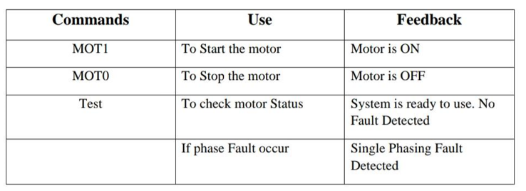
Fig.3. SMS commands for motor control
Send the instruction "START" or "ON" to the specified phone number or device connected to the motor in order to start it via SMS commands. Send "STOP" or "OFF" to the same chosen phone number or device to turn the motor off using SMS commands.
As a convenient and distant way to start, halt, or execute other actions on a motor via a mobile phone or SMS-capable device, SMS commands shown in Fig.3 play an important role in motor control. With the use of this capability, users can operate motors remotely without having to physically interact with them or have access to the motor itself. As long as a user has a mobile phone with SMS capability and access to a cellular network, they can operate motors from any location. When being close to the motor is difficult, dangerous, or unfeasible, this remote-control function is especially useful. Users can control motors without physically being there in a variety of settings or locations. Since, the majority of people have mobile phones with them at all times, using

SMS commands for motor control is convenient and available. Since people can send commands using their own mobile devices, which they are already accustomed to using, SMS commands provide a straightforward and intuitive user interface for motor control. This user-friendliness encourages accessibility and makes the control procedure simpler. In general, SMS instructions offer a versatile, open, and remote way for motor control, allowing users to conveniently control and monitor motors from a distance. They can be used in automation systems and provide real-time control, integration options, and defect detection, all of which improve operational effectiveness and motor functionality.
IV- CONCLUSION
The project is capable of producing the intended results because it was developed utilizing structured modelling. With a few adjustments, it can be successfully implemented as a Real-Time system. As technology continues to advance, numerous discoveries have sparked revolutions and innovations across a wide range of industries. Additionally, the majority of the units can be produced using a single piece of hardware and a microprocessor, packing the system tightly to boost productivity. Implementing components with a wider range will enable the system to be used for real-time applications. The prototype that was created adheres to the requirements and serves the intended purpose. It successfully passed every test and produced the desired outcome based on the various input parameters. Finally, this study will have a wonderful possibility to further develop the concepts and ideas for usage in the future thanks to the continued development in technologies, particularly IoT devices.
REFERENCES
- Joaquín Gutiérrez, Juan Francisco Villa-Medina, Alejandra Nieto-Garibay, and Miguel Ángel Porta-Gándara, “Automated Irrigation System Using a Wireless Sensor Network and GPRS Module”, IEEE TRANSACTIONS ON INSTRUMENTATION AND MEASUREMENT, 0018-9456,2013.
- Dr. V. Vidya Devi, G. Meena Kumari, “Real-Time Automation and Monitoring System for Modernized Agriculture”, International Journal of Review and Research in Applied Sciences and Engineering (IJRRASE) Vol3 No.1. PP 7-12, 2013.
- Y. Kim, R. Evans and W. Iversen, “Remote Sensing and Control of an Irrigation System Using a Distributed Wireless Sensor Network”, IEEE Transactions on Instrumentation and Measurement, pp. 1379–1387, 2008.

- S. R. Nandurkar, V. R. Thool, R. C. Thool, “Design and Development of Precision Agriculture System Using Wireless Sensor Network”, IEEE International Conference on Automation, Control, Energy and Systems (ACES), 2014.
- Arampatzis, T.; Lygeros, J.; Manesis, S. A survey of applications of wireless sensors and Wireless Sensor Networks. In 2005 IEEE International Symposium on Intelligent Control & 13th Mediterranean Conference on Control and Automation. Limassol, Cyprus, 2005, 1-2, 719-724.
- Q. Wang, A. Terzis and A. Szalay, “A Novel Soil Measuring Wireless Sensor Network”, IEEE Transactions on Instrumentation and Measurement, pp. 412–415, 2010.
- Prima E C, Munifaha SS, Salam R, Aziz M H and Suryani A T 2016 Automatic water tank filling system controlled using Arduino based sensor for home application Engineering Physics Int. Conf. 2016 vol 170 pp 373-7.
- Verma P, Kumar A, Rathod N, Jain P, Mallikarjun S, Subramanian R, Amrutur B, Kumar M M and Sundaresan R 2015 Towards an IoT based water management system for a campus Smart Cities Conf. (ISC2) 2015 IEEE First Int. pp 1-6.
- Kim S and Kim H 2011 Systematic optimal design of overlapped ultrasonic sensor ring for high-performance obstacle detection Proc. 15th Int. Conf. on Advanced Robotics pp 600-5.
- Batten J J 2018 Realizing a more sustainable water future from a one water view J. – American Water Works Assoc.
- Ebere E V and Francisca OO 2013 Microcontroller based automatic water level control system Int. J. of Innov. Res. in Comp. and Communication Eng. vol 1 no 6

