Android Phone Speech Recognition Notice Display

Mahendra S. Dandekar¹, Vishakha Dhakare², Priyanka S. Sonar³, Shafique Ansari⁴, Mahesh N. Patil ⁵

^{1,2,3,} B.E. Students, ^{4,5} Asstt. Prof.
^{1,2,3,4,5} Electronics and Telecommunication Engineering, GF’s GCOE jalgaon-425003, India.
¹ dmahendra92@gmail.com

Abstract – Today notice board has become an important thing in institutes/organization or public places like railway stations, bus stands and hospitals. But to use the paper notices stick on a notice board is a time taking and expensive process and there is wastage lot of time, paper and labour. The Notice board is used to display the information in an effective way to the people, but to update the messages instantly is not easy on the notice board. In this project deals about an advanced Hi-Tech wireless Notice Board. This system is enhanced to display the latest information through an Android application of smart phones or tablet.
Main concept behind Voice operated Electronic notice board using display is to show messages. We have already seen GSM based Electronic Notice board, however speech controlled Notice board has additional advantage of ease of use. User has to give voice command in his/her own voice messages displayed on electronic notice board. Voice recognition is done in the Android application. User has to install this Android application in his/her smart phone or tablet.
Wi-Fi technology is a popular technique in the communication arena, and it is one of the fastest growing fields in the wireless technologies. this technology handles the wireless part of the communication channel; it is used in this project to transmit and receive data wirelessly between devices.

Keywords: Android phone, speech recognition, notice display

- INTRODUCTION

The era of mobile technology opens the windows to the android app. The websites are disappearing and the mobile phones are prominent. It’s the time to change from conventional websites and other things to apps, which has become the part of our daily routine. we are introducing “Voice Totextapk” the android application

software which would convert the voice to text. It works on all android platforms, but also it can work with a working internet. Our multipurpose program is considering the user as an Albertan or non-Albertan, student or parent, faculties or office staffs individually. Project gives a total solution to everyone. It gives us more comfort and a better user interface later on Students can interact with Google directly. Latest news and updates is got through the application.
We come across situations where we need to urgently need to display notices on a screen. For areas like railway stations and other such busy facilities the station master/announcer need not have to type in every announcement message manually on the screen. So here we offer an innovative Android based notice display system which allows the user to display the notice without typing manually. Here the announcer/administrator may speak out the message through his/her android phone, the message is then transferred wirelessly and displayed on the screen. To demonstrate this concept we here use an LCD screen to display messages. The LCD is interfaced with an ESP8266 microcontroller. We use a WI-FI to receive Android-transmitted messages, send them to the microcontroller for decode and further into the process. The microcontroller then displays the message on the LCD screen. Use of this notice board system can be used in various places including railway stations, schools, colleges, offices to display emergency announcements on screen instantly, instead of typing the message at all times. So that voice based notice board project is very useful in different organizations.

- LITERATURE SURVEY
R. G. Gupta et al. in his paper basically focused on designing an electronic notice board for different sectors like schools [1]. The notice can be send wirelessly within a second. This creative technique can be used to display latest information. The contents of notice can be changed anytime. This concept is designed to design an SMS based automated display board that can replace the current usable programmable electronic display. Abhishek Gupta et al. the main objective of this paper is to develop a wireless notice board that displays message sent from the user and to design a simple, easy to install, User friendly systems, which can display notice about information and time in a particular way, so that the user can help keep track of the information board easily every day and every time he uses the system. Ramchandra K. Gurav et al. in this paper it is focused on GSM (Global System for Mobile) technology to design a digital notice board, “Wireless Notice Board using GSM System” is wireless module which send message wirelessly with the help of GSM module. This means that users or registered persons may be able to send messages from anywhere and this message is displayed on the LCD display [3-5].

2.1 Problem Statement
Disabled people are more likely to be exposed to daily life problems than other healthy people. While deaf people cannot hear the door bell, Alzheimer diseased people can forget the gas open in the kitchen. These are some encountered examples when they 4 are alone at home. With the help of technology, assistant projects can be developed to overcome their difficulties. Smart homes can also be used to support disabled people, providing safe, secure and empowering environments. The system can allow the user to control many features or automate them. The environment canalso be monitored by the smart home system to ensure safety and alert people when there is some dangerous situation.
2.2 Proposed Method/System
-
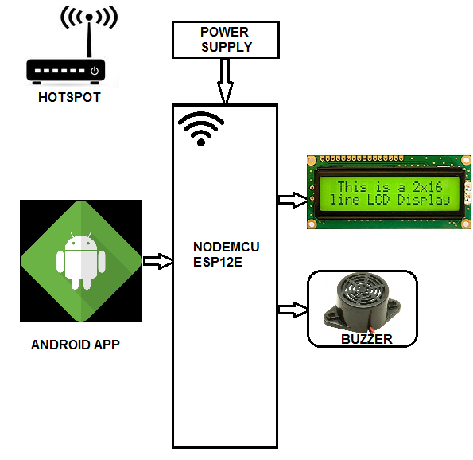
Figure 1. Block diagram
The main objective of the project is to develop a wireless notice board that displays notices when a message is sent from the users mobile. While the user sends the message from the mobile, the remote operation is achieved by any smart-phone/Tablet etc., with Android OS, upon a GUI (Graphical User Interface) based voice operation. Transmitting end uses an Android application device remote through which commands are transmitted. At the receiver end, these commands are converted to texts used which are displayed on a 20X4 LCD - interfaced to the microcontroller. Serial communication data sent from the Android application is received by a Bluetooth receiver interfaced to the microcontroller.
The program on the microcontroller refers to the serial data to display the received data on an 20X4 LCD.
The power supply consists of a step-down transformer 230/12V, which steps down the voltage to 12V AC. This is converted to DC using a Bridge rectifier. The ripples are removed using a capacitive filter and it is then regulated to +5V using a voltage regulator 7805, which is required for the operation of the microcontroller and other components.

3. METHODOLOGY
We are LCD display 2x16 line, ESP12E microcontroller, buzzer, android app, transformer,
We gives electronic signal to transformer it convert it in to predefined voltage then the signal is provide to ESP12E which is microcontroller with embedded wi-fi module then farther signal is provided to buzzer and LCD display
3.1 System Hardware
MICROCONTROLLER ESP-12E:-
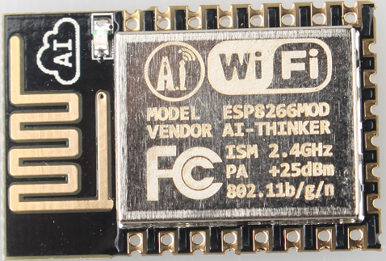
ESP-12E is a low power consumption of the UART-Wi-Fi module, with very competitive prices in the industry and ultra-low power consumption technology, designed specifically for mobile devices and IOT applications, user's physical device can be connected to a Wi-Fi wireless network, Internet or intranet communication and networking capabilities.

Figure 2. Wi-Fi module

ESP-07 the use of small ceramic antenna package can support IPEX interface. Users have a variety of installation options.

Features:-
- 802.11 b/g/n protocol
- Wi-Fi Direct (P2P), soft-AP
- Integrated TCP/IP protocol stack
- +19.5dBm output power in 802.11b mode
- Power down leakage current of < 10uA
- Integrated low power 32-bit MCU
- SDIO 2.0, SPI, UART
- STBC, 1x1 MIMO, 2x1 MIMO
- A-MPDU & A-MSDU aggregation & 0.4μs guard interval
- Wake up and transmit packets in < 2ms
- Standby power consumption of < 1.0mW (DTIM3)

Applications:-
- Smart power plugsFig. ESP-12E
- Home automation
- Mesh network
- Industrial wireless control
- Baby monitors
- IP Cameras
- Sensor networks
- Wi-Fi location-aware devices
- Security ID tags
- Wi-Fi position system beacons

3.2 System Software
ARDUINO IDE:-

Arduino is an open-source platform used for building electronics projects. Arduino consists of both a physical programmable circuit board (often referred to as a microcontroller) and a piece of software, or IDE (Integrated Development Environment) that runs on our computer, used to write and upload computer code to the physical board. Fig. ARDUINO IDE
The Arduino platform has become quite popular with people just starting out with electronics, and for good reason. Unlike most previous programmable circuit boards, the Arduino does not need a separate piece of hardware (called a programmer) in order to load new code onto the board we can simply use a USB cable. Additionally, the Arduino IDE uses a simplified version of C++, making it easier to learn to program. Finally, Arduino provides a standard form factor that breaks out the functions of the micro-controller into a more accessible package.
The Arduino hardware and software was designed for artists, designers, hobbyists, hackers, newbies, and anyone interested in creating interactive objects or environments. Arduino can interact with buttons, LEDs, motors, speakers, GPS units, cameras, the internet, and even our smart-phone or our TV! This flexibility combined with the fact that the Arduino software is free, the hardware boards are pretty cheap, and both the software and hardware are easy to learn has led to a large
community of users who have contributed code and released instructions for a huge variety of Arduino-based projects.
Recently, arduino is compatible for almost all AVR microcontrollers. For programming ESP8266 (32 bit microcontroller with embedded WI-FI) just need to update the existing arduino IDE, it installs the additional boards as nodemcu. Rest of the commands and programming method is same as we did with UNO.

Android App
An Android app is a software application running on the Android platform. Because the Android platform is built for mobile devices, a typical Android app is designed for a smartphone or a tablet PC running on the Android OS.
Although an Android app can be made available by developers through their websites, most Android apps are uploaded and published on the Android Market, an online store dedicated to these applications. The Android Market features both free and priced apps. Android apps are written in the Java programming language and use Java core libraries. They are first compiled to Dalvik executables to run on the Dalvik virtual machine, which is a virtualmachine specially designed for mobile devices.Developers may download the Android software development kit (SDK) from the Android website. The SDK includes tools, sample code and relevant documents for creating Android apps. Novice developers who simply want to play around with Android programming can make use of the App Inventor. Using this online application, a user can construct an Android app as if putting together pieces of a puzzle.
4, RESULT AND DISCUSSION
The system is working efficiently. There is no error occurred in system. Figure 3 shows our implemented system is run as per the requirement.

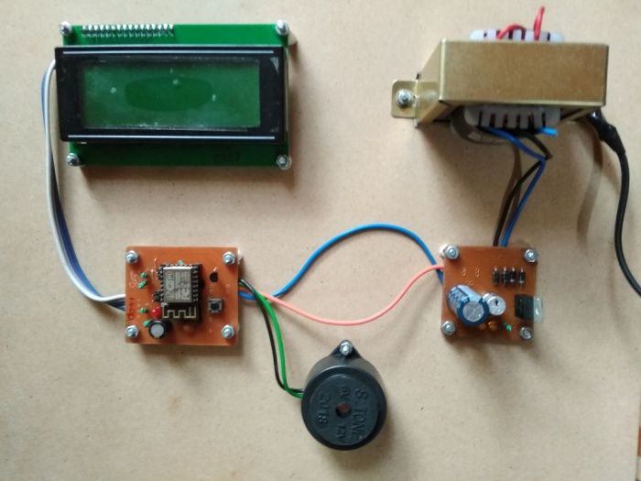
Fig. 3. Our developed system
4. CONCLUSION
By introducing the concept of this technology in the Field of the communication we can make our communication more efficient and faster, with greater efficiency. We can display the messages with less errors and maintenance. This system can be used in college, school, offices, railway station and commercial as well as personal used. The above technical paper explains how we can develop as well as modify voice control Android based wireless notice board.

It is easy to use and easy to install. • Speech controlled rolling display is really helpful for disabled people or handicapped people. • It is a part of iot.

REFERENCES
[1] Jonathan Simon,-Head First Android Development, Published by O’Reilly Media, Inc., 1005 Gravenstein Highway North, Sebastopol, 2011.
[2] Abbey Deitel, Harvey Deitel, Paul Deitel, Android™ How to Program, Second Edition, PrenticeHall, Release Date: January 2014.
[3] Prof. R. G. Gupta, Nawale Shubhangi, TupeUsha, Waghmare Priyanka. Android based E-notice board. International Journal of Advance Research and Innovative Ideas in Education (IJARIIE). 2016
[4] Abhishek Gupta, Rani Borkar, SamitaGawas, Sarang Joshi. GSM based wireless notice board. International Journal of Technical Research and Applications. 2016;
[5] Mr. Ramchandra K. Gurav, Mr. RohitJagtap. Wireless digital notice board using GSM technology. International Research Journal of Engineering and Technology (IRJET) 2015.

