Generation of electricity through refrigerator using conventional energy source as LPG
Ritik S. Sonkamble , Ankit Bobade , Shiv Goswami , Pratik Shingane , Badal Bawankule,
Sujata Barai , Roshan Babulkar
Nagpur institute of technology, India, 441501

Received on: xxxx,20xx, Revised on: xxxx,20xx, Published on: xxxx,20xx

Abstract – P Ongoing electricity supply is not yet available in several parts of the country and the world. In such areas, the project will assist in the installation of refrigerators for food, medicine, etc ... comprising 24.4% propane, 56.4% butane and 17.2% isobutene varying from company to company is used as a refrigerator. LPG is cheap and environmentally friendly with no Ozone Depletion Potential (ODP) and no Global Warming Potential (GDP). It is used worldwide for cooking purposes. The refrigerator used in the current study is designed to work in LPG. Performance parameters are the effect of the refrigerator over a period of time. The refrigerator worked well when the LPG was used as a refrigerator instead of R134a. And from the tests performed on the atmosphere, we can predict the total amount of cooling effect on the optimal operating condition of the control valve and the capillary tube of the system. The use of LPG for the purpose of refrigeration may be environmentally friendly as it has no depletion of ozone depletion (ODP).
Keywords-evaporator, Joule Circuit, Peltier module, High Pressure Pipe, Evaporator, Pressure Gauge, Burner system, Capillary Tube, LPG Cylinder.
INTRODUCTION
Introduction Home refrigerators use about 17,500 metric tons of traditional refrigerators such as chlorofluorocarbon (CFC) and hydrofluorocarbon (HFC) annually contributing to the depletion of the ozone layer energy (ODP) and global warming (GWP). There they are the most remote parts of India where there is no electricity available, which is why LPG as a refrigerator can be another better way. Although government agencies cannot progressively supply a large portion of electricity to both cities as and in rural areas. Yet the

people of these regions need it refrigerator for various purposes related to the community as a cold storage or storage for medical and home items kitchens this project is a new novel to use LPG instead refrigerator electricity. This solution is ready refrigerators in areas with electric shocks. It works with the goal that during the transition of the LPG into gas form, LPG expansion occurs. Because of this expansion is a decrease in pressure and an increase in the volume of LPG leading to temperature drop and a refrigeration effect is produced. This refrigerator effect can used for cooling purposes. Therefore, this function provides refrigerator for social needs and exchange refrigerators for global warming. While passing book review of LPG refrigerator system, Conventional VCR (Vapor Compression Refrigeration System) uses the LPG as a refrigerator and produces freezing effect. But in our proposed version it is much simpler refrigeration system where high-pressure LPG is present passing through the capillary tube and increasing. After the extension of the LPG section is changed and converted from the liquid goes to the gas and passes through the evaporator when it retains heat and produces a refrigerator the result. After the evaporator passes through the gas heater where it burns. Gas heating produces heat and heat will use the pelton module which will help us to convert heat energy into electrical energy without using the moving part.

CONCEPT
THE PELTIER EFFECT
Thermoelectric coolers operate according to the Peltier effect. The effect creates a temperature difference by transferring heat between two electrical junctions. A voltage is applied across joined conductors to create an electric current. When the current flows through the junctions of the two conductors, heat is removed at one junction and cooling occurs. Heat is deposited at the other junction.The main application of the Peltier effect is cooling. However the Peltier effect can also be used for heating or control of temperature. In every case, a DC voltage is required.
JOULE’S THIEF CIRCUIT
The Joule Thief Circuit is a voltage booster circuit which converts a constant low voltage input into a periodic output of a higher voltage. This circuit can be most often seen lighting an LED with an almost dead AA battery. The peaks in voltage occur rapidly, causing the LED to flash at a very fast rate. However, the LED appears to be constantly lit to the human eye due to the persistence effect.
PARTS USED
LPG CYLINDER:
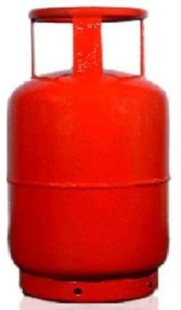
LPG is a mixture of butane and isobutene. It is usually housed in a 12.7 bar cylinder intended to hold the house. Through the appropriate control the LPG is sent to the capillary tube. LPG is used as fuel for domestic, industrial, agricultural, agricultural, cooking, heating and drying processes. LPG can be used as automotive fuel or as an aerosol propellant, in addition to other professional applications LPG can be used to provide light by using pressure lights.

CAPILLARY TUBE:
Capillary tube is a commonly used device in the home refrigerator. The capillary tube is a copper tube with a very small inner diameter. It is too long and is twisted into a few curves to take up little space. The internal diameter of the capillary tube used for refrigeration applications varies from 0.5 to 2.28 mm (0.020 to 0.09 inches). The capillary tube is shown in the picture. The reduction of refrigeration pressure through capillary depends on capillary width and capillary length. The smaller the width and the longer the capillary length the more the refrigeration pressure decreases as it passes through the capillary tube.
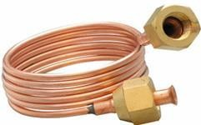

EVAPORATOR:
Evaporators are another important part of refrigeration systems. By using evaporators the cooling effect is produced in the refrigerator system. It is in the evaporators that the real cooling effect takes place in the refrigerator systems. For many people the evaporator is a major part of the refrigeration system, see the other part as a little useful. Evaporators are heat exchangers that transfer heat to an object to cool it in the refrigerator, thus removing heat from the object.
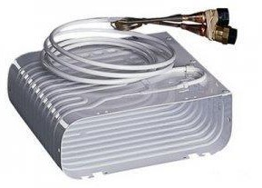
PRESSURE GUAGES:
Many pressure gauges and vacuum systems have been developed. The instruments used to measure pressure are called pressure gauges or vacuum gauges.
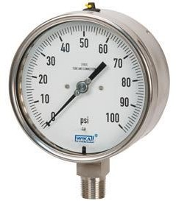

HIGH PROFESSIONAL PIPES:
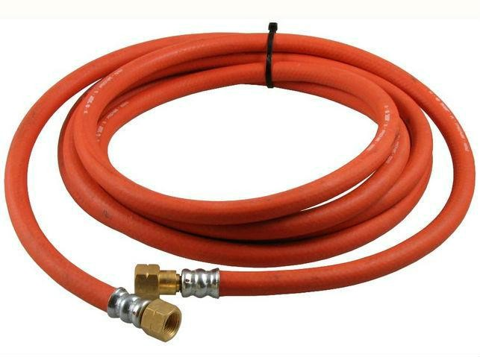
The list of high pressure pipes includes many uses where there is a need to transfer gas at high pressure. They include a steel pipe with a steel ball attached to both ends. Two moving connecting nodes press these balls against the housing of the connecting hole and close against the gas leak. All pipes were tested for pressure to reach 100 M Pa (14,500 psi) above the recommended operating pressure.
HIGH PRESS RULE:
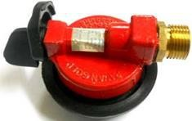
This type of controller is used to send high pressure gas from the cylinders. These are widely used in the operation of Bhatti stoves.

JOULE'S SUPPORTED
The Joule Thief Circuit is a voltage booster circuit that converts low voltage inputs to occasional outputs for high voltage. This cycle can be seen repeatedly lighting an LED with an AA battery that is almost dead. Voltage peaks occur rapidly, enabling the LED to flash at rapid speeds. However, the LED seems to always shine in the human eye due to the persistence effect.
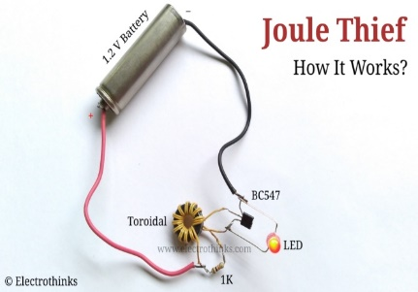

PELTIER MODULE
Thermoelectric coolers work in accordance with the Peltier effect. The result creates a temperature difference by transferring heat between two electrical outlets. A voltage is applied to all connected conductors to generate electrical power. When a current flows at a junction of two conductors, the heat is removed from one place and then cooled. Heat is applied to another junction.
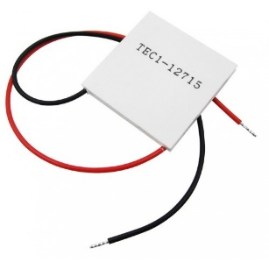

WORKING

WORKING
The basic idea behind LPG refrigerator is to use LPG to absorb heat. An easy way to operate an LPG refrigerator is shown in the image below.
➢ The LPG is stored in the LPG cylinder under high pressure. When the control tank gas is opened then the high pressure LPG passes through the high pressure pipe. This LPG runs through a high-pressure gas pipeline to capillary tubes.
➢ High LPG pressure is converted to low pressure in the capillary tubes and the enthalpy remains unchanged.
➢ After the capillary tube, the low pressure LPG passes through the evaporator. The LPG is converted into low pressure and high humidity and transmits heat that absorbs heat into the room. That way the room cools down. So we can achieve the cooling effect in the fridge.
➢ After passing through the evaporator the low pressure of the LPG is transferred through a pipe to the burner. And we can use low pressure LPG in flammable processes.
The LPG refrigerator works on a simple Vapor Compression Refrigeration system. The functionality of the VCR system is as follows:
Procedure 2-3: When the compressor is started, it pulls the lower vapor from the evaporator to state 2 and presses it intropically to a level high enough to press 3. As the pressure work is carried out on vapor, its temperature rises. And that is why it is converted into adiabatically low pressure ie enthalpy lasts.
Behind the capillary tube, this low-pressure LPG is passed through an evaporator. In the evaporator the LPG is converted into low pressure and heat form that absorbs heat from the cooling chamber. So the cooling room cools down.
Process 3-4: The hot vapor that comes out of the compressor under pressure is released into the berry where the cooling area of ​​the condenser is usually water or the surrounding air absorbs heat from the hot tub. This converts the hot vapor into a liquid and the liquid is collected from the liquid receiver in case 4.
Procedure 4-1: The liquid from the liquid receiver at high pressure is then piped to a refrigerator control valve that controls the flow of fluid to the evaporator. This control valve, while preventing the flow, also reduces the liquid pressure resulting in the conversion of the liquid into the vapor of the dry part represented by condition 1. During this process the temperature of the refrigerator decreases corresponding to its pressure.
Procedure 1-2: Finally, low-temperature, low-temperature refrigerator passes the steaming coil when it absorbs its subtle heat in a cold room or brine mixture with constant pressure and converts it into steam in 2nd condition. It is also supplied to the compressor. Thus, the cycle ends.
The concept of LPG refrigerator is to absorb the surrounding heat through the evaporation of LPG. The pressure of the LPG stored in the cylinder is about 80 psi. We reduce this LPG pressure to 15 psi by using capillary again so that cooling is done in the environment by absorbing natural heat.
The pressure of the LPG cylinder is high, when the gas tank controller is opened and the high pressure LPG passes through the gas pipe. After that this high pressure LPG enters the capillary pipe from the high pressure pipe. In the capillary tube this high LPG pressure is converted to lower pressure and thus lower temperatures due to the increase of LPG gas in the capillary tube.
So we can get the freezing effect in the fridge. After that the low pressure LPG from the evaporator is transferred to the burner using a high pressure pipe and we can use this low pressure LPG to heat it for reuse.
After receiving the burning effect from the burner we will use the peltier module which will help us to convert heat energy into electrical power .The module is able to save costs up to a certain point, therefore, increasing the output, the circuit is called the joule thief. Circuits are used as capacitors. There we can use it for extra use. In this project we are using a repressed LPG cylinder instead of a compressor. In this way we can achieve the freezing effect from this program.

BLOCK DIAGRAM
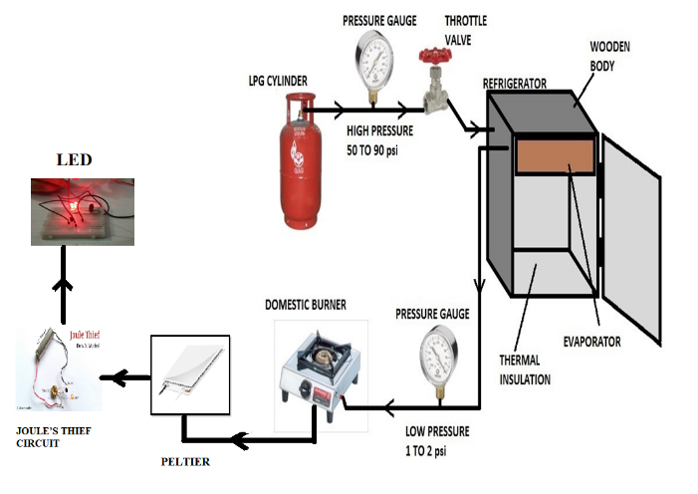
Fig. 1- block diagram of the project.

COP CALCULATION
Coefficient of performance = Desired output / Input
= Refrigeration effect / work done
COP in terms of heat = Q2 / Q1-Q2
Where,
Q2 – Amount of heat absorbed
Q1 – Amount of heat released
COP in terms of temperature = T2 / T1-T2
Where,
T2 - Temperature inside refrigerator
T1 – Room temperature
CONCLUSION
The purpose of the LPG refrigerator was to use the LPG as a refrigerator and to use the high pressure forces waiting for us to produce the refrigerator effect. We have an LPG at a pressure of 12.41 bar at a 14.5 kg home cylinder with high pressure control and this pressure dropped to bar 1.41 with the help of a capillary tube. But if we use a low pressure controller as is customary in a standard LPG gas stove, the LPG pressure after the expansion device and before the temperature is different. We therefore calculated the effect of freezing with the help of LPG structural changes (pressure, temperature, and enthalpy) before and after evaporator using a high pressure controller and the amount of the freezing effect effect is determined. With this installation the COP LPG refrigerator is 5.08 and larger than the home refrigerator. But in the future the result may be different if the power input in 1Kg of LPG production, can be taken from the energy test report of any filter. This program is cheaper in the beginning and in the cost of use. It does not require external power sources to operate the system and no moving part of the system. So maintenance costs are also very low. This program is most suitable for hotels, factories, refineries, chemical industries where LPG usage is very high.
REFERENCES
- Zainal Zakaria and Zulaikha Shahrun “The possibility of using liquefied petroleum gas in domestic refrigeration system” International Journal of Research and Reviews in Applied Science (IJRRAS),December 2011, Volume9
- Vishwadipsingh J. Ghariya and Swastik R. Gajjar “International Journal for Scientific Research and Development” ISSN (online): 2321-0613, March 2014, Vol.2
- Ibrahim Hussain Shah and Kundan Gupta “International Journal of Engineering Sciences and Research Technology” ISSN: 2277-9655, July 2014, Vol. 3(206- 213).
- Khandare R. S. and Bhane A. B “International Journal of[4] Emerging Technology and Advanced Engineering” ISSN: 2250-2459, March 2015, Volume 5.
- A Textbook of Refrigeration and Air Conditioning by R.S. Khurmi, S. Chand Publication.
- “PCRA energy audit report”, HPCL LPG bottling plant Asauda Bahadurgarh (Haryana) Dec. 2006.
- “Basic statics on Indian petroleum and natural gas” 2006-07.
- Shank K. Wang, “Handbook of air conditioning and refrigeration” page no. 11.14 chapter 11.
- S. J. Cleg, “Thermodynamic analysis of LPG as refrigerant for industrial refrigeration and transportation”, Institute of Transport Studies, University of Leeds, Working paper of 471, 1996.
- Dr. Iqbal Husain, “Analysis of VCR and VAR systems using organic refrigerants”, CRC press,Taylor and Francis Group, USA, 2012
- Text book of refrigeration and air conditioning by Arora and Domkundwar.
- Catalogue of Gas Authority of India on “Properties of combustible gases for industrial purpose

