The Application for Warehouse Management
Systems

Pranali Suryawanshi¹, Rinal Mahajan², Payal Borkar³, Latesh Bhope⁴ Prof. Roshan Kolte⁵
^{,5}Assistant Professor, KDKCE, Nagpur, India, 440009

Abstract –Warehouse Management System is the answer to reducing inventory cost and improving degree of customer satisfaction [5]. Warehouse Management is important for the development of firms [3]. A good warehouse management system can enable firms to operate solid foundation. Now-a-days companies are making efforts on warehouse inventory management enhancement in order to deliver products and services to their customers rapidly at low cost [1]. The purpose of this paper is to showcase the management of warehouse inventories based on Enterprise Resource Planning [1].
Keywords- Warehouse Management; Enterprise Resource Planning; Inventory Management.
INTRODUCTION
In general, inventory management and warehouse activity management are called by a joint name of Warehouse Management System which is the core of enterprise’s logistic managements[5]. Using computer in daily management of the warehouse is an inevitable trend. The content of warehouse management is important to the decision makers and managers of the firms, and it is an integral part of the firms[3]. A well-designed warehouse management system can reduce the cost that is spent on warehouse management and reduce the burden on warehouse managers.
Warehouse inventories are work-in-progress goods, finished goods, raw materials that an organization aim to sale and gain profit[1]. It is the best assets that any company value; if warehouse inventory is controlled and monitored in a good way it can add value to the organization .Warehouse Inventory management is a consistent means of running the organization operations smoothly while ensuring that customers are satisfied goods are delivered on-time and manage restocking of goods[2].
The warehouse management system is an implementation tool for managing the staff, inventory, working hours, orders and equipment within the warehouse. The term “warehouse” includes various types of storage warehouses and distribution centers in the field of production and supply.
TECHNOLOGIES USED
1. ASP.Net-
ASP.Net is the successor of Microsoft ASP (Active Server Pages), but it is developed to be more powerful than ASP. It can be used to build dynamic websites and web based distributed applications, respond to data submitted by the user from the HTML form, and access to the data or database, then return the results to the browser. ASP.NET is a development platform provided by .NET Framework and features a completely object-oriented programming model, which includes an event-driven, control-based architecture that encourages code encapsulation and reuse. When coding ASP.NET applications, programmers have access to classes in the .NET Framework. ASP.NET consumes very large in terms of memory usage and execution time, due in a long code path. For web-based applications, these limitations would be a serious problem, because on the web, application may be extended to thousands of users per second. Memory usage may also become a problem on the Web server. On the other side, obviously the advantages of ASP.NET depend on its simple design and implementation. This is the dream of object-oriented programming: Language flexible and support to complex object-oriented features. In this sense, it could be able to interoperate with the existing skills of programmer
2. SQL 2008 Server Database –
Microsoft SQL Server is a database management and analysis system for e-commerce, line-of-business, and data warehousing solutions, it is a powerful and easy-to-operate back-end database management system, increasingly favored by the majority of database users. More and more development tools are provided with SQL Server interface. SQL Server is a relational database management system, originally developed by three companies, Microsoft, Sybase and Ashton-Tate jointly. The first version was OS/2, launched in 1988. After the release of Windows NT, Microsoft and Sybase SQL Server developers parted ways, Microsoft moved SQL Server to Windows NT system, and focused on the development and promotion of SQL Server Windows NT version. SQL Server cannot only be applied to small and medium-sized database management and the establishment of a distributed relational database, but also to develop a desktop database. In fact, the basic structure of the SQL Server database processing uses relational database model. SQL Server Enterprise Manager is a key management tool for SQL Server, and complies with the MMC standard user interface, allowing users to define the instance of SQL Server group. The SQL Server also supports functions like registering individual servers the group, configuring all SQL Server options for each registered server, creating and managing all SQL Server database objects, log-ins, users and permissions in for each registered server, and defining and executing all SQL Server administrative tasks on each registered server.
SYSTEM ANALYSIS
Storage management has a series of characteristics as various functions, complex operation and a high degree of automation and intellectualization. The main business process of this system, which supports the whole warehouse operation, are stocking in, stocking out and sorting.
Stocking in Process
The inventory monitor module monitors commodity automatically and continuously. Making the replenishment plan in accordance with the replenishment strategy, then it suggest supplier to complement a certain quantity of commodity which is in short supply.
Stocking out Process
Stocking out management module receives the delivery order which is generated by the storage scheduling centre, then appoints the storage position of commodity according to the established principle, guiding the workers carry on the operation of fetching commodity from the temporary storage area, selecting commodity from the shelves and inspecting commodity.
Warehouse Management
This module manages warehouse basic information, inventory utilization ratio and other interrelated warehouse information, to achieve visualization management. Warehouse Manager directs or performs all activities related to maintaining a successful database environment. Responsibilities include designing, implementing, and maintaining the database system; establishing policies and procedures pertaining to the management, security, maintenance, and use of the database management system.
Inventory Management
Inventory control is also about knowing where all your stock is and ensuring everything is accounted for at any given time. Inventory control involves keeping track of the stock that is already in the warehouse, such as what products are being stocked and how much of a particular item is available. It also involves aspects of warehousing designs, such as knowing where everything is and ensuring that the products are stored well.
Location Management
Creating, modifying, deleting, querying the records of location and examining detail information are supported in this module.
SYSTEM ARCHITECTURE
Figure 1 describes system architecture and its detailed working procedure. The front end system provides a graphical user interface (GUI) in the Form of website where managers of the system interact with the application whereas the backend Consists of sqlserver database in order to extract product information from warehouse system. The extracted information of products is stored in SqlServer database.

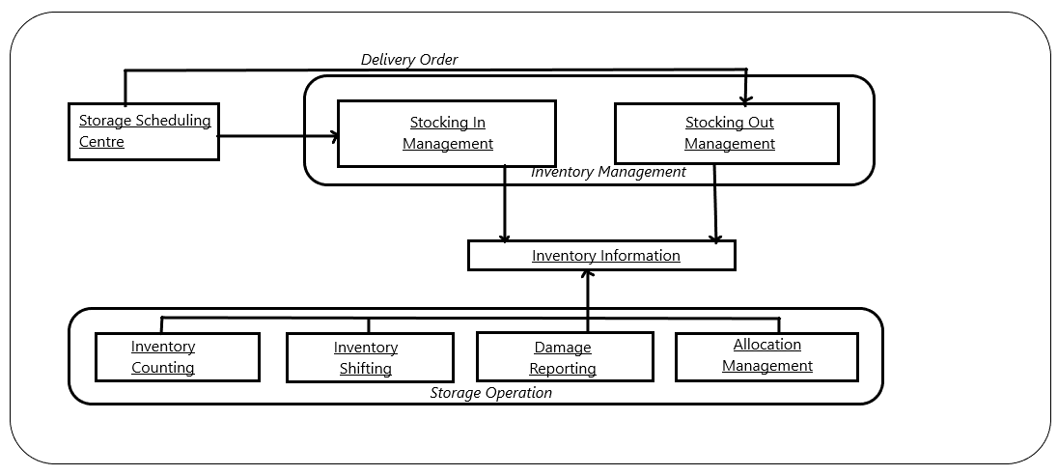
Fig.1 Architecture warehouse inventory system

IMPLEMENTATION
Working of the proposed system is as follows: The backend system consists of sqlserver database. SqlServer is the database system which manage data and analysis system for warehouse inventory management system, it is powerful and easy-to-operate back-end database management system. In this application admin of warehouse has only rights to register overall managers which are belongs to this application. In this application storage scheduling center provide delivery orders i.e. stocking in and stocking out. This information stored in inventory information system. This system working under several storage operations such as inventory counting, inventory shifting, damage reporting, allocation management.
CONCLUSION
In this paper, we analysis system architecture to the warehouse inventorysystem. There are many problems that an organization needs to attend to. It is evident that ineffective warehouse inventory management is the main problem. When procurement staff decides to procure the goods whose amount is less than the minimum inventory, the warehouse management system based on the enterprise resource planning will analyzing data in the system. The warehouse management system based on enterprise resource planning has become a development trend, it will be welcomed by many procurement staff, and it can promote the further improvement and development of warehouse management.
REFERENCES
- Phindile Ndlala and Charles Mbohwa,”The Application of Inventory System in Warehouse” ,International Symposium Industrial Engineering and Opreations Management Bristol, UK, July 2017 IEEE.
- Utkarsha Mendhe, Ankita Lohave,” Research paper on Stock Maintenance And Print Bill”, International Research Journal of Engineering and Technology (IRJET) 2017.
- Zhimin Chen Lizhen Liu,” Research on Warehouse Management System Based on Association Rules ”, 6 th International Conference on Computer Science and Network Technology (ICCSNT ) 2017.
- IU Xiaoping, DU Weifeng, TANG Li, HE Zhenggang ,”The Devolopment of Inventory Management Information System Based on Workflow Technology ”, Second International Symposium on Electronics Commerce and Security 2009.
- Loo Cheng, Xu Didi,”Design and Implementation of Warehouse Management System Based on AOP”, IEEE 2006.

Details of All Authors (Optional)

Sr.No | Photo | Details
1 |  | Name: Pranali suryawanshi  Branch: Information technology
2 |  | Name: Rinal Mahajan  Branch: Information technology
3 |  | Name: Payal Borkar  Branch: Information technology
4 |  | Name: Latesh Bhope  Branch: Information technology

