Fully Automated Cowshed
Harshal P. Patil¹, Aarati R. Chaudhari², Yatin P. Patil³, Vijay D. Chaudhari⁴
^{1,2,3} B.E. Students, ⁴Asstt. Prof.
^{1,2,3,4} Dept. of E&TC Engg, Gf’s Godavari College of Engineering, Jalgaon-425003, Maharashtra, India.
patil.harshal1995@yahoo.in¹, vinuda.chaudhari@gmail.com⁴

Abstract –
Nowadays in rural area the cowsheds are located at the farm area where it is difficult to take care of the cows. If we assume that we can use manpower to keep take care of it but it will leads to increase the cost requirement for it. Hence we have included all the things that required doing in cowshed. A modern cowshed contains a large number of autonomous and semi-autonomous systems. These systems aim to reduce the amount of human resources and reduce time requirement for keeping eye on the Cowshed. This report deals with the system of an automated feeding of cows, providing drinking water , keeping cowshed clean as well as the safety regarded precaution taken here for reduce the labor cost or to reduce the manpower requirement. This all automated process is controlled with the programmable logic controller (PLC).

Keywords- Human resources, Programmable logic controller, Cowsheds

- INTRODUCTION

In current trend the cowshed is appear towards the large in size in India. The cowsheds are located at the farm. In most of the conditions these cowsheds are in farms which are located at the rural areas or outside of the residential area. So there is difficult to arrange the manpower for the cowsheds.
Automation is taking place everywhere in the industry and the other fields very rapidly. We considered that the automation will take place here instead of the manpower. The all activities regarding the cowsheds are can be done using automation. The activities in the cowsheds are feeding thrice a day, providing them a drinking water, cleaning the sheds daily, providing the fire safety, automatic light & the theft protection or the fence breakage alarm in case the cattle tries to break the cowshed fence.

- LITERATURE SURVEY
In this report we studied the different reports regarding the problems comes while taking care of the cowsheds. And the survey has been done in the different locations at local places there were some errors found. Some of the errors are discussed below and the solution to those errors is provided.
The present ways of feeding cows on farms where heads are not tied but are free to move are those of manual or mechanized shaking refreshing fodder out into the feeding trough. The feeding mostly takes place twice a day. This is a usual and a well-established way of feeding, though it has significant faults [1].
In case of feeding water at least two to three times in a day the water has to be provided. Now in current system there is an automatic bowl system in which the system contains a bowl for the drinking of water .each of the cow has a separate bowl for itself, and the water is filled in those bowl. The controlling the level of those bowl is automatic [2].
In the cleaning of the shed there is an existing system which is given below. The proposed model consists of a pair of guide ways which is a primary load carrying member. The rack and pinion mechanism helps in the movement of machine apparatuses along the length of the scaled down frame. Here the electric DC motor is mounted with a gear on top which drives the machine along the rack. The movement along the length of the cow shed is considered as x axis. Similarly the height of the apparatus is considered as Y axis. There are two support guide ways mounted to the bottom of the main frame machine. The brush assembly is made to move along the two guide ways with the help of a screw rod and gear drive mechanism. The screw rod set up is coupled to a controllable DC motor, where the motion of the motor can be controlled by the output of the limit switch [3].

2.1 Problem Statement
The biggest fault is the fact that a great amount of food is shaken out in front of a large number of heads so some of them take more food than they really need, while some do not get enough. If we take a look at a current water feeding system the disadvantages of this system is that it will having a high cost a well as the installation of this system is very difficult. The problem in the present cowshed cleaning system is that, since the process consists of pure mechanical linkages efficiency is less.
2.2 Proposed Method/System
Here the proposed system is a Low Cost Automation (LCA) which is totally base on a Programmable Logic Controller (PLC). All the activities in the cowshed are being done using the PLC.
For the feeding purpose there is a silo which contains the hay which will drop in small amount on the conveyer trough which the feeding is done. The heads of the cows are free so they can easily take their meal; the frequency of feeding is thrice a day. Feeding thrice a day is an average requirement for the cows. If the quantity of hay needs to change as per the intake of the cows then it is possible, if the hay quantity from silo is controlled, here in this system it is included so it is possible to control the intake.
In case of drinking there is trough. In which the water is filled automatically and the water level is also controlled. If any of the cows feels thirsty then they will be able to drink water. Now about cleaning method the cowshed needs to be clean every day or twice a day. So in this system there is a wiper at the surface of the ground which slides from one side to another side cleaning all dung or the waste from the cows and collect it to the other end this assembly is driven with the help of screw rod, if wiper reach to the other end then it will return to its original position and wait for next cycle.
For the fire safety there is a sensor which continuously detects the whether there is fire or not, if the sensor sense the fire then it will turn on the alarm and the motor will be turned on and the sprinkles will spray the water which will extinguish fire as well gates of the cowshed is opened automatically for escaping the cows from the shed. Another feature is added here which is theft protection by which if anyone will try to break fence and tries to get in it will ring the alarm which will help to inform the guard of the shed or any person which is nearby.
- METHODOLOGY
The current system is totally based on the automated process. For the automation there are different types of controllers are present but here programmable logic controller (PLC) is used for the whole controlling and automated process the Delta PLC is been used here of series DVP-SS211R.

3.1 System Hardware
There are many types of methods are used for different operations here we discuss some hardware details of important operations.
3.1.1 Feeding system
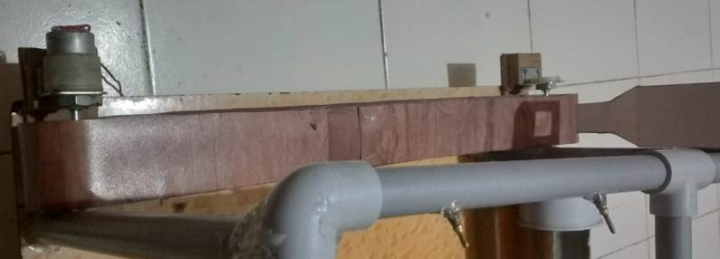
Fig. 1. Feeding Conveyor assembly
In feeding system is consisting of a conveyor belt which is driven by the DC Motor. Motors are supplied through the relay module and the relay is driven by the PLC. There is timer is set in the PLC which defines the frequency of the timing of the conveyor belt. As the conveyor will rotate enough then it will automatically stopped. The timing of the rotation of conveyor is predefined. The timing is changed according to the length of the conveyor.
3.1.2 Water feeding assembly
Here the large Trough is use for drinking water, which is filled with the water pump. The water pump runs on the 230V AC supply. There is a water level controller in the trough to control the water level, if the water tries to overflow it will stops the pump.

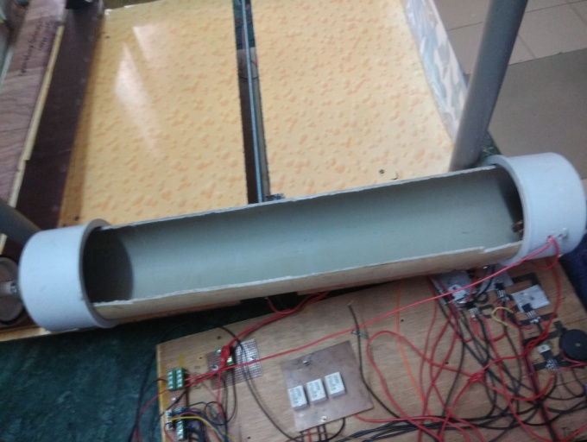
Fig. 2. Water feeding assembly
Water pump is turned on with the relay module which is controlled by the PLC. Here the PLC monitors the water level in the trough.
3.1.3 Fire Safety
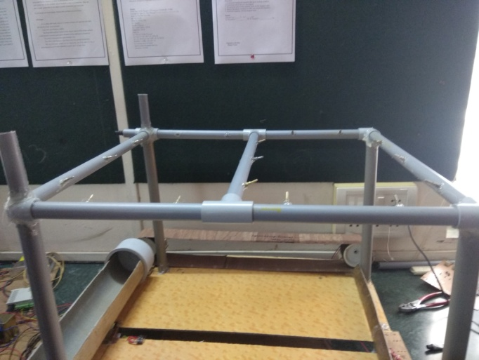
Fig. 3. Fire Safety Assembly
It is one of the most important assembly in this project that is fire safety assembly, which consist of pipe network having a pipe frame interconnected. The water pump of 230V AC is connected at the one end of the whole frame and the pipe consists of the small sprinklers to spray the water over the surface of the cowshed. This assembly is having a flame sensor which used to detect the fire and it is connected to the PLC for the detection. And water pump is connected to the PLC through relay module.
3.1.4 Washing/Cleaning Assembly
The screw rod having a wiper is fitted over it. The screw rod is connected to the 12V DC Motor. There is limit switch is used at the both ends in this assembly to control the movement of the cleaning wiper. There is a relay switching circuit in the circuitry to change the direction of the motor.
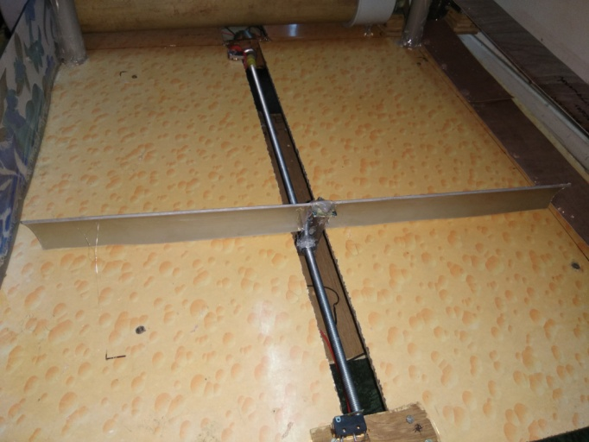
Fig. 4. Washing Assembly
The movement of wiper is forward and backwards. The signals through the limit switch are directly fed to the plc which decides the rotational direction of the motor. The clockwise rotating motor pushes the wiper forward and if the motor is rotating anticlockwise ten it pushes the wiper backwards.
3.2 System Software
PLCs are programmed using application software on personal computers, which now represent the logic in graphic form instead of character symbols. The computer is connected to the PLC through USB, Ethernet, RS-232, RS-485, or RS-422 cabling. The programming software allows entry and editing of the ladder-style logic. Ladder logic is a programming language that creates and represents a program through ladder diagrams that are based on circuit diagrams.
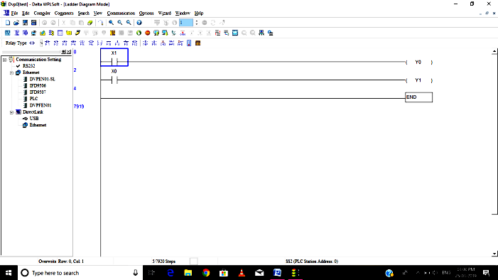

Here WPLSoft 2.30 is used. WPLSoft is a program editor of Delta DVP series PLC for WINDOWS computers. In addition to general PLC programming and WINDOWS editing functions (e.g. Cut, paste, copy, multi-window display, etc.), WPLSoft also provides various comment editing as well as other special functions (e.g. register editing and settings, file accessing and saving, contacts monitoring and setting, etc.).
- CONCLUSION
As design of this new system that is automated cowshed is much better than the previous systems we hope that this will be the very efficient than the other ones and provide the best result as we expected. The previous system includes only single feature while this contains all of the features in a single system. This system is a low cost automation system so it is possible that the lots of farmers can afford this system to use in cowsheds. There is no harm from this automatic system to the animals in the shed. The system is customizable so it can be customized as per the requirement or the quantity.

REFERENCES
- Ivan Kamber, Goran Malčić, Velimir Rajković ‘Automated feeding system’.
- ’ Drinking water for dairy cattle: always a benefit or a microbiological risk?’ Van Eenige MJEMI, Counotte GHMII, Noordhuizen JPTM.
- Gurucharan M Shinde1 Hemanth Kumar R2 Hemanth Kumar S3 Kiran P Naduvinamani4 Uday M ‘Automated Customized Cow Shed Cleaning Machine’ (IJSRD/Vol. 5/Issue 04/2017/142).

