Q Learning Algorithm Is Implemented Improve Network Qos Using Adaptive Congestion Control

Deepali V. Satinge¹, Mrs. Hemlata Dakhore²

¹Master of Technology, Computer science and Engineering Department of Computer science and Engineering
²G. H. Raisoni Institute of Engineering and Technology, Nagpur

deepalisatinge03@gmail.com
Received on: 11 June ,2022 Revised on: 27 July ,2022, Published on: 01 August,2022

Abstract – Congestion Control in TCP is the algorithm that controls allocation of network resources for a number of competing users sharing a network. The nature of computer networks, which can be described from the TCP protocol perspective as unknown resources for unknown traffic of users, means that the functionality of the congestion control algorithm in TCP requires explicit feedback from the network on which it operates. But this is not the way it works with TCP, as one of the fundamental principles of the TCP protocol is to be end- to-end, in order to be able to operate on any network, which can consist of hundreds of routers and hundreds of links with varying bandwidth and capacities. This fact requires the Congestion Control algorithm to be adaptive by nature, to adapt to the network environment under any given circumstances and to obtain the required feedback implicitly through observation and measurements. In this work, we propose a new reinforcement learning-based TCP end-to-end congestion control algorithm that provides performance improvements over existing TCP congestion control algorithms in computer networks in general, and an even greater improvement in wireless and/or high bandwidth delay product networks.

Keywords- TCP Congestion control, Machine Learning, Quality of services, congestion delay, high bandwidth.
- INTRODUCTION
Wireless networks are today widely deployed and critical for many infrastructures, making its efficient operation essential. A lot of research goes into discovering internet-related anomalies resulting from malicious attacks [3], typically using signature-based methods. More flexible systems are needed to rapidly detec t previously unseen anomalies that may not be Necessary related to network security. Machine learning (ML) techniques try to find patterns in data that do not conform to the expected normal behavior, enabling the detection of previously unseen events and thus detecting network anomalies. The objective of this work is to provide a system that can detect these anomalies in almost real-time through ML techniques, and requiring no additional infrastructure to the network. This will be done using only objective and measurable parameters taken from access points (APs). The identification of anomaly situations will be done in a supervised way, using multi-class and one-class classifier techniques. The Utilization of real-time adaptive applications for internetworking multimedia over future wireless and mobile networks is something already agreed in the wireless research community. These networks are formed by a variety of heterogeneous wireless technologies causing an unpredictably capacity-changing network scenario. In these scenarios, the net- work-layer quality of service (QoS) mechanisms cannot guarantee a stable service because most of the variability is due to the wireless channel itself. Adaptive multimedia applications, being able to dynamically change their settings to adapt to the available network resources can alleviate the problems caused by such unpredictable variations in the network conditions. The way in which QoS-aware adaptive applications in the literature auto-configure themselves is commonly driven by low level QoS parameters such as the bandwidth, jitter, delays, packet losses, etc. Their objective is finding a set of settings (audio and video codecs, video sizes, etc.) reducing the data rates to those that the network can support. However, in the author’s opinion, such adaptations should also take into account parameters directly related to the quality which is actually perceived by the user when such settings are used. In fact, the definition of Quality of Service (QoS) given in the ITU-T recommendation ITU- E.800 [1] clearly defines it as ”the collective effect of service performance, which determines the degree of satisfaction of a user of a service. It is characterized by a combination of service performance factors such as operability, accessibility, retain ability and integrity.” The adaptation approaches in the literature present simple adaptation algorithms which offer suboptimal solutions to the problem of selecting the application settings which better fulfill the user’s expectations. Given a concrete network condition, there are many different settings that the application can change to consume less than the available bandwidth (e.g. Reducing video sizes, changing video or audio codecs, reducing the quantization factor in the video codec, etc.). These adaptation algorithms just pick one from these combinations of set- tings satisfying the bandwidth restriction. However, from the user’s point of view, all of these possible combinations of settings do not offer the same quality. We will show that our proposal of real-time adaptive applications challenged with the notion of user-perceived QoS can lead to better adaptation algorithms being able to maintain a good level of satisfaction even when the network conditions are constantly and unpredictably changing.
In this work, we plan to integrate AI and machine learning based systems in order to improve the security and QoS of the wireless network. The proposed system will be able to intelligently select the security algorithms to be applied, it’s parameters to be used and the number of anonymity layers to be used, in addition to this, the overall network QoS will be improved in order to further enhance the performance of the wireless network.
II -LITERATURE REVIEW
Since the rollout of the first-generation wireless communication system, wireless technology has been continuously evolving from supporting basic coverage to satisfying more advanced needs. In particular, the fifth generation (5G) mobile communication system is expected to achieve a considerable increase in data rates, coverage and the number of connected devices with latency and energy consumption significantly reduced [1]. Moreover, 5G is also expected to provide more accurate localization, especially in an indoor environment [2]. These goals can be potentially met by enhancing the system from different aspects. For example, computing and caching resources can be deployed at the network edge to fulfil the demands for low latency and reduce energy consumption [3], [4], and the cloud computing based BBU pool can provide high data rates with the use of large-scale collaborative signal processing among BSs and can save much energy via statistic l multiplexing [5] . Furthermore, the co-existence of heterogeneous nodes, including macro BSs (MBSs), small base stations (SBSs) and user equipment (UEs) with device-to-device (D2D) capability, can boost the throughput and simultaneously guarantee seamless coverage [6]. However, the involvement of computing resource, cache resource and heterogeneous nodes cannot alone satisfy the stringent requirements of 5G. The algorithmic design enhancement for resource management, networking, mobility management and localization is essential as well. Faced with the characteristics of 5G, current resource management, networking, mobility management and localization algorithms expose several limitations. First, with the proliferation of smart phones, the expansion of network scale and the diversification of services in the 5G era, the amount of data, related to applications, users and networks, will experience an explosive growth, which can contribute to an improved system performance if properly utilized [7]. However, many of the existing algorithms are incapable of processing and/or utilizing the data, meaning that much valuable information or patterns are wasted. Second, to adapt to the dynamic network environment, algorithms like RRM algorithms are often fast but heuristic. Since the resulting system performance can be far from optimal, these algorithm s can hardly meet the performance requirements of 5G. To obtain better performance, research has been done based on optimization theory to develop more effective algorithm s to reach optimal or suboptimal solutions. However, many studies assume a static network environment. Considering that 5G networks will be more complex, hence leading to more complex mathematical formulations, the developed algorithms can possess high complexity. Thus, these algorithms will be inapplicable in the real dynamic network, due to their long decision- making time. Third, given the large number of nodes in future 5G networks, traditional centralized algorithms for network management can be infeasible due to the high computing burden and high cost to collect global information. Therefore, it is preferred to enable network nodes to autonomously make decisions based on local observations. As an important enabling technology for artificial intelligence, machine learning has been successfully applied in many areas, including computer vision, medical diagnosis, search engines and speech recognition [8]. Machine learning is a field of study that gives computers the ability to learn without being explicitly programmed. Machine learning techniques can be generally classified as supervised learning, recognition [8]. unsupervised learning and reinforcement learning. In supervised learning, the aim of the learning agent is to learn a general rule mapping inputs to outputs with example inputs and their desired outputs provided, which constitute the labelled data set. In unsupervised learning, no labelled data is needed, and the agent tries to find some structures from its input. While in reinforcement learning, the agent is continuously interacts with an environment and tries to generate a good policy. According to the immediate reward/cost fed back by the environment. In recent years, the development of fast and massively parallel graphical processing units and the significant growth of data have contributed to the progress in deep learning, which can achieve more powerful representation capabilities. For machine learning, it has the following advantages to overcome the drawbacks of traditional resource management, networking, mobility management and localization algorithms. The first advantage is that machine learning has the ability to learn useful information from input data, which can help improve network performance. For example, convolutional neural networks and recurrent neural networks can extract spatial features and sequential features from time-varying Received Signal Strength Indicator (RSSI), which can mitigate the Ping- Pong effect in mobility management [10], and more accurate indoor localization for a three-dimensional space can be achieved by using an auto-encoder to extract robust fingerprint patterns from noisy RSSI measurements [11]. Second, machine learning based resource management, networking and mobility management algorithms can well adapt to the dynamic environment. For instance, by using the deep neural network proven to be an universal function approximate, traditional high complexity algorithms can be closely approximated, and similar performance can be achieved but with much lower complexity [9], which makes it possible to quickly response to environmental changes. In addition, reinforcement learning can achieve fast network control based on learned policies [12]. Third, machine learning helps to realize the goal of network self- organization. For example using multi-agent reinforcement learning, each node in the network can self-optimize its transmission power, sub channel allocation and so on. At last, by involving transfer learning, machine learning has the ability to quickly solve a new problem. It is known that there exist some temporal and spatial relevancies in wireless systems such as traffic loads between neighbouring regions [12]. Hence, it is possible to transfer the knowledge acquired in one task to another relevant task, which can speed up the learning process for the new task. However, in traditional algorithm design, such prior knowledge is often not utilized. In Section VIII, a more comprehensive discussion about the motivations to adopt machine learning rather than traditional approaches is made. Driven by the recent development of the applications of machine learning in wireless networks, some efforts have been made to survey related research and provide useful guidelines. In [13], the basics of some machine learning algorithms along with their applications in future wireless networks are introduced, such as Q-learning for the resource allocation and interference coordination in downlink fem to cell networks and Bayesian learning for channel parameter estimation in a massive, multiple- input-multiple-output network.

III -PROPOSED METHODOLOGY
The proposed methodology can be described with the help of the following block diagram.

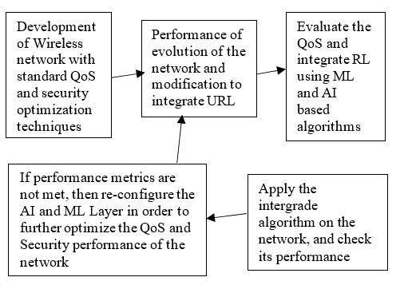
Fig 1 - Flow diagram for the proposed system

From the previous review, we can understand that there is no integrated algorithm researched yet which can not only improve on the security of the network, but also improves the congestion control of the overall network. Due to this fact, our research is directed towards a multi faceted domain, one which includes working on security aspects like anonymity, route security, data security, etc. and other on the congestion control which includes route selection, sleep scheduling, performance improvement of nodes, etc. Due to such a wide variety of domain selection, there are generally issues with algorithm integration. Thus, another need of doing this research is to develop a single algorithm which can take care of the most crucial aspects of the wireless network, namely security and congestion control.
Generally, machine learning and artificial intelligence are applied to data mining and signal processing problem sets, but via this research we will be able to demonstrate that it can be applied to congestion control optimization and security enhancement interactively, thereby improving the overall performance of the wireless network. This is another research for pursuing this research work. From the figure, we can observe that the system will first start by deploying a normal wireless network which will have standard algorithms for congestion control improvement and security. For congestion control improvement algorithms like sleep scheduling, duty cycle-based protocols, clustering methods, and others will be reviewed, while for security improvement algorithms like k-Anonymity, ALERT, and others will be reviewed. Post review, the algorithm with best output parameters will be used for implementation. The developed algorithm will be then reviewed, and a machine learning and AI layer will be added to in order to further evaluate its performance in terms of congestion control improvement. Once the level of congestion control is achieved, then the security parameters of the algorithm will be tuned, and its security performance will be evaluated. This security performance along with the congestion control performance will be fine-tuned will the point, metrics from both the performance evaluations are not satisfied.

1.Network Format :
Wireless network protocol based on the IEEE 802.11 family of standards, which are commonly used for local area networking of devices and Internet access, allowing near by digital devices to exchange data by radio waves.

In this module enter the data in a packet format: This module work by using some step :

- Open the “path.txt”

In this folder all the data to be copy and close the folder

“PATH=$PATH://home/user/Desktop/ns-allinone- 2.34/bin:/home/user/Desktop/ns-allinone- 2.34/tcl8.4.18/unix:/home/user/Desktop/ns-allinone-2.34/tk.4.18/unix”.
2.Open the “terminal”
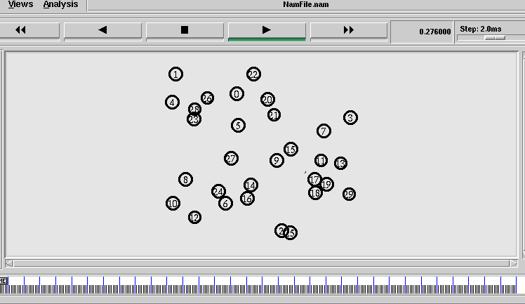
In this folder copy data to be paste and enter button to be click After that some of the command given to the system by user“ cd Desktop cd codes ns network_formation.tcl”
- Given some communication path address for source and destination
Then run “auto fast forward”
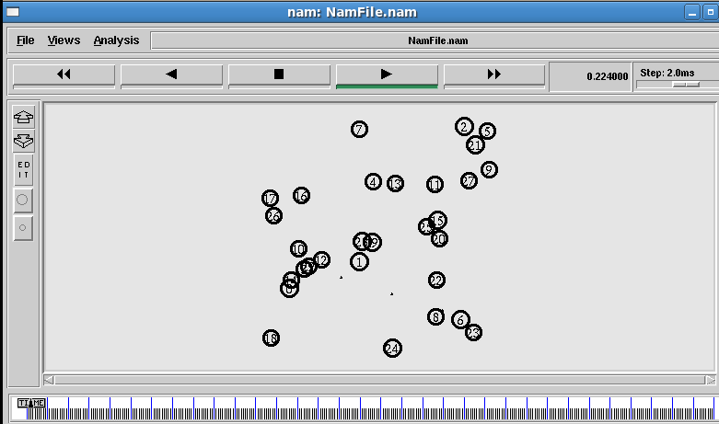
Congestion Delay:
In this module enter the data in a packet format: This module work by using some step :
1. Open the “path.txt”
In that folder all the data to be copy and close the folder
“PATH=$PATH://home/user/Desktop/ns-allinone- 2.34/bin:/home/user/Desktop/ns-allinone- 2.34/tcl8.4.18/unix:/home/user/Desktop/ns-allinone-2.34/tk.4.18/unix”.
2. Open the “terminal”
In that folder the copy data to be paste and enter button to be click
After that some of the command given to the system by user
“ cd Desktop cd codes
ns network_congestion.tcl”
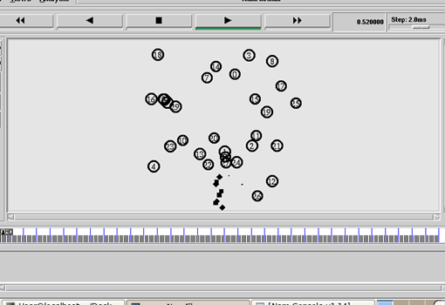
Sometime dropping the packets, this above fig shown the dropping packet.
After resolution the output is given below
RESULT:
• Reduce Delay time
• Increase Energy
• Minimum Pdr(Packet Delivery Ratio)
• Throughput
• Less Jitter

CONCLUSION
Select the data from wireless network in a network format after that it will apply the congestion delay:
- Improved congestion control for any kind of wireless network
- Security and QoS of the network is flexible.
- By Using machine learning & transfer learning technique it will benefit from continuous network configuration and there by the network will always be updated with the latest security and QoS features
- Improvement in congestion control after that response rate for networks will also improved
REFERENCES
[1] A. Aizerman, E. M. Braverman, and L. I. Rozoner. Theoretical foundations of the potential function method in pattern recognition learning. Automation and Remote Control, 25:821– 837, 1964.
[2] J. P. Bernhard Sch¨olkopf, Robert Williamson, Alex Smola, John Shawe-Taylor. Support Vector Method for Novelty Detection. 2000.
[3] M. H. Bhuyan, D. K. Bhattacharyya, and J. K. Kalita. Network Anomaly Detection: Methods, Systems and Tools. IEEE Communications Surveys & Tutorial.
[4] C. Bishop. Pattern recognition and machine learning. 2006.
[5] O. Chapelle, V. Vapnik, O. Bousquet, and S. Mukherjee. Choosing multiple parameters for support vector machines. Machine learning, 46(1-3):131–159, 2002.
[6] S. H. Conrad, R. J. LeClaire, G. P. O’Reilly, and H. Uzunalioglu. Critical national infrastructure reliability modeling and analysis. Bell Labs Technical Journal, 11(3):57–71, 2006.
[7] N. Cristianini and J. Shawe-Taylor. An Introduction to Support Vector Machines: And Other Kernel-based Learning Methods. Cambridge University Press, New York, NY, USA, 2000.
[8] P. Geurts, D. Ernst, and L. Wehenkel. Extremely Randomized Trees. Mach. Learn., 63(1):3–42, 2006.
[9] G. E. Hinton and R. R. Salakhutdinov. Reducing the dimensionality of data with neural networks. Science, 313(5786):504–507, 2006.
[10] G. E. Hinton, N. Srivastava, A. Krizhevsky, I. Sutskever, and R. Salakhutdinov. Improving neural networks by preventing co-adaptation of feature detectors. CoRR, abs/1207.0, 2012.
[11] M. Hubert, P. Rousseeuw, and Vanden. ROBPCA: a new approach to robust principal component analysis. Technometrics, 47:64–79, 2005.
[12] S. B. Kotsiantis. Decision trees: a recent overview. Artificial Intelligence Review, 39(4):261–283, June 2013.
[13] A. Lakhina, M. Crovella, and C. Diot. Diagnosing network-wide traffic anomalies. ACM SIGCOMM Computer Communication Review, 34(4):219, Oct. 2004.
[14] M. A. Pimentel, D. A. Clifton, L. Clifton, and L. Tarassenko. A review of novelty detection. Signal Processing, 99:215–249, June 2014.
[15] J. R. Quinlan. Induction of decision trees. Machine learning, 1(1):81–106, 1986.
[16] H. Ringberg, A. Soule, J. Rexford, and C. Diot. Sensitivity of PCA for traffic anomaly detection. Proceedings of the 2007 ACM SIGMETRICS international conference on Measurement and modeling of computer systems - SIGMETRICS ’07, page 109, 2007.
[17] C. Sammut and G. I. Webb. Encyclopedia of machine learning. Springer Science & Business Media, 2011.
[18] P. Smolensky. Information processing in dynamical systems: Foundations of harmony theory. 1986.
[19] P. J. Werbos. The Roots of Backpropagation: From Ordered Derivatives to Neural Networks and Political Forecasting. Wiley-Interscience, New York, NY, USA, 1994.
[20] B. Zhang, J. Yang, J. Wu, D. Qin, and L. Gao. PCA-subspace method Is it good enough for network- wide anomaly detection. In Network Operations and Management Symposium (NOMS), 2012 IEEE, pages 359–367,2012.

