**Development of Eco-Meter For Environmental Pollution Measurement**

**Monali Wagh1, Rahul Patil2, Ganesh Dhake3, D. P. Marathe 4, Mr.A.D.Vishwakarma5**

*1,2,3 B.E. Students, 4,5  Asso. Prof.*

*1,2,3,4 E&Tc Dept., GF’S GCOE , Jalgaon, India, 425001*

*1 monaliwagh2796@gmail.com*

***Abstract-*** *The level of pollution has increased with times by lot of factors like the increase in population, increased vehicle use, industrialization and urbanization which results in harmful effects on human wellbeing by directly affecting health of population exposed to it. The parameters of the environment to be monitored are chosen as temperature, volume of CO, volume of Combusting gases, detection of leakage of any harmful gases for human being. CO, a dangerous parameter is monitored with an extra precaution. To avoid all this things compete termination of all the harmful industries is not possible hence one effective solution is taken by this project and that is a amount is paled by those industries according to the level of pollution hence in this way complete termination of pollution is not cover but its concentration is definitely reduced. A text message is sent to the base station through GSM module whenever time of period is completed just like our energy meter. Due to that system industries try to reduce the pollution level because the need to reduce the bill, in this way pollution emitted from industries can be reduced.*

***Keywords-*** ***Air Pollution, Arduino, GSM-GPRS***

**1. INTRODUCTION**

**N**owadays environmental pollution has become a critical issue due to increased demand to products and development. Due to deforestation and industrialization, air quality is constantly degrading year on year. Any type of air pollution has sources of industrial activities is known as Industrial air pollution. Cutting down air pollution is the first step to go green. Industrial air pollution is major source of total environmental air pollution Stationary emission sources from industries / Factories includes pollution from stacks, chimney, diesel generators, boilers etc. They emit majorly

Particulate Matter, Sulphur Dioxides (SO2), Nitrogen oxides (NOx), Carbon monoxide (CO), Carbon Dioxide (CO2), VOC etc. Hence to reduce this pollution we use this project Pollution Meter. In this system we monitor the concentration of harmful gases which are emitted

**

Fig 1.1 Air Pollution

from industrial wastage*.* And also give bill for producing more pollution in nature. For that gas sensors and temperature sensor is used to sense those parameters and send an SMS in month end to pay the pollution bill. [1]

**2. LITERATURE SURVEY**

**2.1 Earlier work**

In this paper present the review work on pollution meter The level of pollution has increased with times by lot of factors like the increase in population, increased vehicle use, industrialization and urbanization which results in harmful effects on human wellbeing by directly affecting health of population exposed to it. In order to monitor quality of air, a Wireless sensor network (WSN) based new framework is proposed which is based on data acquisition and transmission. The parameters of the environment to be monitored are chosen as temperature, humidity, volume of CO, volume of CO2, detection of leakage of any gas - smoke, alcohol, LPG. The values of these parameters are transmitted by using Zigbee Pro to a base station where they are being monitored. The value of temperature and humidity are transmitted over Bluetooth also so that every person in the range of the system can check it over their smart phones and laptops as these parameters hold importance to everyone. CO, a dangerous parameter is monitored with an extra precaution. A text message is sent to the base station through GSM module whenever its volume exceeds a particular safe limit intended for a particular application. [2]

In this paper present the review our system of pollution measurement is one of the most important concern of the world. Air pollution may evolve from anthropogenic or natural sources. Air pollutants of atmospheric substances like CO, CO2, SO2, NO2, and O3 suspended particulate matter (SPM), repairable suspended particulate matter (RSPM), and volatile organic compounds (VOCs) have a great effect on the people health. Most of the major cities in developing countries and most cities of the developed countries are suffering from it. Thus to develop a real time air quality and pollution monitoring system is critical. We have developed an arduino based air pollution detector which combined a small-sized, minimum-cost sensor to an arduino microcontroller unit. The advantages of the detector, have a reliable stability, rapid response recovery and long-life features. It is affordable, user-friendly, low-cost and minimum-power requirement hardware which is appropriate for mobile measurement, as well as comprehensible data collection. It has a processing software able to analyze, collected quality data with high precision. Simple instrument which can be commercially utilized [3]

This paper reviews the importance of employing wireless sensor networks in air pollution monitoring in cement factories along with their advantages and disadvantages. As the countries become industrialized, the pollution level to our environments increases and this pollution becomes a major problem for the health of the population and also affects the ecosystem. Although some standards are set with environmental authorities for wastes emissions in air, the monitoring and controlling of that standards are still a challenge in most industries especially chemical industries and cement factories. To avoid such adverse imbalances in the nature, an air pollution monitoring system is utmost important. Some of the pollution monitoring systems in cement factories are OPSIS, U*ras26, Magnos27 and CODEL. These systems are installed to monitor the emissions from chimney only. Wireless Sensor Networks is an excellent technology that can sense, measure, and gather information from the real world and based on some local decision process it transmit the sensed data to the user. These networks allow the physical environment to be measured at any point, and greatly increase the quality of the environment. [4]

Literature review on pollution meter With the coming of the Industrial Revolution, humans were able to advance further into the 21st century. Technology developed rapidly, science became advanced and the manufacturing age came into view. With all of these came one more effect, industrial pollution. Earlier, industries were small factories that produced smoke as the main pollutant. Any form of pollution that can trace its immediate source to industrial practices is known as industrial pollution. Most of the pollution on the planet can be traced back to industries of some kind. In fact, the issue of industrial pollution has taken on grave importance for agencies trying to fight against  environmental degradation. Countries facing sudden and rapid growth of such industries are finding it to be a serious problem which has to be broughunder control immediately. Industrial pollution takes on many faces. It contaminates many sources of drinking water, releases unwanted toxins into the air and reduces the quality of soil all over the world. Major environmental disasters have been caused due to industrial mishaps, which have yet to be brought under control. Below are few of the causes of industrial pollution that have resulted in environment degradation. [2]

**2.2 Problem Statement**

During past decades, as result of civilization and urbanization there is a huge growth in Polluting industries, open burning of refuse and leaves, massive quantities of construction waste, substantial loss of forests and vehicles (particularly diesel-driven cars) on roads that give rise to health endangering pollution. Therefore, it is necessary to regularly monitor and report the hazardous impacts from air pollution. To monitor the quality of air, a new framework is proposed that monitors the parameters of the environment around us such as CO2, CO, presence of smoke, alcohol, LPG, temperature and humidity with the help of GSM, Bluetooth and WSN.

**2.3 Proposed Method**

The proposed air quality monitoring is based on the block diagram as shown in Fig.2 the data in air is acquired by CO2 sensor, CO sensor, gas leakage detection sensor and temperature and humidity sensor. After the data acquisition stage, the pre-processing stage comes in which the Arduino processes the information received from the sensors and changes it into more viable form to be accessed at the base station and by the user.

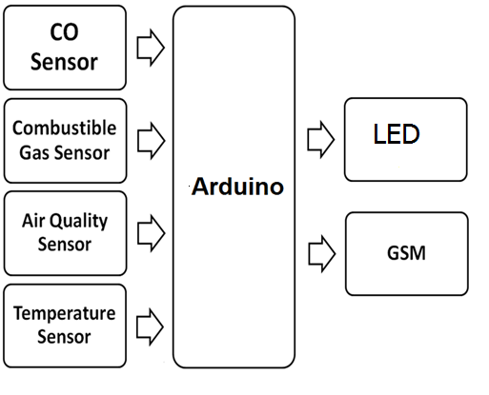Fig -2.3.1 Block Diagram Of pollution meter [5]

Zigbee S2 acts as a gateway for the communication between Arduino and the base station. The text message though GSM module marks an extra precaution for the level of CO in air. Temperature and humidity values are also transmitted via a short range communication with the Bluetooth module [5].

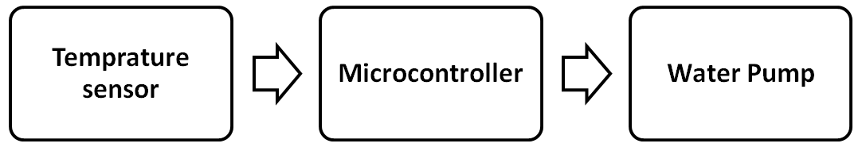Fig.2.3.2 Block Diagram of Heat Exchanger [5]

Also one more block is added Into the Pollution meter and that is pollution remover. To remove the impurity that is temperature of that hot air, we can reduce the temperature of those hot gases by cooling those gases by using cooled water. One more parameter is used to remove the pollution by removing the heavy particles by using air filters. So in this way we can reduce the amount of prolusion and also who create this prolusion are pay the amount which is again used to reduce the pollution.heat exchanger is a device used to transfer heat between a Gas and a [fluid](https://en.wikipedia.org/wiki/Fluid). The fluids may be separated by a solid wall to prevent mixing or they fmay be in direct contact. A  They are widely used in [space heating](https://en.wikipedia.org/wiki/Space_heating), [refrigeration](https://en.wikipedia.org/wiki/Refrigeration),. The classic example of a heat exchanger is found in an [internal combustion engine](https://en.wikipedia.org/wiki/Internal_combustion_engine) in which a circulating fluid known as [engine coolant](https://en.wikipedia.org/wiki/Engine_coolant) flows through [radiator](https://en.wikipedia.org/wiki/Radiator) coils and [air](https://en.wikipedia.org/wiki/Air) flows past the coils.

**3. METHODOLOGY**

The model was designed using an Arduino microcontroller, MQ135 Gas Sensor and a 16 by 2 liquid crystal display (LCD) ScreenThe sensor collected data when operated by the microcontroller and forwarded it over the internet for analysis via the Wi-Fi module. Users were able to monitor measured parameters on their smartphones. We have used Arduino UNO, MQ-135 air quality sensor, LCD display, breadboard, jumper wires, and potentiometer to develop an arduino based air pollution detector which combined a small-sized, minimum-cost sensor to an arduino microcontroller unit. The device is linked to a computer through a serial connection. From the sensor, the collected data through the arduino microcontroller. It will then be transmitted to the computer software, where it becomes documented   
  
**3.1 System Hardware**

In this project we use Arduino which an advance version of today’s microcontroller.

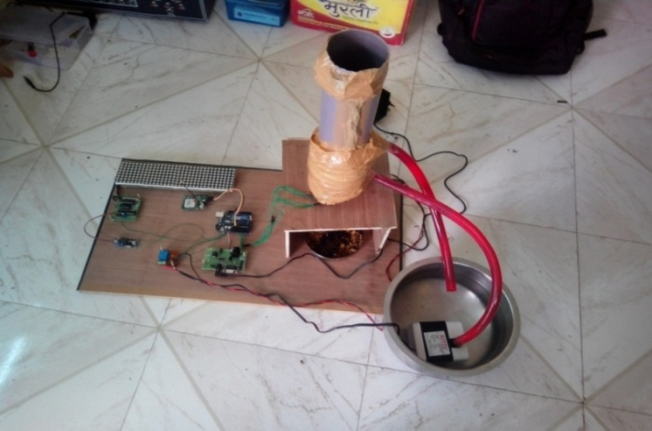

Fig 3.1 Our developed system

Arduino have 14 digital pins from D0 to D13 and 6 analog pines from A0 to A5. In digital pins D0 *and D1 is used for serial communication. D0 is RX pin and D1 is a TX pin serial communication.

The concept of this project is how many amount of pollution is made by industry that amount of bill is taken from those company hence due to paying of money those industries reduce their pollution level hence environment is been secured. To detecting the amount of pollution we use some sensors for measuring the concentration of the harmful gases into the exhaust gas which is coming from the exhaust of the boiler. For Detecting Carbon monoxide we use CO Sensor, Combustible Gas sensor and to detect the other harmful gases we use air quality sensor also to measure the temperature we use LM35. The output of these sensors is given to the Arduino Microcontroller. Then Arduino calculate the amount of pollution and according to rates it find the bill which is pay by the company.

**3.2 System Software**

**Arduino Microcontroller**

Arduino microcontroller is an easy to use yet powerful single board computer that has gained considerable traction in the hobby and professional market. The Arduino is open-source, which means The hardware is reasonably priced and development software is free. This guide is for students in ME 2011, or students anywhere who are confronting the Arduino for the first time. For advanced Arduino users, prowl the web; there are lots of resources.The Arduino project was started in Italy to develop low cost hardware for interaction design. An overview is on the Wikipedia entry for Arduino. The Arduino home page is Arduino hardware comes in several flavors. In the United States, Sparkfun is a good source for Arduino hardware. This guide covers the Arduino Uno board , a good choice for students and educators. With the Arduino board, you can write programs and create interface circuits to read switches and other sensors, and to control motors and lights with very little effort. Many of the pictures and drawings in this guide were taken from the documentation on the Arduino site, the place to turn if you need more information. The Arduino section on the ME 2011 web site, https://sites.google.com/a/umn.edu/me2011/, covers more on interfacing the Arduino to the real world.



Fig -3.4Ardunio Microcontroller [6]

The Duemilanove board features an Atmel ATmega328 micro-controller operating at 5 V with 2 Kb of RAM, 32 Kb of flash memory for storing programs and 1 Kb of EEPROM for storing parameters. The clock speed is 16 MHz, which translates to about executing about 300,000 lines of C source code per second. The board has 14 digital I/O pins and 6 analog input pins. There is a USB connector for talking to the host computer and a DC power jack for connecting an external 6-20 V power source, for example a 9 V battery, when running a program while not connected to the host computer. Headers are provided for interfacing to the I/O pins using 22 g solid wire or header connectors. For additional information on the hardware.

The Arduino programming language is a simplified version of C/C++. If you know C, programming the Arduino will be familiar. If you do not know C, no need to worry as only a few commands are needed to perform useful functions. An important feature of the Arduino is that you can create a control program on the host PC, download it to the Arduino and it will run automatically. Remove the USB cable connection to the PC, and the program will still run from the top each time you push the reset button. Remove the battery and put the Arduino board in a closet for six months. When you reconnect the battery, the last program you stored will run. This means that you connect the board to the host PC to develop and debug your program, but once that is done, you no longer need the PC to run the program. [6]

**3.3 Installing Software**

Follow the instructions on the Getting Started section of the, http://arduino.cc/en/Guide/HomePage. Go all the way through the steps to where you see the pin 13 LED blinking. This is the indication that you have all software and drivers successfully installed and can start exploring with your own programs. [1]

**4. EXPECTED RESULTS**

This pollution meter system can use wireless network card for storage of values from sensors attached to microcontroller as well as more gas sensors could be used like Nitrogen dioxide (NO2), Ammonia (NH3), Sulfureted Hydrogen (H2S), alcohol etc.

**5. CONCLUSION**

In this project we study that how to program the Arduino micro-controller and also how to interface sensors with Arduino microcontroller. The system to monitor various parameter of environment using Arduino microcontroller on 8X8 Dot-matrix. With the use of technologies like GSM enhances the process of monitoring various aspects of environment such as air quality monitoring issue proposed in this project. The detection and monitoring of dangerous gases are and related precautions have been considered here and specific amount of money is taken from those industries to reduce the pollution which is already created by them.

In future, due to use of gas sensor, we can measure the concentration of various gases and detect the parentage amount of polluteon level more accurately.

**REFERENCES**

*[1] Tudose, D. Ş., Pătraşcu, N., Voinescu, A., Tataroiu, R., and Ţăpuş, N. , “Mobile Sensors in Air Pollution Measurement.”, in Positioning Navigation and Communication (WPNC), IEEE , pp. 166-170, 7 Apr 2011.*

*[2]Navreetinder Kaur1, Rita Mahajan2, Deepak Bagai3, “International Journal of Innovative Research in Science, Engineering and Technology”(An ISO 3297: 2007 Certified Organization) Vol. 5, Issue 6, June 2016 .*

*[3] Md. Abdullah Al Ahasan, Saumendu Roy, A. H. M. Saim, Rozina Akter, Md. Zakir Hossain,“ Arduino-Based Real Time Air Quality and Pollution Monitoring System”,International Journal of Innovative Research in Computer Science & Technology) ISSN: 2347-5552, Volume-6, Issue-4, July 2018 DOI: 10.21276/ijircst.2018.6.4.8 .*

*[4] Godbless Swagarya , Shubi Kaijage , Ramadhani S. Sinde,”A Survey On Wireless Sensor Networks Application For Air Pollution Monitoring” International Journal Of Engineering And Computer Science ISSN:2319-7242 Volume 3 Issue 5 may, 2014 Page No. 5975-5979 .*

*[5] TERI. 2015. Air Pollution and Health. Discussion Paper by The Energy and Resources Institute: New Delhi by Rinki Jain (AssociateFellow,TERI), KarnikaPalwa (Research Associate, TERI).*

*[6] Dias, M. J. et al., (2010). “Indoor Air Quality Evaluation in School Buildings Ventilated by Natural and Mechanical Systems”. Climapp.R6-TS62-0P02, Turkey: REHVA. ISBN Code of the CD 978-975-6907-14-6, 2010.*