Smart Energy Controlling System with Advanced Theft Monitoring

Yogita Vilas Mungale¹ ,Prof. Tutkane²

Wainganga College of Engineering& Management, Nagpur, India, 441114

yogita.mungle@gmail.com

Received on: 05 April , 2022 Revised on: 04 May ,2022, Published on: 06 May, 2022

Abstract – Government power supply companies such as MSEB faces problems due to the non bill paid consumers. Currently as per scenario in India 22-25% people are non bill paid consumers. In such cases, the electric supply to the consumer energy meter is cutoff, but some consumers argue with the officials and they try to settle the matter by giving bribes. Even if after disconnecting the supply, some consumers may bypass the system and connect their home appliances from the service mains. Ultimately government suffers to heavy economical loss. So to overcome this issues we are designing a system which will automatically cutoff the electric supply from the pole itself for that particular customer. In India as per the scenario it is observed that government also faces a huge loss due to the various type of electric power theft. To overcome the all these problems this system will overcome the electric power theft problem..
Keywords- Wireless sensor network, data aggregation, architecture, Network Lifetime, Routing, Tree, Cluster, Base Station
- INTRODUCTION
The demand of electricity is increasing day by day in the India and the world. Consumer dishonesty is a problem faced by all power corporations. Electricity Suppliers Companies are having large amount of monetary loss due to electricity wastage and theft by consumers. Electricity theft is defined as the use of electric power without paying the bill amount. Detection of electricity theft is very difficult and requires continuous monitoring to reduce fraud. Electricity can be fraudulently accessed through illegal hook-ups, meter tampering or bypass, billing irregularities and unpaid bills. Distributed Power utilized by consumer from electricity theft and other customer unlawful act are termed as Non-technical Losses. Indian electricity distribution system has several unauthorized consumers, who use various methods such as meter bypassing & tampering, double feeding the meter, and missing neutral condition for domestic and commercial power theft. Energy theft is a very common problem in developing countries like India where consumers for energy are increasing consistently as the population increases. Utilities in electricity system are destroying the amount of revenue each year due to energy power theft. It causes shortage of power supply to residential as well as commercial premises. Ultimately it is the country’s economy which suffers along with the country’s political reputation. Currently as per scenario in India 35-40% people are non-bill paid consumers and 40-45% losses are covered in electricity power theft. The various types of power theft such as direct hooking from line, bypassing the energy meter, injecting foreign element into the energy meter, physical obstruction.
In some areas consumers are non-bill paid consumers which intentionally does not pay bill and when the electric board officials visit to the particular site for disconnecting the supply some consumers try to bypass the connections of the meter and also some consumers try to settle the matter by giving bribes ultimately it regards to electricity power theft. Electric meters can be manipulated, thus causing them to stop, under-register or even bypassing the meter. Consumers, who tamper with electric meter, effectively use power without paying for it. This theft or fraud can be dangerous as well as dishonest.
There is incorporation of mobile technology into MSEB automation system due to the rapidly advancing mobile communication technology and the decrease in costs. We propose a system that collects the energy consumption from residential as well as corporate zones and send it directly to the central server where processing is done on that data for preparation of bills and for the analysis of power theft on the basis of data which is provided by current sensor. In existing system for collection of energy consumption data is that the representatives of MSEB monthly comes and visit every residential, take the snap shot and corporate and manually reads the consumption data from the meter. This collected data is recorded on a piece of paper along with a snap shot of the meter and finally submitted to the local electricity board office. In this project we are going to develop a smart system which can record the excess flow of electricity into the home through which we can detect the theft of electricity. This is done by using the current sensor which is placed in between the electric meter and the transmission line. And the data is transfer to electricity board by using wi-fi module. In this we have use WEMOS ESP8266 wi-fi module for the data transfer to electricity board. This will provide the electricity board to track the meter reading and excess consumption of electricity into someone’s house or area where there is electricity meter and theft is going on.

II-METHOLOGY

In this project, we propose an electricity theft detection system by using two current sensor. The system continuously under monitoring. Both sensors are connected to one of the line conductor and another sensor are connect load of consumer side. This two sensors are connected to microcontroller (NodeMCU 8266). Microcontroller Wireless Power Theft Monitoring continuously compare both sensor and if any difference is occur than microcontroller transfer the data to authorized company by Wi-Fi module. It is use local Wi-Fi internet from area which used to transfer the data. In this projected framework Wi-Fi innovation will transmit the meter readings and theft indication messages to the consumer and electricity board. This procedure will happen when needed that suggests if data is gotten from approved server transportable transmission amongst consumer and government. At that time the energy theft is controlled by relay device. Likewise will cut the power provided to that particular energy meter in keeping with demand of approved server transportable.

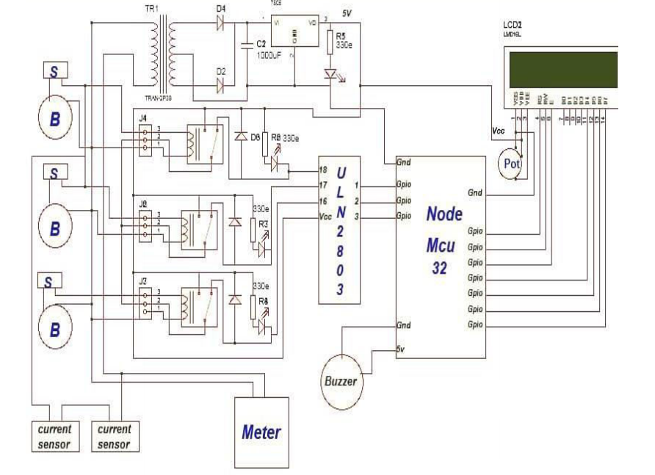Fig. 1

III -DESIGN
Module size 80.0mm(L)*36.0mm(W)*Max13.5(H)mm Viewing area 64.5mm(L)*16.5mm(W) Character size 3.00mm(L)*5.23mm(W) Character pitch 3.51mm(L)*5.75mm(W)

IV- CONCLUSION

In order to overcome the revenue losses due to power theft in our country, we have made a small attempt through this project. By this work we can conclude that the power theft can be effectively curbed, ‘Wireless Power Theft Monitoring', proves useful to the people who use it and helps in eliminating illegal usage of electricity by working reliably and satisfactorily, thus saving the revenue loss to the electricity supplying authority in future which incur due to power theft. A Wireless Power Theft monitoring system has been designed and developed with proper integration of both the hardware and the software. Without any human interface this system provides an effective and easy way to detect electrical theft. The use of WIFI helps in achieving the numerous advantages of wireless network systems. Power theft is actually bypassing the energy meter but in our project we have indicated the theft by increasing the load and this method is cost efficient.

V- ACKNOWLEDGMENT

A successful &amp; satisfactory completion of any significant task is the outcome of invaluable contribution of efforts by different people in all directions explicitly or implicitly. Vast varied and valuable reading efforts leads to considerable gain of knowledge via books &amp; other informative sources, but expertise comes from collateral practical works and experiences. I would like to thank, my Guide Prof. Dr. D.R. Tutkane Department of Electrical Engineering, W.C.E.M. Nagpur and Head of Department Prof. Dr. D.R. Tutkane for his support, encouragement and guidance during the period of my dissertation with a keen interest, enthusiasm and his ever-helping nature from the starting to the completion of this dissertation.
I would also like to thank PG Coordinator of Electrical Department and for their kind blessings and valuable suggestions for completion of dissertation Last but not the least; I am also thankful to all those who have directly or indirectly helped in completion of the dissertation.

REFERENCES

- IOT based Power Theft Detection. R Giridhar Balakrishna, P Yogananda Reddy, M L N Vital.. International Journal of Innovations in Engineering and Technology (IJIET) ISSN: 2319-105, Volume 8, Issue 3, June 2017
- A Survey Of IOT For Power Theft Detection, Fault Identification And Location Tracking. Anshu Singhal, Anupriya Tomar, Neha Kumari, S Hena Kauser, Mrs. Savitha. S.C. International Journal of Science, Engineering and Technology Research (IJSETR) Volume 5, Issue 5, May 2016 I.S. Jacobs and C.P. Bean, “Fine particles, thin films and exchange anisotropy,” in Magnetism, vol. III, G.T. Rado and H. Suhl, Eds. New York: Academic, 1963, pp. 271-350.
- IOT Based Power Theft Detection and Monitoring System. N Kunan, Poornima BK. IJIREEICE. Vol. 5, Issue 5, May 2017
- T. B. Smith, “Electricity Theft: a Comparative Analysis”, Energy Policy, Volume 32, Issue 18, December 2008; 2003, pp. 2067 – 2076.
- Siddarameswara H.N. “WIFI based electricity theft identification in houses and in industry sector”, ICEE-21st june 2014,ISBN-978-93-81693-6603-03.
- P. Rakesh Malhotra et al. / IJET “automatic meter reading and theft control system by using WIFI”, 2013.
- Abhinandan Jain, Dilip Kumar, Jyoti Kedia, “Design and Development of WIFI based Energy Meter”, in IJERT, 2012.
- S. Arun; Dr, sidappa Naidu, “Design and implementation of automatic meter reading system using WIFI, ZIGBEE through GPRS” in international journal of advanced research in computer science engineering, 2012.
- Douglas V.H., “Microcontrollers and Interfacing: Programminng Hardwere” McGraw Hill Inc., New York, 2008,(75-90,101,123,143,). [10] “Electrical Power Supply System for India,” www.wikipedia.org, February 2010

