Characterization of Thermal and Mechanical Properties of PP-PET Blends

Ashish R.Thakre¹, Dr.(Mrs.) R.N.Baxi², Dr.R.S.Shelke³, Pratibha Gupta⁴
¹Research Scholar, Department of Mechanical Engineering,
G.H. Raisoni College of Engineering, Nagpur, India,
²Ex. Professor, Department of Mechanical Engineering, G.H. Raisoni College of Engineering, Nagpur.
³Associate Professor and Head, Department of Mechanical Engineering, G.H. Raisoni College of Engineering, Nagpur.
⁴ R&D Associate , Hytec Resistors Pvt. Ltd, Nagpur

Abstract: This paper revealed the mechanical and thermal properties of the blends of Polypropylene- polythene Terephylate with various wt nothing (up to 2000gm polythene Terephylate) ar appraised primarily. Improvement in mechanical options is bring into being by the buildup of polythene Terephylate ,is valuable as way as during this involved. Conversely, non adherence be declared in all manufactured blends. like chiefly perceived in Differential scanning measuring instrument investigation. These testing consequently availed the means of pilot experimentation as long as opting acceptable opus/Polyethylene Terephylate accumulations within PP used for compatibility for approaching studies.

Keywords: PP, PET, PP-PET blend, DSC, Izod Impact strength.
- INTRODUCTION

Precipitous intensification in production of Polypropylene and its use is well acknowledged through proceeding few decades. Polypropylene is prevalently being use in a variety of fields of industries such as Chemic, Electrical, automobile, domestic, yarn goods, agronomy, protective material, haulage and numerous. Commercialize advisory in addition to organization investigate indicated that PP witnessed vigorous increase throughout last decade and as well forecasted that requirement of polypropylene is expected to intersect its 5-6% usual yearly enlargement rate of past decade in near upcoming [1]. It is merit stated that industrial progress in material scheming and subsequent research and development are the significant heavy parameters for such sheer growing utilization of this product resin. Hisham A. Maddah in current studies shows the potential scenery of the polypropylene as polymer resin and signified the gigantic varieties of usages of polypropylene showed that, it is perfect option amongst all erstwhile resin polymers to make stretchy, lifelong, cost efficient and light weight material for plentiful commercial areas as mentioned over [2].Throughout developmental stages of this resin material unification with polypropylene is widely being studied by diverse researchers. To enhance engineering features matrix of polypropylene and polyester group resins is equally analysed broadly. Another analysis by G.M.Shashidhara et. al. processed Polypropolyne copolymer in addition to nylon 6 blend by polypropylene - grafted-Maleic anhydride compatibilizer. Improvement in Mechanical properties particularly tensile strength was originate in the composites. This outcome supported by TEM analysis of the similar composites. Distinct provinces of the nylon 6 were missing in Polypropylene copolymer Polypropylene -grafted-Maleic anhydride-Nylon6 blends signifying adhesion. No noteworthy enhancement of the thermal properties in this studies be displayed[3]. In related such experiments by Mehdi Afshari et.al.on immensity properties of Polypropylene -Nylon 6 blends rheological properties of polyblends were analyzed and besides associated them with Differential Scanning Calorimeter analysis and Scanning electron microscope analysis. Polypropylene -grafted-Maleic anhydride used as a coupling agent. It was pragmatic that as quantity of Polypropylene -grafted-Maleic anhydride in 80/20 composite enhanced the apparent viscosity at low shear rates improved. Spinnability of polyblends hooked on fibres reported unbalanced condition throughout the spinning of the blends 45/50/5 composition. In respite of the composites polyblend fibres be mechanically persistent. [4] In a new study of Polypropylene -polyester composite, Somit Neogi et.al. deliberate wear properties of Polypropylene –Polyethylene terephylate composite in sliding dry circumstance. To inspect wear behaviour four dissimilar compositions of polypropylene - Polyethylene terephylate be analysed .It was reported by the researchers that adding up of Polyethylene terephylate improves wear confrontation of polypropylene by plummeting the wear loss. Scanning Electron Microscope interpretation of the shabby surfaces indicated that Polyethylene terephylate balls which were observed calmly dispersed prior to wear test were found separated leaving pits by worn surfaces. The momentous plastic deformation was not observed on Polyethylene terephylate balls along with grooves were establish with no wedge pattern. The nonappearance of plastics deformation evidently shows the improved wear presentation of Polyethylene terephylate as compared to polypropylene [5].This strength have contributed to the consequence of development in wear resistance of polypropylene - Polyethylene terephylate blends. According to the difficulties of the discarding of Polyethylene terephylate Renato Carajelescove et. al. synthesized blends of polypropylene -recycled Polyethylene terephylate fibres with Polypropylene -grafted-Maleic anhydride coupling agent using 2² multiple regression statistical examination. As well tensile test , impact tests as well as Fatigue tests representing retort of the surface to the tensile fatigue was studied in this work. Promoted via recycled Polyethylene terephylate fibre heat deflection tests elevated enlarged thermal constancy. In general result of this experiment prove that recycled Polyethylene terephylate fibre be capable as reinforcement in polypropylene because they are compatibilized till 4 wt %. [6] Somewhat exceptional literature concerning absorptive and obstruction properties of Polyethylene terephylate and polypropylene composite assayed by Tadashi Otsuka et.al. The study was in the curiosity of pharmaceutics sector chiefly used for eye drop bottles. Composition of polypropylene and Polyethylene terephylate be analysed by lacking of compatibilization according to the factor of certainty. Apart from 70/30 and 50/50 polypropylene and Polyethylene terephylate composite remaining composite were establish to abide the experimental load indispensable for eye drop bottle. In spite of the fact that 50/50 Polyethylene terephylate and polypropylene and 70/30 Polyethylene terephylate and polypropylene composite displayed sublime constructive stability in wet vapour transmitting speed and anti adsorbent characteristics of L-menthol, on the other hand, deprived mechanical quality were key concern in these composites[7].Twin compatibilization by means of maleated polypropylene and epoxy resin be reported by G.N.Onyeagoro et.al. In this experimentation one such elements is bio polymer and polypropylene and Polyethylene terephylate used was post user in nature. This has show the way in the direction of go-green technology. Upon the accumulation of EPR better miscibility was observed in this study [8]. For defending environment in similar initiative of A.Elamri et.al. reported and analysed recycled Polyethylene terephylate polymers of dissimilar grades and equated with virgin resin material. Still recycled Polyethylene terephylate has moderately low molecular weight, accurate blending it with neat material helped in improvement the properties of recycled material for the noble cause of reusing the equivalent. From morphological and thermal properties both virgin Polyethylene terephylate and recycled Polyethylene terephylate be miscible down to macromolecular level as was understandable [9]. The reassess of mechanical properties of polypropylene conceded by Quazi T. H.Shubhra et.al. acknowledged that reinforcement of polypropylene by different fibres like E glass fibres (synthetic) and flax (natural) receiving very much consideration. This fibre reinforced polymers were extremely firm while the surface of fibres tailored by the treatments like alkalization, oxidation or diazotization [10].
The current work is the part of the material up growth of polypropylene and PET composites. In the present study PP and PET blends in diverse extent are synthesised. These blends are uncompatiblized primarily to authenticate the miscibility of these two resins. Mechanical and Thermal actions of the blends is studied in the present study. The goal of this work is to discover the most excellent composition or compositional scope of the constituents for promote research study.
Experimental work:
Materials and methods
Material- Homopolymer polypropylene ( 10 MFI, density 0.9Gm/ml ,Grade PP AM650N Homopolymer PP of Reliance Ltd. India.) and Polyethylene Terephthalate (0.06 Melt Flow Index, density 1.365 Gm/ml) is procured from PET Brand WK – 802Standard q/WK 007-2017of Zhejeang wankae material company .Limited are use to prepared diverse blends
Table A: Display of particular compositional details of the materials.
Five different composite materials in addition to two neat polymers were experimented in this wark as reported in Table B
Table-A-Typical features of the Polymeric material utilized in this experimentation
Properties | Units | Specific Value  PP PET
Tensile stress | Mpa | 35.01 41.80
% Elongation | % | 12 5.3
Density | Gm/ml | 0.9 1.365
Melt flow index(260 ºC/2.16Kg) | Gm/10 minute | 10 0.06
Izod Impact strength | J/m | 25 20.45
Tensile Modulus | Mpa | 196.63 201.37
Hardness | Shore D | 62 74

Table-B -Compositional features of recently manufactured composites denomination of blend % PP % PET
Sr.No | Code details | Wt % in grams
 |  | PP | PET
a) | PEPA | 2000 | 2000
b) | PEPB | 2400 | 1600
c) | PEPC | 2800 | 1200
d) | PEPD | 3200 | 800
e) | PEPE | 3600 | 400
f) | Neat PP | 4000 | ------
g) | Neat PET | --------------- | 4000

Machine used for Sample : The test sample are manufactured in SM90HC 90T Injection Moulding Machine
Sample Testing : All samples test are conduct at room temperature 23 to 27°C and 48-60 % Relative Humidity
i)) Tensile strength , % Elongation and Tensile Modulus – Sample specimen tested as per standard method ASTM D638. 50mm/min is a cross head speed. Observation done on the basis of 5 average samples .
ii)) Melt Flow Index (260 °C /2.16kg)- Sample specimen tested as per standard method ASTM D638. The sample is immerged in a barrel at 260°C temperature applied were load of 2.16 Kg is applied on the barrel .The extruded wire were cut after 1 min and twenty extruded cuts were taken for varying composites. Reading taken from the average of the weight of 10 extruded wire.
iii) Izod Impact Strength- Testing standard adopted ASTM D256. Energy hammer of 2.71J is used. Number of sample size tested : 5 no.( average value reported)
iv) Hardness- Test standard adopted ASTM D2240. Number of sample size tested : 5 no.( average value reported)f) Density -
v)Differential Scanning Calorimeter- Equipment used Mettler Toledo, DSC with following Specifications Gas atmosphere: Nitrogen purging, standard sample: Aluminium . Scan procedure: ten degree Celsius per minute. Heating upto 210ºC and isothermal heating for ten minutes at 210ºC and cooling upto 50ºC
v) X Ray Diffraction- Equipment used Bruker D8 Advance X-ray diffractometer. Sealed tube used to produced Xray of wavelength 0.154 nm (Cu K-alpha). Scanning rate:5º to 60º, Step size: 0.05º, Scan speed: 0.1 second per step.
vi) Density – Testing were carried out as per ASTM D792. Number of sample size tested : 3 no.( average value reported)

Result and Discussion:
Mechanical properties: Mechanical Characterization of PP - PET blend- Seven different materials including two virgin materials were tested as per the ASTM standard.

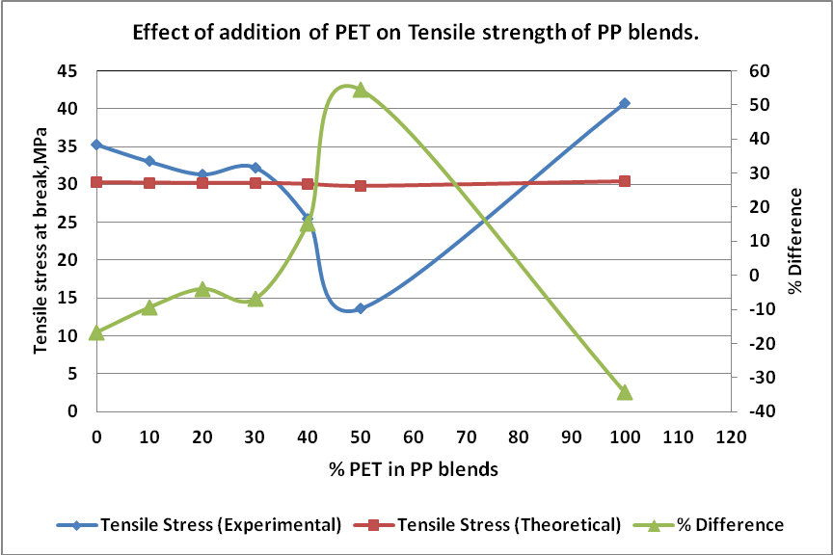
Graph 1: PET versus Tensile strength
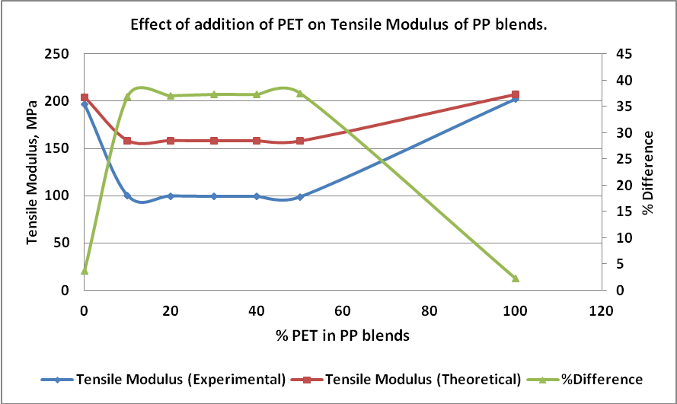
Graph 2: PET versus Tensile Modulus
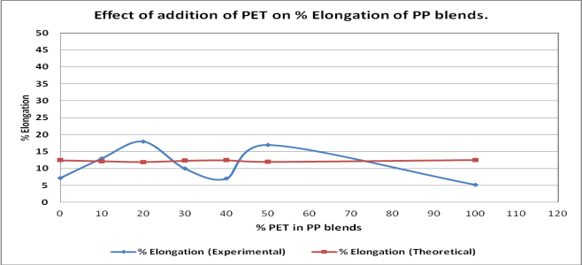
Graph 3: PET versus % elongation
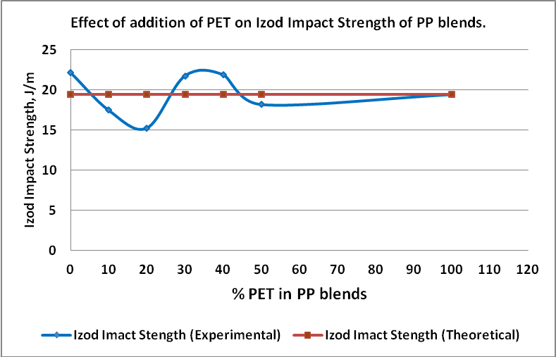
Graph 4: PET versus Impact strength

Table C: Mechanical features of PP - PET composite

Code details | Tensile strength Mpa |  |  | Tensile Modulus Mpa |  |  | %  elongation |  | Impact Strength( Izod) - J/m |  | ShoreD Hardness
 | theoretic | Test Values | Percentage variation | theoretic | Test Values | Percentage variation | theoretic | Test Values | Percentage variation | theoretic | Test Values | Percentage variation
Neat PP | 30.27 | 35.29 | -16.71 | 204.26 | 196.64 | 3.74 | 12.47 | 7.21 | 19.47 | 22.181 | 71.16 | 64.09
PEPA | 30.22 | 33.1 | -9.39 | 158.411 | 99.97 | 36.90 | 12.19 | 13.01 | 19.48 | 17.490 | 71.50 | 70.01
PEPB | 30.18 | 31.35 | -3.89 | 158.302 | 99.74 | 37.02 | 11.95 | 18.02 | 19.48 | 15.28 | 71.50 | 70.01
PEPC | 30.20 | 32.28 | -6.90 | 158.03 | 99.16 | 37.35 | 12.31 | 10.01 | 19.47 | 21.77 | 71.49 | 70.03
PEPD | 30.06 | 25.49 | 15.19 | 158.04 | 99.18 | 37.34 | 12.49 | 7.05 | 19.47 | 21.97 | 71.44 | 69.01
PEPE | 29.81 | 13.68 | 54.42 | 157.80 | 98.64 | 37.47 | 11.99 | 17.05 | 19.48 | 18.21 | 71.62 | 72.03
Neat PET | 30.38 | 40.80 | -34.32 | 206.98 | 202.46 | 2.21 | 12.57 | 5.21 | 19.47 | 19.45 | 71.62 | 72.03

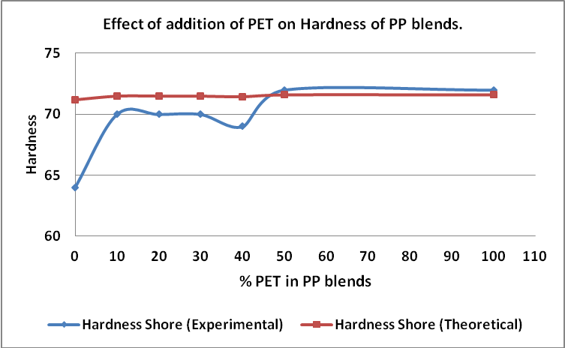
Graph 5: PET versus hardness

On the basis of the test values of mechanical features of diversifying Polypropylene and Polyethylene terephylate composite ,manifest that the loading of PET increases than Ts depletes in all composites. Despite of , composites above 1200 gram of PET loading observed that Ts is correspondent to the neat polypropylene. Estimation of theoretic values done by rule of mixtures of the composites . Test values and theoretic values of the composites moreover remarkably nearer excluding the results of PEPD plus PEPE. Signifying scarcity of miscibility presented poor Ts in composite PEPD plus PEPE. Increment in PET and its result on Ts and on the basis of graph upon the theoretic results overlying over it is as shown in graph 1.Test result and theoretic result somehow remains nearer when the composite constituent is miscible herewith. Binary stage of the composites material discussed by Anna Ujhelyiová et al (2007) [11]. May be accountable for this manner. From the graph 2, it is observed that the test result of Tensile modulus

decrease in the entire composite which is validated by the test result of Ts. For such manner possibility of incoherence in the composites is accountable . Hike in % elongation proved uppermost amongst neat constituent as shown in graph3. The straightening of the polymeric chain which are initially may be in the twisted condition is the probable reason for the rubbery behavior of the newly formed blend. PEPE found elastic attribute as compare with rest of the composites. From the graph 4 it is found by theoretic that impact results of the test were imminent impact result of PEPC and PEPD along with neat polypropylene. Neat PET has higher hardness than neat PP whereas the test values of hardness of all the composites were observed nearer to the neat PET which is displayed in graph 5.

Physical Properties of PP-PET composite- High strength to weight ratio is always in demand for various industrial applications and density is important feature for these application.
Table D: Physical features of PP-PET composite
Composite details | Density gm/cc
Neat PP | 0.91
PEPA | 0.87
PEPB | 0.95
PEPC | 1.04
PEPD | 1.04
PEPE | 1.07
Neat PET | 1.35

The test result of density in all the composites signifies the progressively decreasing order by the increase loading of PET where as PEPA has found to be lowest density amongst all the composites. Strength per weight ratio in the material is always important factor in product designing. Composite feature of PP and PET showed these properties whereas, evident on the basis of the values mentioned in table D

Rheological Properties of PP-PET blend- Properties regarding melt flow index of diversifying composites and along with neat PP and neat PET mentioned in table E.As perceived from the properties of MFI , increase loading of PET material Rheology properties of the constituent enhanced .Discontinuity of the polymeric chains in the composite material is clear by test values. Reported by Bremner, T.; A. Rudin [12][13] for as much melt flow index and molecular weight has converse association. Same matter expressed by the researches which are as (1/Melt Flow Index = Shear modulus(G) * Molecular weight(Mxw).From the results of MFI it appears that the viscosity be in decreasing side which correlates to the high in extrusion rates and long injection length.

Table E: Rheological Properties of PP-PET blend

Composite details | Melt Flow Index gm/10min
 | Theoretic | Test value
Neat PP | 29.64 | 11.01
PEPA | 40.31 | 28.57
PEPB | 55.08 | 52.93
PEPC | 48.49 | 42.06
PEPD | 55.7 | 53.96
PEPE | 47.46 | 40.39
Neat PET | 23.02 | 0.06

Differential Scanning Calorimeter of PP-PET blend- Analysis of neat Constituent and different composites were done by Differential Scanning Calorimeter as displayed in figure (1) ,(2) ,(3) .Non compatibility of the material is correlated with the two isolated heat absorbing peaks displayed in figure (3). The similar test results of melt temperature of the composite constituent is showed in Table F. Mechanical features are complemental by these observations as expressed above and also manifest the binary nature of the composites

Table F: Differential Scanning Calorimeter of PP-PET Composite

Composite  details | Glass Transition |  | Melt temperature |  | Melt temperature
 | X(melt temperature) | Y(Heat flow) | X(Melt temperature) | Y(Heat flow) | X(Melt temperature) | Y(Heat flow)
Neat PP | -78.413 | -0.154 | 165.804 | -10.755 | _____ | _____
PEPA | 27.678 | -1.436 | 164.327 | -7.446 | 251.614 | -3.85
PEPB | 28.765 | -1.071 | 164.642 | -1.619 | 251.554 | 3.053
PEPC | 27.865 | -1.467 | 163.415 | -6.444 | 250.51 | -4.194
PEPD | 28.395 | -1.551 | 163.583 | -6.104 | 251.355 | -4.554
PEPE | -78.413 | -0.154 | 165.807 | -10.755 | _____ | _____
Neat PET | 27.664 | -1.25 | 249.537 | -5.593 | _____ | _____

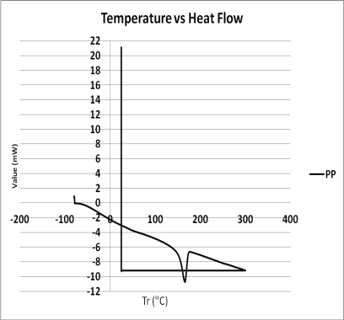
Figure (1)
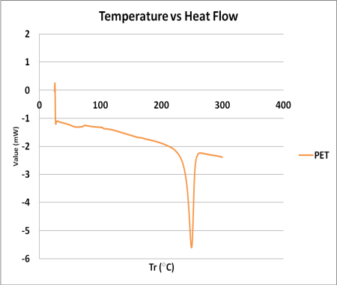
Figure (2)
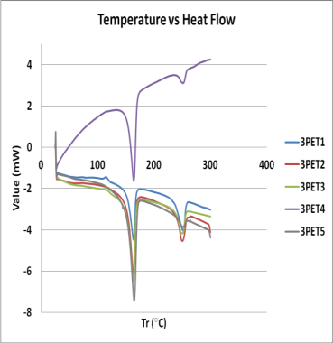
Figure (3)
Figure (1), (2) and (3) DSC Analysis of neat PP, PET and PP-PET composite.

Structural Properties of PP-PET blend- Compositional properties and structural properties Morphological features about neat materials are as sighted in figure(4), (5) and (6) . Viewed, the nature of neat polymeric material as partially crystalline . Table G stated the feature of the humps Characteristic peak positions into neat PET. By comparison with the neat polymers and composites minor ordered variation in peaks marked in composites. Furthermore , noticed that that the peaks of the newly manufactured composites are nearer to the neat PET. Distinct positions of the peak of new manufactured composites signifying partial crystalline nature and additional bonds formation have clearly anticipated on the basis of observational evidence.
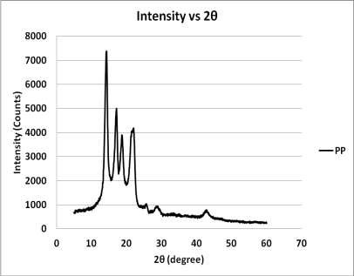
Figure 4.7(a)
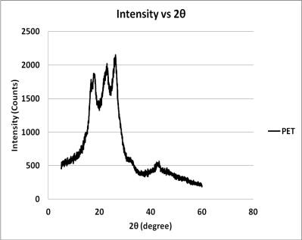
Figure 4.7(b)
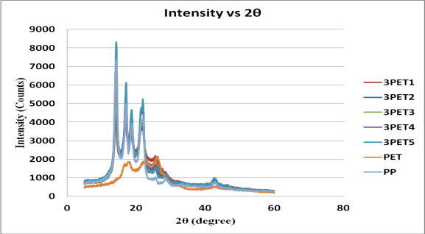
Figure 4.7 (c)
Figure (4), (5) and (6): X Ray Diffractograph of neat PP ,neat PET and new synthesised composites.

Table G: Structural Properties of PP-PET composite

Code details | PEAK 1 |  | PEAK 2 |  | PEAK 3 |  | PEAK 4 |  | PEAK 5 |  | PEAK 6 |  | PEAK 7
 | X | Y | X | Y | X | Y | X | Y | X | Y | X | Y | X | Y
Neat PP | 17.841 | 1866 | 22.883 | 1984 | 26.091 | 2101 | 42.701 | 5274 | 17.841 | 1866
PEPA | 14.272 | 8286 | 17.111 | 6124 | 18.701 | .465 | 22.009 | 5226 | 25.649 | 1535 | 28.711 | 1202 | 42.939
PEPB | 14.272 | 7342 | 17.086 | 5647 | 18.745 | 4472 | 21.864 | 4775 | 25.811 | 0.161 | 28.721 | 1166 | 42.641
PEPC | 14.306 | 5969 | 17.142 | 4648 | 18.611 | 3778 | 21.891 | 0.391 | 25.663 | 1717 | 42.793 | 793.28
PEPD | 14.181 | 4660 | 17.03 | 4212 | 18.583 | 3457 | 21.632 | 3754 | 25.321 | 1815 | 28.581 | 1169 | 42.772
PEPE | 14.170 | 4143 | 16.97 | 4035 | 18.651 | 0.331 | 21.815 | 0.32 | 25.581 | 2180 | 42.881 | 814.832
Neat PET | 14.298 | 7346 | 17.121 | 4984 | 18.663 | 3827 | 21.764 | 4053 | 25.672 | 1035 | 28.682 | 908.561 | 42.881 | 757.676

CONCLUSION
This experimentation was performed by the intend of merging commodity resin by engineering polymeric material. From the tensile strength accomplished that adhesion of the two constituents is moderately poor as of the composites. The similar was correlated by thermal studies i.e DSC. Partial crystalline manner of the composites gives sign for ability of increasing mechanical properties of PP-PET composite. The miscibility of the composite desire to be increase by utilizing appropriate coupling agent. Accomplished precisely that, PET absorption above 1200 gram is desired to enhance mechanical characteristics. Tensile modulus , , % elongation ,Tensile strength of PEPA, PEPB and PEPC are obtained to be supreme as compared to the remaining composite. Composite PEPC holding outstanding impact strength over PEPA and PEPB. Viscidity in all the composites require melioration and coupling agent will assist in escalating the chain length which in turn will be supportive for improving kinetics of the flow properties of the PP-PET blends.
ACKNOWLEDGEMENTS
The authors are grateful to UGC-DAE Consortium for Scientific Research, Indore(MP) for giving facilities of DSC and XRD.

REFERENCES

[1] Growth opportunities for PP resin in the Global Composite Industry,2016, Luncintel, Market research and management consulting.

[2] Hisham A.Maddah,” Polypropylene as a Promising Plastic: A Review”, American Journal of Polymer Science 2016,6(1):1-11

[3] G.M.Shashidhara et al,(2009), ”Effect of PP-G-MAH compatibilizer content in polypropylene / nylon -6 blends.”Polmer bulletin(2009),63:147-157.

[4] Mehdi Afshari et. al, ”Effect of blend ratio on bulk properties and matrix – fibril morphology of polypropylene/nylon 6 polyblend fibers”. Journal of Polymer 43(2002) 1331-1341.

[5] SOMIT NEOGI et. al,” Role of PET in improving wear properties of PP in dry sliding condition” . Bull. Mater. Sci., Vol. 26, No. 6, October 2003, pp. 579–583. © Indian Academy of Sciences ,pp-1468-1476.

[6] Renato Carajelescov et al,” A study of PP/PET Composites:Factorial design,mechanical and thermal properties”,Journal of Polymer testing 56(2016) 167-173.

[7] Tadashi Otsuka et al ,” Barrier , adsoptive, and Mechanical Properties of Containers Molded from PET/PP Blends for use in Pharmaceutical Solutions”, Journal of Materials Science and Applications,2013,4,589-594.

[8] G.N.Onyeagoro et al ,” Properties of Reactive Compatibilized Dika Nutshell Powder filled Recycled Polypropylene (PP)/Polyethylene Terephthalate (PET) Biocomposites using Maleated polypropylene and Epoxy resin Dual Compatibilizers” American Journal Of Engineering Research ,Volume-2,Issue-4,pp-158-169,2013.

[9] A.Elamri et al,”Characterization of Recycled /Virgin PET Polymers and their Composites”,American Journal of Nano Research and applications,2015;3(4-1):11-16

[10] Quasi T.H.Shubra et al,”Mechanical Properties of polypropylene composites :A review”.Journal of Thermoplastic composite material,1-30,2011

[11] Anna Ujhelyiová et al (2007) Blended Polypropylene/Polyethylene Terephthalate Fibres: Crystallization Behaviour of Polypropylene and Mechanical Properties, FIBRES & TEXTILES in Eastern Europe October / December 2007, Vol. 15, No. 4 (63).

[12] Bremner, T.; A. Rudin, Melt Flow Index Values and Molecular Weight Distributions of Commercial Thermoplastics. J. Appl. Polym. Sci. 1990, 41, 1617-1627 .
[13]Bremner, T., Cook, D.G., Rudin, A. “Further Comments on the Relations between Melt Flow Index Values and Molecular Weight Distributions of Commercial Plastics,” J. Appl. Polym. Sci. 2003, 43, 1773

