Postpartum Depression Predictor using Machine Learning
1. Mast. Prasad V. Gade 2 Mr. Sunil H. Sangale
Student Lecturer
prasadgade4405@gmail.com shsangale@kkwagh.edu.in

3. Mast. Kalash S. Baldota 4. Mast. Yash C. Bagale 5. Miss. Anushka B. Kolhe
Student Student Student
kalashbaldota604@gmail.com bagaleyash20@gmail.com anushkakolhe28@gmail.com

Received on: xxxx,20xx, Revised on: xxxx,20xx, Published on: xxxx,20xx

Abstract –Postpartum depression(PPD) is a mental health issue affecting new mothers after giving childbirth due to changes in their emotional and physical state. Postpartum depressions are common, affecting at least 10% mothers worldwide. PPDs are usually hard to predict and have complex symptoms. This paper presents a novel approach to addressing postpartum depression through an AI based system that analyzes the symptoms and predicts the likeliness of PPD via machine learning approaches. Specifically, we aim to compare multiple machine learning techniques including decision tree, random forest, logistic regression and XG Boost to identify the most effective algorithm. This system utilizes machine learning algorithms trained on a dataset to predict PPD based on the symptoms provided as an input to it. This study compares multiple algorithms for accuracy, ultimately selecting and optimizing the decision tree model. The resulting system demonstrates promising capabilities of the model in predicting postpartum depression.
Keywords- Postpartum Depression(PPD), Machine Learning, Decision Tree.

INTRODUCTION
Postpartum depression is a prevalent and debilitating mental health condition that affects a significant number of new mothers worldwide, its prevalence has increased from 13% to 17% from 2013 to 2018. PPD is serious because of its impact on the mother-child relationship and the child’s development. It is characterized by a number of symptoms including persistent feeling of sadness, feeling irritable towards baby, anxiety, having trouble sleeping to name a few. It not only affects the development of the infant but also impacts the overall family dynamics.
Despite its prevalence and potential consequences PPD often goes undiagnosed potentially due to many factors including lack of awareness, stigma reliance of traditional diagnosing methods on resource extensive and time consuming clinical assessments, which may not accurately capture the full spectrum of symptoms or may be limited by the availability of trained healthcare professionals.
In recent years there has been a growing interest in leveraging machine learning techniques to address mental health challenges including postpartum depression. These techniques offer the potential of early detection of such mental health issues, improving the diagnostics.
This paper contributes to this field by proposing a machine learning based approach to predict postpartum depression in new mothers. Specifically, we aim to train and compare multiple machine learning algorithms, including decision tree, random forest, logistic regression, and XG Boost, to identify the most effective algorithm for PPD prediction to identify the most effective algorithm in detecting postpartum depression. By leveraging a curated data set containing relevant features associated with postpartum depression.
The findings and inferences of this study have the potential to inform the development of a more accurate, personalized and scalable AI based systems for diagnosing postpartum depression, ultimately leading to early intervention and improved outcomes for mothers and their families affected with PPD, we aim to overcome the limitations of traditional diagnosis which are time and resource expensive clinical assessments.
LITERATURE REVIEW
The analysis of existing research papers and development work done in the field of using AI based systems to diagnose mental health issues highlights that several studies have demonstrated the effectiveness of AI based approaches such as using natural language processing (NLP) for sentiment analysis, use of support vector machine (SVM) to predict postpartum depression in a convenient and effective way also several machine learning algorithms have been promising in the area.
Techniques such as Naïve Bayes algorithm and the Support Vector Machine have been showing promising results for detecting depression, Where the data was collected from the users posts from social media sites such as X (Formerly Twitter) and Facebook [1]
The posts of users on Reddit and X (formerly Twitter) were processed and used as inputs to feed forward neural networks which revealed the probability of the user suffering from a mental condition such as depression. The accuracy of such feed forward neural networks have been recorded to be pretty high. The researchers have also proposed that these methods can be used for further development and research purposes on a large scale [2].
A preprocessed dataset that contained token list was used in order to detect mental health conditions such as depression. The use of techniques such as natural language processing helped perform sentiment analysis of posts of user from various social media sites. The performance metrics of this system have been published with parameters such as accuracy, precision, recall and macro average, weighted average [3].
A strategy utilizing multilayer perceptron (MLP) to anticipate postpartum discouragement (PPD) was proposed [4]. The demonstrate experienced preparing utilizing information from 1397 Spanish ladies and was developed as a completely associated feed-forward multilayer perceptron with pruning calculations. At first, a subject demonstrate missing a pruning demonstrate accomplished a tall affectability of 0.84 in foreseeing postpartum discouragement. Be that as it may, this think about utilized hyperbolic digression as the enactment work, driving to issues such as vanishing slopes and expanded computational complexity. Another system planned for foreseeing postpartum misery hazard utilized information extricated from electronic wellbeing records [5]. Five machine learning calculations were consolidated into this system for forecast. The illustrated execution, as measured by the range beneath the bend (AUC), in both the designer and approval databases, was 0.937 and 0.886, separately. The MLP demonstrate in [4] displayed predominant execution in forecast with a tall exactness level. Outstandingly, both thinks about [4] and [5] exclusively centered on deciding the nearness or nonappearance of PPD as the essential result. In a partitioned think about, MLP, together with bolster vector machine (SVM), was utilized to classify pregnant ladies at tall chance for uneasiness and antenatal sadness based on a database of 500 ladies from Pakistan [6]. The MLP and SVM models illustrated AUCs of 88% and 80% for antenatal discouragement and 85% and 77% for pre-birth uneasiness, separately. Another ponder, utilizing a dataset comprising 40 elderly people from an Elderly Care Center in Iran, utilized MLP with the sigmoid work, accomplishing an exactness of 94.79% in diagnosing sadness [7].
METHOLOGY
The proposed system aims to develop an efficient and accurate machine learning model that can predict postpartum depression in new mothers based on the symptoms given.
The system architecture [Fig. 1] demonstrates the work flow of the model, an application will be created for interacting with the user and using the curated and preprocessed dataset a questionnaire will be generated which will gather the information about symptoms from the user. These inputs gathered from the user will be fed to the machine learning model as an input which will predict whether the user is suffering from postpartum depression.
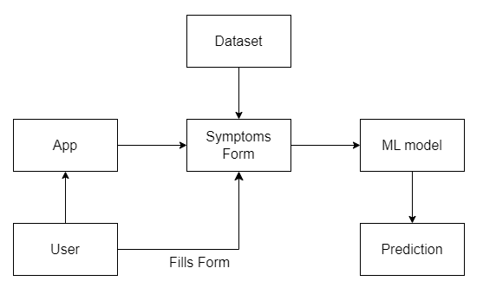
Fig. 1- System Architecture
The development of machine learning model includes various steps such as data preprocessing, feature selection, model training and testing, hyper parameter tuning. Figure [Fig. 2] below demonstrates this process.
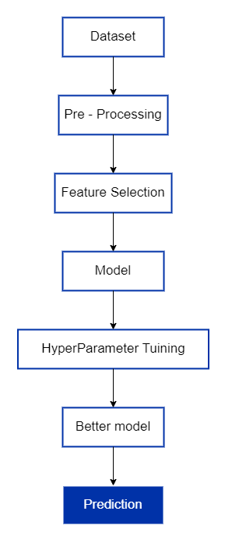
Fig. 2- Methodology of Predictive ML Model
Feature selection, it is a process that involves identifying the most relevant features (symptoms in this case) associated with PPD. Through techniques such as mutual information analysis and SelectKBest, the system selects a subset of features that exhibit the strongest predictive power.This system utilizes multiple machine learning models namely random forest, decision tree, logistic regression and XG Boost for predicting postpartum depression. These algorithms are trained on the curated dataset that consists of the features from the process of feature selection. After training these models are evaluated based on their accuracy.
Hyper parameter tuning is performed on the best performing model from the above four in order to optimize its performance. Techniques such as Grid search and cross validation are utilized to fine tune the hyper parameters of the decision tree model such as maximum depth, maximum samples leaf and criterion.
Finally, the results of testing the model are represented visually using the confusion matrix and factually using various performance metrics such as accuracy, precision, recall and f1 score.
IV. RESULT & DISCUSSION
After the development of 4 machine learning models each created using a different algorithm here is the comparison of accuracy of each of them
Accuracy of Random Forest Classifier = 67.8571 %
Accuracy of Logistic Regression classifier = 47.0982%
Accuracy of Decision Tree Classifier = 68.3035%
Accuracy of XG Boost Classifier = 67.8571%
Inference: The randomness of data is quite high. Therefore, the accuracy is little low than expected after feature selection.
Random Forest Classifier, Decision Tree Classifier, XG Boost Classifier show almost 68% accuracy. With decision tree being more accurate.
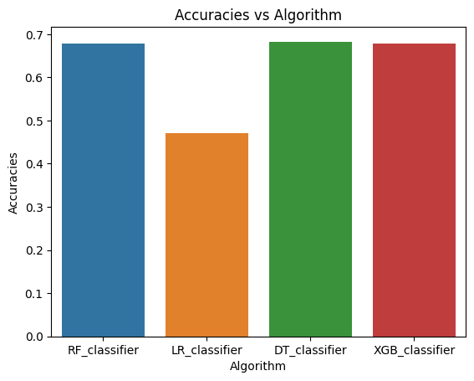
Fig. 3- Accuracies of Algorithms
From the process of hyper parameter tuning of the decision tree model the following results are achieved
Accuracy of the model = 84.375%
The predictions vs actual class of the predictions made by this tuned model are shown in the fig.4 below with the help of a confusion matrix.
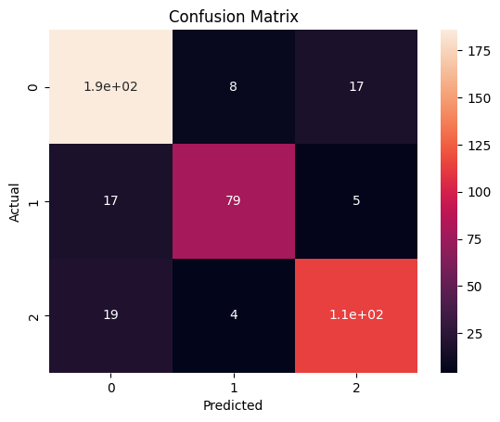
Fig. 4- Decision Tree Model Confusion Matrix
The classification model experiment results are shown in the table below:
Table 1- Decision Tree Model Performance Metrics
 | Precision | Recall | F1-score | support
0 | 0.87 | 0.85 | 0.86 | 211
1 | 0.80 | 0.84 | 0.82 | 101
2 | 0.83 | 0.84 | 0.84 | 136
Accuracy |  |  | 0.84 | 488
Macro avg. | 0.84 | 0.84 | 0.84 | 488
Weighted avg. | 0.84 | 0.84 | 0.84 | 488
Applications:
1. Early Intervention Programs: Enable healthcare providers to identify at-risk mothers promptly, facilitating timely interventions to mitigate the effects of postpartum depression on maternal and infant well-being.
2. Telemedicine Platforms: Integrate the predictive model into telemedicine platforms to remotely screen and monitor postpartum depression risk, enhancing accessibility to mental health care for new mothers.
3. Maternal Health Screenings: Incorporate the model into routine maternal health screenings to augment traditional assessment methods, improving the accuracy and efficiency of postpartum depression detection.
4. Research Studies: Facilitate research endeavors by providing a standardized and objective tool for assessing postpartum depression risk, contributing to the advancement of knowledge in maternal mental health.
CONCLUSION
This paper presents the approach of predicting mental health issues, postpartum depression in this case with the help of machine learning algorithms. This paper depicts the approach for developing such prediction models in sector of health field. It also demonstrates the comparison of 4 different machine learning models and then fine tuning the best from those models to get an even more accurate and more efficient model.
ACKNOWLEDGMENT
I would like to show my sincere gratitude towards Mr. S. H, Sangale Lecturer, Department of Computer Technology, K. K. Wagh Polytechnic, Nashik and Mrs. M. A. Shaikh, Lecturer, Department of Computer Technology, K. K. Wagh Polytechnic, Nashik for their valuable guidance and encouragement.
REFERENCES
- N. A. Asad, M. A. Mahmud Pranto, S. Afreen and M. M. Islam, "Depression Detection by Analyzing Social Media Posts of User," 2019 IEEE International Conference on Signal Processing, Information, Communication & Systems (SPICSCON), Dhaka, Bangladesh, 2019, pp. 13- 17, doi: 10.1109/SPICSCON48833.2019.9065101..
- Yates, A., Cohan, A., and Goharian, N.: Depression and self-harm risk assessment in online forums. arXiv preprint arXiv:1709.01848 (2017).
- M. Deshpande and V. Rao, "Depression detection using emotion artificial intelligence," 2017 International Conference on Intelligent Sustainable Systems (ICISS), Palladam, 2017, pp. 858-862, doi: 10.1109/ISS1.2017.8389299.
- ] S. Tortajada et al., “Prediction of postpartum depression using multilayer perceptrons and pruning,” Methods Inf. Med., vol. 48, no. 3, pp. 291–298, 2009, doi: 10.3414/ME0562.
- Y. Zhang, S. Wang, A. Hermann, R. Joly, and J. Pathak, “Development and validation of a machine learning algorithm for predicting the risk of postpartum depression among pregnant women,” J. Affect. Disord., vol. 279, pp. 1–8, Jan. 2021, doi: 10.1016/J.JAD.2020.09.113..
- F. Javed, S. O. Gilani, S. Latif, A. Waris, M. Jamil, and A. Waqas, “Predicting risk of antenatal depression and anxiety using multi-layer perceptrons and support vector machines,” J. Pers. Med., vol. 11, no. 3, Mar. 2021, doi: 10.3390/jpm11030199.
- M. Mirza, “Detecting Depression in Elderly People by Using Artificial Neural Network,” Elder. Heal. J., Dec. 2020, doi: 10.18502/ehj.v6i2.5017.

