Static analysis of tungsten carbide chaff cutter blade by finite element method
Dr.Hemant R.Nehete¹, Dr.Nilesh Diwakar²
¹Assistant Professor, Department of Mechanical engineering, Godavari college of engineering, Jalgaon,Maharashtra ²Professor, Department of Mechanical engineering, RKDF Institute of science & Technology, Bhopal,M.P
Email:hrn.srkphd@gmail.com

“Received on: xxxx,20xx, Revised on: xxxx,20xx, Published on: xxxx,20xx”

Abstract –, A waste shaper is utilized to cut the debris ,sugarcane likewise stem, resulting in improved creature processing. Because of this the refuse is cut into tiny pieces. This debris and roughage assumes a vital part in horticulture creation. In this paper we need to further develop the edge life by utilizing various materials, different slope points and different sharp edge thickness and cutting edge thickness. In this paper we utilized tungsten carbide cutting edges. In this paper our primary point is to build the efficiency. We can do pressure examination by ANSYS programming and furthermore by UTM.
Keywords- thickness, material, edge, carbide
INTRODUCTION
A Waste shaper is mechanical gadget used to cut the straw or roughage into little pieces an effective method for mixing it together and took care of to steers. This works on creature processing and hinders creature from dismissing any a piece of their dinners. As in sync with nowadays' situation the general population of bison and livestock is quite broadened. So to development the efficiency and abatement the actual exertion expected for running the gadget the mechanized apparatuses came into ways of life it's far perfect for dairy ranchers. By and by grain cutting machines are electric pushed as well as hand worked or motor pushed.
The assorted kinds of grub might be handled on this gadget are rummage grass, unpracticed grass, dry corn straw, and wheat tail. The last product might be utilized to take care of domesticated animals, goats, deer, and

ponies. It can likewise framework cotton tail, bark, little branches, they can likewise be utilized to produce strength, and to make paper. Waste cutters have grown bit by bit from the essential machines into business well known machines that might be driven at various velocities with the expectation to acquire various lengths of slices of debris with perceive to creature decision type. New refuse shaper machines incorporates versatile farm hauler driven waste shaper - in which debris shaper might be in the discipline and freight streetcars.
The current green grub cutting machine includes a solitary, just pole molded cut green feed, green grain can't cut block. Whether laborer family, council or homesteads and deals markets are needing a new, reasonable, practical and greener grain shaper. The number of inhabitants in dairy cattle in India in 1987 was 274 million. For such sort of populace customary human
fueled grub cutting machines were utilized, yet because of this the endeavors for running the machine was truly requesting. So to expand the efficiency and lessen the actual exertion expected for running the machine the mechanized hardware appeared.
II. LITERATURE REVIEW
The debris shaper machine's adjustment was the subject of Nilesh Sankpal et al. [1]. They continuously develop machines, starting with basic ones and ending with standard machines that can run on electricity. They develop this machine to achieve varying debris cutting lengths based on inclination. They modified this device to achieve grass blockage and minimize its impact.
An analysis of the design and modification of a debris cutting machine is presented by Sanjay Patil et al. [2]. They alter the design of the trash shaper so that the rancher can grind other waste materials such dried corn straw, grass, soyabene, and wheat tail in addition to cutting the sugarcane into a structure that animals can consume. As a result, less effort is done by humans and more feed is produced. They employ different kinds of edges to collect different kinds of waste for animals.
Making minor adjustments to the debris cutting machine, Anna Sarak et al. [3]. With the help of this modified waste-slicing machine, ranchers can chop various maintenance materials like wheat tail, grass, and sugarcane top. In this instance, the electric engine is replaced with a spring instrument, requiring less work and providing effortless access to springs. There is not a single fossil fuel present. It is also operated by physical labor. It consistently chops the stuff. It requires little assistance and is robust and trustworthy.
A detritus cutting machine is fostered by Mr. P.B. Patil et al [4]. While they were eating, they glanced through that, creatures discarding more trash. They waste between 40 and 50 percent of the refuse. It's a very big misfortune. Some ranchers also use the traditional method of chopping the debris to prevent this waste of refuse. Certain ones employ machines similar to debris shapers.
This kind of Debris is a lot of fundamental for quicker development of goats and boats. It can likewise be utilized for creature like pony too. So it is a lot of fundamental for fabricate a machine to cut the wet Refuse too. It ought to be sliced in size of up to 3-4 crawls long. Machine shouldn't make slurry and wastage of that Debris.
P. B. Khope, J. P. Modak [5] addresses the turn of events and execution of a Human Controlled Flywheel Engine (HPFM) worked manufacture shaper. This set-up is utilized to cut crop buildups like maize stovers, sorghum stovers in dry condition. This slice stovers can be taken care of to dairy cattle straightforwardly.
K. S. Zakiuddin, J. P. Modak [6] expressed that a debris shaper is a mechanical gadget used to cut the straw or roughage into little pieces to combine it as one with other scavenge Refuse and took care of to ponies and dairy cattle. This works on the creature's absorption and keeps creatures from dismissing any piece of their food.
Dinesh Mohan et al [7] has addressed paper on investigation of wellbeing highlights in grub cutting machine. An epidemiological review done in north India showed that all age bunches sus-tain grub shaper wounds while working the machine. They introduced paper on wellbeing systems for running the feed cutting machines.
Prof.J.G.Shinde, Prof.S.V.Pandit [8] foster a waste shaper in a basic development. They plan the machine with the end goal that it will require least space. As the engine is set inside the machine stand not external the machine, the space is significantly saved. To build the efficiency and lessen the actual exertion expected for running the machine the mechanized apparatuses appeared it is best for dairy ranchers. As of now grain cutting machines are electric driven as well as hand worked or
motor driven.
ChinmayBandiwadekar et al [9] planned an exceptional purposed limited scope machine for limited scope ranchers who have prerequisite to take care of their steers on everyday schedule in little to medium premise. They made sense of in this paper that, the machine has little aspects contrasted with tradi-tional 'kadbakutti' machine, the energy expected for our machine is less and chips away at single stage, the moving pieces of the machine are totally covered so activity of mama chine is protected. Because of new cutting innovation the mileage of the edges is immaterial then again customary machine requires incessant honing of sharp edges. The expense would likewise be less once it is efficiently manufactured.
P.B.Khope, J.P.Modak [10] gives result of their exploration that, the utilization of human controlled flywheel motoras an energy hotspot for rustic age of electrical energy for provincial applications alongside PC supported examination of battery charging process.
Jizhan Liu, Zhiguo Li, Pingping Li, and Hanping Mao [11] planned a laser stem cutting gadget for reaping robot. In this paper a laser stem-cutting gadget for natural product reaping robot was planned, which incorporates a laser age and control unit and an impelling system. a laser stem-cutting gadget for natural product reaping robot was planned, which incorporates a laser age and control unit and an inciting component. A 30W high-power fiber-coupled laser diode is chosen, and it is provided with a lithium battery whose bit by bit dropped voltage is gone to consistent current by a steady current inventory circuit. In the security/control circuit, two-step slow beginning of the laser diode is accomplished by a RC defer circuit and a postpone transfer circuit. To remove stems, the zeroing in focal point introduced on the end-effector of gathering robot and associated with the laser by a fiber is driven by a Maxon small scale DC engine through a heading structure. Tests show that this gadget functions admirably and actually.

III. NOTEWORTHY CONTRIBUTION IN THE PREVIOUS WORK
In the past work (Nilesh Sankpal, Vaibhav Powar et al.) , a waste shaper is changed to work on the efficiency. The machine require least space. Twofold honing edges are utilized. Powder scoating packaging is accommodated security. Feed cutting rate is 300kg/hr. There is a course of action of forward and switch pivot of cutting edges.
In the past work (Anna sarak, Aniket Shinde et al.) the various sorts of sharp edges are utilized, to acquire various kinds of debris for creatures. Likewise the in the past work, an electric engine is supplanted by spring system and they required less exertion for that since spring is accessible without any problem. So in that work, they utilize zero petroleum product. The machine has capacity to cutting grass 144kg/hr.
In the past work (Mr.P.B.Patil, Mr.P.V.Mali et al.), the waste shaper machine is changed for its conservativeness and for staying away from blockage of grass. In this for 50 N-m force they select 2HP engine. In this there is a game plan of stuff, belt and pulley, and orientation. So the refuse shaper has less clamor and less weight because of cog wheels and because of smallness. In this work twofold honing cutting edges are utilized.
In the proposed work , for expanding the efficiency and decrease in actual exertion, a few mechanized machines are existing. These machines are electric driven as well as hand worked or motor driven. As the engine is set inside the machine stand not external the machine, the space is extensively saved. To build the efficiency and diminish the actual exertion required forrunning the machine the mechanized apparatuses appeared it is best for dairy ranchers.
In the past work (Jayant P Modak, zakiuddin syedkazi ), there is human empowered debris shaper. Their idea is normal work pace of man working constantly equivalent to 0.13 HP. The flywheel is utilized as a power source and labor supply is expected to stimulate the flywheel. Furthermore, when energy is put away in flywheel then it is provided through grasp and outfitting unit to the shaft.
In the proposed work (Dinesh Mohan, Adarshkumar et al.) , a waste shaper is created to keep away from serious wounds to hands of the two grown-ups and youngsters in the town of north India. In grown-ups injury occure during taking care of side. They are doing a creations in their work to stay away from wounds. In that work they utilize cautioning roller, cutting edge wellbeing monitor, gear cover, flywheel locking pin, finger watch.
In the past work(Chinmay Bandiwadekar, Ajinkya Kambale et al.) another machine is intended for little ranchers who have little to medium premise day to day necessity to take care of the steers. This machine deals with single stage and energy expected for the machine is less. They covered every one of the moving parts so it is protected to utilize. In their work the mileage of edges is immaterial.
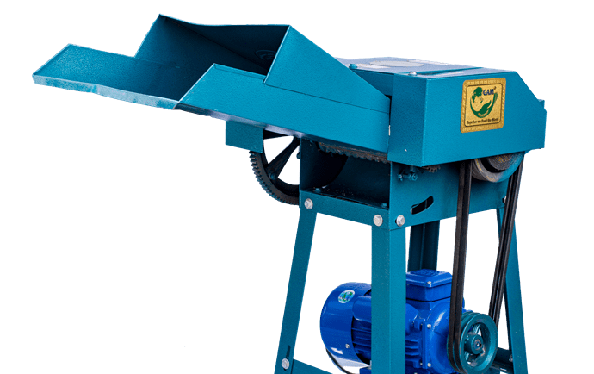
Fig.1 High speed chaff cutter

IV. KINEMATICS OF CUTTING
During cutting of chaff, one kinematic relations obtained are as showing in figure.
V1 is circumferential velocity during cutting edge rotates around point ‘O’
V₂ = Tangential Component
V_{n} = Normal Component
tanθ = $\frac{V_{2}}{V_{n}}$ ₌ $\frac{C_{1}}{\sqrt{{Cr}^{2}-C^{2}}}$
tanθ is sliding coefficient.
The force F acting at point D is
F =F₁+F₂ = N₁cosθ + T₁cosθ
Where,
N₁ = P.l
Force N1 acts normally to cutting edge.
T ₁ is tangential force and T₁ = μN₁
μ is coefficient of Friction
The peripheral force F is
F = F.l (cosθ + μsinθ)
This is obtained by combining eq. II, III and IV
Deformation coursed by Cutting –
Due to penetration of blade during cutting process, the material suffer from deformation. N₁ is normal force acting on inclined face of blade.
N₁ =F_{v} sinθ +F_{h} cosθ
F_{v} = Vertical force component in Newton.
F_{n} = horizontal force component in Newton.
θ = blade bevel angle
Tangential force T₂ on inclined force is
T₂ = μN₁ = N₁ + tanΦ
Where,
μ = tan Φ = coefficient of friction.
$T_{2}^{ǀ}$ is vertical component of force.
Also, $T_{2}^{ǀ}$= (F_{V} sinθcosθ + F_{h} cos²θ)
∴ $T_{2}^{ǀ}$ = μ($\frac{1}{2}$ F_{V} sin2θ + F_{h} cos²θ)
Resisting force F_{e} acting on blade edge during cutting
F_{e} = t.l.b
Where,
t = blade edge thickness. (cm)
l = length of cut. (cm)
b = yield strength of material. (N/cm²)
Equilibirum of vertical force is
F = F_{e}+F_{v}+T₂+$T_{2}^{ǀ}$
The elemental force dF_{V} acting on surface of dx per unit length is
dF_{V} = e.E.dx
e = shear strain
E = modulus of elasticity N/cm²
dF_{V} = (b/d)E tanθ.db
Vertical force F_{V} is
F_{V} = (E/d) tanθ.$\int_{0}^{b}{b.db}$
F_{V} = (E/2d).b² tanθ
The horizontal force is
dF_{n} = VeE.db
V is poisson’s ratio
∴F_{h} = $\left(\frac{VE}{d}\right)$ $\int_{0}^{b}{b.db}$
F_{h} = $\left(\frac{VE}{d}\right)$ .b²
Putting the values of F_{e}, F_{v}, T₂ and $T_{2}^{ǀ}$ in equation V.
At the time of penetration, the force F is
F = t.б +$\left(\frac{E}{2d}\right)$b² tanθ + $\left(\frac{μVE}{2d}\right)$b² + μ [$\frac{1}{2}$F_{V}sin2θ $\left(\frac{E}{2d}\right)$b² tanθ +$\left(\frac{VE}{2d}\right)$b² cos²θ]
F = t.б +$\frac{{Eb}^{2}}{2d}$ [tanθ + μsi$n^{2}$θ + v(μ+co$s^{2}$θ)]
It consists of cylinder, permanent magnet, neodymium magnet, crank, piston, bearings, crank, piston, bearings, DC motor, clamp, socket, wood, screw, spoke, glow gun, M-seal, wire, gear, electric board, nail, bulb, socket.
V. FINITE ELEMENT METHOD
A powerful numerical strategy for handling issues in strong mechanics and physical science is FEA. It is very useful in tackling issues with convoluted designs and strong techniques. It separates a confounded design into reasonable pieces and tackles the issue utilizing a versatility computation. The component makes the aide component experience an equivalent and inverse power and avoidance. Subsequently, a wide assortment of conditions arise and are settled by PCs. Network is a model investigation of complicated framework hubs created by limited component examination. An estimation strategy used to give approximative answers for limit esteem issues is limited component examination (FEA). It utilizes a computational strategy known as the limited component technique (FEM). A PC based plan model is stacked and exposed to a limited component examination to decide indicated results, including pressure, deformity, redirection, regular frequencies, mode shapes, and temperature circulations
VI. STATIC ANALYSIS FOR 2MM THICK BLADE
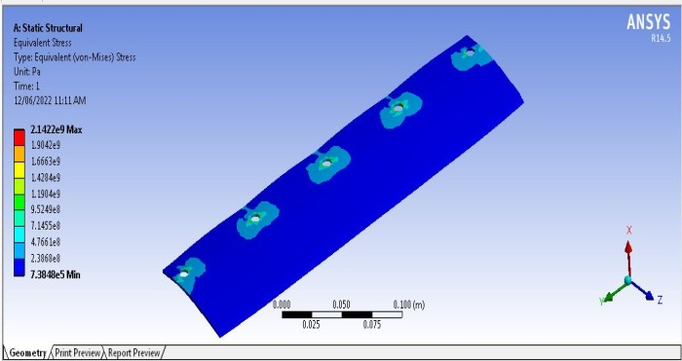
Fig.2stress for 20 degree angle
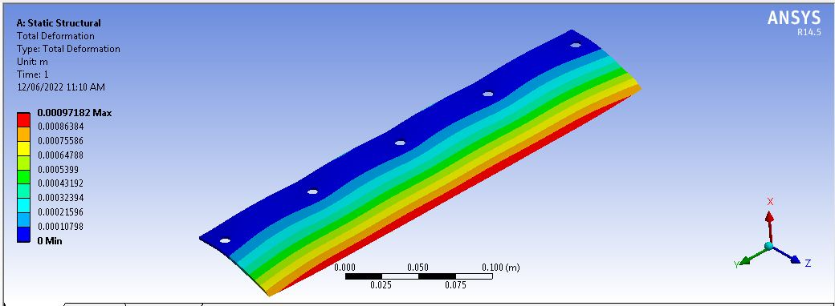
Fig.3 Deformation for 20 degree angle
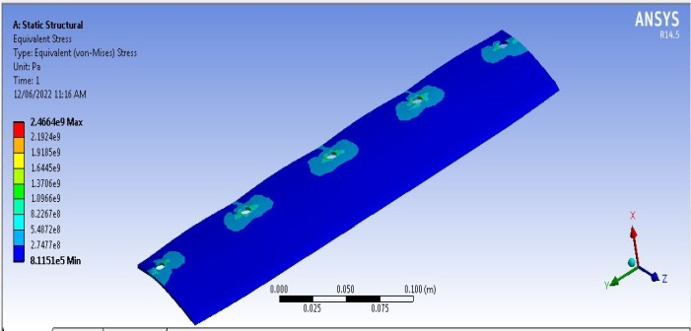
Fig.4stress for 25 degree angle
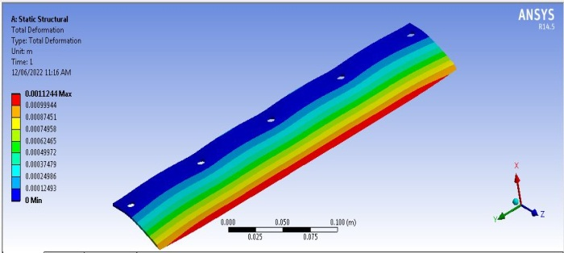
Fig.5Deformation for 25 degree angle
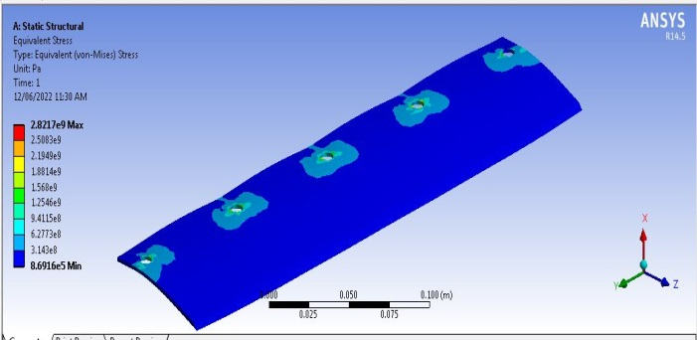
Fig.6stress for 30 degree angle
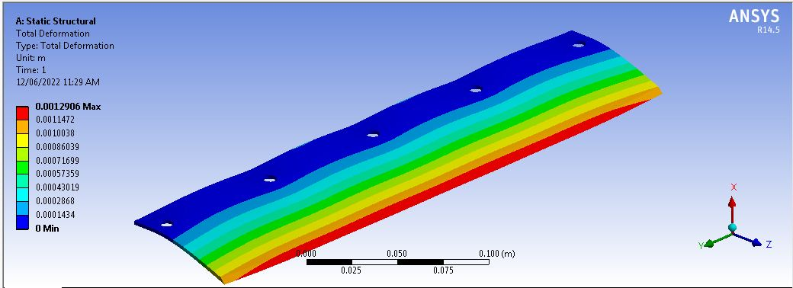
Fig.7Deformation for 30degree angle

CONCLUSION
We are choosing tungsten carbide material for cutting edge for examination with high carbon steel and FRP steel composites. So according to FEA examination of tungsten carbide cutting edges , these cutting edges gives better execution as the pressure and distortion values are least as contrasted and high carbon steel edges. So according to FEA examination these edges are more successful as they have more life expectancy when contrasted with high carbon steel cutting edges. However, tungsten carbide is an extravagant material and sharp edges made by tungsten carbide are exorbitant which can't bear the cost of by ordinary ranchers. Yet, in future in the event that tungsten will be added as an alloying component with different materials and in the event that cost will diminished, it will be the future development
..REFERENCES
[1] Nilesh Sankpal, Vaibhav Powar, Shubham Patil, Kuldeep Salunke, S. V. Pandit (2017), “Design and Modification of Chaff Cutter Machine” International Journal of Innovative Research in Science, Engineering and Technology (An ISO 3297: 2007 Certified Organization) ISSN(Online) : 2319-8753, Issue4, (April 2017)
[2] Anna Sarak, Aniket Shinde, Rohan Kondval, Sanjay Salgar, Parth Mirjkar, A.R. Matkar (2018), “Design and Modification of Chaff Cutting Machine” International Research Journal of Engineering and Technology (IRJET), e-ISSN: 2395-0056 Volume: 05 Issue: 04 (Apr-2018).
[3] Sanjay Patil, Harshkumar Jain, Jayshree Raut, Tushar Kalikate, Viraj Gandhi (2016), “Design & Modification of Chaff Cutting Machine” International Research Journal of Engineering and Technology (IRJET) e-ISSN: 2395 -0056, Volume: 03 Issue: 04.
[4] U.S. Kankal, D.S. Karale, V. P. Khambalkar, S.H. Thakare (2016), “Performance evaluation of power chaff cutter” Engineering and Technology in India; Volume 7 | Issue 1 | April, 2016 | 18-25 ; ISSN-2230-9284 (April, 2016).
[5] Mane Prithviraj Jayendra1 Gajgeshwar Yuvraj Suresh (2020), “Design and Modification of Chaff Cutter” IJSRD - International Journal for Scientific Research & Development| Vol. 8, Issue 2, 2020 | ISSN (online): 2321-0613 (2020).
[6] P.B. Khope and J.P. Modak (2013), “Design of Experimental Set-up for Establishing Empirical Relationship for Chaff Cutter Energized by Human Powered Flywheel Motor” International Journal of Agricultural Technology 2013 Vol. 9(4): 779-791, ISSN 2630-0192 (2013).
[7] Kanhaiya Lal, et.al, (2018), “Design of straw size cutting machine for mushroom production”, Journal of Pharmacognosy and Phytochemistry 2018; 7(2): 1638-1640, E-ISSN: 2278-4136 (2018).

[8] K. S. Zakiuddin, J. P. Modak (2010), Formulation of Data Based Ann Model For The Human Powered Fodder Chopper, Journal of Theoretical and Applied Information Technology, Volume 15, Issue 2, (May 2010).
[9] Akki Sathish et.al (2020), “Measurement of Force Requirement for Manually Operated Chaff Cutter Measurements of Mechanical Parameters” International Journal of Current Microbiology and Applied Sciences ISSN: 2319-7706 Volume 9 Number 10.
[10] Mohan, D. and Kumar (2014), A. “Development of safer fodder-cutter machines: a case study from north India. Safety Sci.” 42(1): PP. 43-55, (2004).

